## Create a CloudFormation Stack

CloudFormation is a great tool for tying together related AWS resources such as instances, DynamoDB tables, IAM users, and more. In this lab we'll deploy the [WordPress CMS](https://wordpress.org/) using a CloudFormation template.

A CloudFormation stack can have many types of resources, including EC2 instances, S3 buckets, IAM users or policies, and Route53 record sets. The template we're using will only contain one EC2 instance and its security group, but stacks can be as complex as you like, containing dozens of different resource types.

First, download the [CloudFormation template](https://bitbucket.org/toorroot/devops_base/raw/3513886432bdfba99979d82a1192f8301202092f/Labs/base-launch-wordpress.template) that we are going to use.

Now open the CloudFormation console. From the dashboard, click on the logo.

[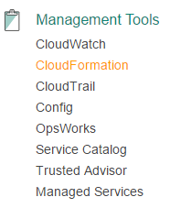](https://assets.cloudacademy.com/bakery/media/uploads/lab-step/blobid1-a8b2d612-a563-4aac-8395-eecf1e23f6c9.png)

You're now in the CloudFormation dashboard where we will be for the rest of the lab. Let's create a new stack by clicking "Create Stack".

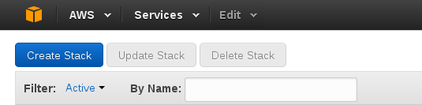

Now click on **choose file** and select the template file that you just downloaded and click **next**.

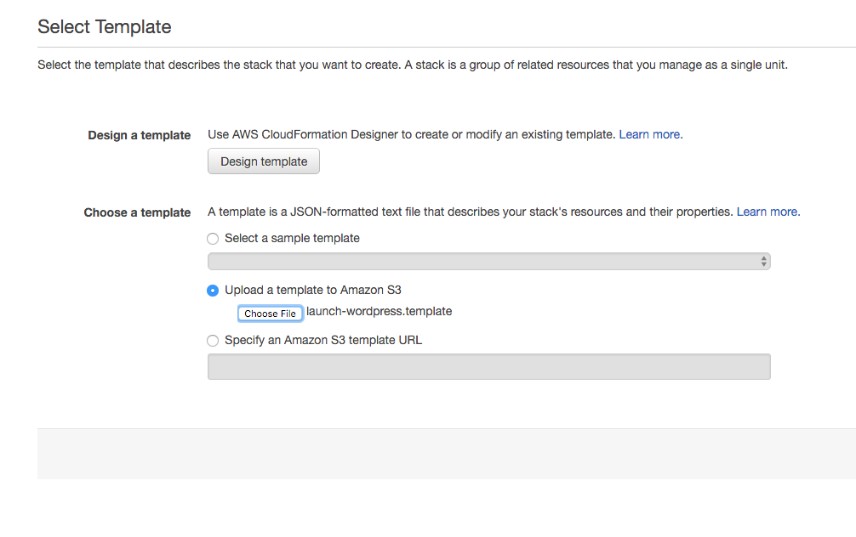

In the Parameters page, you'll fill in the values for Stack name, Database password, Root password, DB username, instance type, Keypair name, SSH Location, SubnetID, and VPC ID. Feel free to customize the settings or use the default ones. Just make sure to select a subnet that is inside the selected VPC otherwise you will have problems.

**Note: The default password is Start1234**

In the end, you should have something like this:

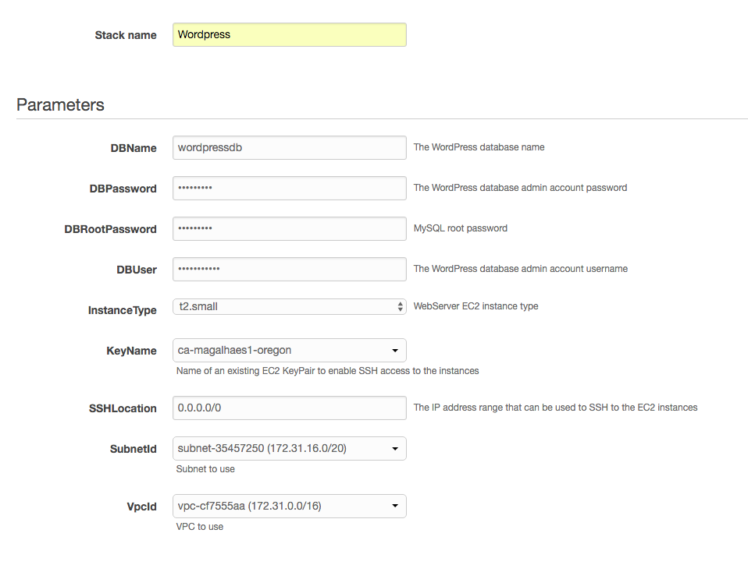

Click "Next" to advance to the tagging screen. It's not required to tag your stack, but in shared/organizational accounts tags help document who owns a resource.

For fun, let's tag the resource as a member of the testing environment. You won't be using this tag, so if you don't want to add it that's ok.

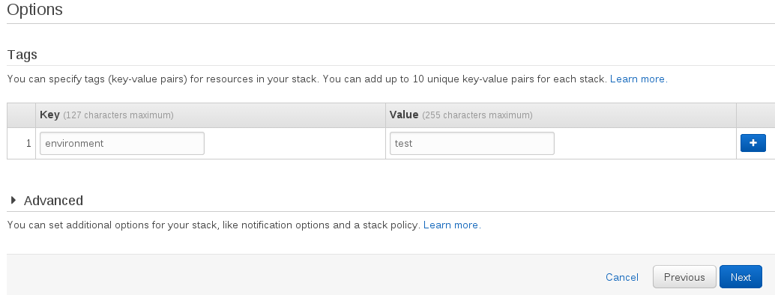

Hit "Next" and you'll be taken to the last piece of the stack creation process, the review screen. You should be able to see all the parameters you selected (except passwords). Scroll to the bottom and click "Create" to get your stack started. You'll be taken back to the CloudFormation dashboard where we started the stack.

## Check Stack Status

Now that your stack has been created, we're going to watch it finish building your WordPress blog. Click on your new stack to see more information about it.

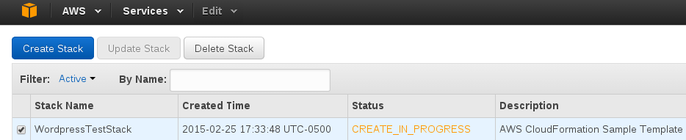

The first thing you should notice is in the stack's status column. All CloudFormation stacks and resources have a status that reflects the last action done to them (CREATE in this case) and the status of that action (IN_PROGRESS). As a user, these statuses are helpful for at-a-glance information about the condition of your deployment.

Down in the "Events" tab of the stack information, we can see which resources CloudFormation is working on. The stack itself contains all the other resources, so it needed to be created first. Next, the security group for our WordPress instance needed to be created, and now we'll wait a little bit for our actual instance to finish. This should take no more than 10 minutes.

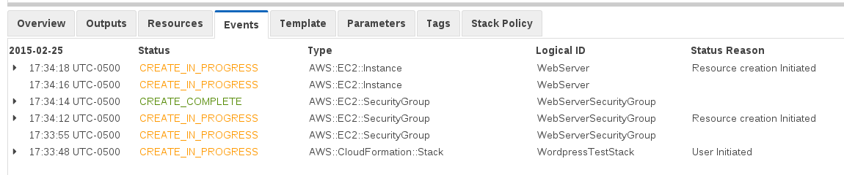

Newer events are at the top of the list, and you can see how CloudFormation automatically handles dependencies between the resources in the stack. The EC2 instance can't be created without a security group, so CloudFormation waits for the security group to finish before moving on.

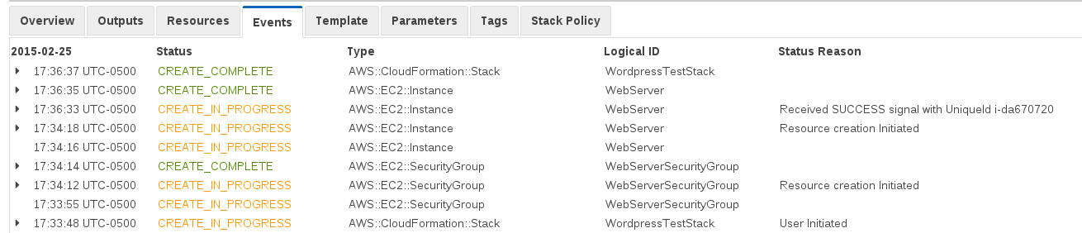

After waiting a few minutes, we can see that the instance was created and then CloudFormation set the stack's status to CREATE_COMPLETE.

Now let's see if WordPress works for us.

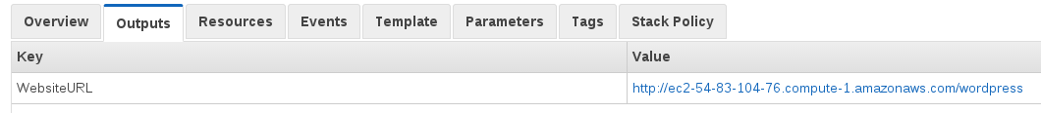

Go to the "Outputs" tab for the URL of the WordPress instance. CloudFormation used the EC2 instance's DNS name to build the URL you see here. From the console, click the link for your new WordPress installation. You can log in using the username and password credentials you selected when creating the stack.

## View Stack Resources

You've successfully created a CloudFormation stack, now let's take a look at what's inside. From the CloudFormation dashboard click on your stack, then go to the "Resources" panel.

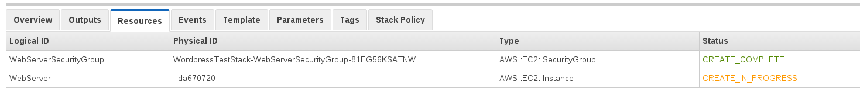

CloudFormation is easy to integrate into other workflows because all it does is orchestrate other AWS products and make it easy to repeat patterns. In your stack, the resources are the security group for the EC2 instance and the EC2 instance itself. You can see that the resource has a name in the template (WebServer) that maps to a "physical ID" (i-da670720) which is the real resource. Here is an excerpt of the template to give you an idea of what resources look like in that form. The [full template](https://bitbucket.org/toorroot/devops_base/raw/b6c196c6f57e11b40867665f123ffaf206bc177c/Labs/launch-wordpress.template) is also available for you to review.

...  
 "Resources" : {

"WebServerSecurityGroup" : {

"Type" : "AWS::EC2::SecurityGroup",

"Properties" : {

"GroupDescription" : "Enable HTTP access via port 80 locked down to the load balancer + SSH access",

"SecurityGroupIngress" : [

{"IpProtocol" : "tcp", "FromPort" : "80", "ToPort" : "80", "CidrIp" : "0.0.0.0/0"},

{"IpProtocol" : "tcp", "FromPort" : "22", "ToPort" : "22", "CidrIp" : { "Ref" : "SSHLocation"}}

]

}

},  
 ...

You can see that we actually didn't specify a name for the security group itself because CloudFormation generates one automatically. This is common for CloudFormation resources like IAM users, security groups, and DynamoDB tables if their name is left unspecified.

Now that you understand the resources underlying your WordPress installation, it's time to delete your stack. This will also destroy all its resources.

## Delete the Stack

Now that you've tested CloudFormation's built-in WordPress template and made sure your installation works, it's time to clean up the resources that CloudFormation created for you. Click on your stack and then hit the "**Delete Stack**" button at the top of the console.



Now go to the "Events" tab for your stack to see what is happening to your resources.

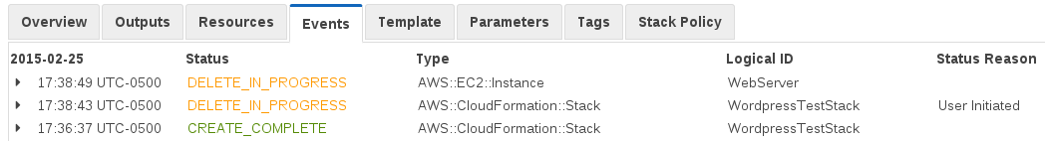

CloudFormation begins by deleting its resources and transitioning the stack to the DELETE_IN_PROGRESS state. Since there isn't a resource that depends on the EC2 instance, that is deleted first.

After a few minutes, all the resources will be deleted and your Events console will look like this.

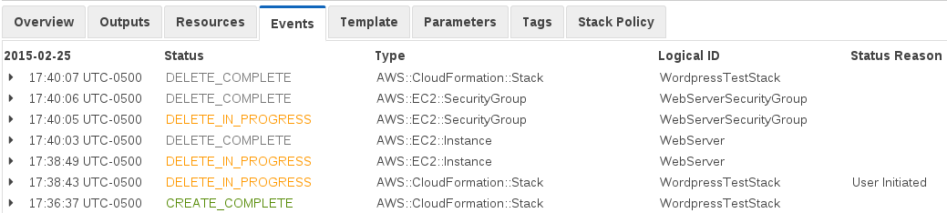

You can see that the order in which resources are deleted in the exact reverse of the order in which they were created. In a stack with only one "dependency chain" like this one, things always get deleted in the same order. In larger stacks, CloudFormation can delete resources in any order as long as all their dependents are deleted first. Since the security group was in use by the EC2 instance, it could not be deleted until **after** the instance.

Congratulations! You've successfully created, tested, and deleted your first stack.