**AWS – S3 service – LAB EXERCISES**

The following lab exercises will help you in deep understanding and hands-on practice for Amazon Simple Storage Service (S3).

Before doing the lab you must be signed-in AWS Management Console as described in AWS_Intro lab:

1. **Signing-in AWS Management Console**

We are using URL

<https://goliaf.signin.aws.amazon.com/console>

to sign-in AWS Management Console for training purpose.

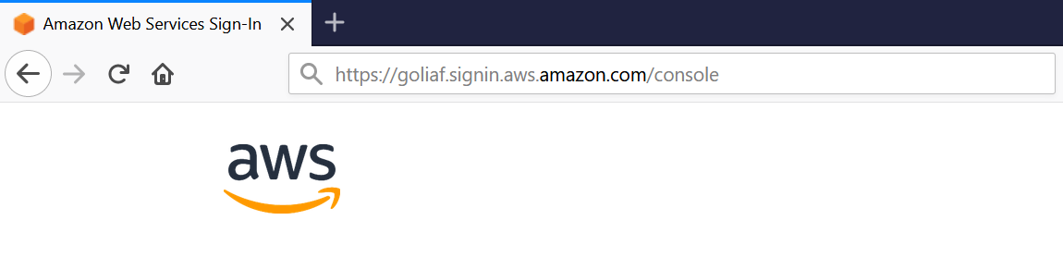

After that we will be redirected to AWS Login page: 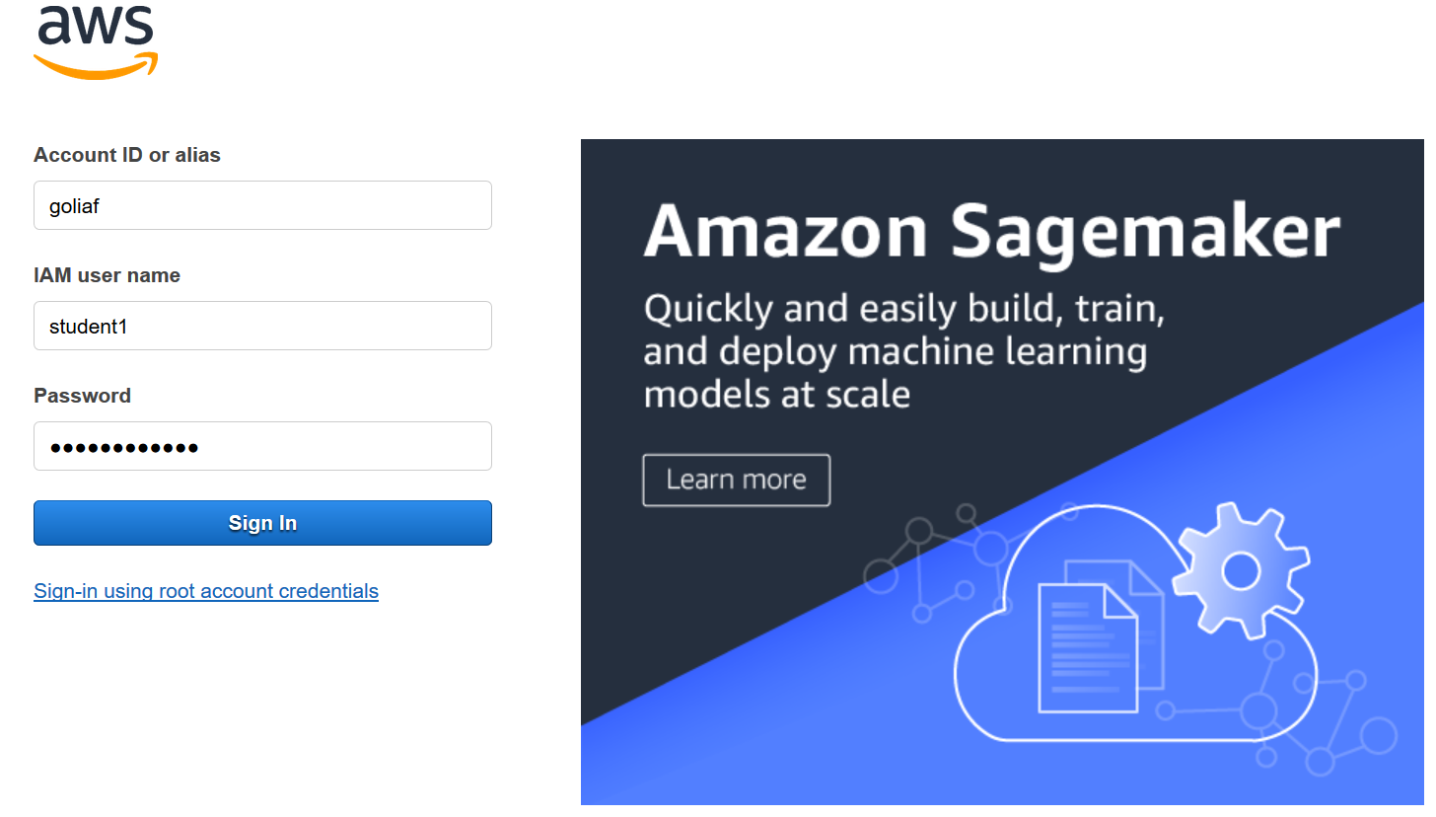

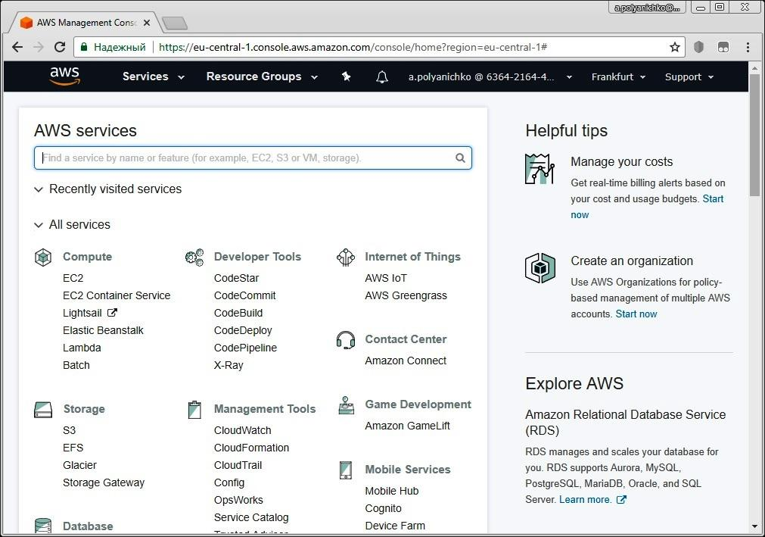

1. **Create AWS S3 Bucket**

Please find the link to S3 service on AWS Management Console main page or use search bar below the top menu.

|  |  |
| --- | --- |
| note icon | It is quite well approach to use search bar to find something you need in AWS Console or Dashboards, because not all services or items can be found directly on the page. Using search bar allows you to avoid wasting time when you are looking for something specific. |

Click on S3 link will open AWS S3 Dashboard:

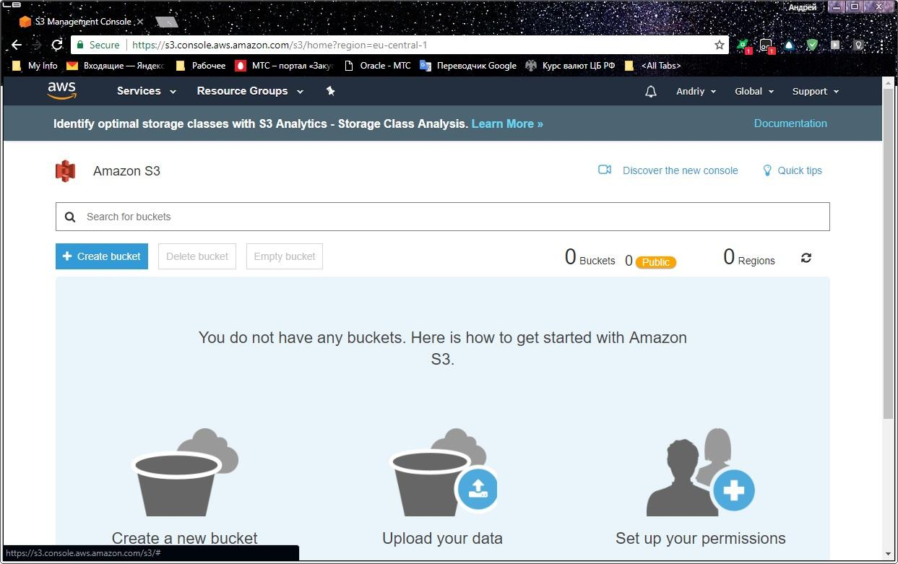

Normally your training account does not contain any bucket at this stage.

Start creation the bucket by clicking on appropriate button:

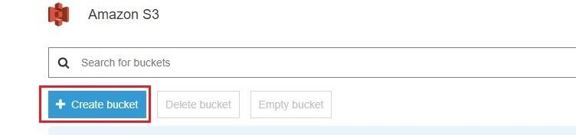

Define the name and region for new bucket:

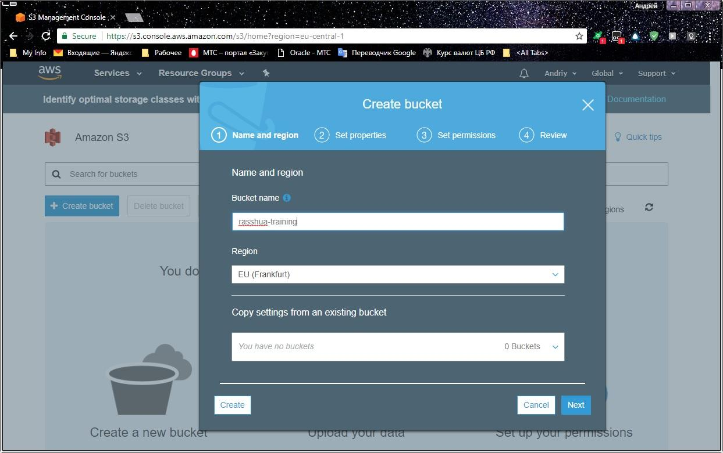

|  |  |
| --- | --- |
| alert, attention, error, message, warning icon | Please take in account that bucket name must be unique across all bucket names in Amazon S3. |
| alert, attention, error, message, warning icon | You must take in account some restrictions on S3 bucket names; you can found them in MODULE 2 training manual. The system may help you in some mistakes: |

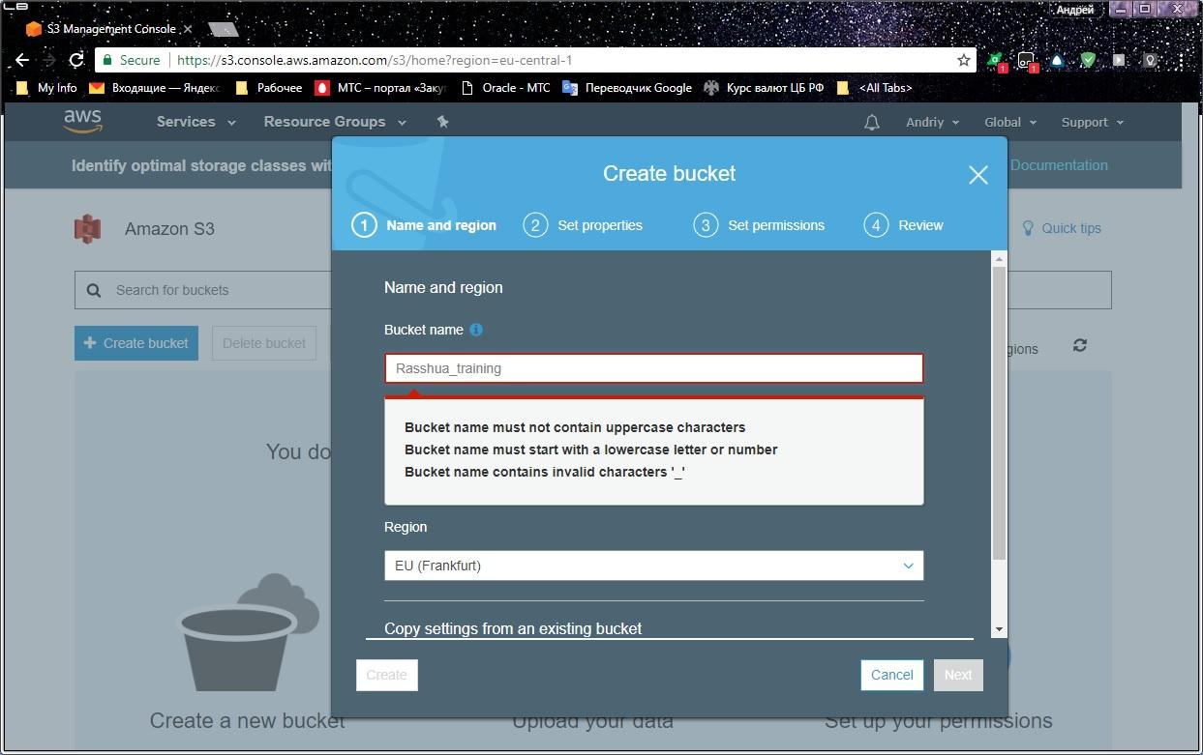

Click on “Next” button at the bottom.

On the next page you may define bucket properties:

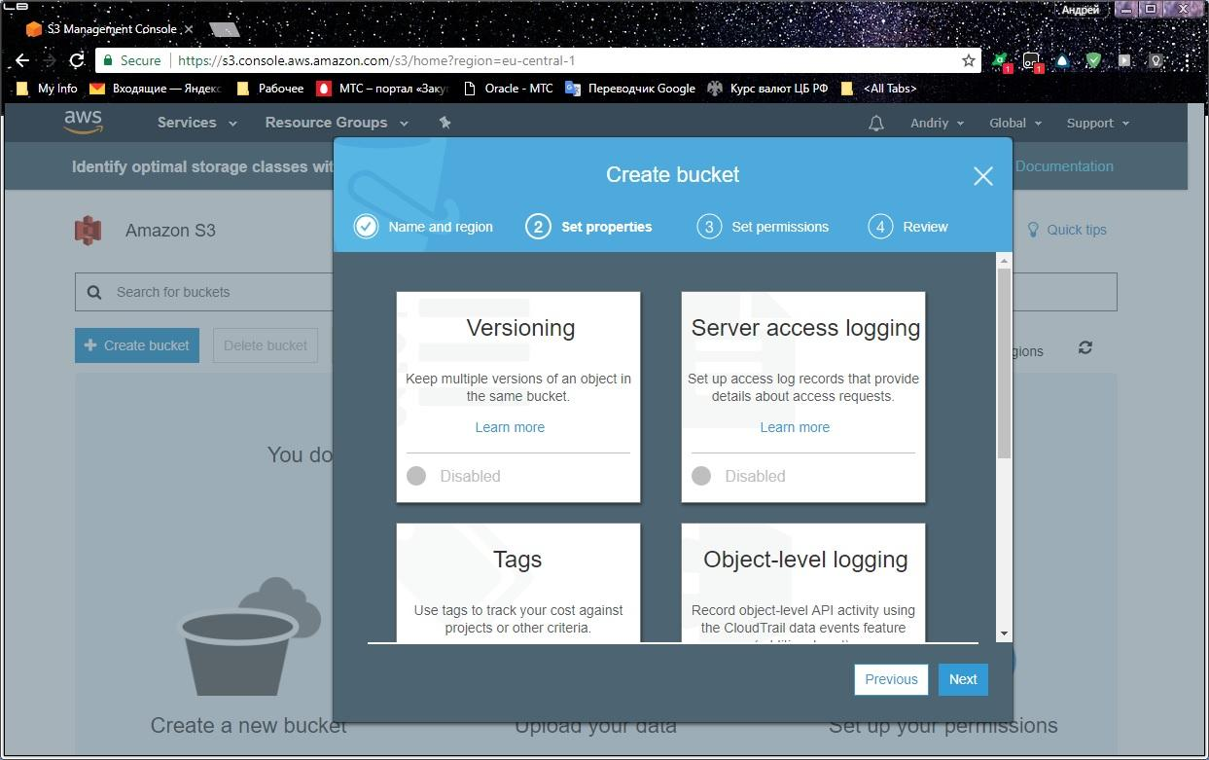

Please explore and identify all kinds of bucket properties here. Finally please leave all properties in default state for training purpose.

Clcik on “Next” button at the bottom.

On the next page you may define bucket permissions:

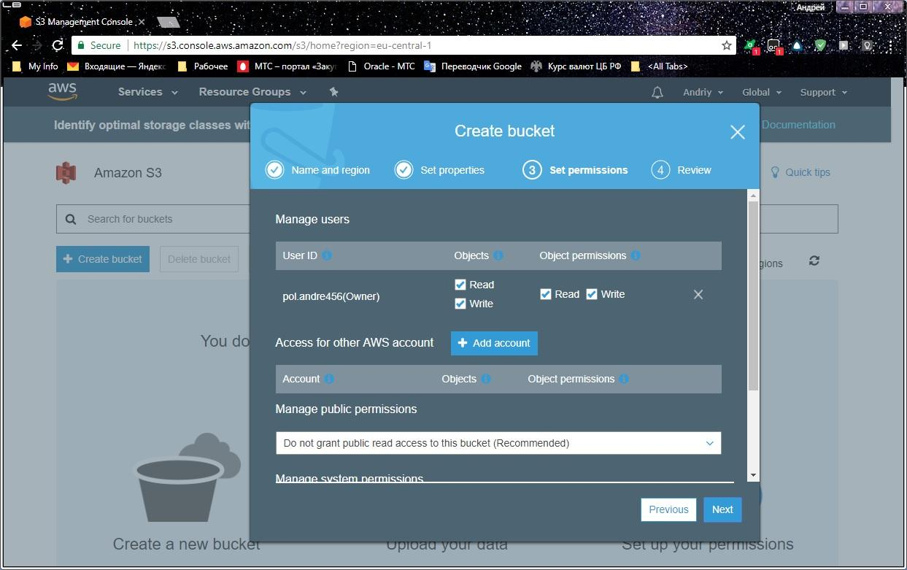

Please explore all items on page and finally leave permission unchanged for training purpose.

Click on “Next” button at the bottom and review the new bucket before creation:

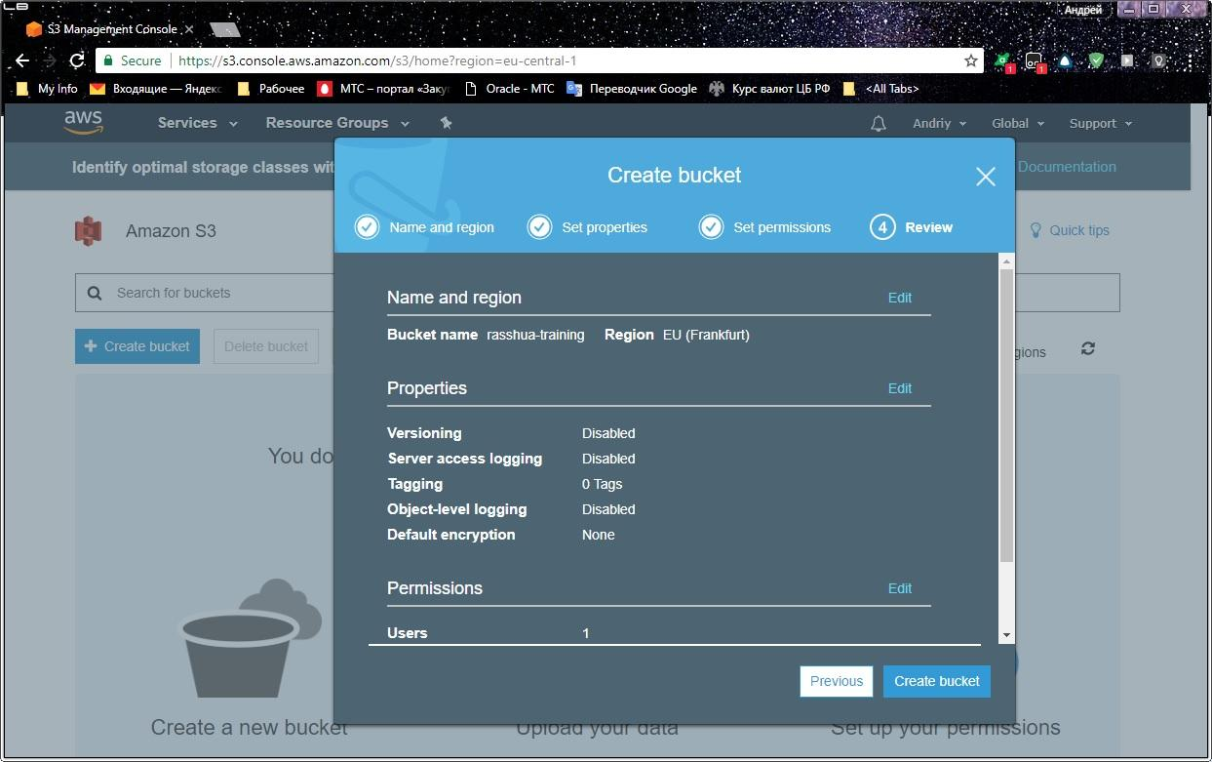

Finally click on “Create bucket” button at the bottom and find your new bucket on S3 Dashboard page:

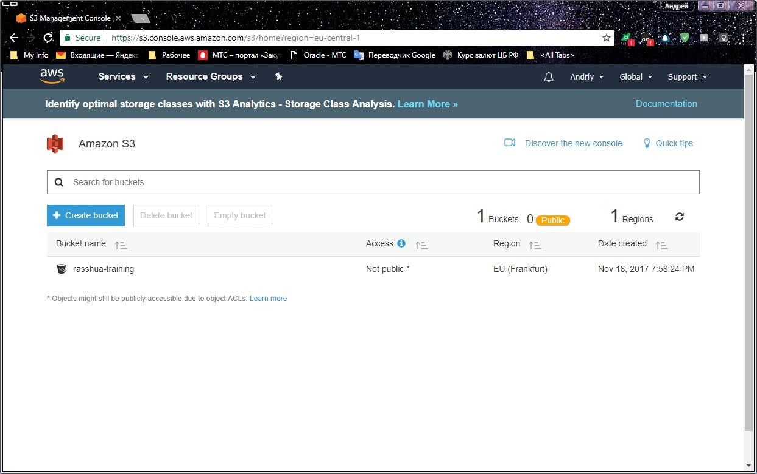

1. **Upload the file**

Click on bucket name to navigate it:

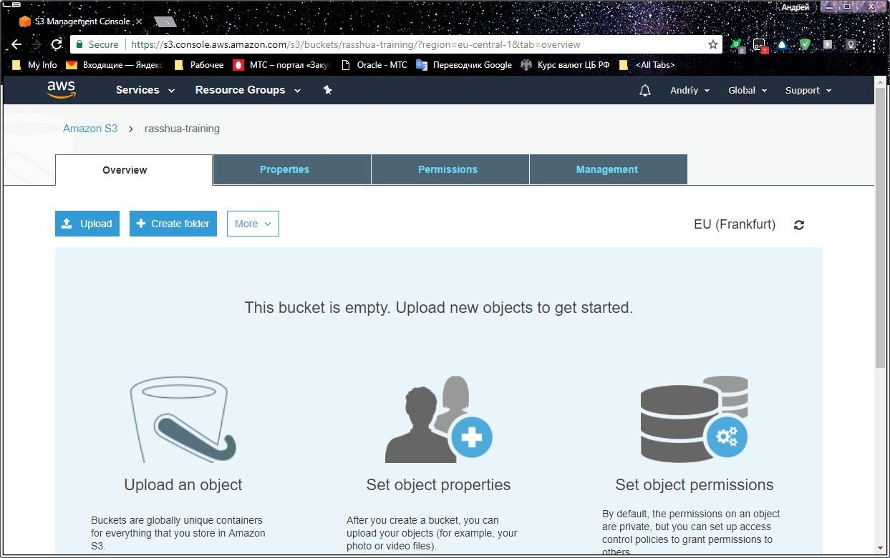

As you can see, you may upload the file or create “folder” in the bucket. Please refer to MODULE 2 training manual for bucket structuring details.

Click on “Upload” button to start file uploading process:

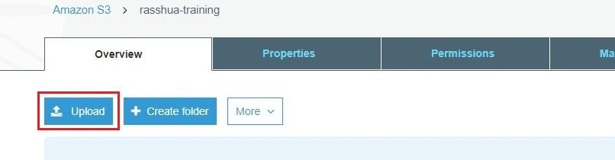

Drag & Drop the file or specify filename and location:

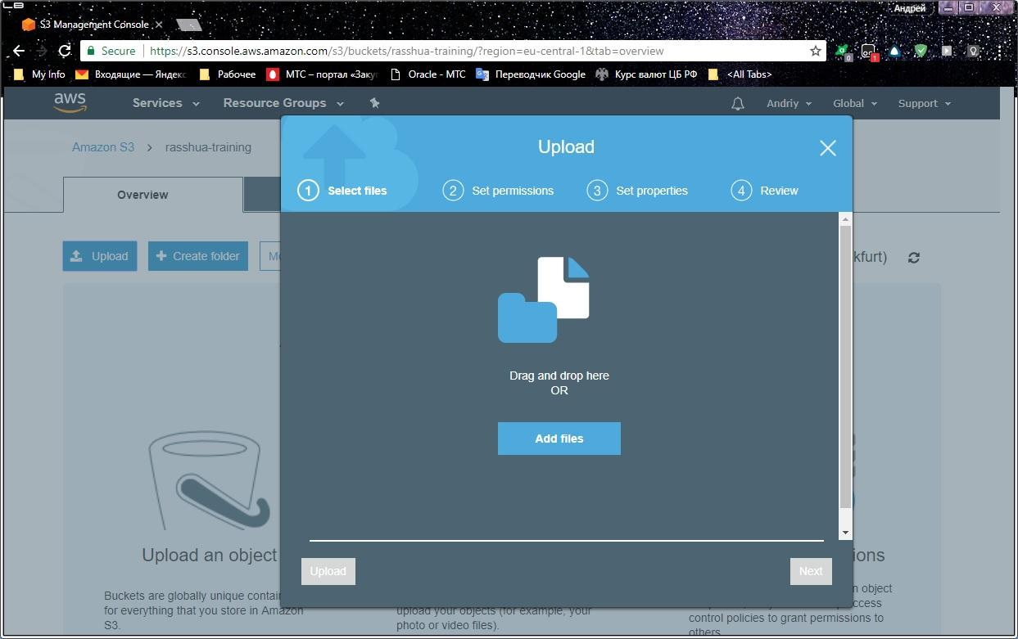

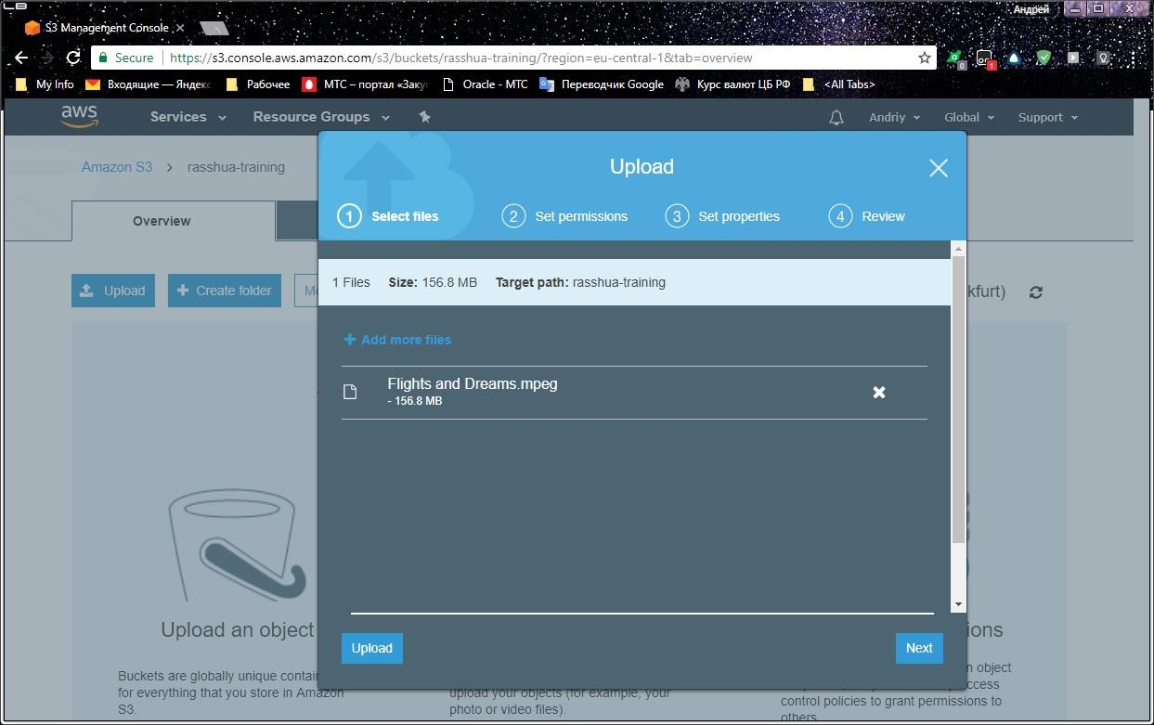

You may upload your file just now with default options.

Please click “Next” button at the bottom for reviewing of optional parameters:

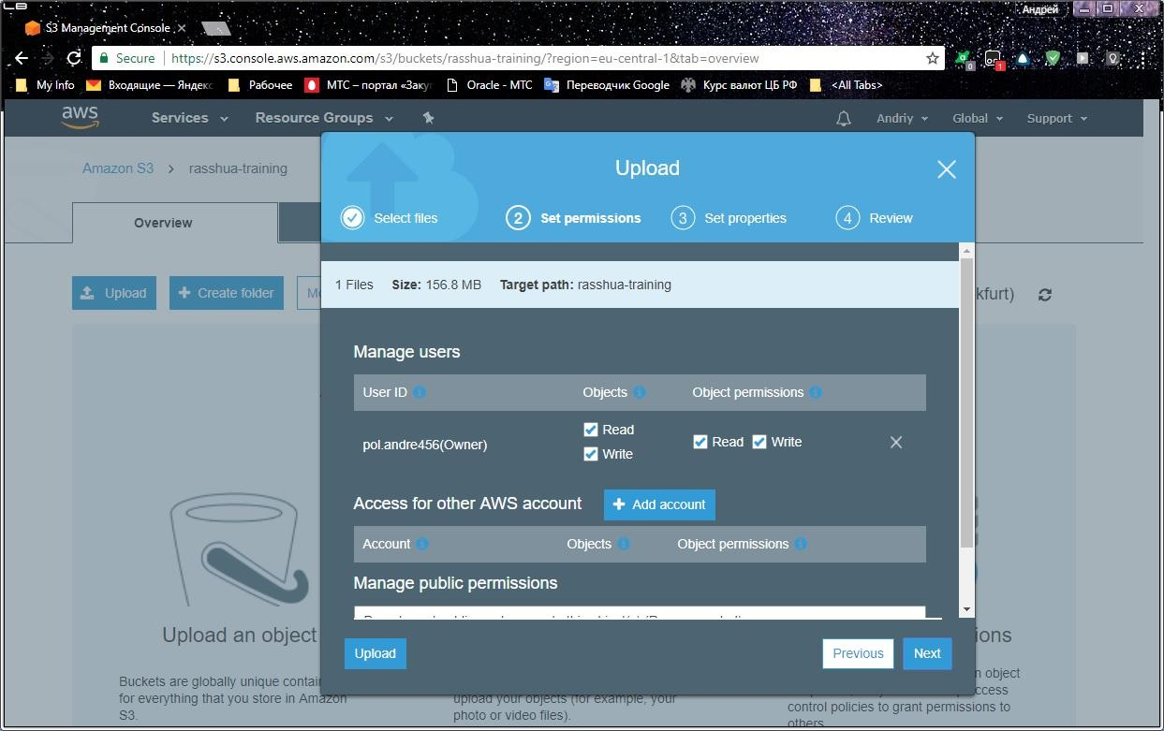

You may define permission options for your file here and it is similar to permission options for bucket.

Please click “Next” button at the bottom:

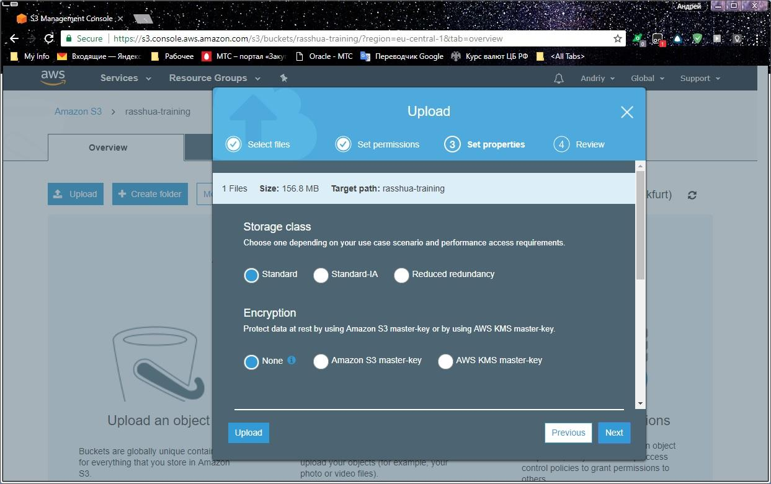

At the page you may set storage class, encryption and tags; you may define user metadata for your file as well.

Please click “Next” button at the bottom for file reviewing before uploading:

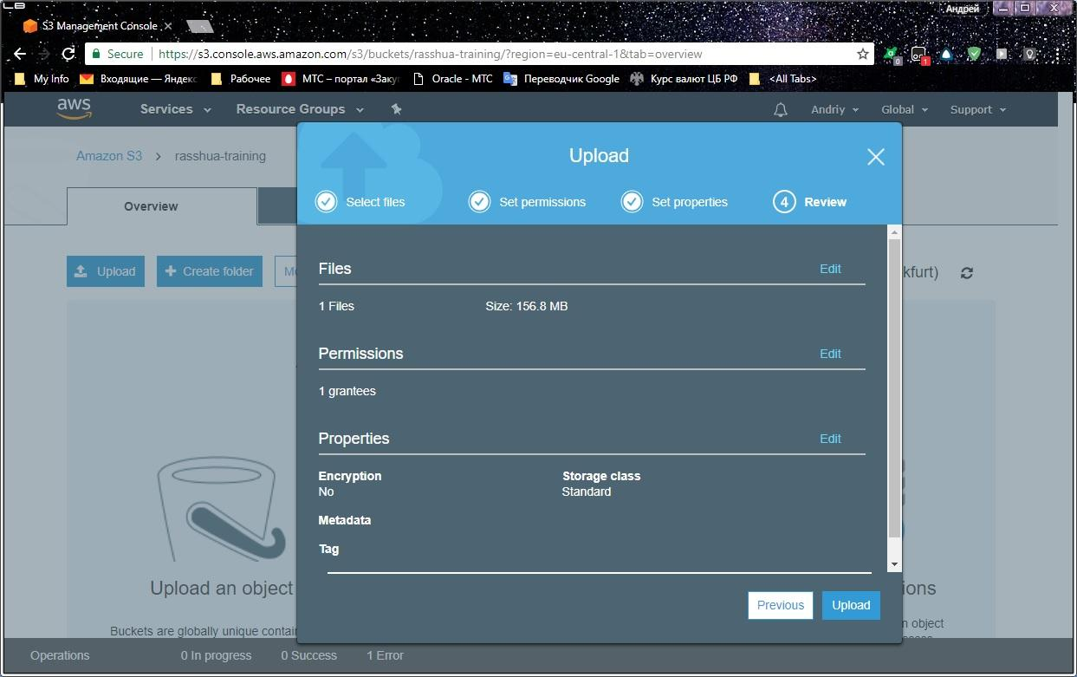

Please click “Upload” button at the bottom ant then find your file in the bucket after uploading:

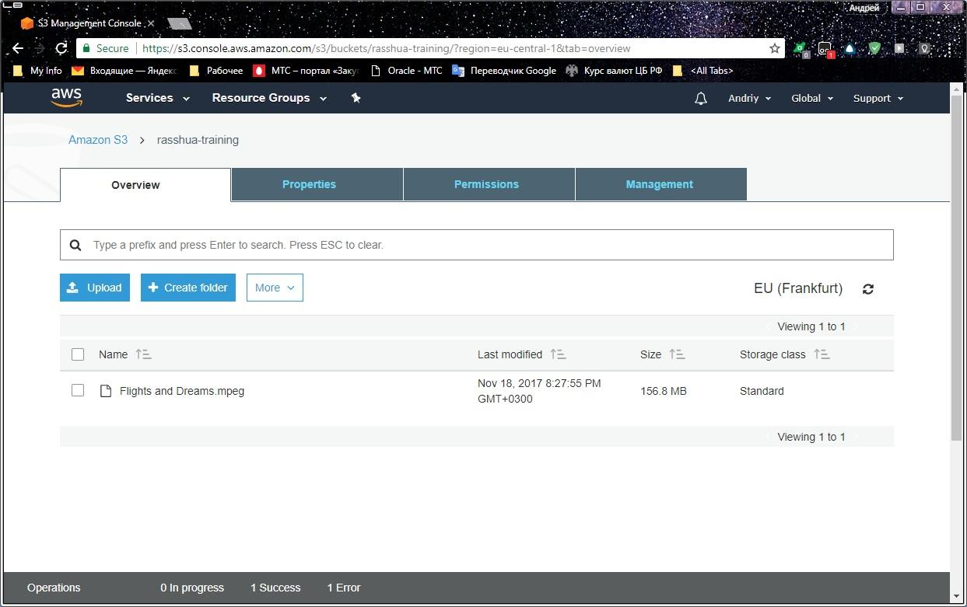

1. **Retrieve the file**

Please select checkbox to the left on filename to access the relevant functions:

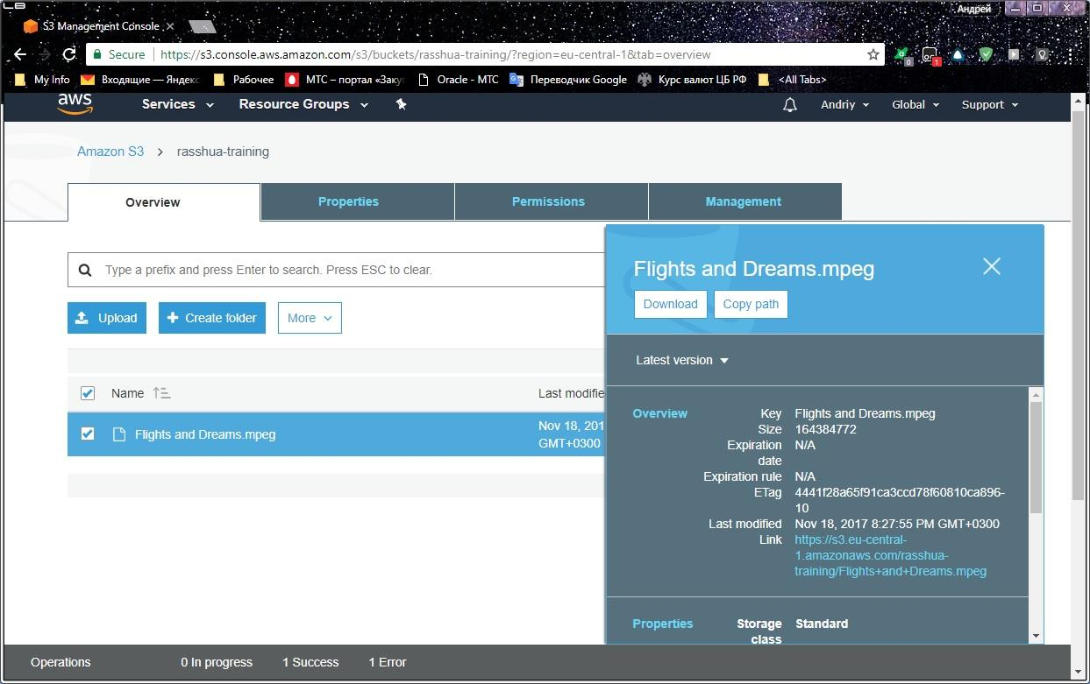

You may use “Download” button If you want to store your file locally:

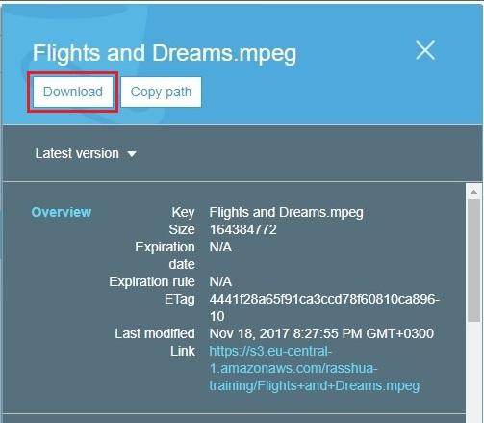

The system will request you to specify file name and location as usual.

Please note that “More” menu item becomes available as soon as we select a file in the list. You may explore this menu item by yourself.

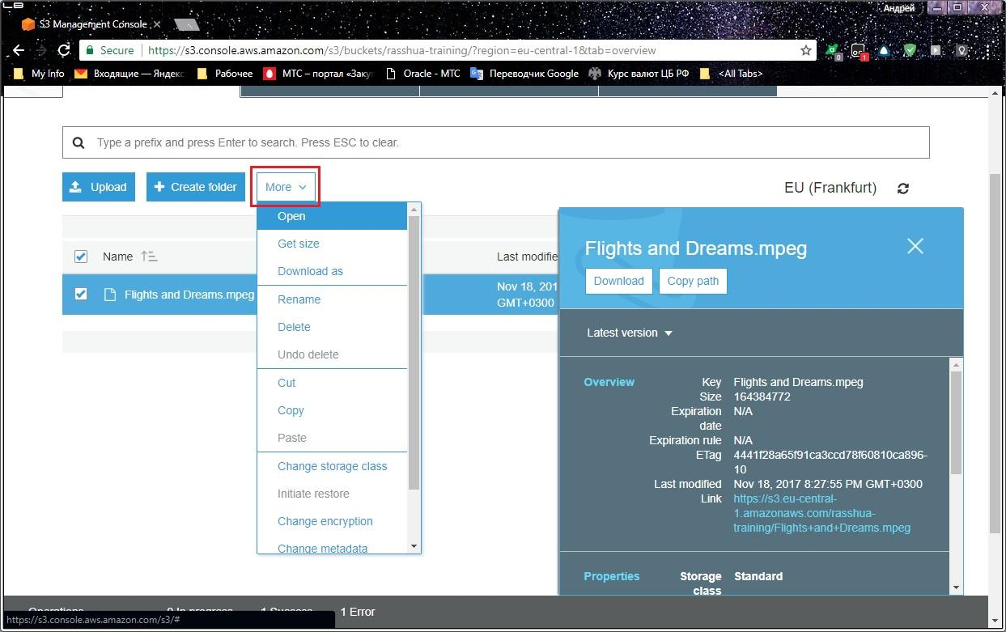

1. **Delete the file and the bucket**

|  |  |
| --- | --- |
| note icon | In fact it is the best practice to delete files and buckets which are not in use more. When you are deleting unused objects you preserve yourself against extra charge for them. |

Select the file you want to delete in the bucket then issue the command “More” → “Delete”:

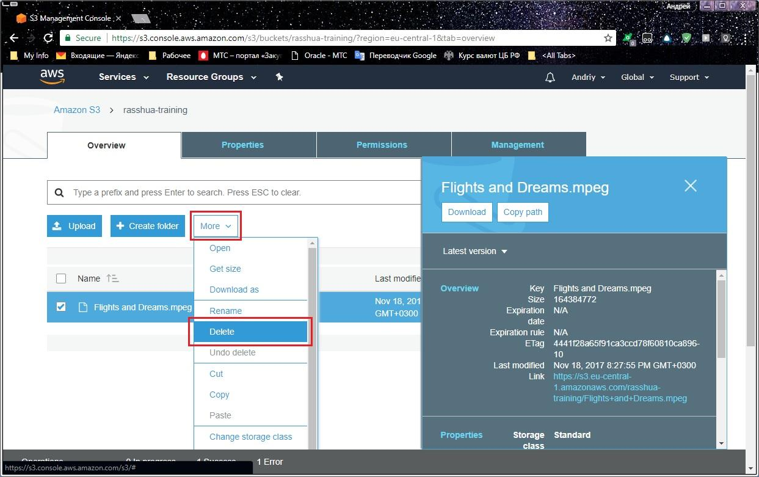

Review and confirm the operation:

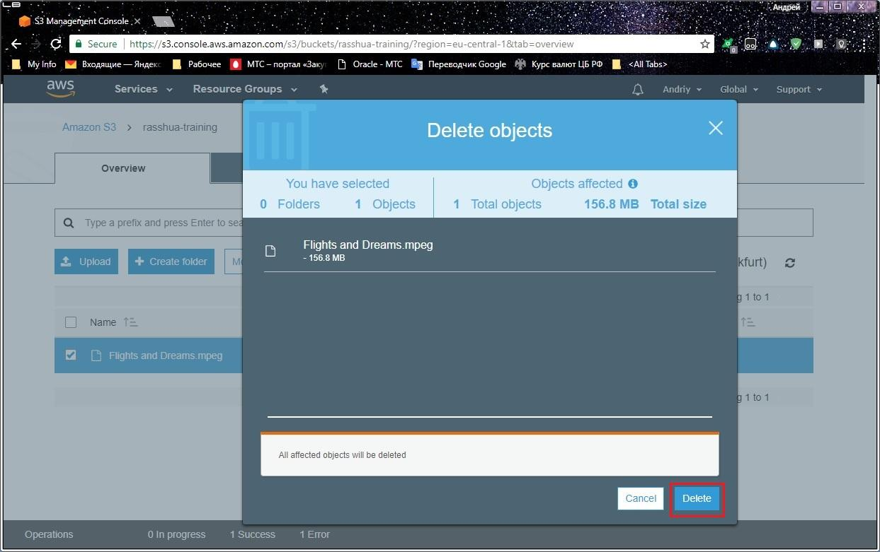

The file will disappear in the bucket:

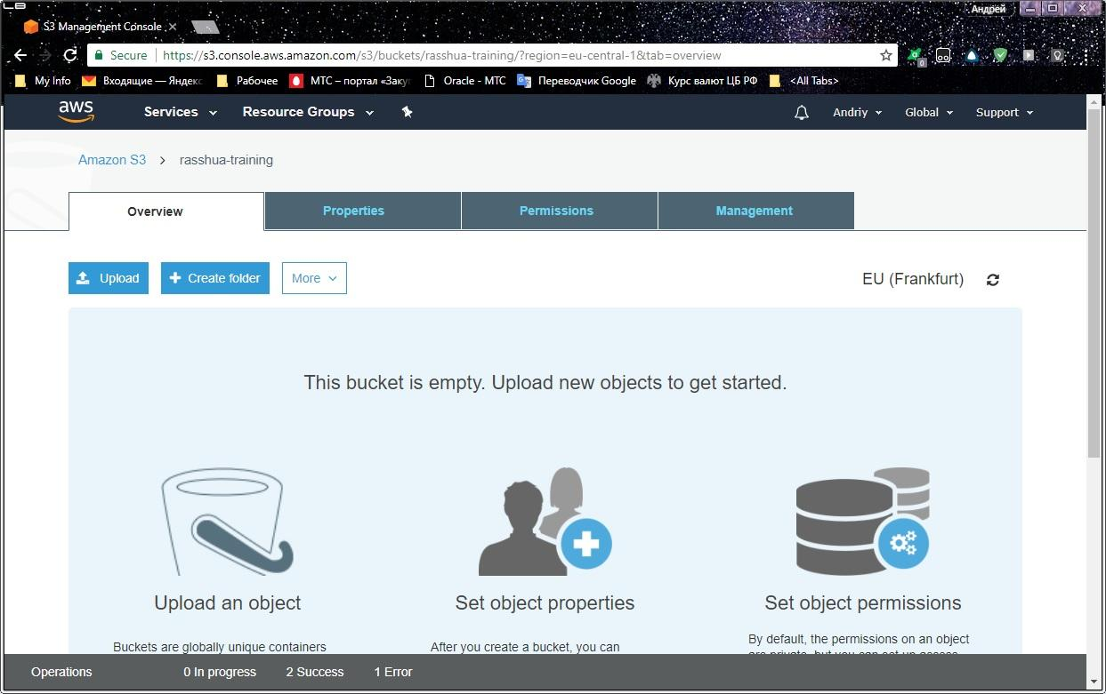

Go up on Amazon S3 level, select the bucket you want to delete and click “Delete bucket” button:

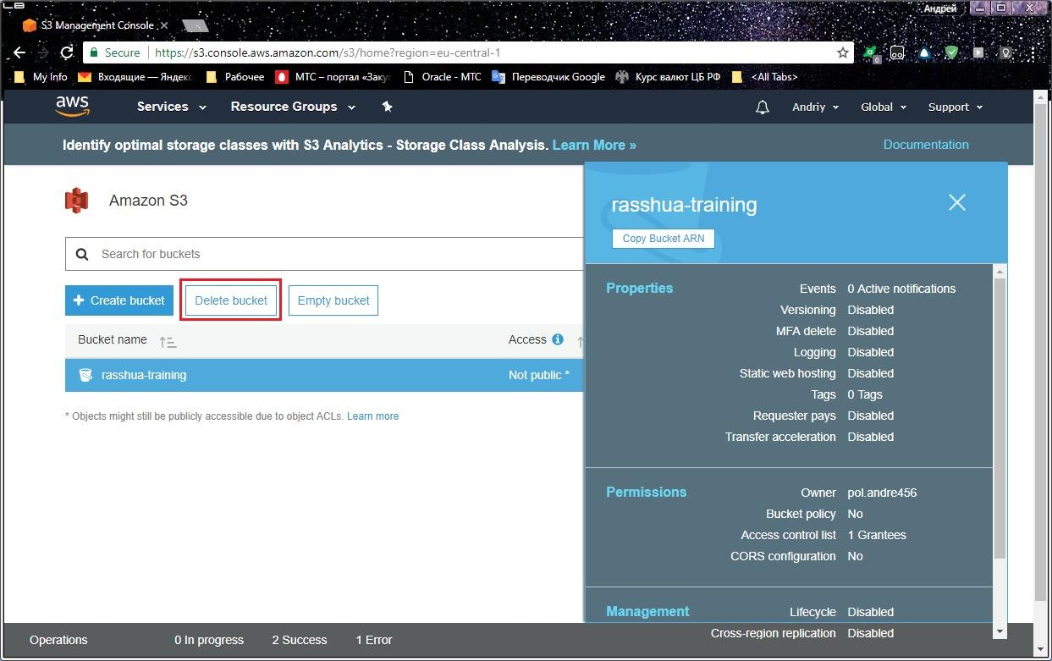

The system will request you to confirm deleting:

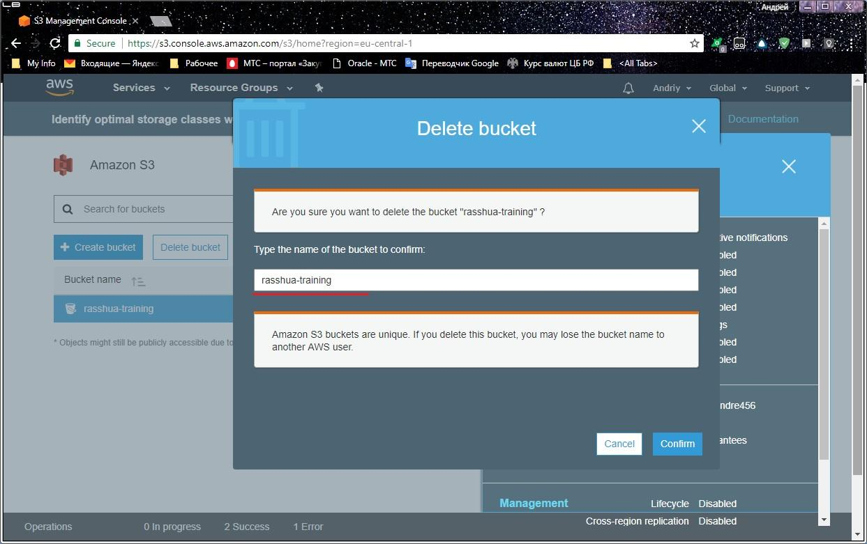

Please type the bucket name exactly in the input line.

1. **Batch backing up to Amazon S3 using CLI**

On this hands-on exercise we will try to operate Amazon AWS services using Amazon Command Line Interface (CLI). To be able to complete hands-on sequence you must have Amazon CLI application installed on your PC and you will need security credentials available for Amazon CLI configuration purpose.

Your security credential file may look like this:

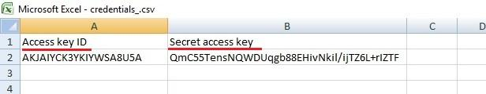

|  |  |
| --- | --- |
| note icon | Amazon AWS CLI is available for downloading through the following links:   * For Windows 64-bit: <https://s3.amazonaws.com/aws-cli/AWSCLI64.msi> * For Windows 32-bits: <https://s3.amazonaws.com/aws-cli/AWSCLI32.msi> * For MAC OS: <http://docs.aws.amazon.com/cli/latest/userguide/installing.html#install-bundle-other-os> |

Please open Command prompt (for Windows) or Terminal (for MAC) and perform initial configuring of your AWS CLI by determining Access Key ID, Secret Access Key, region and default output format:

|  |  |
| --- | --- |
| utilities terminal icon | C:\Users\USER>**aws configure**  AWS Access Key ID [None]:**AKJAIYCK3YKIYWSA8U5A**  AWS Secret Access Key [None]: **QmC55TensNQWDUqgb88EHivNkil/ijTZ6L+rlZTF**  Default region name [None]:**us-east-1**  Default output format [None]:  C:\Users\USER> |

Create the bucket by using CLI command:

|  |  |
| --- | --- |
| utilities terminal icon | C:\Users\USER>**aws s3 mb s3://my-100500-backup-bucket**  make_bucket: my-100500-backup-bucket  C:\Users\USER> |

|  |  |
| --- | --- |
| alert, attention, error, message, warning icon | Please remember that the bucket name (my-100500-backup-bucket in our example) must be unique around entire Amazon S3 services otherwise the system returns error message. |

Open S3 Dashboard in AWS Console and ensure that your new bucket is listed there:

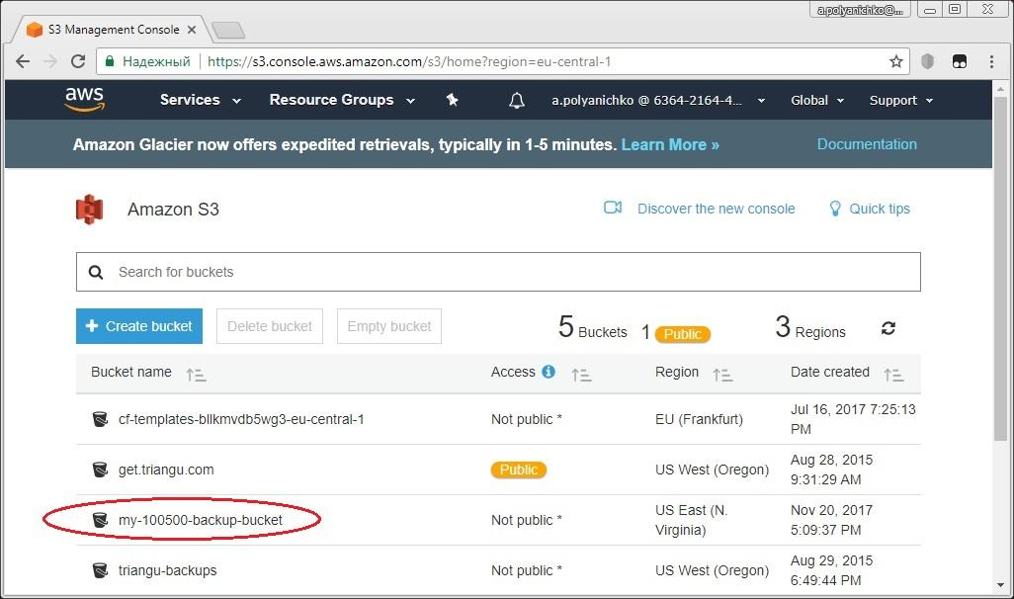

Upload your backup file into desired bucket:

|  |  |
| --- | --- |
| utilities terminal icon | C:\Users\USER>**aws s3 cp "C:\Users\Backup example.zip" s3://my-100500-backup-bucket**  upload: ..\Backup example.zip to s3://my-100500-backup-bucket/Backup example.zip |

In the output above "C:\Users\Backup example.zip" is the filename of your backup file. You may use original syntax of filename if name of file does not contain spaces.

Please ensure that your file is in the bucket using S3 Dashboard:

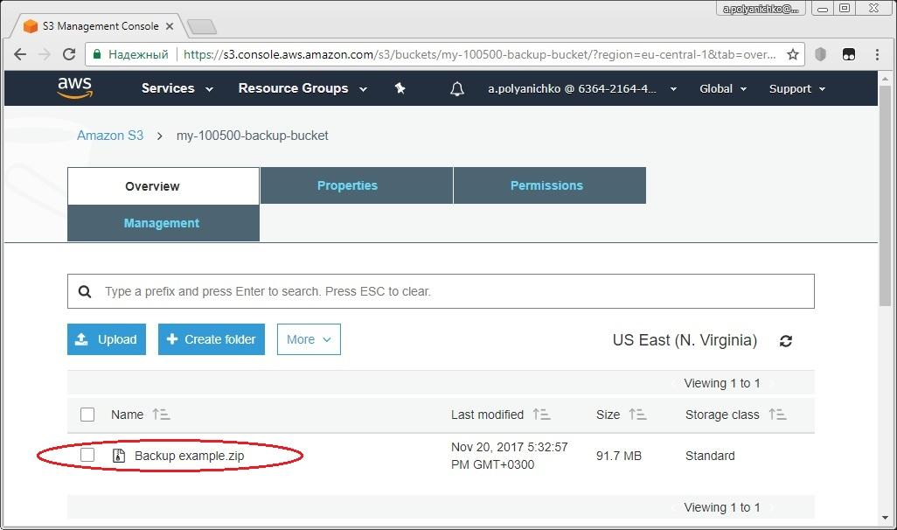

If you want to download the file from your bucket and save it locally on PC you will use the same command with reversed arguments like this:

|  |  |
| --- | --- |
| utilities terminal icon | C:\Users\USER>**aws s3 cp "s3://my-100500-backup-bucket/Backup example.zip" D:\Repository\**  download: s3://my-100500-backup-bucket/Backup example.zip to D:\Repository\Backup example.zip  C:\Users\USER> |

You can delete your file in the bucket through the single command line:

|  |  |
| --- | --- |
| utilities terminal icon | C:\Users\USER>**aws s3 rm "s3://my-100500-backup-bucket/Backup example.zip"**  delete: s3://my-100500-backup-bucket/Backup example.zip  C:\Users\USER> |

And finally you may delete the bucket if necessary:

|  |  |
| --- | --- |
| utilities terminal icon | C:\Users\USER>**aws s3 rb s3://my-100500-backup-bucket**  remove_bucket: my-100500-backup-bucket  C:\Users\USER> |