**MODULE 1 – LAB EXERCISES**

The following lab exercises are designed to give trainee an opportunity to test in practice the material outlined in Introduction to AWS Services training manual.

1. **Signing-in AWS Management Console**

We are using URL

<https://goliaf.signin.aws.amazon.com/console>

to sign-in AWS Management Console for training purpose.

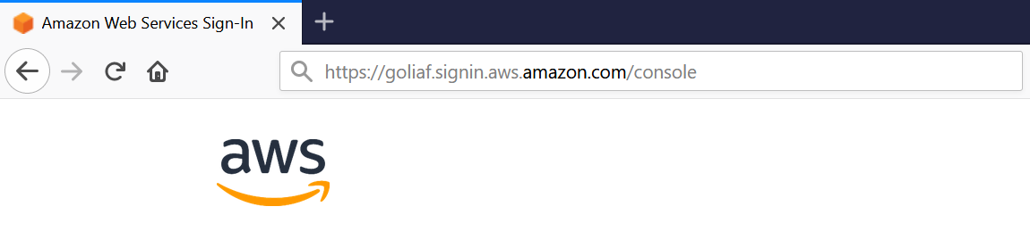

After that we will be redirected to AWS Login page: 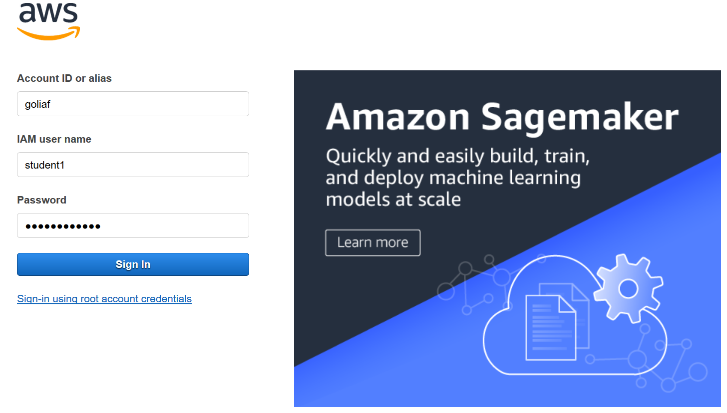

Enter IAM User name and Password here and then click “Sign In” button. AWS Console Home page will be opened:

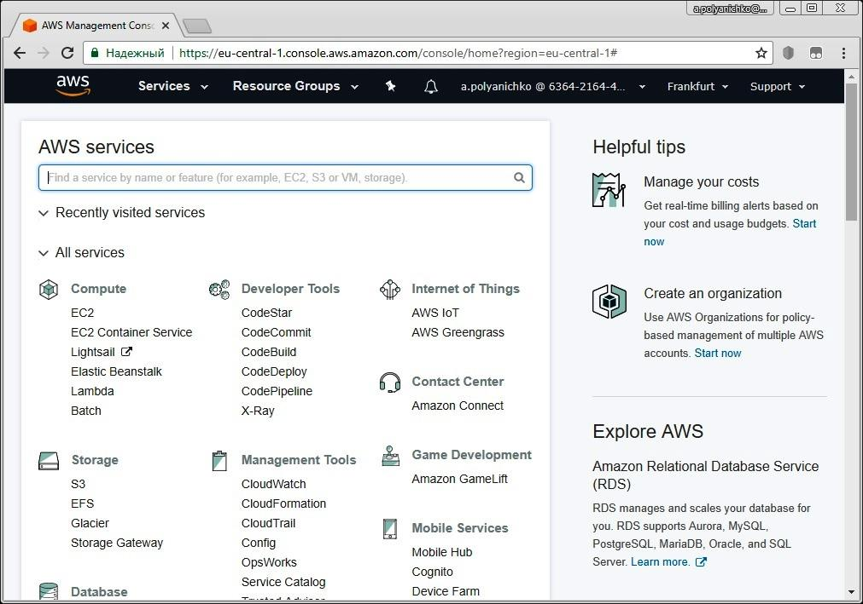

|  |  |
| --- | --- |
| note icon | “**Student1**” ... “**Student50**” values are pre-defined as IAM user names for training purpose. Password is set to **$training0** by default. |

1. **Exploring AWS Console main page**

Please have a look at AWS Console main page entirely (scroll it down). Identify primary topics, sections and items.

Please try to open all scroll-down menus at the top of page:

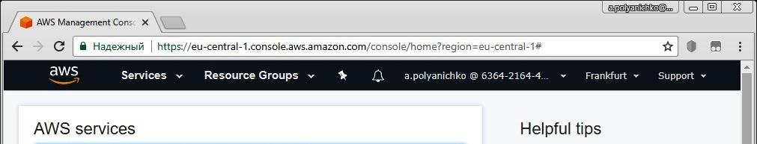

Determine for what each scroll-down menu is intended and what the content of each of them is.

Please explore in details AWS Regions scroll-down menu:

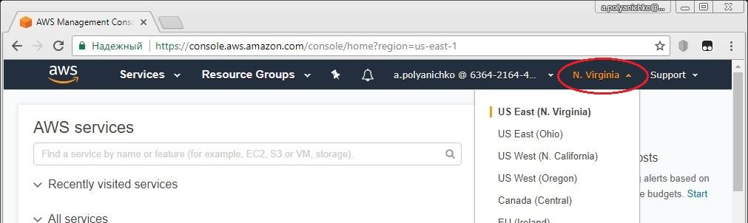

Determine which AWS regions and Availability zones are available to be selected for training purpose.

Please select your desired region / zone for further using in lab exercises (the screenshot below is an example only; it is not mandatory recommendation for everybody).

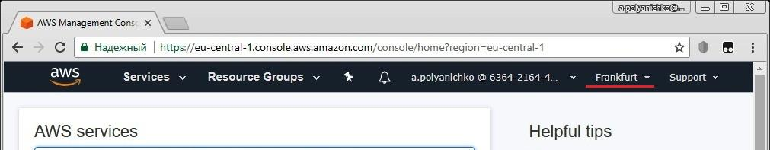

Please identify all AWS services listed in MODULE 1 training manual:

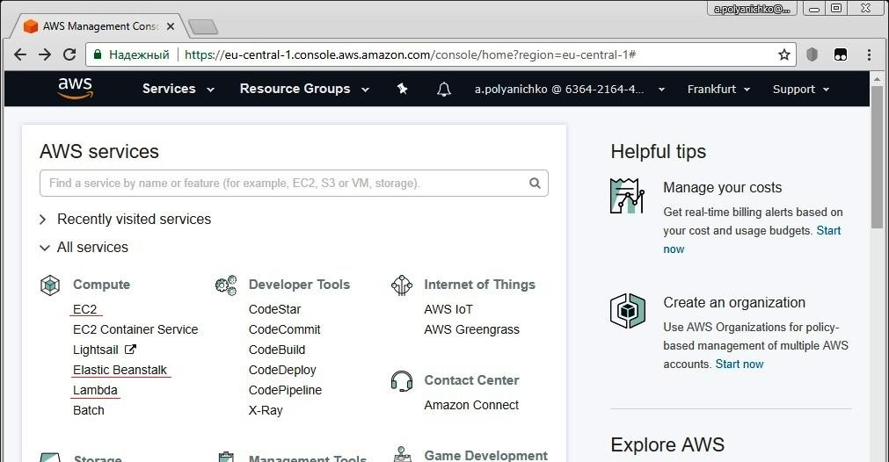

(At the training preparation we counted 29 listed services. Let’s compare our attentions!)

1. **Search function and AWS Billing Dashboard**

Please try to use search function on AWS Console main page to find AWS Billing service:

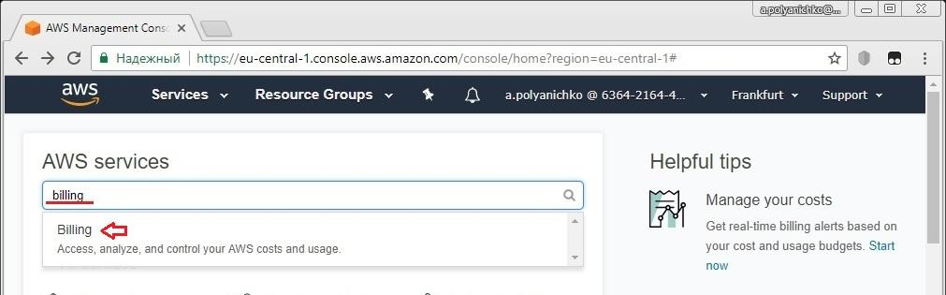

Type “billing” keystroke in search field and then click on Billing item the system offers. AWS Billing Dashboard page will be opened:

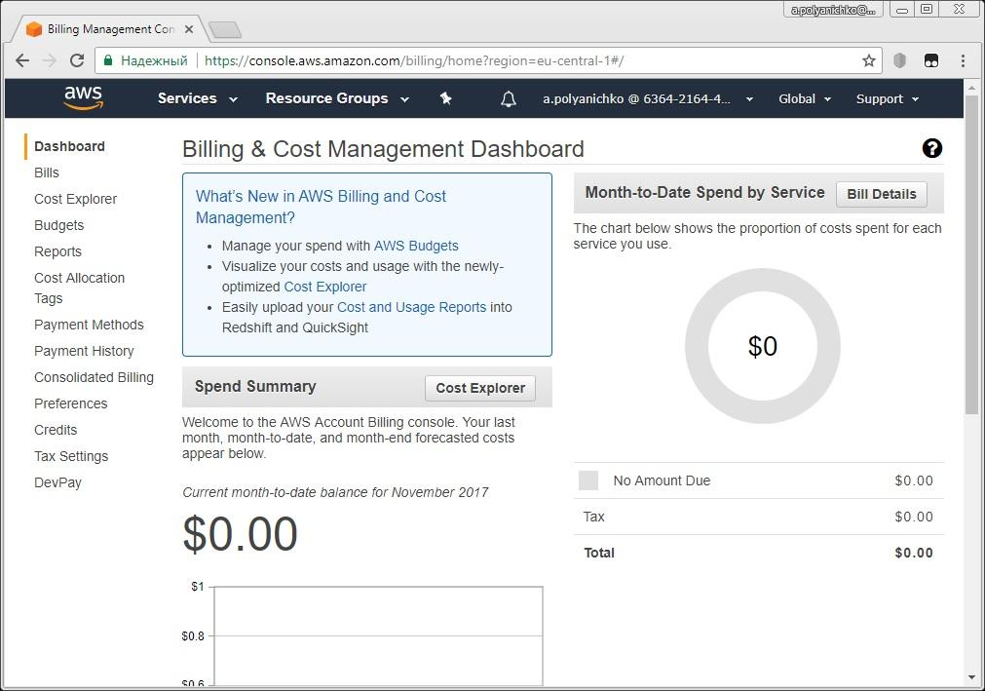

Please explore left-hand menu on the page in brief.