

PROGRAMMING TECHNIQUES

Homework 4

Student : Tudor Vlad Bresan
Group: 30423
Table of Contents
Homework 4 1
1 Problem specification 3
2 Problem analysis, modeling, scenarios, use cases 4
2.1 Problem analysis 4
2.2 Modeling 4
2.3 Scenario and use cases 5
3 Design 5
3.1 Class Diagram 5
3.1.1 Bank Proc 7
3.1.2 Bank 7
3.1.3 Account 7
3.1.4 GUI Class 7
3.1.5 Controller 7
3.1.6 Saving account 7
3.1.7 Main Class 7
3.2 Package diagram 8
3.3 Data Structures 8
3.4 Relationships 9
3.4.1 Algorithms 9
3.4.2 User Interface 11
4 Implementation 11
5 Results 14
6 Conclusion and feature development 15

Problem specification
Consider the system of classes in the class diagram below.
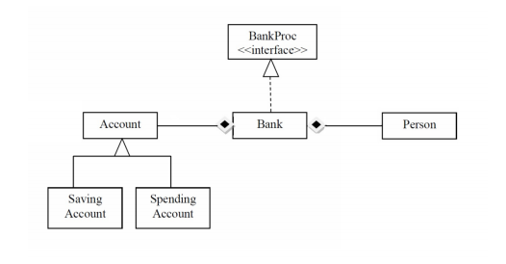
1. Define the interface BankProc (add/remove persons, add/remove holder associated accounts,read/write accounts data, report generators, etc). Specify the pre and post conditions for theinterface methods.
2. Define and implement the classes Person, Account, SavingAccount and SpendingAccount. Other classes may be added as needed (give reasons for the new added classes).
3. An Observer DP will be defined and implemented. It will notify the account main holder about any account related operation.
4. Implement the class Bank using a predefined collection which uses a hashtable. The hashtable key will be generated based on the account main holder (ro. titularul contului). A person may act as main holder for many accounts. Use JTable to display Bank related information.
4.1 Define a method of type “well formed” for the class Bank.
4.2 Implement the class using Design by Contract method (involving pre, post conditions,invariants, and assertions).
5. Implement a test driver for the system.
6. The account data for populating the Bank object will be loaded/saved from/to a file.

Problem analysis, modeling, scenarios, use cases

Problem analysis
We’ll try to create an application as close as possible to a real life bank. The bank is going to hold persons and accounts , each person having at least one account otherwise the bank is going to be inconsistent. So we either have a person with at least one account or if that person does not have any accounts that person should not exist in the bank records. We’ll create two types of accounts , one will be a saving account where the user will get an additional amount of money in relation to an interest , and the other account being a spending account. Each account will have it’s conditions which will be applied.

Modeling
The implementation of this project is going to be done as follows :we’ll have a class that is responsible of reading and writing into a .ser file, an interface called BankProc which will contain the main methods to be applied in a bank such as: deposit , withdraw , delete account etc. ; the Bank class will implement the methods declared in the interface ; the person class will contain attributes , getters and setters which are needed for each client; the Account class as an abstract class which will be the super class for the SavingAccount class and the SpendingAccount class; and the classes that will make the interaction with the application possible , the controller class which implements action listeners for each button, text field etc. and the GUI class which will initialiaze the graphic user interface.

Scenario and use cases
The user will be able to do some actions like : adding a new account , deleting an existing account , deleting an existing client along with all his/hers affiliated accounts , add/withdraw money from an account . In order to do any operation the user must enter the necessary data. The data that can be entered are : first name and last name of the client , the national identification number ( CNP ) the account id, the amount of money
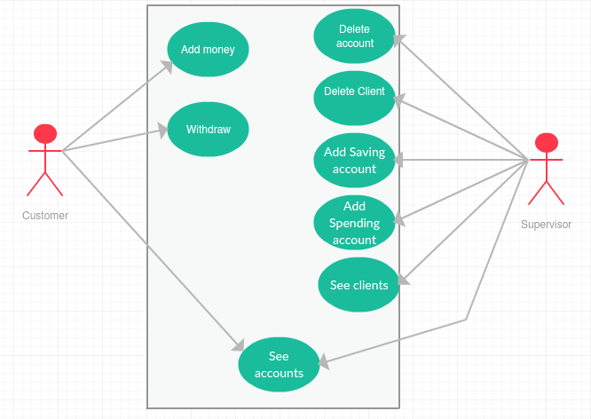

Design

Class Diagram
The UML diagram is a class diagram in which we can find the relationship between classes and also the elements(class variables , methods) a specific class contains.
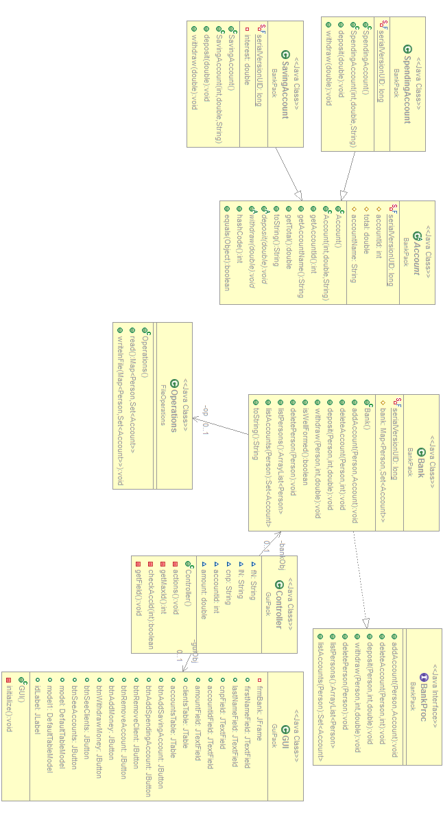

Bank Proc
The BankProc , as the name is suggesting , it’s showing the “behavior” of the class Bank .All the methods with empty bodies are going to be implemented in the class mentioned here (3.1.1)

Bank
The Bank class implements all the methods declared in the Bank Proc interface. The methods implemented by this class are: addAccount, deleteAccount, deposit, withdraw , deletePerson , listPersons and listAccounts.

Account
The account class will be created as an abstract class due to the fact that it’s going to be a super class for 2 other classes i.e. Saving Account class and Spending Account class.

GUI Class
This class is designed to create a graphical user friendly interface to simplify the use of the application. This class is a subclass JFRame for the purpose of using objects like : buttons , frames, textfields, panels.
In the graphic user interface we can observer text fields which are as follows First name , Last name , national identification number ( CNP ), the account id, the amount of money. Furthermore it initializes the buttons for which we will create action listeners int the Controller class. The buttons are :Add Saving account, add spending account , remove client , remove account , add money, withdraw money , see clients and see accounts. We also have two JTables which will serve as display tables for clients and for accounts , and finally we have a label which shows us the next account id available.

Controller
In this class we will implement the action listeners for each text field , button , label and tables . It also contains methods which help us filter the results. It uses objects of class GUI and of class Bank

Saving account
This class implements overridden methods that were previously declared in the Account class. These methods are : deposit and withdraw . The override happens due to the fact that each type of account has different behaviour

Main Class
The main class purpose is to create a new object of type Controller. This creation is being made in the main method “public static void (String[] args) which makes the whole application run. When the new object is created the controller will initialize the GUI which will pop on the screen and the application will be ready to use.

Package diagram
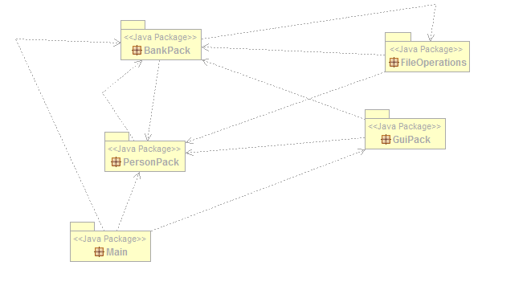

These packages contain classes that implement specific methods. Each package has it’s role and will not implement any other methods that are not related to the others.

Data Structures
The main data structure used in this project is the HashTable. In computing, a hash table (hash map) is a data structure used to implement an associative array, a structure that can map keys to values. A hash table uses a hash function to compute an index into an array of buckets or slots, from which the desired value can be found.

Ideally, the hash function will assign each key to a unique bucket, but it is possible that two keys will generate an identical hash causing both keys to point to the same bucket. Instead, most hash table designs assume that hash collisions—different keys that are assigned by the hash function to the same bucket—will occur and must be accommodated in some way.

In a well-dimensioned hash table, the average cost (number of instructions) for each lookup is independent of the number of elements stored in the table. Many hash table designs also allow arbitrary insertions and deletions of key-value pairs, at (amortized) constant average cost per operation.

In many situations, hash tables turn out to be more efficient than search trees or any other table lookup structure. For this reason, they are widely used in many kinds of computer software, particularly for associative arrays, database indexing, caches, and sets.

Relationships
To solve the problem specifications the program uses 10 classes and 1 interface , so it can be more clear and be understood better . The name of the classes are representative and they do exactly what they’re supposed to be doing .
There are dependencies between the classes of this project, which means that a class uses another class methods or objects . The hierarchy is at follows : the class main creates a new Controller object which means it uses the Controller class. The controller class will initialize the graphic user interface . Each time a button is pressed on that interface an action listener will be ran from the Controller class. In that action listener we’ll have pieces of code that are specialized in executing the commands that are supposed to be executed when a specific button is pressed . That being said , a link to the other classes appear,Controller uses methods from the two classes that implement the operations , Bank and GUI . The reading and writing methods are created in the Operations Class which is specialized in file operations. This feature was needed due to the fact that we had to use the Serializable interface

Algorithms
Add account method is going to check the Bank if the user exists in their database . If the user exists , it will add the desired account to the set of accounts that client hold , otherwise the add account method will add the client to the database and afterwards create the desired account.After the addition is performed the Operation class object will write the data into the bank file.
Delete account method is going to check if the account to be deleted exists. If it exists , there might be a chance that the client hold only that account meaning that the client will be deleted as well. If the client holds more than one account then the method is going to iterate through the set of accounts that are held by the client and it will delete the specified account.
The deposit method is different for each account, each account has their restriction. The main idea of this method is that it is going to add the inputed amount to the amount that was currently present in the account. For example , if the client wants to deposit a sum of money in a saving account , that sum must be greater than 1000 currency an when the deposit is made the client will be granted an intereset due to the fact that it is a saving account.
The withdraw method , as the deposit method above says , it does the exact opposite. It subtracts an amount of money from an account based on some constraints.
The delete person method will delete the desired client from the database and it will also delete all the affiliated accounts.
See clients method will iterate through the HashTable and will print all the clients in the JTable designated for the clients .
See accounts will iterate through the clients accounts and will print all the accounts in the JTable designated for the accounts.

User Interface

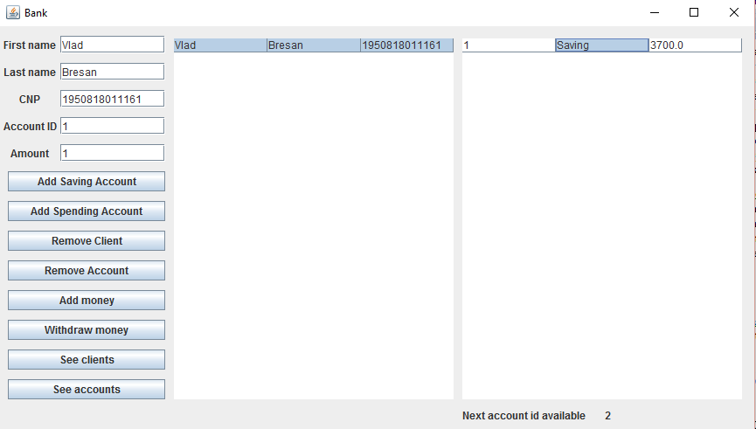

Implementation
Each class designed in this project has a specific task. We’ll continue by presenting the tasks for each Class.
The Account Class provides the main attributes for an account i.e. an account id, a total , and the type of the account.
public abstract class Account extends Observable implements Serializable {

private static final long serialVersionUID = 1L;
protected int accountId;
protected double total;
protected String accountName;

public Account() {

}

public Account(int accountId, double total, String type) {
super();
this.accountId = accountId;
this.total = total;
this.accountName = type;
}
The Bank class implements all the methods that are needed for a bank to be operational.
public class Bank implements BankProc, Serializable {

private static final long serialVersionUID = 1L;
protected Map<Person, Set<Account>> bank = new HashMap<Person, Set<Account>>();
private Operations op = new Operations();

public Bank() {
bank=op.read();
}
We’ll add one method of this class as an example:
public void deleteAccount(Person p, int accId) {
assert accId > 0 : "Invalid account";
assert p != null : "Invalid person";
assert isWellFormed():"Bank isn't consistent";
int val = bank.size();
if (bank.get(p).size() == 1) {
deletePerson(p);
assert bank.size() == val - 1 : "Something went wrong";
} else {
if (bank.containsKey(p)) {
Set<Account> accounts = bank.get(p);
int valPrecAcc = bank.get(p).size();
for (Account ac : accounts) {
if (ac.getAccountId()==accId) {
bank.get(p).remove(ac);
break;
}
}
assert bank.get(p).size() == valPrecAcc - 1 : "ERROR deleting account";
}
}
op.writeInFile(bank);
assert isWellFormed():"Bank isn't consistent";

Next we will present the Interface of the Bank class:
public interface BankProc {
/**
* @pre acc != null p!=null
* @post size = prev size +1;
* @param acc - the account to be added
* @return
*/
public void addAccount(Person p,Account acc);
/**
* @pre acc!=null && p!=null
* @post size = prev size -1;
* @param acc - the account to be deleted
* @return
*/
public void deleteAccount(Person p,int accId);
/**
* @pre accountId > 0 && amount > 0
* @post
* @param
* @return
*/
public void deposit(Person p,int accountId,double amount);
/**
* @pre accountId > 0 && amount <= total && amount > 0
* @post
* @param
* @return
*/
public void withdraw(Person p,int accountId,double amount);

/**
* @pre p!=null
* @post size = prev size -1;
* @param p
* @return
*/
public void deletePerson(Person p);

/**
* @pre
* @post
* @return an ArrayList of persons
*/
public ArrayList<Person> listPersons();
/**
* @pre
* @post
* @return a Set of accounts
*/
public Set<Account> listAccounts(Person p);
}
Next , we’ll present one of the accounts , Saving account:
public class SavingAccount extends Account{

private static final long serialVersionUID = 1L;
private double interest=0.4;

public SavingAccount() {
}

public SavingAccount(int accId,double amount,String type) {
super(accId,amount,type);
}

@Override
public void deposit(double amount) {
if(amount<1000)
notifyObservers("The amount to be deposited must be larger than 1000");
else{
this.total = total + amount + amount*interest;
}
setChanged();
notifyObservers(amount+"were added to account"+this.getAccountId());
}

@Override
public void withdraw(double amount) {
if(amount>3000){
notifyObservers("You cannot withdraw a sum larger than 3000");
}
else{
this.total = total - amount;

}
setChanged();
notifyObservers(amount+"were withdrawn from account"+this.getAccountId());
}

} And finally , we’ll present the implementation of the Person class .
public class Person implements Serializable, Observer {

private static final long serialVersionUID = 1L;
private String firstName;
private String lastName;
private String cnp;

public Person(){

}

public Person(String firstName, String lastName, String cnp) {
this.setFirstName(firstName);
this.setLastName(lastName);
this.setCnp(cnp);
}}
We’re not going to present the Operations , Controller and GUI class implementations because they are not so relevant.
In order to write in the .ser file we’ve used Serializable interface and the Observable class in order to notify clients when an action was performed.

Results
The results can be seen in the JTables present in the graphic user interface. After entering the information in the text fields and pressing the add Spending Account , the information will be transmited and it will be written in the bank.ser file. Afterwards , the user could press the see accounts for that specific person and it will show all the accounts that are owned by that person.
As another result we can explain what the add money button does. Once the data in inputed in the text fields the user can select an account by it’s account id and input a sum of money to be deposited. In the spending account the same amount of money will be added whereas in a saving account it will be deposited the sum + the product between the sum and the interest.

Conclusion and future development

Well first of all , I liked the idea of creating a bank , it seemed hard at first but I’ve managed to pull it through. I’ve learned the basics of using the Serializable interface as well as the Observable interface. Furthermore I’ve improved my skills regarding the HashMap getting fresh and new information (they were new for me ) with the help of websites like stackoverflow.com . As a future development I thought of adding and modifying a few things:
- Creating separate user interfaces for the bank employees and the clients
- Adding more accounts available for the clients(different types)
- Creating a Login based access for the bank employees
- Adding an interest for each withdrawal performed
- Increasing interest over time (i.e. 1 year – 0.4 interest , 2 years – 0.45 interest etc.)
- Change the input methods such that not all text fields should contain something
- Changing the graphic user interface into a more aesthetic one

