

PROGRAMMING TECHNIQUES

Homework 2

Student : Tudor Vlad Bresan
Group: 30423

Contents
Homework 2 1
1 Problem specification 3
2 Problem analysis, modeling, scenarios, use cases 3
2.1 Problem analysis 3
2.2 Modeling 3
2.3 Scenario and use cases 4
3 Design 5
3.1 UML Diagram ( Class Diagram ) 5
3.1.1 OrderAccess Class 6
3.1.2 ProductAccess Class 6
3.1.3 UserAccess Class 6
3.1.4 WarehouseAccess Class 6
3.1.5 Order Class 7
3.1.6 Product Class 7
3.1.7 User Class 7
3.1.8 Warehouse Class 7
3.1.9 GuiLogin Class 7
3.1.10 GuiAdmin Class 7
3.1.11 GuiCustomer Class 7
3.1.12 Controller class 7
3.1.13 testMain Class 8
3.2 Data Structures 8
3.3 Relationships 8
3.3.1 Algorithms 8
3.3.2 User Interface 9
4 Implementation and testing 11
5 Conclusion and feature development 13

Problem specification

Consider an application OrderManagement for processing customer orders. The application uses (minimally) the following classes: Order , OPDept (Order Processing Department) , Customer , Product, and Warehouse. The classes OPDept and Warehouse use a BinarySearchTree for storing orders.
The program will be able to perform the following operations:
- Add new customer
- Update existing customer address
- Delete exiting customer
- Place an order
- Delete an order
- Update an order
- Add new products
- Update exiting products
- Delete existing products
- Modify the content of warehouse according to the submitted orders
It will have a graphical user interface: first a frame corresponding to the login phase will appear, then according to the logged user ( admin or customer) another frame will appear in which the user can create orders or update its’ account, or if the admin logged in, the frame corresponding to the products access, user access and order viewing will appear. In both cases a table containing information about the current order or the current sold products will be visible. Also the admin has the possibility to view the current orders and what customer ordered it.

Problem analysis, modeling, scenarios, use cases

Problem analysis

An order application can be modeled in several ways: it can store the available products in a database or in a BinarySearchTree, respectivley in a seriazible text file. The most efficient way is to work with a database, because you can store as many products as you want and you will have easy access to them. The downside is the fact that you have to know, or learn, the SQL query language ( syntax) . Beside the storing of the products you also have to think about storing the customer and order details, which is also easier to do when you have a database.

Modeling

The implementation of this project is going to be done as follows : all the data ( the customer details, the products , the orders and the warehouses ) is going to be stored in a databse which has tables for each component that builds up the store concept. All the tables in the database have a corresponding model in the Java project, that are at the base of this implementation. The access to the database is done in separate classes. What is read from input will be „placed” in the SQL query syntax.

Scenario and use cases

The users have access only to what personally concerns them. So they can update ( edit ) the current order, they can add (submit ) a new order when they are sure about what they want to order, or they can update their profile. All the orders for one customer have different IDs but have a second field that holds the customer’s Id so it is easier to know who ordered what. After they click the submit button a message box will appear that will inform them that their order was successfully submitted.
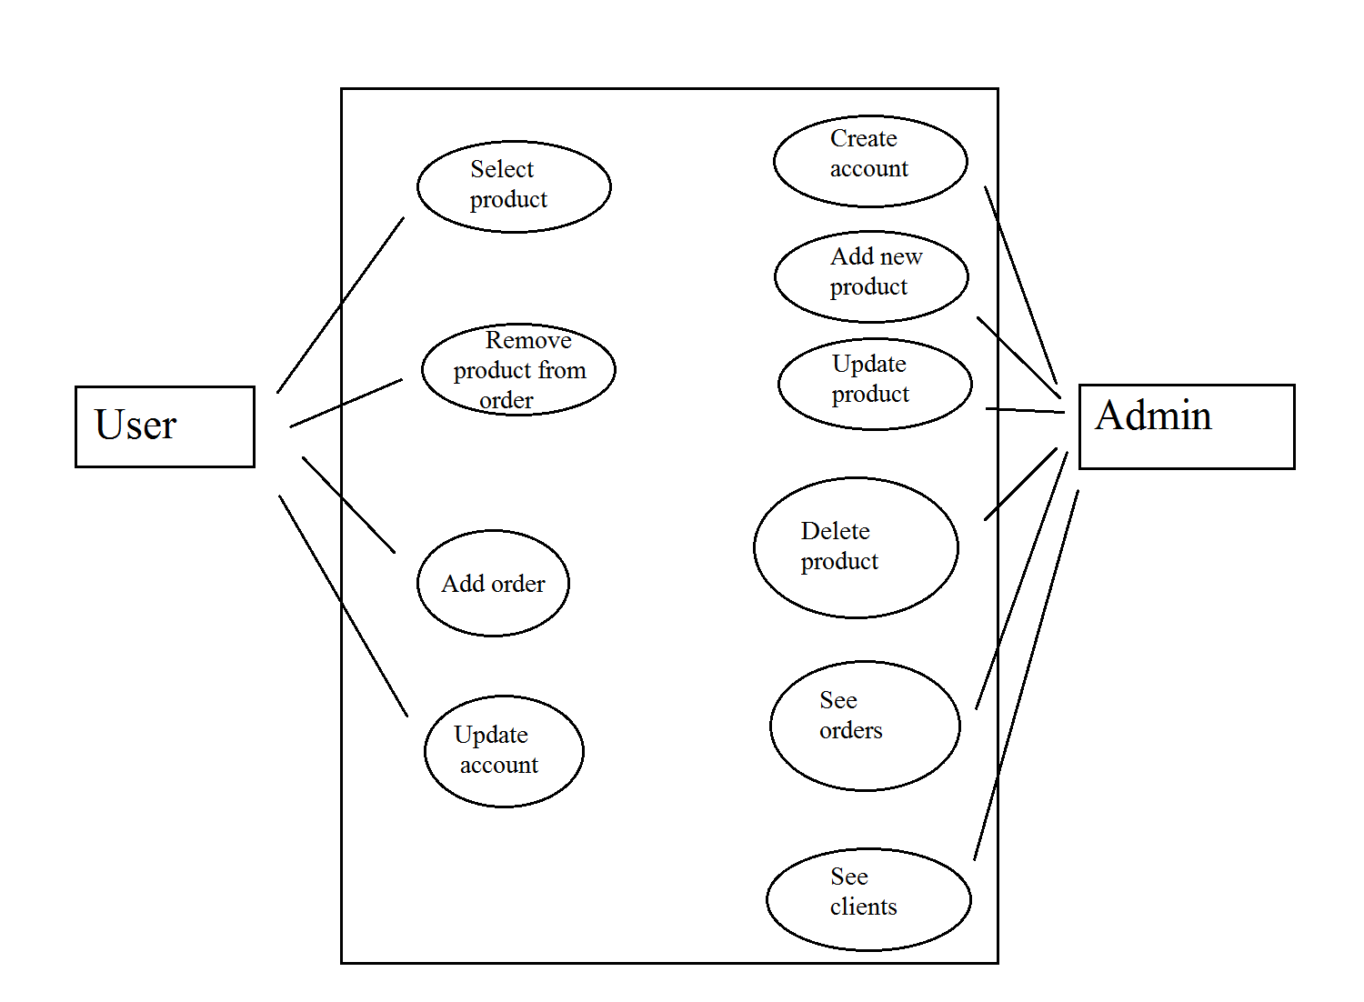
The admin has the power to add new products by specifying the name, price and quantity, the id is not necessary because it will be automatically incremented. He or she can update an existing product quantity or can delete a certain product, but he or she has to specify the product id. The product id can be known by looking in the table. The admin can also create new accounts for new clients, can see which are his current customers and see the orders.

Design

UML Diagram ( Class Diagram )

- Design phase diagram
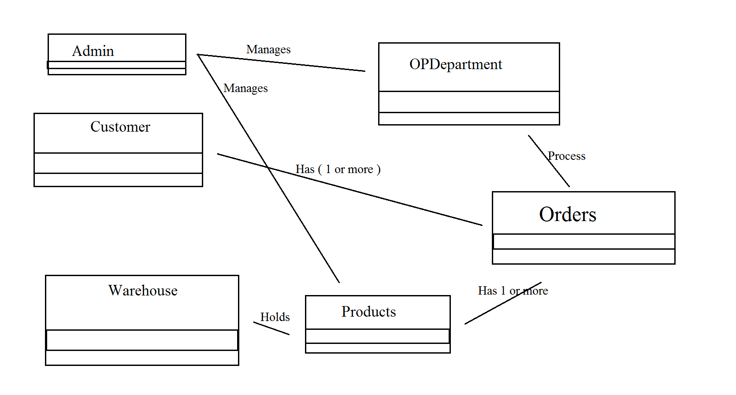
In the design step of the project I thought about the simplest and most necessary classes that I need in order to start a store.
- UML Diagram
The UML diagram is a class diagram that shows a set of classes, interfaces and collaborations and their relationships. Class diagrams may also contain packages or sub-systems, both of which are used to group elements of the model.
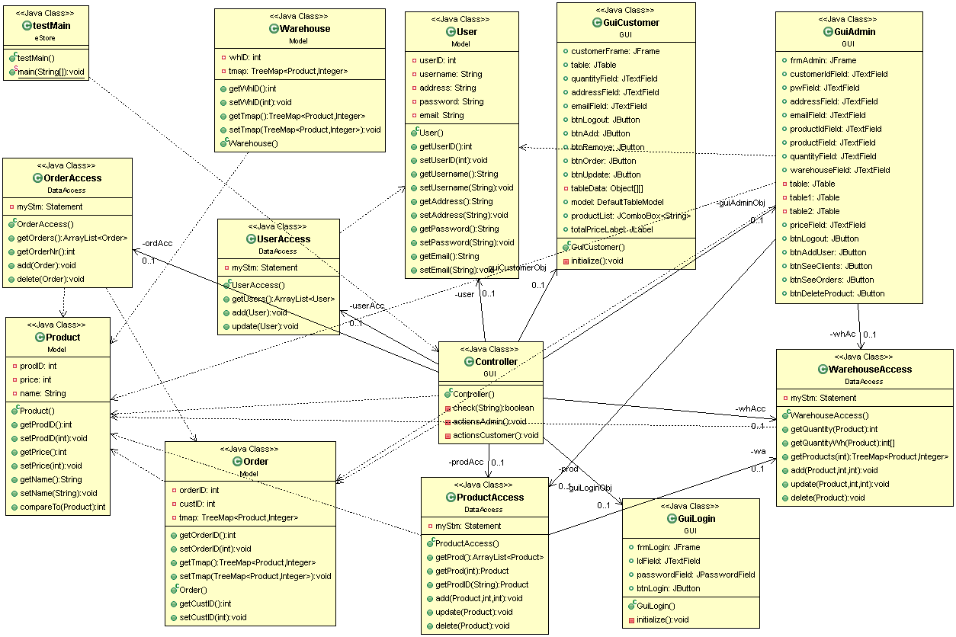

OrderAccess Class
This class is responsible to the direct access to the database. It holds methods to all the operations that can be done to the order table, such as: delete the order, insert a new order. When creating a new order it gets its’ contents from a treeMap and puts them in the database. It also has a method that returns an array that holds all the orders currently made and a method that sets the order id.

ProductAccess Class
This class is responsible to the direct access to the database. It holds methods to all the operations that can be done to the product table, such as delete the product or insert a new product, or updating an already existing product. It also has a method for retrieving the product id by name, one for retrieving all the products ( in an arrayList ) and one for getting the product with a certain id.

UserAccess Class
This class is responsible to the direct access to the database. It holds methods to all the operations that can be done to the customer table, such as update the address or the email, delete the customer or insert a new customer. It also has a method that returns all the existing users in the table which is useful when the admin wants to add new clients.

WarehouseAccess Class
This class is responsible to the direct access to the database. It holds methods to all the operations that can be done to the warehouse table, such as delete the product or insert a new product. It also sets the corresponding warehouse number. It also calculates how many products there are in each warehouse and how many are in total, so when a product is placed in an order it calculates if the order is possible or not.

Order Class
The order class has the id , and the getter and setter for it, the customer id, and the getter and setter for it, and a treeMap of products , so all the products for one order are stored togheter. It also has an add and remove method for modifying the treeMap according to the customer needs.

Product Class
The product class has details about the products such as id, name, price and quantity which you can access by calling the getters or setters for each one. It also implements the Comaparable interface and overrides the comareTo method because it is the key of the treeMap from the Order Class.

User Class
The customer class has the details that describe a customer: the id , name , address, email address and password which are all private, but you can get information about a certain customer by calling the get function or you can modify an information by calling the set function.

Warehouse Class
This class holds the fields that describe a warehouse. It has the warehouse id ( because the store can have multiple warehouses ) and a treeMap that holds all the products that are available in that particular warehouse. In the treeMap the key is the product and the value returned is the quantity.

GuiLogin Class
This class creates the user interface corresponding to the login phase of the store.

GuiAdmin Class
This class creates the user interface for the admin, which has the table of available products and how many are still in stock, the text fields for adding or updating the products, the fields for adding a new user. Also it has 2 buttons for viewing the customer table and one for viewing the orders table.

GuiCustomer Class
This class creates the user interface for the customer, which has the table of currently ordered products and you can remove a row by selecting it and the press the remove button. Also it has the possibility of updating his or her address or email, or both.

Controller class
This is the main class for user interface operations. It holds all the actionListener methods for all the buttons or text fields. From this class “signals” are transmitted to the database access classes so operations are performed on the database. Also here are done certain verifications such as: some filed is empty or the introduced value does not have the appropriate format. Also error or success messages are displayed when something goes wrong or right, when updating the address a pop-up message will appear informing the user what the new address is, or when not sufficient products are available it will inform the user how many he or she can order. This class updates the content of the tables that are displayed and the label corresponding to the total price of the current products that the customer has in basket.
It also controls which frame is available to whom. First the login frame appears then according to the logged user it will appear the user frame or the admin frame. If the username is not correctly introduced then a message error will appear and you will have another chance to introduce your username.

testMain Class
This class starts the program by calling the Controller class

Data Structures
The base data structures in this project are the Customer, Product, Order and Warehouse. With this data structures we send information from the user interface to the database and back, and no direct access is done. Every class depends on them to do the necessary operations.
The order object also has an treeMap of products so if one customer buys more products they are stored togheter and have the same customerID even if the order id is different .
The TreeMap class implements the Map interface by using a tree. A TreeMap provides an efficient means of storing key/value pairs in sorted order, and allows rapid retrieval.

Relationships
There are strong relationships between the Customer class and the CustomerAccess class, Product and ProductAccess class, Order class and OrderAccess class.
Also there is a association relationship between the Controller class and the OrderAccess, ProductAccess and WarehouseAccess , the program will still somehow work but no updates will be done on the database.
Between the Controller and all the graphic user interface classes there is also a strong dependency but only in this direction.

Algorithms
The login phase can be done in 2 different ways: with an exiting user, the program will verify if the user really exists and if so it will open the user frame, otherwise an error message will appear; if the Admin loggs in then a different frame will appear that allows the admin to make certain modifications to the products and it will display the current products for sale and how many there are in the warehouse and in which warehouse , this will be done by accesing the product table and also the warehouse table. Also the admin can create new customer accounts. All this verifications and accessing will pass throug a layer which will make sure all the objects fields have the corresponding format.
After a certain user is logged in then it can add products by chosing from a drop down list, when selecting the product and entering the quantity and pressing enter the program will search to see if there are so many products available, in all the warehouses, as the user wants if not an message will appear. If there are enough then it will add the product and the quantity to the table, but it will add the order to the order table only when the submit button is pressed. Also when the button is pressed the orderd qunatity is removed from the warehouse table. The program also calculates the total price of the order accorinding to how many products are bought.
If the admin loggs in then it will appear a table with all the products and if he or she wants to add a new product the program will verify if the product does not exist yet and do the certain settings before transmitting the object to the database access. The same procedure is executed when the admin wants to update or remove a certain product. This operations do not affect only the product table from the database but also the warehouse table. Also the admin can create new users and after pressing the add user button a new user will apear in the database table and also in the table from the interface.
Another important aspect is the fact that the products in the order are stored in a treeMap and not as single objects or in an array.

User Interface

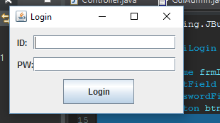

First frame that appears is the login one. You can enter either as a customer or as the admin.
If the id you entered is not in the database an error message will appear.
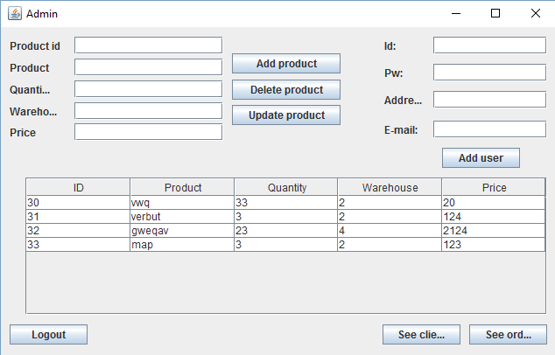
In the admin frame you can do several operations. You can add, delete or update a product by filling the required text fields. Also the admin does not have to memorize the product id or any other details because all the products are printed in the table at the bottom of the window.
If the admin wants to create a new user account he or she has to complete all the fields before pressing the “ Add user “ button.
By pressing the “ Logout “ button the admin frame is closed and the login frame reappears.
By pressing the “ See clients “ button another table, in a different frame, will appear and it will contain all the already existing customers.
By pressing the “ See orders “ button another table, in a different frame, will appear and it will contain all the orders that were made and the id of the customer who made them.
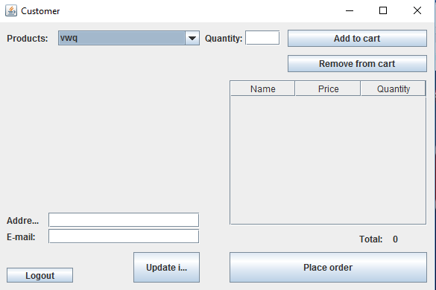

In the user frame there is a drop down list that contains all the products that the store sells even if they are not currently in stock. After entering the quantity and pressing the “ Add to cart “ button if there are not enough products in all the warehouses combined an error message will appear, but if there are enough they are added to the table that represents an overview of the not placed order. If you want to update your address or email you complete one of the fields and then press the “ update information “ button, and only the completed one is modified in the database.
If the user wants to remove something from the order he or she has to select the row from the table and then press the “ remove from cart “ button.
By pressing the “ Logout “ button the customer frame is closed and the login frame reappears.

Implementation and testing

public ArrayList<Order> getOrders() {
ArrayList<Order> res = new ArrayList<Order>();
ResultSet myRes;

try {
myRes = myStm.executeQuery("Select orderID,custId,prodID,quantity FROM `store`.`order`");
while (myRes.next()) {
Order ord = new Order();
ord.setCustID(myRes.getInt("custId"));
ord.setOrderID(myRes.getInt("orderID"));
res.add(ord);
}
} catch (SQLException e) {
e.printStackTrace();
}

return res;
}
This method from the OrderAccess class executes an SQL query syntax for accessing the database and retrieving all the orders from the order table and then stores them in an arrayList so it can be used later.
public Product getProdID(String name) {

Product p = new Product();
ResultSet myRes;
try {
myRes = myStm.executeQuery("Select prodID,name, price from `store`.`product` where `name`='" + name + "';");
while (myRes.next()) {

p.setName(myRes.getString("name"));
p.setPrice(myRes.getInt("price"));
p.setProdID(myRes.getInt("prodID"));
}
} catch (SQLException e) {
e.printStackTrace();
}

return p;

}
This method takes as argument a String which represents the name of the product from the Product table and it returns an object of type Product.
public ArrayList <User> getUsers() {

User c;
ArrayList<User> existingUser = new ArrayList<User>();
ResultSet myRes;
try {
myRes = myStm.executeQuery("Select * from `store`.`customer`");
while (myRes.next()) {
c = new User();
c.setAddress(myRes.getString("address"));
c.setUsername(myRes.getString("username"));
c.setUserID(Integer.valueOf(myRes.getString("customerID")));
c.setPassword(myRes.getString("password"));
c.setEmail(myRes.getString("email"));
existingUser.add(c);
}
} catch (SQLException e) {
e.printStackTrace();
}

return existingUser;

This method returns an arrayList of users, but before doing so it sets to all the users the address, username, id and email that it gets from the database.
private void displayProd() {
for (Product prod1 : prod.getProd()) {
int aux[] = whAc.getQuantityWh(prod1);
for (int i = 0; i < aux.length; i++) {
if (aux[i] != 0) {
Object ob[] = { prod1.getProdID(), prod1.getName(), aux[i], i, prod1.getPrice() };
model.addRow(ob);
}
}

}
model.fireTableDataChanged();
table.repaint();
scrollPane.repaint();

}
The method mentioned above is from the class GuiAdmin and it fills the cells of the table with the corresponding data, that it gets from the database, through the whAc object. An object of type WarehouseAccess.
public OrderAccess() {
try {
Connection myConn = DriverManager.getConnection("jdbc:mysql://127.0.0.1:3306/", "root", null);
myStm = (Statement) myConn.createStatement();
} catch (SQLException e) {
e.printStackTrace(); }
}

This method connects the java project to the mySql server and desired account that manages the store tables. It does this in the constructor of the class so every time a new object is instantiated the connection is done.

Conclusion and feature development
Working at this project I development my way of working with databases and connecting the user with it, without compromising any important data of my store.
An improvement may be the option for the user to see all the orders he or she has ever placed and their status ( if they were deliverd or not ). Another improvement may be the ability to create a new user account right from the login frame without having to „ask” the admin to create one for the client.

