**Shopping list project**

**By Vasile Vlad Brincoveanu**

**1.Technologies**

-REACT front end

- mobx for auto managing de front end models data

- axios for some requests ( or fetch with async await and Promise!)

-bootstrap css

-blueprint components ( buttons, icons, etc)

-asp.net back-end

-identity user framework ( for user detailed info , login etc,)

-entity framework ( communicating with DB)

-lots of external services used ( like send mail, generate pdf ,etc)

Use case of a user!

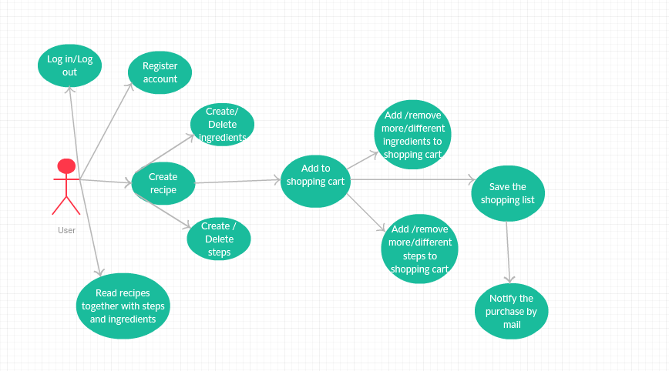

Use case of admin!

