ГУАП

КАФЕДРА № 42

ОТЧЕТ   
ЗАЩИЩЕН С ОЦЕНКОЙ _____________________

ПРЕПОДАВАТЕЛЬ

| Ассистент |  |  |  | Н.А. Янковский |
| --- | --- | --- | --- | --- |
| должность, уч. степень, звание |  | подпись, дата |  | инициалы, фамилия |

| ОТЧЕТ О ЛАБОРАТОРНОЙ РАБОТЕ №4 |
| --- |
| **Дискретные сигналы. БПФ.**  Вариант 5 |
|  |
| по курсу: Цифровая обработка и передача сигналов |
|  |

РАБОТУ ВЫПОЛНИЛ

| СТУДЕНТ ГР. № | 4128 |  |  |  | В.А.Воробьев |
| --- | --- | --- | --- | --- | --- |
|  |  |  | подпись, дата |  | инициалы, фамилия |

Санкт-Петербург 2023

**1 Задание**

f = 3N, T = 10/F, где N – номер по списку. Написать программу, которая позволит:

1. Провести дискретизацию функции u(t) = sin(2πft) на заданном интервале с частотой дискретизации 3f.
2. Вычислить прямое и обратное быстрое преобразование Фурье исследуемой функции.
3. Произвести декодирование аудио-файла с записью тонального сигнала (Dual-Tone Multi-Frequency (DTMF)) сигнала в формате WAV PCM 16 bit, mono. Данный способ кодирования предполагает, что кодируемое значение представляется в виде пары различных частот (f1/f2) в соответствии с приведенной таблицей 4.1. Затем, сигнал представляется в виде отсчетов суммы двух синусоид соответствующих частот. Для декодирования сигнала необходимо произвести прямое быстрое преобразование Фурье для имеющегося набора отсчетов и определить частоты используемых

**2 Выполнение работы**

Построим график функции и реализуем быстрое преобразование Фурье и обратное к нему.

Результат представлен на рис. 1.

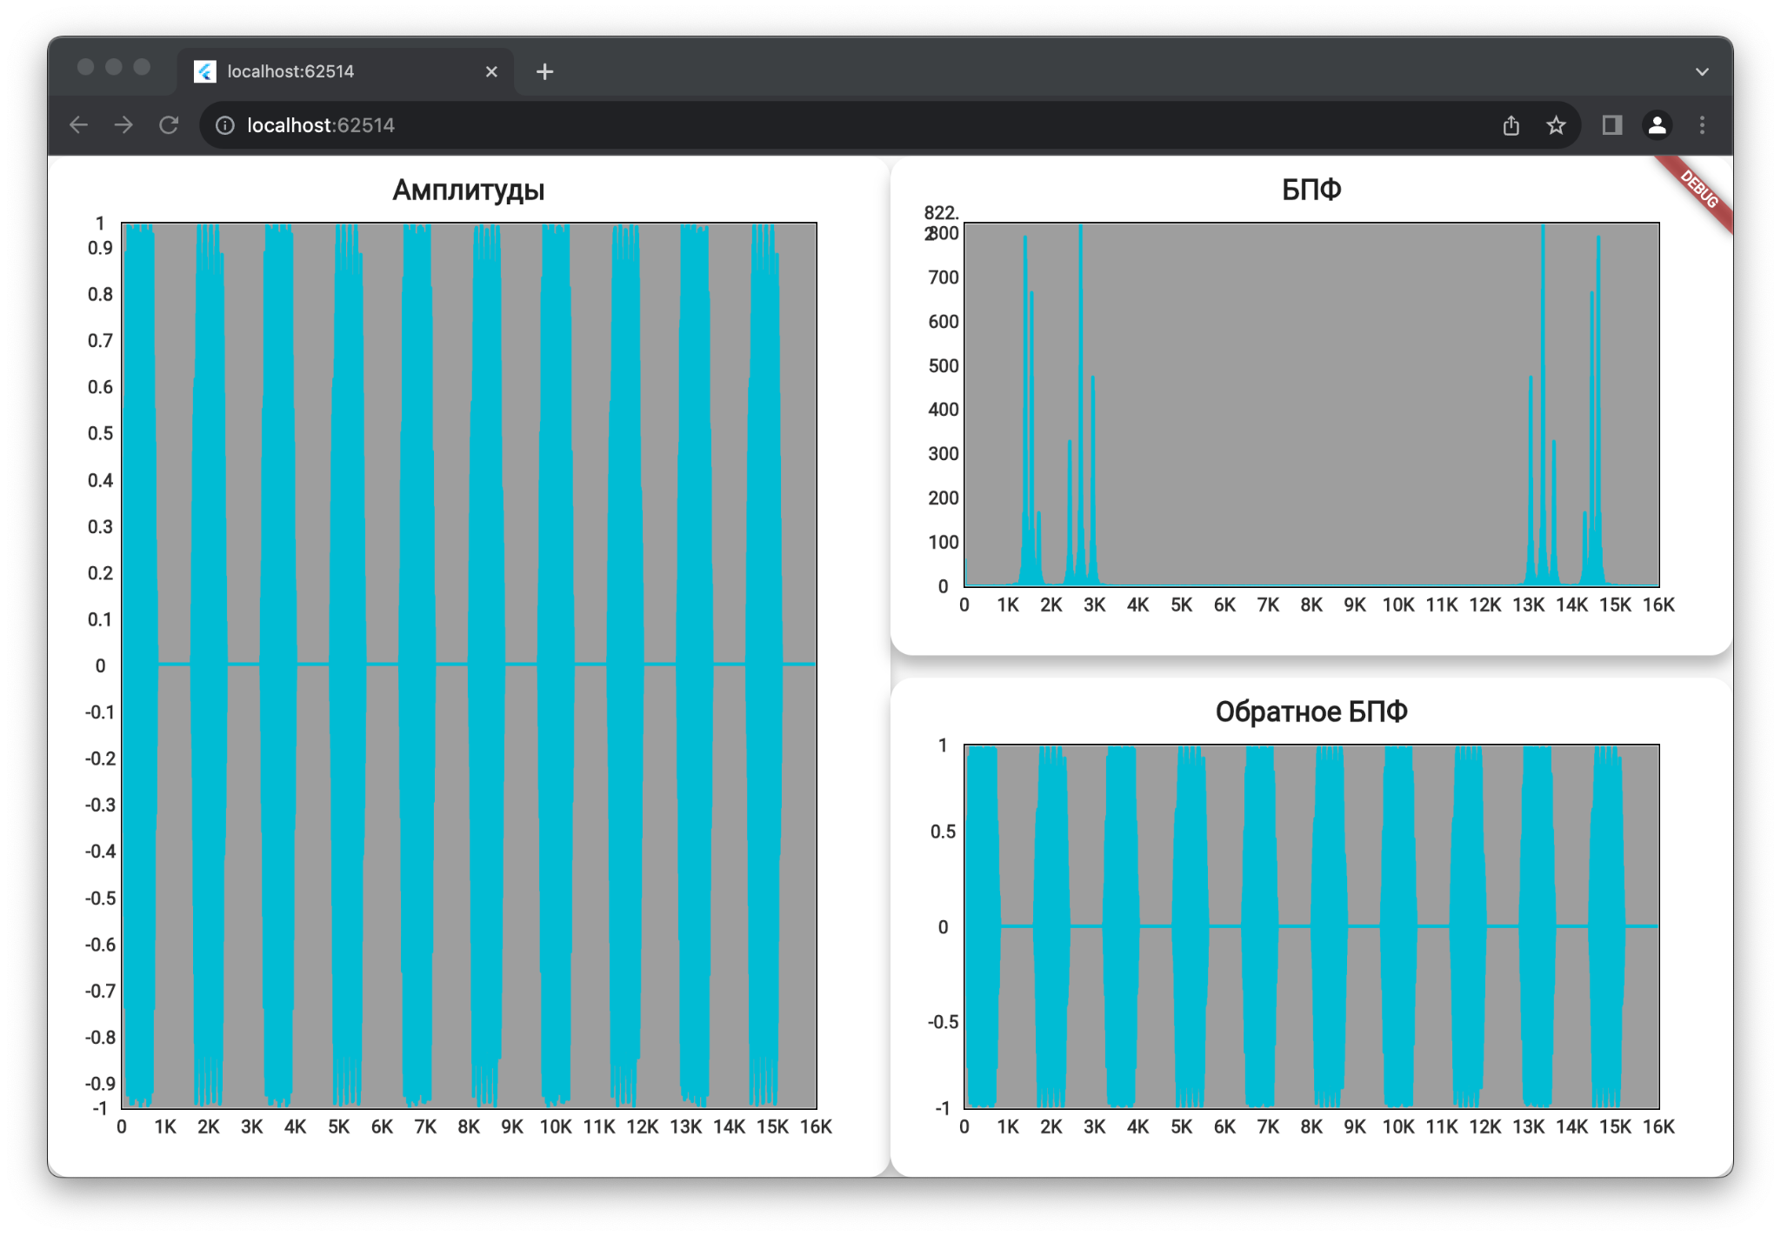

Рисунок 1 – Результат работы программы

**3 Вывод**

В ходе выполнения лабораторной работы мы приобрели практические навыки вычисления и визуализации математических функций, эти навыки в дальнейшем могут быть полезны в анализе данных, обработке сигналов, а также в других областях, где важно понимание и работа с математическими функциями.

ПРИЛОЖЕНИЕ

preview_app.dart

import 'package:extend_math/extend_math.dart';

import 'package:flutter/widgets.dart';

import 'package:lab4/logic/calculations.dart';

import 'package:ui_kit/ui_kit.dart';

class PreviewApp extends StatelessWidget {

const PreviewApp({super.key});

@override

Widget build(BuildContext context) {

return Row(

children: [

Expanded(

child: Column(

children: [

Expanded(

child: KitTitleContainer(

title: 'Амплитуды',

child: KitLineChart(

lines: [

KitLineData(

dots: Calculations.points

.map((e) => KitDot(e.x, e.y))

.toList(),

),

],

),

),

),

],

),

),

Expanded(

child: Column(

children: [

Expanded(

child: KitTitleContainer(

title: 'БПФ',

child: KitLineChart(

lines: [

KitLineData(

dots: Calculations.bft

.map((e) => KitDot(e.x, e.y))

.toList(),

),

],

),

),

),

const SizedBox(height: 16),

Expanded(

child: KitTitleContainer(

title: 'Обратное БПФ',

child: KitLineChart(

lines: [

KitLineData(

dots: Calculations.points.bft.inverseBft

.map((e) => KitDot(e.x, e.y))

.toList(),

),

],

),

),

),

],

),

)

],

);

}

}

variant.dart

abstract final class Variant {

static const String filePath = 'test1.wav';

}

audio.dart

import 'package:flutter/services.dart';

import 'package:wav/wav_file.dart';

Future<List<double>> extractAudioData(String filePath) async {

final data = await rootBundle.load('assets/test1.wav');

final bytes = data.buffer.asUint8List();

final waveFile = Wav.read(bytes);

final List<double> audioData = waveFile.toMono().toList();

return audioData;

}

calculations.dart

import 'package:complex/complex.dart';

import 'package:extend_math/extend_math.dart';

abstract final class Calculations {

// Yep, its not good but fast!

static late List<double> readedAudio;

static List<Point2> get points {

return readedAudio

.asMap()

.entries

.map((e) => Point2(e.key.toDouble(), e.value))

.toList();

}

static List<Point2>? cachedDft;

static List<Point2> get dft {

if (cachedDft != null) return cachedDft!;

cachedDft = points.dft

.asMap()

.entries

.map((e) => Point2(e.key.toDouble(), e.value.abs()))

.toList();

return cachedDft!;

}

static List<String> get match {

final spectralComponents = points.dft;

// Определите пороги для определения наличия частот в спектре

double magnitudeThreshold = 200.0; // Подстройте подходящий порог

double frequencyThreshold = 150.0; // Подстройте подходящий порог

List<String> dtmfCodes = [];

for (int i = 1; i < spectralComponents.length - 1; i++) {

Complex current = spectralComponents[i];

double magnitude = current.abs();

double frequency = i * 16000 / spectralComponents.length;

if (magnitude > magnitudeThreshold) {

if ((frequency % 697) < frequencyThreshold ||

(frequency % 1209) < frequencyThreshold) {

dtmfCodes.add('1');

} else if ((frequency % 697) < frequencyThreshold ||

(frequency % 1336) < frequencyThreshold) {

dtmfCodes.add('2');

} else if ((frequency % 697) < frequencyThreshold ||

(frequency % 1477) < frequencyThreshold) {

dtmfCodes.add('3');

} else if ((frequency % 697) < frequencyThreshold ||

(frequency % 1633) < frequencyThreshold) {

dtmfCodes.add('A');

} else if ((frequency % 770) < frequencyThreshold ||

(frequency % 1209) < frequencyThreshold) {

dtmfCodes.add('4');

} else if ((frequency % 770) < frequencyThreshold ||

(frequency % 1336) < frequencyThreshold) {

dtmfCodes.add('5');

} else if ((frequency % 770) < frequencyThreshold ||

(frequency % 1477) < frequencyThreshold) {

dtmfCodes.add('6');

} else if ((frequency % 770) < frequencyThreshold ||

(frequency % 1633) < frequencyThreshold) {

dtmfCodes.add('B');

} else if ((frequency % 852) < frequencyThreshold ||

(frequency % 1209) < frequencyThreshold) {

dtmfCodes.add('7');

} else if ((frequency % 852) < frequencyThreshold ||

(frequency % 1336) < frequencyThreshold) {

dtmfCodes.add('8');

} else if ((frequency % 852) < frequencyThreshold ||

(frequency % 1477) < frequencyThreshold) {

dtmfCodes.add('9');

} else if ((frequency % 852) < frequencyThreshold ||

(frequency % 1633) < frequencyThreshold) {

dtmfCodes.add('C');

} else if ((frequency % 941) < frequencyThreshold ||

(frequency % 1209) < frequencyThreshold) {

dtmfCodes.add('*');

} else if ((frequency % 941) < frequencyThreshold ||

(frequency % 1336) < frequencyThreshold) {

dtmfCodes.add('0');

} else if ((frequency % 941) < frequencyThreshold ||

(frequency % 1477) < frequencyThreshold) {

dtmfCodes.add('#');

} else if ((frequency % 941) < frequencyThreshold ||

(frequency % 1633) < frequencyThreshold) {

dtmfCodes.add('D');

}

}

}

return dtmfCodes.toList();

}

static List<int> findFrequencyPeaks(

List<Complex> spectralComponents, int sampleRate) {

List<int> peaks = [];

double threshold =

200.0; // Установите подходящий порог для определения пиков

for (int i = 1; i < spectralComponents.length - 1; i++) {

double magnitude = spectralComponents[i].abs();

if (magnitude > threshold &&

magnitude > spectralComponents[i - 1].abs() &&

magnitude > spectralComponents[i + 1].abs()) {

double frequency = i * sampleRate / spectralComponents.length;

peaks.add(frequency.round());

}

}

return peaks;

}

static List<String> matchFrequenciesToDTMF(List<int> frequencies) {

final dtmfFrequencies = {

697 / 1209: '1',

697 / 1336: '2',

697 / 1477: '3',

697 / 1633: 'A',

770 / 1209: '4',

770 / 1336: '5',

770 / 1477: '6',

770 / 1633: 'B',

852 / 1209: '7',

852 / 1336: '8',

852 / 1477: '9',

852 / 1633: 'C',

941 / 1209: '*',

941 / 1336: '0',

941 / 1477: '#',

941 / 1633: 'D'

};

List<String> dtmfCodes = [];

for (int frequency in frequencies) {

String closestFrequency = findClosestFrequency(

frequency,

dtmfFrequencies.keys.toList(),

).toString();

dtmfCodes.add(dtmfFrequencies[closestFrequency] ?? "???");

}

return dtmfCodes;

}

static double findClosestFrequency(

int targetFrequency, List<double> frequencies) {

var minDifference = 99999999.0;

late double closestFrequency;

for (var frequency in frequencies) {

var difference = (frequency - targetFrequency).abs();

if (difference < minDifference) {

minDifference = difference;

closestFrequency = frequency;

}

}

return closestFrequency;

}

}

main.dart

import 'package:flutter/material.dart';

import 'package:lab4/logic/audio.dart';

import 'package:lab4/logic/calculations.dart';

import 'package:lab4/logic/variant.dart';

import 'package:lab4/ui/preview_app.dart';

void main() async {

WidgetsFlutterBinding.ensureInitialized();

Calculations.readedAudio = await extractAudioData(Variant.filePath);

print(Calculations.match);

runApp(const MainApp());

}

class MainApp extends StatelessWidget {

const MainApp({super.key});

@override

Widget build(BuildContext context) {

return const MaterialApp(

home: Scaffold(

body: Center(

child: PreviewApp(),

),

),

);

}

}

extend_math.dart

library extend_math;

export 'src/extension/amplitude_spectrum_ext.dart';

export 'src/extension/distribution_map_ext.dart';

export 'src/extension/fft_extension.dart';

export 'src/extension/math_interval_ext.dart';

export 'src/extension/sprectrum_energy_ext.dart';

export 'src/logic/list_functions.dart';

export 'src/models/point2.dart';

export 'src/models/math_interval.dart';

distribution_map_ext.dart

import 'dart:core';

import 'dart:math';

import '../models/point2.dart';

extension DistributionMapStatistics on Map<double, double> {

List<Point2> get cumulativeDistribution {

final listEntries = entries.toList();

final res = <Point2>[Point2(listEntries.first.key - 1, 0)];

var cumulative = listEntries.first.value;

res.add(Point2(listEntries.first.key, cumulative));

for (int i = 1; i < listEntries.length; i++) {

cumulative = (cumulative + listEntries[i].value);

res.add(Point2(listEntries[i].key, cumulative));

}

res.add(Point2(listEntries.last.key + 1, 1));

return res;

}

double calcCumulativeProbability(double x0) {

double cumulativeProbability = 0.0;

forEach((key, value) {

if (key <= x0) {

cumulativeProbability += value;

}

});

return cumulativeProbability;

}

double get mean {

double mean = 0.0;

forEach((key, value) {

mean += key * value;

});

return mean;

}

double get secondMoment {

double secondMoment = 0.0;

forEach((key, value) {

secondMoment += (key * key) * value;

});

return secondMoment;

}

double get thirdMoment {

double thirdMoment = 0.0;

forEach((key, value) {

thirdMoment += (key * key * key) * value;

});

return thirdMoment;

}

double get fourthMoment {

double fourthMoment = 0.0;

forEach((key, value) {

fourthMoment += (key * key * key * key) * value;

});

return fourthMoment;

}

double get mode {

double maxProbability = -1.0;

double mode = 0;

forEach((key, value) {

if (value > maxProbability) {

maxProbability = value;

mode = key;

}

});

return mode.toDouble();

}

double get median {

final sortedEntries = entries.toList()

..sort((a, b) => a.key.compareTo(b.key));

final numEntries = sortedEntries.length;

if (numEntries % 2 == 0) {

final middle1 = sortedEntries[numEntries ~/ 2 - 1].key;

final middle2 = sortedEntries[numEntries ~/ 2].key;

return (middle1 + middle2) / 2.0;

} else {

return sortedEntries[numEntries ~/ 2].key.toDouble();

}

}

double get excess {

double mean = 0.0;

double variance = 0.0;

forEach((key, value) {

mean += key * value;

});

forEach((key, value) {

variance += (key - mean) * (key - mean) * value;

});

final stdDev = sqrt(variance);

final numEntries = length.toDouble();

double excess = 0.0;

forEach((key, value) {

excess += ((key - mean) * (key - mean) * (key - mean) * value) /

(stdDev * stdDev * stdDev);

});

return excess / numEntries;

}

double get variance {

double mean = 0.0;

double variance = 0.0;

forEach((key, value) {

mean += key * value;

});

forEach((key, value) {

variance += ((key - mean) * (key - mean)) * value;

});

return variance;

}

double get standardDeviation => sqrt(variance);

double get skewness {

double thirdMoment = this.thirdMoment;

final stdDev = standardDeviation;

final numEntries = length.toDouble();

double skewness = thirdMoment / (stdDev * stdDev * stdDev * numEntries);

return skewness;

}

double get centralSecondMoment {

double centralSecondMoment = 0.0;

forEach((key, value) {

centralSecondMoment += ((key - mean) * (key - mean)) * value;

});

return centralSecondMoment;

}

double get centralThirdMoment {

double centralThirdMoment = 0.0;

forEach((key, value) {

centralThirdMoment +=

((key - mean) * (key - mean) * (key - mean)) * value;

});

return centralThirdMoment;

}

double get centralFourthMoment {

double centralFourthMoment = 0.0;

forEach((key, value) {

centralFourthMoment +=

((key - mean) * (key - mean) * (key - mean) * (key - mean)) * value;

});

return centralFourthMoment;

}

}

sprectrum_energy_ext.dart

import 'dart:math';

import 'package:extend_math/extend_math.dart';

extension SpectrumAmplEnergyExt on List<double> {

double get energy {

final total = sum(map((e) => e * e));

final normalize = map((e) => e * sqrt(0.5 / total));

return sum(normalize.map((e) => e * e));

}

}

extension SpectrumPointEnergyExt on List<Point2> {

double calculateEnergy(MathInterval interval) {

double integral = 0;

for (final point in this) {

integral += pow(point.y, 2);

}

final energy = integral / interval.length;

return energy;

}

}

math_interval_ext.dart

import 'package:extend_math/extend_math.dart';

import '../utils/typedefs.dart';

extension MathIntervalExt on MathInterval {

List<Point2> applyFx(Func1 fx, {required double step}) {

final count = length ~/ step;

return [

for (var x = start; x <= end; x += length / count) Point2(x, fx(x))

];

}

}

amplitude_spectrum_ext.dart

import 'dart:math';

import '../models/point2.dart';

extension AmplitudeSpectrumExtension on List<Point2> {

double amplitudeSpectrumFor(

double freq, {

required double step,

}) {

double realPart = 0.0;

double imagPart = 0.0;

for (int j = 0; j < length; j++) {

double value = this[j].y;

double angle = 2 * pi * freq * this[j].x;

realPart += value * cos(angle) * step;

imagPart += value * sin(angle) * step;

}

return sqrt(realPart * realPart + imagPart * imagPart);

}

}

fft_extension.dart

// ignore_for_file: prefer_const_constructors

import 'dart:math';

import 'package:complex/complex.dart';

import '../models/point2.dart';

extension DFTExtension on List<Point2> {

List<Complex> get dft {

int N = length;

List<Complex> dftResult = List<Complex>.generate(N, (i) {

Complex sum = const Complex(0.0, 0.0);

for (int j = 0; j < N; j++) {

double angle = 2 * pi * i * j / N;

Complex c = Complex.polar(this[j].y, angle);

sum += c;

}

return sum;

});

return dftResult;

}

}

extension InverseDFTExtension on List<Complex> {

List<Point2> get inverseDft {

final spectrum = this;

int N = spectrum.length;

List<Point2> signal = List<Point2>.generate(N, (i) {

Complex sum = Complex(0.0, 0.0);

for (int j = 0; j < N; j++) {

double angle = -2 * pi * i * j / N;

Complex c = spectrum[j] * Complex.polar(1.0, angle);

sum += c;

}

return Point2(i.toDouble(), sum.real / N);

});

return signal;

}

}

list_functions.dart

double sum(Iterable<double> list) =>

list.reduce((value, element) => value + element);

List<T> roll<T>(List<T> inputList, int shiftAmount) {

final length = inputList.length;

if (length == 0) {

return inputList;

}

// Calculate the effective shift amount, wrapping around if necessary

final effectiveShift = shiftAmount % length;

if (effectiveShift == 0) {

return inputList;

}

// Split the input list into two parts and rejoin them with the shift

final startIndex = effectiveShift < 0 ? -effectiveShift : length - effectiveShift;

final part1 = inputList.sublist(startIndex);

final part2 = inputList.sublist(0, startIndex);

return [...part1, ...part2];

}

typedefs.dart

typedef Func1 = double Function(double x);

math_interval.dart

final class MathInterval {

final double start;

final double end;

const MathInterval(this.start, this.end);

double get length => (end - start).abs();

}

point2.dart

class Point2 {

final double x;

final double y;

const Point2(this.x, this.y);

static const zero = Point2(0, 0);

}