|  |  |  |
| --- | --- | --- |
| IBM SPSS Web Report - 10_01_Exporting.spv  Contents  Previous  Next  Help |  | Controls disabled by the system |

Log

* Log

Explore

* Case Processing Summary
* Descriptives
* gc06 Privacy
  + Stem-and-Leaf Plot
  + Boxplot

Log

* Log

Explore

* Case Processing Summary
* Descriptives
* M-Estimators
* Percentiles
* Extreme Values
* Tests of Normality
* gc06 Privacy
  + Histogram
  + Stem-and-Leaf Plot
  + Normal Q-Q Plot
  + Detrended Normal Q-Q Plot
  + Boxplot

Delete

**Log**

Log - Log - September 25, 2019

EXAMINE VARIABLES=gc06

  /PLOT BOXPLOT STEMLEAF

  /COMPARE GROUPS

  /STATISTICS DESCRIPTIVES

  /CINTERVAL 95

  /MISSING LISTWISE

  /NOTOTAL.

**Explore**

Explore - Case Processing Summary - September 25, 2019

Case Processing SummaryCase Processing Summary, table, 3 levels of column headers and 1 levels of row headers, table with 7 columns and 5 rows

|  |  |  |  |  |  |  |
| --- | --- | --- | --- | --- | --- | --- |
|  | Cases | | | | | |
| Valid | | Missing | | Total | |
| N | Percent | N | Percent | N | Percent |
| gc06 Privacy | 48 | 100.0% | 0 | 0.0% | 48 | 100.0% |
|  |  |  |  |  |  |  |

**Explore**

Explore - Descriptives - September 25, 2019

DescriptivesDescriptives, table, 1 levels of column headers and 3 levels of row headers, table with 5 columns and 15 rows

|  |  |  |  |  |
| --- | --- | --- | --- | --- |
|  | | | Statistic | Std. Error |
| gc06 Privacy | Mean | | -.09258 | .104716 |
| 95% Confidence Interval for Mean | Lower Bound | -.30324 |  |
| Upper Bound | .11808 |  |
| 5% Trimmed Mean | | -.11566 |  |
| Median | | -.14000 |  |
| Variance | | .526 |  |
| Std. Deviation | | .725492 |  |
| Minimum | | -2.067 |  |
| Maximum | | 2.870 |  |
| Range | | 4.937 |  |
| Interquartile Range | | .719 |  |
| Skewness | | 1.007 | .343 |
| Kurtosis | | 5.468 | .674 |
|  |  |  |  |  |

**gc06 Privacy**

gc06 Privacy - Stem-and-Leaf Plot - September 25, 2019

Privacy Stem-and-Leaf Plot

 Frequency    Stem &  Leaf

     1.00 Extremes    (=<-2.1)

     3.00       -1 .  000

     6.00       -0 .  677888

    17.00       -0 .  01112222233333444

    14.00        0 .  00001122223444

     6.00        0 .  555689

     1.00 Extremes    (>=2.9)

 Stem width:     1.000

 Each leaf:        1 case(s)

**gc06 Privacy**

gc06 Privacy - Boxplot - September 25, 2019

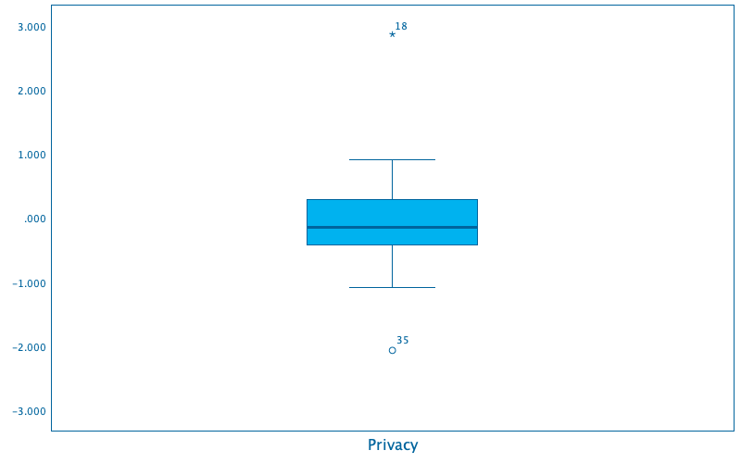

**Log**

Log - Log - September 25, 2019

EXAMINE VARIABLES=gc06

  /ID=State

  /PLOT BOXPLOT STEMLEAF HISTOGRAM NPPLOT

  /COMPARE GROUPS

  /MESTIMATORS HUBER(1.339) ANDREW(1.34) HAMPEL(1.7,3.4,8.5) TUKEY(4.685)

  /PERCENTILES(5,10,25,50,75,90,95) HAVERAGE

  /STATISTICS DESCRIPTIVES EXTREME

  /CINTERVAL 95

  /MISSING LISTWISE

  /NOTOTAL.

**Explore**

Explore - Case Processing Summary - September 25, 2019

Case Processing SummaryCase Processing Summary, table, 3 levels of column headers and 1 levels of row headers, table with 7 columns and 5 rows

|  |  |  |  |  |  |  |
| --- | --- | --- | --- | --- | --- | --- |
|  | Cases | | | | | |
| Valid | | Missing | | Total | |
| N | Percent | N | Percent | N | Percent |
| gc06 Privacy | 48 | 100.0% | 0 | 0.0% | 48 | 100.0% |
|  |  |  |  |  |  |  |

**Explore**

Explore - Descriptives - September 25, 2019

DescriptivesDescriptives, table, 1 levels of column headers and 3 levels of row headers, table with 5 columns and 15 rows

|  |  |  |  |  |
| --- | --- | --- | --- | --- |
|  | | | Statistic | Std. Error |
| gc06 Privacy | Mean | | -.09258 | .104716 |
| 95% Confidence Interval for Mean | Lower Bound | -.30324 |  |
| Upper Bound | .11808 |  |
| 5% Trimmed Mean | | -.11566 |  |
| Median | | -.14000 |  |
| Variance | | .526 |  |
| Std. Deviation | | .725492 |  |
| Minimum | | -2.067 |  |
| Maximum | | 2.870 |  |
| Range | | 4.937 |  |
| Interquartile Range | | .719 |  |
| Skewness | | 1.007 | .343 |
| Kurtosis | | 5.468 | .674 |
|  |  |  |  |  |

**Explore**

Explore - M-Estimators - September 25, 2019

M-EstimatorsM-Estimators, table, 1 levels of column headers and 1 levels of row headers, table with 5 columns and 7 rows

|  |  |  |  |  |
| --- | --- | --- | --- | --- |
|  | Huber's M-Estimatora | Tukey's Biweightb | Hampel's M-Estimatorc | Andrews' Waved |
| gc06 Privacy | -.10269 | -.10934 | -.11696 | -.10942 |
| a. The weighting constant is 1.339. | | | | |
| b. The weighting constant is 4.685. | | | | |
| c. The weighting constants are 1.700, 3.400, and 8.500 | | | | |
| d. The weighting constant is 1.340*pi. | | | | |
|  |  |  |  |  |

**Explore**

Explore - Percentiles - September 25, 2019

PercentilesPercentiles, table, 2 levels of column headers and 2 levels of row headers, table with 9 columns and 5 rows

|  |  |  |  |  |  |  |  |  |
| --- | --- | --- | --- | --- | --- | --- | --- | --- |
|  | | Percentiles | | | | | | |
| 5 | 10 | 25 | 50 | 75 | 90 | 95 |
| Weighted Average(Definition 1) | gc06 Privacy | -1.05590 | -.87720 | -.43025 | -.14000 | .28875 | .59360 | .87655 |
| Tukey's Hinges | gc06 Privacy |  |  | -.42550 | -.14000 | .28150 |  |  |
|  |  |  |  |  |  |  |  |  |

**Explore**

Explore - Extreme Values - September 25, 2019

Extreme ValuesExtreme Values, table, 1 levels of column headers and 3 levels of row headers, table with 6 columns and 12 rows

|  |  |  |  |  |  |
| --- | --- | --- | --- | --- | --- |
|  | | | Case Number | State | Value |
| gc06 Privacy | Highest | 1 | 18 | Maryland | 2.870 |
| 2 | 7 | Delaware | .904 |
| 3 | 27 | New Hampshire | .843 |
| 4 | 3 | Arkansas | .689 |
| 5 | 1 | Alabama | .583 |
| Lowest | 1 | 35 | Oregon | -2.067 |
| 2 | 41 | Texas | -1.082 |
| 3 | 14 | Kansas | -1.024 |
| 4 | 16 | Louisiana | -1.023 |
| 5 | 32 | North Dakota | -.861 |
|  |  |  |  |  |  |

**Explore**

Explore - Tests of Normality - September 25, 2019

Tests of NormalityTests of Normality, table, 2 levels of column headers and 1 levels of row headers, table with 7 columns and 6 rows

|  |  |  |  |  |  |  |
| --- | --- | --- | --- | --- | --- | --- |
|  | Kolmogorov-Smirnova | | | Shapiro-Wilk | | |
| Statistic | df | Sig. | Statistic | df | Sig. |
| gc06 Privacy | .102 | 48 | .200* | .909 | 48 | .001 |
| *. This is a lower bound of the true significance. | | | | | | |
| a. Lilliefors Significance Correction | | | | | | |
|  |  |  |  |  |  |  |

**gc06 Privacy**

gc06 Privacy - Histogram - September 25, 2019

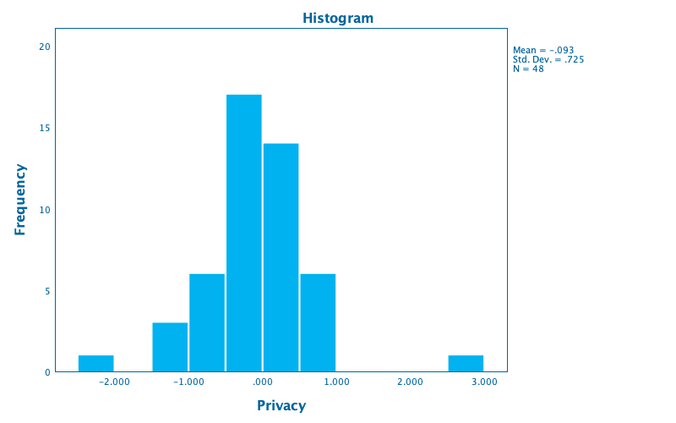

**gc06 Privacy**

gc06 Privacy - Stem-and-Leaf Plot - September 25, 2019

Privacy Stem-and-Leaf Plot

 Frequency    Stem &  Leaf

     1.00 Extremes    (=<-2.1)

     3.00       -1 .  000

     6.00       -0 .  677888

    17.00       -0 .  01112222233333444

    14.00        0 .  00001122223444

     6.00        0 .  555689

     1.00 Extremes    (>=2.9)

 Stem width:     1.000

 Each leaf:        1 case(s)

**gc06 Privacy**

gc06 Privacy - Normal Q-Q Plot - September 25, 2019

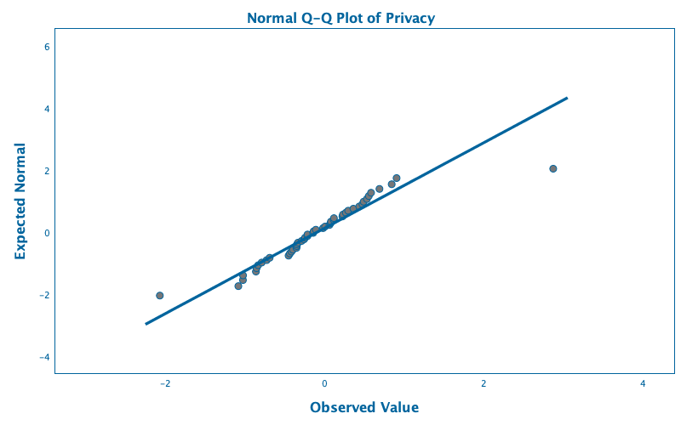

**gc06 Privacy**

gc06 Privacy - Detrended Normal Q-Q Plot - September 25, 2019

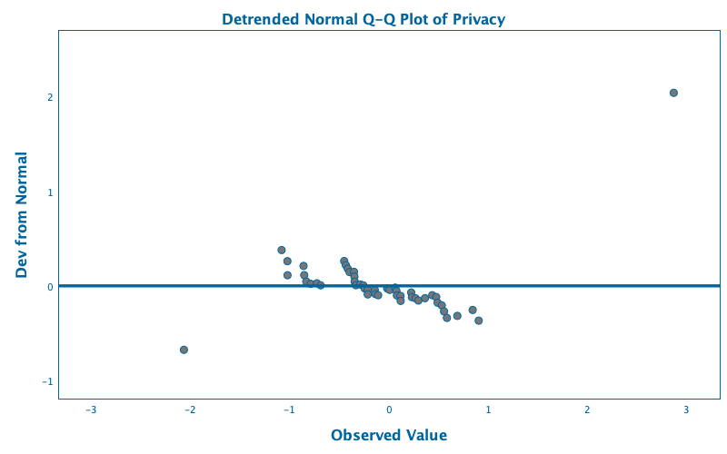

{"copyright":"(C) Copyright IBM Corp. 2011","grammar":[{"elements":[{"data":{"$ref":"dSource"},"style":{"symbol":"circle","outline":{"r":0,"b":157,"g":100},"size":8.0,"fill":{"r":119,"b":119,"g":118}},"position":[{"field":{"$ref":"fVariable1"}},{"field":{"$ref":"fVariable"}}],"type":"point"},{"data":{"$ref":"dSource"},"style":{"fill":{"r":0,"b":157,"g":100},"stroke":{"width":3.3333333}},"position":[{"value":"0"},{"field":{"$ref":"fVariable"}}],"type":"line"}],"coordinates":{"style":{"outline":{"r":0,"b":157,"g":100},"fill":{"r":255,"b":255,"g":255}},"dimensions":[{"scale":{"padding":{"left":"5%","right":"5%"}},"axis":[{"tickStyle":{"padding":5.0,"fill":{"r":0,"b":157,"g":100},"font":{"size":"8pt","weight":"normal","family":"'SanSerif,Verdana', sans-serif"}},"lineStyle":{"fill":{"r":0,"b":157,"g":100},"stroke":{"width":0.6666667}},"titleStyle":{"padding":6.0,"fill":{"r":0,"b":157,"g":100},"font":{"size":"12pt","weight":"bold","family":"'SanSerif,Verdana', sans-serif"}},"title":["Dev from Normal"],"markStyle":{"fill":{"a":0,"r":0,"b":157,"g":100},"stroke":{"width":1.3333334}}}]},{"scale":{"padding":{"left":"5%","right":"5%"}},"axis":[{"tickStyle":{"padding":5.0,"fill":{"r":0,"b":157,"g":100},"font":{"size":"8pt","weight":"normal","family":"'SanSerif,Verdana', sans-serif"}},"lineStyle":{"fill":{"r":0,"b":157,"g":100},"stroke":{"width":0.6666667}},"titleStyle":{"padding":6.0,"fill":{"r":0,"b":157,"g":100},"font":{"size":"12pt","weight":"bold","family":"'SanSerif,Verdana', sans-serif"}},"title":["Observed Value"],"markStyle":{"fill":{"a":0,"r":0,"b":157,"g":100},"stroke":{"width":1.3333334}}}]}]}}],"data":[{"id":"dSource","fields":[{"min":-2.067,"max":2.87,"id":"fVariable","label":"X Variable_1"},{"min":-0.6760965046180649,"max":2.038161195019384,"id":"fVariable1","label":"Y Axis"},{"id":"fVariable2","label":"V11","categories":[]}],"rows":[[-2.067,-0.6760965046180649,0],[-1.082,0.3775029402904295,1],[-1.024,0.2607336029004494,2],[-1.023,0.1117097016730775,3],[-0.861,0.210841733488877,4],[-0.854,0.1133132368868277,5],[-0.834,0.04561997989934796,6],[-0.789,0.02120234818749056,7],[-0.727,0.02698971063798394,8],[-0.689,0.005044104542739847,9],[-0.452,0.261706181893606,10],[-0.435,0.2186547213703365,11],[-0.416,0.1812820887897129,12],[-0.398,0.1449699814605377,13],[-0.353,0.1479196780897161,14],[-0.348,0.09745349832226302,15],[-0.346,0.0442950995960123,16],[-0.334,0.006125490953497903,17],[-0.289,0.01443891374942069,18],[-0.258,0.004266018356414214,19],[-0.244,-0.02869664879889522,20],[-0.215,-0.04049630407530694,21],[-0.214,-0.09054877881945361,22],[-0.143,-0.04391246732579449,23],[-0.137,-0.08680347277175157,24],[-0.109,-0.09943730634868467,25],[-0.019,-0.02681436455137305,26],[0.007,-0.04274914622805856,27],[0.062,-0.01919841924629201,28],[0.075,-0.05418207304094166,29],[0.08,-0.1010036689153374,30],[0.116,-0.1060922663556603,31],[0.118,-0.1592506650819112,32],[0.224,-0.07050092270681091,33],[0.231,-0.1199294938144348,34],[0.267,-0.1314308427419669,35],[0.296,-0.1550197206550108,36],[0.362,-0.1305307833071406,37],[0.436,-0.09854390703782112,38],[0.476,-0.1177327621995492,39],[0.49,-0.1781074221534378,40],[0.532,-0.2066601802655686,41],[0.555,-0.2702183108527748,42],[0.583,-0.3388009226529072,43],[0.689,-0.3168579169755532,44],[0.843,-0.2549903717889581,45],[0.904,-0.3676245827786633,46],[2.87,2.038161195019384,47]]}],"size":{"width":800.0,"height":500.0},"style":{"outline":{"a":0.0,"r":0,"b":0,"g":0},"fill":{"r":255,"b":255,"g":255}},"titles":[{"backgroundStyle":{"outline":{"a":0.0,"r":0,"b":0,"g":0},"fill":{"a":0.0,"r":0,"b":0,"g":0}},"style":{"padding":3.0,"fill":{"r":0,"b":157,"g":100},"font":{"size":"12pt","weight":"bold","family":"'SanSerif,Verdana', sans-serif"}},"type":"title","content":["Detrended Normal Q-Q Plot of Privacy"]}],"version":"6.0"}

**gc06 Privacy**

gc06 Privacy - Boxplot - September 25, 2019

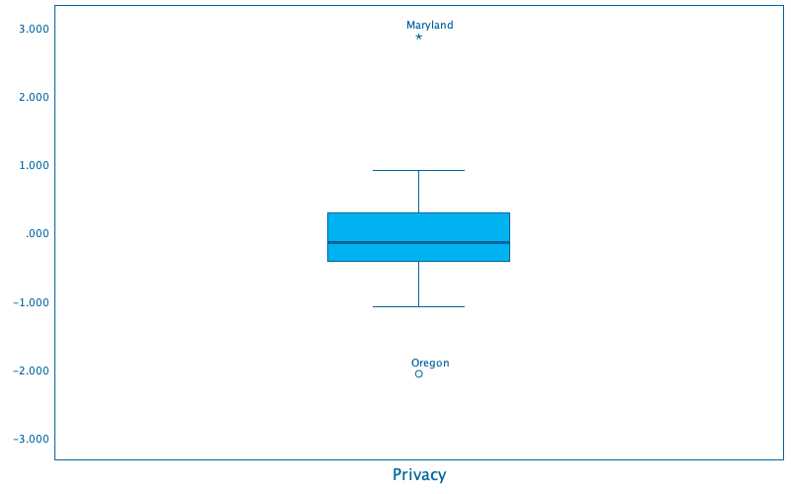

**IBM SPSS Web Report**

**X**

ABOUT

|  |
| --- |
| Created Using: IBM SPSS Statistics 26 |
| Creation Date: Sep 25, 2019 |
| Document Version: OriginalSaved Copy |
| Saved Date: Sep 25, 2019 |

Navigation Controls

|  |
| --- |
| **Contents** - Opens and closes the list of charts and tables in the Web Report |
| **Next** & **Previous** - Display the next or previous table or chart in the Web Report |
| **Help** - Opens Help |

Toolbar Buttons

|  |  |
| --- | --- |
|  | Undo - Undoes the last change in the document. |
|  | Edit - Open the Editor tool for tables and charts. Certain editing options are only available when you are connected to an Internet server. |
|  | Save - Creates a new copy of the Web Report with the saved changes. |
|  | Print - Prints the current object when in Object View and all objects in Page View. |
|  | Page View - Switches the Web Report to display all the tables and charts on a single page. |
|  | Object View - Switches the Web Report so that each table or chart is displayed one at a time. |

Connecting to a Server

The status of the Web Report's connection to an Internet server appears in the top right corner of the Web Report.An Internet connection is not required to open a Web Report. With a saved copy of the Web Report you can view all of the charts and tables, and have some limited editing ability, when not connected to the Internet.Connecting a Web Report to an Internet server will enable far greater editing capabilities for tables and for charts.

* If the author specified an Internet server when they created the Web Report, the Web Report will attempt to connect to the server automatically when it is opened.
* If the Web Report does not connect to a server, click on the server Status Message to open tools to retry the connection, try a different server, or enter a new server address.
* For information about adding the enhanced controls to your Internet Server, go to <https://developer.ibm.com/predictiveanalytics>.
* If you specify a new server connection, the preferred format is http://xxx.xxx.xxx.xxx:xxxx.

Editing Tables

|  |  |
| --- | --- |
| Some of this functionality is only available when connected to an Internet server. | |
|  | Create a chart - Create a chart from the selected cells in the table. |
|  | Pivot and Sort - Transpose, sort, and pivot the table. |
|  | Background color - The background color of the selected cells. |
|  | Text Color and Style - Font color, style, and size. |
|  | Number Format - Font color, style, and size. |

Editing Charts

|  |  |
| --- | --- |
| All of this functionality is only available when connected to an Internet server. | |
|  | Chart Size - Change the height and width of the chart |
|  | Background color - The background color of the selected object. |
|  | Border and Line Style - The color and thickness of the line or border. |
|  | Text Color and Style - Font color, style, and size. |
|  | Number Format - Font color, style, and size. |
|  | Axis Properties - Change the scale and display axis titles and ticks. |

**Save**

**X** New Name

What to Save

Save the entire document

Only save the current object

**Server Connection**

**X**

Saved Server Connections

Status

Add a chart

Pivot and Sort

Chart Size

|  |  |  |
| --- | --- | --- |
|  |  |  |
|  |  |  |
| Lock aspect ratio | | |

Background

|  |  |  |  |  |  |
| --- | --- | --- | --- | --- | --- |
|  | |  | |  | |
|  |  |  |  |  |  |
|  |  |  |  |  |  |
|  |  |  |  |  |  |

Line and Borders

|  |  |  |  |  |  |
| --- | --- | --- | --- | --- | --- |
|  | |  | |  | |
|  |  |  |  |  |  |
|  |  |  |  |  |  |
|  |  |  |  |  |  |

|  |  |  |
| --- | --- | --- |
|  |  |  |

Text Format

|  |  |  |  |  |  |
| --- | --- | --- | --- | --- | --- |
|  | |  | |  | |
|  |  |  |  |  |  |
|  |  |  |  |  |  |
|  |  |  |  |  |  |

|  |  |  |
| --- | --- | --- |
|  |  |  |

|  |  |  |  |
| --- | --- | --- | --- |
|  |  |  | Font Family .SF NS Text Abadi MT Condensed Extra Bold Abadi MT Condensed Light ABeeZee Adobe Caslon Pro Al Bayan Al Nile Al Tarikh American Typewriter Andale Mono Antro Vectra Apple Braille Apple Chancery Apple Color Emoji Apple SD Gothic Neo Apple Symbols AppleGothic AppleMyungjo Arial Arial Black Arial Hebrew Arial Hebrew Scholar Arial Narrow Arial Rounded MT Bold Arial Unicode MS Athelas Avenir Avenir Next Avenir Next Condensed Ayuthaya Baghdad Banda Regular Bangla MN Bangla Sangam MN Baskerville Baskerville Old Face Batang Bauhaus 93 Bebas Neue Beirut Bell MT Bernard MT Condensed Big Caslon Bodoni 72 Bodoni 72 Oldstyle Bodoni 72 Smallcaps Bodoni Ornaments Book Antiqua Bookman Old Style Bookshelf Symbol 7 Bradley Hand Braggadocio Britannic Bold Brush Script MT Calibri Calisto MT Calynda Cambria Cambria Math Candara Century Century Gothic Century Schoolbook Chalkboard Chalkboard SE Chalkduster Charter Cochin Colonna MT Comic Sans MS Consolas Constantia Cooper Black Copperplate Copperplate Gothic Bold Copperplate Gothic Light Corbel Corsiva Hebrew Courier Courier New Curlz MT Damascus DecoType Naskh Desdemona Devanagari MT Devanagari Sangam MN Dialog DialogInput Didot DIN Alternate DIN Condensed Diwan Kufi Diwan Thuluth Edwardian Script ITC Engravers MT Euphemia UCAS Eurostile Farah Farisi Footlight MT Light Franklin Gothic Book Franklin Gothic Medium Futura Gabriola Garamond GB18030 Bitmap Geeza Pro Geneva Georgia Gill Sans Gill Sans MT Gill Sans Ultra Bold Gloucester MT Extra Condensed Goudy Old Style Gujarati MT Gujarati Sangam MN Gulim Gurmukhi MN Gurmukhi MT Gurmukhi Sangam MN Haettenschweiler Harrington Heiti SC Heiti TC Helvetica Helvetica Neue HelvNeue Roman for IBM Herculanum Hiragino Kaku Gothic Pro Hiragino Kaku Gothic ProN Hiragino Kaku Gothic Std Hiragino Kaku Gothic StdN Hiragino Maru Gothic Pro Hiragino Maru Gothic ProN Hiragino Mincho Pro Hiragino Mincho ProN Hiragino Sans Hiragino Sans GB Hoefler Text Impact Imprint MT Shadow InaiMathi Iowan Old Style ITF Devanagari ITF Devanagari Marathi Kailasa Kannada MN Kannada Sangam MN Kefa Khmer MN Khmer Sangam MN Kino MT Kohinoor Bangla Kohinoor Devanagari Kohinoor Telugu Kokonor Krungthep KufiStandardGK Lao MN Lao Sangam MN Lucida Blackletter Lucida Bright Lucida Calligraphy Lucida Console Lucida Fax Lucida Grande Lucida Handwriting Lucida Sans Lucida Sans Typewriter Lucida Sans Unicode Luminari Malayalam MN Malayalam Sangam MN Marion Marker Felt Marlett Matura MT Script Capitals Meiryo Menlo Microsoft Himalaya Microsoft Sans Serif Microsoft Tai Le Microsoft Yi Baiti MingLiU MingLiU-ExtB MingLiU_HKSCS MingLiU_HKSCS-ExtB Mishafi Mishafi Gold Mistral Modern No. 20 Monaco Mongolian Baiti Monospaced Monotype Corsiva Monotype Sorts Montserrat MS Gothic MS Mincho MS PGothic MS PMincho MS Reference Sans Serif MS Reference Specialty Mshtakan MT Extra Muna Myanmar MN Myanmar Sangam MN Myriad Pro Myriad Web Pro Nadeem New Peninim MT News Gothic MT Noteworthy Noto Emoji Noto Mono Noto Nastaliq Urdu Noto Sans Noto Sans Runic Noto Sans UI Noto Serif Onyx Open Sans Optima Oriya MN Oriya Sangam MN Palatino Palatino Linotype Papyrus Perpetua Perpetua Titling MT Phosphate PingFang HK PingFang SC PingFang TC Plantagenet Cherokee Playbill PMingLiU PMingLiU-ExtB PT Mono PT Sans PT Sans Caption PT Sans Narrow PT Serif PT Serif Caption Raanana Rockwell Rockwell Extra Bold Sana SansSerif Sathu Savoye LET Seravek Serif Shree Devanagari 714 SignPainter Silom SimHei SimSun SimSun-ExtB Sinhala MN Sinhala Sangam MN Skia Snell Roundhand Songti SC Songti TC Source Code Pro Stencil STIXGeneral STIXIntegralsD STIXIntegralsSm STIXIntegralsUp STIXIntegralsUpD STIXIntegralsUpSm STIXNonUnicode STIXSizeFiveSym STIXSizeFourSym STIXSizeOneSym STIXSizeThreeSym STIXSizeTwoSym STIXVariants STSong Sukhumvit Set Superclarendon Symbol Tahoma Tamil MN Tamil Sangam MN Telugu MN Telugu Sangam MN Thonburi Times Times New Roman Trattatello Trebuchet MS Tw Cen MT Verdana Waseem Webdings Wide Latin Wingdings Wingdings 2 Wingdings 3 Zapf Dingbats Zapfino |

Number Format

|  |  |  |
| --- | --- | --- |
| 0.00 |  |  |

Axis Options

|  |  |  |
| --- | --- | --- |
|  |  |  |
|  |  |  |
| Display Axis Title | | | |
| Display Ticks | | | |