EXAMINE VARIABLES=gc06

  /PLOT BOXPLOT STEMLEAF

  /COMPARE GROUPS

  /STATISTICS DESCRIPTIVES

  /CINTERVAL 95

  /MISSING LISTWISE

  /NOTOTAL.

**Explore**

Case Processing SummaryCase Processing Summary, table, 3 levels of column headers and 1 levels of row headers, table with 7 columns and 5 rows

|  |  |  |  |  |  |  |
| --- | --- | --- | --- | --- | --- | --- |
|  | Cases | | | | | |
| Valid | | Missing | | Total | |
| N | Percent | N | Percent | N | Percent |
| gc06 Privacy | 48 | 100.0% | 0 | 0.0% | 48 | 100.0% |
|  |  |  |  |  |  |  |

DescriptivesDescriptives, table, 1 levels of column headers and 3 levels of row headers, table with 5 columns and 15 rows

|  |  |  |  |  |
| --- | --- | --- | --- | --- |
|  | | | Statistic | Std. Error |
| gc06 Privacy | Mean | | -.09258 | .104716 |
| 95% Confidence Interval for Mean | Lower Bound | -.30324 |  |
| Upper Bound | .11808 |  |
| 5% Trimmed Mean | | -.11566 |  |
| Median | | -.14000 |  |
| Variance | | .526 |  |
| Std. Deviation | | .725492 |  |
| Minimum | | -2.067 |  |
| Maximum | | 2.870 |  |
| Range | | 4.937 |  |
| Interquartile Range | | .719 |  |
| Skewness | | 1.007 | .343 |
| Kurtosis | | 5.468 | .674 |
|  |  |  |  |  |

**gc06 Privacy**

Privacy Stem-and-Leaf Plot

 Frequency    Stem &  Leaf

     1.00 Extremes    (=<-2.1)

     3.00       -1 .  000

     6.00       -0 .  677888

    17.00       -0 .  01112222233333444

    14.00        0 .  00001122223444

     6.00        0 .  555689

     1.00 Extremes    (>=2.9)

 Stem width:     1.000

 Each leaf:        1 case(s)

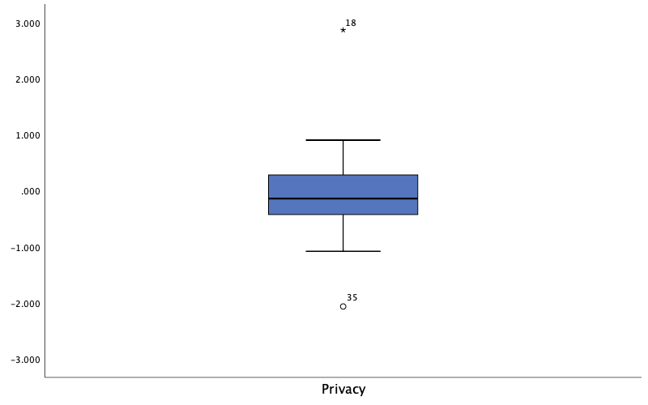

EXAMINE VARIABLES=gc06

  /ID=State

  /PLOT BOXPLOT STEMLEAF HISTOGRAM NPPLOT

  /COMPARE GROUPS

  /MESTIMATORS HUBER(1.339) ANDREW(1.34) HAMPEL(1.7,3.4,8.5) TUKEY(4.685)

  /PERCENTILES(5,10,25,50,75,90,95) HAVERAGE

  /STATISTICS DESCRIPTIVES EXTREME

  /CINTERVAL 95

  /MISSING LISTWISE

  /NOTOTAL.

**Explore**

Case Processing SummaryCase Processing Summary, table, 3 levels of column headers and 1 levels of row headers, table with 7 columns and 5 rows

|  |  |  |  |  |  |  |
| --- | --- | --- | --- | --- | --- | --- |
|  | Cases | | | | | |
| Valid | | Missing | | Total | |
| N | Percent | N | Percent | N | Percent |
| gc06 Privacy | 48 | 100.0% | 0 | 0.0% | 48 | 100.0% |
|  |  |  |  |  |  |  |

DescriptivesDescriptives, table, 1 levels of column headers and 3 levels of row headers, table with 5 columns and 15 rows

|  |  |  |  |  |
| --- | --- | --- | --- | --- |
|  | | | Statistic | Std. Error |
| gc06 Privacy | Mean | | -.09258 | .104716 |
| 95% Confidence Interval for Mean | Lower Bound | -.30324 |  |
| Upper Bound | .11808 |  |
| 5% Trimmed Mean | | -.11566 |  |
| Median | | -.14000 |  |
| Variance | | .526 |  |
| Std. Deviation | | .725492 |  |
| Minimum | | -2.067 |  |
| Maximum | | 2.870 |  |
| Range | | 4.937 |  |
| Interquartile Range | | .719 |  |
| Skewness | | 1.007 | .343 |
| Kurtosis | | 5.468 | .674 |
|  |  |  |  |  |

M-EstimatorsM-Estimators, table, 1 levels of column headers and 1 levels of row headers, table with 5 columns and 7 rows

|  |  |  |  |  |
| --- | --- | --- | --- | --- |
|  | Huber's M-Estimatora | Tukey's Biweightb | Hampel's M-Estimatorc | Andrews' Waved |
| gc06 Privacy | -.10269 | -.10934 | -.11696 | -.10942 |
| a. The weighting constant is 1.339. | | | | |
| b. The weighting constant is 4.685. | | | | |
| c. The weighting constants are 1.700, 3.400, and 8.500 | | | | |
| d. The weighting constant is 1.340*pi. | | | | |
|  |  |  |  |  |

PercentilesPercentiles, table, 2 levels of column headers and 2 levels of row headers, table with 9 columns and 5 rows

|  |  |  |  |  |  |  |  |  |
| --- | --- | --- | --- | --- | --- | --- | --- | --- |
|  | | Percentiles | | | | | | |
| 5 | 10 | 25 | 50 | 75 | 90 | 95 |
| Weighted Average(Definition 1) | gc06 Privacy | -1.05590 | -.87720 | -.43025 | -.14000 | .28875 | .59360 | .87655 |
| Tukey's Hinges | gc06 Privacy |  |  | -.42550 | -.14000 | .28150 |  |  |
|  |  |  |  |  |  |  |  |  |

Extreme ValuesExtreme Values, table, 1 levels of column headers and 3 levels of row headers, table with 6 columns and 12 rows

|  |  |  |  |  |  |
| --- | --- | --- | --- | --- | --- |
|  | | | Case Number | State | Value |
| gc06 Privacy | Highest | 1 | 18 | Maryland | 2.870 |
| 2 | 7 | Delaware | .904 |
| 3 | 27 | New Hampshire | .843 |
| 4 | 3 | Arkansas | .689 |
| 5 | 1 | Alabama | .583 |
| Lowest | 1 | 35 | Oregon | -2.067 |
| 2 | 41 | Texas | -1.082 |
| 3 | 14 | Kansas | -1.024 |
| 4 | 16 | Louisiana | -1.023 |
| 5 | 32 | North Dakota | -.861 |
|  |  |  |  |  |  |

Tests of NormalityTests of Normality, table, 2 levels of column headers and 1 levels of row headers, table with 7 columns and 6 rows

|  |  |  |  |  |  |  |
| --- | --- | --- | --- | --- | --- | --- |
|  | Kolmogorov-Smirnova | | | Shapiro-Wilk | | |
| Statistic | df | Sig. | Statistic | df | Sig. |
| gc06 Privacy | .102 | 48 | .200* | .909 | 48 | .001 |
| *. This is a lower bound of the true significance. | | | | | | |
| a. Lilliefors Significance Correction | | | | | | |
|  |  |  |  |  |  |  |

**gc06 Privacy**

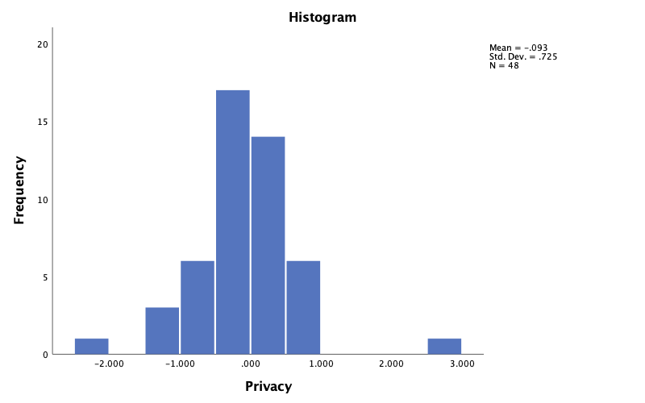

Privacy Stem-and-Leaf Plot

 Frequency    Stem &  Leaf

     1.00 Extremes    (=<-2.1)

     3.00       -1 .  000

     6.00       -0 .  677888

    17.00       -0 .  01112222233333444

    14.00        0 .  00001122223444

     6.00        0 .  555689

     1.00 Extremes    (>=2.9)

 Stem width:     1.000

 Each leaf:        1 case(s)

