MetaBonk Visual Artifacts Fix
Updated: 2025-12-28

Problem
Some headless GPU → NVENC streaming paths can produce three classic artifacts:
- Off-color frames (green/magenta tint or swapped channels)
- Occasional upside-down frames
- Banding/tearing/diagonal shear artifacts

Root Causes
- Stride/pitch mismatch: GPU buffers often have padded row pitch (stride_bytes > width*bytes_per_pixel). Treating them as tightly packed corrupts rows.
- Format mismatch: DRM/XWayland commonly exports XR24/AR24 (little-endian BGRA). If consumer assumes RGBA/RGB without swizzle, colors shift.
- Origin mismatch: some render paths are bottom-up; consumers expecting top-down need a vertical flip.

Fix Implemented

1) Pack pitched/offset DMA-BUF frames on GPU
File: src/agent/tensor_bridge.py
When importing a linear-mapped DMA-BUF, MetaBonk now detects non-tight stride/offset and performs a GPU→GPU 2D copy (cuMemcpy2DAsync) into a contiguous torch.uint8 tensor before downstream processing.
- Default behavior is enabled via METABONK_TENSOR_BRIDGE_PACK_PITCHED=1 (default).
- This removes banding/tearing caused by treating pitched memory as a flat buffer.

2) Keep channel order correct for common DRM formats
File: src/worker/main.py
Synthetic Eye frames exported as XRGB8888 / ARGB8888 (XR24/AR24) are little-endian BGRA in memory. The worker applies a channel swizzle (BGR→RGB) before producing pixel observations / stream frames.

3) Optional vertical flip for bottom-up sources
File: src/worker/main.py
If your stack produces bottom-up buffers, enable a per-frame vflip after import/swizzle:
- METABONK_SYNTHETIC_EYE_VFLIP=1
- (alias: METABONK_EYE_VFLIP=1)

4) Browser-safe pixel format for MP4/MSE
File: src/worker/nvenc_streamer.py
The FFmpeg pixel_obs backend now forces yuv420p output by default (overrideable via METABONK_FFMPEG_OUT_OPTS). This avoids browsers rejecting 4:4:4 / 10-bit outputs.

How To Verify
- Launch: ./start --mode train --workers 1 --no-go2rtc
- Open UI: http://127.0.0.1:5173/neural/broadcast (Spectator Cam)
- Open UI: http://127.0.0.1:5173/neural (Neural Interface)
- If frames are upside-down, set METABONK_SYNTHETIC_EYE_VFLIP=1 and restart.

Updated UI Screenshots
Spectator Cam (pixel_obs → NVENC → MP4):
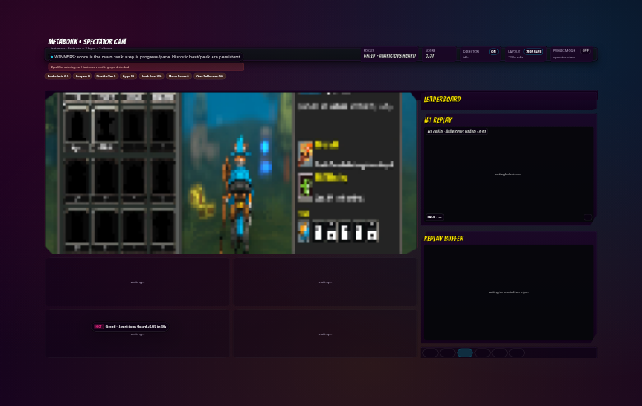
Neural Interface (focused instance stream):
