**[MARKETING](https://wearecandescent.com/category/marketing/)**

**Testimonials, reviews and quotes: Everything you need to know**



When you’re considering buying a product or service, do negative client testimonials put you off and make you reconsider?

Alternatively, do you feel more empowered to take the plunge if you see a positive review?

The psychology behind client testimonials, reviews and quotes is simple: you are more likely to trust a business who has proof that their products and services are effective and therefore worth your time and money.

Testimonials, reviews and quotes are especially handy when you’re just starting out as a small business, as building a customer base is all about showing why people should invest in you when there’s multiple businesses for them to choose from.

If you’re wondering where to start with testimonials, reviews and quotes, this blog post has all the answers. After reading, you’ll understand:

* What testimonials, reviews and quotes are,
* How to find them,
* How to use them when marketing your business.

**What are testimonials, reviews and quotes, and why should I use them?**

The good news is that testimonials, reviews and quotes are very similar. They all act as a recommendation of sorts from your previous customers, and speak to the effectiveness of a product/service a customer has experience of.

A customer’s testimonial, review or quote usually offers some thoughts on what they loved about a product or what they enjoyed about a service, how using the product/service has changed their life, and why they’d suggest others invest their interest in the product/service. 

The main reason why you should be using testimonials, reviews and quotes is that they are the perfect way to encourage others to go ahead and check your products/services out for themselves. Ultimately, knowing someone else has had a positive experience with your business is one of the most effective ways you can ensure more people come to see what you have to offer.

Spotlighting a customer’s positive experience will have a huge influence on whether or not a potential customer will buy it for themselves. Whilst it costs nothing for you to claim your products/services are worth the money, having direct confirmation of this from a paying customer is extremely valuable, as it’s coming from an external party and therefore is unlikely to have any bias towards your business.

Also, when you start the line of communication that leads to a positive review (see below for more on this), you’re interacting with your audience and therefore nurturing them. This is a great way to secure future sales from a happy customer, as you’re talking to them directly and therefore learning more about them and showing an interest in their experience.

Even negative testimonials, reviews and quotes can be helpful; whilst you certainly don’t want to publicise them as you want to do with the positive ones, they can definitely help you see where you might be going wrong, so that you can improve the quality and efficiency of your products/services in the future.

For now, let’s get back to the positive stuff…

**Where do I obtain testimonials, reviews and quotes from?**

There are multiple places you can find positive testimonials, reviews and quotes from…

**1. Social media:**

Happy customers may share a post with their thoughts about your business on their social media. Use this as an opportunity to get a great quote or review; send a follow-up message after you spot these posts, asking if the person would mind having their comment used for promotional purposes. If they agree, you’ve got your first recommendation!

To get ahead of the game, you can ask customers to do this when they make the purchase. It can be super simple: ‘Share your thoughts about CANDESCENT’S Lead Magnet eGuide on social media and tag us [@WeAreCandescent](https://www.instagram.com/wearecandescent/?hl=en) so we see it!’ This way, you’re planting the seed that will hopefully get you some social media posts to use in the future. Another tip is encouraging people to share pictures of themselves featuring your product/service, as the visual element is always influential when showcasing the best of what your business offers.

The same goes for direct messages on social media, especially the ones that are super positive – ask the sender if you can use their comment, and you’ve got even more quotes to choose from!

Why not embed your Twitter or Facebook feed onto your website, so that when people tag you in a tweet or post they make about your business it pops up on your website for everyone who is browsing to see? This requires no effort from you as the quotes will seamlessly appear on your website, and they will showcase all the positive things people are saying about you; it may just seal another deal from a potential customer.

**2. Website pop-ups:**

Having a pop-up on your website whereby people can offer their thoughts on your business is another effective way to build a bank of testimonials and quotes.

Here are a few questions you may want to consider using in your pop-up:

* What product or service did you purchase from [insert business name]?
* What 3 things did you like about the product or service?
* Was there anything that could have been improved?
* Do you think the product or service has value for money?
* Would you recommend the product or service to someone else?

It can be a simple form with checkboxes that you can use as anonymous data to create ‘customer experience’ charts to showcase on your website. For example: ‘80% of customers said they would recommend [insert product/service] to someone else’.

Alternatively, you can insert comment boxes for longer answers, which will encourage customers to detail specifics about the product/service that can be used as testimonials later on.

Flexibility with the form is key to ensuring people take the time to fill them out, so you may wish to use a mix of both, so customers can choose between ticking boxes and offering longer answers.

Whichever option you go for, you’ll be collecting impactful thoughts from your customers that will be super helpful in the long-term.

**3.  Follow-up emails:**

This one is similar to the good old social media posts. There are two strands to the follow-up email.

Firstly, customers who have had such a positive experience with your business may want to share this with you. One of the ways they may choose to do this is through emails, which they send once they’ve tried your product/service and realised how much they love it. When you receive these emails, send an appreciative reply and ask whether you can use their comments as a testimonial. BOOM – another positive testimonial coming your way!

Secondly, you can be the one to send a follow-up email asking your customers how they found the product/service. Keep track of what people buy from you, and send them targeted emails with a form they can fill out to share their thoughts. You may gain nothing from it, but you never know unless you try; if you receive any gems, you’ve got a selection of great quotes to use in the future!

At every stage of this process, make it clear you intend to use these comments for promotional purposes, explaining how you’d like to use them and where you may publish them. If you’re using a form, make sure to add an opt-in section for them to check to confirm they’re happy for you to do so, and always ask whether they’d prefer to remain anonymous or wouldn’t mind having their name displayed. Permission is key!

Now you know how you can find them, let’s see how you can make testimonials, reviews and quotes work wonders for your business…

**How do I use testimonials, reviews and quotes when marketing my business?**

There’s many ways you can share positive reviews and recommendations with potential customers. Here’s a few easy-to-implement ideas…

**1.  Your website:**

This is one of the places people turn to for testimonials. Set up a dedicated section on your homepage or website where people can read about how wonderful your business is.  Here’s how we do it at CANDESCENT…

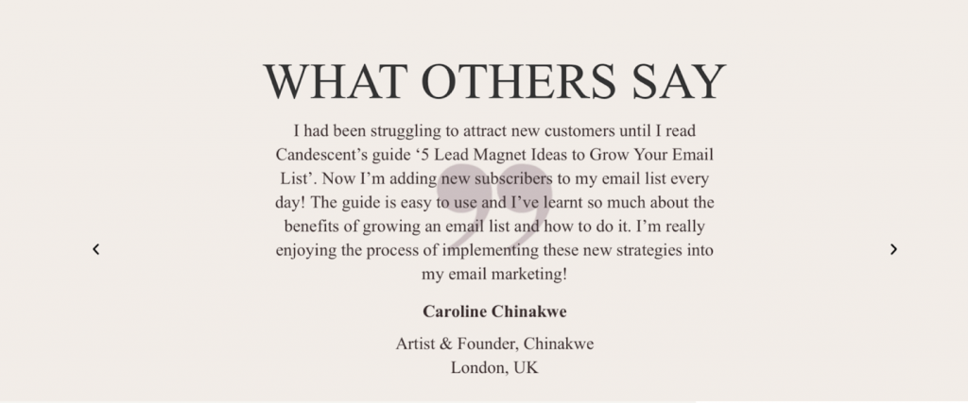

Having multiple positive reviews is even more effective, as it is not just one person but multiple people who are telling us why others should love your business.

To prove the integrity of the quote, you may want to provide a link to the individual’s social media or website (this is especially easy if they’re a business, although less helpful when they’re a single customer).

**2. Social media:**

You may wish to schedule one day a week into your content calendar that is dedicated to posting a customer review or quote. This will not only mix your feeds up, but also give you the chance to showcase how brilliant people think your business is without seeming too focused on client testimonials when you should also be focusing on nurturing your current audience.

**3. Email sequences:**

In your emails, you may want to include a few testimonials. This works well when you’re promoting a certain product/service, as you can explain what you’re promoting whilst simultaneously showing your subscribers how others have found it too. This is all part of the push to secure future sales.

**Final tips…**

* Don’t bombard your customers with testimonials; instead, choose the very best ones and add them here and there to your website, social media posts and emails. You want to draw attention to them without making them the centre of your content.
* As was mentioned above, always ask permission to use testimonials, reviews and quotes and determine whether the customer would like to be named or anonymous.

Testimonials, reviews and quotes are not only simple to find, they’re also absolutely key to showcasing why people should take an interest in your business. They will have a positive impact on the overall impression of your brand, and will hopefully allow you to secure future sales too.