Derkach Vladyslav

|  |  |  |  |  |  |  |
| --- | --- | --- | --- | --- | --- | --- |
| **Birth date:** | 30/04/1993 |  | |  | | |
| **Location:** | Kharkiv | | | | | |
| **Phone:** | +38(093) 504 59 30 | | | |  |  |
| **E-mail:** | [derkach.vladyslav](mailto:derkach.vladyslav@gmail.com) | | | | | |
| **Linkedin:** |  | | |  | | |
| [derkachvladyslav](https://ua.linkedin.com/in/derkachvladyslav) | |  |  | | |
| **Skype:** |  | | | | | |
| vladhd93 | | |  | | |

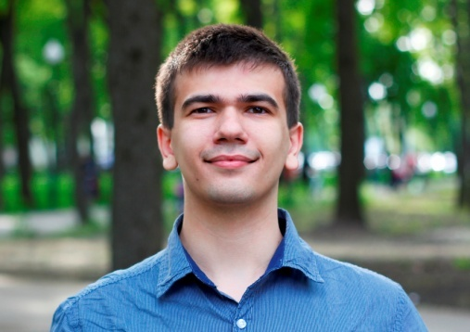

**Objective**

To obtain junior (trainee) HTML/CSS developer position.

**Skills and knowledge**

* Solid knowledge of HTML 4.01/HTML 5, CSS2.1/CSS3.
* Good understanding of cross-browser (IE 8+) compatibility issues, semantic code.
* Solid skills in responsive design (mobile first, desktop first methods).
* Ability to customize the components, modules, plugins.
* Experience with GIT and github.com.
* **Frameworks and libraries**: Twitter Bootstrap 2/3, Jquery (in progress).
* **Preprocessors**: LESS, SASS (in progress).
* **Soft**: Webstorm, Brackets, SublimeText 2/3, Adobe Photoshop.

**Portfolio**

**Visit my github:** <http://vladhd93.github.io.> ( there are submitted all my works.)

**Languages**

**English**: pre-intermediate **Ukrainian:** native. **Russian:** native.

**Work experience**

**Engineer-constructor (trainee)**

* Design and calculation of metallic structures, execution of drawings. Work with CAD and finite element method-systems.

*December 2014 - May 2015*

LLC PSK Kharkiv

* Inspection of buildings and structures, implementation of calculations in SCAD 11.5, working drawings in AutoCAD 2012 complex.

**Civil Engineer**

*June 2012 - December 2014*

Sole proprietor Savyovsky V.V

**Education**

* Building faculty, bachelor degree in civil engineering, specialist degree in civil engineering.

**Kharkiv national university of civil**

**engineering and architecture**

*September 2010 - June 2015*

**Additional education**

**Source-it courses**

* Markup development course.

*March 2015 - June 2015*

**Additional information**

* **Personal qualities:**
* **Hobbies:** Computer technologies, philosophy, bicycle sport, basketball.