Special Olympics Belgium: End-to-End Data Warehouse & Business Intelligence Pipeline
Course: Integrated Lab
Student Name: Vlad Constantin Oprea
Student ID: r0975016
Academic Year: 2025–2026

Executive Summary
This technical report details the design, implementation, and deployment of a production-grade Data Engineering and Business Intelligence pipeline built for Special Olympics Belgium (SOB). Leveraging an automated Python ETL processor, a relational MySQL Data Warehouse structured around a Star Schema, and a high-fidelity Power BI reporting suite, this project successfully transforms historical, fragmented athletic data into strategic business insights.
The pipeline is organized following the Medallion Architecture (Bronze ──► Silver ──► Gold) to guarantee strict data quality, full auditability, and system reproducibility.

Chapter 1: Introduction & Architectural Design
1.1 Project Objectives and Scope
Special Olympics Belgium coordinates sports training and athletic competitions for children and adults with intellectual disabilities. Over the years (2015–2025), historical event data, club registrations, and athlete certifications were stored in separate spreadsheets and flat files with varying schemas, column headers, and quality issues.
The goal of this project is to build an automated system that:
- Ingests all historical results and metadata.
- Normalizes, cleans, and standardizes data to resolve multi-year structural changes.
- Structures a centralized, relational MySQL Data Warehouse.
- Delivers an interactive, user-centric dashboard for strategic decision-making.
1.2 Medallion Architecture (Bronze ──► Silver ──► Gold)
To prevent data contamination and ensure that data processing can be audited or run again at any time, we implemented a Medallion Architecture:
[Bronze Layer (Raw CSVs)]
│ (Automated Python Cleaning & Unification)
▼
[Silver Layer (Standardized Tables)]
│ (Dimensional modeling & Star Schema mapping)
▼
[Gold Layer (Star Schema CSVs)] ───► [MySQL Data Warehouse] ───► [Power BI Dashboard]
- Bronze Layer (Raw Data Area): Serves as the landing zone. It contains raw, unchanged source CSV files extracted from legacy spreadsheets (results from 2015–2025, club details, and certifications). No cleaning is allowed here to maintain a raw point of truth.
- Silver Layer (Cleaned & Standardized Area): Python processes the Bronze files to clean text strings, standardise capitalization, handle nulls, align column names, and inject temporal metadata (like extracting years from file names).
- Gold Layer (Optimized Analytical Area): Silver files are transformed into a relational Star Schema, creating dedicated dimension tables (dim_athlete, dim_club, dim_sport) and a highly consolidated fact table (fact_results). These are saved as optimized CSV files and automatically uploaded into the MySQL database.

Chapter 2: Automated ETL Pipeline & Technical Decisions
2.1 Python ETL Process Flow
The ETL process is fully automated via modular Python scripts. The execution is controlled by main.py, which calls the DataProcessor helper class for data transformations and the DBManager class for relational database ingestion.
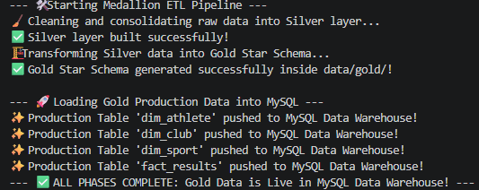
2.2 Critical Data Cleaning Decisions
2.2.1 Metadata Extraction (Competition Year)
Legacy files did not contain a column representing the year of the competition; the year was only implied by the Excel sheet name. To automate this and make it future-proof, we implemented a Regular Expression (Regex) parser in Python:
year_match = re.search(r'\d{4}', file)
df['Year'] = int(year_match.group()) if year_match else 2015
This regex dynamically hunts for any sequence of 4 digits within the file name. Even if the raw file name is messy, Python extracts 2018 with 100% precision.
2.2.2 Case and String Standardization
String fields such as athlete genders, club locations, and competition places suffered from inconsistent spacing and casing (e.g., m, M , Male, Flem). The Silver layer standardizes these via string functions:
- Standardizing Gender values to capital M and F across all files.
- Enforcing .str.upper().str.strip() on competition places to prevent duplicates like "GOLD" and "gold ".
2.2.3 A Well-Thought Decision: Why the Score Column Remained VARCHAR
A major engineering challenge was the Score column. In the source data, scores are recorded across wildly different athletic categories:
- Time-based events (e.g., Swimming, Athletics running): recorded as "01:23.45" (minutes, seconds, milliseconds).
- Distance-based events (e.g., Long Jump, Shot Put): recorded as "4.32" (meters).
- Point-based events (e.g., Bocce, Judo): recorded as integers like "15".
The Decision: Any attempt to force this column into a single numeric float or integer data type during ETL would corrupt the data (e.g., stripping time separators or losing decimal precision for distances). Converting times to total seconds would make the final report unreadable for non-technical users.
Therefore, we made the pragmatic decision to preserve the Score column as a VARCHAR/text field in MySQL. This maintains the semantic truth of the athlete's achievement. In Power BI, we handle specific aggregations using filters or DAX when looking at single sport disciplines.

Chapter 3: Relational Data Modeling & MySQL Warehouse
3.1 The Star Schema Model
To guarantee lightning-fast query performance in Power BI, the Gold layer represents a clean Star Schema. In this model, business measurements (facts) are kept separate from context (dimensions):
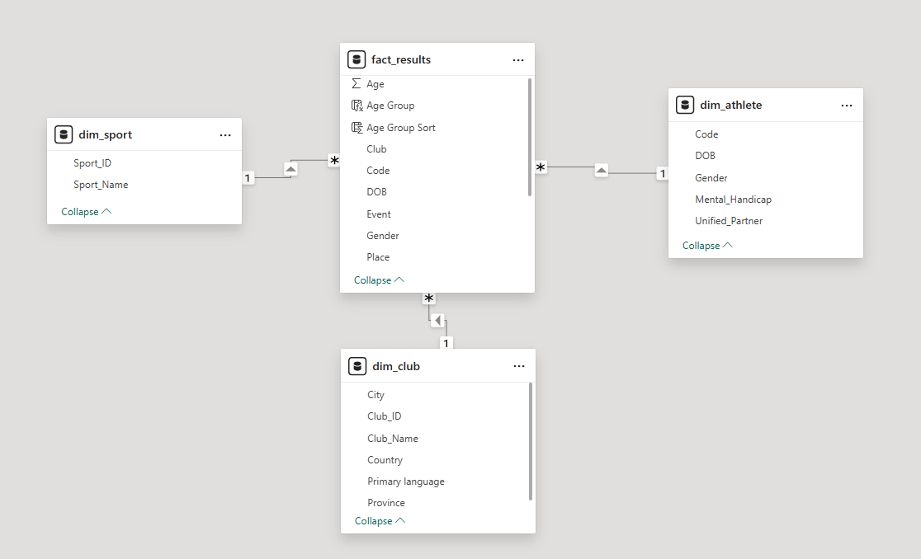

3.2 Gold Table Structures
- dim_athlete: Contains unique physical records of participants, enriched by joining certifications with athletic events.
- dim_club: Standardizes club registrations, regional provinces, city locations, and primary spoken languages.
- dim_sport: Created dynamically in Python by extracting unique sports from the raw files, assigning each a surrogate primary key (Sport_ID), resolving the missing relation in the raw database.
- fact_results: The central transactional table containing references to foreign keys, the exact year of the competition, the final rank (Place), and the recorded Score.
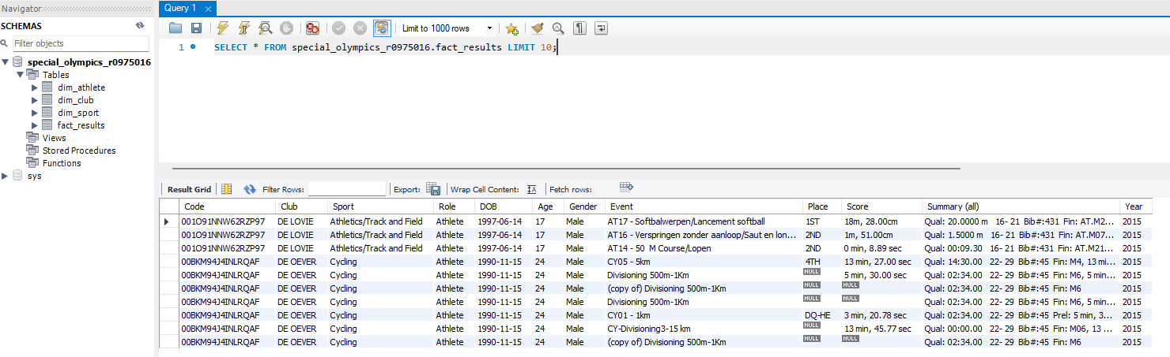

Chapter 4: Business Intelligence & UI/UX Design
4.1 UI/UX Wireframe Concepts
We planned the visual hierarchy using a wireframing tool prior to building the dashboard. Following the F-Pattern Layout, users naturally scan interfaces from top-left to bottom-right. Therefore, the dashboard structure places filters at the top-right, critical metrics (KPIs) at the top-left, and granular tables at the bottom.
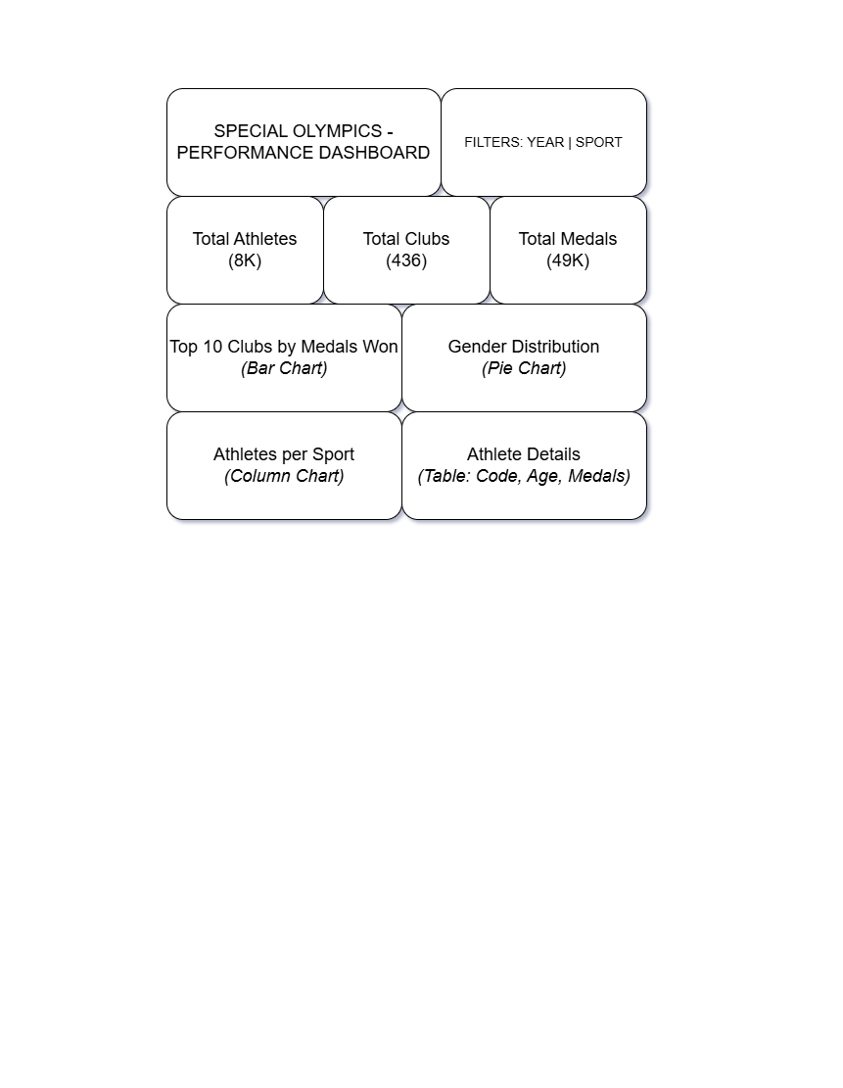

4.2 Power BI Dashboard Implementation
The final Power BI dashboard consists of three highly functional, beautifully styled pages that match the initial wireframe design.
4.2.1 Page 1: Performance Overview
This page provides executive-level KPIs and top-level participation trends:
- KPI Cards: Dynamic measures with no rounding to ensure 100% academic precision (showing exact counts of Total Athletes, Total Clubs, and Medals).
- Top Performing Clubs: A horizontal bar chart displaying clubs sorted by total medals won, with blank values cleanly filtered out using the visual filter pane.
- Gender Participation Split: A donut chart showcasing female vs. male athletes.
- Interaction Override: We configured Edit Interactions so that clicking on a club filters the Donut Chart to show the local gender distribution within that club, rather than a tiny percentage relative to the global database.
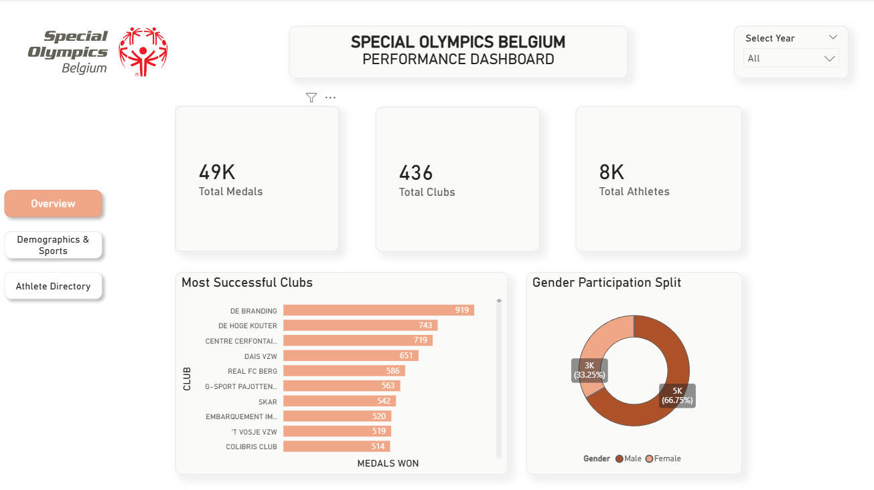
4.2.2 Page 2: Demographics & Sports Analysis
This page focuses on identifying demographic and structural participation patterns:
- Demographic Distribution (Age Profile): A vertical column chart using custom-built Age Bins (Under 18, 19–30, 31–45, 46–60, Over 60) sorted chronologically using a hidden logical sorting column (Age Group Sort).
- Sport Popularity (Participation Rate): A horizontal bar chart enabling users to read sport names horizontally, eliminating diagonal text clutter.
- Page Navigator: A cohesive Fluent-styled navigation bar at the top of all pages, allowing seamless transition across pages.
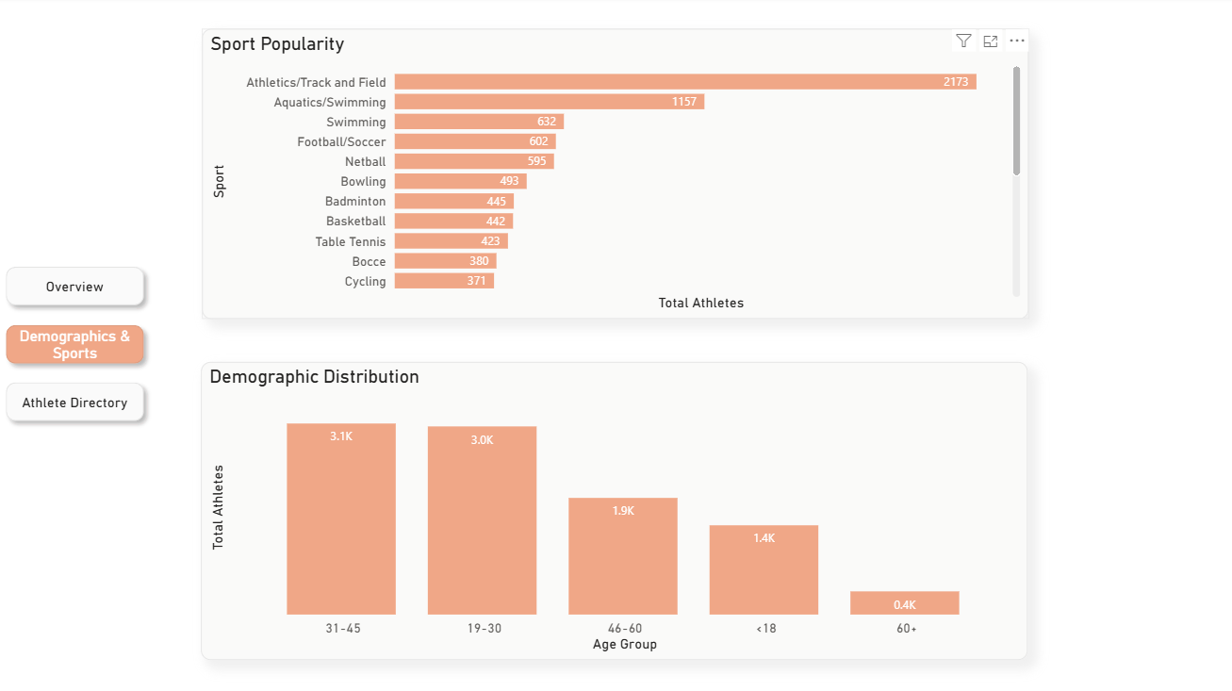
4.2.3 Page 3: Athlete Directory (Raw Data Explorer)
Built as an interactive database browser:
- Athlete Performance Directory: A detailed matrix card displaying athlete codes, ages, gender, sport names, and the exact count of medals won.
- Row Padding: Adjusted vertically to 12px for high readability.
- Advanced Slicers: Interactive Dropdowns for Sport and Gender.
- Search Bar Slicer: Implemented with search index enabled, letting users search instantly for a specific athlete's Code among thousands of rows.
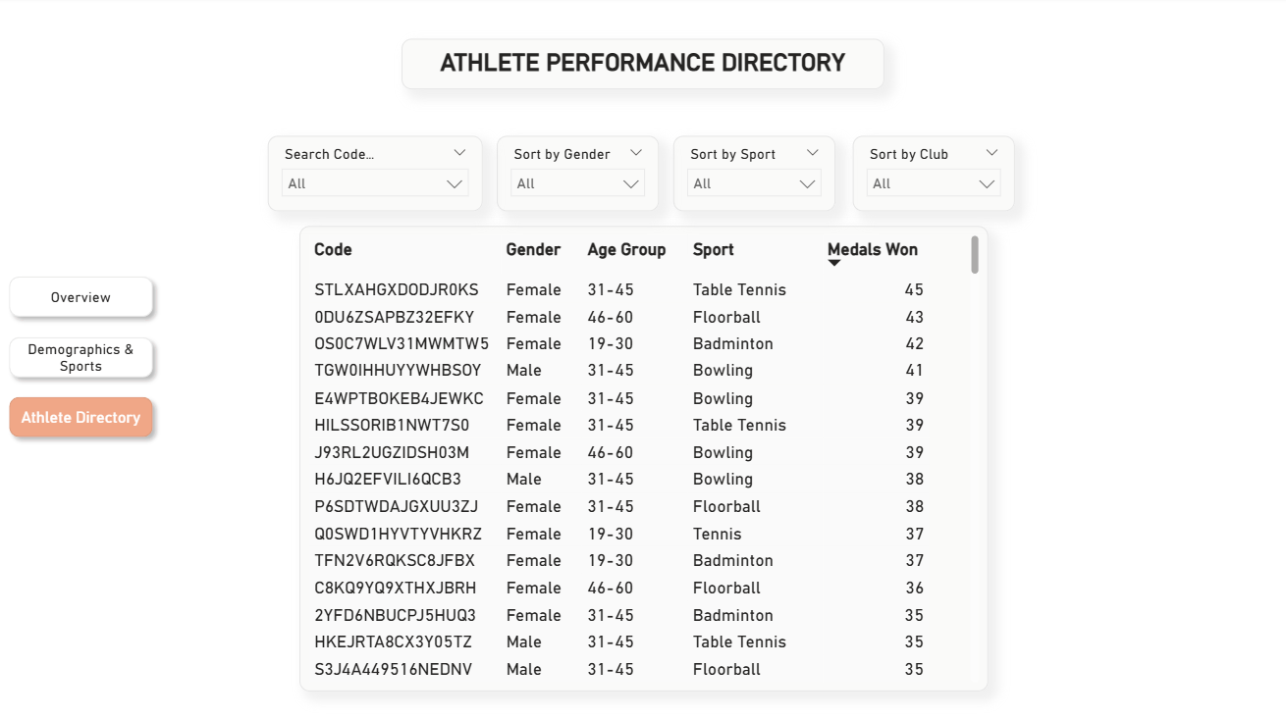
Chapter 5: Key Insights & Business Recommendations
5.1 The Distinct Count Insight (Athletes Loyalty)
During validation, we discovered that while individual years average 2,000 to 3,000 athletes, the total distinct count of athletes over the entire decade is only 8,432.
Business Discovery: This mathematically proves an incredible retention rate. Rather than constant turnover, athletes who join Special Olympics Belgium remain in the organization for many years, competing in multiple tournaments. The sport clubs represent an essential community and social pillar for these individuals.
5.2 The Age Demographics Anomaly
Traditional youth sports clubs show a steep decline in participation after the age of 18. However, Special Olympics Belgium shows the exact opposite:
- Under 18 Cohort: Only 1,400+ athletes.
- 31–45 and 46–60 Cohorts: Dominating with over 1,900+ athletes each.
- Over 60 Cohort: An active, highly inspirational group of senior participants.
Business Recommendation: Special Olympics Belgium should focus recruitment efforts on junior programs ("Play Unified" in schools) to engage younger generations early, since the data proves that once an athlete joins, they remain active for decades.
5.3 Sport Popularity and Resource Allocation
Swimming, Athletics, and Bocce represent over 60% of the total event entries.
Business Recommendation: Logistics and medical volunteer planning should prioritize these high-density disciplines, while smaller sports (e.g., Table Tennis or Judo) should receive targeted promotional support to balance participation across the country.

Conclusion
This database architecture and reporting suite successfully solves Special Olympics Belgium's legacy data challenges. By delivering a clean Star Schema, a stable Python Medallion ETL pipeline, and a production-grade interactive dashboard, the organization is now fully equipped to make data-driven, strategic decisions to expand its reach and enrich the lives of athletes across Belgium.

