Open project5 and press OK

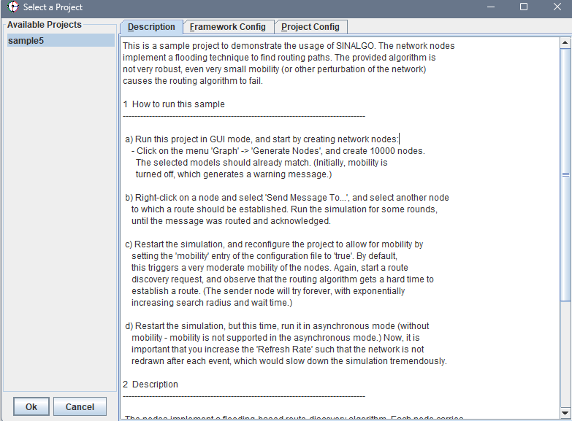

Add node with connectivity UDG:

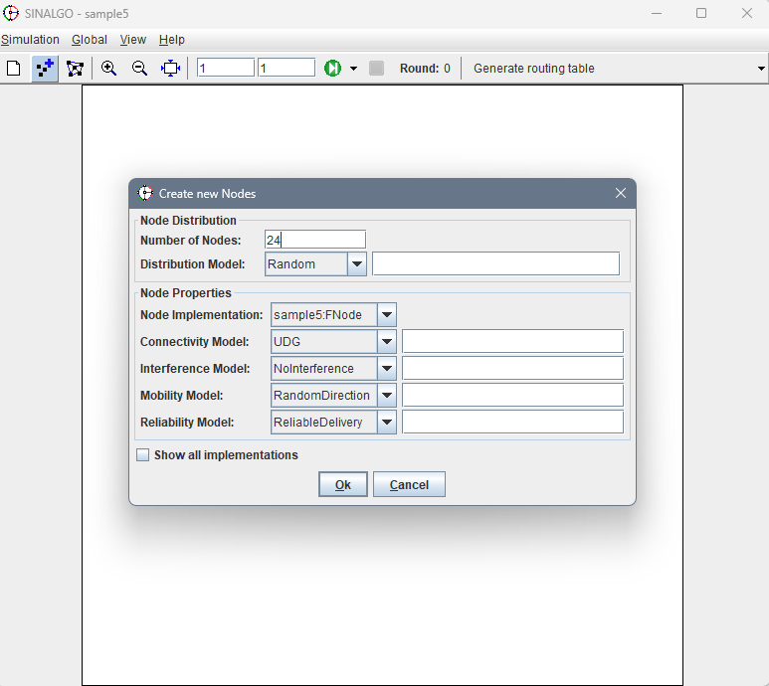

Connect the edges:

Press “Generate routing table” + starting running the simulation up until you get the message that U set is generated and then path will be generated. Run the simulation up until you get the message “path generated”.

From here the routing table is generate and we can send messages between node.

Press right click on node and send messages to

You will see in right

It means you pick the from node correclt now need to press on the node that you want message to

From there run the simulation until you get the message that the message received.

