USB | Universal Serial Bus
UART = serial IO | Universal asynchronous receiver-transmitter
SPI | Serial Peripheral Interface  SPI uses a main–subnode (master/slave) architecture, where one main device orchestrates communication by providing the clock signal and chip select signal(s) which control any number of subservient peripherals.  SCLK : Serial Clock (clock signal from main)  MOSI : Main Out Sub In (data output from main)  MISO : Main In Sub Out (data output from sub)  CS : Chip Select (active low signal from main to address subs and initiate transmission)
EEPROM | Erasable programmable memory (through SPI)
I2C | It is a synchronous, multi-master/multi-slave (controller/target), single-ended, serial communication bus  I2C uses only two bidirectional open-collector or open-drain lines: serial data line (SDA) and serial clock line (SCL), pulled up with resistors
DAC | Digital to analog converter
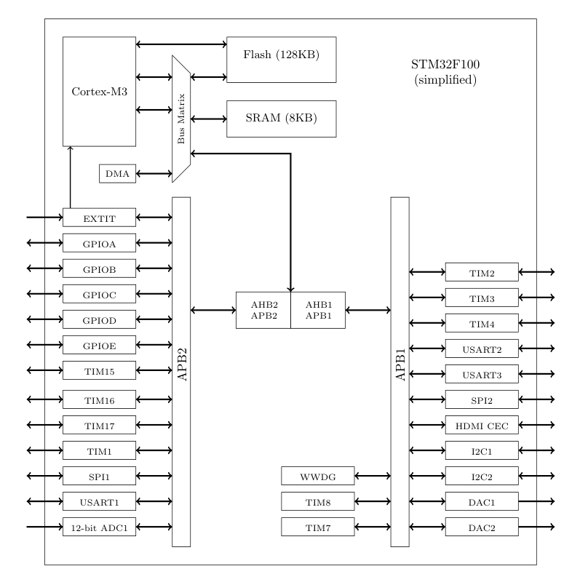  DMA | Direct memory access is a feature of computer systems that allows certain hardware subsystems to access main system memory independently of the central processing unit (CPU).

Cortex-M3  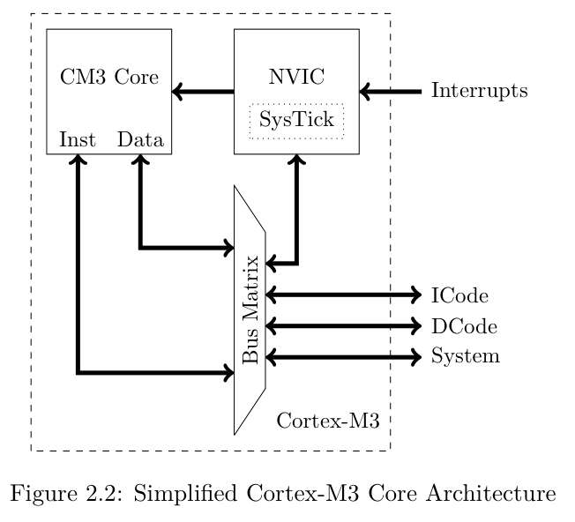 | Core architecture consists of a 32-bit processor (CM3) with a small set of key peripherals – a simplified version of this core is illus-  trated. The CM3 core has a Harvard architecture meaning that it uses separate interfaces to fetch instructions (Inst) and (Data). From the perspective of the CM3, everything looks like memory – it only differentiates between instruction fetches and data accesses. It communicates with hardware is through three memory buses – ICode, DCode, and System  – which are defined to access different regions of memory. In the STM32,  the ICode bus connects the CM3 instruction interface to Flash Memory, the  DCode bus connects to Flash memory for data fetch and the System bus pro-  vides read/write access to SRAM and the STM32 peripherals. The peripheral  sub-system is supported by the AHB bus which is further divided into two sub-bus regions AHB1 and AHB2. The STM32 provides a sophisticated direct memory access (DMA) controller that supports direct transfer of data  between peripherals and memory.
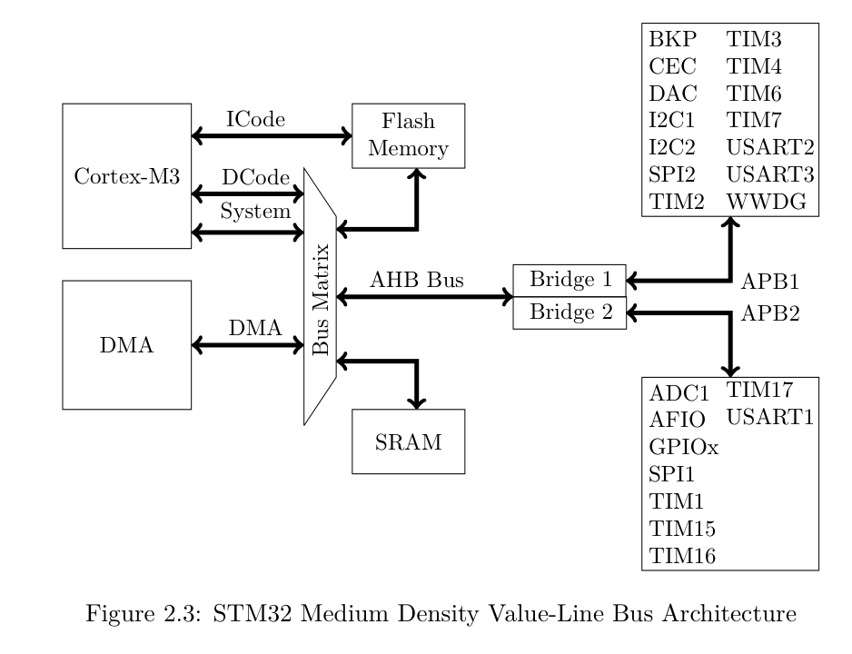 | As with all RISC processors, the Cortex-M3 is a load/store architecture with three basic types of instructions:  - Register-to-register operations for processing data  - Memory operations which move data between memory and registers  - Control flow operations enabling programming language control flow such as if and while statements and procedure calls.
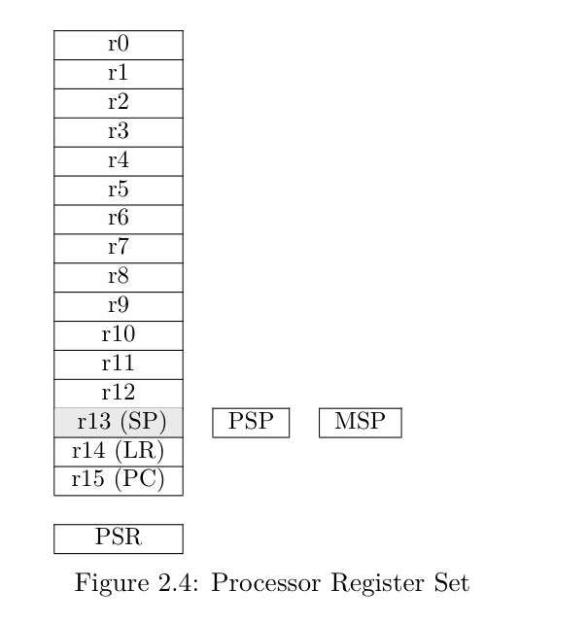  Registers | The Cortex-M3 core has 16 user-visible registers (illustrated in Figure 2.4) – all processing takes place in these registers. Three of these registers  have dedicated functions including the program counter (PC), which holds the address of the next instruction to execute, the link register (LR), which holds the address from which the current procedure was called, and “the” stack  pointer (SP) which holds the address of the current stack top (as we shall discuss in Chapter 11, the CM3 supports multiple execution modes, each with their own private stack pointer). Separately illustrated is a processor status  register (PSR) which is implicitly accessed by many instructions
ABI | Procedure call standard (Application Binary Interface) dictates how registers are used  This model explicitly assumes that the RAM for an executing program is divided into three regions as illustrated in Figure 2.5. The data in RAM are allocated during the link process and initialized by startup code at reset. The (optional) heap is managed at runtime by library code implementing functions such as the malloc and free
ICode | instructions
DCode | constant data
NVIC | Vectored Interrupt Controller is a programmable  device that sits between the CM3 core and the micro-controller. The NVIC also provides key system control registers including the Sys-  tem Timer (SysTick) that provides a regular timer interrupt.
APB1, APB2 | Two peripheral communication buses, supporting a wide variety of peripherals.  Peripherals are controlled by the core with load and store instructions that access memory-  mapped registers. The peripherals can “interrupt” the core to request attention through peripheral specific interrupt requests routed through the NVIC. Finally, data transfers between peripherals and memory can be automated using DMA (without Core)
HSE | The HSE signal is derived from an  8MHz crystal or other resonator. Internally, the HSE is multiplied in frequency through the use of a PLL; the output of this, SYSCLK is used to derive (by division) various on-chip time sources include clocks for the ABP1 and APB2 peripherals as well as  for the various programmable timers
LSE | The LSE signal is derived from a 32.768  kHz crystal. The LSE is used to manage a low-power real-time clock. The STM32F100 micro-controllers can support a maximum  SYSCLK frequency of 24MHz while the other STM32 F1xx micro-controllers  support a SYSCLK frequency of 72MHz. Fortunately, most of the code required to manage these clocks is provided in the standard peripheral library module (system_stm32f10x.[ch]) which provides an initialization function  – SystemInit(void) to be called at startup. This module also exports a variable SystenCoreClock which contains the SYSCLK frequency
GPIOs  {  volatile uint32_t CRL;  volatile uint32_t CRH;  volatile uint32_t IDR;  volatile uint32_t ODR;  volatile uint32_t BSRR;  volatile uint32_t BRR;  volatile uint32_t LCKR;  } GPIO_TypeDef;  [1] | General-Purpose Input/Output. GPIO ports are defined by the following register structure.  typedef struct. Each GPIO port (GPIOA, GPIOB, etc.) has seven registers. Two are used to configure the sixteen port bits individually, two are used to read/write the sixteen port bits in parallel, two are used to set/reset the sixteen port bits individually, and one is used to implement a “locking sequence” that is intended to prevent  rogue code from accidentally modifying the port configuration. This final feature can help minimize the possibility that software bugs lead to hardware failures; e.g, accidentally causing a short circuit.
IRQ | Interrupt request
VDD = VCC | VSS = GND

