# Advanced Word

# Mary Pyett (youn_mrp@access-k12.org)

# Columns [columns]

To quickly place text in a column format, click the **Columns** button on the standard toolbar and select the number of columns by dragging the mouse over the diagram.

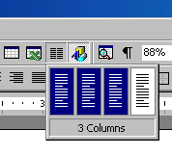

For more column options, select **Format|Columns** from the menu bar. The **Columns** dialog box allows you to choose the properties of the columns. Select the number and width of the columns from the dialog box.

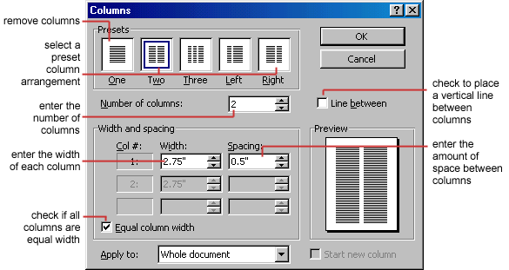

# Drop Caps

A drop cap is a large letter that begins a paragraph and drops through several lines of text as shown below.

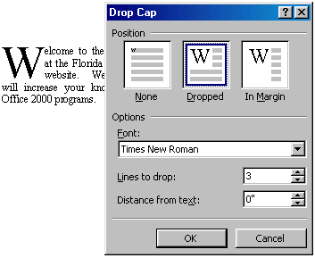

Add a drop cap to a paragraph by following these steps:

1. Place the cursor within the paragraph whose first letter will be dropped.
2. Select **Format|Drop Cap** from the menu bar.
3. The **Drop Cap** dialog box allows you to select the position of the drop cap, the font, the number of lines to drop, and the distance from the body text.
4. Click **OK** when all selections have been made.
5. To modify a drop cap, select **Format|Drop Cap** again to change the attributes, or click on the letter and use the handles to move and resize the letter.

The use of styles in Word will allow you to quickly format a document with a consistent and professional look. Paragraph and character styles can be saved for use in many documents.

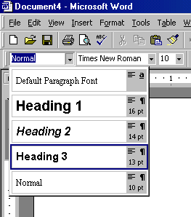

# Applying a Style

1. Place the cursor in the paragraph where the style will be applied.
2. Click the **Style** drop-down menu on the Formatting toolbar and select a style by clicking on it.
3. To apply the same style to multiple paragraphs, double click the **Format Painter** button [format painter]on the standard toolbar and click in all the paragraphs that the style should be applied to. Press the **ESC** key to disable the Format Painter.

# Apply a Style from the Style Dialog Box

Choose from a larger selection of styles from the **Style** dialog box.

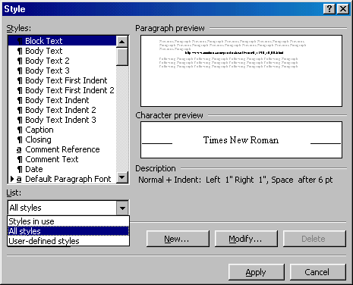

1. Click in the paragraph you want to add a style to.
2. Select **Format|Style...** from the menu bar.
3. From the **List** drop-down menu, choose **All styles** to view all the styles available.
4. The styles are displayed in the **Styles** list. Preview each style by clicking once on the name. Paragraph styles are preceded by the paragraph symbol ([p]) and character styles are preceded by an "a" icon ([a]). A pointer arrow is located next to the current style. Highlight the style you want to apply to the paragraph and click **Apply**.

# Create a New Style from a Model

To create a style from text that is already formatted in a document, follow these steps:

1. Place the cursor in the paragraph you would like to set as a new style.
2. 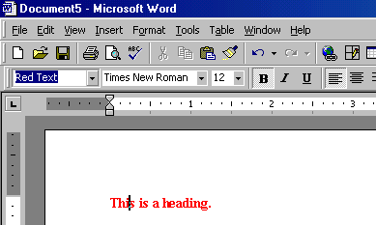Click the **Style** box on the formatting toolbar so the style name is highlighted.
3. Delete the text in the field and type the name of the new style.
4. Press the **ENTER** key to save the new style.

# Create a Simple Style from the Style Dialog Box

1. Select **Format|Style...** from the menu bar and click the **New** button on the **Style** dialog box to access the **New Style** dialog box.   
   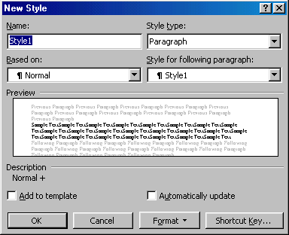
2. Type the name for the new style in the **Name** field.
3. Select "Paragraph" or "Character" from the **Style type** drop-down menu.
4. Click the **Format** button at the bottom of the window and choose the paragraph element that will be formatted for the style. Continue to make changes from the options from the Format button menu, making changes to the dialog boxes for each element you choose.
5. Click **OK** to set the style and close the **New Style** dialog box.
6. Click **Apply** on the **Style** dialog box to apply the new style to the current paragraph.

# Modify or Rename a Style

An existing style can be changed from the Style dialog box.

1. Select **Format|Style...** from the menu bar.
2. 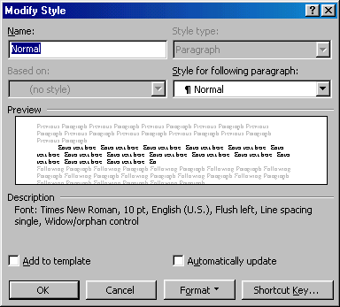Highlight the style from the **Styles** list that you want to modify and click the **Modify** button.
3. Use the same methods to modify the style from the **Modify Style** dialog box that were used for the New Style box.
4. To only rename the style, type a new name in the **Name** field.
5. Click **OK** when you are finished making modifications.
6. Click **Apply** to update the style in the document.

# Delete a Style

Preset styles created by Word cannot be deleted, but to delete a style you have made, follow these steps:

1. Select **Format|Style...** from the menu bar
2. Highlight the style from the **Styles** list that you want to delete.
3. Click the **Delete** button.
4. You will be asked if you really want to delete the style. Click **Yes**.
5. Click **Close** on the dialog box.

To create a bulleted or numbered list, use the list features provided by Word.

# Bulleted and Numbered Lists

1. Click the **Bulleted List** button [bulleted list]or **Numbered List** button [numbered list]on the formatting toolbar.
2. Type the first entry and press **ENTER**.  This will create a new bullet or number on the next line. If you want to start a new line without adding another bullet or number, hold down the **SHIFT** key while pressing **ENTER**.
3. Continue to typing entries and press **ENTER** twice when you are finished typing to end the list.

Use the **Increase Indent** [Increase Indent]and **Decrease Indent** [Decrease Indent]buttons on the formatting toolbar to create lists of multiple levels.

***NOTE:*** You can also type the text first, highlight the section, and press the **Bulleted List** or **Numbered List** buttons to add the bullets or numbers.

# Nested Lists

To create a nested list, such as a numbered list inside of a bulleted list, follow these steps:

1. Type the list and increase the indentation of the items that will make up the nested list by clicking the **Increase Indent** button for each item.  
   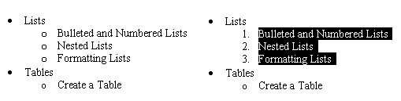
2. Highlight the items and click the **Numbered List** button on the formatting toolbar.

# Formatting Lists

The bullet image and numbering format can be changed by using the **Bullets and Numbering** dialog box.

1. Highlight the entire list to change all the bullets or numbers, or  
   Place the cursor on one line within the list to change a single bullet.
2. 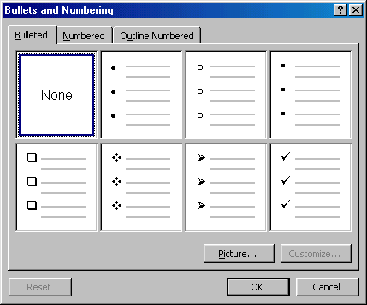Access the dialog box by selecting **Format|Bullets and Numbering** from the menu bar or by right-clicking within the list and selecting **Bullets and Numbering** from the shortcut menu.
3. Select the list style from one of the seven choices given, or click the **Picture...** button to choose a different icon. Click the **Numbered** tab to choose a numbered list style.
4. Click **OK** when finished.

Tables are used to display data and there are several ways to build them in Word. Begin by placing the cursor where you want the table to appear in the document and choose one of the following methods.

# Insert a Table

There are two ways to add a table to the document using the Insert feature:

1. Click the **Insert Table** button on the standard toolbar. Drag the mouse along the grid, highlighting the number of rows and columns for the table.  
   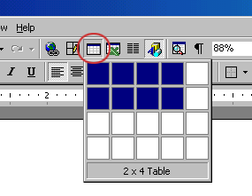
2. Or, select **Table|Insert|Table** from the menu bar. Select the number of rows and columns for the table and click **OK**.  
   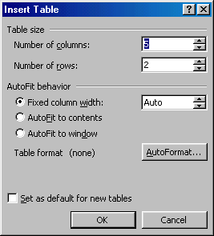

# Draw the Table

A table can also be drawn onto the document:

1. Draw the table by selecting **Table|Draw Table** from the menu bar. The cursor is now the image of a pencil and the **Tables and Borders** toolbar has appeared.  
   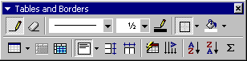
2. Draw the cells of the table with the mouse. If you make a mistake, click the **Eraser** button [eraser]and drag the mouse over the area to be deleted.
3. To draw more cells, click on the **Draw Table** button [draw table].

# Inserting Rows and Columns

Once the table is drawn, insert additional rows by placing the cursor in the row you want to be adjacent to. Select **Table|Insert|Rows Above** or **Rows Below**. Or, select an entire row and right-click with the mouse. Choose **Insert Rows** from the shortcut menu.  
  
Much like inserting a row, add a new column by placing the cursor in a cell adjacent to where the new column will be added. Select **Table|Insert|Columns to the Left** or **Columns to the Right**. Or, select the column, right-click with the mouse, and select **Insert Columns**.

# Moving and Resizing a Table

A four-sided moving arrow and open box resizing handle will appear on the corners of the table if the mouse is placed over the table. Click and drag the four-ended arrow to move the table and release the mouse button when the table is positioned where you want it. Click and drag the open box handle to resize the table. Change the column widths and row heights by clicking the cell dividers and dragging them with the mouse.

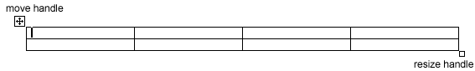

# Tables and Borders Toolbar

The Tables and Borders toolbar allows you to add border styles, shading, text effects, alignment, and more options to your table. Access the toolbar by clicking **Table|Draw Table** or **View|Toolbars|Tables and Borders**.



You will need to highlight the cells of the table you want to format. Click and drag the mouse over the cells, or use the following shortcuts:

|  |  |  |
| --- | --- | --- |
| **Selection** | **Menu Method** | **Mouse Method** |
| One cell | **Table|Select|Cell** | Click the bottom, left corner of the cell when a black arrow appears |
| One row | **Table|Select|Row** | Click outside the table to the left of the row |
| One column | **Table|Select|Column** | Click outside the table above the column when a black arrow appears |
| Several rows | **(none)** | Click outside the table to the left of the row and drag the mouse down |
| Several columns | **(none)** | Click outside the table above the column |
| Entire table | **Table|Select|Table** | Triple-click to the left of the table |

# Table Properties

Use the **Table Properties** dialog box to modify the alignment of the table with the body text and the text within the table. Access the box by selecting **Tables|Table Properties**.

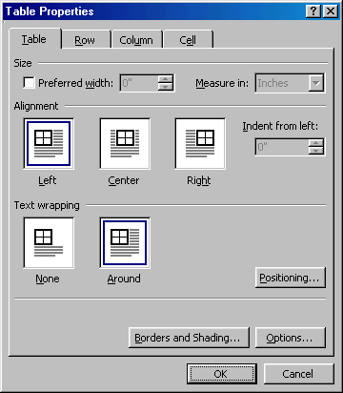

* **Size** - Check the **Preferred width** box and enter a value if the table should be an exact width.
* **Alignment** - Highlight the illustration that represents the alignment of the table in relation to the text of the document.
* **Text wrapping** - Highlight "None" if the table should appear on a separate line from the text or choose "Around" if the text should wrap around the table.

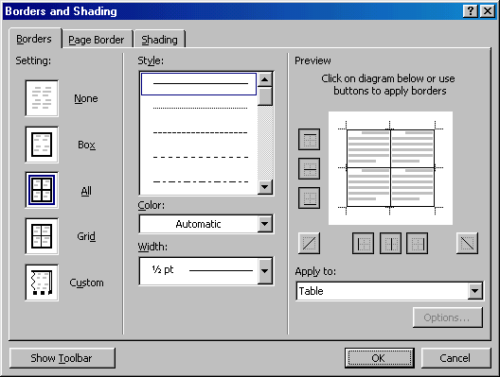**Borders and Shading** - Select from a number of border styles, colors, and widths. Click the **Shading** tab to change the background color and pattern.

**Options** - Click the **Options** button on the **Table Properties** window. To change the spacing between the document text and the table borders under **Default cell margins**. Check the **Allow spacing between cells** box and enter a value to add space between the table cells.  
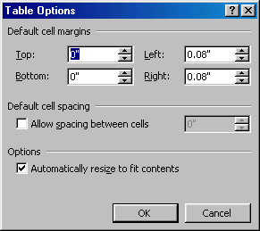

# [AutoCorrect dialog box]AutoCorrect

Word automatically corrects many commonly misspelled words and punctuation marks with the AutoCorrect feature. To view the list of words that are automatically corrected, select **Tools|AutoCorrect**. This may be a hidden feature so click the double arrows at the bottom of the **Tools** menu listing if the AutoCorrect choice is not listed.

Many options including the accidental capitalization of the first two letters of a word and capitalization of the first word of the sentence can be automatically corrected from this page. If there are words you often misspell, enter the wrong and correct spellings in the **Replace** and **With** fields.

# Print Preview and Printing

Preview your document by clicking the Print Preview button on the standard toolbar or by selecting **File|Print Preview**. When the document is ready to print, click the Print button from the Print Preview screen or select **File|Print**.

Macros are advanced features that can speed up editing or formatting you may perform often in a Word document. They record sequences of menu selections that you choose so that a series of actions can be completed in one step.

# Recording A Macro

To record a macro, follow these steps:

1. Click **Tools|Macro|Record New Macro** on the menu bar.  
   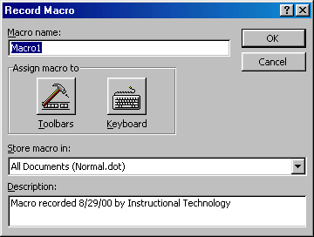
2. Name the macro in the **Macro name** field. This name cannot contain spaces and or begin with a number.
3. From the **Store macro in** drop-down box, select the document you would like the macro to be associated with or choose "All Documents" be able to use the macro in any document.
4. Enter a description of the macro in the **Description** field. This is for your reference only so you remember what the macro does.
5. Click **OK** to begin recording.
6. Select options from the drop-down menus and Word will record the options you choose from the dialog boxes, such as changing the margins on the Page Setup window. Select only options that modify the document. Word will not record toggle actions such as **View|Toolbars** that have no effect on the document itself.
7. The recording toolbar will allow you to stop, pause, and resume recording.  
   [Macro toolbar]
8. Click the **Stop** button the recording toolbar. The macro is now saved.

# Running A Macro

To run an existing macro, follow these steps.

1. Select **Tools|Macro|Macros** from the menu bar.
2. From the **Macros** window, highlight the **Macro name** in the list and click **Run**.  
   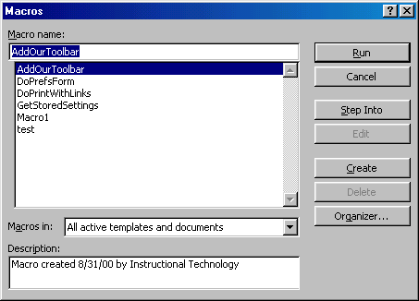
3. If the macro is long and you want to stop it while it is running, press **BREAK** (hold **CTRL** and press **PAUSE**).

Word will automatically create a Table of Contents page if a document is designed using Heading and Paragraph styles (see the [Styles](http://www.fgcu.edu/support/office2000/word/styles.html) section). Follow the steps on this page to create a Table of Contents.

# Mark Table of Contents Entries

1. Highlight a heading that you would like to appear in the Table of Contents (TOC).
2. Press **ALT+SHIFT+O** and the **Mark Table of Contents Entry** box will appear.  
   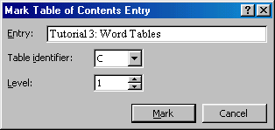
3. **Entry** - Rename the entry if you would like a different heading to appear in the TOC.
4. **Table identifier** - Select "C".
5. **Level** - Choose "1" for first-level heading, "2" for second-level heading, etc.
6. Click the **Mark** button.
7. The document will be toggled to "reveal codes" view and notice the TOC field code. To hide all codes click the **Show/Hide codes button** [Show/Hide codes button]on the standard toolbar.
8. Select another heading to add to the TOC, or click the **Close** button on the **Mark Table of Contents Entry** dialog box.

# Generate a Table of Contents

After you have marked all the headings for your TOC, follow these steps to generate the Table of Contents.

1. Place the cursor where you would like the TOC to appear in the document.
2. Select **Insert|Index and Tables** from the menu bar.  
   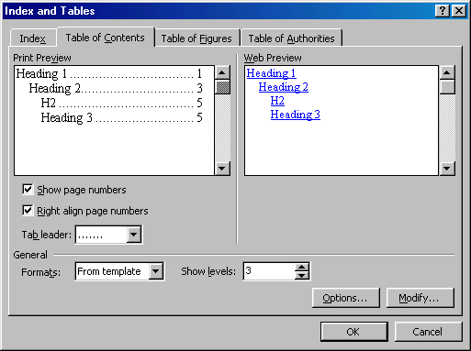
3. Customize the appearance of the TOC from the **Table of Contents** tab. You may choose a preset design from the **Formats** drop-down menu. A preview of each design will be shown in the **Print Preview** window.
4. Check the **Show page numbers** box if you would like page numbers to show on the TOC. Check the **Right align page numbers** box if the page numbers should appear on the right side, then select the **Tab leader** between the heading and the page number. Uncheck the box if the page numbers should appear right next to the heading.
5. Click **OK**.

Word's Web Page Wizard will help you quickly create web pages for the Internet with preset layouts and graphics. Follow these steps to create a web page using the wizard.

1. Select **File|New...** from the menu bar.
2. Click the **Web Pages** tab on the **New** dialog box.  
   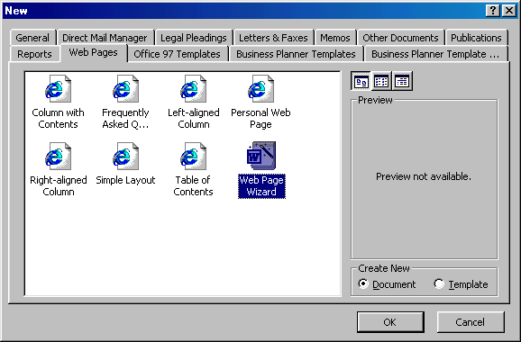
3. Highlight the **Web Page Wizard** icon and click **OK**.
4. Click the **Next** button on the first Web Page Wizard box.
5. **Title and Location** - Enter a title for your web site and select the location on your computer where the files will be saved. Click **Next** when finished.  
   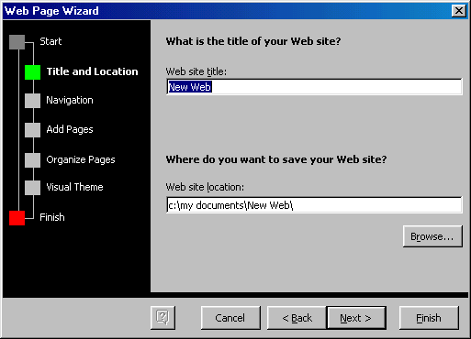
6. **Navigation** - Select a navigation type for the web page. **Separate page** is usually the best choice as it is the easiest to use.  
   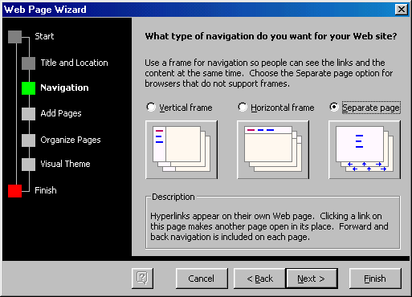
7. **Add Pages** - The next screen will list the pages currently in the web site. Click the **Add New Blank Page** button to add a new page, and highlight a page in the list and click **Remove Page** to delete pages from the web site. To add a page that you have already created to the site, click the **Add Existing File...** button and select the page you want to add.  
   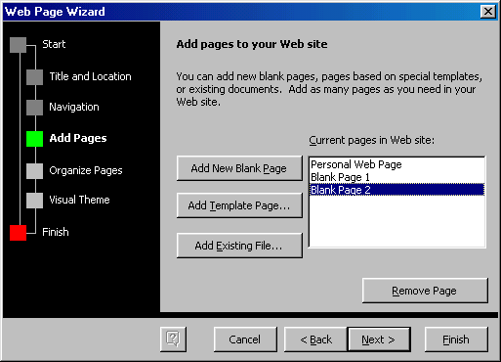  
   Click the **Add Template Page...** to insert a page with a layout. Highlight the choices in the **Web Page Templates** window to preview the template in the main window. Click **OK** to select a template.  
   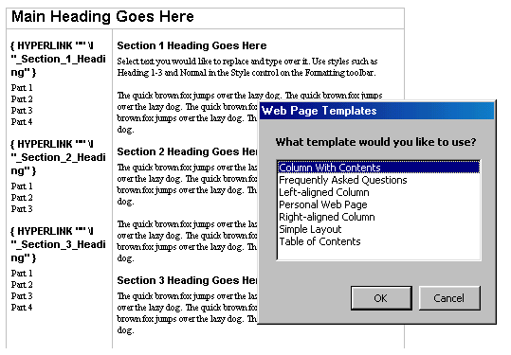
8. **Organize Pages** - Reorder the pages of the web site. Highlight the name of the page that will be moved and click the **Move Up** and **Move Down** buttons. Click **Rename** to rename a page.  
   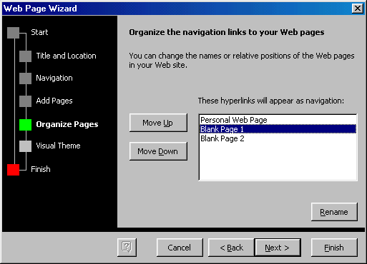
9. **Visual Theme** - Select **No visual theme** for a blank page or select check **Add a visual theme** and click **Browse Themes...** to select a graphical theme.  
   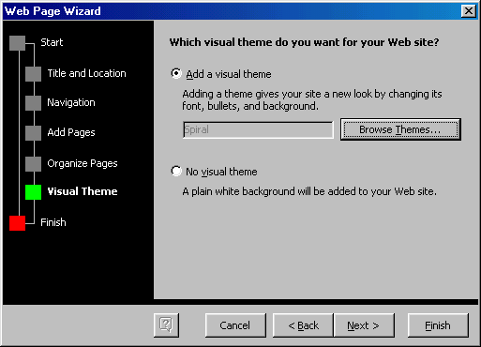  
   From the **Themes** window, highlight the themes in the list to preview them. Check the **Vivid Colors** and **Active Graphics** boxes to apply those options. Uncheck the Background Image box to remove the graphic from the background of the page. Click **OK** when finished.  
   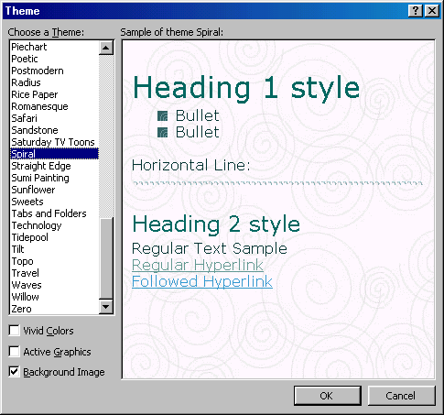
10. Click **Finish** to create the web site.

The previous page explained how to create a web page using the Web Page Wizard. This page describes creating a web page from scratch and adding elements to a page from the wizard. When working on a web format document, view the page in web layout by selecting **View|Web Layout** from the menu bar. Enter text and insert graphics just as you would in a normal Word document.

# Hyperlinks hyperlink button

A hyperlink is a connection between two web pages on the Internet. Hyperlinks can be produced from text or graphics and both methods will be discussed here. Follow these steps to create links to other web sites and pages within your site:

1. Type the text you want to appear on the page as a link or add the graphic that will be a link.
2. Highlight the text or graphic and click the **Insert Hyperlink** button on the standard toolbar or press **CTRL+K**.
3. From the **Insert Hyperlink** dialog box, change the **Text to display** if necessary.  
   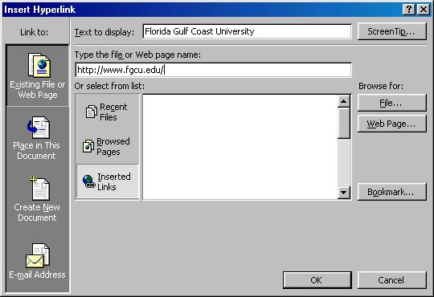
4. **Type the file or Web page name** in the appropriate box or **select from list**.
5. Click **OK** to create the link.

# Saving Web Pages

Pages on the web must be saved in a format called HTML (Hypertext Markup Language) that is readable by web browsers. Word will convert your document to HTML using the **Save as Web Page** feature.

1. Select **File|Save as Web Page** from the menu bar.
2. Click the **Change Title** button to add a title to the web page.  
   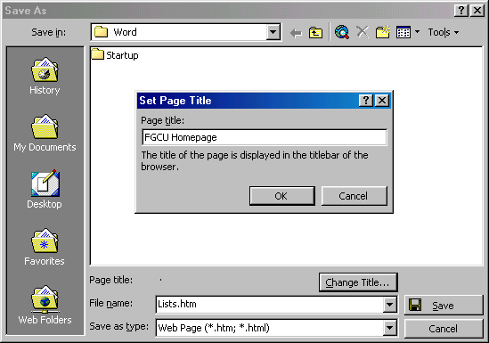
3. Type the **File name** in the box provided.
4. Be sure the **Save as type** is set to **Web Page**.
5. Click **Save**.

# Creating a Web Page from a Template

Word features several layout templates that you can add your own content to. Create a web page from a template by following these steps:

1. Select **File|New...** from the menu bar.
2. Click the **Web Pages** tab on the **New** dialog box.
3. Highlight one of the templates listed and click **OK**.  
   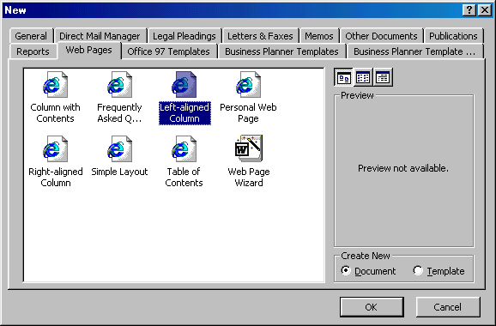
4. The template will now appear in the main window. Replace the placeholding text with your own text by highlighting it and typing. Replace photos and images by deleting them and adding new images.  
   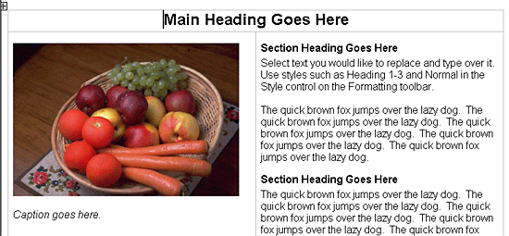
5. Save the page by selecting **File|Save as Web Page** from the menu bar.

# Web Page Themes

The Visual Theme feature from the Web Page Wizard can be accessed for any web page. To add a theme to a blank page or existing page, select **Format|Theme...** from the menu bar. Choose a theme from the list and click **OK**. The page content will remain blank unless a background image is part of the theme that was selected. The style listings, default font, and bullet images have been changed to reflect the new theme. To change the theme of the page, simply select **Format|Theme...** from the menu bar again and choose a different theme.

# Preview the Web Page

The page may look slightly different when converted to HTML and viewed on the web. Before publishing your web page, be sure to use Word's web preview feature. Select **File|Web Page Preview** to open the page in a web browser.

Keyboard shortcuts can save time and the effort of switching from the keyboard to the mouse to execute simple commands. Print this list of Word keyboard shortcuts and keep it by your computer for a quick reference.

**Note:** A plus sign indicates that the keys need to be pressed at the same time.

|  |  |  |  |  |  |  |  |  |  |  |  |  |  |  |  |  |  |  |  |  |  |  |  |  |  |  |  |  |  |  |  |  |  |  |  |  |  |  |  |  |  |  |  |  |  |  |  |  |  |  |  |  |  |  |  |  |  |  |  |  |  |  |  |  |  |  |  |  |  |  |  |  |  |  |  |  |  |  |  |  |  |  |  |  |  |  |  |  |  |  |  |  |  |  |  |  |  |  |  |  |  |  |  |  |  |  |  |  |  |  |  |  |  |  |  |  |  |  |  |  |  |  |  |  |  |  |  |  |  |  |  |  |  |  |  |  |  |  |  |  |  |  |
| --- | --- | --- | --- | --- | --- | --- | --- | --- | --- | --- | --- | --- | --- | --- | --- | --- | --- | --- | --- | --- | --- | --- | --- | --- | --- | --- | --- | --- | --- | --- | --- | --- | --- | --- | --- | --- | --- | --- | --- | --- | --- | --- | --- | --- | --- | --- | --- | --- | --- | --- | --- | --- | --- | --- | --- | --- | --- | --- | --- | --- | --- | --- | --- | --- | --- | --- | --- | --- | --- | --- | --- | --- | --- | --- | --- | --- | --- | --- | --- | --- | --- | --- | --- | --- | --- | --- | --- | --- | --- | --- | --- | --- | --- | --- | --- | --- | --- | --- | --- | --- | --- | --- | --- | --- | --- | --- | --- | --- | --- | --- | --- | --- | --- | --- | --- | --- | --- | --- | --- | --- | --- | --- | --- | --- | --- | --- | --- | --- | --- | --- | --- | --- | --- | --- | --- | --- | --- | --- | --- | --- | --- | --- |
| |  |  | | --- | --- | | **Action** | **Keystroke** |  |  |  | | --- | --- | | **Document actions** | | | Open a file | CTRL+O | | New file | CTRL+N | | Close a file | CTRL+W | | Save As | F12 | | Save | CTRL+S or SHIFT+F12 | | Print Preview | CTRL+F2 | | Print | CTRL+P | | Show/Hide paragraph symbols | CTRL+* | | Spelling and grammar | F7 | | Help | F1 | | Find | CTRL+F | | Replace | CTRL+H | | Go To | CTRL+G |  |  |  | | --- | --- | | **Cursor movement** | | | Select all - entire document | CTRL+A | | Select from cursor to beginning of line | SHIFT+Home | | Select from cursor to end of line | SHIFT+END | | Go to beginning of line | HOME | | Go to end of line | END | | Go to beginning of document | CTRL+Home | | Go to end of document | CTRL+End |  |  |  | | --- | --- | | **Formatting** | | | Cut | CTRL+X | | Copy | CTRL+C | | Paste | CTRL+V | | Undo | CTRL+Z | | Redo | CTRL+Y | | Format painter | CTRL+SHIFT+C | | Left alignment | CTRL+L | | Center alignment | CTRL+E | | Right alignment | CTRL+R | | Justified | CTRL+J | | Delete previous word | CTRL+Backspace | | Apply bulleted list | CTRL+SHIFT+L | | Indent | CTRL+M | | Page break | CTRL+Enter | |  | |  |  | | --- | --- | | **Action** | **Keystroke** |  |  |  | | --- | --- | | **Text Style** | | | Font face | CTRL+SHIFT+F | | Font size | CTRL+SHIFT+P | | Bold | CTRL+B | | Italics | CTRL+I | | Underline | CTRL+U | | Double underline | CTRL+SHIFT+D | | Word underline | CTRL+SHIFT+W | | All caps | CTRL+SHIFT+A | | Change case | SHIFT+F3 | | Subscript | CTRL+= | | Superscript | CTRL+SHIFT+= | | Make web hyperlink | CTRL+K |  |  |  | | --- | --- | | **Tables** | | | Go to next cell | Tab | | Go to previous cell | SHIFT+Tab | | Go to beginning of column | ALT+PageUp | | Highlight to beginning of column | ALT+SHIFT+PageUp | | Go to end of column | ALT+PageDown | | Highlight to end of column | ALT+SHIFT+PageDown | | Go to beginning of row | ALT+Home | | Highlight to beginning of row | ALT+SHIFT+Home | | Go to end of row | ALT+End | | Highlight to end of row | ALT+SHIFT+End | | Column break | CTRL+SHIFT+Enter |  |  |  | | --- | --- | | **Miscellaneous** | | | Copyright symbol - © | ALT+CTRL+C | | Date field | ALT+SHIFT+D | | Go to footnotes | ALT+CTRL+F | | Show/Hide ¶ | CTRL+SHIFT+8 | | Thesaurus | SHIFT+F7 | |

# All Shortcuts

This list shows only the most common keyboard shortcuts. To print a list of all the shortcuts in Word, follow these steps:

1. Select **Tools|Macro|Macros** from the menu bar.
2. From the **Macros In** drop-down menu, select **Word Commands**.
3. Select **ListCommands** from the macro listing.
4. Click the **Run** button.
5. Choose **Current Menu and Keyboard Settings** from the popup window and click **OK**.
6. Word will automatically open a new document containing a table of keystrokes. **Print** the document.

# Advanced Word

# Mary Pyett (youn_mrp@access-k12.org)

# Columns [columns]

To quickly place text in a column format, click the **Columns** button on the standard toolbar and select the number of columns by dragging the mouse over the diagram.



For more column options, select **Format|Columns** from the menu bar. The **Columns** dialog box allows you to choose the properties of the columns. Select the number and width of the columns from the dialog box.



# Drop Caps

A drop cap is a large letter that begins a paragraph and drops through several lines of text as shown below.



Add a drop cap to a paragraph by following these steps:

1. Place the cursor within the paragraph whose first letter will be dropped.
2. Select **Format|Drop Cap** from the menu bar.
3. The **Drop Cap** dialog box allows you to select the position of the drop cap, the font, the number of lines to drop, and the distance from the body text.
4. Click **OK** when all selections have been made.
5. To modify a drop cap, select **Format|Drop Cap** again to change the attributes, or click on the letter and use the handles to move and resize the letter.

The use of styles in Word will allow you to quickly format a document with a consistent and professional look. Paragraph and character styles can be saved for use in many documents.



# Applying a Style

1. Place the cursor in the paragraph where the style will be applied.
2. Click the **Style** drop-down menu on the Formatting toolbar and select a style by clicking on it.
3. To apply the same style to multiple paragraphs, double click the **Format Painter** button [format painter]on the standard toolbar and click in all the paragraphs that the style should be applied to. Press the **ESC** key to disable the Format Painter.

# Apply a Style from the Style Dialog Box

Choose from a larger selection of styles from the **Style** dialog box.



1. Click in the paragraph you want to add a style to.
2. Select **Format|Style...** from the menu bar.
3. From the **List** drop-down menu, choose **All styles** to view all the styles available.
4. The styles are displayed in the **Styles** list. Preview each style by clicking once on the name. Paragraph styles are preceded by the paragraph symbol ([p]) and character styles are preceded by an "a" icon ([a]). A pointer arrow is located next to the current style. Highlight the style you want to apply to the paragraph and click **Apply**.

# Create a New Style from a Model

To create a style from text that is already formatted in a document, follow these steps:

1. Place the cursor in the paragraph you would like to set as a new style.
2. Click the **Style** box on the formatting toolbar so the style name is highlighted.
3. Delete the text in the field and type the name of the new style.
4. Press the **ENTER** key to save the new style.

# Create a Simple Style from the Style Dialog Box

1. Select **Format|Style...** from the menu bar and click the **New** button on the **Style** dialog box to access the **New Style** dialog box.   
   
2. Type the name for the new style in the **Name** field.
3. Select "Paragraph" or "Character" from the **Style type** drop-down menu.
4. Click the **Format** button at the bottom of the window and choose the paragraph element that will be formatted for the style. Continue to make changes from the options from the Format button menu, making changes to the dialog boxes for each element you choose.
5. Click **OK** to set the style and close the **New Style** dialog box.
6. Click **Apply** on the **Style** dialog box to apply the new style to the current paragraph.

# Modify or Rename a Style

An existing style can be changed from the Style dialog box.

1. Select **Format|Style...** from the menu bar.
2. Highlight the style from the **Styles** list that you want to modify and click the **Modify** button.
3. Use the same methods to modify the style from the **Modify Style** dialog box that were used for the New Style box.
4. To only rename the style, type a new name in the **Name** field.
5. Click **OK** when you are finished making modifications.
6. Click **Apply** to update the style in the document.

# Delete a Style

Preset styles created by Word cannot be deleted, but to delete a style you have made, follow these steps:

1. Select **Format|Style...** from the menu bar
2. Highlight the style from the **Styles** list that you want to delete.
3. Click the **Delete** button.
4. You will be asked if you really want to delete the style. Click **Yes**.
5. Click **Close** on the dialog box.

To create a bulleted or numbered list, use the list features provided by Word.

# Bulleted and Numbered Lists

1. Click the **Bulleted List** button [bulleted list]or **Numbered List** button [numbered list]on the formatting toolbar.
2. Type the first entry and press **ENTER**.  This will create a new bullet or number on the next line. If you want to start a new line without adding another bullet or number, hold down the **SHIFT** key while pressing **ENTER**.
3. Continue to typing entries and press **ENTER** twice when you are finished typing to end the list.

Use the **Increase Indent** [Increase Indent]and **Decrease Indent** [Decrease Indent]buttons on the formatting toolbar to create lists of multiple levels.

***NOTE:*** You can also type the text first, highlight the section, and press the **Bulleted List** or **Numbered List** buttons to add the bullets or numbers.

# Nested Lists

To create a nested list, such as a numbered list inside of a bulleted list, follow these steps:

1. Type the list and increase the indentation of the items that will make up the nested list by clicking the **Increase Indent** button for each item.  
   
2. Highlight the items and click the **Numbered List** button on the formatting toolbar.

# Formatting Lists

The bullet image and numbering format can be changed by using the **Bullets and Numbering** dialog box.

1. Highlight the entire list to change all the bullets or numbers, or  
   Place the cursor on one line within the list to change a single bullet.
2. Access the dialog box by selecting **Format|Bullets and Numbering** from the menu bar or by right-clicking within the list and selecting **Bullets and Numbering** from the shortcut menu.
3. Select the list style from one of the seven choices given, or click the **Picture...** button to choose a different icon. Click the **Numbered** tab to choose a numbered list style.
4. Click **OK** when finished.

Tables are used to display data and there are several ways to build them in Word. Begin by placing the cursor where you want the table to appear in the document and choose one of the following methods.

# Insert a Table

There are two ways to add a table to the document using the Insert feature:

1. Click the **Insert Table** button on the standard toolbar. Drag the mouse along the grid, highlighting the number of rows and columns for the table.  
   
2. Or, select **Table|Insert|Table** from the menu bar. Select the number of rows and columns for the table and click **OK**.  
   

# Draw the Table

A table can also be drawn onto the document:

1. Draw the table by selecting **Table|Draw Table** from the menu bar. The cursor is now the image of a pencil and the **Tables and Borders** toolbar has appeared.  
   
2. Draw the cells of the table with the mouse. If you make a mistake, click the **Eraser** button [eraser]and drag the mouse over the area to be deleted.
3. To draw more cells, click on the **Draw Table** button [draw table].

# Inserting Rows and Columns

Once the table is drawn, insert additional rows by placing the cursor in the row you want to be adjacent to. Select **Table|Insert|Rows Above** or **Rows Below**. Or, select an entire row and right-click with the mouse. Choose **Insert Rows** from the shortcut menu.  
  
Much like inserting a row, add a new column by placing the cursor in a cell adjacent to where the new column will be added. Select **Table|Insert|Columns to the Left** or **Columns to the Right**. Or, select the column, right-click with the mouse, and select **Insert Columns**.

# Moving and Resizing a Table

A four-sided moving arrow and open box resizing handle will appear on the corners of the table if the mouse is placed over the table. Click and drag the four-ended arrow to move the table and release the mouse button when the table is positioned where you want it. Click and drag the open box handle to resize the table. Change the column widths and row heights by clicking the cell dividers and dragging them with the mouse.



# Tables and Borders Toolbar

The Tables and Borders toolbar allows you to add border styles, shading, text effects, alignment, and more options to your table. Access the toolbar by clicking **Table|Draw Table** or **View|Toolbars|Tables and Borders**.



You will need to highlight the cells of the table you want to format. Click and drag the mouse over the cells, or use the following shortcuts:

|  |  |  |
| --- | --- | --- |
| **Selection** | **Menu Method** | **Mouse Method** |
| One cell | **Table|Select|Cell** | Click the bottom, left corner of the cell when a black arrow appears |
| One row | **Table|Select|Row** | Click outside the table to the left of the row |
| One column | **Table|Select|Column** | Click outside the table above the column when a black arrow appears |
| Several rows | **(none)** | Click outside the table to the left of the row and drag the mouse down |
| Several columns | **(none)** | Click outside the table above the column |
| Entire table | **Table|Select|Table** | Triple-click to the left of the table |

# Table Properties

Use the **Table Properties** dialog box to modify the alignment of the table with the body text and the text within the table. Access the box by selecting **Tables|Table Properties**.



* **Size** - Check the **Preferred width** box and enter a value if the table should be an exact width.
* **Alignment** - Highlight the illustration that represents the alignment of the table in relation to the text of the document.
* **Text wrapping** - Highlight "None" if the table should appear on a separate line from the text or choose "Around" if the text should wrap around the table.

**Borders and Shading** - Select from a number of border styles, colors, and widths. Click the **Shading** tab to change the background color and pattern.

**Options** - Click the **Options** button on the **Table Properties** window. To change the spacing between the document text and the table borders under **Default cell margins**. Check the **Allow spacing between cells** box and enter a value to add space between the table cells.  


# [AutoCorrect dialog box]AutoCorrect

Word automatically corrects many commonly misspelled words and punctuation marks with the AutoCorrect feature. To view the list of words that are automatically corrected, select **Tools|AutoCorrect**. This may be a hidden feature so click the double arrows at the bottom of the **Tools** menu listing if the AutoCorrect choice is not listed.

Many options including the accidental capitalization of the first two letters of a word and capitalization of the first word of the sentence can be automatically corrected from this page. If there are words you often misspell, enter the wrong and correct spellings in the **Replace** and **With** fields.

# Print Preview and Printing

Preview your document by clicking the Print Preview button on the standard toolbar or by selecting **File|Print Preview**. When the document is ready to print, click the Print button from the Print Preview screen or select **File|Print**.

Macros are advanced features that can speed up editing or formatting you may perform often in a Word document. They record sequences of menu selections that you choose so that a series of actions can be completed in one step.

# Recording A Macro

To record a macro, follow these steps:

1. Click **Tools|Macro|Record New Macro** on the menu bar.  
   
2. Name the macro in the **Macro name** field. This name cannot contain spaces and or begin with a number.
3. From the **Store macro in** drop-down box, select the document you would like the macro to be associated with or choose "All Documents" be able to use the macro in any document.
4. Enter a description of the macro in the **Description** field. This is for your reference only so you remember what the macro does.
5. Click **OK** to begin recording.
6. Select options from the drop-down menus and Word will record the options you choose from the dialog boxes, such as changing the margins on the Page Setup window. Select only options that modify the document. Word will not record toggle actions such as **View|Toolbars** that have no effect on the document itself.
7. The recording toolbar will allow you to stop, pause, and resume recording.  
   [Macro toolbar]
8. Click the **Stop** button the recording toolbar. The macro is now saved.

# Running A Macro

To run an existing macro, follow these steps.

1. Select **Tools|Macro|Macros** from the menu bar.
2. From the **Macros** window, highlight the **Macro name** in the list and click **Run**.  
   
3. If the macro is long and you want to stop it while it is running, press **BREAK** (hold **CTRL** and press **PAUSE**).

Word will automatically create a Table of Contents page if a document is designed using Heading and Paragraph styles (see the [Styles](http://www.fgcu.edu/support/office2000/word/styles.html) section). Follow the steps on this page to create a Table of Contents.

# Mark Table of Contents Entries

1. Highlight a heading that you would like to appear in the Table of Contents (TOC).
2. Press **ALT+SHIFT+O** and the **Mark Table of Contents Entry** box will appear.  
   
3. **Entry** - Rename the entry if you would like a different heading to appear in the TOC.
4. **Table identifier** - Select "C".
5. **Level** - Choose "1" for first-level heading, "2" for second-level heading, etc.
6. Click the **Mark** button.
7. The document will be toggled to "reveal codes" view and notice the TOC field code. To hide all codes click the **Show/Hide codes button** [Show/Hide codes button]on the standard toolbar.
8. Select another heading to add to the TOC, or click the **Close** button on the **Mark Table of Contents Entry** dialog box.

# Generate a Table of Contents

After you have marked all the headings for your TOC, follow these steps to generate the Table of Contents.

1. Place the cursor where you would like the TOC to appear in the document.
2. Select **Insert|Index and Tables** from the menu bar.  
   
3. Customize the appearance of the TOC from the **Table of Contents** tab. You may choose a preset design from the **Formats** drop-down menu. A preview of each design will be shown in the **Print Preview** window.
4. Check the **Show page numbers** box if you would like page numbers to show on the TOC. Check the **Right align page numbers** box if the page numbers should appear on the right side, then select the **Tab leader** between the heading and the page number. Uncheck the box if the page numbers should appear right next to the heading.
5. Click **OK**.

Word's Web Page Wizard will help you quickly create web pages for the Internet with preset layouts and graphics. Follow these steps to create a web page using the wizard.

1. Select **File|New...** from the menu bar.
2. Click the **Web Pages** tab on the **New** dialog box.  
   
3. Highlight the **Web Page Wizard** icon and click **OK**.
4. Click the **Next** button on the first Web Page Wizard box.
5. **Title and Location** - Enter a title for your web site and select the location on your computer where the files will be saved. Click **Next** when finished.  
   
6. **Navigation** - Select a navigation type for the web page. **Separate page** is usually the best choice as it is the easiest to use.  
   
7. **Add Pages** - The next screen will list the pages currently in the web site. Click the **Add New Blank Page** button to add a new page, and highlight a page in the list and click **Remove Page** to delete pages from the web site. To add a page that you have already created to the site, click the **Add Existing File...** button and select the page you want to add.  
     
   Click the **Add Template Page...** to insert a page with a layout. Highlight the choices in the **Web Page Templates** window to preview the template in the main window. Click **OK** to select a template.  
   
8. **Organize Pages** - Reorder the pages of the web site. Highlight the name of the page that will be moved and click the **Move Up** and **Move Down** buttons. Click **Rename** to rename a page.  
   
9. **Visual Theme** - Select **No visual theme** for a blank page or select check **Add a visual theme** and click **Browse Themes...** to select a graphical theme.  
     
   From the **Themes** window, highlight the themes in the list to preview them. Check the **Vivid Colors** and **Active Graphics** boxes to apply those options. Uncheck the Background Image box to remove the graphic from the background of the page. Click **OK** when finished.  
   
10. Click **Finish** to create the web site.

The previous page explained how to create a web page using the Web Page Wizard. This page describes creating a web page from scratch and adding elements to a page from the wizard. When working on a web format document, view the page in web layout by selecting **View|Web Layout** from the menu bar. Enter text and insert graphics just as you would in a normal Word document.

# Hyperlinks hyperlink button

A hyperlink is a connection between two web pages on the Internet. Hyperlinks can be produced from text or graphics and both methods will be discussed here. Follow these steps to create links to other web sites and pages within your site:

1. Type the text you want to appear on the page as a link or add the graphic that will be a link.
2. Highlight the text or graphic and click the **Insert Hyperlink** button on the standard toolbar or press **CTRL+K**.
3. From the **Insert Hyperlink** dialog box, change the **Text to display** if necessary.  
   
4. **Type the file or Web page name** in the appropriate box or **select from list**.
5. Click **OK** to create the link.

# Saving Web Pages

Pages on the web must be saved in a format called HTML (Hypertext Markup Language) that is readable by web browsers. Word will convert your document to HTML using the **Save as Web Page** feature.

1. Select **File|Save as Web Page** from the menu bar.
2. Click the **Change Title** button to add a title to the web page.  
   
3. Type the **File name** in the box provided.
4. Be sure the **Save as type** is set to **Web Page**.
5. Click **Save**.

# Creating a Web Page from a Template

Word features several layout templates that you can add your own content to. Create a web page from a template by following these steps:

1. Select **File|New...** from the menu bar.
2. Click the **Web Pages** tab on the **New** dialog box.
3. Highlight one of the templates listed and click **OK**.  
   
4. The template will now appear in the main window. Replace the placeholding text with your own text by highlighting it and typing. Replace photos and images by deleting them and adding new images.  
   
5. Save the page by selecting **File|Save as Web Page** from the menu bar.

# Web Page Themes

The Visual Theme feature from the Web Page Wizard can be accessed for any web page. To add a theme to a blank page or existing page, select **Format|Theme...** from the menu bar. Choose a theme from the list and click **OK**. The page content will remain blank unless a background image is part of the theme that was selected. The style listings, default font, and bullet images have been changed to reflect the new theme. To change the theme of the page, simply select **Format|Theme...** from the menu bar again and choose a different theme.

# Preview the Web Page

The page may look slightly different when converted to HTML and viewed on the web. Before publishing your web page, be sure to use Word's web preview feature. Select **File|Web Page Preview** to open the page in a web browser.

Keyboard shortcuts can save time and the effort of switching from the keyboard to the mouse to execute simple commands. Print this list of Word keyboard shortcuts and keep it by your computer for a quick reference.

**Note:** A plus sign indicates that the keys need to be pressed at the same time.

|  |  |  |  |  |  |  |  |  |  |  |  |  |  |  |  |  |  |  |  |  |  |  |  |  |  |  |  |  |  |  |  |  |  |  |  |  |  |  |  |  |  |  |  |  |  |  |  |  |  |  |  |  |  |  |  |  |  |  |  |  |  |  |  |  |  |  |  |  |  |  |  |  |  |  |  |  |  |  |  |  |  |  |  |  |  |  |  |  |  |  |  |  |  |  |  |  |  |  |  |  |  |  |  |  |  |  |  |  |  |  |  |  |  |  |  |  |  |  |  |  |  |  |  |  |  |  |  |  |  |  |  |  |  |  |  |  |  |  |  |  |  |  |
| --- | --- | --- | --- | --- | --- | --- | --- | --- | --- | --- | --- | --- | --- | --- | --- | --- | --- | --- | --- | --- | --- | --- | --- | --- | --- | --- | --- | --- | --- | --- | --- | --- | --- | --- | --- | --- | --- | --- | --- | --- | --- | --- | --- | --- | --- | --- | --- | --- | --- | --- | --- | --- | --- | --- | --- | --- | --- | --- | --- | --- | --- | --- | --- | --- | --- | --- | --- | --- | --- | --- | --- | --- | --- | --- | --- | --- | --- | --- | --- | --- | --- | --- | --- | --- | --- | --- | --- | --- | --- | --- | --- | --- | --- | --- | --- | --- | --- | --- | --- | --- | --- | --- | --- | --- | --- | --- | --- | --- | --- | --- | --- | --- | --- | --- | --- | --- | --- | --- | --- | --- | --- | --- | --- | --- | --- | --- | --- | --- | --- | --- | --- | --- | --- | --- | --- | --- | --- | --- | --- | --- | --- | --- |
| |  |  | | --- | --- | | **Action** | **Keystroke** |  |  |  | | --- | --- | | **Document actions** | | | Open a file | CTRL+O | | New file | CTRL+N | | Close a file | CTRL+W | | Save As | F12 | | Save | CTRL+S or SHIFT+F12 | | Print Preview | CTRL+F2 | | Print | CTRL+P | | Show/Hide paragraph symbols | CTRL+* | | Spelling and grammar | F7 | | Help | F1 | | Find | CTRL+F | | Replace | CTRL+H | | Go To | CTRL+G |  |  |  | | --- | --- | | **Cursor movement** | | | Select all - entire document | CTRL+A | | Select from cursor to beginning of line | SHIFT+Home | | Select from cursor to end of line | SHIFT+END | | Go to beginning of line | HOME | | Go to end of line | END | | Go to beginning of document | CTRL+Home | | Go to end of document | CTRL+End |  |  |  | | --- | --- | | **Formatting** | | | Cut | CTRL+X | | Copy | CTRL+C | | Paste | CTRL+V | | Undo | CTRL+Z | | Redo | CTRL+Y | | Format painter | CTRL+SHIFT+C | | Left alignment | CTRL+L | | Center alignment | CTRL+E | | Right alignment | CTRL+R | | Justified | CTRL+J | | Delete previous word | CTRL+Backspace | | Apply bulleted list | CTRL+SHIFT+L | | Indent | CTRL+M | | Page break | CTRL+Enter | |  | |  |  | | --- | --- | | **Action** | **Keystroke** |  |  |  | | --- | --- | | **Text Style** | | | Font face | CTRL+SHIFT+F | | Font size | CTRL+SHIFT+P | | Bold | CTRL+B | | Italics | CTRL+I | | Underline | CTRL+U | | Double underline | CTRL+SHIFT+D | | Word underline | CTRL+SHIFT+W | | All caps | CTRL+SHIFT+A | | Change case | SHIFT+F3 | | Subscript | CTRL+= | | Superscript | CTRL+SHIFT+= | | Make web hyperlink | CTRL+K |  |  |  | | --- | --- | | **Tables** | | | Go to next cell | Tab | | Go to previous cell | SHIFT+Tab | | Go to beginning of column | ALT+PageUp | | Highlight to beginning of column | ALT+SHIFT+PageUp | | Go to end of column | ALT+PageDown | | Highlight to end of column | ALT+SHIFT+PageDown | | Go to beginning of row | ALT+Home | | Highlight to beginning of row | ALT+SHIFT+Home | | Go to end of row | ALT+End | | Highlight to end of row | ALT+SHIFT+End | | Column break | CTRL+SHIFT+Enter |  |  |  | | --- | --- | | **Miscellaneous** | | | Copyright symbol - © | ALT+CTRL+C | | Date field | ALT+SHIFT+D | | Go to footnotes | ALT+CTRL+F | | Show/Hide ¶ | CTRL+SHIFT+8 | | Thesaurus | SHIFT+F7 | |

# All Shortcuts

This list shows only the most common keyboard shortcuts. To print a list of all the shortcuts in Word, follow these steps:

1. Select **Tools|Macro|Macros** from the menu bar.
2. From the **Macros In** drop-down menu, select **Word Commands**.
3. Select **ListCommands** from the macro listing.
4. Click the **Run** button.
5. Choose **Current Menu and Keyboard Settings** from the popup window and click **OK**.
6. Word will automatically open a new document containing a table of keystrokes. **Print** the document.

# Advanced Word

# Mary Pyett (youn_mrp@access-k12.org)

# Columns [columns]

To quickly place text in a column format, click the **Columns** button on the standard toolbar and select the number of columns by dragging the mouse over the diagram.



For more column options, select **Format|Columns** from the menu bar. The **Columns** dialog box allows you to choose the properties of the columns. Select the number and width of the columns from the dialog box.



# Drop Caps

A drop cap is a large letter that begins a paragraph and drops through several lines of text as shown below.



Add a drop cap to a paragraph by following these steps:

1. Place the cursor within the paragraph whose first letter will be dropped.
2. Select **Format|Drop Cap** from the menu bar.
3. The **Drop Cap** dialog box allows you to select the position of the drop cap, the font, the number of lines to drop, and the distance from the body text.
4. Click **OK** when all selections have been made.
5. To modify a drop cap, select **Format|Drop Cap** again to change the attributes, or click on the letter and use the handles to move and resize the letter.

The use of styles in Word will allow you to quickly format a document with a consistent and professional look. Paragraph and character styles can be saved for use in many documents.



# Applying a Style

1. Place the cursor in the paragraph where the style will be applied.
2. Click the **Style** drop-down menu on the Formatting toolbar and select a style by clicking on it.
3. To apply the same style to multiple paragraphs, double click the **Format Painter** button [format painter]on the standard toolbar and click in all the paragraphs that the style should be applied to. Press the **ESC** key to disable the Format Painter.

# Apply a Style from the Style Dialog Box

Choose from a larger selection of styles from the **Style** dialog box.



1. Click in the paragraph you want to add a style to.
2. Select **Format|Style...** from the menu bar.
3. From the **List** drop-down menu, choose **All styles** to view all the styles available.
4. The styles are displayed in the **Styles** list. Preview each style by clicking once on the name. Paragraph styles are preceded by the paragraph symbol ([p]) and character styles are preceded by an "a" icon ([a]). A pointer arrow is located next to the current style. Highlight the style you want to apply to the paragraph and click **Apply**.

# Create a New Style from a Model

To create a style from text that is already formatted in a document, follow these steps:

1. Place the cursor in the paragraph you would like to set as a new style.
2. Click the **Style** box on the formatting toolbar so the style name is highlighted.
3. Delete the text in the field and type the name of the new style.
4. Press the **ENTER** key to save the new style.

# Create a Simple Style from the Style Dialog Box

1. Select **Format|Style...** from the menu bar and click the **New** button on the **Style** dialog box to access the **New Style** dialog box.   
   
2. Type the name for the new style in the **Name** field.
3. Select "Paragraph" or "Character" from the **Style type** drop-down menu.
4. Click the **Format** button at the bottom of the window and choose the paragraph element that will be formatted for the style. Continue to make changes from the options from the Format button menu, making changes to the dialog boxes for each element you choose.
5. Click **OK** to set the style and close the **New Style** dialog box.
6. Click **Apply** on the **Style** dialog box to apply the new style to the current paragraph.

# Modify or Rename a Style

An existing style can be changed from the Style dialog box.

1. Select **Format|Style...** from the menu bar.
2. Highlight the style from the **Styles** list that you want to modify and click the **Modify** button.
3. Use the same methods to modify the style from the **Modify Style** dialog box that were used for the New Style box.
4. To only rename the style, type a new name in the **Name** field.
5. Click **OK** when you are finished making modifications.
6. Click **Apply** to update the style in the document.

# Delete a Style

Preset styles created by Word cannot be deleted, but to delete a style you have made, follow these steps:

1. Select **Format|Style...** from the menu bar
2. Highlight the style from the **Styles** list that you want to delete.
3. Click the **Delete** button.
4. You will be asked if you really want to delete the style. Click **Yes**.
5. Click **Close** on the dialog box.

To create a bulleted or numbered list, use the list features provided by Word.

# Bulleted and Numbered Lists

1. Click the **Bulleted List** button [bulleted list]or **Numbered List** button [numbered list]on the formatting toolbar.
2. Type the first entry and press **ENTER**.  This will create a new bullet or number on the next line. If you want to start a new line without adding another bullet or number, hold down the **SHIFT** key while pressing **ENTER**.
3. Continue to typing entries and press **ENTER** twice when you are finished typing to end the list.

Use the **Increase Indent** [Increase Indent]and **Decrease Indent** [Decrease Indent]buttons on the formatting toolbar to create lists of multiple levels.

***NOTE:*** You can also type the text first, highlight the section, and press the **Bulleted List** or **Numbered List** buttons to add the bullets or numbers.

# Nested Lists

To create a nested list, such as a numbered list inside of a bulleted list, follow these steps:

1. Type the list and increase the indentation of the items that will make up the nested list by clicking the **Increase Indent** button for each item.  
   
2. Highlight the items and click the **Numbered List** button on the formatting toolbar.

# Formatting Lists

The bullet image and numbering format can be changed by using the **Bullets and Numbering** dialog box.

1. Highlight the entire list to change all the bullets or numbers, or  
   Place the cursor on one line within the list to change a single bullet.
2. Access the dialog box by selecting **Format|Bullets and Numbering** from the menu bar or by right-clicking within the list and selecting **Bullets and Numbering** from the shortcut menu.
3. Select the list style from one of the seven choices given, or click the **Picture...** button to choose a different icon. Click the **Numbered** tab to choose a numbered list style.
4. Click **OK** when finished.

Tables are used to display data and there are several ways to build them in Word. Begin by placing the cursor where you want the table to appear in the document and choose one of the following methods.

# Insert a Table

There are two ways to add a table to the document using the Insert feature:

1. Click the **Insert Table** button on the standard toolbar. Drag the mouse along the grid, highlighting the number of rows and columns for the table.  
   
2. Or, select **Table|Insert|Table** from the menu bar. Select the number of rows and columns for the table and click **OK**.  
   

# Draw the Table

A table can also be drawn onto the document:

1. Draw the table by selecting **Table|Draw Table** from the menu bar. The cursor is now the image of a pencil and the **Tables and Borders** toolbar has appeared.  
   
2. Draw the cells of the table with the mouse. If you make a mistake, click the **Eraser** button [eraser]and drag the mouse over the area to be deleted.
3. To draw more cells, click on the **Draw Table** button [draw table].

# Inserting Rows and Columns

Once the table is drawn, insert additional rows by placing the cursor in the row you want to be adjacent to. Select **Table|Insert|Rows Above** or **Rows Below**. Or, select an entire row and right-click with the mouse. Choose **Insert Rows** from the shortcut menu.  
  
Much like inserting a row, add a new column by placing the cursor in a cell adjacent to where the new column will be added. Select **Table|Insert|Columns to the Left** or **Columns to the Right**. Or, select the column, right-click with the mouse, and select **Insert Columns**.

# Moving and Resizing a Table

A four-sided moving arrow and open box resizing handle will appear on the corners of the table if the mouse is placed over the table. Click and drag the four-ended arrow to move the table and release the mouse button when the table is positioned where you want it. Click and drag the open box handle to resize the table. Change the column widths and row heights by clicking the cell dividers and dragging them with the mouse.



# Tables and Borders Toolbar

The Tables and Borders toolbar allows you to add border styles, shading, text effects, alignment, and more options to your table. Access the toolbar by clicking **Table|Draw Table** or **View|Toolbars|Tables and Borders**.



You will need to highlight the cells of the table you want to format. Click and drag the mouse over the cells, or use the following shortcuts:

|  |  |  |
| --- | --- | --- |
| **Selection** | **Menu Method** | **Mouse Method** |
| One cell | **Table|Select|Cell** | Click the bottom, left corner of the cell when a black arrow appears |
| One row | **Table|Select|Row** | Click outside the table to the left of the row |
| One column | **Table|Select|Column** | Click outside the table above the column when a black arrow appears |
| Several rows | **(none)** | Click outside the table to the left of the row and drag the mouse down |
| Several columns | **(none)** | Click outside the table above the column |
| Entire table | **Table|Select|Table** | Triple-click to the left of the table |

# Table Properties

Use the **Table Properties** dialog box to modify the alignment of the table with the body text and the text within the table. Access the box by selecting **Tables|Table Properties**.



* **Size** - Check the **Preferred width** box and enter a value if the table should be an exact width.
* **Alignment** - Highlight the illustration that represents the alignment of the table in relation to the text of the document.
* **Text wrapping** - Highlight "None" if the table should appear on a separate line from the text or choose "Around" if the text should wrap around the table.

**Borders and Shading** - Select from a number of border styles, colors, and widths. Click the **Shading** tab to change the background color and pattern.

**Options** - Click the **Options** button on the **Table Properties** window. To change the spacing between the document text and the table borders under **Default cell margins**. Check the **Allow spacing between cells** box and enter a value to add space between the table cells.  


# [AutoCorrect dialog box]AutoCorrect

Word automatically corrects many commonly misspelled words and punctuation marks with the AutoCorrect feature. To view the list of words that are automatically corrected, select **Tools|AutoCorrect**. This may be a hidden feature so click the double arrows at the bottom of the **Tools** menu listing if the AutoCorrect choice is not listed.

Many options including the accidental capitalization of the first two letters of a word and capitalization of the first word of the sentence can be automatically corrected from this page. If there are words you often misspell, enter the wrong and correct spellings in the **Replace** and **With** fields.

# Print Preview and Printing

Preview your document by clicking the Print Preview button on the standard toolbar or by selecting **File|Print Preview**. When the document is ready to print, click the Print button from the Print Preview screen or select **File|Print**.

Macros are advanced features that can speed up editing or formatting you may perform often in a Word document. They record sequences of menu selections that you choose so that a series of actions can be completed in one step.

# Recording A Macro

To record a macro, follow these steps:

1. Click **Tools|Macro|Record New Macro** on the menu bar.  
   
2. Name the macro in the **Macro name** field. This name cannot contain spaces and or begin with a number.
3. From the **Store macro in** drop-down box, select the document you would like the macro to be associated with or choose "All Documents" be able to use the macro in any document.
4. Enter a description of the macro in the **Description** field. This is for your reference only so you remember what the macro does.
5. Click **OK** to begin recording.
6. Select options from the drop-down menus and Word will record the options you choose from the dialog boxes, such as changing the margins on the Page Setup window. Select only options that modify the document. Word will not record toggle actions such as **View|Toolbars** that have no effect on the document itself.
7. The recording toolbar will allow you to stop, pause, and resume recording.  
   [Macro toolbar]
8. Click the **Stop** button the recording toolbar. The macro is now saved.

# Running A Macro

To run an existing macro, follow these steps.

1. Select **Tools|Macro|Macros** from the menu bar.
2. From the **Macros** window, highlight the **Macro name** in the list and click **Run**.  
   
3. If the macro is long and you want to stop it while it is running, press **BREAK** (hold **CTRL** and press **PAUSE**).

Word will automatically create a Table of Contents page if a document is designed using Heading and Paragraph styles (see the [Styles](http://www.fgcu.edu/support/office2000/word/styles.html) section). Follow the steps on this page to create a Table of Contents.

# Mark Table of Contents Entries

1. Highlight a heading that you would like to appear in the Table of Contents (TOC).
2. Press **ALT+SHIFT+O** and the **Mark Table of Contents Entry** box will appear.  
   
3. **Entry** - Rename the entry if you would like a different heading to appear in the TOC.
4. **Table identifier** - Select "C".
5. **Level** - Choose "1" for first-level heading, "2" for second-level heading, etc.
6. Click the **Mark** button.
7. The document will be toggled to "reveal codes" view and notice the TOC field code. To hide all codes click the **Show/Hide codes button** [Show/Hide codes button]on the standard toolbar.
8. Select another heading to add to the TOC, or click the **Close** button on the **Mark Table of Contents Entry** dialog box.

# Generate a Table of Contents

After you have marked all the headings for your TOC, follow these steps to generate the Table of Contents.

1. Place the cursor where you would like the TOC to appear in the document.
2. Select **Insert|Index and Tables** from the menu bar.  
   
3. Customize the appearance of the TOC from the **Table of Contents** tab. You may choose a preset design from the **Formats** drop-down menu. A preview of each design will be shown in the **Print Preview** window.
4. Check the **Show page numbers** box if you would like page numbers to show on the TOC. Check the **Right align page numbers** box if the page numbers should appear on the right side, then select the **Tab leader** between the heading and the page number. Uncheck the box if the page numbers should appear right next to the heading.
5. Click **OK**.

Word's Web Page Wizard will help you quickly create web pages for the Internet with preset layouts and graphics. Follow these steps to create a web page using the wizard.

1. Select **File|New...** from the menu bar.
2. Click the **Web Pages** tab on the **New** dialog box.  
   
3. Highlight the **Web Page Wizard** icon and click **OK**.
4. Click the **Next** button on the first Web Page Wizard box.
5. **Title and Location** - Enter a title for your web site and select the location on your computer where the files will be saved. Click **Next** when finished.  
   
6. **Navigation** - Select a navigation type for the web page. **Separate page** is usually the best choice as it is the easiest to use.  
   
7. **Add Pages** - The next screen will list the pages currently in the web site. Click the **Add New Blank Page** button to add a new page, and highlight a page in the list and click **Remove Page** to delete pages from the web site. To add a page that you have already created to the site, click the **Add Existing File...** button and select the page you want to add.  
     
   Click the **Add Template Page...** to insert a page with a layout. Highlight the choices in the **Web Page Templates** window to preview the template in the main window. Click **OK** to select a template.  
   
8. **Organize Pages** - Reorder the pages of the web site. Highlight the name of the page that will be moved and click the **Move Up** and **Move Down** buttons. Click **Rename** to rename a page.  
   
9. **Visual Theme** - Select **No visual theme** for a blank page or select check **Add a visual theme** and click **Browse Themes...** to select a graphical theme.  
     
   From the **Themes** window, highlight the themes in the list to preview them. Check the **Vivid Colors** and **Active Graphics** boxes to apply those options. Uncheck the Background Image box to remove the graphic from the background of the page. Click **OK** when finished.  
   
10. Click **Finish** to create the web site.

The previous page explained how to create a web page using the Web Page Wizard. This page describes creating a web page from scratch and adding elements to a page from the wizard. When working on a web format document, view the page in web layout by selecting **View|Web Layout** from the menu bar. Enter text and insert graphics just as you would in a normal Word document.

# Hyperlinks hyperlink button

A hyperlink is a connection between two web pages on the Internet. Hyperlinks can be produced from text or graphics and both methods will be discussed here. Follow these steps to create links to other web sites and pages within your site:

1. Type the text you want to appear on the page as a link or add the graphic that will be a link.
2. Highlight the text or graphic and click the **Insert Hyperlink** button on the standard toolbar or press **CTRL+K**.
3. From the **Insert Hyperlink** dialog box, change the **Text to display** if necessary.  
   
4. **Type the file or Web page name** in the appropriate box or **select from list**.
5. Click **OK** to create the link.

# Saving Web Pages

Pages on the web must be saved in a format called HTML (Hypertext Markup Language) that is readable by web browsers. Word will convert your document to HTML using the **Save as Web Page** feature.

1. Select **File|Save as Web Page** from the menu bar.
2. Click the **Change Title** button to add a title to the web page.  
   
3. Type the **File name** in the box provided.
4. Be sure the **Save as type** is set to **Web Page**.
5. Click **Save**.

# Creating a Web Page from a Template

Word features several layout templates that you can add your own content to. Create a web page from a template by following these steps:

1. Select **File|New...** from the menu bar.
2. Click the **Web Pages** tab on the **New** dialog box.
3. Highlight one of the templates listed and click **OK**.  
   
4. The template will now appear in the main window. Replace the placeholding text with your own text by highlighting it and typing. Replace photos and images by deleting them and adding new images.  
   
5. Save the page by selecting **File|Save as Web Page** from the menu bar.

# Web Page Themes

The Visual Theme feature from the Web Page Wizard can be accessed for any web page. To add a theme to a blank page or existing page, select **Format|Theme...** from the menu bar. Choose a theme from the list and click **OK**. The page content will remain blank unless a background image is part of the theme that was selected. The style listings, default font, and bullet images have been changed to reflect the new theme. To change the theme of the page, simply select **Format|Theme...** from the menu bar again and choose a different theme.

# Preview the Web Page

The page may look slightly different when converted to HTML and viewed on the web. Before publishing your web page, be sure to use Word's web preview feature. Select **File|Web Page Preview** to open the page in a web browser.

Keyboard shortcuts can save time and the effort of switching from the keyboard to the mouse to execute simple commands. Print this list of Word keyboard shortcuts and keep it by your computer for a quick reference.

**Note:** A plus sign indicates that the keys need to be pressed at the same time.

|  |  |  |  |  |  |  |  |  |  |  |  |  |  |  |  |  |  |  |  |  |  |  |  |  |  |  |  |  |  |  |  |  |  |  |  |  |  |  |  |  |  |  |  |  |  |  |  |  |  |  |  |  |  |  |  |  |  |  |  |  |  |  |  |  |  |  |  |  |  |  |  |  |  |  |  |  |  |  |  |  |  |  |  |  |  |  |  |  |  |  |  |  |  |  |  |  |  |  |  |  |  |  |  |  |  |  |  |  |  |  |  |  |  |  |  |  |  |  |  |  |  |  |  |  |  |  |  |  |  |  |  |  |  |  |  |  |  |  |  |  |  |  |
| --- | --- | --- | --- | --- | --- | --- | --- | --- | --- | --- | --- | --- | --- | --- | --- | --- | --- | --- | --- | --- | --- | --- | --- | --- | --- | --- | --- | --- | --- | --- | --- | --- | --- | --- | --- | --- | --- | --- | --- | --- | --- | --- | --- | --- | --- | --- | --- | --- | --- | --- | --- | --- | --- | --- | --- | --- | --- | --- | --- | --- | --- | --- | --- | --- | --- | --- | --- | --- | --- | --- | --- | --- | --- | --- | --- | --- | --- | --- | --- | --- | --- | --- | --- | --- | --- | --- | --- | --- | --- | --- | --- | --- | --- | --- | --- | --- | --- | --- | --- | --- | --- | --- | --- | --- | --- | --- | --- | --- | --- | --- | --- | --- | --- | --- | --- | --- | --- | --- | --- | --- | --- | --- | --- | --- | --- | --- | --- | --- | --- | --- | --- | --- | --- | --- | --- | --- | --- | --- | --- | --- | --- | --- |
| |  |  | | --- | --- | | **Action** | **Keystroke** |  |  |  | | --- | --- | | **Document actions** | | | Open a file | CTRL+O | | New file | CTRL+N | | Close a file | CTRL+W | | Save As | F12 | | Save | CTRL+S or SHIFT+F12 | | Print Preview | CTRL+F2 | | Print | CTRL+P | | Show/Hide paragraph symbols | CTRL+* | | Spelling and grammar | F7 | | Help | F1 | | Find | CTRL+F | | Replace | CTRL+H | | Go To | CTRL+G |  |  |  | | --- | --- | | **Cursor movement** | | | Select all - entire document | CTRL+A | | Select from cursor to beginning of line | SHIFT+Home | | Select from cursor to end of line | SHIFT+END | | Go to beginning of line | HOME | | Go to end of line | END | | Go to beginning of document | CTRL+Home | | Go to end of document | CTRL+End |  |  |  | | --- | --- | | **Formatting** | | | Cut | CTRL+X | | Copy | CTRL+C | | Paste | CTRL+V | | Undo | CTRL+Z | | Redo | CTRL+Y | | Format painter | CTRL+SHIFT+C | | Left alignment | CTRL+L | | Center alignment | CTRL+E | | Right alignment | CTRL+R | | Justified | CTRL+J | | Delete previous word | CTRL+Backspace | | Apply bulleted list | CTRL+SHIFT+L | | Indent | CTRL+M | | Page break | CTRL+Enter | |  | |  |  | | --- | --- | | **Action** | **Keystroke** |  |  |  | | --- | --- | | **Text Style** | | | Font face | CTRL+SHIFT+F | | Font size | CTRL+SHIFT+P | | Bold | CTRL+B | | Italics | CTRL+I | | Underline | CTRL+U | | Double underline | CTRL+SHIFT+D | | Word underline | CTRL+SHIFT+W | | All caps | CTRL+SHIFT+A | | Change case | SHIFT+F3 | | Subscript | CTRL+= | | Superscript | CTRL+SHIFT+= | | Make web hyperlink | CTRL+K |  |  |  | | --- | --- | | **Tables** | | | Go to next cell | Tab | | Go to previous cell | SHIFT+Tab | | Go to beginning of column | ALT+PageUp | | Highlight to beginning of column | ALT+SHIFT+PageUp | | Go to end of column | ALT+PageDown | | Highlight to end of column | ALT+SHIFT+PageDown | | Go to beginning of row | ALT+Home | | Highlight to beginning of row | ALT+SHIFT+Home | | Go to end of row | ALT+End | | Highlight to end of row | ALT+SHIFT+End | | Column break | CTRL+SHIFT+Enter |  |  |  | | --- | --- | | **Miscellaneous** | | | Copyright symbol - © | ALT+CTRL+C | | Date field | ALT+SHIFT+D | | Go to footnotes | ALT+CTRL+F | | Show/Hide ¶ | CTRL+SHIFT+8 | | Thesaurus | SHIFT+F7 | |

# All Shortcuts

This list shows only the most common keyboard shortcuts. To print a list of all the shortcuts in Word, follow these steps:

1. Select **Tools|Macro|Macros** from the menu bar.
2. From the **Macros In** drop-down menu, select **Word Commands**.
3. Select **ListCommands** from the macro listing.
4. Click the **Run** button.
5. Choose **Current Menu and Keyboard Settings** from the popup window and click **OK**.
6. Word will automatically open a new document containing a table of keystrokes. **Print** the document.

# Advanced Word

# Mary Pyett (youn_mrp@access-k12.org)

# Columns [columns]

To quickly place text in a column format, click the **Columns** button on the standard toolbar and select the number of columns by dragging the mouse over the diagram.



For more column options, select **Format|Columns** from the menu bar. The **Columns** dialog box allows you to choose the properties of the columns. Select the number and width of the columns from the dialog box.



# Drop Caps

A drop cap is a large letter that begins a paragraph and drops through several lines of text as shown below.



Add a drop cap to a paragraph by following these steps:

1. Place the cursor within the paragraph whose first letter will be dropped.
2. Select **Format|Drop Cap** from the menu bar.
3. The **Drop Cap** dialog box allows you to select the position of the drop cap, the font, the number of lines to drop, and the distance from the body text.
4. Click **OK** when all selections have been made.
5. To modify a drop cap, select **Format|Drop Cap** again to change the attributes, or click on the letter and use the handles to move and resize the letter.

The use of styles in Word will allow you to quickly format a document with a consistent and professional look. Paragraph and character styles can be saved for use in many documents.



# Applying a Style

1. Place the cursor in the paragraph where the style will be applied.
2. Click the **Style** drop-down menu on the Formatting toolbar and select a style by clicking on it.
3. To apply the same style to multiple paragraphs, double click the **Format Painter** button [format painter]on the standard toolbar and click in all the paragraphs that the style should be applied to. Press the **ESC** key to disable the Format Painter.

# Apply a Style from the Style Dialog Box

Choose from a larger selection of styles from the **Style** dialog box.



1. Click in the paragraph you want to add a style to.
2. Select **Format|Style...** from the menu bar.
3. From the **List** drop-down menu, choose **All styles** to view all the styles available.
4. The styles are displayed in the **Styles** list. Preview each style by clicking once on the name. Paragraph styles are preceded by the paragraph symbol ([p]) and character styles are preceded by an "a" icon ([a]). A pointer arrow is located next to the current style. Highlight the style you want to apply to the paragraph and click **Apply**.

# Create a New Style from a Model

To create a style from text that is already formatted in a document, follow these steps:

1. Place the cursor in the paragraph you would like to set as a new style.
2. Click the **Style** box on the formatting toolbar so the style name is highlighted.
3. Delete the text in the field and type the name of the new style.
4. Press the **ENTER** key to save the new style.

# Create a Simple Style from the Style Dialog Box

1. Select **Format|Style...** from the menu bar and click the **New** button on the **Style** dialog box to access the **New Style** dialog box.   
   
2. Type the name for the new style in the **Name** field.
3. Select "Paragraph" or "Character" from the **Style type** drop-down menu.
4. Click the **Format** button at the bottom of the window and choose the paragraph element that will be formatted for the style. Continue to make changes from the options from the Format button menu, making changes to the dialog boxes for each element you choose.
5. Click **OK** to set the style and close the **New Style** dialog box.
6. Click **Apply** on the **Style** dialog box to apply the new style to the current paragraph.

# Modify or Rename a Style

An existing style can be changed from the Style dialog box.

1. Select **Format|Style...** from the menu bar.
2. Highlight the style from the **Styles** list that you want to modify and click the **Modify** button.
3. Use the same methods to modify the style from the **Modify Style** dialog box that were used for the New Style box.
4. To only rename the style, type a new name in the **Name** field.
5. Click **OK** when you are finished making modifications.
6. Click **Apply** to update the style in the document.

# Delete a Style

Preset styles created by Word cannot be deleted, but to delete a style you have made, follow these steps:

1. Select **Format|Style...** from the menu bar
2. Highlight the style from the **Styles** list that you want to delete.
3. Click the **Delete** button.
4. You will be asked if you really want to delete the style. Click **Yes**.
5. Click **Close** on the dialog box.

To create a bulleted or numbered list, use the list features provided by Word.

# Bulleted and Numbered Lists

1. Click the **Bulleted List** button [bulleted list]or **Numbered List** button [numbered list]on the formatting toolbar.
2. Type the first entry and press **ENTER**.  This will create a new bullet or number on the next line. If you want to start a new line without adding another bullet or number, hold down the **SHIFT** key while pressing **ENTER**.
3. Continue to typing entries and press **ENTER** twice when you are finished typing to end the list.

Use the **Increase Indent** [Increase Indent]and **Decrease Indent** [Decrease Indent]buttons on the formatting toolbar to create lists of multiple levels.

***NOTE:*** You can also type the text first, highlight the section, and press the **Bulleted List** or **Numbered List** buttons to add the bullets or numbers.

# Nested Lists

To create a nested list, such as a numbered list inside of a bulleted list, follow these steps:

1. Type the list and increase the indentation of the items that will make up the nested list by clicking the **Increase Indent** button for each item.  
   
2. Highlight the items and click the **Numbered List** button on the formatting toolbar.

# Formatting Lists

The bullet image and numbering format can be changed by using the **Bullets and Numbering** dialog box.

1. Highlight the entire list to change all the bullets or numbers, or  
   Place the cursor on one line within the list to change a single bullet.
2. Access the dialog box by selecting **Format|Bullets and Numbering** from the menu bar or by right-clicking within the list and selecting **Bullets and Numbering** from the shortcut menu.
3. Select the list style from one of the seven choices given, or click the **Picture...** button to choose a different icon. Click the **Numbered** tab to choose a numbered list style.
4. Click **OK** when finished.

Tables are used to display data and there are several ways to build them in Word. Begin by placing the cursor where you want the table to appear in the document and choose one of the following methods.

# Insert a Table

There are two ways to add a table to the document using the Insert feature:

1. Click the **Insert Table** button on the standard toolbar. Drag the mouse along the grid, highlighting the number of rows and columns for the table.  
   
2. Or, select **Table|Insert|Table** from the menu bar. Select the number of rows and columns for the table and click **OK**.  
   

# Draw the Table

A table can also be drawn onto the document:

1. Draw the table by selecting **Table|Draw Table** from the menu bar. The cursor is now the image of a pencil and the **Tables and Borders** toolbar has appeared.  
   
2. Draw the cells of the table with the mouse. If you make a mistake, click the **Eraser** button [eraser]and drag the mouse over the area to be deleted.
3. To draw more cells, click on the **Draw Table** button [draw table].

# Inserting Rows and Columns

Once the table is drawn, insert additional rows by placing the cursor in the row you want to be adjacent to. Select **Table|Insert|Rows Above** or **Rows Below**. Or, select an entire row and right-click with the mouse. Choose **Insert Rows** from the shortcut menu.  
  
Much like inserting a row, add a new column by placing the cursor in a cell adjacent to where the new column will be added. Select **Table|Insert|Columns to the Left** or **Columns to the Right**. Or, select the column, right-click with the mouse, and select **Insert Columns**.

# Moving and Resizing a Table

A four-sided moving arrow and open box resizing handle will appear on the corners of the table if the mouse is placed over the table. Click and drag the four-ended arrow to move the table and release the mouse button when the table is positioned where you want it. Click and drag the open box handle to resize the table. Change the column widths and row heights by clicking the cell dividers and dragging them with the mouse.



# Tables and Borders Toolbar

The Tables and Borders toolbar allows you to add border styles, shading, text effects, alignment, and more options to your table. Access the toolbar by clicking **Table|Draw Table** or **View|Toolbars|Tables and Borders**.



You will need to highlight the cells of the table you want to format. Click and drag the mouse over the cells, or use the following shortcuts:

|  |  |  |
| --- | --- | --- |
| **Selection** | **Menu Method** | **Mouse Method** |
| One cell | **Table|Select|Cell** | Click the bottom, left corner of the cell when a black arrow appears |
| One row | **Table|Select|Row** | Click outside the table to the left of the row |
| One column | **Table|Select|Column** | Click outside the table above the column when a black arrow appears |
| Several rows | **(none)** | Click outside the table to the left of the row and drag the mouse down |
| Several columns | **(none)** | Click outside the table above the column |
| Entire table | **Table|Select|Table** | Triple-click to the left of the table |

# Table Properties

Use the **Table Properties** dialog box to modify the alignment of the table with the body text and the text within the table. Access the box by selecting **Tables|Table Properties**.



* **Size** - Check the **Preferred width** box and enter a value if the table should be an exact width.
* **Alignment** - Highlight the illustration that represents the alignment of the table in relation to the text of the document.
* **Text wrapping** - Highlight "None" if the table should appear on a separate line from the text or choose "Around" if the text should wrap around the table.

**Borders and Shading** - Select from a number of border styles, colors, and widths. Click the **Shading** tab to change the background color and pattern.

**Options** - Click the **Options** button on the **Table Properties** window. To change the spacing between the document text and the table borders under **Default cell margins**. Check the **Allow spacing between cells** box and enter a value to add space between the table cells.  


# [AutoCorrect dialog box]AutoCorrect

Word automatically corrects many commonly misspelled words and punctuation marks with the AutoCorrect feature. To view the list of words that are automatically corrected, select **Tools|AutoCorrect**. This may be a hidden feature so click the double arrows at the bottom of the **Tools** menu listing if the AutoCorrect choice is not listed.

Many options including the accidental capitalization of the first two letters of a word and capitalization of the first word of the sentence can be automatically corrected from this page. If there are words you often misspell, enter the wrong and correct spellings in the **Replace** and **With** fields.

# Print Preview and Printing

Preview your document by clicking the Print Preview button on the standard toolbar or by selecting **File|Print Preview**. When the document is ready to print, click the Print button from the Print Preview screen or select **File|Print**.

Macros are advanced features that can speed up editing or formatting you may perform often in a Word document. They record sequences of menu selections that you choose so that a series of actions can be completed in one step.

# Recording A Macro

To record a macro, follow these steps:

1. Click **Tools|Macro|Record New Macro** on the menu bar.  
   
2. Name the macro in the **Macro name** field. This name cannot contain spaces and or begin with a number.
3. From the **Store macro in** drop-down box, select the document you would like the macro to be associated with or choose "All Documents" be able to use the macro in any document.
4. Enter a description of the macro in the **Description** field. This is for your reference only so you remember what the macro does.
5. Click **OK** to begin recording.
6. Select options from the drop-down menus and Word will record the options you choose from the dialog boxes, such as changing the margins on the Page Setup window. Select only options that modify the document. Word will not record toggle actions such as **View|Toolbars** that have no effect on the document itself.
7. The recording toolbar will allow you to stop, pause, and resume recording.  
   [Macro toolbar]
8. Click the **Stop** button the recording toolbar. The macro is now saved.

# Running A Macro

To run an existing macro, follow these steps.

1. Select **Tools|Macro|Macros** from the menu bar.
2. From the **Macros** window, highlight the **Macro name** in the list and click **Run**.  
   
3. If the macro is long and you want to stop it while it is running, press **BREAK** (hold **CTRL** and press **PAUSE**).

Word will automatically create a Table of Contents page if a document is designed using Heading and Paragraph styles (see the [Styles](http://www.fgcu.edu/support/office2000/word/styles.html) section). Follow the steps on this page to create a Table of Contents.

# Mark Table of Contents Entries

1. Highlight a heading that you would like to appear in the Table of Contents (TOC).
2. Press **ALT+SHIFT+O** and the **Mark Table of Contents Entry** box will appear.  
   
3. **Entry** - Rename the entry if you would like a different heading to appear in the TOC.
4. **Table identifier** - Select "C".
5. **Level** - Choose "1" for first-level heading, "2" for second-level heading, etc.
6. Click the **Mark** button.
7. The document will be toggled to "reveal codes" view and notice the TOC field code. To hide all codes click the **Show/Hide codes button** [Show/Hide codes button]on the standard toolbar.
8. Select another heading to add to the TOC, or click the **Close** button on the **Mark Table of Contents Entry** dialog box.

# Generate a Table of Contents

After you have marked all the headings for your TOC, follow these steps to generate the Table of Contents.

1. Place the cursor where you would like the TOC to appear in the document.
2. Select **Insert|Index and Tables** from the menu bar.  
   
3. Customize the appearance of the TOC from the **Table of Contents** tab. You may choose a preset design from the **Formats** drop-down menu. A preview of each design will be shown in the **Print Preview** window.
4. Check the **Show page numbers** box if you would like page numbers to show on the TOC. Check the **Right align page numbers** box if the page numbers should appear on the right side, then select the **Tab leader** between the heading and the page number. Uncheck the box if the page numbers should appear right next to the heading.
5. Click **OK**.

Word's Web Page Wizard will help you quickly create web pages for the Internet with preset layouts and graphics. Follow these steps to create a web page using the wizard.

1. Select **File|New...** from the menu bar.
2. Click the **Web Pages** tab on the **New** dialog box.  
   
3. Highlight the **Web Page Wizard** icon and click **OK**.
4. Click the **Next** button on the first Web Page Wizard box.
5. **Title and Location** - Enter a title for your web site and select the location on your computer where the files will be saved. Click **Next** when finished.  
   
6. **Navigation** - Select a navigation type for the web page. **Separate page** is usually the best choice as it is the easiest to use.  
   
7. **Add Pages** - The next screen will list the pages currently in the web site. Click the **Add New Blank Page** button to add a new page, and highlight a page in the list and click **Remove Page** to delete pages from the web site. To add a page that you have already created to the site, click the **Add Existing File...** button and select the page you want to add.  
     
   Click the **Add Template Page...** to insert a page with a layout. Highlight the choices in the **Web Page Templates** window to preview the template in the main window. Click **OK** to select a template.  
   
8. **Organize Pages** - Reorder the pages of the web site. Highlight the name of the page that will be moved and click the **Move Up** and **Move Down** buttons. Click **Rename** to rename a page.  
   
9. **Visual Theme** - Select **No visual theme** for a blank page or select check **Add a visual theme** and click **Browse Themes...** to select a graphical theme.  
     
   From the **Themes** window, highlight the themes in the list to preview them. Check the **Vivid Colors** and **Active Graphics** boxes to apply those options. Uncheck the Background Image box to remove the graphic from the background of the page. Click **OK** when finished.  
   
10. Click **Finish** to create the web site.

The previous page explained how to create a web page using the Web Page Wizard. This page describes creating a web page from scratch and adding elements to a page from the wizard. When working on a web format document, view the page in web layout by selecting **View|Web Layout** from the menu bar. Enter text and insert graphics just as you would in a normal Word document.

# Hyperlinks hyperlink button

A hyperlink is a connection between two web pages on the Internet. Hyperlinks can be produced from text or graphics and both methods will be discussed here. Follow these steps to create links to other web sites and pages within your site:

1. Type the text you want to appear on the page as a link or add the graphic that will be a link.
2. Highlight the text or graphic and click the **Insert Hyperlink** button on the standard toolbar or press **CTRL+K**.
3. From the **Insert Hyperlink** dialog box, change the **Text to display** if necessary.  
   
4. **Type the file or Web page name** in the appropriate box or **select from list**.
5. Click **OK** to create the link.

# Saving Web Pages

Pages on the web must be saved in a format called HTML (Hypertext Markup Language) that is readable by web browsers. Word will convert your document to HTML using the **Save as Web Page** feature.

1. Select **File|Save as Web Page** from the menu bar.
2. Click the **Change Title** button to add a title to the web page.  
   
3. Type the **File name** in the box provided.
4. Be sure the **Save as type** is set to **Web Page**.
5. Click **Save**.

# Creating a Web Page from a Template

Word features several layout templates that you can add your own content to. Create a web page from a template by following these steps:

1. Select **File|New...** from the menu bar.
2. Click the **Web Pages** tab on the **New** dialog box.
3. Highlight one of the templates listed and click **OK**.  
   
4. The template will now appear in the main window. Replace the placeholding text with your own text by highlighting it and typing. Replace photos and images by deleting them and adding new images.  
   
5. Save the page by selecting **File|Save as Web Page** from the menu bar.

# Web Page Themes

The Visual Theme feature from the Web Page Wizard can be accessed for any web page. To add a theme to a blank page or existing page, select **Format|Theme...** from the menu bar. Choose a theme from the list and click **OK**. The page content will remain blank unless a background image is part of the theme that was selected. The style listings, default font, and bullet images have been changed to reflect the new theme. To change the theme of the page, simply select **Format|Theme...** from the menu bar again and choose a different theme.

# Preview the Web Page

The page may look slightly different when converted to HTML and viewed on the web. Before publishing your web page, be sure to use Word's web preview feature. Select **File|Web Page Preview** to open the page in a web browser.

Keyboard shortcuts can save time and the effort of switching from the keyboard to the mouse to execute simple commands. Print this list of Word keyboard shortcuts and keep it by your computer for a quick reference.

**Note:** A plus sign indicates that the keys need to be pressed at the same time.

|  |  |  |  |  |  |  |  |  |  |  |  |  |  |  |  |  |  |  |  |  |  |  |  |  |  |  |  |  |  |  |  |  |  |  |  |  |  |  |  |  |  |  |  |  |  |  |  |  |  |  |  |  |  |  |  |  |  |  |  |  |  |  |  |  |  |  |  |  |  |  |  |  |  |  |  |  |  |  |  |  |  |  |  |  |  |  |  |  |  |  |  |  |  |  |  |  |  |  |  |  |  |  |  |  |  |  |  |  |  |  |  |  |  |  |  |  |  |  |  |  |  |  |  |  |  |  |  |  |  |  |  |  |  |  |  |  |  |  |  |  |  |  |
| --- | --- | --- | --- | --- | --- | --- | --- | --- | --- | --- | --- | --- | --- | --- | --- | --- | --- | --- | --- | --- | --- | --- | --- | --- | --- | --- | --- | --- | --- | --- | --- | --- | --- | --- | --- | --- | --- | --- | --- | --- | --- | --- | --- | --- | --- | --- | --- | --- | --- | --- | --- | --- | --- | --- | --- | --- | --- | --- | --- | --- | --- | --- | --- | --- | --- | --- | --- | --- | --- | --- | --- | --- | --- | --- | --- | --- | --- | --- | --- | --- | --- | --- | --- | --- | --- | --- | --- | --- | --- | --- | --- | --- | --- | --- | --- | --- | --- | --- | --- | --- | --- | --- | --- | --- | --- | --- | --- | --- | --- | --- | --- | --- | --- | --- | --- | --- | --- | --- | --- | --- | --- | --- | --- | --- | --- | --- | --- | --- | --- | --- | --- | --- | --- | --- | --- | --- | --- | --- | --- | --- | --- | --- |
| |  |  | | --- | --- | | **Action** | **Keystroke** |  |  |  | | --- | --- | | **Document actions** | | | Open a file | CTRL+O | | New file | CTRL+N | | Close a file | CTRL+W | | Save As | F12 | | Save | CTRL+S or SHIFT+F12 | | Print Preview | CTRL+F2 | | Print | CTRL+P | | Show/Hide paragraph symbols | CTRL+* | | Spelling and grammar | F7 | | Help | F1 | | Find | CTRL+F | | Replace | CTRL+H | | Go To | CTRL+G |  |  |  | | --- | --- | | **Cursor movement** | | | Select all - entire document | CTRL+A | | Select from cursor to beginning of line | SHIFT+Home | | Select from cursor to end of line | SHIFT+END | | Go to beginning of line | HOME | | Go to end of line | END | | Go to beginning of document | CTRL+Home | | Go to end of document | CTRL+End |  |  |  | | --- | --- | | **Formatting** | | | Cut | CTRL+X | | Copy | CTRL+C | | Paste | CTRL+V | | Undo | CTRL+Z | | Redo | CTRL+Y | | Format painter | CTRL+SHIFT+C | | Left alignment | CTRL+L | | Center alignment | CTRL+E | | Right alignment | CTRL+R | | Justified | CTRL+J | | Delete previous word | CTRL+Backspace | | Apply bulleted list | CTRL+SHIFT+L | | Indent | CTRL+M | | Page break | CTRL+Enter | |  | |  |  | | --- | --- | | **Action** | **Keystroke** |  |  |  | | --- | --- | | **Text Style** | | | Font face | CTRL+SHIFT+F | | Font size | CTRL+SHIFT+P | | Bold | CTRL+B | | Italics | CTRL+I | | Underline | CTRL+U | | Double underline | CTRL+SHIFT+D | | Word underline | CTRL+SHIFT+W | | All caps | CTRL+SHIFT+A | | Change case | SHIFT+F3 | | Subscript | CTRL+= | | Superscript | CTRL+SHIFT+= | | Make web hyperlink | CTRL+K |  |  |  | | --- | --- | | **Tables** | | | Go to next cell | Tab | | Go to previous cell | SHIFT+Tab | | Go to beginning of column | ALT+PageUp | | Highlight to beginning of column | ALT+SHIFT+PageUp | | Go to end of column | ALT+PageDown | | Highlight to end of column | ALT+SHIFT+PageDown | | Go to beginning of row | ALT+Home | | Highlight to beginning of row | ALT+SHIFT+Home | | Go to end of row | ALT+End | | Highlight to end of row | ALT+SHIFT+End | | Column break | CTRL+SHIFT+Enter |  |  |  | | --- | --- | | **Miscellaneous** | | | Copyright symbol - © | ALT+CTRL+C | | Date field | ALT+SHIFT+D | | Go to footnotes | ALT+CTRL+F | | Show/Hide ¶ | CTRL+SHIFT+8 | | Thesaurus | SHIFT+F7 | |

# All Shortcuts

This list shows only the most common keyboard shortcuts. To print a list of all the shortcuts in Word, follow these steps:

1. Select **Tools|Macro|Macros** from the menu bar.
2. From the **Macros In** drop-down menu, select **Word Commands**.
3. Select **ListCommands** from the macro listing.
4. Click the **Run** button.
5. Choose **Current Menu and Keyboard Settings** from the popup window and click **OK**.
6. Word will automatically open a new document containing a table of keystrokes. **Print** the document.

# Advanced Word

# Mary Pyett (youn_mrp@access-k12.org)

# Columns [columns]

To quickly place text in a column format, click the **Columns** button on the standard toolbar and select the number of columns by dragging the mouse over the diagram.



For more column options, select **Format|Columns** from the menu bar. The **Columns** dialog box allows you to choose the properties of the columns. Select the number and width of the columns from the dialog box.



# Drop Caps

A drop cap is a large letter that begins a paragraph and drops through several lines of text as shown below.



Add a drop cap to a paragraph by following these steps:

1. Place the cursor within the paragraph whose first letter will be dropped.
2. Select **Format|Drop Cap** from the menu bar.
3. The **Drop Cap** dialog box allows you to select the position of the drop cap, the font, the number of lines to drop, and the distance from the body text.
4. Click **OK** when all selections have been made.
5. To modify a drop cap, select **Format|Drop Cap** again to change the attributes, or click on the letter and use the handles to move and resize the letter.

The use of styles in Word will allow you to quickly format a document with a consistent and professional look. Paragraph and character styles can be saved for use in many documents.



# Applying a Style

1. Place the cursor in the paragraph where the style will be applied.
2. Click the **Style** drop-down menu on the Formatting toolbar and select a style by clicking on it.
3. To apply the same style to multiple paragraphs, double click the **Format Painter** button [format painter]on the standard toolbar and click in all the paragraphs that the style should be applied to. Press the **ESC** key to disable the Format Painter.

# Apply a Style from the Style Dialog Box

Choose from a larger selection of styles from the **Style** dialog box.



1. Click in the paragraph you want to add a style to.
2. Select **Format|Style...** from the menu bar.
3. From the **List** drop-down menu, choose **All styles** to view all the styles available.
4. The styles are displayed in the **Styles** list. Preview each style by clicking once on the name. Paragraph styles are preceded by the paragraph symbol ([p]) and character styles are preceded by an "a" icon ([a]). A pointer arrow is located next to the current style. Highlight the style you want to apply to the paragraph and click **Apply**.

# Create a New Style from a Model

To create a style from text that is already formatted in a document, follow these steps:

1. Place the cursor in the paragraph you would like to set as a new style.
2. Click the **Style** box on the formatting toolbar so the style name is highlighted.
3. Delete the text in the field and type the name of the new style.
4. Press the **ENTER** key to save the new style.

# Create a Simple Style from the Style Dialog Box

1. Select **Format|Style...** from the menu bar and click the **New** button on the **Style** dialog box to access the **New Style** dialog box.   
   
2. Type the name for the new style in the **Name** field.
3. Select "Paragraph" or "Character" from the **Style type** drop-down menu.
4. Click the **Format** button at the bottom of the window and choose the paragraph element that will be formatted for the style. Continue to make changes from the options from the Format button menu, making changes to the dialog boxes for each element you choose.
5. Click **OK** to set the style and close the **New Style** dialog box.
6. Click **Apply** on the **Style** dialog box to apply the new style to the current paragraph.

# Modify or Rename a Style

An existing style can be changed from the Style dialog box.

1. Select **Format|Style...** from the menu bar.
2. Highlight the style from the **Styles** list that you want to modify and click the **Modify** button.
3. Use the same methods to modify the style from the **Modify Style** dialog box that were used for the New Style box.
4. To only rename the style, type a new name in the **Name** field.
5. Click **OK** when you are finished making modifications.
6. Click **Apply** to update the style in the document.

# Delete a Style

Preset styles created by Word cannot be deleted, but to delete a style you have made, follow these steps:

1. Select **Format|Style...** from the menu bar
2. Highlight the style from the **Styles** list that you want to delete.
3. Click the **Delete** button.
4. You will be asked if you really want to delete the style. Click **Yes**.
5. Click **Close** on the dialog box.

To create a bulleted or numbered list, use the list features provided by Word.

# Bulleted and Numbered Lists

1. Click the **Bulleted List** button [bulleted list]or **Numbered List** button [numbered list]on the formatting toolbar.
2. Type the first entry and press **ENTER**.  This will create a new bullet or number on the next line. If you want to start a new line without adding another bullet or number, hold down the **SHIFT** key while pressing **ENTER**.
3. Continue to typing entries and press **ENTER** twice when you are finished typing to end the list.

Use the **Increase Indent** [Increase Indent]and **Decrease Indent** [Decrease Indent]buttons on the formatting toolbar to create lists of multiple levels.

***NOTE:*** You can also type the text first, highlight the section, and press the **Bulleted List** or **Numbered List** buttons to add the bullets or numbers.

# Nested Lists

To create a nested list, such as a numbered list inside of a bulleted list, follow these steps:

1. Type the list and increase the indentation of the items that will make up the nested list by clicking the **Increase Indent** button for each item.  
   
2. Highlight the items and click the **Numbered List** button on the formatting toolbar.

# Formatting Lists

The bullet image and numbering format can be changed by using the **Bullets and Numbering** dialog box.

1. Highlight the entire list to change all the bullets or numbers, or  
   Place the cursor on one line within the list to change a single bullet.
2. Access the dialog box by selecting **Format|Bullets and Numbering** from the menu bar or by right-clicking within the list and selecting **Bullets and Numbering** from the shortcut menu.
3. Select the list style from one of the seven choices given, or click the **Picture...** button to choose a different icon. Click the **Numbered** tab to choose a numbered list style.
4. Click **OK** when finished.

Tables are used to display data and there are several ways to build them in Word. Begin by placing the cursor where you want the table to appear in the document and choose one of the following methods.

# Insert a Table

There are two ways to add a table to the document using the Insert feature:

1. Click the **Insert Table** button on the standard toolbar. Drag the mouse along the grid, highlighting the number of rows and columns for the table.  
   
2. Or, select **Table|Insert|Table** from the menu bar. Select the number of rows and columns for the table and click **OK**.  
   

# Draw the Table

A table can also be drawn onto the document:

1. Draw the table by selecting **Table|Draw Table** from the menu bar. The cursor is now the image of a pencil and the **Tables and Borders** toolbar has appeared.  
   
2. Draw the cells of the table with the mouse. If you make a mistake, click the **Eraser** button [eraser]and drag the mouse over the area to be deleted.
3. To draw more cells, click on the **Draw Table** button [draw table].

# Inserting Rows and Columns

Once the table is drawn, insert additional rows by placing the cursor in the row you want to be adjacent to. Select **Table|Insert|Rows Above** or **Rows Below**. Or, select an entire row and right-click with the mouse. Choose **Insert Rows** from the shortcut menu.  
  
Much like inserting a row, add a new column by placing the cursor in a cell adjacent to where the new column will be added. Select **Table|Insert|Columns to the Left** or **Columns to the Right**. Or, select the column, right-click with the mouse, and select **Insert Columns**.

# Moving and Resizing a Table

A four-sided moving arrow and open box resizing handle will appear on the corners of the table if the mouse is placed over the table. Click and drag the four-ended arrow to move the table and release the mouse button when the table is positioned where you want it. Click and drag the open box handle to resize the table. Change the column widths and row heights by clicking the cell dividers and dragging them with the mouse.



# Tables and Borders Toolbar

The Tables and Borders toolbar allows you to add border styles, shading, text effects, alignment, and more options to your table. Access the toolbar by clicking **Table|Draw Table** or **View|Toolbars|Tables and Borders**.



You will need to highlight the cells of the table you want to format. Click and drag the mouse over the cells, or use the following shortcuts:

|  |  |  |
| --- | --- | --- |
| **Selection** | **Menu Method** | **Mouse Method** |
| One cell | **Table|Select|Cell** | Click the bottom, left corner of the cell when a black arrow appears |
| One row | **Table|Select|Row** | Click outside the table to the left of the row |
| One column | **Table|Select|Column** | Click outside the table above the column when a black arrow appears |
| Several rows | **(none)** | Click outside the table to the left of the row and drag the mouse down |
| Several columns | **(none)** | Click outside the table above the column |
| Entire table | **Table|Select|Table** | Triple-click to the left of the table |

# Table Properties

Use the **Table Properties** dialog box to modify the alignment of the table with the body text and the text within the table. Access the box by selecting **Tables|Table Properties**.



* **Size** - Check the **Preferred width** box and enter a value if the table should be an exact width.
* **Alignment** - Highlight the illustration that represents the alignment of the table in relation to the text of the document.
* **Text wrapping** - Highlight "None" if the table should appear on a separate line from the text or choose "Around" if the text should wrap around the table.

**Borders and Shading** - Select from a number of border styles, colors, and widths. Click the **Shading** tab to change the background color and pattern.

**Options** - Click the **Options** button on the **Table Properties** window. To change the spacing between the document text and the table borders under **Default cell margins**. Check the **Allow spacing between cells** box and enter a value to add space between the table cells.  


# [AutoCorrect dialog box]AutoCorrect

Word automatically corrects many commonly misspelled words and punctuation marks with the AutoCorrect feature. To view the list of words that are automatically corrected, select **Tools|AutoCorrect**. This may be a hidden feature so click the double arrows at the bottom of the **Tools** menu listing if the AutoCorrect choice is not listed.

Many options including the accidental capitalization of the first two letters of a word and capitalization of the first word of the sentence can be automatically corrected from this page. If there are words you often misspell, enter the wrong and correct spellings in the **Replace** and **With** fields.

# Print Preview and Printing

Preview your document by clicking the Print Preview button on the standard toolbar or by selecting **File|Print Preview**. When the document is ready to print, click the Print button from the Print Preview screen or select **File|Print**.

Macros are advanced features that can speed up editing or formatting you may perform often in a Word document. They record sequences of menu selections that you choose so that a series of actions can be completed in one step.

# Recording A Macro

To record a macro, follow these steps:

1. Click **Tools|Macro|Record New Macro** on the menu bar.  
   
2. Name the macro in the **Macro name** field. This name cannot contain spaces and or begin with a number.
3. From the **Store macro in** drop-down box, select the document you would like the macro to be associated with or choose "All Documents" be able to use the macro in any document.
4. Enter a description of the macro in the **Description** field. This is for your reference only so you remember what the macro does.
5. Click **OK** to begin recording.
6. Select options from the drop-down menus and Word will record the options you choose from the dialog boxes, such as changing the margins on the Page Setup window. Select only options that modify the document. Word will not record toggle actions such as **View|Toolbars** that have no effect on the document itself.
7. The recording toolbar will allow you to stop, pause, and resume recording.  
   [Macro toolbar]
8. Click the **Stop** button the recording toolbar. The macro is now saved.

# Running A Macro

To run an existing macro, follow these steps.

1. Select **Tools|Macro|Macros** from the menu bar.
2. From the **Macros** window, highlight the **Macro name** in the list and click **Run**.  
   
3. If the macro is long and you want to stop it while it is running, press **BREAK** (hold **CTRL** and press **PAUSE**).

Word will automatically create a Table of Contents page if a document is designed using Heading and Paragraph styles (see the [Styles](http://www.fgcu.edu/support/office2000/word/styles.html) section). Follow the steps on this page to create a Table of Contents.

# Mark Table of Contents Entries

1. Highlight a heading that you would like to appear in the Table of Contents (TOC).
2. Press **ALT+SHIFT+O** and the **Mark Table of Contents Entry** box will appear.  
   
3. **Entry** - Rename the entry if you would like a different heading to appear in the TOC.
4. **Table identifier** - Select "C".
5. **Level** - Choose "1" for first-level heading, "2" for second-level heading, etc.
6. Click the **Mark** button.
7. The document will be toggled to "reveal codes" view and notice the TOC field code. To hide all codes click the **Show/Hide codes button** [Show/Hide codes button]on the standard toolbar.
8. Select another heading to add to the TOC, or click the **Close** button on the **Mark Table of Contents Entry** dialog box.

# Generate a Table of Contents

After you have marked all the headings for your TOC, follow these steps to generate the Table of Contents.

1. Place the cursor where you would like the TOC to appear in the document.
2. Select **Insert|Index and Tables** from the menu bar.  
   
3. Customize the appearance of the TOC from the **Table of Contents** tab. You may choose a preset design from the **Formats** drop-down menu. A preview of each design will be shown in the **Print Preview** window.
4. Check the **Show page numbers** box if you would like page numbers to show on the TOC. Check the **Right align page numbers** box if the page numbers should appear on the right side, then select the **Tab leader** between the heading and the page number. Uncheck the box if the page numbers should appear right next to the heading.
5. Click **OK**.

Word's Web Page Wizard will help you quickly create web pages for the Internet with preset layouts and graphics. Follow these steps to create a web page using the wizard.

1. Select **File|New...** from the menu bar.
2. Click the **Web Pages** tab on the **New** dialog box.  
   
3. Highlight the **Web Page Wizard** icon and click **OK**.
4. Click the **Next** button on the first Web Page Wizard box.
5. **Title and Location** - Enter a title for your web site and select the location on your computer where the files will be saved. Click **Next** when finished.  
   
6. **Navigation** - Select a navigation type for the web page. **Separate page** is usually the best choice as it is the easiest to use.  
   
7. **Add Pages** - The next screen will list the pages currently in the web site. Click the **Add New Blank Page** button to add a new page, and highlight a page in the list and click **Remove Page** to delete pages from the web site. To add a page that you have already created to the site, click the **Add Existing File...** button and select the page you want to add.  
     
   Click the **Add Template Page...** to insert a page with a layout. Highlight the choices in the **Web Page Templates** window to preview the template in the main window. Click **OK** to select a template.  
   
8. **Organize Pages** - Reorder the pages of the web site. Highlight the name of the page that will be moved and click the **Move Up** and **Move Down** buttons. Click **Rename** to rename a page.  
   
9. **Visual Theme** - Select **No visual theme** for a blank page or select check **Add a visual theme** and click **Browse Themes...** to select a graphical theme.  
     
   From the **Themes** window, highlight the themes in the list to preview them. Check the **Vivid Colors** and **Active Graphics** boxes to apply those options. Uncheck the Background Image box to remove the graphic from the background of the page. Click **OK** when finished.  
   
10. Click **Finish** to create the web site.

The previous page explained how to create a web page using the Web Page Wizard. This page describes creating a web page from scratch and adding elements to a page from the wizard. When working on a