Font System - Technical documentation

1. Introduction

Basic idea behind the font system is to render text, that can be scaled and transformed freely, fast and with good quality. Vector font data is processed and converted into triangles in a way that we can render multiple glyphs with a single draw call, still keeping the data in vector form throughout the pipeline maintaining the possibility to scale the text freely without artifacts.

2. Functionality

2.1. Basic rendering

Normally the rendering engine uses the very simple layout engine, introduced later, that places glyphs sequentially based on different glyph metrics (including kerning if the font file supports it). This rendering mode is recommended as it is very fast and has a very low overhead.

2.2. Very simple layout engine

Font system includes a very simple layout engine which supports line changes, alignment to left, right or center based on a given line width. After adding texts into a Text object, user can query line count, vertical offset of a desired line, glyph counts, glyph positions and individual transforms of the glyphs. Based on this data, the actual placement of the Text object can be handled in the 3D engine.

This layout engine is currently included in the font system implementation and should be separated at some point. It was supposed to be only a basic example of how the provided data could be used.

2.3. Font color

For each Text object, a single (RGBA) color can be set which is then used to output the font with constant color and desired alpha. User can render a single Text object in smaller pieces if rendering text using multiple colors is required. Color change is practically free, so no data processing needs to be done there.

2.4. Individual glyph transformations

Using the dynamic rendering mode, each glyph can have its own transformation matrix. Thus a single glyph in a large Text object can be transformed freely. Dynamic rendering mode is enabled if at least one glyph in Text object contains a user defined transformation matrix. Performance is basically the same whether one or multiple user defined matrices are enabled. The rendering engine will render as many glyphs in a single draw call as possible by grouping them based on the number of the uniforms the GPU supports.

3. Implementation

3.1. Vector font data conversion

Vector data for a single glyph is queried from external font library, introduced later. All path sections are then analyzed and converted to triangles. Linear path sections form the hull (green parts in the diagram a below) of the glyph and thus they are sent to tessellator as-is. Curved (Bézier) paths form the shell (red/blue parts in the diagram b below) of the glyph. For curved paths we first determine if the curve is convex/concave and based on this information we convert the curve to a triangle with certain sign/weight information that our fragment shader can use to calculate for each pixel whether it is inside or outside the actual curve area, and send desired points to tessellator that either increase or decrease the area of the hull. As a result we have some triangles that will produce our convex/concave curves and rest of the triangles (solid) we get from the tessellator output.

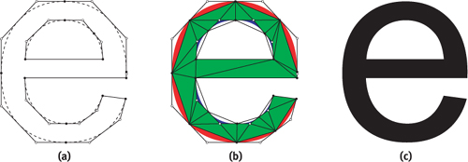
Diagram 1. (a) Path data (b) triangulated path data (c) resulting glyph

As the input data and transformations are same for all steps there will be no gaps or holes in the output data. All geometry is rendered using the same shader, just input parameters differ so we can render single glyph (or single Text object if hardware supports enough uniforms) with a single draw call for maximum performance.

There is a problem with this technique when the paths in a single glyph are self-intersecting. If our tessellator reports that self-intersecting is in place we store the points that cause the intersection (including the intersection points) and iteratively re-convert the data by splitting the possibly self-intersecting paths into smaller paths based on the iteration level. Currently there is a maximum iteration level of 4 which seems to handle all problematic cases with some false positives reported by the font system.

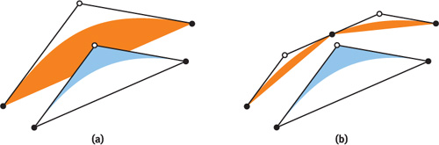
Diagram 2. Self-intersecting triangles and how they are split if needed.

3.2. Vertex data

This technique produces rather large number of vertices/triangles per glyph. At the moment font system supports both 16 and 32 bit indices but by default the 16 bit indices are enabled as some of the possible target hardwares didn't support 32 bit indices. When a Text object is first drawn a necessary vertex buffer object is generated by copying data from the glyph cache, which holds all the necessary data for all previously used glyphs to create hardware buffers to render any Text object.

3.3. Non-curved path AA

Font system has a support for non-curved path antialiasing, where all triangles that have non-curved outer edges are split in a way that a single triangle only contains a single edge that needs to be antialiased. This technique consumes about 0.5 pixels from the AA edge which causes some minor artifacts when Text object is really small and there is a small overhead during the edge processing when glyphs are instanced. Because MSAA produces perfect results for straight line AA this technique is currently disabled by default.

4. External libraries

4.1. STB TrueType Library

Currently the font system supports TrueType Fonts (.ttf) using STB TrueType Library to parse the font data. Most of the font files we have tried so far are working perfectly and the vector data we can query from the library is perfect. We have encountered some font files that do not follow the spec due to path ordering and self-intersections should not exist but our font system handles these during the vector font data conversion.

4.2. gluTessellator

Currently font system uses gluTessellator to generate triangles inside the glyph. We tried rather many different tessellators but hardly any of them automatically supported holes in the path data. Poly2Tri produced promising triangle data but in some cases it just miserably failed and could not be used. As a result the first tessellator we tried was really the best there was available for our needs.

