1.
SW-L#show spanning-tree
VLAN0001
Spanning tree enabled protocol rstp
Root ID Priority 32769
Address 0001.C929.89AA
Cost 19
Port 2(FastEthernet0/2)
Hello Time 2 sec Max Age 20 sec Forward Delay 15 sec

Bridge ID Priority 32769 (priority 32768 sys-id-ext 1)
Address 0030.F23E.DDA3
Hello Time 2 sec Max Age 20 sec Forward Delay 15 sec
Aging Time 20

Interface Role Sts Cost Prio.Nbr Type
---------------- ---- --- --------- -------- --------------------------------
Fa0/3 Desg FWD 19 128.3 P2p
Fa0/2 Root FWD 19 128.2 P2p
Fa0/4 Desg FWD 19 128.4 P2p
Fa0/21 Desg FWD 19 128.21 P2p
Fa0/22 Desg FWD 19 128.22 P2p
Po1 Desg FWD 12 128.27 Shr

VLAN0100
Spanning tree enabled protocol rstp
Root ID Priority 4196
Address 0030.F23E.DDA3
This bridge is the root
Hello Time 2 sec Max Age 20 sec Forward Delay 15 sec

Bridge ID Priority 4196 (priority 4096 sys-id-ext 100)
Address 0030.F23E.DDA3
Hello Time 2 sec Max Age 20 sec Forward Delay 15 sec
Aging Time 20

Interface Role Sts Cost Prio.Nbr Type
---------------- ---- --- --------- -------- --------------------------------
Fa0/3 Desg FWD 19 128.3 P2p
Fa0/2 Desg FWD 19 128.2 P2p
Fa0/4 Desg FWD 19 128.4 P2p
Po1 Desg FWD 12 128.27 Shr

VLAN0200
Spanning tree enabled protocol rstp
Root ID Priority 4296
Address 0030.F23E.DDA3
This bridge is the root
Hello Time 2 sec Max Age 20 sec Forward Delay 15 sec

Bridge ID Priority 4296 (priority 4096 sys-id-ext 200)
Address 0030.F23E.DDA3
Hello Time 2 sec Max Age 20 sec Forward Delay 15 sec
Aging Time 20

Interface Role Sts Cost Prio.Nbr Type
---------------- ---- --- --------- -------- --------------------------------
Fa0/3 Desg FWD 19 128.3 P2p
Fa0/2 Desg FWD 19 128.2 P2p
Fa0/4 Desg FWD 19 128.4 P2p
Po1 Desg FWD 12 128.27 Shr

VLAN0300
Spanning tree enabled protocol rstp
Root ID Priority 4396
Address 0030.F23E.DDA3
This bridge is the root
Hello Time 2 sec Max Age 20 sec Forward Delay 15 sec

Bridge ID Priority 4396 (priority 4096 sys-id-ext 300)
Address 0030.F23E.DDA3
Hello Time 2 sec Max Age 20 sec Forward Delay 15 sec
Aging Time 20

Interface Role Sts Cost Prio.Nbr Type
---------------- ---- --- --------- -------- --------------------------------
Fa0/3 Desg FWD 19 128.3 P2p
Fa0/2 Desg FWD 19 128.2 P2p
Fa0/4 Desg FWD 19 128.4 P2p
Po1 Desg FWD 12 128.27 Shr

VLAN0400
Spanning tree enabled protocol rstp
Root ID Priority 4496
Address 0030.F23E.DDA3
This bridge is the root
Hello Time 2 sec Max Age 20 sec Forward Delay 15 sec

Bridge ID Priority 4496 (priority 4096 sys-id-ext 400)
Address 0030.F23E.DDA3
Hello Time 2 sec Max Age 20 sec Forward Delay 15 sec
Aging Time 20

Interface Role Sts Cost Prio.Nbr Type
---------------- ---- --- --------- -------- --------------------------------
Fa0/3 Desg FWD 19 128.3 P2p
Fa0/2 Desg FWD 19 128.2 P2p
Fa0/4 Desg FWD 19 128.4 P2p
Po1 Desg FWD 12 128.27 Shr

VLAN0500
Spanning tree enabled protocol rstp
Root ID Priority 4596
Address 0030.F23E.DDA3
This bridge is the root
Hello Time 2 sec Max Age 20 sec Forward Delay 15 sec

Bridge ID Priority 4596 (priority 4096 sys-id-ext 500)
Address 0030.F23E.DDA3
Hello Time 2 sec Max Age 20 sec Forward Delay 15 sec
Aging Time 20

Interface Role Sts Cost Prio.Nbr Type
---------------- ---- --- --------- -------- --------------------------------
Fa0/3 Desg FWD 19 128.3 P2p
Fa0/2 Desg FWD 19 128.2 P2p
Fa0/4 Desg FWD 19 128.4 P2p
Po1 Desg FWD 12 128.27 Shr

SW-L#show standby
Vlan100 - Group 100 (version 2)
State is Active
7 state changes, last state change 00:00:18
Virtual IP address is 10.10.10.254
Active virtual MAC address is 0000.0C9F.F064
Local virtual MAC address is 0000.0C9F.F064 (v2 default)
Hello time 3 sec, hold time 10 sec
Next hello sent in 0.765 secs
Preemption enabled
Active router is local
Standby router is 10.10.10.2
Priority 100 (default 100)
Track interface FastEthernet0/1 state Up decrement 10
Group name is hsrp-Vl1-100 (default)
Vlan200 - Group 200 (version 2)
State is Active
8 state changes, last state change 00:00:21
Virtual IP address is 10.10.11.254
Active virtual MAC address is 0000.0C9F.F0C8
Local virtual MAC address is 0000.0C9F.F0C8 (v2 default)
Hello time 3 sec, hold time 10 sec
Next hello sent in 1.262 secs
Preemption enabled
Active router is local
Standby router is 10.10.11.2, priority 95 (expires in 9 sec)
Priority 100 (default 100)
Track interface FastEthernet0/1 state Up decrement 10
Group name is hsrp-Vl2-200 (default)
Vlan300 - Group 300 (version 2)
State is Active
8 state changes, last state change 00:00:18
Virtual IP address is 10.10.12.254
Active virtual MAC address is 0000.0C9F.F12C
Local virtual MAC address is 0000.0C9F.F12C (v2 default)
Hello time 3 sec, hold time 10 sec
Next hello sent in 1.79 secs
Preemption enabled
Active router is local
Standby router is 10.10.12.2
Priority 100 (default 100)
Track interface FastEthernet0/1 state Up decrement 10
Group name is hsrp-Vl3-300 (default)
Vlan400 - Group 400 (version 2)
State is Active
9 state changes, last state change 00:00:28
Virtual IP address is 10.10.13.254
Active virtual MAC address is 0000.0C9F.F190
Local virtual MAC address is 0000.0C9F.F190 (v2 default)
Hello time 3 sec, hold time 10 sec
Next hello sent in 1.066 secs
Preemption enabled
Active router is local
Standby router is 10.10.13.2, priority 95 (expires in 7 sec)
Priority 100 (default 100)
Track interface FastEthernet0/1 state Up decrement 10
Group name is hsrp-Vl4-400 (default)
Vlan500 - Group 500 (version 2)
State is Active
9 state changes, last state change 00:00:27
Virtual IP address is 10.10.14.254
Active virtual MAC address is 0000.0C9F.F1F4
Local virtual MAC address is 0000.0C9F.F1F4 (v2 default)
Hello time 3 sec, hold time 10 sec
Next hello sent in 1.823 secs
Preemption enabled
Active router is local
Standby router is 10.10.14.2
Priority 100 (default 100)
Track interface FastEthernet0/1 state Up decrement 10
Group name is hsrp-Vl5-500 (default)

2.
SW-L#show ip route
Codes: C - connected, S - static, I - IGRP, R - RIP, M - mobile, B - BGP
D - EIGRP, EX - EIGRP external, O - OSPF, IA - OSPF inter area
N1 - OSPF NSSA external type 1, N2 - OSPF NSSA external type 2
E1 - OSPF external type 1, E2 - OSPF external type 2, E - EGP
i - IS-IS, L1 - IS-IS level-1, L2 - IS-IS level-2, ia - IS-IS inter area
* - candidate default, U - per-user static route, o - ODR
P - periodic downloaded static route

Gateway of last resort is 10.10.1.9 to network 0.0.0.0

10.0.0.0/8 is variably subnetted, 10 subnets, 2 masks
O 10.10.1.0/30 [110/2] via 10.10.1.9, 00:38:13, FastEthernet0/1
C 10.10.1.8/30 is directly connected, FastEthernet0/1
O 10.10.2.0/30 [110/3] via 10.10.10.2, 00:38:03, Vlan100
O 10.10.2.8/30 [110/2] via 10.10.10.2, 00:38:13, Vlan100
O 10.10.9.0/24 [110/3] via 10.10.10.2, 00:38:03, Vlan100
C 10.10.10.0/24 is directly connected, Vlan100
C 10.10.11.0/24 is directly connected, Vlan200
C 10.10.12.0/24 is directly connected, Vlan300
C 10.10.13.0/24 is directly connected, Vlan400
C 10.10.14.0/24 is directly connected, Vlan500
O*IA 0.0.0.0/0 [110/3] via 10.10.1.9, 00:38:13, FastEthernet0/1

3.
SW-L#show etherchannel summary
Flags: D - down P - in port-channel
I - stand-alone s - suspended
H - Hot-standby (LACP only)
R - Layer3 S - Layer2
U - in use f - failed to allocate aggregator
u - unsuitable for bundling
w - waiting to be aggregated
d - default port

Number of channel-groups in use: 1
Number of aggregators: 1

Group Port-channel Protocol Ports
------+-------------+-----------+----------------------------------------------

1 Po1(SU) LACP Fa0/21(P) Fa0/22(P)

4.
R1#show ip route
Codes: L - local, C - connected, S - static, R - RIP, M - mobile, B - BGP
D - EIGRP, EX - EIGRP external, O - OSPF, IA - OSPF inter area
N1 - OSPF NSSA external type 1, N2 - OSPF NSSA external type 2
E1 - OSPF external type 1, E2 - OSPF external type 2, E - EGP
i - IS-IS, L1 - IS-IS level-1, L2 - IS-IS level-2, ia - IS-IS inter area
* - candidate default, U - per-user static route, o - ODR
P - periodic downloaded static route

Gateway of last resort is 172.1.0.1 to network 0.0.0.0

8.0.0.0/24 is subnetted, 1 subnets
B 8.8.8.0/24 [20/0] via 172.1.0.1, 00:00:00
10.0.0.0/8 is variably subnetted, 22 subnets, 3 masks
C 10.10.1.0/30 is directly connected, GigabitEthernet0/1
L 10.10.1.1/32 is directly connected, GigabitEthernet0/1
O 10.10.1.8/30 [110/2] via 10.10.1.2, 00:04:15, GigabitEthernet0/1
C 10.10.1.254/32 is directly connected, Loopback0
O 10.10.2.0/30 [110/5] via 10.10.1.2, 00:04:15, GigabitEthernet0/1
O 10.10.2.8/30 [110/4] via 10.10.1.2, 00:04:15, GigabitEthernet0/1
C 10.10.4.0/30 is directly connected, GigabitEthernet0/0/0
L 10.10.4.1/32 is directly connected, GigabitEthernet0/0/0
C 10.10.6.0/30 is directly connected, Tunnel1
L 10.10.6.1/32 is directly connected, Tunnel1
O 10.10.6.4/30 [110/2000] via 10.10.6.2, 00:05:00, Tunnel1
O 10.10.9.0/24 [110/5] via 10.10.1.2, 00:04:15, GigabitEthernet0/1
O 10.10.10.0/24 [110/3] via 10.10.1.2, 00:04:15, GigabitEthernet0/1
O 10.10.11.0/24 [110/3] via 10.10.1.2, 00:04:15, GigabitEthernet0/1
O 10.10.12.0/24 [110/3] via 10.10.1.2, 00:04:15, GigabitEthernet0/1
O 10.10.13.0/24 [110/3] via 10.10.1.2, 00:04:15, GigabitEthernet0/1
O 10.10.14.0/24 [110/3] via 10.10.1.2, 00:04:15, GigabitEthernet0/1
O 10.10.15.0/24 [110/1001] via 10.10.6.2, 00:05:00, Tunnel1
O 10.10.16.0/24 [110/1001] via 10.10.6.2, 00:05:00, Tunnel1
O 10.10.17.0/24 [110/1001] via 10.10.6.2, 00:05:00, Tunnel1
O 10.10.18.0/24 [110/1001] via 10.10.6.2, 00:05:00, Tunnel1
O 10.10.19.0/24 [110/1001] via 10.10.6.2, 00:05:00, Tunnel1
172.1.0.0/16 is variably subnetted, 2 subnets, 2 masks
C 172.1.0.0/30 is directly connected, GigabitEthernet0/0
L 172.1.0.2/32 is directly connected, GigabitEthernet0/0
172.2.0.0/30 is subnetted, 1 subnets
B 172.2.0.0/30 [20/0] via 172.1.0.1, 00:00:00
172.3.0.0/30 is subnetted, 1 subnets
B 172.3.0.0/30 [20/0] via 172.1.0.1, 00:00:00
S* 0.0.0.0/0 [1/0] via 172.1.0.1

5.
Pinging 8.8.8.8 with 32 bytes of data:

Request timed out.
Reply from 8.8.8.8: bytes=32 time=14ms TTL=124
Reply from 8.8.8.8: bytes=32 time=49ms TTL=124
Reply from 8.8.8.8: bytes=32 time=7ms TTL=124

Ping statistics for 8.8.8.8:
Packets: Sent = 4, Received = 3, Lost = 1 (25% loss),
Approximate round trip times in milli-seconds:
Minimum = 7ms, Maximum = 49ms, Average = 23ms

6.
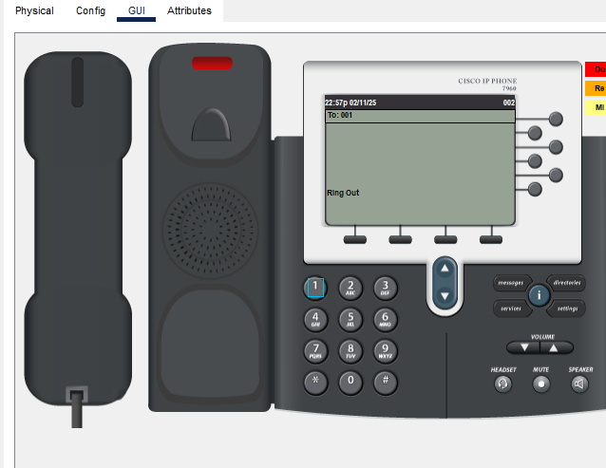
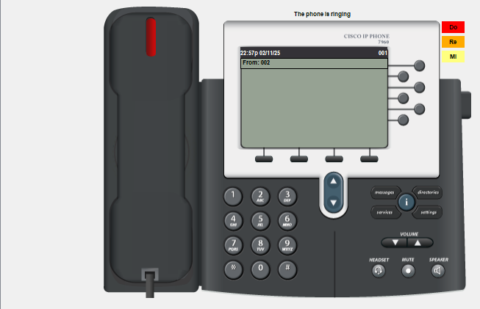

7.
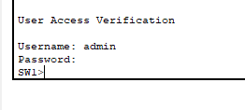

8.
SW1#show ntp status
Clock is synchronized, stratum 2, reference is 10.10.10.10
nominal freq is 250.0000 Hz, actual freq is 249.9990 Hz, precision is 2**24
reference time is EB2C25E3.0000038E (23:4:3.910 UTC Tue Feb 11 2025)
clock offset is 0.00 msec, root delay is 1.00 msec
root dispersion is 67.86 msec, peer dispersion is 0.12 msec.
loopfilter state is 'CTRL' (Normal Controlled Loop), drift is - 0.000001193 s/s system poll interval is 4, last update was 7 sec ago.

9.
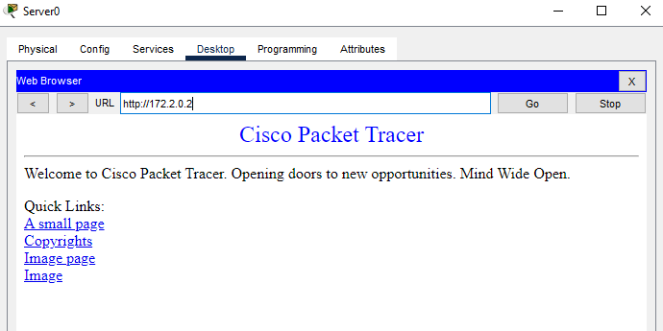

10.
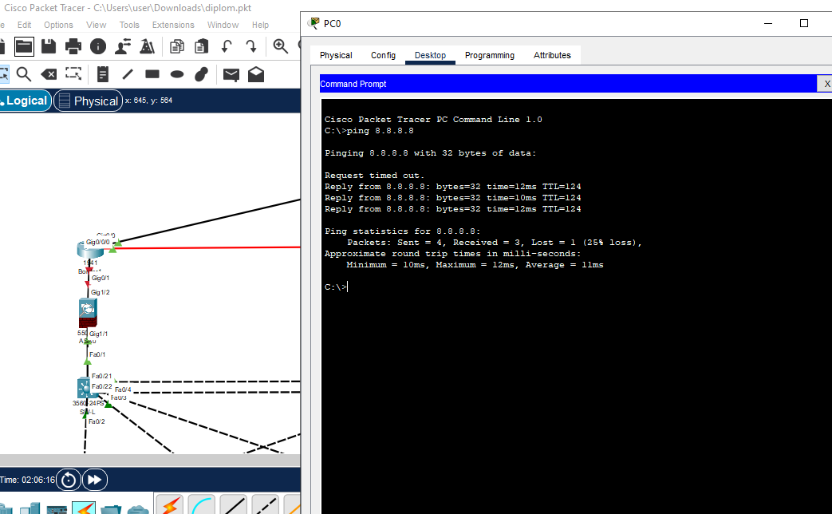

11.
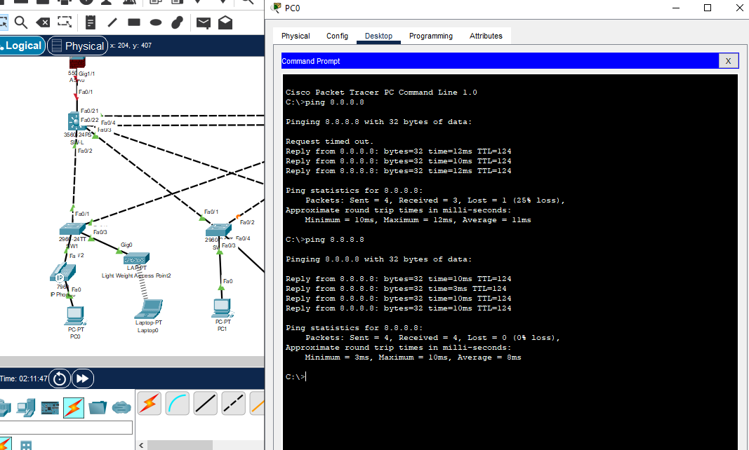

12.
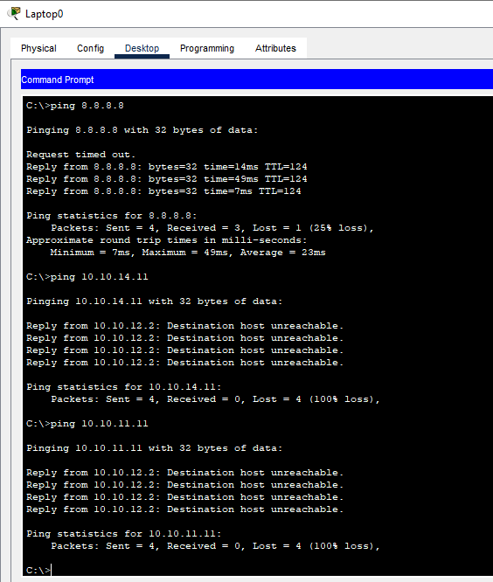

13.
