Repository Link

Git Hub Link - github.com/vladimirovbobi/AeroPlastics  
We agree on using IntelliJ

Database Schema

Products/Inventory

|  |  |  |  |  |
| --- | --- | --- | --- | --- |
| productID | productName | price | rawMaterial | inventoryLevel |

Materials/Inventory

|  |  |  |  |  |
| --- | --- | --- | --- | --- |
| materialID | materialName | moldTemperature | Plastic Density | inventoryLevel |

Customer

|  |  |  |  |
| --- | --- | --- | --- |
| customerID | firstName | lastName | company |

Vendor

|  |  |  |  |  |  |
| --- | --- | --- | --- | --- | --- |
| vendorID | companyName | rawMaterial | price | orderPlaced | arrivalDate |

Employee

|  |  |  |  |  |  |
| --- | --- | --- | --- | --- | --- |
| employeeID | firstName | lastName | username | password | Role(bool isAdmin) |

Order

|  |  |  |  |  |
| --- | --- | --- | --- | --- |
| orderID | cartID | address | isShipped | customerID |

Cart

|  |  |  |  |  |  |  |  |  |  |
| --- | --- | --- | --- | --- | --- | --- | --- | --- | --- |
| cartID | amount | orderDate | deliveryDate | productID  (PI) | ProductQuantity (PQ) | PI  Can be null | PQ Can be null | PI  Can be null | PQ Can be null |

Application Windows

Login Screen

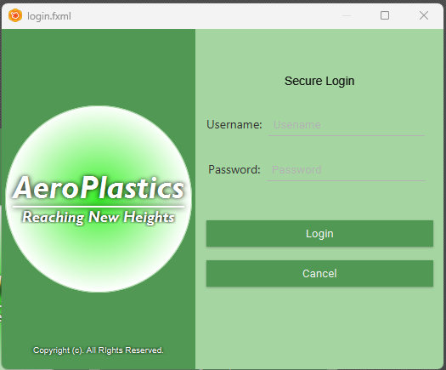

*\*Used for demo purposes. Will be replaced with logo.*

Menu Screen (Customers, Orders, Products, Order Supplies, Reports, Create new products)

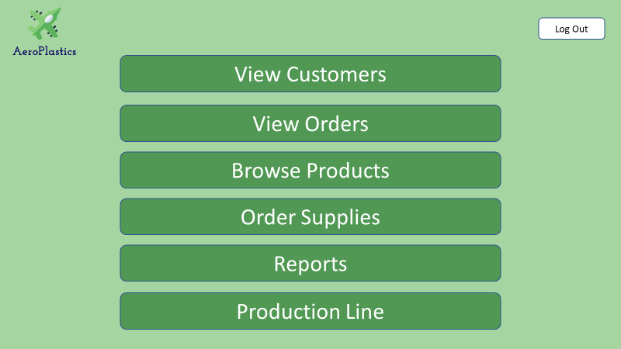

Customer Screen – View order, Pending Orders, modify order, Cancel order, Purchase history.

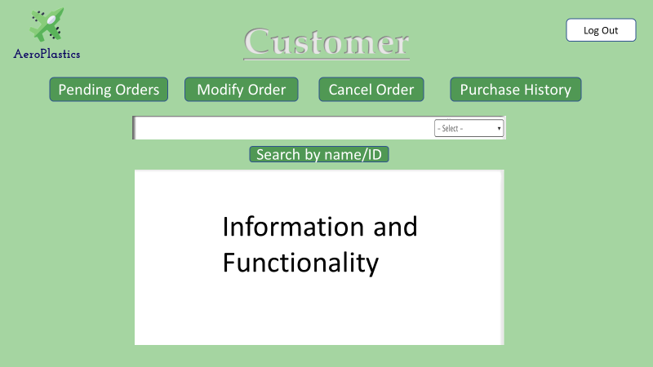

Products Screen- List products and attributes, Sort products by category,

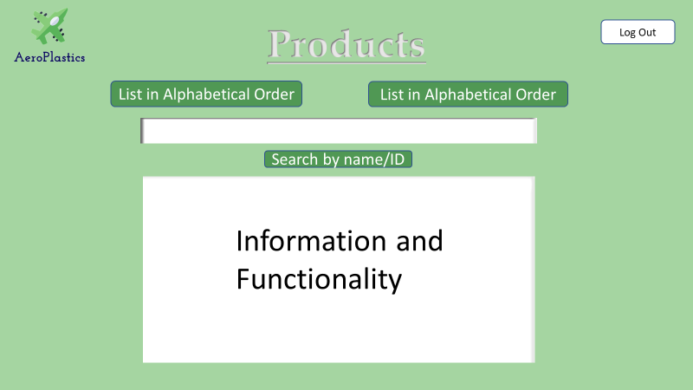

Order Products Screen- Inspect existing orders, pending orders, search by order id or name 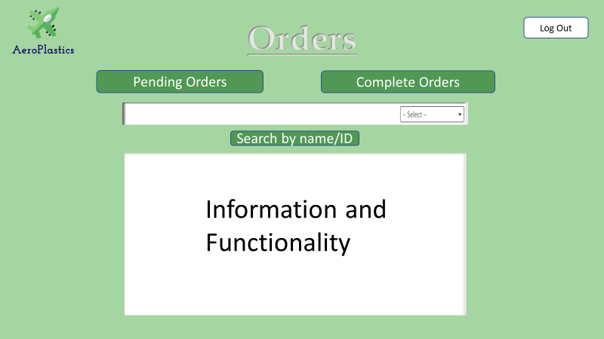

Order Supplies – Search Material, Products with low quantity, List Vendors and their materials

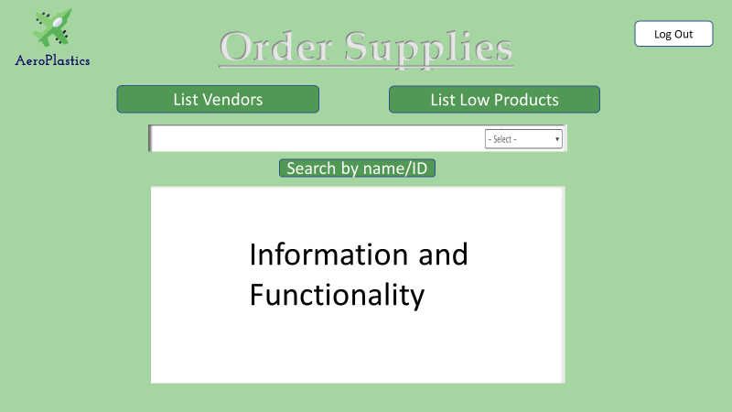

Statistics/Reports - total products sold, revenue from sales, delivery locations, number of defected products

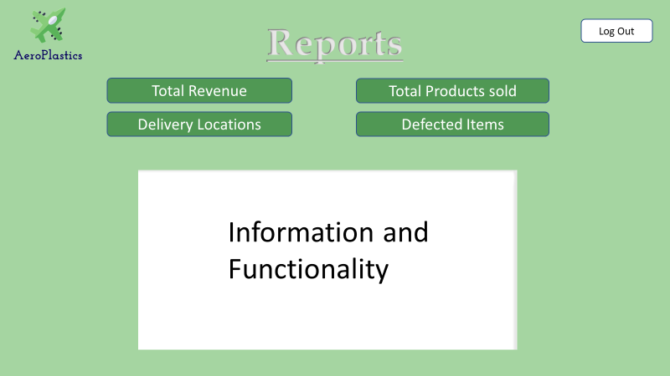

UML Diagram

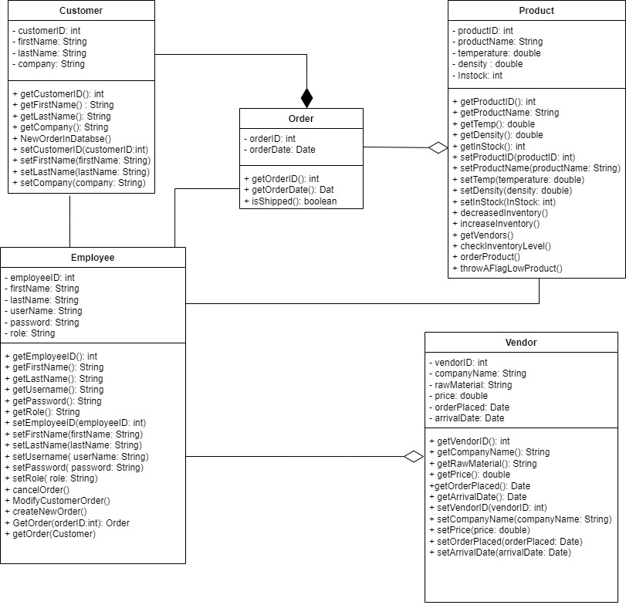

Use Case Diagram

