**Interim Report**

**Project Title:**

**Estimating personal energy expenditure with location data**

**Student Name:** Vladimir Hartmann

**Degree program:** BSc Computer Science

**Department:** School of Informatics

**Candidate Number:** 52665

**Project Supervisor:** Dr. Martin Berger

**Year of Submission:** 2012

**2. Statement of originality**

**3. Summary**

Modern society is putting unsustainable demands on personal wellbeing as well as the wellbeing of the planet. Human pressure on the biosphere is greatly exceeding global sustainability. While there is an ongoing discussion about an importance of achieving sustainable state of the planet, there seems to be a lack of personal accountability towards this problem. From the number of proposed solutions, the one attributing an equal allocation of emission rights to each person on the Earth has gained increasing recognition. However implementing such a solution imposes great challenges as energy estimates for each person must come from various meters, sensors and location systems distributed globally. I propose a simplified version of estimating personal energy expenditure as an intermediate step towards global personal energy metering and raising awareness of energy consumption by individuals……..

…..

….

**4. Table of Contents**

**5. Introduction**

* **Motivation, Aims and objective**

“Every day each of us consumes a significant amount of energy, both directly through transportation, heating and use of appliances, and indirectly from our needs for the production of food, manufacture of goods and provision of services” [1]. The aim of this project was to create a new interactive application, which would measure personal energy expenditure. Research of previous attempts in solving this problem has been carried out to identify possible gaps for developing a simple application capable of calculating energy expenditure estimates….

Modern society is putting unsustainable demands on personal wellbeing as well as the wellbeing of the planet. Pervasive sedentary lifestyle has been creating many health conditions while excess in energy consumption has had adverse effects on our ecosystem. There is a clear connection between personal and planetary wellbeing and actions that help to improve our own health often have a positive effect on our environment. Location data such as GPS tracking can be utilised to address both issues. As it is most frequently collected piece of contextual data in computing, it can be applied to many healthcare applications. This technique offers a number of improvements over traditional methods, which involve carrying a dedicated accelerometer device.

**Aims and objectives**

**Aim**

Estimatepersonal energy expenditure and provide healthy recommendations for personal and planetary wellbeing.

**Objectives\***

Primary:

* **Design and develop the Personal Energy Meter (PEM), an iPhone application**
* **Design and develop an Interactive Dynamic Website**

Extensions:

* **Ensure that both systems are reliable and accurate**
* **Validated with real biomedical measurements**
* **Extended functionality for better user experience**

*For details on objectives see Requirements Analysis (Project after negotiation) section

….

….

* **About this project**

……

….

**6. Background**

Ongoing progress is being made by various universities and institutes to address the issue of personal energy expenditure monitoring. This is due to the fact that the global economy is not able to meet the minimum conditions for sustainability. The Rio Declaration of 1992 and the United Nations Millennium Development Goals have demonstrated that human demand for ecosystem goods and services exceed the biosphere's total capacity. A fundamental solution is to manage food, fibre and energy consumption and maintain or increase the productivity of natural and agricultural ecosystems. From the number of proposed solutions, the 'shrink and share' framework has gained increasing recognition. This solution emphasises an equal allocation of emission rights to each person on the Earth and has been established by European Parliament as a basic principle to reducing global emissions of carbon dioxide [2]. Simon Hay at University of Cambridge proposed a 'Global Personal Energy Meter' (PEM) [1], device which can record and apportion an individual's energy usage. Architecture of this PEM would consist of a global sensor network and devices such as smartphones would communicate with it and receive estimates of energy used by individual. Data from a 'world model' (recommended energy usage allocations) would be fed into PEM to estimates keep up-to-date. Further research undertaken by Simon Hay, this time together with Stamatina Th. Rassia , Dr. Alastair Beresford and Dr. Nick V. Baker include 'Movement dynamics in office environment' [3] and 'Estimating personal energy expenditure with location data' [4]. The task of this research was to explore the relationship between indoor environments and physical activity by gathering location and physical activity data. Devices used in an experiment were Active Bat location tracking device and GTIM Actigraph. To estimate personal energy expenditure an energy consumption model had to calculate gravitational and kinetic energy.

Tracking people’s movement has been known for some time now. Romans used odometer calibrated to steps, although technically not a step counter, the idea was similar. Leonardo Da Vinci designed a mechanical pedometer, which was used for civil and military purposes. Most of the movements tracking solution on the market today make use accelerometer, which is a device able to monitor any movement in X, Y and Z coordinates. This approach however requires wearing a special device, which might not me convenient. It is also not accurate in many cases (user can cheat by only moving the device in certain way to mimic the actual walking/running).

Proposed approach in this project uses mainly GPS data to track users movement. This can be supported (with project extensions) by accelerometer data and data obtained from signals of the heartbeat. All three technologies combined can produce very accurate and reliable system.

**7. Professional Considerations**

**Code of Conduct**

The project raises the issue set out in section 1, subsection (a) of Code of Conduct. Implementation of Personal Energy Meter (PEM) requires use of the iPhone Location Services that gather location data of user. It must be assured that any storage or transfer of this data is secure and not leaked.

PEM is in accordance (only if the system is used for commercial purposes) with section 1, subsections (c) and (d) of Code of Conduct, as the system will be distributed via the Apple’s App Store to which anybody can have access.

Further issues may rise from the section 2, subsections (a) and (b) of Code of Conduct, if the systems developed would be used for commercial purposes. As part of my project is to undertake the challenge of learning new programming language and iPhone development, no full competence for these has been obtained yet. These issues have been taken into consideration however for future professional career.

**Code of Good Practice**

Although about 70% of the document is closely related to this project it will be an excellent guide to ensuring that it is done correctly with highest possible quality.

Study of this document will be included as a milestone in this project.

**8. Requirements analysis**

**Requirements discovery**

Requirements discovery has been carried out on three individuals. The project supervisor/main customer Martin and two friends of mine Tim and Richard. The requirements are very vague and high-level but refined throughout the stages of the Requirement Analysis.

**Collected scenarios**

Scenario 1

Martin has a busy lifestyle in which time to rest and sleep is very precious. Therefore he would like to find a way of measuring and controlling the amount of energy he uses doing certain activities such as walking, running, cycling, working out in the gym or climbing stairs. As he is also very aware of the carbon footprint on the environment he would be interested in how much he could eliminate the emissions by changing his forms of transport.

Scenario 2

Tim spends lots of hours in an office doing a sedentary job. To preserve his wellbeing he wants to know each day/week whether he had enough recommended physical activity. He would like to get accurate calorie expenditure results with healthy advices and recommendations directly on his iPhone or access it online via web page where he can log in, see all the results collected, graphically displayed using charts, and access and share other people’s results to see general healthy trends.

Scenario 3

Richard is a bodybuilder and therefore maintaining a strict workout program with enough rest each day is very important to him. As he is not a professional athlete he would appreciate some conventional way of keeping track of his calorie expenditure via heartbeat pulses while he works out in the gym. As a result, he would like to obtain very accurate data from which he could design or improve his workout program.

**Requirements classification and organization**

On examination of all three scenarios and after consideration of the resources available for undertaking the project, following decisions have been made and presented to customer at one of the formal meetings: iPhone development will be used as this device was already available. (Developing for an iPhone also brings new challenges of learning new programming language, API and interesting development methods and models to this project.)

**Product functionality**

The iPhone application should have following functionalities:

* Capture, categorize and process data (GPS, sound signal, accelerometer)
* Calculate calories expenditure using an Energy Consumption Model
* Calculate a carbon footprint
* Graphically output the results of the calculations
* Give recommendations on personal and planetary wellbeing

For accessing captured data from a computer an interactive dynamic website will be build. For the purposes of applying the knowledge of a Java language and Web Computing the website will be coded using Java EE 6 which is the industry standard for enterprise Java computing. This website should have following functionalities:

* Create and maintain user profiles
* Receive and process data from the iPhone application
* Graphically output results of calculations
* Give recommendations on personal and planetary wellbeing
* Share personal energy expenditure data with other users
* Energy expenditure trends visualisation (personal, carbon footprint)

The classification and organization of the requirements discovery was a first important step of translating the high level user’s scenarios to more technical and measurable units.

**Requirements prioritization and negotiation**

Although the classification and organization phase of the requirements discovery laid down some understandable structure to the project, which is closer to implementation than vague user scenarios, the time constraint of the project became very apparent. Negotiations with the customer therefore had to take place in order to preserve prototype and final product release dates schedule.

**Project after negotiation**

1. Primary objectives:

**Design and develop the Personal Energy Meter (PEM), an iPhone application that should have following functionalities:**

* + Capture and process GPS data of five activity domains (Walk, Run, Car, Bus and Train)
  + Calculate calories expenditure using an Energy Consumption Model
  + Calculate a carbon footprint
  + Graphically output results of the calculations
  + Give recommendations on personal and planetary wellbeing

**Design and develop an interactive website which should have following functionalities:**

* Create and maintain user profiles
* Receive and process data from the PEM, an iPhone application
* Graphically output results of calculations using charts
* Give recommendations on personal and planetary wellbeing

1. Extensions:

* More precise GPS data processing by PEM
* Live GPS data categorization (walking, driving car, running, using public transport)
* iPhone in-built headphones microphone integration for capturing the heartbeat (for estimating energy expenditure indoors where high volume of energy can be used for example in the gym or climbing stairs)
* Validation of the Energy Consumption Model with real biomedical measurements
* Improve accuracy and reliability of capturing the GPS data
* Share the personal energy expenditure data with other users
* Energy expenditure trends visualization (personal, carbon footprint)

Splitting the project requirements, by negotiating with the customer, into two categories (Primary, Extensions) reduced a development overhead, which wasn’t apparent in the initial stages of formal meetings. The negotiation gave both stakeholders more clear understanding of what can be achieved within designated time of the project (or how much the customer can have for what s/he paid). The development company has however offered the customer, for keeping a good customer relations, an implementation of some or all ‘Extensions’ if time allows.

**Requirements specification**

To solidify the requirements a Requirements Document (RD) was created which forms an official statement of what the system developer (myself) should implement. Simplified RD was designed based on an IEEE standard for requirements documents (IEEE, 1998) and used as one-stop-point of information in further system design phase.

**Requirements Document**

Introduction

PEM is a small iPhone application that solves the problem of knowing person’s energy expenditure in everyday life. It monitors person’s movements and from data obtained it estimates the amount of calories a person burned in various activities. As an output, PEM provides a graphically aided representation of results together with healthy recommendations. PEMWEBAPP is a website which solves a problem of having to interact with limited real estate of an iPhone screen and present the results in better graphical way on computer monitor.

Glossary

Following is an explanation of symbols, terms and acronyms used throughout this document:

PEM – Personal Energy Meter (iPhone application)  
PEMWEBAPP – PEM web application (hosted on remote server), previously known as IDW  
GPS – Global Positioning System  
VO2 – Volume of Oxygen  
CO2 – Carbon Dioxide (used in conjunction with carbon footprint)  
CoreData – Apple’s persistence framework build on top of SQL  
SQLite - Cross-platform C library that implements a self-contained, embeddable, zero- configuration SQL database engine (used mostly by mobile devices).  
MySQL - the world's most used relational database management system  
- // - – denotes a repetition of content

User requirements definition

The PEM shall create user profile and shall provide profile view where updating user’s profile data is possible. The PEM shall provide GPS tracking for five activity domains (Walk, Run, Car, Bus and Train) and shall be calculating calorie expenditure and carbon footprint, and shall have an option to save the activity tracking as a session into persistent store for later retrieval. The PEM shall have a session details view where retrieved information will be displayed and emphasized by graphical aids. The PEM shall have an upload feature for uploading the data (profile and sessions) into online PEMWEBAPP. The PEM shall provide recommendations on personal and planetary wellbeing and have user authentication feature.

The PEMWEBAPP shall manage user profiles, display profile and profile’s sessions and shall provide sessions details view. The PEMWEBAPP shall provide a delete profile button for deletion of the profile and all its sessions. The PEMWEBAPP shall also have a statistics view where each session will be depicted on a line chart showing calorie expenditure and carbon footprint data. The PEMWEBAPP shall provide recommendations on personal and planetary wellbeing and have user authentication feature.

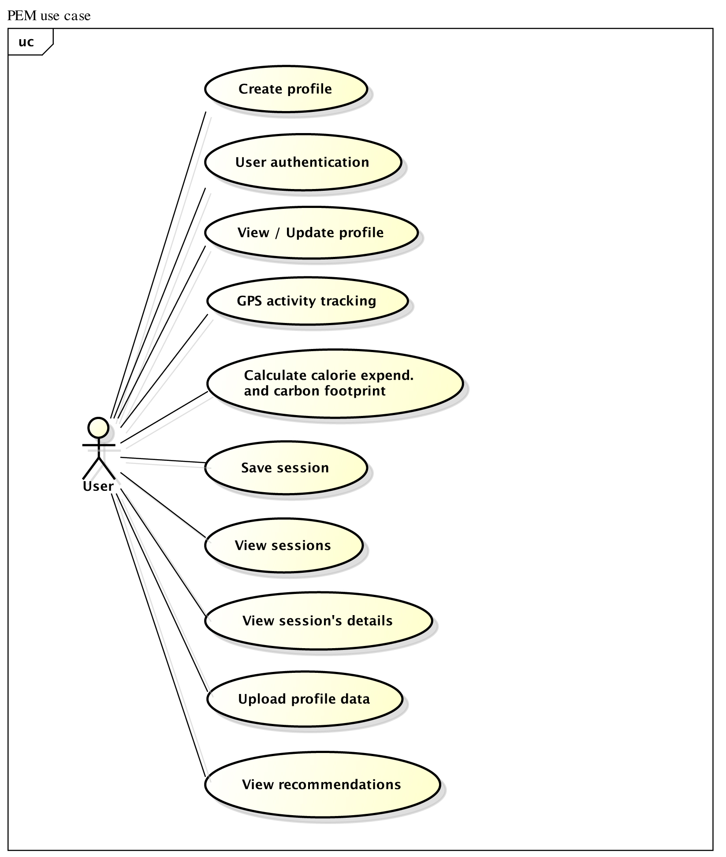

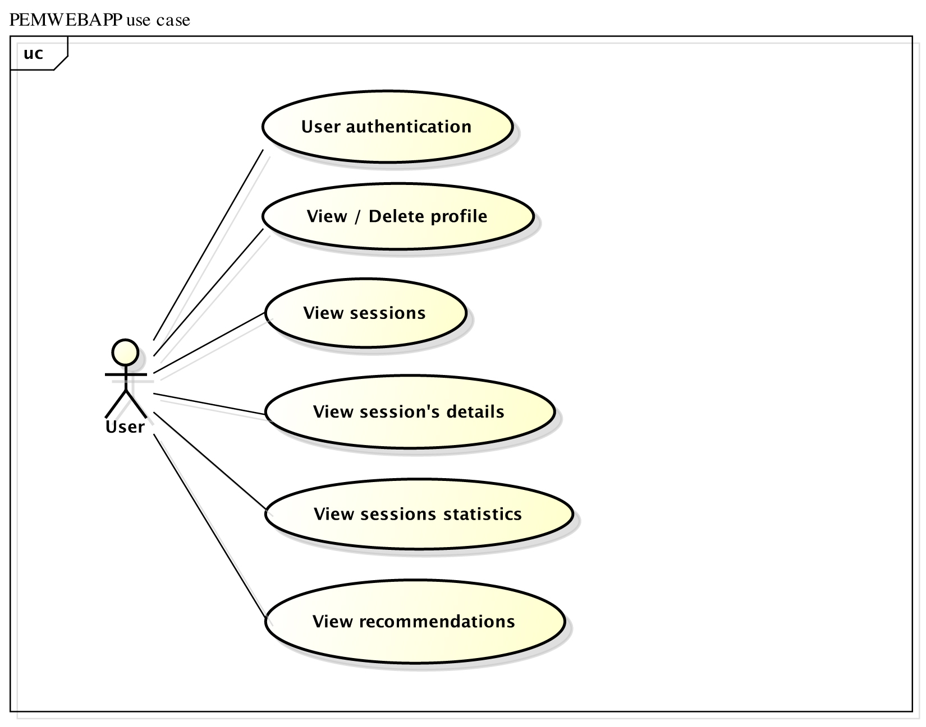

System architecture

To better understand how PEM and PEMWEBAPP applications should be organised, *an architectural design phase* has been used with focus on *a design view* of the applications [REF]. The design view includes architectural patterns, which are outlined below. This level of abstraction allowed both programs to be decomposed into individual components. The only correct way of developing iPhone applications is to follow a Model-View-Controller (MVC) architectural pattern, thus development of the PEM application shall be following it.

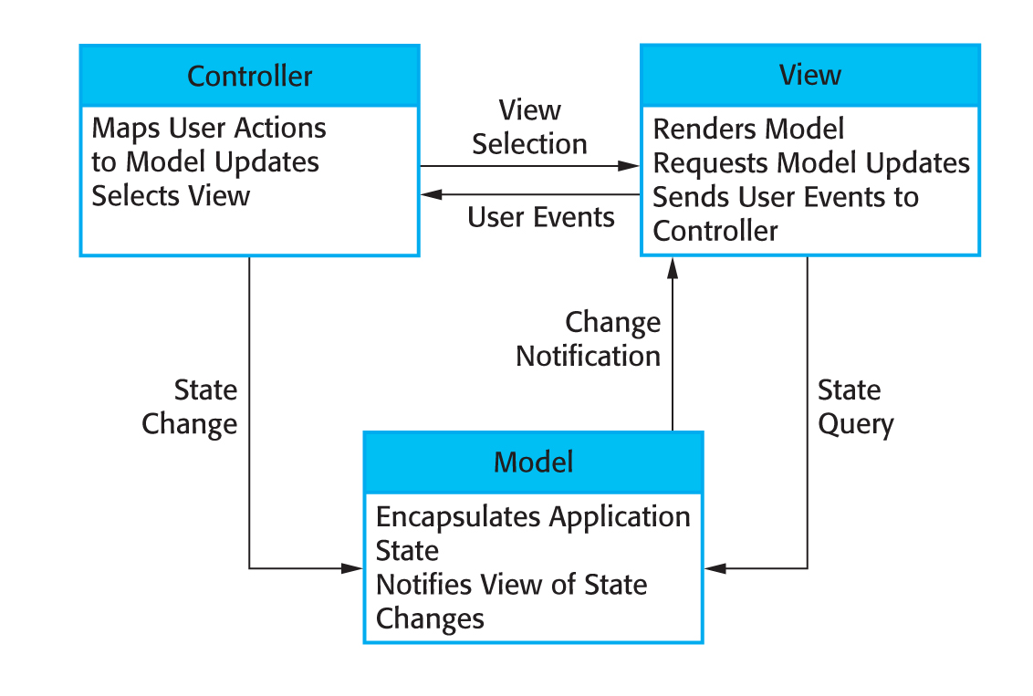

*[The organisation of MVC][REF]*

Although the PEMWEBAPP application will be deployed on a desktop computer rather than iPhone, it has similar properties to PEM and therefore using the MVC pattern would also be a good choice. However for experimental purposes, *the layered architectural pattern* has been chosen instead as it is another way of achieving separation and independence. Both, PEM and PEMWEBAPP will also comply with the Client-server architectural pattern. Detailed description of mapping both applications on mentioned architectural patterns and justification of choices is presented later in the design phase [*** plus describe what is MVC ***].

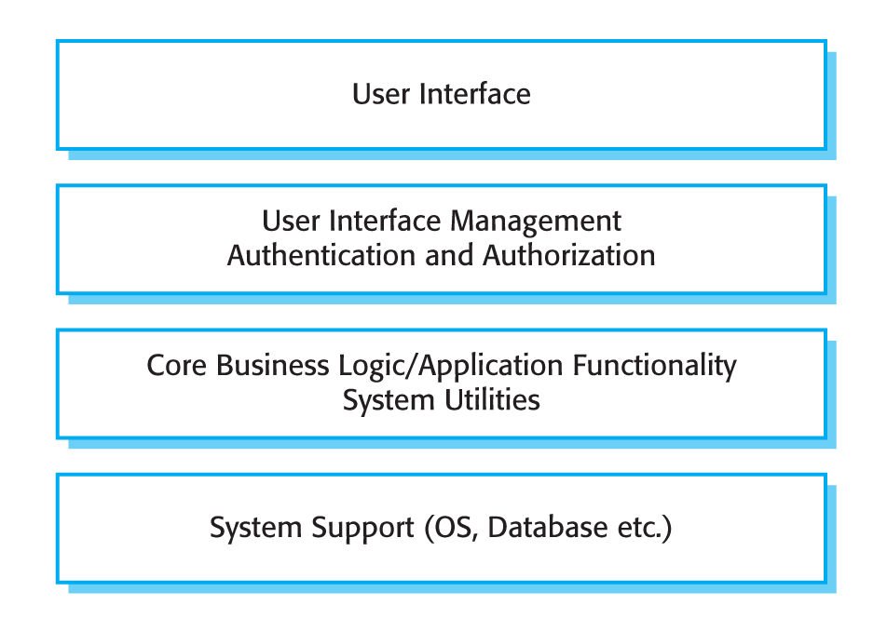

*[A generic layered architecture][REF]*

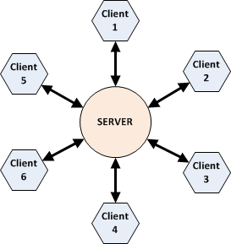

*[Client-server architectural pattern][* *http://www.clear.rice.edu/comp310/f11/lectures/lec26/]*

System requirements specification

This section of the report has undergone some formatting and filtering changes to reflect following:

1. Mainly because the agile software development method has been used (form more details and justifications please refer to Design section of the report).
2. Feedback received on an interim report, which advised to simplify very detailed requirements specifications.

Most of the underlying functional requirements have been left unchanged, but there might be some additions or improvements to them as the project development progressed. Some features have been renamed to convey better meaning and for consistency. There was a need for PEM’s user interface changes with subsequent knowledge of an iPhone development acquired. For a coherent explanation of design methodologies in later chapters, the changes to this requirements specification were inevitable. Customer has been informed and was happy to proceed with changes as long as a basic required functionality is preserved.

Following is a detailed description of PEM’s and PEMWEBAPP’s functional and non-functional requirements, how the applications should react to particular inputs and how they should behave in particular situations.

**Functional requirements**

**Personal Energy Meter (PEM)**

## 1. Create Profile

This feature shall provide the ability to create a new profile on the PEM. It is the first thing a user must do to begin using PEM. Its main function is to set up a new profile with personal details such as email and password. Email shall act as a username and must be unique. Password must be at least 4 characters long, no longer than 20 and must contain at least one numeric character. No special characters are allowed.

1.1 Basic Data Flow

1. User launches PEM
2. Login screen opens
3. User selects Create Profile
4. User writes his/her email and password (password 2x)
5. User selects OK
6. Profile is created, user is notified and prompted to log-in
7. The login screen opens

1.2 Alternative Data Flow 2

1. - // -
2. - // -
3. User selects Create Profile (after profile has been created)
4. The error message pops up. PEM supports only one active profile at a time.

1.2 Alternative Data Flow 3

1. - // -
2. - // -
3. User enters email or password in incorrect format
4. User selects OK
5. The error message pops up

**2. Log-in**

This feature shall allow the user to log in to the existing profile on PEM. When choosing to log in, the user is asked to enter his/her email and password. After a successful authentication the activity screen appears.

2.1 Basic Data Flow

1. User launches PEM
2. Login screen opens
3. User writes his/her email and password
4. User selects Login
5. The activity screen opens

2.2 Alternative Data Flow

1. - // -
2. - // -
3. User enters email or password in incorrect format or non-existing details
4. User selects OK
5. The error message pops up

**3. Edit profile**

This feature shall allow the user to edit his/her personal details on PEM. When the user is logged in he/she should be able to edit his/her personal details such as adding first and second name or change a body weight. There shall be a constraint on editing the email to preserve correct transfer of data to the appropriate profile on the remote server (email is unique and represents a profile). Password must be at least 4 characters long, no longer than 20 and must contain at least one numeric character. No special characters are allowed.

3.1 Basic Data Flow

1. After successful login user chooses Profile tab from a navigation tab bar
2. View/Edit Profile screen opens
3. User can change any of the personal data except email
4. User selects Save
5. Data is updated in the database

3.2 Alternative Data Flow

1. - // -
2. - // -
3. User enters an incorrect password (invalid format) or two passwords don’t match
4. User selects Save
5. The error message pops up
6. Nothing is updated in the database

**4. Delete profile**

This feature shall allow user to delete his/her profile from the PEM. Users not wanting to keep their profile for various reasons or wanting to start from scratch should have an option to delete their profile with all the data gathered. This operation should only affect the PEM system. Users should be able to still access their profile online to see all of the data and results. Deleting online profile shall be done in the PEMWEBAPP.

4.1 Basic Data Flow

1. After successful login user chooses Profile tab from a navigation tab bar
2. View/Edit Profile screen opens
3. User selects Account button
4. Option list appears
5. User selects delete profile
6. Warning massage pops up
7. User confirms the warning by selecting OK
8. Profile is deleted from PEM’s database
9. Login screen opens

4.2 Alternative Data Flow

1. - // -
2. - // -
3. - // -
4. - // -
5. - // -
6. - // -
7. User selects Cancel on the warning message to prevent profile deletion
8. Warning message disappears and deletion never occurs

**5. Start tracking**

This feature shall allow user to start his/her energy expenditure or carbon footprint monitoring. By pressing the Start button, the iPhone device shall start to receive GPS data and at the same time shall perform live calculations of calories burned and/or CO2 emissions calculations. The Location Services on iPhone have to be enabled in order for PEM to receive any GPS data.

5.1 Basic Data Flow

1. If not already in an activity screen, user selects Tracking from navigation tab bar
2. Activity screen opens
3. Users chooses an activity (Walk, Run, Car, Bus, Train)
4. Tracking screen opens
5. User selects Start
6. Monitoring screen opens
7. PEM starts to receive GPS data and performs live calorie burn and CO2 emission calculations

5.2 Alternative Data Flow

1. - // -
2. - // -
3. - // -
4. - // -
5. - // -
6. Alert about entering a body weight pops up if tracking launched for the first time. PEM calorie calculations use body weight as an input.
7. User selects OK, nothing happens

**6. Stop tracking**

This feature shall allow user to stop his/her energy expenditure or carbon footprint monitoring as well as to stop receiving GPS data. By pressing the Stop button, user should be prompted if he/she whishes to save a session. Monitoring needs to be in progress in order for Stop to have an effect and ask about saving the data.

6.1 Basic Data Flow

1. While tracking, user selects Stop
2. Alert about saving a session pops up
3. User selects OK
4. GPS tracking and all calculations stop
5. Save sessions screen opens
6. User types a session name and selects Save
7. Session is saved into database
8. Activity screen opens

6.2 Alternative Data Flow

1. - // -
2. - // -
3. - // -
4. - // -
5. - // -
6. User selects Cancel
7. Tracking screen pops back

6.2 Alternative Data Flow 2

1. - // -
2. - // -
3. User selects Cancel
4. Alert about saving a session disappears

**7. Pause tracking**

This feature shall allow user to pause their energy expenditure or carbon footprint monitoring as well as to stop receiving GPS data and resume it all again.

**8. Google maps and tracking information**

This feature shall allow user to see live position on Google maps and GPS data as they are received in intervals (every second). Data such as horizontal accuracy, elevation, distance traveled, grade, speed, time, VO2, Calories and CO2 emissions should be displayed under map view. The map view should be zoom-able and follow user current position.

**9. Sessions view**

This feature shall allow user to navigate through all saved sessions (related to his/her profile) and choose desired session to show in the details view. This view shall pull limited session data from the PEM’s database to show only a session name and timestamp. User should be able to delete the session from this view by swiping the session cell or by using an edit button.

9.1 Basic Data Flow

1. If not already in a session screen, user selects Sessions from navigation tab bar
2. Sessions are retrieved from a database and shown in the table

9.2 Alternative Data Flow

1. - // -
2. - // -
3. User swipes across table cell
4. Delete button appears
5. User selects Delete button
6. Session is deleted from database and removed from the table

9.2 Alternative Data Flow 2

1. - // -
2. - // -
3. User selects Edit button
4. Minus signs appear next to each session in the table
5. User selects the minus sign and a Delete button appears
6. User selects Delete button
7. Session is deleted from database and removed from the table

**10. Session details view**

This feature shall allow user to see session details. View shall contain all information gathered by GPS tracking and also results of calculations (session name, timestamp, activity, horizontal accuracy, elevation, distance traveled, grade, speed, time, VO2, Calories and CO2 emissions). Most important data such as total calorie expenditure or total CO2 emissions should be emphasized using graphical aids.

10.1 Basic Data Flow

1. User selects Sessions from navigation tab bar
2. Sessions are retrieved from a database and shown in the table
3. User selects table cell
4. Session details view opens with all session data

**11. Recommendations**

This feature shall provide the most important information and facts about a type of activity monitored. For example if the Walk or Run activity has been monitored and stored the feature should provide relevant information about recommended amount of daily calorie intake and guidelines on how to lose or maintain weight. For sessions, which monitored activity such as Car, Bus or Train, recommendations should advice user about ways on how to reduce carbon footprint.

11.1 Basic Data Flow

1. If not already in a session details screen, user selects Sessions from navigation tab bar
2. Sessions are retrieved from a database and shown in the table
3. User selects table cell
4. Session details view opens with all session data
5. User selects Info button
6. Recommendation window pops up with information relevant to the type of activity

**12. Upload profile**

This feature shall upload user’s profile with all sessions to the remote PEMWEBAPP. This operation should be available at any time after user profile has been created.

12.1 Basic Data Flow

1. After successful login user chooses Profile tab from a navigation tab bar
2. View/Edit Profile screen opens
3. User selects Account button
4. Option list appears
5. User selects Upload profile button
6. Upload indicator appears and data is being transferred to PEMWEBAPP
7. Upload successful/error message pops up
8. User selects OK

12.2 Alternative Data Flow

1. - // -
2. - // -
3. - // -
4. - // -
5. User selects Cancel button
6. Option list disappears

**13. Log-out**

This feature shall log user out from the PEM.

13.1 Basic Data Flow

1. After successful login user chooses Profile tab from a navigation tab bar
2. View/Edit Profile screen opens
3. User selects Account button
4. Option list appears
5. User selects Log out profile button
6. User is logged out and login screen opens

13.2 Alternative Data Flow

1. - // -
2. - // -
3. - // -
4. - // -
5. User selects Cancel button
6. Option list disappears

**PEM Web Application (PEMWEBAPP) – functional requirements**

**1. Log-in**

This feature shall allow the user to log in to the existing profile on PEMWEBAPP. When choosing to log in, the user is asked to enter his/her username and password. After a successful authentication a profile view appears.

1.1 Basic Data Flow

1. User launches PEMWEBAPP with suggested URL
2. Welcome/Login page opens
3. User writes his/her username and password
4. User selects OK
5. The profile page opens

1.1 Alternative Data Flow

1. - // -
2. - // -
3. User writes incorrect username or password
4. User selects OK
5. The error message pops up

**2. Profile page**

This feature shall allow user to see his/her profile. Information such as first and last name, email and body weight should appear as user entered them in the PEM. Password shall not show in this view. None of the information shall be editable.

**3. Delete profile**

This feature shall allow a user to delete his/her profile from the PEMWEBAPP. Users can delete unwanted profile together with all the data gathered. This operation can’t be undone.

3.1 Basic Data Flow

1. From the profile view user clicks a Delete profile button
2. Confirmation message poops up
3. User clicks Yes
4. Profile id deleted from PEMWEBAPP’s database
5. User is logged out and login page opens

3.1 Alternative Data Flow

1. - // -
2. - // -
3. User clicks Cancel
4. Confirmation message disappears and nothing is deleted

**4. Sessions page**

This feature shall allow user to navigate through all uploaded sessions (related to his/her profile) and choose desired session to show in the details view. View shall pull limited session data from the PEMWEBAPP’s database to show only a session name and timestamp. None of the information shall be editable.

4.1 Basic Data Flow

1. If not already in a session page, user selects Sessions from navigation bar
2. Sessions are retrieved from a database and shown in the table

**5. Session details page**

This feature shall allow user to see session details. View shall contain all information as they were stored by PEM (session name, timestamp, activity, horizontal accuracy, elevation, distance traveled, grade, speed, time, VO2, Calories and CO2 emissions).

10.1 Basic Data Flow

1. User selects Sessions from navigation bar
2. Sessions are retrieved from a database and shown in the table
3. User selects Details button next to desired session record
4. Session details page opens with all session data

**6. Statistics page**

This feature shall allow user to see statistics of recorded activities in a line chart. Line chart shall show Calories burned and CO2 emissions for each session.

6.1 Basic Data Flow

1. User selects Statistics from navigation bar
2. Statistics page opens and line chart will pull required data from PEMWEBAPP’s database

**7. Recommendations**

This feature shall provide the most important information and facts about a type of activity monitored (very similar to PEM’s recommendation feature with exception that it should be accessible from the statistics page rather than session details page).

7.1 Basic Data Flow

1. User selects Statistics from navigation bar
2. Statistics page opens and line chart will pull required data from PEMWEBAPP’s database
3. User clicks either Personal wellbeing recommendations or Planetary wellbeing recommendations
4. Window pops up with relevant information to user selection

**8. Log-out**

This feature shall log user out from the PEMWEBAPP.

13.1 Basic Data Flow

1. After successful login user chooses Logout from a navigation bar
2. Session is cancelled and user is logged out
3. Login page opens

**99 Non-functional requirements**

**99.1 Product requirements**

**Usability and user experience:**

Following are the Human-Computer-Interaction guidelines against which the PEM application should be evaluated. PEMWEBAPP should be also evaluated against these guidelines where appropriate.

**Usability goals**

1. Effectiveness: energy and calorie estimates must be of the highest accuracy possible for the application to be effective.

2. Efficiency: the application needs to have immediate response and perform live calculations

3. Safety: safe storage and data transfer is critical for this type of application and users should not have to worry whether their data is safe.

4. Utility: PEM should be build correctly and do only what is its intention to maximize utility. There should be no adverts or misleading content.

5. Learnability: PEM must be easy to learn. Following Apple’s Human Interface guidelines, the Norman’s design principles and using well identifiable buttons and other UI controls will be necessary to achieve this. Furthermore, the application must be simple to use for users who are complete novices. It must have step-by-step instructions for initial setup, tracking and data upload. Option selection should be constrained to prevent wrong choices. There is no need for extra flexibility or shortcuts for advance users because the PEM will be very easy to use with a limited number of features.

6. Remembering: PEM will be a multiscreen application. To maximize recognition rather than recall, each screen will have unique elements wrapped into consistent design used throughout the application.

**Experience goals**

1. Satisfaction: the PEM should invoke satisfying feeling when it proofs itself effective.

2. Enjoyment, Fun and Entertainment: PEM should strive for this goal by using simple, responsive and swift GUI. The session details view could be a good place investing into creativity.

3. Helpfulness: PEM should deserve this goal by being reliable and delivering correct data when needed. Users then can make wise decisions based on application’s recommendations.

4. Motivation: PEM should be able to motivate people to reduce carbon footprint and motivate them to live healthily.

5. Aesthetic: PEM should have aesthetic qualities if the design will follow the design principles and human interface guidelines.

6. Support: PEM should have a help section which is easy accessible and readable.

7. Reward and Emotional fulfillment: Users of PEM should be able to feel rewarded and emotional fulfilled for helping to improve their health and planetary wellbeing.

## User Interfaces:

PEM user interface shall be made of various forms, views and pickers all of which are standard iPhone UI components. It should consist of following screens (Login, Activity, Profile, Tracking, Save session, Sessions and Session details). Tab bar at the bottom of the GUI will allow switching between individual screens.

PEMWEBAPP user interface shall be made of Java Servlet Faces and third party PrimeFaces components, which support AJAX for better user experience. It should consist of the following pages (Login, Profile, Sessions, Session details and Statistics). To navigate through the website, standard top-horizontal navigation consisting of links shall be used.

**Efficiency requirements**

1. PEM’s monitoring feature should be able to pin point most accurate current position within 10-20 sec outdoors.
2. iPhone’s inaccurate altitude data received from GPS shall be replaced with accurate elevation data. For this purpose the Google Maps Elevation API shall be used

**Security requirements**

1. Both applications shall use hashing of stored data
2. Use secure data transfer
3. User authentication

**99.2 Organizational requirements**

# Software development method

It has been decided on using agile software development method for implementing both PEM and PEMWEBAPP. This is very suitable method for software projects such as the final year project because of the limited time available and unpredictable forecast of the development process. Requirements of learning new programming languages, frameworks and toolkits make the project challenging and therefore there might be unexpected changes which might require to backtrack and re-design the system.

**Platforms and languages**

1. PEM – Apple (Objective-C)
2. PEMWEBAPP – Oracle (Java Enterprise Edition)
3. PEM - SQLite database wrapped by CoreData
4. PEMWEBAPP - MySQL database

**Interoperability**

PEMWEBAPP shall be implemented as a RESTfull service so that iPhone can communicate with it using GET and POST commands.

**Metabolic and carbon footprint calculations**

PEM shall make use of the ACSM’s Metabolic Calculation Handbook for calculating VO2 and consequently calculating of Calorie expenditure.

PEM shall make use of the Carbon Trust’s passenger transport conversion factors for calculating carbon footprint.

**99.3 External requirements**

The PEM must be built correctly to pass Apple’s requirements for application distribution in the App Store. Both PEM and PEMWEBAPP must comply with the Code of Conduct and the Code of Good practice and must use secure file transfer to online website, cannot violate personal privacy by broadcasting user’s location and location history must be stored securely.

System models

Following models are activity diagrams of both applications. First diagram was created in the initial stages of development where as the second diagram was created in later stages of development where more knowledge and experience has been acquired.

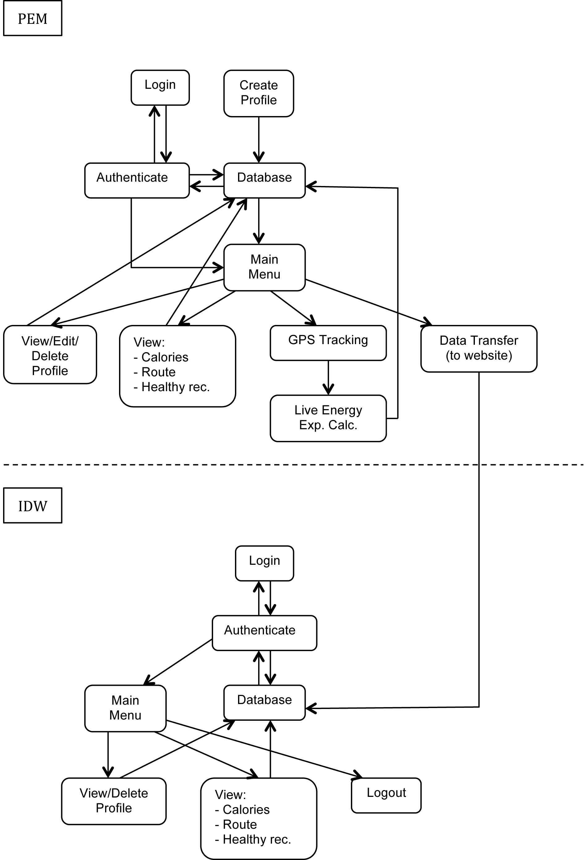

Initial object diagram showing interaction between PEM and IDW (aka. PEMWEBAPP)

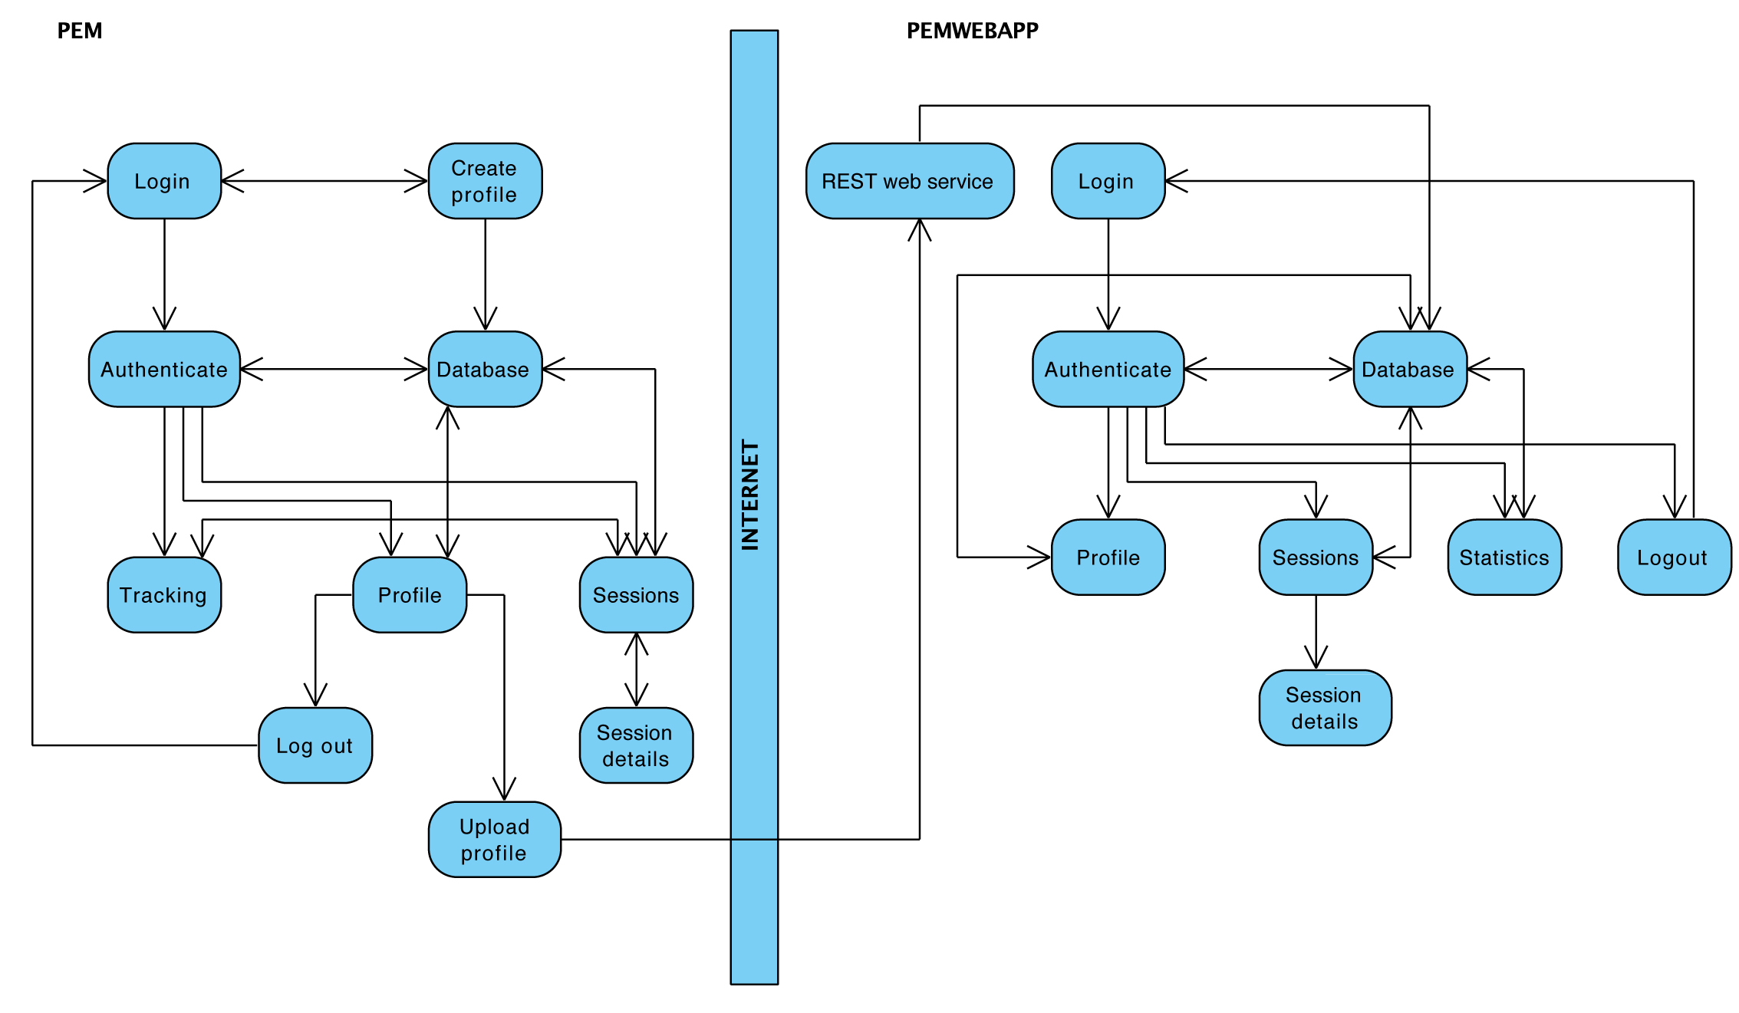

Improved object diagram showing interaction between PEM and PEMWEBAPP

**Project Plan**

**Project Outline**

The goal of the project is to develop a system that can estimate user’s energy expenditure and advice him/her about their personal wellbeing or about wellbeing of the planetary environment. The main idea is to implement an iPhone application, which will be able to receive GPS data and perform live calculations of Calorie expenditure and CO2 emissions. The basic implementation of this application requires that user performs some activity, which involves location movement.

More advanced implementation (using the project extensions) will allow user to perform any physical activity. This means that except GPS data, the application will be able to process heartbeat signals and accelerometer data.

The system is split into two parts, the Personal Energy Meter (PEM) which is an iPhone application and web application (PEMWEBAPP). Implementation of PEMWEBAPP has two purposes. First, is to receive data from PEM and present them in better graphical way using all real estate of computer monitor. Second, to demonstrate skills acquired during a course of study.

**Project Schedule**

There are several important milestones for this project and each of those has several key tasks that must be performed. More information is given in the phase plan.

The main milestones for the project include:

* **General research** of the problem the project is concerned with, and production of the project plan overall (including the  creation of this document as a guideline for the rest of the project, as well as being used  as a general schedule).
* **Requirements Analysis**, aimed at finding all ambiguities,  and determining exactly what the customer/user wants. This will include a decision on which  design model to use.
* **Design of the system**, which will help to determine how the applications will be structured given the limits and freedoms determined within the requirements Analysis phase.
* **Implementation and Testing**, the stage in which the actual software systems are developed, using the designs created in previous stage. Many different ways of checking that the completed applications are of a good standard and implementation is on schedule will also be included here.
* **Evaluation** stage will be concerned with answering the questions whether the systems implemented solved given problem, how well they solved it and how accurately the solution matches with requirements. Here will also be included material about how accurate the results from the PEM were to real biological measurements of energy expenditure.

**Phase plan:**

**General research – phase plan**

1. Literature reviews
   1. Research materials about GPS systems
   2. Research materials about Accelerometer
   3. Research materials about human wellbeing by physical activity
   4. Research materials about human calories expenditure
   5. Research materials about iPhone development and iOS SDK
   6. Research materials about Objective-C
   7. Research materials about Java EE 6, Tomcat, GlassFish
   8. Follow the book “Projects in Computing and Information Systems”
2. Meeting with customer/user
   1. Meetings with project supervisor
   2. Getting feedback on application prototypes from friends
3. Write the project proposal

**Requirements Analysis – phase plan**

1. Requirements discovery
   1. User scenarios
   2. Customer/supervisor meetings
2. Requirements classification and organization
   1. Organizing and clarifying what has been gathered from customer/users
3. Requirements prioritization and negotiation
   1. Negotiating possible changes with customer/users and advice them on better suitable alternatives to meet the deadlines/budged
4. Requirements specification
   1. Clearing out ambiguities
   2. Producing a document which will act as a contract between customer and developer
5. Write the interim report

**Design – phase plan**

1. PEM (Objective-C)
   1. High and low level design for Profile manager
   2. High and low level design for Login with authentication
   3. High and low level design for Database (Apple’s Core data)
   4. High and low level design for Statistics
   5. High and low level design for GPS tracking
   6. High and low level design for Live energy expenditure calculation
   7. High and low level design for Data transfer
2. PEMWEBAPP (Java)
   1. High and low level design for Login with authentication
   2. High and low level design Profile view
   3. High and low level design Database (MySQL)
   4. High and low level design Statistics

Subtasks of tasks above will consist of creating appropriate architectural design and UML diagrams, which will be later used in the implementation stage.

**Implementation and Testing – phase plan**

The aim is to start as soon as possible without having to wait for total completion of solid software design – hence the agile development model. Modularization is used and attention is focused on some parts of the project, which will not change. In this way, implementation can start with only partial design. This strategy will be necessary in order to allow for any unforeseen complications in the design or implementation.

1. Set up version control in Git
2. PEM development
   1. Implement Profile manager module
   2. Implement Login with authentication module
   3. Implement Database module
   4. Implement Statistics module
   5. Implement GPS tracking module
   6. Implement Live energy expenditure calculation module
   7. Implement Data transfer module

Subtasks of the PEM development tasks will consist of:

* Interpreting high and low level design diagrams in Objective-C language and trying to predict any deviations from the design.
* Coding the agreed design
* De-bugging
* Refactoring for better code structure
* Writing a test cases

1. PEMWEBAPP development
   1. Implement Login with authentication module
   2. Implement Profile view module
   3. Implement Database module
   4. Implement Statistics module

Subtasks of the PEMWEBAPP development tasks will consist of:

* Interpreting high and low level design diagrams in Java language and trying to predict any deviations from the design.
* Coding the agreed design
* De-bugging
* Refactoring for better code structure
* Writing a test cases

**Evaluation – phase plan**

1. Evaluation of how well the systems meet customer/user requirement
   1. There will be feedback received from the customer/user throughout the development process. Prototypes of the systems will be released in intervals to ensure meeting the requirements as closely as possible
2. Evaluation of how the systems are reliable
   1. One of the extension features is to ensure the reliability of the PEM system by researching deep into iPhone Location Services and Accelerometer and utilizing full power of the hardware. Task of this part of evaluation will be proving the reliability of PEM in extreme conditions where two or more technologies might by interchanging in live energy expenditure monitoring mode.
3. Evaluation of how the systems are accurate
   1. In this part of the evaluation phase real biological results of obtained from health centers or fitness centers will be compared to those calculated by PEM. Results maybe obtained on request from staff or by measuring calorie expenditure of myself on treadmill. This is very important part to having a product, which has some value at the end of the development. Note that it is also one of the extensions and not a priority to complete project.

**Time estimates**

Some progress on the project has already been made in form of gathering required literature, Requirements Analysis and PEM prototype implementation. Documents produced in the Requirements Analysis phase should only change if the extensions will be implemented and they will only change in terms of adding some functionality and not changing a core specification.

Work expected in second term should include completion of high and low level design and more usable prototypes of PEM and PEMWEBAPP with most of the required functionality. Time has also been allowed for writing a draft report.

Activity-on-node diagrams below show estimates of the time to complete both PEM and PEMWEBAPP systems. The figures have been estimated with constraints of learning new programming language in mind.

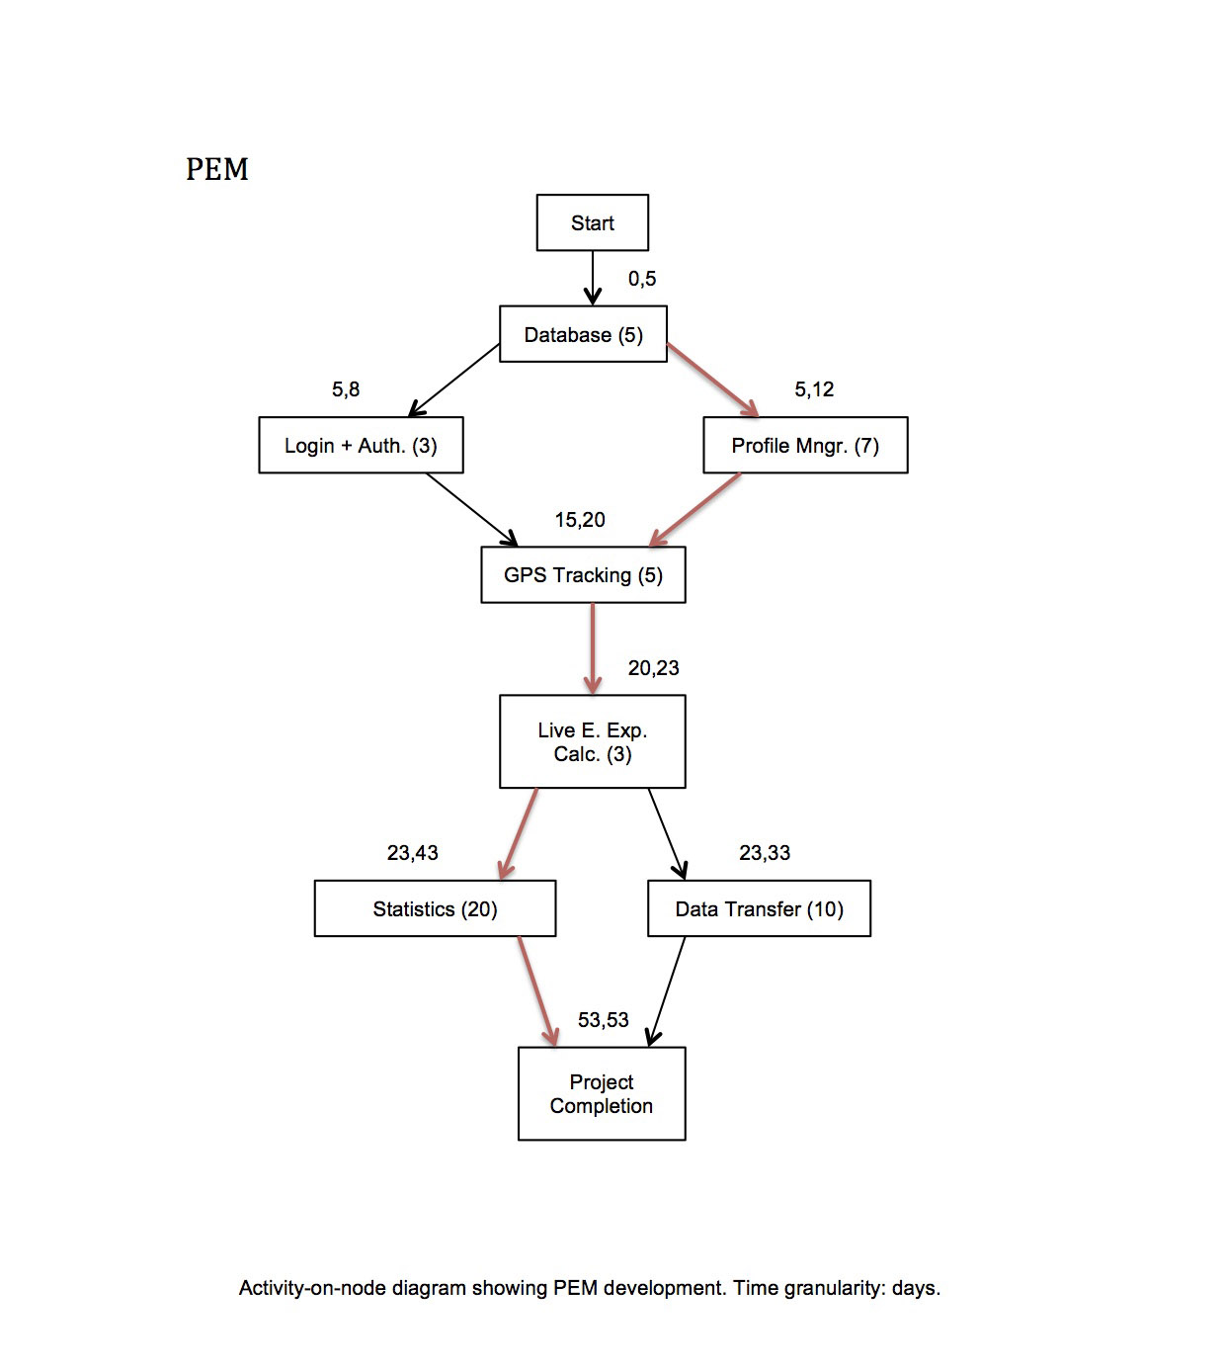

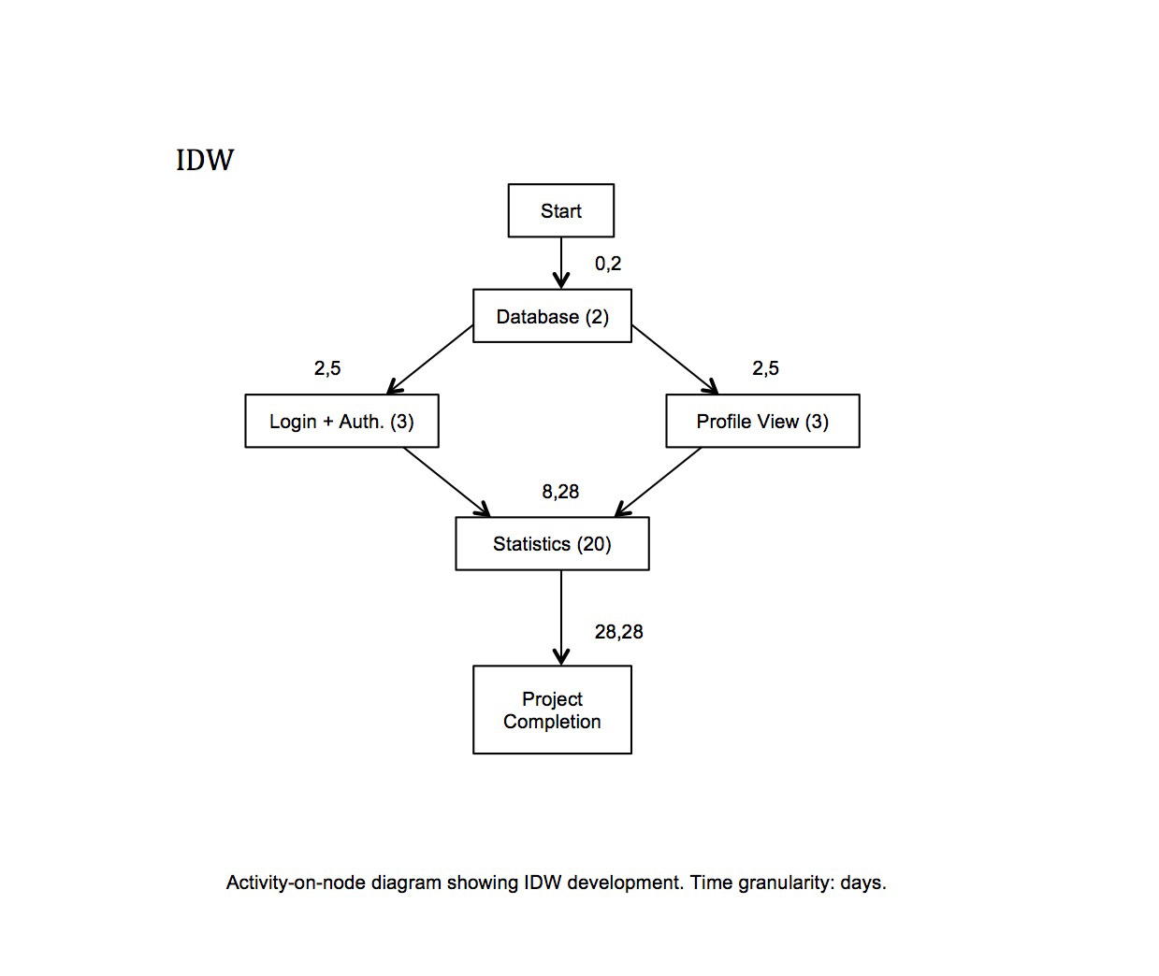

* **Problem specification**
* **Design**

Introduction

As already mentioned, the agile software development method was most appropriate for this project and therefore there was no solid design during the development of PEM and PEMWEBAPP.

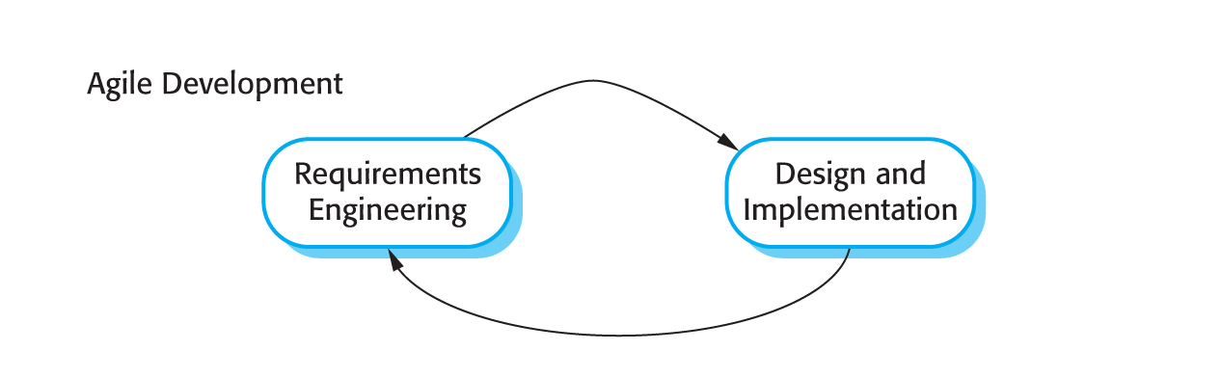

[REF – Chapter 3.2]

The design was being developed continuously by getting ideas, proposing solutions, and refining these solutions as information became available. Many times there was a need to backtrack and re-design when problems arose [REF – Chapter 7.1]. Paper sketches and Xcode’s storyboards were the only key documents from which the development progressed. There was a time when vast majority of the PEM had to be redesigned as knowledge of an iPhone development improved.

Initial paper sketch scan….

Initial storyboard image….

* **Implementation**
* **Evaluation / testing**

**9. Conclusion**

**10. References**

**11. Appendices**

* **Logs**

**Interim Log**

**22 Sep 2011, 1pm** - Initial meeting, focusing on the project topic

**03 Oct 2011, 4pm** - Discussed further chosen topic, its objectives and extensions

**10 Oct 2011, 12.30pm** - Demonstration of my first iPhone application

**17 Oct 2011, 12.30pm** - Discussed focus on starting to program ASAP even before the design is completely done (emphasis on agile method)

**24 Oct 2011, 4pm** - Demo of my GPS data gathering app, discussion of signal processing methods to improve accuracy of energy expenditure, discussion of GPS data storage

**31 Oct 2011, 12.30pm** - Demo of my iPhone app and the storage implemented using Apple’s Core Data

**07 Nov 2011, 12.30pm** – Demonstrating the first PEM prototype, discussion about GPS altitude accuracy

**Project Proposal**

**Name:** Vladimir Hartmann

**Name of supervisor:** Dr. Martin Berger

**Working title:** Estimating personal energy expenditure with location data  
*(based on previous work of Simon Hay, Stamatina Th. Rassia, Alastair R. Beresford at University of Cambridge)*

**Aims and objectives:**

Modern society is putting unsustainable demands on personal wellbeing as well as the wellbeing of the planet. Pervasive sedentary lifestyle has been creating many health conditions while excess in energy consumption has had adverse effects on our ecosystem. There is a clear connection between personal and planetary wellbeing and actions that help to improve our own health often have a positive effect on our environment. Location data such as GPS tracking can be utilised to address both issues. As it is most frequently collected piece of contextual data in computing, it can be applied to many healthcare applications. This technique offers a number of improvements over traditional methods which involve carrying a dedicated accelerometer device.

Aim: To estimatepersonal energy expenditure and provide healthy recommendations for personal and planetary wellbeing.

Objectives:

Primary: **Design and develop the Personal Energy Meter (PEM), an iPhone application that is capable of:**

* Capture and process GPS data
* Calculate calories expenditure using an Energy Consumption Model
* Calculate a carbon footprint
* Graphically output the results of the calculations
* Give recommendations on personal and planetary wellbeing

**Design and develop an interactive website which is capable of:**

* Create and maintain user profiles
* Receive and process the data from the PEM, an iPhone application
* Graphically output the results of the calculations
* Give recommendations on personal and planetary wellbeing

Extensions:

* More precise GPS data processing by PEM
  + Live GPS data categorisation (walking, driving car, running, using public transport)
  + iPhone in-built headphones microphone integration for capturing the heartbeat (for estimating energy expenditure indoors where high volume of energy can be used for example in the gym or climbing stairs)
* Validation of the Energy Consumption Model with real biomedical measurements
* Improve accuracy and reliability of capturing the GPS data
* Share the personal energy expenditure data with other users
* Energy expenditure trends visualisation (personal, carbon footprint)

**Relevance:**

This project is suitable for me to undertake as I can use the knowledge I have acquired from previous years in areas of:

* Programming Languages (I have learned the fundamental principles of programming languages so I am confident to learn Objective C, language needed for an iPhone development)
* Databases (both PEM and the website will need a database)
* HCI (to be able to build right, useful and easy to use GUIs)
* Software Engineering (inevitable for undertaking any project of this size)
* Machine Learning (needed for processing/categorising large amounts of gathered GPS data)
* Networks (very useful for data transfer and online security of this project)
* Web Development (useful for developing the interactive website)

**Personal weekly timetable**

|  |  |  |  |  |  |  |  |
| --- | --- | --- | --- | --- | --- | --- | --- |
| Time | Monday | Tuesday | Wednesday | Thursday | Friday | Saturday | Sunday |
| 08:00 |  |  |  |  |  |  |  |
| 09:00 |  |  |  |  |  |  |  |
| 10:00 |  | Project work |  | Project work |  |  |  |
| 11:00 |  |  |  |  |  |
| 12:00 |  | Lecture | Lecture | Work | Work |
| 13:00 | Lecture |  |  |
| 14:00 | Seminar | Class | Project work |
| 15:00 |  | Society |
| 16:00 | Term module  study | Gym |
| 17:00 | Term module  study | Term module  study |  |
| 18:00 | Project work |
| 19:00 |  |  |  |
| 20:00 | Project work | Skating | Project work |
| 21:00 |
| 22:00 |  |  |
| 23:00 |  |  |
| 24:00 |  |  |  |  |  |  |  |

*Project work: 34h/w*

**Resources required:**

* Mac OSX based computer
* iPhone

All available

**Bibliography of background reading**

* Beginning iPhone Development: Exploring the iPhone SDK (Dave Mark, Jeff LaMarche)
* Learn Objective-C on the Mac (Mark Dalrymple, Scott Knaster)
* Beginning Java EE 6 with GlassFish 3 2nd Edition (Antonio Goncalves)
* Computing for the future of the planet (A. Hopper and A. Rice)
* A global personal energy meter (S. Hay)
* Location systems for ubiquitous computing (J. Hightower and G. Borriello)
* Time spent being sedentary and weight gain in healthy adults (U. Ekelund, S. Brage, H. Besson, S. Sharp, and N. J. Wareham)
* The anatomy of a context-aware application (A. Harter, A. Hopper, P. Steggles, A. Ward, and P. Webster)
* Implementing a sentient computing system (M. Addlesee, R. Curwen, S. Hodges, J. F. Newman, P. Steggles, A. Ward, and A. Hopper)

**List of other students doing related projects**

None

**Interim log**

* 22 September 2011, 1pm – Initial meeting, focusing on the project topic
* 03 October 2011, 4pm – Discussed further chosen topic, its objectives and extensions
* 10 October 2011, 12.30pm – Demonstration of my first iPhone application
* 17 October 2011, 12.30pm – Discussed focus on starting to program ASAP even before the design is completely done (emphasis on agile method)
* **System data**
* **Test data**