Exercitiul 1
1.1 X si Y sunt repartizate uniform, deci $f\left(x\right)=\frac{1}{b-a}$.
$$f_{X}\left(x\right)=\frac{1}{1-(-1)}=\frac{1}{2}$$
$$f_{Y}\left(y\right)=\frac{1}{1-(-1)}=\frac{1}{2}$$
X, Y independente, deci $f_{\left(X,Y\right)}\left(x,y\right)=f_{X}\left(x\right)* f_{Y}\left(y\right)=\frac{1}{4}$

Definitia denistatii unei repartitii uniforme pe o suprafata este $\frac{1}{Arie}$
Arie patrat pe [-1,1] este 4, deci $f_{\left(X,Y\right)}\left(x,y\right)=\frac{1}{4}$
Deoarece densitatea calculata prin independenta este egala cu definitia teoretica a densitatii pe patrat, metoda este corecta.
1.2
library(ggplot2)

set.seed(123)

N <- 1000 # 1000 de puncte
x_square <- runif(N, min = -1, max = 1) # in patratul [-1, 1]
y_square <- runif(N, min = -1, max = 1)

#distanta fata de origine
distanta <- sqrt(x_square^2 + y_square^2)

# conditia de acceptare
# daca distanta de la (0,0) pana la (x,y) <= 1 atunci punctul se afla in cerc
acceptat <- distanta <= 1

#data frame pentru plotare
df_respingere <- data.frame(
x = x_square,
y = y_square,
Tip = ifelse(acceptat, "Interior (Acceptat)", "Exterior (Respins)"),
Dist = distanta
)

p1 <- ggplot(df_respingere, aes(x = x, y = y, color = Tip)) +
geom_point(alpha = 0.6) +
#cercul unitate pentru referinta
annotate("path",
x = cos(seq(0, 2*pi, length.out = 100)),
y = sin(seq(0, 2*pi, length.out = 100)),
color = "black", size = 1) +
coord_fixed() #pastreaza aspectul de cerc
scale_color_manual(values = c("red", "blue")) +
theme_minimal() +
labs(title = "Metoda 1: Acceptare-Respingere",
subtitle = "Puncte generate uniform in patrat [-1, 1]",
x = "X", y = "Y")

print(p1)

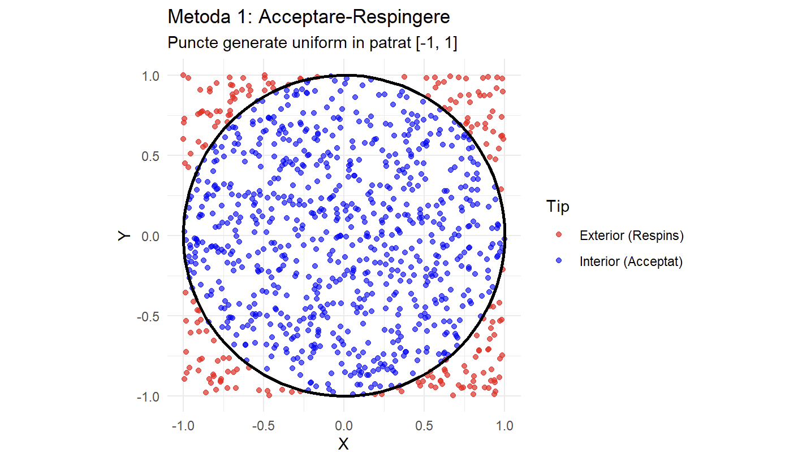
1.3
# Luam doar punctele acceptate
puncte_disc <- df_respingere[df_respingere$Tip == "Interior (Acceptat)", ]
media_empirica <- mean(puncte_disc$Dist) # medie aritmetica
media_teoretica <- 2/3

cat(" Rezultate Metoda 1 \n")
cat("Numar puncte acceptate:", nrow(puncte_disc), "\n")
cat("Media distantei (Empiric):", round(media_empirica, 4), "\n")
cat("Media distantei (Teoretic):", round(media_teoretica, 4), "\n")

cat("Eroare absoluta:", abs(media_empirica - media_teoretica), "\n\n")
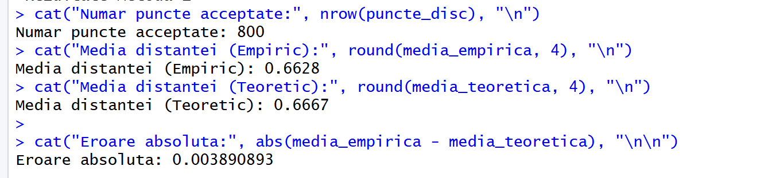
Cum am calculat media teoretica:
$$E= \iint_{D(1)}{\sqrt{{(x}^{2}+y^{2}}*f(x,y) }dx dy$$
$$E= \iint_{D(1)}{\sqrt{{(x}^{2}+y^{2}}*\frac{1}{π} }dx dy$$
$$E= \frac{1}{π}\iint_{D(1)}{\sqrt{{(x}^{2}+y^{2}} }dx dy$$
Pentru a rezolva integrala, trecem la coordinate polare.
$$x=r cos⁡(θ)$$
$$y=r\sin{(θ)}$$
$$E =\frac{1}{π} \int_{0}^{2π}{\int_{0}^{1}{\sqrt{r^{2}}}}∙r dr dθ =\frac{1}{π}\int_{0}^{2π}{\int_{0}^{1}{r^{2}}} dr dθ= \frac{1}{π}\int_{0}^{2π}{ {\frac{r^{3}}{3}}_{0}^{1}}dθ= \frac{1}{π}\int_{0}^{2π}{\frac{1}{3}}dθ=\frac{2π}{3π}=\frac{2}{3}$$
1.4
$$f_{θ\left(θ\right)}= \int_{0}^{1}{f_{R,θ}\left(r, θ\right)dr}= \int_{0}^{1}{\left(\frac{r}{π}\right)dr}$$
$$f_{θ\left(θ\right)}=\frac{1}{π}⋅{\left[\frac{r^{2}}{2}\right]}_{0}^{1}=\frac{1}{2π}$$
$f_{R}\left(r\right)= \int_{0}^{2π}{f_{R,θ}\left(r, θ\right)dθ}= \int_{0}^{2π}{\left(\frac{r}{π}\right)dθ}$
$$f_{R}\left(r\right)=\frac{r}{π}⋅{\left[θ\right]}_{0}^{2π}=\frac{r}{π}⋅2π = 2r$$
1.5
theta <- runif(N, 0, 2*pi)
# daca folosesc doar runif(N, 0, 1), punctele se aglomereaza in centru
r <- sqrt(runif(N, 0, 1))

# Conversia in cartezian
x_polar <- r * cos(theta)
y_polar <- r * sin(theta)

df_polar <- data.frame(x = x_polar, y = y_polar)

p2 <- ggplot(df_polar, aes(x = x, y = y)) +
geom_point(color = "darkgreen", alpha = 0.6) +
annotate("path",
x = cos(seq(0, 2*pi, length.out = 100)),
y = sin(seq(0, 2*pi, length.out = 100)),
color = "black", size = 1) +
coord_fixed(xlim = c(-1, 1), ylim = c(-1, 1)) +
theme_minimal() +
labs(title = "Metoda 2: Coordonate Polare",
x = "X", y = "Y")

print(p2)
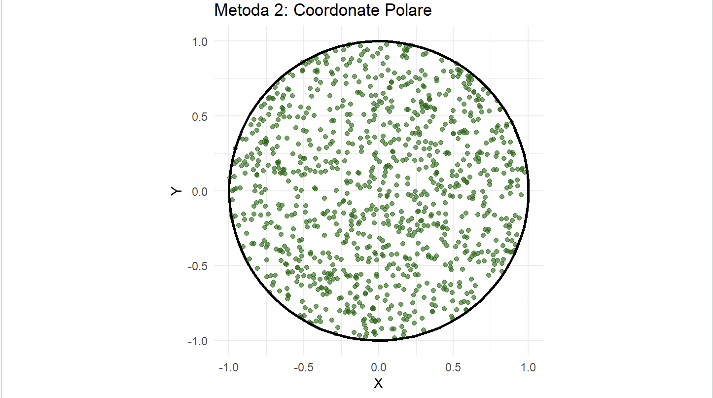

- Am folosit ggplot2 pentru vizualizari mai bune
Probleme indentificate:
- Intelegerea necesitatii transformarii inverse a functiei de repartitie pentru raza in metoda polara. Fara sqrt, distributia nu ar fi fost uniforma pe suprafata (puncte aglomerate in centru).
- Implementarea vizualizarii coord_fixed() in ggplot2 pentru a preveni deformarea cercului in elipsa din cauza scalarii axelor monitorului.

Exercitiul 3
A )
A.1 Abordare din punct de vedere theoretic.
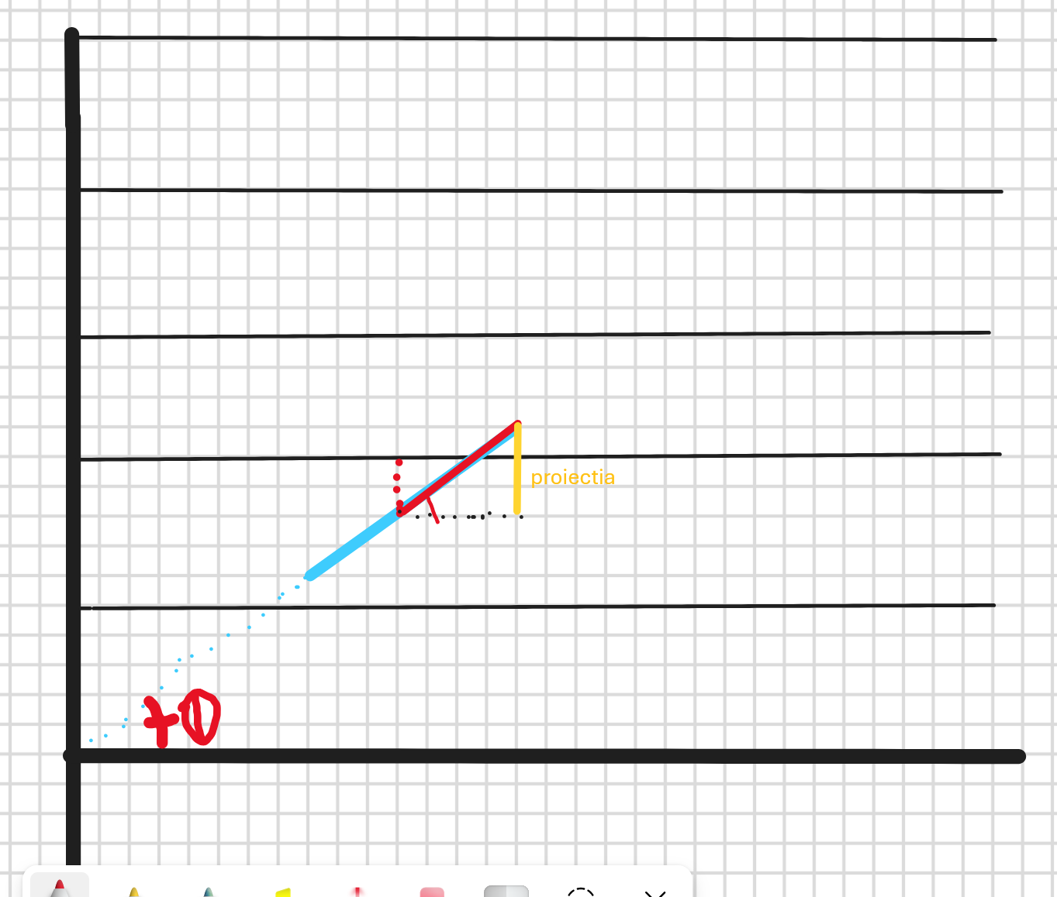
Intuitiv: Daca distanta de la centrul acului ( [0,1/2 ] ) pana la cea mai apropiata linie este mai mica sau egala decat proiectia jumatati acului, atunci acul se intersectaeza cu o linie.
$$Fie x distanta de la centrul acului la cea mai apropiata dreapta.$$
$$x apartine [0,1/2] ( deoarece lungimea acului este 1,$$
$$daca x > ½ atunci nu ne referim la cea mai apropiata dreapta).$$
$Fie θ unghiul la care a cazut acul. θ∈\left[0,\frac{π}{2}\right]$
$$Pentru a calcula lungimea proiectiei\left(pr\right)ne folosim de sin\left(θ\right)=\frac{cateta opusa}{ipotenuza}=\frac{pr}{\frac{1}{2}}=>pr=\frac{1}{2} sin⁡(θ)$$
$$Deci\frac{1}{2}\sin\left(θ\right)≥x =>acul se intersecteaza cu o dreapta.$$
Calculul probabilitatii. Probabilitatea este raportul dintre aria regiunii favorabile si aria saptiului probelor.
$P=\frac{\int_{0}^{\frac{π}{2}}{\frac{1}{2}\sin\left(θ\right)dθ}}{\int_{0}^{\frac{π}{2}}{\frac{1}{2}dθ}}=\frac{\frac{1}{2}⋅\left({-\cos\left(θ\right)}_{0}^{\frac{π}{2}}\right)}{\frac{1}{2}⋅\frac{π}{2}}=\frac{\frac{1}{2}}{\frac{π}{4}}=\frac{2}{π}$
A.2 Abordare prin simulari.
library(ggplot2)

set.seed(123)
N <- 1000

#a

# distanta centrului acului fata de cea mai apropiata linie (x in [0, 0.5])
x <- runif(N, 0, 0.5)
# unghiul format de ac cu liniile (theta in [0, pi/2])
theta <- runif(N, 0, pi/2)

# conditia de intersectie: (1/2)*sin(theta) >= x
intersecteaza_a <- (0.5 * sin(theta)) >= x
prob_a <- sum(intersecteaza_a) / N
pi_estimat_a <- 2 / prob_a

cat("Probabilitate estimata (Empiric):", round(prob_a, 4), "\n")
cat("Probabilitate teoretica (2/pi):", round(2/pi, 4), "\n")

B)
$$Fie I_{1} 1 daca acul 1 se intersecteaza cu o dreapta, 0 altfel$$
$$I_{2} 1 daca acul 2 se intersecteaza cu o dreapta, 0 altfel$$
$$Z= I_{1}+ I_{2} este numarul de intersectii$$
$$din subpunctul a stim P\left(I_{1}=1\right)=P\left(I_{2}=1\right)=\frac{π}{2}$$
$Calculam media E[\frac{Z}{2}$]
$$E\left[\frac{Z}{2}\right]=\frac{1}{2}E\left[Z\right]=\frac{1}{2}E\left[I_{1}+I_{2}\right]=\frac{1}{2}E\left[I_{1}\right]+E\left[I_{2}\right]=\frac{1}{2} \left(\frac{2}{π}+\frac{2}{π}\right)=\frac{2}{π}$$
$$Calculam Var\left(\frac{Z}{2}\right)$$
$$Var\left(\frac{Z}{2}\right)=E\left[{\left(\frac{Z}{2}\right)}^{2}\right]-E{\left[\frac{Z}{2}\right]}^{2}$$
$$E\left[{\left(\frac{Z}{2}\right)}^{2}\right]=\frac{1}{4}E\left[{\left(I_{1}\right)}^{2}+{2I}_{1}I_{2}{+\left(I_{2}\right)}^{2}\right]=E\left[I_{1}+I_{2}+ {2I}_{1}I_{2}\right]=\frac{1}{4}(E\left[Z\right]+2E\left[I_{1}I_{2}\right])$$
$=\frac{4}{π}+2P(I_{1}=1 ∩ I_{2}=1)$
$$Continuand ideea de la punctul a$$
$$Conditia de intersectie pentru acul 1 este \frac{1}{2}\sin\left(θ\right)≥x$$
$$Conditia de intersectie pentru acul 2 este\frac{1}{2}\sin\left(θ+\frac{π}{2}\right)≥x =>\frac{1}{2}\cos\left(θ\right)≥x.$$
$$Pentru ca acul 2 este perpendicular pe acul 1.$$
$$Pentru ca ambele sa se intample simultan x≤\min\left(\frac{1}{2}\sin\left(θ\right),\frac{1}{2}\cos\left(θ\right)\right)$$
$$P\left(I_{1}=1∩ I_{2}=1\right)= \int_{0}^{\frac{π}{2}}{\min\left(\frac{1}{2}\sin\left(θ\right),\frac{1}{2}\cos\left(θ\right)\right)dθ}= \int_{0}^{\frac{π}{4}}{\frac{1}{2}\sin\left(θ\right)dθ}+ \int_{\frac{π}{4}}^{\frac{π}{2}}{\frac{1}{2}\cos\left(θ\right) dθ}$$
$$=\frac{1}{2}\left(-\frac{\sqrt{2}}{2}-\left(-1\right)\right)+\frac{1}{2}\left(1-\frac{\sqrt{2}}{2}\right)=1-\frac{\sqrt{2}}{2}$$
$$P\left(I_{1}∩I_{2}\right)=\frac{1-\frac{\sqrt{2}}{2}}{\frac{π}{4}}=\frac{4-2\sqrt{2}}{π}$$
$E\left[{\left(\frac{Z}{2}\right)}^{2}\right]=\frac{1}{4}\left(\frac{4}{π}+2\left(\frac{4-2\sqrt{2}}{π}\right)\right)=\frac{1}{4}\left(\frac{12-4\sqrt{2}}{π}\right)=\frac{3-\sqrt{2}}{π}$
$$E{\left[\frac{Z}{2}\right]}^{2}=\frac{4}{π^{2}}$$
$$Var\left(\frac{Z}{2}\right)=\frac{3-\sqrt{2}}{π}-\frac{4}{π^{2}}$$
B.2 prin simulare
#b
N <- 10001

# distanta centrului acului fata de cea mai apropiata linie (x in [0, 0.5])
x <- runif(N, 0, 0.5)
# unghiul format de ac cu liniile (theta in [0, pi/2])
theta <- runif(N, 0, pi/2)
intersecteaza_ac1 <- (0.5 * sin(theta)) >= x
intersecteaza_ac2 <- (0.5 * cos(theta)) >= x

Z <- as.numeric(intersecteaza_ac1) + as.numeric(intersecteaza_ac2)
media_Z_pe_2 <- mean(Z/2)
var_Z_pe_2 <- var(Z/2)

cat("Media E[Z/2] (Empiric):", round(media_Z_pe_2, 4), "\n")
cat("Media E[Z/2] (Teoretic):", round(2/pi, 4), "\n")
cat("Varianta Var(Z/2) (Empiric):", round(var_Z_pe_2, 4), "\n")

Pentru aproximarea lui pi as alege metoda simularii pentru cruce, deoarece are variatia mai mica.

C)
C.1 teoretic
d lungimea acului
$$Redefinim x∈\left[0,\frac{d}{2}\right], θ∈\left[0,\frac{π}{2}\right]$$
$$Spatiul Total al Probelor=A=\frac{d}{2}⋅\frac{π}{2}=\frac{d⋅π}{4 }$$
$$Conditia de intersectie:x≤\frac{L}{2}\sin\left(θ\right)$$
$$A_{fav}= \int_{0}^{\frac{π}{2}}{\frac{L}{2}\sin\left(θ\right)dθ}=\frac{L}{2} \left( 0-\left(-1\right)\right)=\frac{L}{2}$$
$$P=\frac{\frac{L}{2}}{\frac{πd}{4}}=\frac{2L}{πd }$$
c.2
#c
L <- 0.7
d <- 1.2
x_centru_c <- runif(N, 0, d/2)
intersecteaza_c <- (L/2 * sin(theta)) >= x_centru_c
prob_c <- sum(intersecteaza_c) / N

cat("Probabilitate estimata (Empiric):", round(prob_c, 4), "\n")
cat("Probabilitate teoretica (2L/pid):", round((2*L)/(pi*d), 4), "\n")

