Task 1

Started Jenkins using Docker:
docker run -p 8080:8080 -p 50000:50000 --restart=on-failure -v jenkins_home:/var/jenkins_home jenkins/jenkins:lts-jdk21

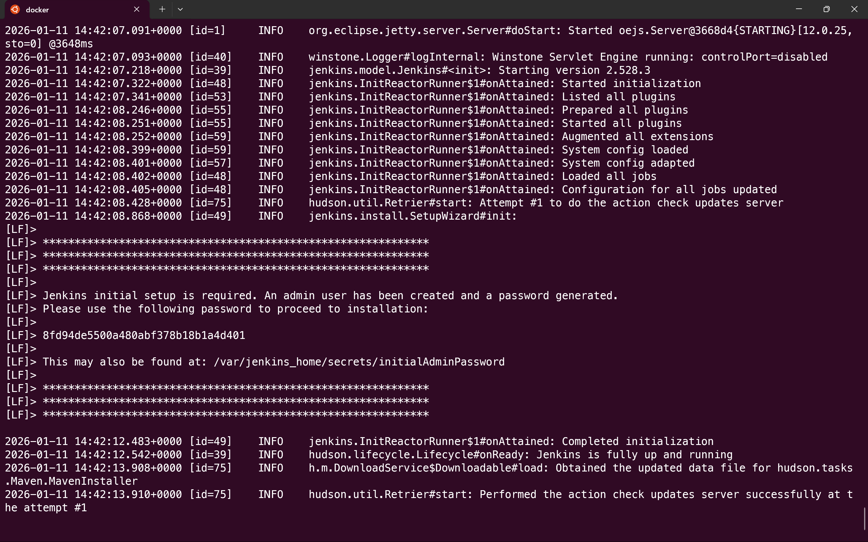
Created the initial admin user during Jenkins setup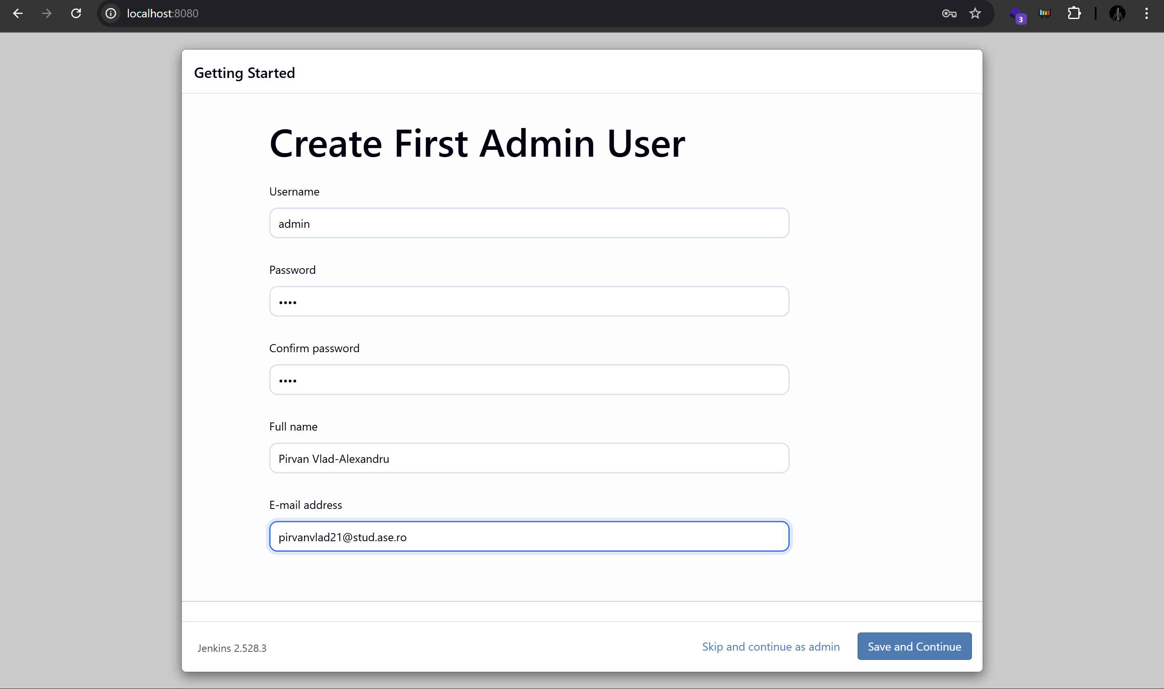
Accessed the Jenkins main dashboard at localhost:8080
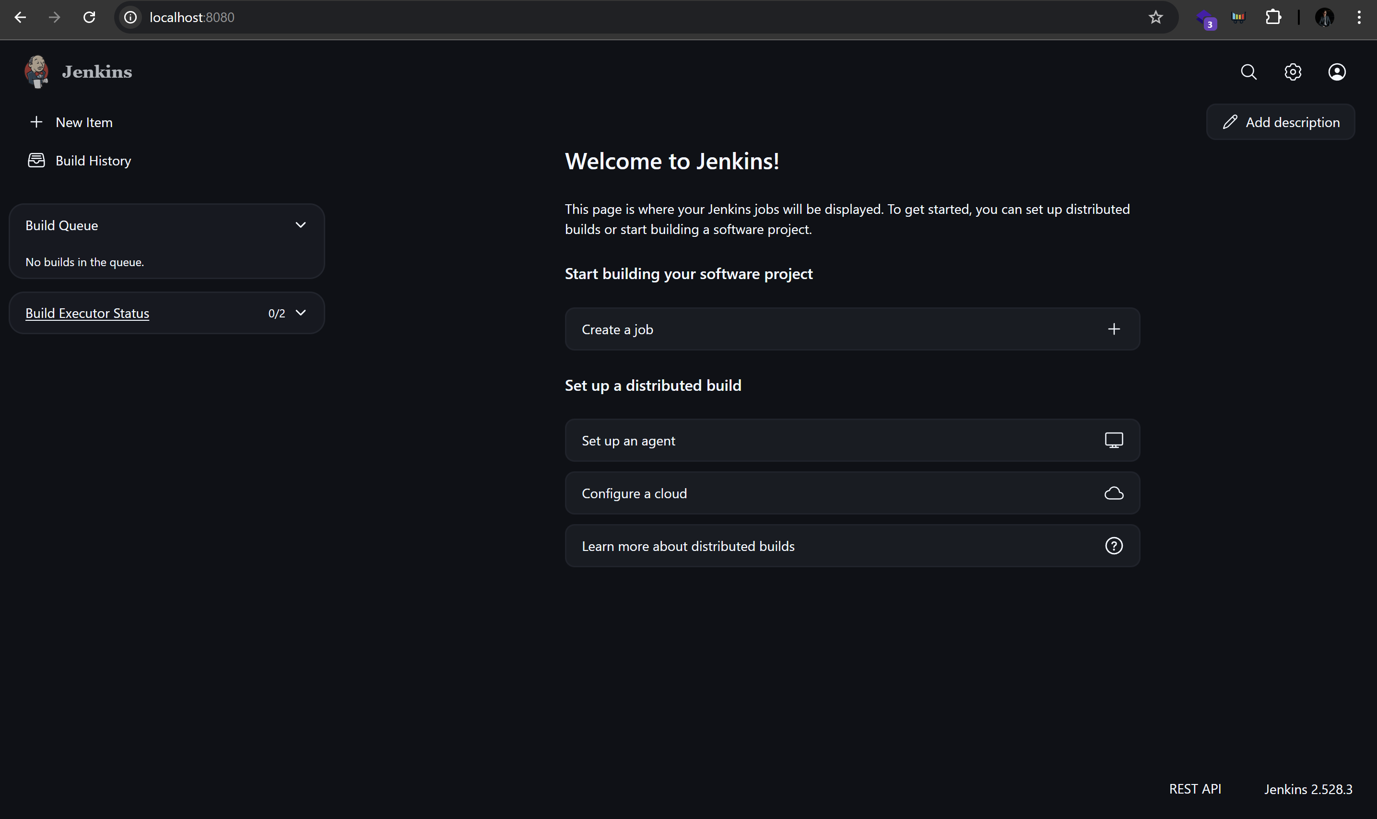
Created a Freestyle parameterized. Added a String parameter that allows the user to choose which Junit TestCase class to execute.
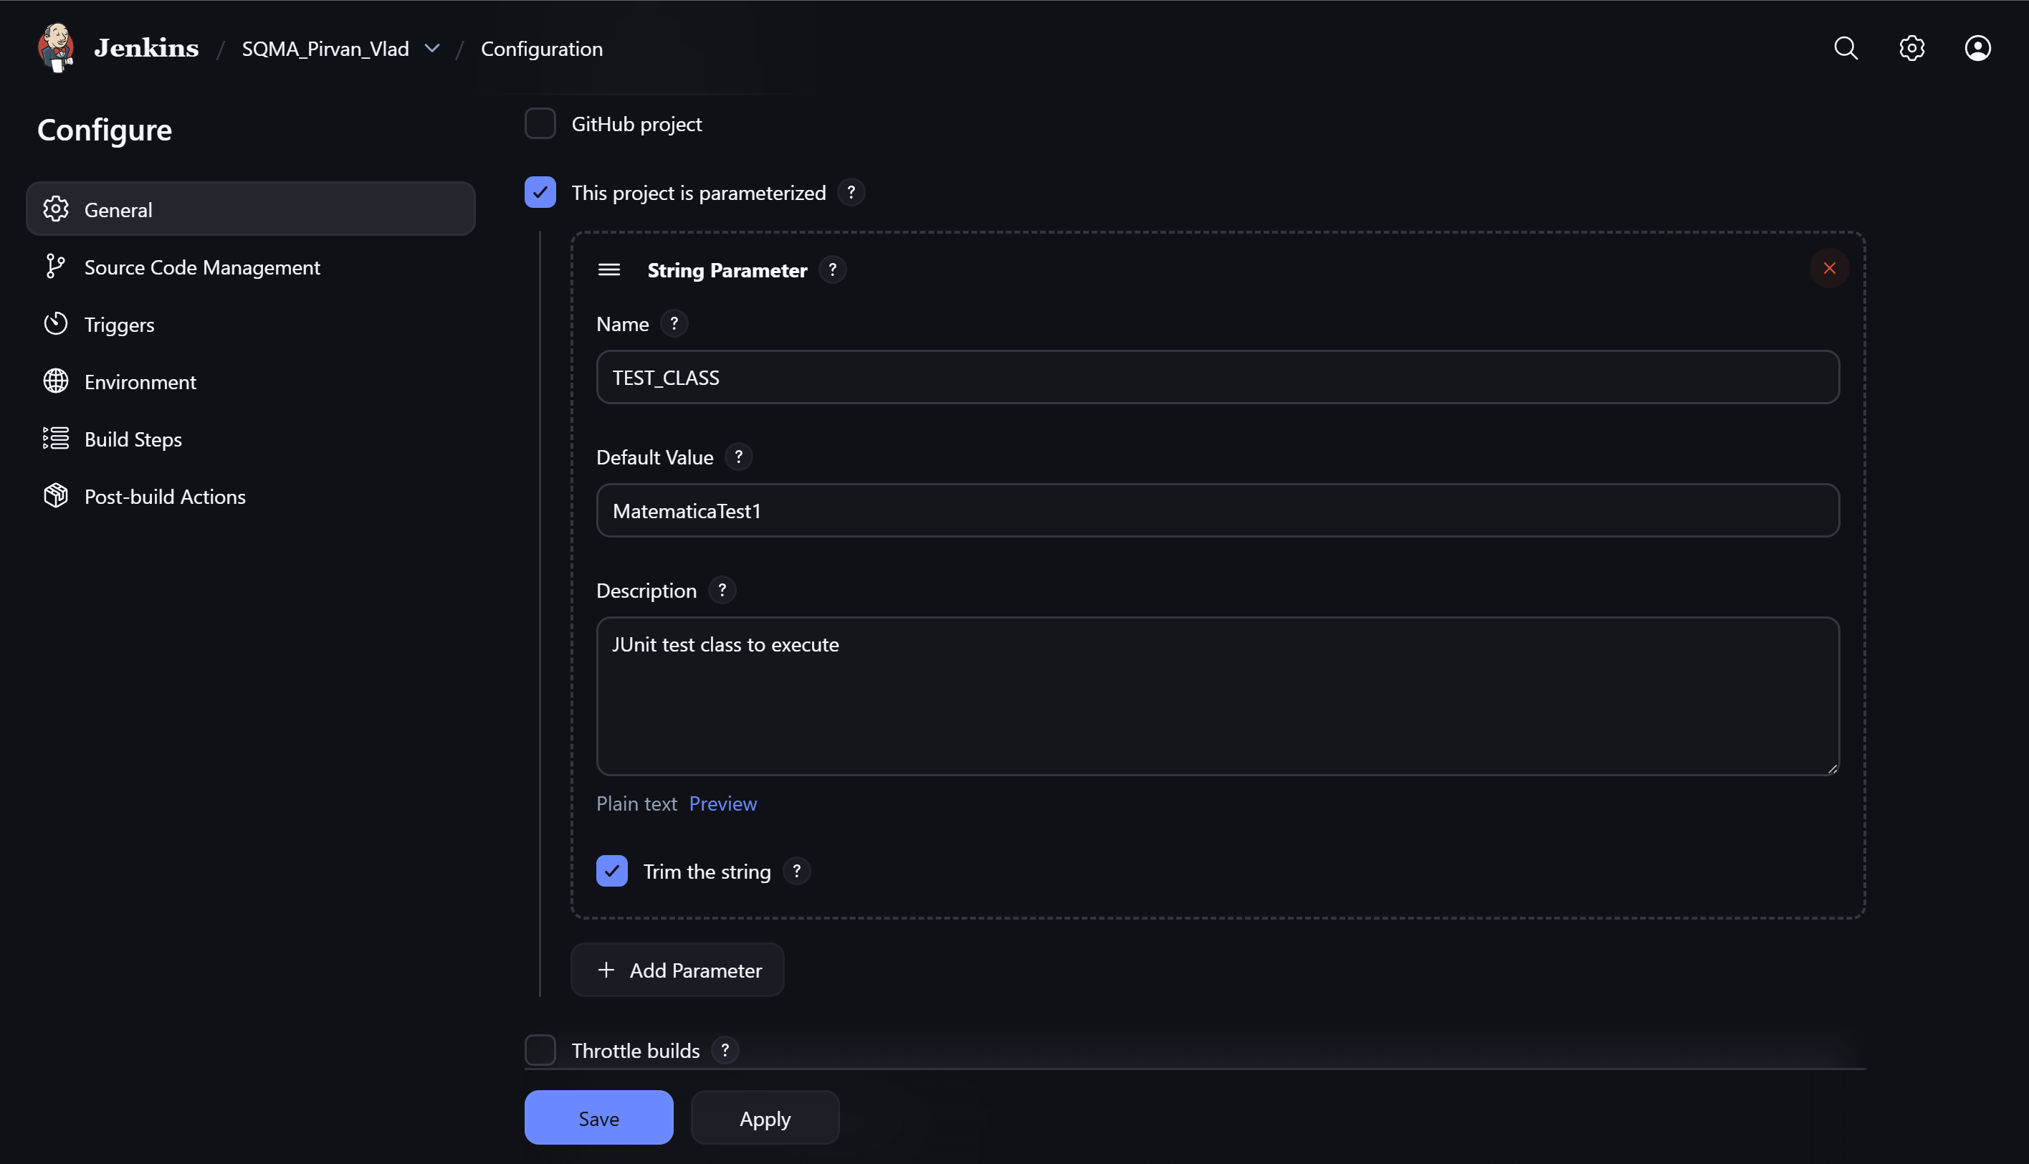
Configured Source Code Management to connect to the GitHub repository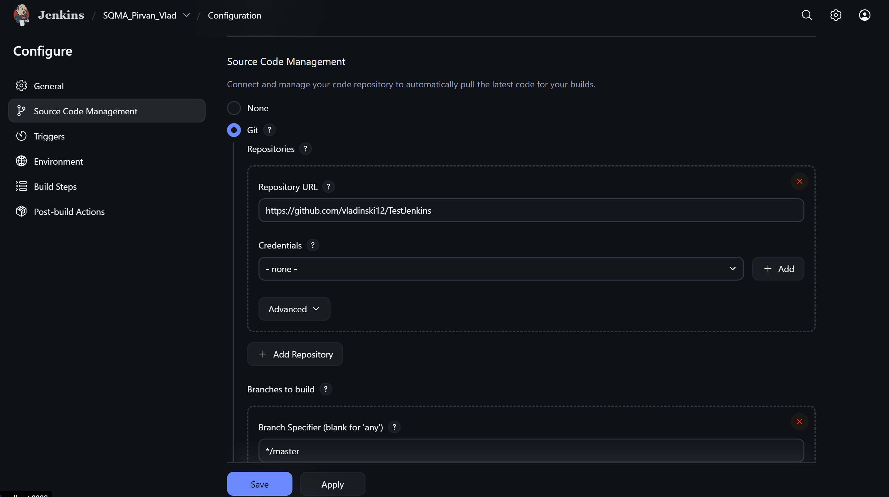
Configured the Build step using Maven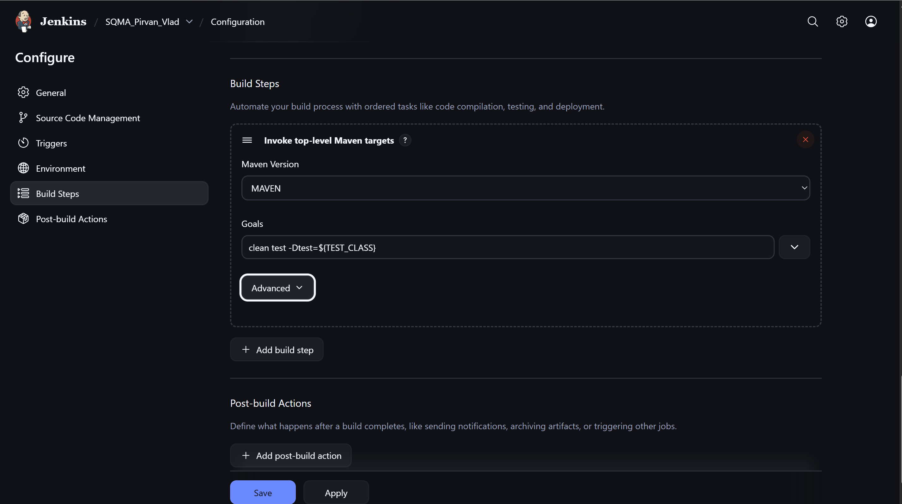
Ran the job using Build with Parameters.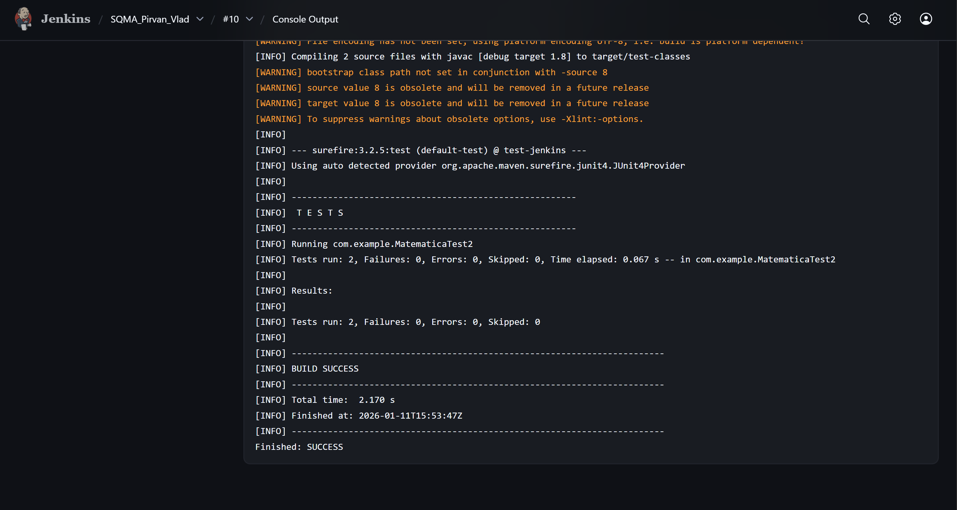

Task 2
Created a Freestyle project named Build_Project. Configured the Build step to compile the project with mvn clean compile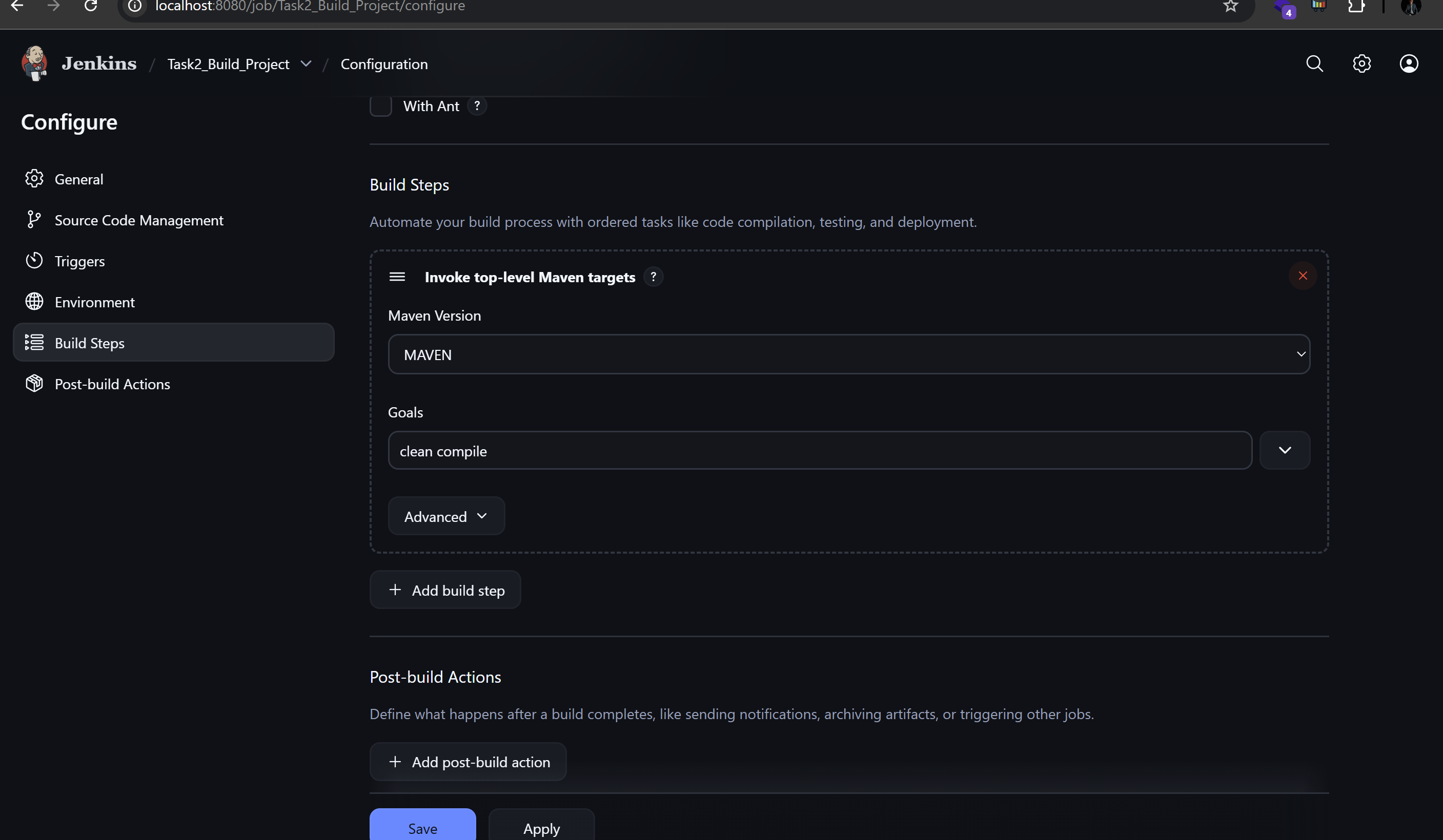

Created a second Freestyle project named Run_All_Tests . Configured Build Triggers so that Run_All_Tests is executed only after Build_Project finishes successfully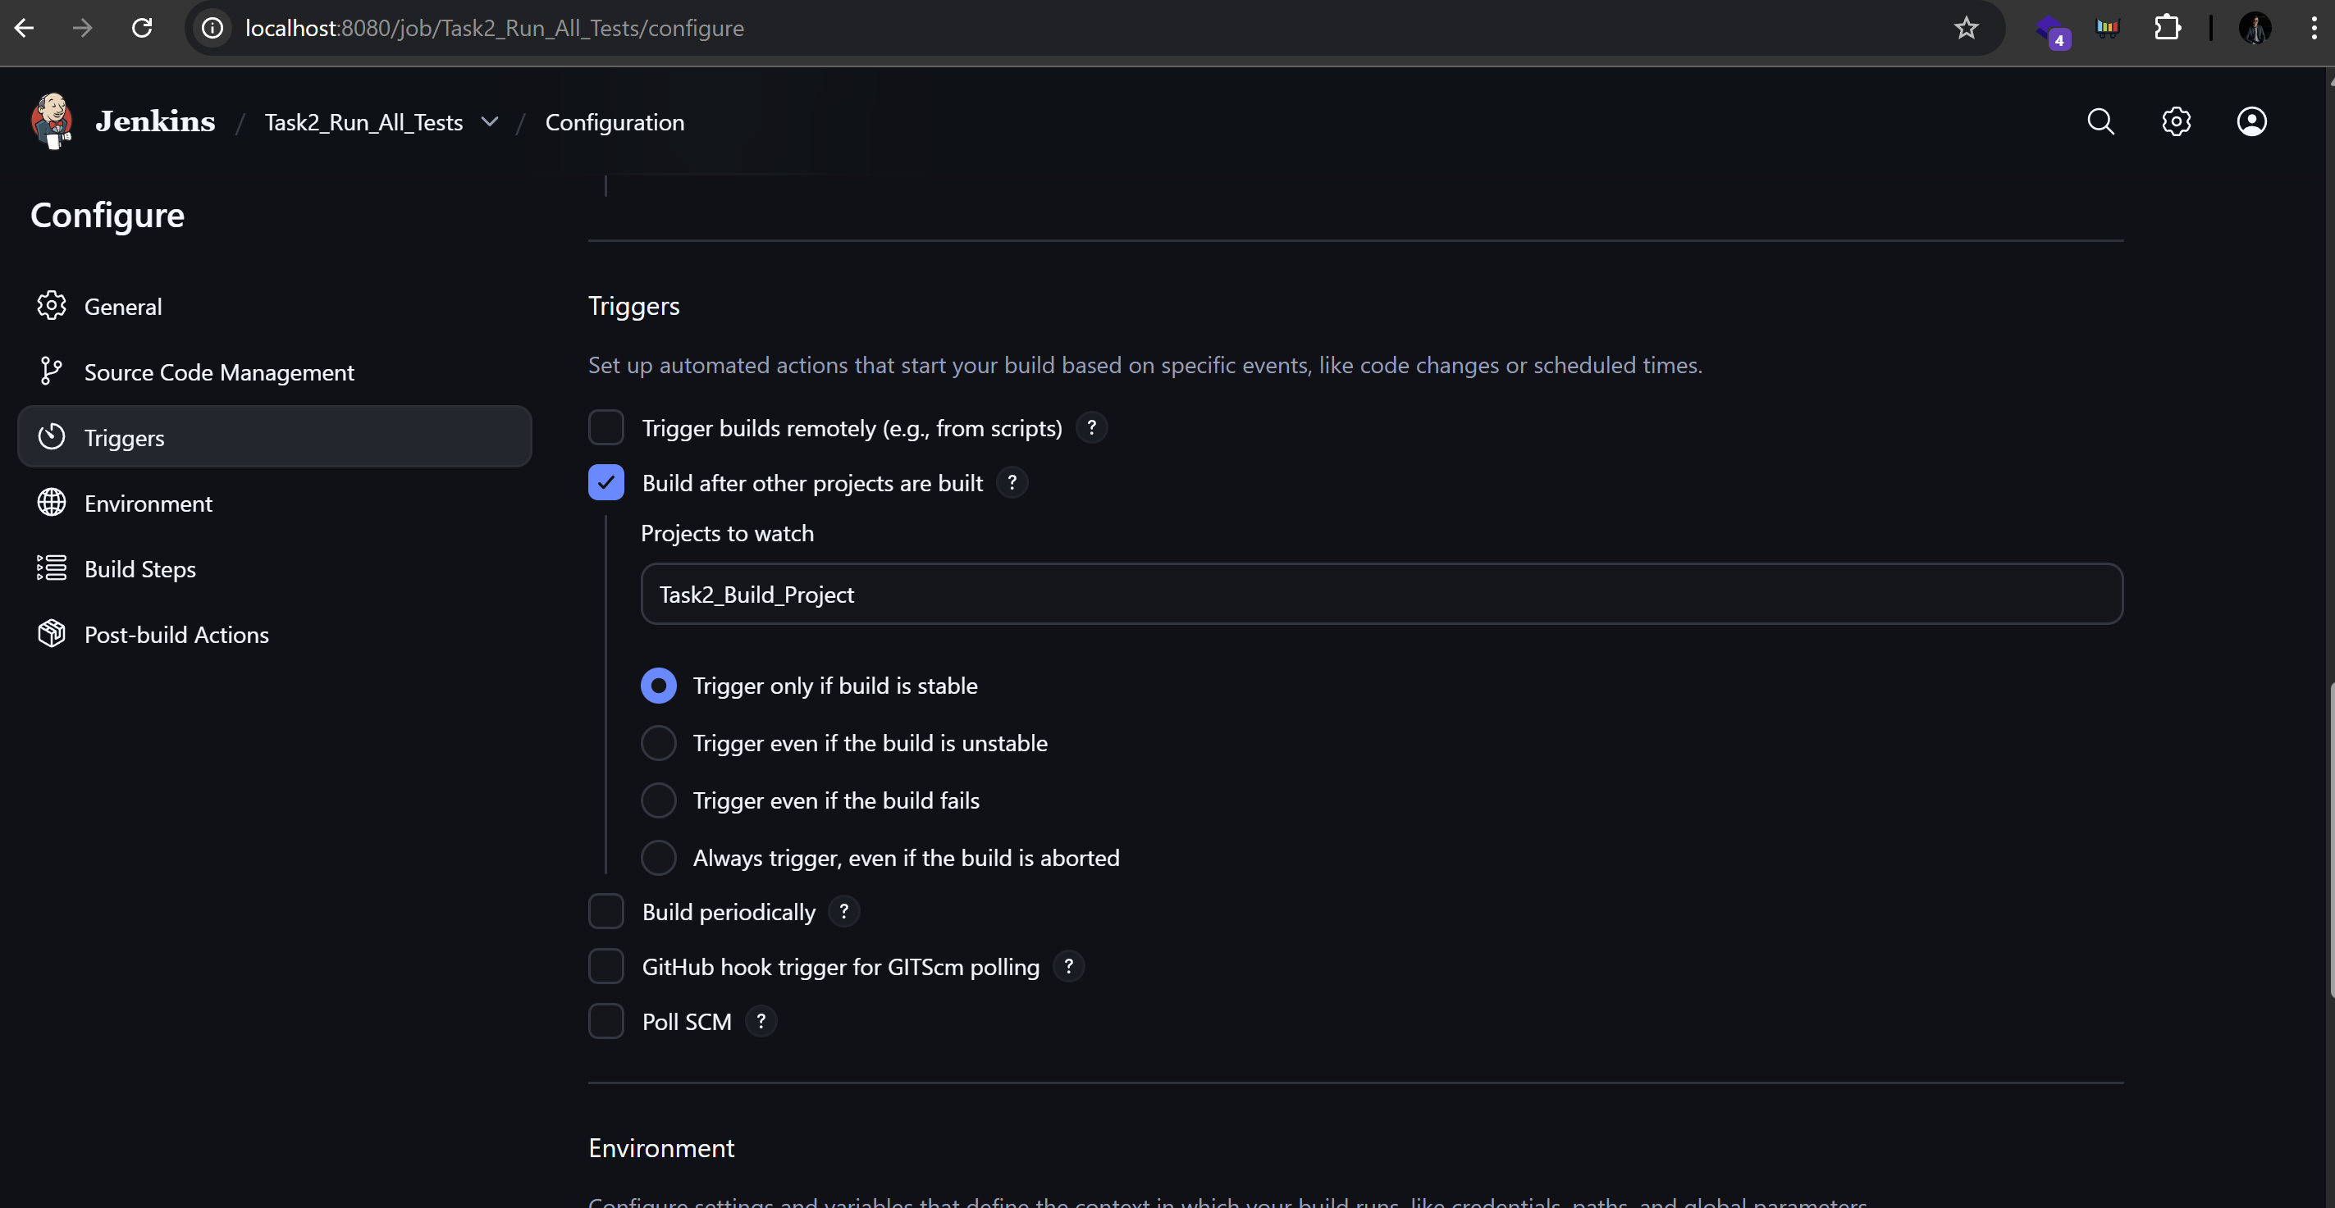
Configured the Build step to execute all tests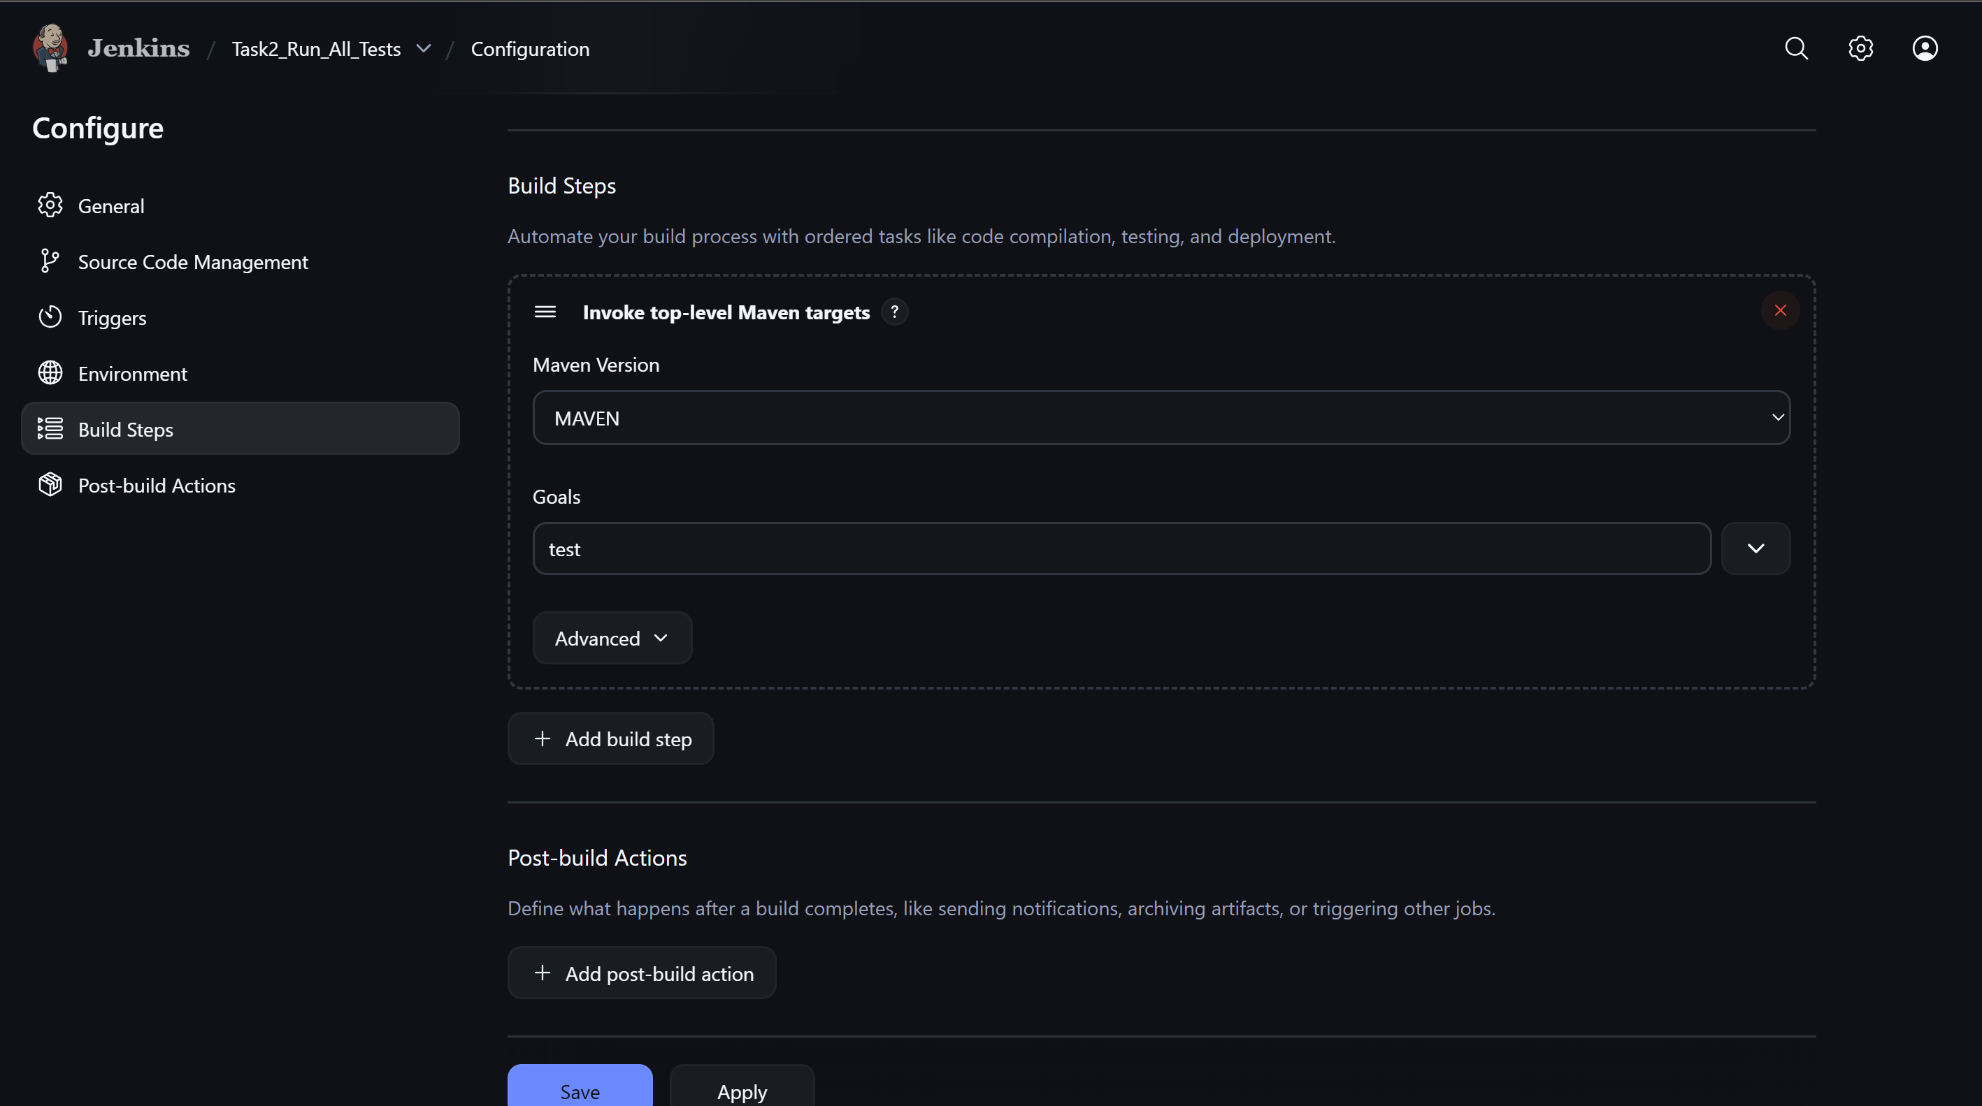
Console Output Build_Project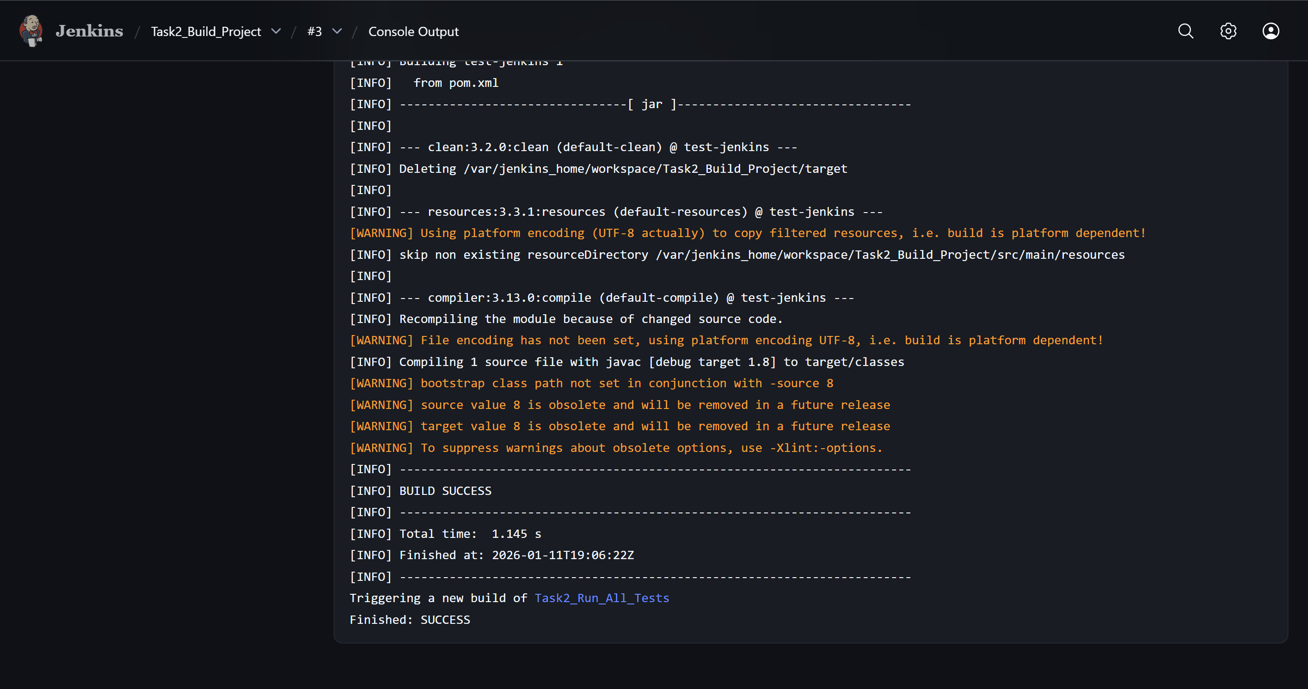
Console Output Run_All_Tests
