Пензенский государственный университет

Кафедра «Вычислительная техника»  
  
  
  
  
  
 **ОТЧЁТ**

по лабораторной работе №3

по курсу «Программирование на языке Java»

на тему «Графические интерфейсы»

Вариант 10

Выполнили:

cтуденты группы 21ВВП2

Головинов В.Р.

Пронин И.Г.

Лукьянова Д.М

Приняли:

Юрова О.В.

Карамышева Н.С.

Пенза 2024

**Цель работы:** **Цель работы:** изучить механизм обработки исключительных ситуаций.

**Лабораторное задание:**

Модифицировать приложение из предыдущей лабораторной работы, реализовав проверку вводимых данных с использованием механизма исключений. Необходимо создать свой класс, унаследованный от класса Exception, и генерировать исключение, если возникает попытка создать экземпляр класса RecIntegral со значениями, не являющимися числами в диапазоне от 0,000001 до 1000000. В качестве обработки исключения необходимо выводить диалог, содержащий предупреждение о некорректности введенных данных. Оформление лабораторной работы должно быть выполнено в соответствии с требованиями, приведенными в Приложении 2.**Листинг программы:**

/*

* Click nbfs://nbhost/SystemFileSystem/Templates/Licenses/license-default.txt to change this license

* Click nbfs://nbhost/SystemFileSystem/Templates/GUIForms/JFrame.java to edit this template

*/

/**

*

* @author влад

*/

import java.util.ArrayList;

import javax.swing.table.*;

import javax.swing.JOptionPane;

import java.io.Serializable;

import java.io.BufferedInputStream;

import java.io.BufferedOutputStream;

import java.io.FileInputStream;

import java.io.FileNotFoundException;

import java.io.FileOutputStream;

import java.io.FileReader;

import java.io.FileWriter;

import java.io.IOException;

import java.io.ObjectInputStream;

import java.io.ObjectOutputStream;

import java.util.ArrayList;

import java.util.logging.Level;

import java.util.logging.Logger;

import javax.swing.*;

import javax.swing.event.TableModelEvent;

import javax.swing.table.*;

import javax.swing.table.TableModel;

public class NewJFrame extends javax.swing.JFrame {

class MyExeption extends Exception{

private int number;

public int getNumber(){return number;}

public MyExeption(String message, int num){

super(message);

number = num;

}

}

class RecIntegral {

double num1;

double num2;

double num3;

double num4;

public RecIntegral(double num1,double num2,double num3, double num4) throws MyExeption

{

if(num1 < 0.000001 || num1 > 1000000) throw new MyExeption("Error Buttom", 1);

if(num2 < 0.000001 || num2 > 1000000) throw new MyExeption("Error Top", 2);

if(num3 < 0.000001 || num3 > 1000000) throw new MyExeption("Error Step", 3);

this.num1 = num1;

this.num2 = num2;

this.num3 = num3;

this.num4 = num4;

}

public RecIntegral()

{

num1 = 0;

num2 = 0;

num3 = 0;

}

}

ArrayList<RecIntegral> numb = new ArrayList();

JFileChooser dlg = new JFileChooser();

FileReader myfile;

/**

* Creates new form NewJFrame

*/

public NewJFrame() {

initComponents();

}

/**

* This method is called from within the constructor to initialize the form.

* WARNING: Do NOT modify this code. The content of this method is always

* regenerated by the Form Editor.

*/

@SuppressWarnings("unchecked")

// <editor-fold defaultstate="collapsed" desc="Generated Code">

private void initComponents() {

jScrollBar1 = new javax.swing.JScrollBar();

jPanel1 = new javax.swing.JPanel();

jScrollPane1 = new javax.swing.JScrollPane();

jTable1 = new javax.swing.JTable();

jTextField1 = new javax.swing.JTextField();

jTextField2 = new javax.swing.JTextField();

jTextField3 = new javax.swing.JTextField();

jLabel1 = new javax.swing.JLabel();

jLabel2 = new javax.swing.JLabel();

jLabel3 = new javax.swing.JLabel();

jButton4 = new javax.swing.JButton();

jButton5 = new javax.swing.JButton();

jButton6 = new javax.swing.JButton();

jLabel4 = new javax.swing.JLabel();

jButton1 = new javax.swing.JButton();

jLabel5 = new javax.swing.JLabel();

jButton2 = new javax.swing.JButton();

jLabel6 = new javax.swing.JLabel();

jButton3 = new javax.swing.JButton();

setDefaultCloseOperation(javax.swing.WindowConstants.EXIT_ON_CLOSE);

jPanel1.setBorder(javax.swing.BorderFactory.createTitledBorder("Res"));

jTable1.setModel(new javax.swing.table.DefaultTableModel(

new Object [][] {

},

new String [] {

"Bottom", "Top", "Step", "Result"

}

));

jTable1.addMouseListener(new java.awt.event.MouseAdapter() {

public void mouseClicked(java.awt.event.MouseEvent evt) {

jTable1MouseClicked(evt);

}

});

jScrollPane1.setViewportView(jTable1);

jTextField1.addActionListener(new java.awt.event.ActionListener() {

public void actionPerformed(java.awt.event.ActionEvent evt) {

jTextField1ActionPerformed(evt);

}

});

jTextField1.addKeyListener(new java.awt.event.KeyAdapter() {

public void keyPressed(java.awt.event.KeyEvent evt) {

jTextField1KeyPressed(evt);

}

});

jTextField2.addActionListener(new java.awt.event.ActionListener() {

public void actionPerformed(java.awt.event.ActionEvent evt) {

jTextField2ActionPerformed(evt);

}

});

jTextField3.addActionListener(new java.awt.event.ActionListener() {

public void actionPerformed(java.awt.event.ActionEvent evt) {

jTextField3ActionPerformed(evt);

}

});

jLabel1.setFont(new java.awt.Font("Segoe UI", 0, 14)); // NOI18N

jLabel1.setHorizontalAlignment(javax.swing.SwingConstants.CENTER);

jLabel1.setText("bottom");

jLabel2.setFont(new java.awt.Font("Segoe UI", 0, 14)); // NOI18N

jLabel2.setHorizontalAlignment(javax.swing.SwingConstants.CENTER);

jLabel2.setText("top");

jLabel3.setFont(new java.awt.Font("Segoe UI", 0, 14)); // NOI18N

jLabel3.setHorizontalAlignment(javax.swing.SwingConstants.CENTER);

jLabel3.setText("step");

javax.swing.GroupLayout jPanel1Layout = new javax.swing.GroupLayout(jPanel1);

jPanel1.setLayout(jPanel1Layout);

jPanel1Layout.setHorizontalGroup(

jPanel1Layout.createParallelGroup(javax.swing.GroupLayout.Alignment.LEADING)

.addGroup(jPanel1Layout.createSequentialGroup()

.addGroup(jPanel1Layout.createParallelGroup(javax.swing.GroupLayout.Alignment.LEADING)

.addGroup(jPanel1Layout.createSequentialGroup()

.addGap(22, 22, 22)

.addComponent(jScrollPane1, javax.swing.GroupLayout.DEFAULT_SIZE, 461, Short.MAX_VALUE))

.addGroup(jPanel1Layout.createSequentialGroup()

.addGap(20, 20, 20)

.addGroup(jPanel1Layout.createParallelGroup(javax.swing.GroupLayout.Alignment.LEADING, false)

.addComponent(jLabel1, javax.swing.GroupLayout.DEFAULT_SIZE, javax.swing.GroupLayout.DEFAULT_SIZE, Short.MAX_VALUE)

.addComponent(jTextField1, javax.swing.GroupLayout.DEFAULT_SIZE, 71, Short.MAX_VALUE))

.addGap(71, 71, 71)

.addGroup(jPanel1Layout.createParallelGroup(javax.swing.GroupLayout.Alignment.LEADING, false)

.addComponent(jTextField2, javax.swing.GroupLayout.DEFAULT_SIZE, 71, Short.MAX_VALUE)

.addComponent(jLabel2, javax.swing.GroupLayout.DEFAULT_SIZE, javax.swing.GroupLayout.DEFAULT_SIZE, Short.MAX_VALUE))

.addPreferredGap(javax.swing.LayoutStyle.ComponentPlacement.RELATED, 63, Short.MAX_VALUE)

.addGroup(jPanel1Layout.createParallelGroup(javax.swing.GroupLayout.Alignment.LEADING, false)

.addComponent(jTextField3, javax.swing.GroupLayout.DEFAULT_SIZE, 71, Short.MAX_VALUE)

.addComponent(jLabel3, javax.swing.GroupLayout.DEFAULT_SIZE, javax.swing.GroupLayout.DEFAULT_SIZE, Short.MAX_VALUE))

.addGap(116, 116, 116)))

.addContainerGap())

);

jPanel1Layout.setVerticalGroup(

jPanel1Layout.createParallelGroup(javax.swing.GroupLayout.Alignment.LEADING)

.addGroup(jPanel1Layout.createSequentialGroup()

.addGap(14, 14, 14)

.addComponent(jScrollPane1, javax.swing.GroupLayout.PREFERRED_SIZE, 113, javax.swing.GroupLayout.PREFERRED_SIZE)

.addGap(50, 50, 50)

.addGroup(jPanel1Layout.createParallelGroup(javax.swing.GroupLayout.Alignment.BASELINE)

.addComponent(jTextField1, javax.swing.GroupLayout.PREFERRED_SIZE, javax.swing.GroupLayout.DEFAULT_SIZE, javax.swing.GroupLayout.PREFERRED_SIZE)

.addComponent(jTextField2, javax.swing.GroupLayout.PREFERRED_SIZE, javax.swing.GroupLayout.DEFAULT_SIZE, javax.swing.GroupLayout.PREFERRED_SIZE)

.addComponent(jTextField3, javax.swing.GroupLayout.PREFERRED_SIZE, javax.swing.GroupLayout.DEFAULT_SIZE, javax.swing.GroupLayout.PREFERRED_SIZE))

.addPreferredGap(javax.swing.LayoutStyle.ComponentPlacement.UNRELATED)

.addGroup(jPanel1Layout.createParallelGroup(javax.swing.GroupLayout.Alignment.LEADING)

.addGroup(jPanel1Layout.createSequentialGroup()

.addGroup(jPanel1Layout.createParallelGroup(javax.swing.GroupLayout.Alignment.BASELINE)

.addComponent(jLabel1, javax.swing.GroupLayout.DEFAULT_SIZE, 22, Short.MAX_VALUE)

.addComponent(jLabel2, javax.swing.GroupLayout.DEFAULT_SIZE, javax.swing.GroupLayout.DEFAULT_SIZE, Short.MAX_VALUE))

.addGap(10, 10, 10))

.addGroup(jPanel1Layout.createSequentialGroup()

.addComponent(jLabel3)

.addContainerGap(javax.swing.GroupLayout.DEFAULT_SIZE, Short.MAX_VALUE))))

);

jButton4.setText("Add");

jButton4.addActionListener(new java.awt.event.ActionListener() {

public void actionPerformed(java.awt.event.ActionEvent evt) {

jButton4ActionPerformed(evt);

}

});

jButton5.setText("Result");

jButton5.addActionListener(new java.awt.event.ActionListener() {

public void actionPerformed(java.awt.event.ActionEvent evt) {

jButton5ActionPerformed(evt);

}

});

jButton6.setText("Del");

jButton6.addActionListener(new java.awt.event.ActionListener() {

public void actionPerformed(java.awt.event.ActionEvent evt) {

jButton6ActionPerformed(evt);

}

});

jLabel4.setHorizontalAlignment(javax.swing.SwingConstants.CENTER);

jLabel4.setText("fill");

jButton1.addActionListener(new java.awt.event.ActionListener() {

public void actionPerformed(java.awt.event.ActionEvent evt) {

jButton1ActionPerformed(evt);

}

});

jLabel5.setHorizontalAlignment(javax.swing.SwingConstants.CENTER);

jLabel5.setText("clear");

jButton2.addActionListener(new java.awt.event.ActionListener() {

public void actionPerformed(java.awt.event.ActionEvent evt) {

jButton2ActionPerformed(evt);

}

});

jLabel6.setText("download");

jButton3.addActionListener(new java.awt.event.ActionListener() {

public void actionPerformed(java.awt.event.ActionEvent evt) {

jButton3ActionPerformed(evt);

}

});

javax.swing.GroupLayout layout = new javax.swing.GroupLayout(getContentPane());

getContentPane().setLayout(layout);

layout.setHorizontalGroup(

layout.createParallelGroup(javax.swing.GroupLayout.Alignment.LEADING)

.addGroup(layout.createSequentialGroup()

.addContainerGap(50, Short.MAX_VALUE)

.addGroup(layout.createParallelGroup(javax.swing.GroupLayout.Alignment.LEADING)

.addGroup(javax.swing.GroupLayout.Alignment.TRAILING, layout.createSequentialGroup()

.addComponent(jPanel1, javax.swing.GroupLayout.PREFERRED_SIZE, javax.swing.GroupLayout.DEFAULT_SIZE, javax.swing.GroupLayout.PREFERRED_SIZE)

.addGap(18, 18, 18)

.addGroup(layout.createParallelGroup(javax.swing.GroupLayout.Alignment.LEADING)

.addGroup(layout.createParallelGroup(javax.swing.GroupLayout.Alignment.LEADING, false)

.addComponent(jButton1, javax.swing.GroupLayout.DEFAULT_SIZE, javax.swing.GroupLayout.DEFAULT_SIZE, Short.MAX_VALUE)

.addGroup(javax.swing.GroupLayout.Alignment.TRAILING, layout.createSequentialGroup()

.addComponent(jLabel4, javax.swing.GroupLayout.PREFERRED_SIZE, 59, javax.swing.GroupLayout.PREFERRED_SIZE)

.addGap(8, 8, 8))

.addComponent(jLabel5, javax.swing.GroupLayout.DEFAULT_SIZE, javax.swing.GroupLayout.DEFAULT_SIZE, Short.MAX_VALUE)

.addGroup(layout.createSequentialGroup()

.addGap(10, 10, 10)

.addComponent(jLabel6, javax.swing.GroupLayout.PREFERRED_SIZE, 54, javax.swing.GroupLayout.PREFERRED_SIZE))

.addComponent(jButton3, javax.swing.GroupLayout.DEFAULT_SIZE, javax.swing.GroupLayout.DEFAULT_SIZE, Short.MAX_VALUE))

.addComponent(jButton2, javax.swing.GroupLayout.Alignment.TRAILING, javax.swing.GroupLayout.PREFERRED_SIZE, 72, javax.swing.GroupLayout.PREFERRED_SIZE))

.addContainerGap())

.addGroup(javax.swing.GroupLayout.Alignment.TRAILING, layout.createSequentialGroup()

.addComponent(jButton6)

.addGap(34, 34, 34)

.addComponent(jButton4)

.addGap(151, 151, 151)

.addComponent(jButton5)

.addGap(118, 118, 118))))

);

layout.setVerticalGroup(

layout.createParallelGroup(javax.swing.GroupLayout.Alignment.LEADING)

.addGroup(layout.createSequentialGroup()

.addGroup(layout.createParallelGroup(javax.swing.GroupLayout.Alignment.LEADING)

.addGroup(layout.createSequentialGroup()

.addContainerGap(36, Short.MAX_VALUE)

.addComponent(jPanel1, javax.swing.GroupLayout.PREFERRED_SIZE, javax.swing.GroupLayout.DEFAULT_SIZE, javax.swing.GroupLayout.PREFERRED_SIZE))

.addGroup(layout.createSequentialGroup()

.addGap(83, 83, 83)

.addComponent(jLabel4)

.addPreferredGap(javax.swing.LayoutStyle.ComponentPlacement.RELATED)

.addComponent(jButton1, javax.swing.GroupLayout.PREFERRED_SIZE, 22, javax.swing.GroupLayout.PREFERRED_SIZE)

.addGap(42, 42, 42)

.addComponent(jLabel5)

.addPreferredGap(javax.swing.LayoutStyle.ComponentPlacement.RELATED)

.addComponent(jButton2, javax.swing.GroupLayout.PREFERRED_SIZE, 22, javax.swing.GroupLayout.PREFERRED_SIZE)

.addGap(36, 36, 36)

.addComponent(jLabel6)

.addPreferredGap(javax.swing.LayoutStyle.ComponentPlacement.RELATED)

.addComponent(jButton3, javax.swing.GroupLayout.PREFERRED_SIZE, 22, javax.swing.GroupLayout.PREFERRED_SIZE)

.addPreferredGap(javax.swing.LayoutStyle.ComponentPlacement.RELATED, javax.swing.GroupLayout.DEFAULT_SIZE, Short.MAX_VALUE)))

.addGap(30, 30, 30)

.addGroup(layout.createParallelGroup(javax.swing.GroupLayout.Alignment.BASELINE)

.addComponent(jButton4)

.addComponent(jButton5)

.addComponent(jButton6))

.addGap(41, 41, 41))

);

pack();

}// </editor-fold>

private void jTextField1ActionPerformed(java.awt.event.ActionEvent evt) {

}

private void jTextField2ActionPerformed(java.awt.event.ActionEvent evt) {

}

private void jTextField3ActionPerformed(java.awt.event.ActionEvent evt) {

}

private void jTextField1KeyPressed(java.awt.event.KeyEvent evt) {

}

private void jButton4ActionPerformed(java.awt.event.ActionEvent evt) {

if( jTextField1.getText().equals("") || jTextField2.getText().equals("") || jTextField3.getText().equals("")){

return;

}

DefaultTableModel model = (DefaultTableModel)jTable1.getModel();

model.addRow(new Object[] { Double.parseDouble(jTextField1.getText()),

Double.parseDouble(jTextField2.getText()),

Double.parseDouble(jTextField3.getText()),

" "});

}

private void jButton5ActionPerformed(java.awt.event.ActionEvent evt) {

int index = jTable1.getSelectedRow();

if(index == -1){

for(int i = 0; i < jTable1.getRowCount(); i += 1){

if(jTable1.getValueAt(i, 3).toString().equals(" ")){

index = i;

break;

}

}

if(index == -1) return;

}

try{

double S = 0;

double niz = Double.parseDouble(jTable1.getValueAt(index, 0).toString());

double verx = Double.parseDouble(jTable1.getValueAt(index, 1).toString());

double step = Double.parseDouble(jTable1.getValueAt(index, 2).toString());

for(double i = niz; i < verx; i += step){

double S1 = Math.exp(i) / i;

double S2 = Math.exp(Math.min(i + step, verx)) / Math.min(i + step, verx);

S += ((S1 + S2) * Math.min(step, verx - i)) / 2;

}

String str = String.valueOf(S);

numb.add(new RecIntegral(niz, verx, step, S));

jTable1.setValueAt(str, index, 3);

}catch(MyExeption ex){

JOptionPane.showMessageDialog(null, ex.getMessage());

System.out.println(ex.getMessage());

System.out.println(ex.getNumber());

}

}

private void jButton6ActionPerformed(java.awt.event.ActionEvent evt) {

int index = jTable1.getSelectedRow();

if(index == -1){

index = jTable1.getRowCount() - 1;

}

DefaultTableModel model = (DefaultTableModel)jTable1.getModel();

model.removeRow(index);

}

private void jTable1MouseClicked(java.awt.event.MouseEvent evt) {

}

private void jButton2ActionPerformed(java.awt.event.ActionEvent evt) {

DefaultTableModel model = (DefaultTableModel)jTable1.getModel();

for(int i = model.getRowCount(); i > 0; i -= 1){

model.removeRow(0);

}

}

private void jButton1ActionPerformed(java.awt.event.ActionEvent evt) {

DefaultTableModel model = (DefaultTableModel)jTable1.getModel();

for(int i = 0; i < numb.size(); i += 1){

model.addRow(new Object[] {

numb.get(i).num1,

numb.get(i).num2,

numb.get(i).num3,

numb.get(i).num4

});

}

}

private void jButton3ActionPerformed(java.awt.event.ActionEvent evt) {

// TODO add your handling code here:

}

/**

* @param args the command line arguments

*/

public static void main(String args[]) {

/* Set the Nimbus look and feel */

//<editor-fold defaultstate="collapsed" desc=" Look and feel setting code (optional) ">

/* If Nimbus (introduced in Java SE 6) is not available, stay with the default look and feel.

* For details see http://download.oracle.com/javase/tutorial/uiswing/lookandfeel/plaf.html

*/

try {

for (javax.swing.UIManager.LookAndFeelInfo info : javax.swing.UIManager.getInstalledLookAndFeels()) {

if ("Nimbus".equals(info.getName())) {

javax.swing.UIManager.setLookAndFeel(info.getClassName());

break;

}

}

} catch (ClassNotFoundException ex) {

java.util.logging.Logger.getLogger(NewJFrame.class.getName()).log(java.util.logging.Level.SEVERE, null, ex);

} catch (InstantiationException ex) {

java.util.logging.Logger.getLogger(NewJFrame.class.getName()).log(java.util.logging.Level.SEVERE, null, ex);

} catch (IllegalAccessException ex) {

java.util.logging.Logger.getLogger(NewJFrame.class.getName()).log(java.util.logging.Level.SEVERE, null, ex);

} catch (javax.swing.UnsupportedLookAndFeelException ex) {

java.util.logging.Logger.getLogger(NewJFrame.class.getName()).log(java.util.logging.Level.SEVERE, null, ex);

}

//</editor-fold>

/* Create and display the form */

java.awt.EventQueue.invokeLater(new Runnable() {

public void run() {

new NewJFrame().setVisible(true);

}

});

}

// Variables declaration - do not modify

private javax.swing.JButton jButton1;

private javax.swing.JButton jButton2;

private javax.swing.JButton jButton3;

private javax.swing.JButton jButton4;

private javax.swing.JButton jButton5;

private javax.swing.JButton jButton6;

private javax.swing.JLabel jLabel1;

private javax.swing.JLabel jLabel2;

private javax.swing.JLabel jLabel3;

private javax.swing.JLabel jLabel4;

private javax.swing.JLabel jLabel5;

private javax.swing.JLabel jLabel6;

private javax.swing.JPanel jPanel1;

private javax.swing.JScrollBar jScrollBar1;

private javax.swing.JScrollPane jScrollPane1;

private javax.swing.JTable jTable1;

private javax.swing.JTextField jTextField1;

private javax.swing.JTextField jTextField2;

private javax.swing.JTextField jTextField3;

// End of variables declaration

}

**Результат работы программы:**

Введем неправильные значения

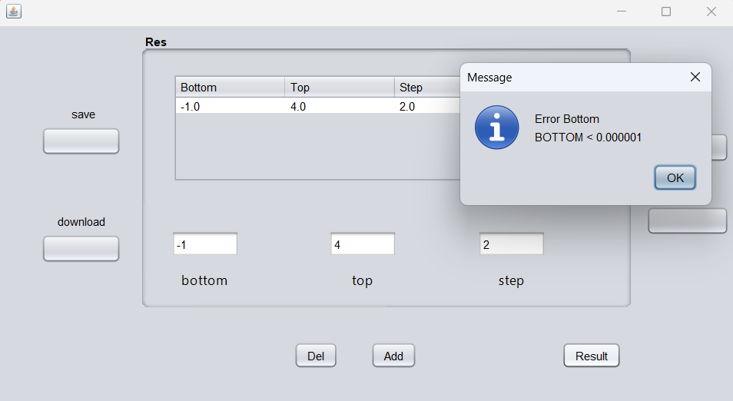

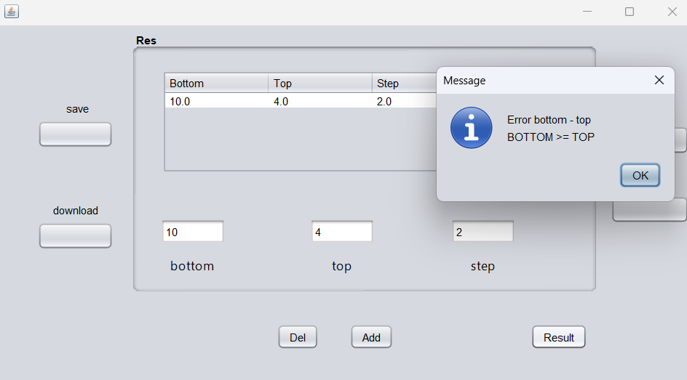

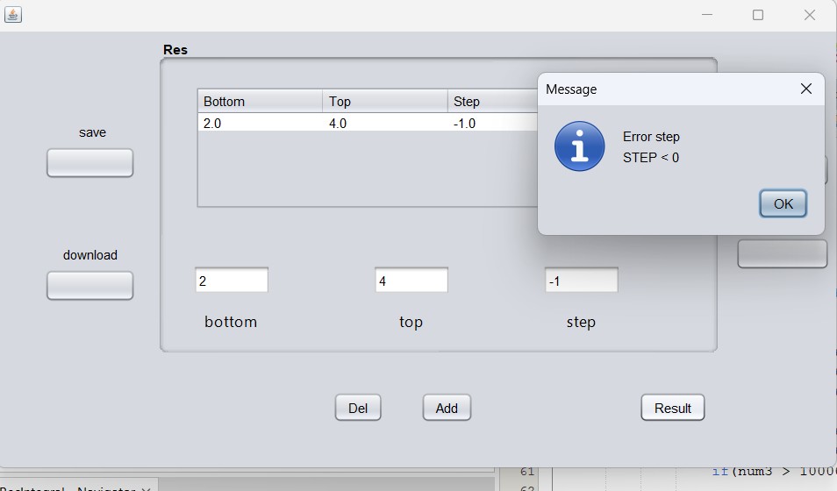

**Вывод:** Мыизучили механизм обработки исключительных ситуаций.