Пензенский государственный университет

Кафедра «Вычислительная техника»  
  
  
  
  
  
 **ОТЧЁТ**

по лабораторной работе №4

по курсу «Программирование на языке Java»

на тему «Графические интерфейсы»

Вариант 10

Выполнили:

cтуденты группы 21ВВП2

Головинов В.Р.

Пронин И.Г.

Лукьянова Д.М

Приняли:

Юрова О.В.

Карамышева Н.С.

Пенза 2024

**Работа с файлами**

**Цель работы:** изучить работу с файлами и механизмы сериализации данных.

**Задание на лабораторную работу:** Модифицировать приложение из предыдущей лабораторной работы,

реализовав сохранение в файл и загрузку данных из файла. Предусмотреть

сохранение данных, как в текстовом виде, так и в двоичном (с

использованием механизма сериализации). Для этого нужно добавить 4

кнопки для сохранения и загрузки в текстовом и двоичном виде

соответственно. Кроме того, в программе нужно предусмотреть

использование стандартного диалога открытия файла (JFileChooser).

**Листинг программы:**

/*

* Click nbfs://nbhost/SystemFileSystem/Templates/Licenses/license-default.txt to change this license

* Click nbfs://nbhost/SystemFileSystem/Templates/GUIForms/JFrame.java to edit this template

*/

/**

*

* @author влад

*/

import java.util.ArrayList;

import javax.swing.table.*;

import javax.swing.JOptionPane;

import java.io.Serializable;

import java.io.BufferedInputStream;

import java.io.BufferedOutputStream;

import java.io.FileInputStream;

import java.io.FileNotFoundException;

import java.io.FileOutputStream;

import java.io.FileReader;

import java.io.FileWriter;

import java.io.IOException;

import java.io.ObjectInputStream;

import java.io.ObjectOutputStream;

import java.util.ArrayList;

import java.util.logging.Level;

import java.util.logging.Logger;

import javax.swing.*;

import javax.swing.event.TableModelEvent;

import javax.swing.table.*;

import javax.swing.table.TableModel;

public class NewJFrame extends javax.swing.JFrame {

class MyExeption extends Exception{

private int number;

public int getNumber(){return number;}

public MyExeption(String message, int num){

super(message);

number = num;

}

}

static class RecIntegral implements Serializable {

double num1;

double num2;

double num3;

double num4;

public RecIntegral(double num1,double num2,double num3, double num4) throws MyExeption

{

this.num1 = num1;

this.num2 = num2;

this.num3 = num3;

this.num4 = num4;

}

public RecIntegral()

{

num1 = 0;

num2 = 0;

num3 = 0;

}

}

ArrayList<RecIntegral> numb = new ArrayList();

JFileChooser dlg = new JFileChooser();

FileReader myfile;

/**

* Creates new form NewJFrame

*/

public NewJFrame() {

initComponents();

}

/**

* This method is called from within the constructor to initialize the form.

* WARNING: Do NOT modify this code. The content of this method is always

* regenerated by the Form Editor.

*/

@SuppressWarnings("unchecked")

// <editor-fold defaultstate="collapsed" desc="Generated Code">

private void initComponents() {

jScrollBar1 = new javax.swing.JScrollBar();

jPanel1 = new javax.swing.JPanel();

jScrollPane1 = new javax.swing.JScrollPane();

jTable1 = new javax.swing.JTable();

jTextField1 = new javax.swing.JTextField();

jTextField2 = new javax.swing.JTextField();

jTextField3 = new javax.swing.JTextField();

jLabel1 = new javax.swing.JLabel();

jLabel2 = new javax.swing.JLabel();

jLabel3 = new javax.swing.JLabel();

jButton4 = new javax.swing.JButton();

jButton5 = new javax.swing.JButton();

jButton6 = new javax.swing.JButton();

jButton1 = new javax.swing.JButton();

jButton2 = new javax.swing.JButton();

jButton3 = new javax.swing.JButton();

jButton7 = new javax.swing.JButton();

jButton8 = new javax.swing.JButton();

jButton9 = new javax.swing.JButton();

setDefaultCloseOperation(javax.swing.WindowConstants.EXIT_ON_CLOSE);

jPanel1.setBorder(javax.swing.BorderFactory.createTitledBorder("Res"));

jTable1.setModel(new javax.swing.table.DefaultTableModel(

new Object [][] {

},

new String [] {

"Bottom", "Top", "Step", "Result"

}

));

jTable1.addMouseListener(new java.awt.event.MouseAdapter() {

public void mouseClicked(java.awt.event.MouseEvent evt) {

jTable1MouseClicked(evt);

}

});

jScrollPane1.setViewportView(jTable1);

jTextField1.addActionListener(new java.awt.event.ActionListener() {

public void actionPerformed(java.awt.event.ActionEvent evt) {

jTextField1ActionPerformed(evt);

}

});

jTextField1.addKeyListener(new java.awt.event.KeyAdapter() {

public void keyPressed(java.awt.event.KeyEvent evt) {

jTextField1KeyPressed(evt);

}

});

jTextField2.addActionListener(new java.awt.event.ActionListener() {

public void actionPerformed(java.awt.event.ActionEvent evt) {

jTextField2ActionPerformed(evt);

}

});

jTextField3.addActionListener(new java.awt.event.ActionListener() {

public void actionPerformed(java.awt.event.ActionEvent evt) {

jTextField3ActionPerformed(evt);

}

});

jLabel1.setFont(new java.awt.Font("Segoe UI", 0, 14)); // NOI18N

jLabel1.setHorizontalAlignment(javax.swing.SwingConstants.CENTER);

jLabel1.setText("bottom");

jLabel2.setFont(new java.awt.Font("Segoe UI", 0, 14)); // NOI18N

jLabel2.setHorizontalAlignment(javax.swing.SwingConstants.CENTER);

jLabel2.setText("top");

jLabel3.setFont(new java.awt.Font("Segoe UI", 0, 14)); // NOI18N

jLabel3.setHorizontalAlignment(javax.swing.SwingConstants.CENTER);

jLabel3.setText("step");

javax.swing.GroupLayout jPanel1Layout = new javax.swing.GroupLayout(jPanel1);

jPanel1.setLayout(jPanel1Layout);

jPanel1Layout.setHorizontalGroup(

jPanel1Layout.createParallelGroup(javax.swing.GroupLayout.Alignment.LEADING)

.addGroup(jPanel1Layout.createSequentialGroup()

.addGap(22, 22, 22)

.addComponent(jScrollPane1, javax.swing.GroupLayout.DEFAULT_SIZE, 461, Short.MAX_VALUE)

.addContainerGap())

.addGroup(jPanel1Layout.createSequentialGroup()

.addGap(20, 20, 20)

.addGroup(jPanel1Layout.createParallelGroup(javax.swing.GroupLayout.Alignment.LEADING, false)

.addComponent(jLabel1, javax.swing.GroupLayout.DEFAULT_SIZE, javax.swing.GroupLayout.DEFAULT_SIZE, Short.MAX_VALUE)

.addComponent(jTextField1, javax.swing.GroupLayout.DEFAULT_SIZE, 71, Short.MAX_VALUE))

.addPreferredGap(javax.swing.LayoutStyle.ComponentPlacement.RELATED, javax.swing.GroupLayout.DEFAULT_SIZE, Short.MAX_VALUE)

.addGroup(jPanel1Layout.createParallelGroup(javax.swing.GroupLayout.Alignment.LEADING)

.addComponent(jTextField2, javax.swing.GroupLayout.Alignment.TRAILING, javax.swing.GroupLayout.PREFERRED_SIZE, 71, javax.swing.GroupLayout.PREFERRED_SIZE)

.addComponent(jLabel2, javax.swing.GroupLayout.Alignment.TRAILING, javax.swing.GroupLayout.PREFERRED_SIZE, 71, javax.swing.GroupLayout.PREFERRED_SIZE))

.addGap(84, 84, 84)

.addGroup(jPanel1Layout.createParallelGroup(javax.swing.GroupLayout.Alignment.LEADING)

.addComponent(jTextField3, javax.swing.GroupLayout.Alignment.TRAILING, javax.swing.GroupLayout.PREFERRED_SIZE, 71, javax.swing.GroupLayout.PREFERRED_SIZE)

.addComponent(jLabel3, javax.swing.GroupLayout.Alignment.TRAILING, javax.swing.GroupLayout.PREFERRED_SIZE, 71, javax.swing.GroupLayout.PREFERRED_SIZE))

.addGap(79, 79, 79))

);

jPanel1Layout.setVerticalGroup(

jPanel1Layout.createParallelGroup(javax.swing.GroupLayout.Alignment.LEADING)

.addGroup(jPanel1Layout.createSequentialGroup()

.addGap(14, 14, 14)

.addComponent(jScrollPane1, javax.swing.GroupLayout.PREFERRED_SIZE, 113, javax.swing.GroupLayout.PREFERRED_SIZE)

.addGap(50, 50, 50)

.addGroup(jPanel1Layout.createParallelGroup(javax.swing.GroupLayout.Alignment.BASELINE)

.addComponent(jTextField1, javax.swing.GroupLayout.PREFERRED_SIZE, javax.swing.GroupLayout.DEFAULT_SIZE, javax.swing.GroupLayout.PREFERRED_SIZE)

.addComponent(jTextField2, javax.swing.GroupLayout.PREFERRED_SIZE, javax.swing.GroupLayout.DEFAULT_SIZE, javax.swing.GroupLayout.PREFERRED_SIZE)

.addComponent(jTextField3, javax.swing.GroupLayout.PREFERRED_SIZE, javax.swing.GroupLayout.DEFAULT_SIZE, javax.swing.GroupLayout.PREFERRED_SIZE))

.addPreferredGap(javax.swing.LayoutStyle.ComponentPlacement.UNRELATED)

.addGroup(jPanel1Layout.createParallelGroup(javax.swing.GroupLayout.Alignment.BASELINE)

.addComponent(jLabel1, javax.swing.GroupLayout.DEFAULT_SIZE, 22, Short.MAX_VALUE)

.addComponent(jLabel2, javax.swing.GroupLayout.DEFAULT_SIZE, javax.swing.GroupLayout.DEFAULT_SIZE, Short.MAX_VALUE)

.addComponent(jLabel3))

.addGap(10, 10, 10))

);

jButton4.setText("Add");

jButton4.addActionListener(new java.awt.event.ActionListener() {

public void actionPerformed(java.awt.event.ActionEvent evt) {

jButton4ActionPerformed(evt);

}

});

jButton5.setText("Result");

jButton5.addActionListener(new java.awt.event.ActionListener() {

public void actionPerformed(java.awt.event.ActionEvent evt) {

jButton5ActionPerformed(evt);

}

});

jButton6.setText("Del");

jButton6.addActionListener(new java.awt.event.ActionListener() {

public void actionPerformed(java.awt.event.ActionEvent evt) {

jButton6ActionPerformed(evt);

}

});

jButton1.setText("fill");

jButton1.addActionListener(new java.awt.event.ActionListener() {

public void actionPerformed(java.awt.event.ActionEvent evt) {

jButton1ActionPerformed(evt);

}

});

jButton2.setText("clear");

jButton2.addActionListener(new java.awt.event.ActionListener() {

public void actionPerformed(java.awt.event.ActionEvent evt) {

jButton2ActionPerformed(evt);

}

});

jButton3.setText("save");

jButton3.addActionListener(new java.awt.event.ActionListener() {

public void actionPerformed(java.awt.event.ActionEvent evt) {

jButton3ActionPerformed(evt);

}

});

jButton7.setText("download");

jButton7.addActionListener(new java.awt.event.ActionListener() {

public void actionPerformed(java.awt.event.ActionEvent evt) {

jButton7ActionPerformed(evt);

}

});

jButton8.setText("download binary");

jButton8.addActionListener(new java.awt.event.ActionListener() {

public void actionPerformed(java.awt.event.ActionEvent evt) {

jButton8ActionPerformed(evt);

}

});

jButton9.setText("save binary");

jButton9.addActionListener(new java.awt.event.ActionListener() {

public void actionPerformed(java.awt.event.ActionEvent evt) {

jButton9ActionPerformed(evt);

}

});

javax.swing.GroupLayout layout = new javax.swing.GroupLayout(getContentPane());

getContentPane().setLayout(layout);

layout.setHorizontalGroup(

layout.createParallelGroup(javax.swing.GroupLayout.Alignment.LEADING)

.addGroup(layout.createSequentialGroup()

.addGap(44, 44, 44)

.addGroup(layout.createParallelGroup(javax.swing.GroupLayout.Alignment.LEADING)

.addGroup(javax.swing.GroupLayout.Alignment.TRAILING, layout.createSequentialGroup()

.addGroup(layout.createParallelGroup(javax.swing.GroupLayout.Alignment.TRAILING)

.addComponent(jButton8, javax.swing.GroupLayout.DEFAULT_SIZE, javax.swing.GroupLayout.DEFAULT_SIZE, Short.MAX_VALUE)

.addComponent(jButton9, javax.swing.GroupLayout.DEFAULT_SIZE, javax.swing.GroupLayout.DEFAULT_SIZE, Short.MAX_VALUE)

.addComponent(jButton7, javax.swing.GroupLayout.DEFAULT_SIZE, javax.swing.GroupLayout.DEFAULT_SIZE, Short.MAX_VALUE)

.addComponent(jButton3, javax.swing.GroupLayout.DEFAULT_SIZE, javax.swing.GroupLayout.DEFAULT_SIZE, Short.MAX_VALUE))

.addGap(18, 18, 18)

.addComponent(jPanel1, javax.swing.GroupLayout.PREFERRED_SIZE, javax.swing.GroupLayout.DEFAULT_SIZE, javax.swing.GroupLayout.PREFERRED_SIZE)

.addPreferredGap(javax.swing.LayoutStyle.ComponentPlacement.UNRELATED)

.addGroup(layout.createParallelGroup(javax.swing.GroupLayout.Alignment.LEADING)

.addComponent(jButton1, javax.swing.GroupLayout.PREFERRED_SIZE, 86, javax.swing.GroupLayout.PREFERRED_SIZE)

.addComponent(jButton2, javax.swing.GroupLayout.PREFERRED_SIZE, 86, javax.swing.GroupLayout.PREFERRED_SIZE))

.addContainerGap())

.addGroup(layout.createSequentialGroup()

.addGap(0, 0, Short.MAX_VALUE)

.addComponent(jButton6, javax.swing.GroupLayout.PREFERRED_SIZE, 91, javax.swing.GroupLayout.PREFERRED_SIZE)

.addGap(69, 69, 69)

.addComponent(jButton4, javax.swing.GroupLayout.PREFERRED_SIZE, 90, javax.swing.GroupLayout.PREFERRED_SIZE)

.addGap(104, 104, 104)

.addComponent(jButton5, javax.swing.GroupLayout.PREFERRED_SIZE, 89, javax.swing.GroupLayout.PREFERRED_SIZE)

.addGap(149, 149, 149))))

);

layout.setVerticalGroup(

layout.createParallelGroup(javax.swing.GroupLayout.Alignment.LEADING)

.addGroup(layout.createSequentialGroup()

.addGroup(layout.createParallelGroup(javax.swing.GroupLayout.Alignment.LEADING)

.addGroup(layout.createSequentialGroup()

.addGroup(layout.createParallelGroup(javax.swing.GroupLayout.Alignment.TRAILING)

.addGroup(layout.createSequentialGroup()

.addContainerGap(javax.swing.GroupLayout.DEFAULT_SIZE, Short.MAX_VALUE)

.addComponent(jPanel1, javax.swing.GroupLayout.PREFERRED_SIZE, javax.swing.GroupLayout.DEFAULT_SIZE, javax.swing.GroupLayout.PREFERRED_SIZE))

.addGroup(layout.createSequentialGroup()

.addGap(111, 111, 111)

.addComponent(jButton1, javax.swing.GroupLayout.PREFERRED_SIZE, 31, javax.swing.GroupLayout.PREFERRED_SIZE)

.addGap(46, 46, 46)

.addComponent(jButton2, javax.swing.GroupLayout.PREFERRED_SIZE, 30, javax.swing.GroupLayout.PREFERRED_SIZE)

.addGap(0, 71, Short.MAX_VALUE)))

.addGap(30, 30, 30))

.addGroup(layout.createSequentialGroup()

.addGap(73, 73, 73)

.addComponent(jButton3, javax.swing.GroupLayout.PREFERRED_SIZE, 30, javax.swing.GroupLayout.PREFERRED_SIZE)

.addGap(18, 18, 18)

.addComponent(jButton7, javax.swing.GroupLayout.PREFERRED_SIZE, 30, javax.swing.GroupLayout.PREFERRED_SIZE)

.addGap(44, 44, 44)

.addComponent(jButton9, javax.swing.GroupLayout.PREFERRED_SIZE, 32, javax.swing.GroupLayout.PREFERRED_SIZE)

.addGap(18, 18, 18)

.addComponent(jButton8, javax.swing.GroupLayout.PREFERRED_SIZE, 31, javax.swing.GroupLayout.PREFERRED_SIZE)

.addPreferredGap(javax.swing.LayoutStyle.ComponentPlacement.RELATED, javax.swing.GroupLayout.DEFAULT_SIZE, Short.MAX_VALUE)))

.addGroup(layout.createParallelGroup(javax.swing.GroupLayout.Alignment.BASELINE)

.addComponent(jButton4, javax.swing.GroupLayout.PREFERRED_SIZE, 33, javax.swing.GroupLayout.PREFERRED_SIZE)

.addComponent(jButton5, javax.swing.GroupLayout.PREFERRED_SIZE, 33, javax.swing.GroupLayout.PREFERRED_SIZE)

.addComponent(jButton6, javax.swing.GroupLayout.PREFERRED_SIZE, 33, javax.swing.GroupLayout.PREFERRED_SIZE))

.addGap(41, 41, 41))

);

pack();

}// </editor-fold>

private void jTextField1ActionPerformed(java.awt.event.ActionEvent evt) {

}

private void jTextField2ActionPerformed(java.awt.event.ActionEvent evt) {

}

private void jTextField3ActionPerformed(java.awt.event.ActionEvent evt) {

}

private void jTextField1KeyPressed(java.awt.event.KeyEvent evt) {

}

private void jButton4ActionPerformed(java.awt.event.ActionEvent evt) {

try{

if( jTextField1.getText().equals("") || jTextField2.getText().equals("") || jTextField3.getText().equals("")){

return;

}

DefaultTableModel model = (DefaultTableModel)jTable1.getModel();

if(Double.parseDouble(jTextField1.getText()) < 0.000001) throw new MyExeption("Error Bottom\nBOTTOM < 0.000001", 1);

if(Double.parseDouble(jTextField2.getText()) < 0.000001) throw new MyExeption("Error Top\nTOP < 0.000001", 2);

if(Double.parseDouble(jTextField3.getText()) < 0.0001) throw new MyExeption("Error Step\nSTEP < 0.0001", 3);

if(Double.parseDouble(jTextField1.getText()) > 1000000) throw new MyExeption("Error Bottom\nBOTTOM > 1000000", 1);

if(Double.parseDouble(jTextField2.getText()) > 1000000) throw new MyExeption("Error Top\nTOP > 1000000", 2);

if(Double.parseDouble(jTextField3.getText()) > 1000000) throw new MyExeption("Error Step\nSTEP > 1000000", 3);

model.addRow(new Object[] { Double.parseDouble(jTextField1.getText()),

Double.parseDouble(jTextField2.getText()),

Double.parseDouble(jTextField3.getText()),

" "});

}catch(MyExeption ex){

JOptionPane.showMessageDialog(null, ex.getMessage());

System.out.println(ex.getMessage());

System.out.println(ex.getNumber());

}

}

private void jButton5ActionPerformed(java.awt.event.ActionEvent evt) {

int index = jTable1.getSelectedRow();

if(index == -1){

for(int i = 0; i < jTable1.getRowCount(); i += 1){

if(jTable1.getValueAt(i, 3).toString().equals(" ")){

index = i;

break;

}

}

if(index == -1) return;

}

try{

double S = 0;

double niz = Double.parseDouble(jTable1.getValueAt(index, 0).toString());

double verx = Double.parseDouble(jTable1.getValueAt(index, 1).toString());

double step = Double.parseDouble(jTable1.getValueAt(index, 2).toString());

if(niz >= verx) throw new MyExeption("Error bottom - top\nBOTTOM >= TOP", 1);

if(step < 0) throw new MyExeption("Error step\nSTEP < 0", 1);

for(double i = niz; i < verx; i += step){

double S1 = Math.exp(i) / i;

double S2 = Math.exp(Math.min(i + step, verx)) / Math.min(i + step, verx);

S += ((S1 + S2) * Math.min(step, verx - i)) / 2;

}

if(jTable1.getValueAt(index, 3).equals(S)) return;

RecIntegral tmp = new RecIntegral(niz, verx, step, S);

numb.add(tmp);

jTable1.setValueAt(S, index, 3);

}catch(MyExeption ex){

JOptionPane.showMessageDialog(null, ex.getMessage());

System.out.println(ex.getMessage());

System.out.println(ex.getNumber());

}

}

private void jButton6ActionPerformed(java.awt.event.ActionEvent evt) {

int index = jTable1.getSelectedRow();

if(index == -1){

index = jTable1.getRowCount() - 1;

if(index == -1) return;

}

if(!jTable1.getValueAt(index, 3).toString().equals((" ")) && index < numb.size()){

numb.remove(index);

}

DefaultTableModel model = (DefaultTableModel)jTable1.getModel();

model.removeRow(index);

}

private void jTable1MouseClicked(java.awt.event.MouseEvent evt) {

}

private void jButton2ActionPerformed(java.awt.event.ActionEvent evt) {

DefaultTableModel model = (DefaultTableModel)jTable1.getModel();

for(int i = model.getRowCount(); i > 0; i -= 1){

model.removeRow(0);

}

}

private void jButton1ActionPerformed(java.awt.event.ActionEvent evt) {

DefaultTableModel model = (DefaultTableModel)jTable1.getModel();

for(int i = 0; i < numb.size(); i += 1){

model.addRow(new Object[] {

numb.get(i).num1,

numb.get(i).num2,

numb.get(i).num3,

numb.get(i).num4

});

}

}

private void jButton3ActionPerformed(java.awt.event.ActionEvent evt) {

try {

JFileChooser dlg = new JFileChooser();

dlg.showSaveDialog(this);

FileWriter myfile = new FileWriter(dlg.getSelectedFile());

for(int i = 0; i < numb.size(); i += 1){

myfile.write((String.valueOf(numb.get(i).num1) + ';' + String.valueOf(numb.get(i).num2) + ';'+ String.valueOf(numb.get(i).num3) + ';' + String.valueOf(numb.get(i).num4) + '\n'));

}

myfile.flush();

myfile.close();

} catch (IOException ex) {

Logger.getLogger(NewJFrame.class.getName()).log(Level.SEVERE, null, ex);

}

}

private void jButton7ActionPerformed(java.awt.event.ActionEvent evt) {

DefaultTableModel model = (DefaultTableModel)jTable1.getModel();

numb.clear();

try {

JFileChooser dlg = new JFileChooser();

dlg.showOpenDialog(this);

//jFileChooser1.getSelectedFile();

// FileReader myfile = new FileReader("data.txt");

FileReader myfile = new FileReader(dlg.getSelectedFile());

char[] buffer = new char[10000];

myfile.read(buffer);

String s = new String(buffer);

String row[] = s.split("\n");

String val1[] = row[0].split(";");

if (val1.length !=4)

throw new MyExeption("error file\nFORMAT", 4);

for (int i = 0; i<row.length-1; i++){

String val[] = row[i].split(";");

// model.addRow(new Object[] {val[0], val[1], val[2], val[3]});

try {

RecIntegral recIntegral = new RecIntegral(Double.parseDouble(val[0]), Double.parseDouble(val[1]), Double.parseDouble(val[2]), Double.parseDouble(val[3]));

numb.add(recIntegral);

} catch (MyExeption ex) {

JOptionPane.showMessageDialog(null, ex.getMessage());

}

}

} catch (FileNotFoundException ex) {

Logger.getLogger(NewJFrame.class.getName()).log(Level.SEVERE, null, ex);

} catch (IOException ex) {

Logger.getLogger(NewJFrame.class.getName()).log(Level.SEVERE, null, ex);

} catch (MyExeption ex) {

JOptionPane.showMessageDialog(null, ex.getMessage());

}

if (jTable1.getRowCount() != numb.size()){

for(int i = 0; i < numb.size(); i += 1){

model.addRow(new Object[] {numb.get(i).num1, numb.get(i).num2, numb.get(i).num3, numb.get(i).num4});

}

}

}

private void jButton8ActionPerformed(java.awt.event.ActionEvent evt) {

ObjectInputStream in = null;

numb.clear();

try {

JFileChooser dlg = new JFileChooser();

dlg.showOpenDialog(this);

// in = new ObjectInputStream(new BufferedInputStream(new FileInputStream("RecIntegral.ser")));

in = new ObjectInputStream(new BufferedInputStream(new FileInputStream(dlg.getSelectedFile())));

try {

numb = (ArrayList<RecIntegral>)in.readObject();

} catch (ClassNotFoundException ex) {

Logger.getLogger(NewJFrame.class.getName()).log(Level.SEVERE, null, ex);

}

} catch ( IOException ex ) {

JOptionPane.showMessageDialog(null, "Неправльный формат файла");

ex.printStackTrace();

}

DefaultTableModel model = (DefaultTableModel)jTable1.getModel();

if (jTable1.getRowCount() != numb.size())

for (RecIntegral rec:numb ){

model.addRow(new Object[] {rec.num1, rec.num2, rec.num3, rec.num4});

}

}

private void jButton9ActionPerformed(java.awt.event.ActionEvent evt) {

ObjectOutputStream out = null;

try {

JFileChooser dlg = new JFileChooser();

dlg.showSaveDialog(this);

out = new ObjectOutputStream(new BufferedOutputStream(new FileOutputStream(dlg.getSelectedFile())));

out.writeObject(numb);

out.flush();

out.close();

} catch ( IOException ex ) {

ex.printStackTrace();

}

}

/**

* @param args the command line arguments

*/

public static void main(String args[]) {

/* Set the Nimbus look and feel */

//<editor-fold defaultstate="collapsed" desc=" Look and feel setting code (optional) ">

/* If Nimbus (introduced in Java SE 6) is not available, stay with the default look and feel.

* For details see http://download.oracle.com/javase/tutorial/uiswing/lookandfeel/plaf.html

*/

try {

for (javax.swing.UIManager.LookAndFeelInfo info : javax.swing.UIManager.getInstalledLookAndFeels()) {

if ("Nimbus".equals(info.getName())) {

javax.swing.UIManager.setLookAndFeel(info.getClassName());

break;

}

}

} catch (ClassNotFoundException ex) {

java.util.logging.Logger.getLogger(NewJFrame.class.getName()).log(java.util.logging.Level.SEVERE, null, ex);

} catch (InstantiationException ex) {

java.util.logging.Logger.getLogger(NewJFrame.class.getName()).log(java.util.logging.Level.SEVERE, null, ex);

} catch (IllegalAccessException ex) {

java.util.logging.Logger.getLogger(NewJFrame.class.getName()).log(java.util.logging.Level.SEVERE, null, ex);

} catch (javax.swing.UnsupportedLookAndFeelException ex) {

java.util.logging.Logger.getLogger(NewJFrame.class.getName()).log(java.util.logging.Level.SEVERE, null, ex);

}

//</editor-fold>

/* Create and display the form */

java.awt.EventQueue.invokeLater(new Runnable() {

public void run() {

new NewJFrame().setVisible(true);

}

});

}

// Variables declaration - do not modify

private javax.swing.JButton jButton1;

private javax.swing.JButton jButton2;

private javax.swing.JButton jButton3;

private javax.swing.JButton jButton4;

private javax.swing.JButton jButton5;

private javax.swing.JButton jButton6;

private javax.swing.JButton jButton7;

private javax.swing.JButton jButton8;

private javax.swing.JButton jButton9;

private javax.swing.JLabel jLabel1;

private javax.swing.JLabel jLabel2;

private javax.swing.JLabel jLabel3;

private javax.swing.JPanel jPanel1;

private javax.swing.JScrollBar jScrollBar1;

private javax.swing.JScrollPane jScrollPane1;

private javax.swing.JTable jTable1;

private javax.swing.JTextField jTextField1;

private javax.swing.JTextField jTextField2;

private javax.swing.JTextField jTextField3;

// End of variables declaration

}

**Результат работы программы:**

Вводим данные 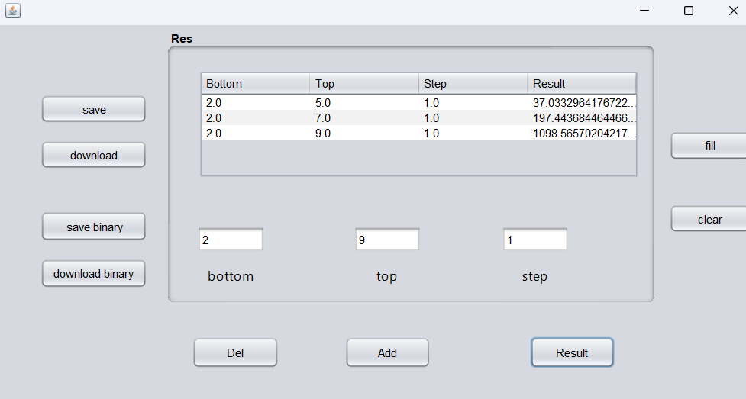

Записываем их в файл

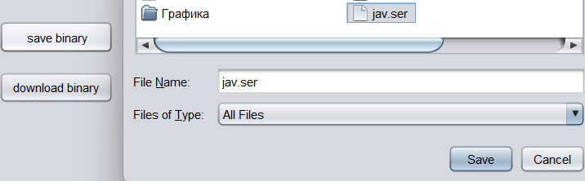

Загружаем из файла в таблицу

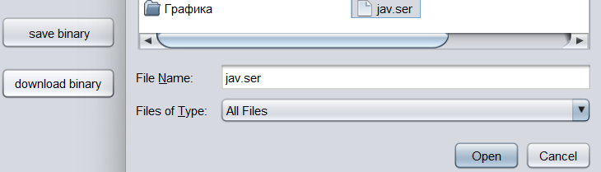

Смотрим результат

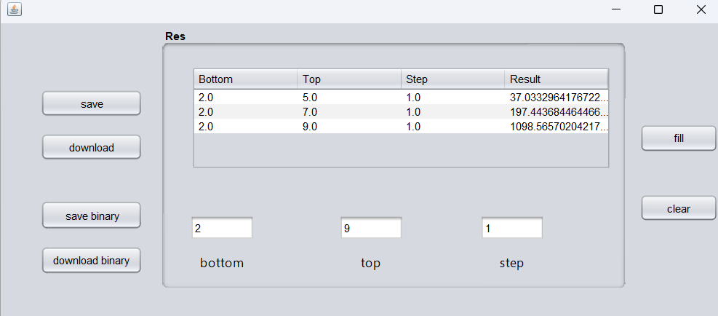

**Вывод:** Мы изучили работу с файлами и механизмы сериализации данных.