Practicing SQL with MySQL test employees database

Vladimir Kotushenko

2020-01-28

What insights about organization could be found in this data set?
Browsing on internet, searching for a test database i can practice SQL skills on , i found this MySQL test database, that looks good for a given purpose.
It's a employees database with their titles, salaries and departments also includes some historical data in.
Here is schema from dev.mysql.com:
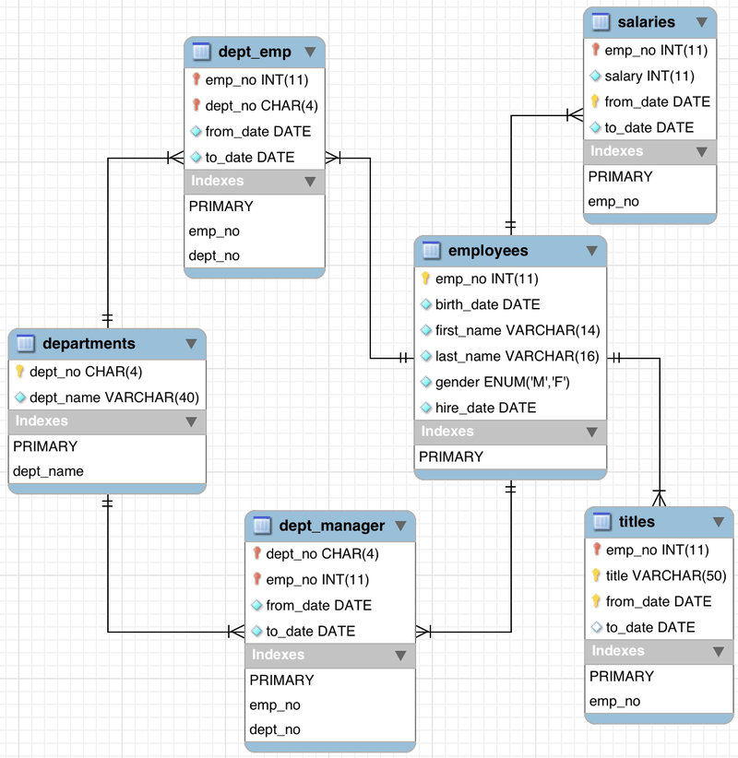

MySQL test DB

How many departments are exists?
SELECT count(*) FROM departments
count(*)
9

How many active managers there are in company?
SELECT count(*) FROM dept_manager WHERE to_date > NOW()
count(*)
9
Each department have exactly one manager.

What are manager's salaries:
SELECT
e.first_name, e.last_name, e.gender,
d.dept_name, s.salary
FROM
dept_manager AS dm
LEFT JOIN employees AS e ON e.emp_no = dm.emp_no
LEFT JOIN dept_emp AS de ON e.emp_no = de.emp_no
LEFT JOIN departments AS d ON d.dept_no = de.dept_no
LEFT JOIN salaries AS s ON s.emp_no = e.emp_no
WHERE
dm.to_date > now()
AND s.to_date > now()
ORDER BY
s.salary DESC
first_name | last_name | gender | dept_name | salary
Vishwani | Minakawa | M | Marketing | 106491
Hauke | Zhang | M | Sales | 101987
Isamu | Legleitner | F | Finance | 83457
Hilary | Kambil | F | Research | 79393
Leon | DasSarma | F | Development | 74510
Dung | Pesch | M | Quality Management | 72876
Karsten | Sigstam | F | Human Resources | 65400
Yuchang | Weedman | M | Customer Service | 58745
Oscar | Ghazalie | M | Production | 56654

How many employees currently are working in every department and what their average salary?
SELECT
d.dept_no, d.dept_name, count(*) AS emp_count, AVG(s.salary) as salary
FROM
employees AS e
LEFT JOIN dept_emp AS de ON e.emp_no = de.emp_no
LEFT JOIN departments AS d ON d.dept_no = de.dept_no
LEFT JOIN titles AS t ON t.emp_no = e.emp_no
LEFT JOIN salaries AS s ON s.emp_no = e.emp_no
WHERE
de.to_date > NOW()
AND t.to_date > NOW()
AND s.to_date > NOW()
GROUP BY
d.dept_name
ORDER BY
emp_count
dept_no | dept_name | emp_count | salary
d002 | Finance | 12437 | 78559.9370
d003 | Human Resources | 12898 | 63921.8998
d006 | Quality Management | 14546 | 65441.9934
d001 | Marketing | 14842 | 80058.8488
d008 | Research | 15441 | 67913.3750
d009 | Customer Service | 17569 | 67285.2302
d007 | Sales | 37701 | 88852.9695
d004 | Production | 53304 | 67843.3020
d005 | Development | 61386 | 67657.9196

What is average salary by gender?
SELECT
e.gender, AVG(s.salary) as avg_salary
FROM
dept_manager AS dm
LEFT JOIN employees AS e ON e.emp_no = dm.emp_no
LEFT JOIN dept_emp AS de ON e.emp_no = de.emp_no
LEFT JOIN departments AS d ON d.dept_no = de.dept_no
LEFT JOIN titles AS t ON t.emp_no = e.emp_no
LEFT JOIN salaries AS s ON s.emp_no = e.emp_no
WHERE
dm.to_date > NOW()
AND t.to_date > NOW()
AND s.to_date > NOW()
GROUP BY e.gender
gender | avg_salary
M | 79350.6000
F | 75690.0000
% | 4.61

Distribution of salaries across departments and roles: [ARCHIVE]

