R Markdown Tutorial

Vlad Krotov

2/24/2020

## This is YAML header

## Installing ‘rmarkdown’ Package

install.packages("rmarkdown")  
install.packages("knitr")  
install.packages("stargazer")  
library(rmarkdown)  
library(knitr)  
library(stargazer)

#Seting global options:

Note that the code above will not be run or evaluated due to “include=FALSE” option

## R Markdown

This is an R Markdown document. Markdown is a simple formatting syntax for authoring HTML, PDF, and MS Word documents. For more details on using R Markdown see <http://rmarkdown.rstudio.com>.

When you click the **Knit** button a document will be generated that includes both content as well as the output of any embedded R code chunks within the document. You can embed an R code chunk like this:

summary(cars)

## speed dist   
## Min. : 4.0 Min. : 2.00   
## 1st Qu.:12.0 1st Qu.: 26.00   
## Median :15.0 Median : 36.00   
## Mean :15.4 Mean : 42.98   
## 3rd Qu.:19.0 3rd Qu.: 56.00   
## Max. :25.0 Max. :120.00

## Including Plots

You can also embed plots, for example:



Note that the echo = FALSE parameter was added to the code chunk to prevent printing of the R code that generated the plot.

## Code Chunk Parameters

There are many other paramaters for code chunks:

Rule | Example | Function

eval eval=TRUE Is the code run and the results included in the output? include include=TRUE Are the code and the results included in the output? echo echo=TRUE Is the code displayed alongside the results? warning warning=TRUE Are warning messages displayed? error error=FALSE Are error messages displayed? message message=TRUE Are messages displayed? tidy tidy=FALSE Is the code reformatted to make it look “tidy”? results results=“markup” How are results treated? “hide” = no results “asis” = results without formatting “hold” = results only compiled at end of chunk (use if many commands act on one object) cache cache=FALSE Are the results cached for future renders? comment comment=“##” What character are comments prefaced with? fig.width fig.width=7 What width (in inches) are the plots?  
fig.height fig.height=5 What height (in inches) are the plots? fig.align fig.align=“left” How is figure aligned? Can be “left” “right” “center”

## Inserting Figures

A <- c(1, 2, 3, 4)  
B <- c(5, 10, 15, 20)  
df <- data.frame(A, B)  
plot(df)

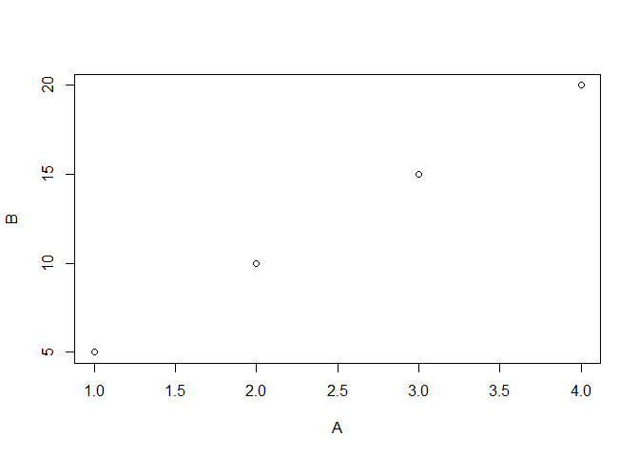

## Inserting Tables

You can just print a dataframe instead of a table

cars

## speed dist  
## 1 4 2  
## 2 4 10  
## 3 7 4  
## 4 7 22  
## 5 8 16  
## 6 9 10  
## 7 10 18  
## 8 10 26  
## 9 10 34  
## 10 11 17  
## 11 11 28  
## 12 12 14  
## 13 12 20  
## 14 12 24  
## 15 12 28  
## 16 13 26  
## 17 13 34  
## 18 13 34  
## 19 13 46  
## 20 14 26  
## 21 14 36  
## 22 14 60  
## 23 14 80  
## 24 15 20  
## 25 15 26  
## 26 15 54  
## 27 16 32  
## 28 16 40  
## 29 17 32  
## 30 17 40  
## 31 17 50  
## 32 18 42  
## 33 18 56  
## 34 18 76  
## 35 18 84  
## 36 19 36  
## 37 19 46  
## 38 19 68  
## 39 20 32  
## 40 20 48  
## 41 20 52  
## 42 20 56  
## 43 20 64  
## 44 22 66  
## 45 23 54  
## 46 24 70  
## 47 24 92  
## 48 24 93  
## 49 24 120  
## 50 25 85

Or you can use kable function:

## Warning: package 'knitr' was built under R version 4.0.3

|  |  |
| --- | --- |
| A | B |
| 1 | 5 |
| 2 | 10 |
| 3 | 15 |
| 4 | 20 |

You can create a table manually using R Markdown:

|  |  |  |
| --- | --- | --- |
| Plant | Temp. | Growth |
| A | 20 | 0.65 |
| B | 20 | 0.95 |
| C | 20 | 0.15 |

Here’s the syntax for alignment:

:----: Centre :----- Left -----: Right ------ Auto

Tables can also be created using ’stargazer’package

library(stargazer)

## Warning: package 'stargazer' was built under R version 4.0.3

##   
## Please cite as:

## Hlavac, Marek (2018). stargazer: Well-Formatted Regression and Summary Statistics Tables.

## R package version 5.2.2. https://CRAN.R-project.org/package=stargazer

stargazer(attitude, type = "html")

##   
## <table style="text-align:center"><tr><td colspan="8" style="border-bottom: 1px solid black"></td></tr><tr><td style="text-align:left">Statistic</td><td>N</td><td>Mean</td><td>St. Dev.</td><td>Min</td><td>Pctl(25)</td><td>Pctl(75)</td><td>Max</td></tr>  
## <tr><td colspan="8" style="border-bottom: 1px solid black"></td></tr><tr><td style="text-align:left">rating</td><td>30</td><td>64.633</td><td>12.173</td><td>40</td><td>58.8</td><td>71.8</td><td>85</td></tr>  
## <tr><td style="text-align:left">complaints</td><td>30</td><td>66.600</td><td>13.315</td><td>37</td><td>58.5</td><td>77</td><td>90</td></tr>  
## <tr><td style="text-align:left">privileges</td><td>30</td><td>53.133</td><td>12.235</td><td>30</td><td>45</td><td>62.5</td><td>83</td></tr>  
## <tr><td style="text-align:left">learning</td><td>30</td><td>56.367</td><td>11.737</td><td>34</td><td>47</td><td>66.8</td><td>75</td></tr>  
## <tr><td style="text-align:left">raises</td><td>30</td><td>64.633</td><td>10.397</td><td>43</td><td>58.2</td><td>71</td><td>88</td></tr>  
## <tr><td style="text-align:left">critical</td><td>30</td><td>74.767</td><td>9.895</td><td>49</td><td>69.2</td><td>80</td><td>92</td></tr>  
## <tr><td style="text-align:left">advance</td><td>30</td><td>42.933</td><td>10.289</td><td>25</td><td>35</td><td>47.8</td><td>72</td></tr>  
## <tr><td colspan="8" style="border-bottom: 1px solid black"></td></tr></table>

## Other Elements of R Syntax

*Italic*

**Bold**

Bold

This is code in text

# Header 1

## Header 2

Note that when a # symbol is placed inside a code chunk it acts as a normal R comment, but when placed in text it controls the header size.

* Unordered list item

1. Ordered list item

[Link](https://www.google.com)

$A=π×r^{2}$