Predictive Modeling using Weight Lifting Exercise Dataset
Loading and Pre-processing of the training data set
The training dataset was, first, downloaded using the web-link (https://d396qusza40orc.cloudfront.net/predmachlearn/pml-training.csv) and then brought into R with read.csv function.
Data mining of the data set revealed large number of variables with either missing data or empty strings. All those variables had exactly the same “informative” and/or non-missing observations. I introduced a new variable “flag” to capture in dichotomized way whether the observation was informative or missing across these variables. Subsequently, the original variables with high fraction of missing values were dropped from the data frame.
## Preserving flag for potential outlier observations
>dat1$flag<-ifelse(dat1$kurtosis_roll_belt !="",1,0)
## Retaining variables with >=20% non-missing (or informative) values
>dat1<-dat1[,sapply(dat1, function(x) sum(x=="" | is.na(x)==1))/nrow(dat1)<0.8]
As I am going to use Random Forest, and it does not require scaling, I did NOT use pre-processing of the data such as scaling, or centering etc.
Splitting the data set into the Training and Testing
70% of samples were allocated to the training set, 30% -to the testing set. I employed createDataPartition function from the caret package to divide the dataset. Compared to sample function, it allows to perform sampling within class, thus, to preserve the distribution of the outcome (variable dat1$classe in our case) in the training and test sets.
## 70% to training set, 30% to testing
>inTrain<-createDataPartition(y=dat1$classe, p=0.7,list=F)
>train<-dat1[inTrain,]
>test<-dat1[-inTrain,]
Reduction of the number of features
Random forest takes very long time to compute. Therefore, although it is not necessary for the algorithm itself, I reduced the number of variables in the dataset. This trick should decrease the number of hours needed to compute Random Forest classification. On a separate note, from a practical perspective, smaller number of predicting variables is advantageous in real life as it reduces the cost of assays, data storage etc.
As the feature filter, a univariate ANOVA was employed. Based on visual inspection of ANOVA F-values histogram, a cut-off was set to retain all variables with F-value>70 in the training subset. After this step the training dataset has 22 numeric variables to perform prediction with Random Forest.
This step could be problematic if all retained numeric variables are strongly correlated (or anti-correlated) to each other. Heatmap of the correlation distance matrix, (1-abs(r) to be exact) shows that there are at least ~11 uncorrelated blocks of variables. While I could further reduce the number of predicting variables by removing, for example, magnet_belt_y (the top raw) which gives the same information as magnet_belt_z, but with lower F-value (190 vs. 450), I was curious how Random Forest will handle it; and I decided against further refinement of variables.
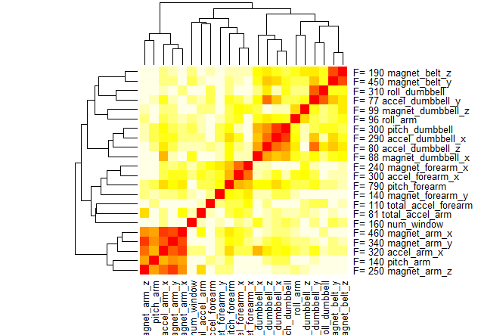

Random Forest performance on the training and testing sets
Random Forest algorithm was employed using caret package in the following way:
>modFit<-train(classe~.,method="rf",data=train,prox=T)
Classe variable is trained to be predicted by the 22 numeric variables using Accuracy as the metric. Random Forests is the unique learning machine because of its use of bootstrap sampling for every tree. This ensures that every tree in the forest is built on about 63% of the available data, leaving the remaining approximately 37% for testing [the OOB (out-of-bag) data]. Essentially, Random Forest uses “internal” cross-validation; thus, I have not used prohibitively computationally long K-fold cross-validation. Actually, the Random Forest run itself took >8 hours on my computer.
>modFit$finalModel
Call:
randomForest(x = x, y = y, mtry = param$mtry, proximity = ..1)
Type of random forest: classification
Number of trees: 500
No. of variables tried at each split: 12

OOB estimate of error rate: 0.32%
Confusion matrix:
A B C D E class.error
A 3904 2 0 0 0 0.0005120328
B 5 2644 7 2 0 0.0052671181
C 0 14 2381 1 0 0.0062604341
D 0 0 4 2247 1 0.0022202487
E 0 3 1 4 2517 0.0031683168

OOB (out-of-bag) error rate estimate was found to be around 0.32%. It is more critical to review the performance on the testing set, which has not been touched in any way, so far.
>table(test$classe,predict(modFit,newdata=test))
A B C D E
A 1674 0 0 0 0
B 4 1132 2 0 1
C 0 5 1020 1 0
D 0 2 11 951 0
E 0 0 1 3 1078
> (accuracy<-100*sum(test$classe==predict(modFit,newdata=test))/length(test$classe))
[1] 99.49023
> (errorrate<-100-accuracy)
[1] 0.5097706

Thus, using the preserved testing set, the accuracy of prediction is 99.5%. The error rate is 0.51%, which is, as expected, somewhat larger than 0.32% in the OOB estimate.
Predicting 20 new observations
The testing/exam dataset was, first, downloaded using the web-link (https://d396qusza40orc.cloudfront.net/predmachlearn/pml-testing.csv) and then brought into R with read.csv function. The same 21 predicting variables were retained. New observations were classified using:
> answers <-predict(modFit,newdata=val)

