aicas GmbH / Fischertechnik

Sorting Line – Demo

Usage and Manual

Preparation and Startup
Make sure that you have physical access to the Fischertechnik Sorting Line and its TXT controller. Make sure that you have a Notebook (or a Desktop PC) from which you will connect to the device and run the Demo on Jamaica-IoT.

Power-On
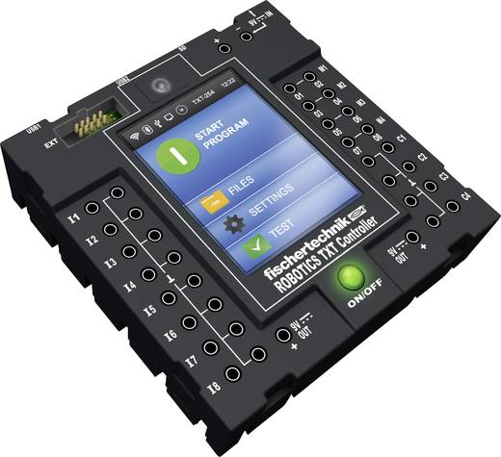Illustration 1: Fischertechnik TXT Controller

Press on/off button and hold it (for at least a second). The touch display should turn on. The operating system and services need a little time (~ 30 sec.) until they are up and running.

Configure Network / WiFi (optional if not done yet)

Connect to the Fischertechnik TXT Device
You need a remote terminal program on you PC. For Linux you can just use your standard Terminal with SSH. For Windows you explicitly need an (SSH) terminal client, e.g. Putty.
For Windows:
If you do not have Putty on your PC, please download and install it from: https://www.chiark.greenend.org.uk/~sgtatham/putty/latest.html
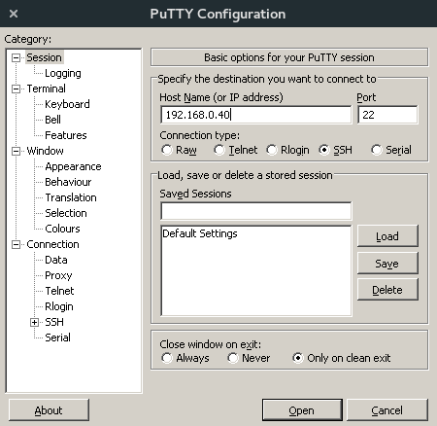Illustration 2: Putty configuration

Start Putty → Enter the given IP address and press open → When requested please type the following user information:
Username: root
Password: acc4txt%18
For Linux:
Start a new Terminal (press Windows key on your keyboard, type “terminal”, press Enter) → Execute the following command:
ssh root@192.168.0.40
(expect a short delay of a couple of seconds ...)
Type as password: acc4txt%18
You terminal should be now connected to the TXT controller.

Mount the SD-Card
Jamaica-IoT as well as all the Demo components (bundles) are deployed on the SD-Card which is plugged into the TXT Controller.
The SD-Card must be initialized (mounted) to the OS file system. For that execute the following commands in the Terminal which is remotely connected to the TXT controller:
mount /dev/mmc… /mnt/sdcard1
mount /dev/mmc… /mnt/sdcard2
The deployed Jamaica-IoT framework can be then found under:
/mnt/sdcard2/opt/aicas/jiot

Start the Jamaica-IoT Framework
Execute the following commands in your remote terminal on the TXT controller:
cd /mnt/sdcard2/opt/aicas/jiot
./start
Wait until the Framework is up and running (i.e. there is no more new text coming out in the console). This might take up to 30 – 60 sec.
Note: A Jamaica-IoT (OSGi) command line prompt (a shell) should appear. Press a couple times Enter to see a new prompt on each line. Type “lb” and press Enter to see the state of the installed components in the running Jamaica-IoT instance . If you can see the bundle list, than your framework is up and running.

Using the Sorting Line Demo
Once Jamaica-IoT is up and running you can install and start the Sorting Line Demo. The Demo consists of several dependent components (bundles), which have to be installed and started in a particular order, e.g. from the app store provided by aicas. Which bundles must be deployed and executed, and how this is done from the app store, depends on the actual demo scenario, and will be explained further below.
Note: After start-up, Jamaica-IoT may already have the required Demo bundles installed (from its own cache) and available from previous runs. This should be okay. Depending on their last state (stopped or running) the components might be automatically started again. If everything required is already there, you should see a message like:
aicas standard sorting
or
aicas multiple sorting
and
waiting for a new object ...
Then, respectively, the single or the multiple object sorting program is up and ready for experiments.
However, you will still need to understand the precise scenarios and the respective components setup in order to play-through the whole Demo.

Sorting Line Demo Scenarios
Typically we tell a common story about how the Demo was created and designed to show our technical strengths and easy development with JamaicaVM and Jamaica-IoT.
Standard Sorting
In a first setup we show that we were able to implement Fischertechnik’s original Sorting Line functionality with (Real-Time) Java. For that we implemented the logic in several Jamaica-IoT components (bundles) which are separately deployed and executed on top of the framework on the target device (the TXT controller).
This demo showcases only the standard Fischertechnik logic, which can sort only one object put on the line in a predefined and static order, i.e. white, red and blue (in line rotation direction).
Multiple Sorting
This scenario is motivated by reaching a higher throughput on the sorting line, by parallelizing the sorting procedure. However, because the Fischertechnik Sorting Line was not designed for such an use case, we may encounter some interference on the color sensor, if objects are put-in too close. Please make sure to have at least 3 – 5 cm distance between the colored objects when putting them one after the other on the sorting line.
Multiple Sorting with Exchangeable Sorting Logic
Here we explain, that the sorting logic (push-out mechanism in particular color order) is exchangeable. It is implemented by a service and provided by a bundle (component) which can be easily exchanged during runtime. Our Multiple Sorting program is clever enough to track for the latest deployed Sorting Logic Version and to automatically wire against it. In this case during runtime we simply update the bundle holding the particular sorting logic with another implementation for a different color order, e.g. Blue – White – Red (in line rotation direction). Note: Once put in the belt, for each object a sorting logic is queried and referenced. Therefore, in our example, a logic exchange holds for all new objects placed on the line after a particular logic update.

Running the different Scenarios
Here I assume that you are familiar with our app store, its dashboard and in particular with:
- how to connect to it
- how to introspect, install and update application components in the app store
- how to introspect the configuration of running devices
- how to install, start and stop components on a particular device
- how to upload a new component version to the app store
- how to update a component on a device from the app store
After getting warm with our app store and succeeding with the tasks mentioned above, you should know enough to be able to run our Demo and implement the mentioned scenarios.
Standard Sorting
Open the device configuration of the TXT controller in the app store front end.
Note: make sure that the AicasTxtMultipleSorting component is stopped.
For the standard sorting the following components must be installed and started in the specified order:
1. AicasTxtDriverBundle – implements a basic Java driver for controlling the Sorting Line hardware (motor, color sensor, light barriers, valves, compressor)
2. SmackContainerBundle – provides XMPP connection services for the application components
3. AicasTxtSortingLogic – this is the actual standard sorting program
If these bundles are already installed on the device, it is okay, just make sure that they are started in the given order.
When you start these bundles in Jamaica-IoT on the TXT controller a message should appear in your remote terminal like:
aicas standard sorting
...
waiting for a new object …
Done. You can start now putting objects on the belt. Show that if you put several objects in parallel only the first one is sorted out and then the belt stops. (original Fischertechnik functionality)

