Technical University of Košice

Department of Computers and Informatics

Problem Set 6

The maze runner

Plotkin Vladyslav 2023/2024 **Assignment**

Using the ncurses library, create a program (game, presentation or other artistic work), with the following minimal requirements:

* Project contains 2D world.
* Project meets at least 3 challenges:
  + Work with colors
  + Keyboard control (no Enter needed)
  + Multiply levels
  + Work in time (in the time the program is changed)
  + Work with command-line arguments
  + Work with files
* Project must be more complicated than the sample programs, with an adequate level of difficulty

# Game Logic

The game consists 6 functions

* void roll_text() - function that moves the text at the bottom of the screen.
* void draw_logo() – using an ASCI table to display large text.
* void moving_arrow(char map1[][81]) – implementation of walking through the maze with output control.
* void screensaver() – function, let the text float from the corner, diagonally.
* void print_logo() – represents levels 1-3 in game.
* void draw_maze() – display a two-dimensional field on the screen.
* void map1(), void map2() , void map3() – drawing the map line by line with a delay of 0.1 seconds.

# Game play

After starting the game, you will be presented with a menu of three different maps, each with varying difficulty, and you can choose between different maps. You can scroll up and down to select a card or quit the game altogether. The Maze Runner is a text-based maze exploration game implemented in C using the curses library. The player navigates through various mazes, solving puzzles, and avoiding obstacles to reach the exit. The game consists of three maps with increasing difficulty levels.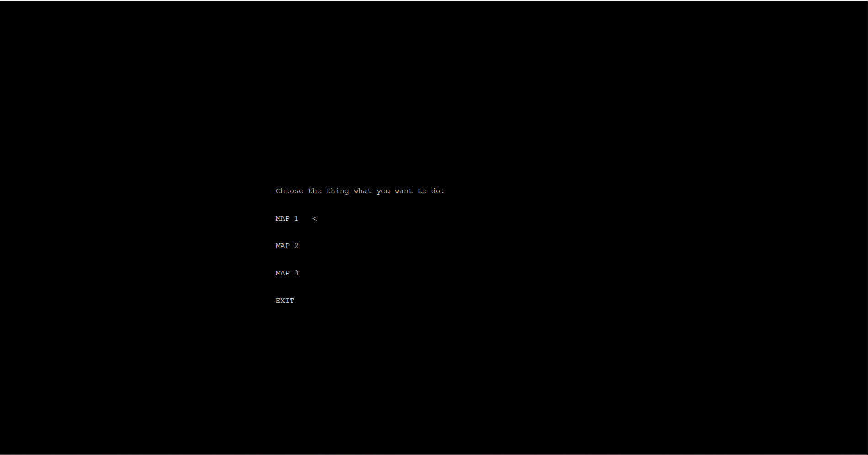

You can choose a map from the menu, you need to select it with the Enter key. After selecting the map you want to go through, a new window will appear in which the map will be drawn from top to bottom with a delay. You can move the ">" character using the arrow keys on the keyboard "<", ">", "^", "v". The character will always appear in the upper left corner and you have children until the end, then the game ends with the successful completion of the map. And then, when you get there, you can go back using the "B/b" key, or you can go back to the menu list using Esc, this is done if you are tired of going through the map or it seems difficult or difficult or boring for you to go through this map, then you can easily leave this tab and choose another one to your taste.

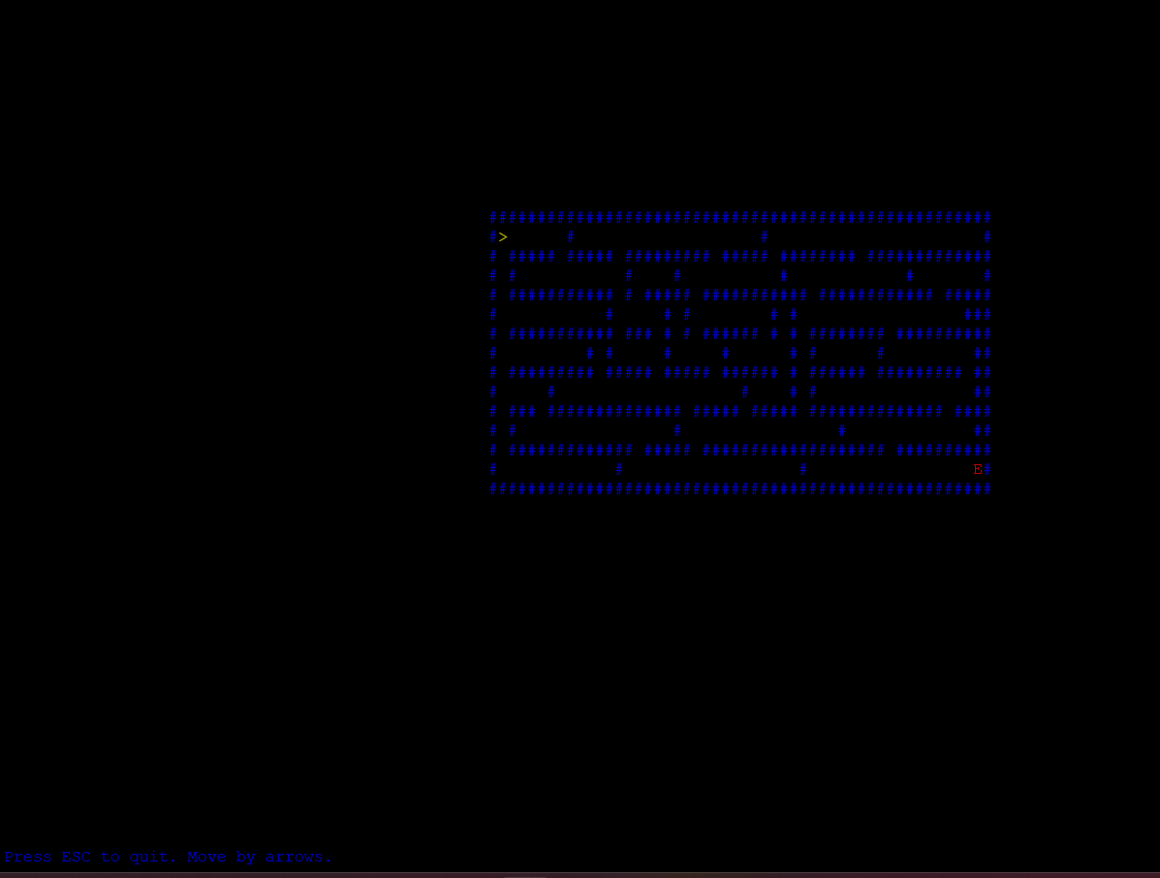

Displays a specific map on the screen. Animates the map display. Calls the

move_arrow function to allow the player to move. move_arrow. Controls the player's movement in the maze. Handles user input for the arrow keys. Updates the player's position and checks for collisions or reaching the exit. Displays a message when the exit is reached.

Records the number of steps taken in a file.

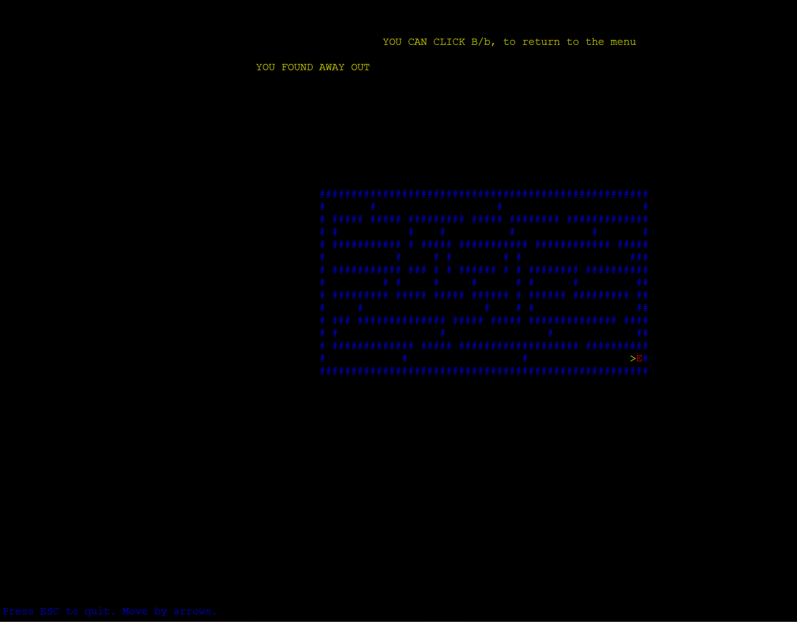

Mazes are presented as two-dimensional symbol arrays. The following symbols are used:

#: wall

E: Exit

Gameplay

The player starts from a certain position. Move through the maze using the arrow keys (<, >, ^, v). Avoid obstacles in the form of walls (#). Reach the exit (E) to end the level. It counts the number of steps taken and writes it to a file.

Quit the game:

Press ESC to exit the game at any time.

Šetrič obrazovky:

Ak je hra neaktívna, zobrazí sa šetrič obrazovky s pohyblivou správou.

File Output:

The game records the number of steps the player has taken in a file named countsteps.txt.

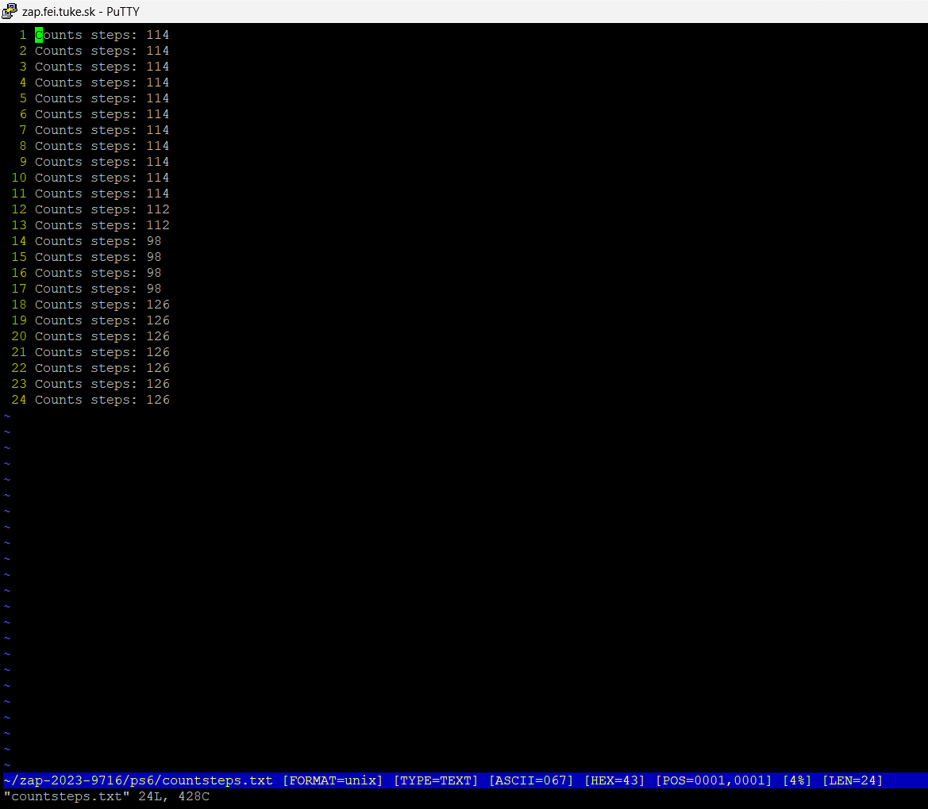

# The maze runner game offers an exciting maze-solving experience using several maps of varying difficulty levels. Players can navigate the maze, solve puzzles, and record their achievements.

# We can go back by pressing the B or b key.

# Conclusion

In The Maze Runner, the choice of cards not only determines the character's path through the maze, but also influences the development of a unique story. Each map reveals new secrets and brings its own challenges and important decisions for the player.

In addition, the player can record the number of steps in the maze, which adds an element of strategy and competition. This feature allows you to compare your results with other players and encourages you to improve your strategy during the game.

Thus, the choice of cards and the ability to fix the number of steps make the game exciting, including elements of choice, strategy and competition, which make each game unique and interesting for the player, using the Esc key. can completely exit the game