Assignment 3.2

Description Document

Table of contents:

1. Conceptual architecture of the distributed system
2. UML Deployment diagram
3. Readme
4. Conceptual architecture of the distributed system

The application consists of 3 parts: 2 web services & one GUI application.

The Java web service deals with the administrator operations

The .Net web service handles user operations.

The GUI application consumes both web services.

1. UML Deployment Diagram

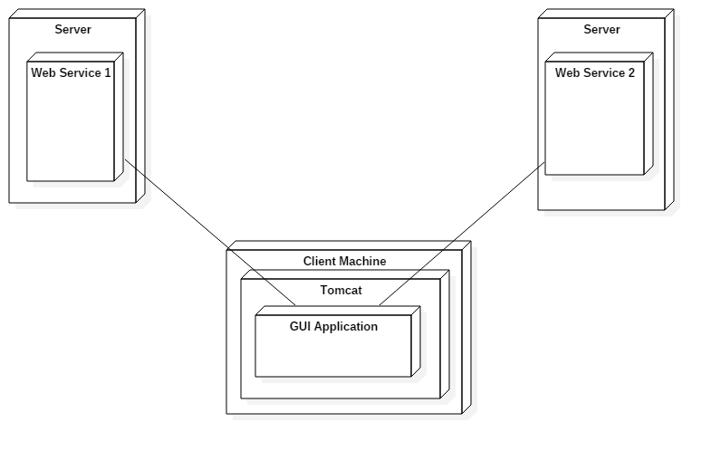

1. Readme

In order to run the application the following are required:

* Java 1.6 or any newer version
* A MySQL database
* .Net Framework 3.5 or newer

To run the application, follow the next steps:

* Start the java web service
* Start the .net web service
* Start the gui application