Assignment 3.2

Description Document

Table of contents:

1. Conceptual architecture of the distributed system
2. UML Deployment diagram
3. Readme
4. Conceptual architecture of the distributed system

The application is structured on 4 modules.

The first module is a web server which allows DVD store administrators to input data that will be pushed in the queue.

The second module is an email consumer, which sends an email to all clients whenever it consumes a message from the queue.

The third module is a file consumer, which creates a file for each message consumed from the queue.

The fourth module consists of common classes & interfaces used by all the other modules.

1. UML Deployment Diagram

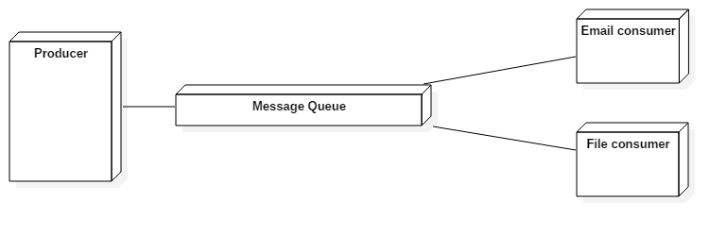

1. Readme

In order to run the application the following are required:

* Java 1.6 or any newer version
* RabbitMQ (along with Erlang)
* A MySQL database

To run the application, follow the next steps:

* Start the producer module
* Start the email consumer
* Start the file consumer
* Go to localhost:8080 on your browser and input some data