Assignment 2.2

Description Document

Table of contents:

1. Conceptual architecture of the distributed system
2. UML Deployment diagram
3. Readme
4. Conceptual architecture of the distributed system

The application is structured on 2 modules.

The first module is a webserver which allows clients to input data that will be sent to the remote server.

The second module is a remote server which computes the required calculations based on the input received from the user.

1. UML Deployment Diagram

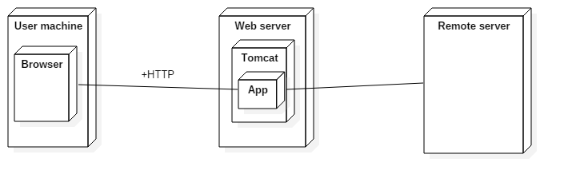

1. Readme

In order to run the application the following are required:

* Java 1.6 or any newer version

To run the application, follow the next steps:

* Start the web server
* Start the remote server
* Go to localhost:8080 on your browser and input some data