 |  | ATCA U-Boot and Linux Software Specification  Author: Dave Lyons  Email: dave.lyons@radisys.com  Owner: Dave Lyons
002-04713-0000  draft 1.0.62  July 28, 2009 |  | Note: To verify signoff, see the on-line repository.
 |  | Name | Title/Department
Approver: |  | Himanshu Parikh | Project Lead
Reviewers: |  | Andy Legard | NPI Program Manager
 |  | Brian Dominy | Software Engineer
 |  | Eric Gregory | Product Line Manager
 |  | Jared Lewis | Software Engineer
 |  | Kim Kempf | Software Engineer
 |  | Nilan Naidoo | Software Architect
 |  | Vlad Rakocevic | Manager, Platform Management Software
Agile
0000.doc
Preface
Revision History
All revisions that start with zero (i.e., 0.5, 0.65, etc.) are preliminary drafts for internal reviews.
- Revision history
No. | Date | Author | Description
0.0 | 1/9/2006 | Eric Oosterhof | Initial draft.
0.5 | 1/17/2006 | Eric Oosterhof | Send out for internal comments
0.6w | 2/3/2006 | Eric Oosterhof | Work in progress - updates from internal comments. Word change tracking enabled - review for change list.
0.7 | 5/17/2006 | Eric Oosterhof | Work in progress – updates from additional comments.  Word change tracking enabled – review for change list.
0.8 | 7/25/2006 | Eric Oosterhof | Work in progress. Internal review changes. See review comments and Word change tracking for details on changes
0.81 |  | Eric Oosterhof | Changes due to final internal review  - Spelling, minor grammar issues  - Added NTP server, SSH in overview  - Added RadiSys P/N  - Replace section 5.11 with reference to Mike’s API document  - Added section 6 on Security  - Added rsysMMServer script info to boot sequence detail  - Added boot timeline diagrams  - Updated boot ordering  - Replaced section 5.4 with new section directly from Ken M
0.9 | 8/4/2006 | Eric Oosterhof | Version ready for Nokia internal review
0.91 | 9/7/2006 | Eric Oosterhof | Changes due to Nokia internal review  - Added Appendix I to cross-reference customer requirements with spec sections  - Added many spec items to meet requirements
0.92 | 9/25/2006 | Eric Oosterhof | Additional internal review comments  - Formatting changes to header/footer  - Formatting changes to cross-ref table at end of document  - Minor tweaks
0.99 | 9/29/2006 | Eric Oosterhof | Added boot from base and fabric capability to U-Boot
0.991 | 12/12/2006 | Dave Lyons | Updated to address customer specific issues
0.992 | 03/21/2007 | Dave Lyons | Additional updates for customer specific issues. Changed sections include:  Added list of RadiSys standard products covered by this specification.  Updated section 3 to address Persistent Default Flash Device and updated description of CFD watchdog.  Updated U-Boot Flowchart in Figure 2.  Updated section 4.1.1 to describe IPMC Warm Reset Counter.  Removed Section on DHCP.  Removed mention of booting via Base Interconnect.  Changed BMC timeout value in section 5.8 from 7 seconds to 2 seconds.  Updated Boot Sequence Details in section 7.1 to match flowchart in Figure 2.  Added section describing pre-timeout interrupt.  Added description of hotkey to enable U-Boot CLI.  Added example boot sequence for ATCA 2210.  Added reference to IPMI 1.5 specification.
0.993 | 03/22/2007 | Dave Lyons | Additional changes including:  - Updated Bootstrap Flow Diagram in Figure 2.
0.994 | 04/23/2007 | Dave Lyons | Updated based on Nokia-Siemens review feedback. Changes include:  - Removed “Preliminary” watermark.  - Added explanation of minimum amount of memory needed by reflash tool to section 5.2.2.
1.0 | 06/01/2007 | Dave Lyons | Approved version.
1.0.6 | 07/06/2009 | Dave Lyons | Added content to describe new features.
1.0.61 | 07/09/09 | Dave Lyons | Added appendix for NSN-specific information.
1.0.62 | 07/28/09 | Dave Lyons | Incorporated updates to U-Boot section.
1.0.63 | 07/28/09 | Dave Lyons | Formatting changes.

Notational Conventions
Screen text and syntax strings appear in this font.

Contents
1. Introduction 10
1.1 Purpose 10
1.2 Scope 10
1.3 Assumptions 11
1.4 Policy 11
1.4.1 Deeply Embedded Modules 11
1.4.2 Compute Modules 11
1.5 Delivery 11
2. Functionality Overview 12
2.1 Overview 12
2.2 Additional Documentation 13
3. Dual Bootstrap Mechanism 14
3.1 Bootstrap Image Selection 14
3.2 Corrupt Flash Detection Watchdog 14
3.3 BMC Watchdog Timer and Redundant Bootstrap Image Selection 14
3.4 Bootstrap Flow 15
4. U-Boot Boot Monitor 17
4.1 U-Boot Operation 17
4.1.1 Cold Reset and Warm Reset 17
4.1.2 Memory Initialization 17
4.1.2.1 Error Checking and Correction (ECC) 17
4.1.3 PCI Initialization 17
4.1.4 PCI Express Initialization 18
4.1.5 Ethernet Initialization 18
4.1.6 Serial Port Initialization 18
4.2 Booting Linux 18
4.2.1 U-Boot Boot Device Processes 18
4.2.1.1 Overview 18
4.2.2 DHCP Request 19
4.2.2.1 RadiSys-specific DHCP Option 61 20
4.2.3 UShell Application Design 21
4.2.3.1 Overview 21
4.2.3.2 UShell Description 21
4.2.4 Configuration Options 23
4.3 U-Boot Monitor Commands 24
4.3.1 Reflash Operations 24
4.3.2 TFTP 24
4.4 Additional U-Boot Command Capabilities 25
4.4.1 U-Boot Environment Variables 25
5. Operating System and Services 28
5.1 OS and integrated filesystems 28
5.1.1 Source Code 28
5.1.2 Filesystem Hierarchy Standard overview 28
5.1.2.1 Shareable and static files 28
5.1.2.2 Unshareable and static files 28
5.1.2.3 Variable files 28
5.2 File Systems 29
5.2.1 JFFS2 File System 29
5.2.2 RAMfs 29
5.3 Runlevels 29
5.4 OnBoot utility 30
5.4.1 Overlay 30
5.4.2 Bind mounting 31
5.4.2.1 Bind mounting a single file 31
5.4.2.2 Bind mounting a directory 31
5.4.3 Remove 31
5.4.4 Packages [future release] 32
5.4.5 Live patches [future release] 32
5.5 IP Addressing 32
5.5.1 Local Loopback Interface (lo) 32
5.5.2 LMP Ethernet Connections 32
5.5.3 Update Channel Ethernet Connections 33
5.5.4 Base Ethernet Connections 33
5.5.5 Fabric Ethernet Connections 33
5.5.6 Default IP Addressing 33
5.6 Control of IP Addressing 35
5.6.1 Standard Client Identifier Used for Dynamic Interfaces 36
5.6.2 RadiSys-specific Client Identifier Used for Dynamic Interfaces 36
5.6.2.1 DHCP Client 36
5.6.2.2 DHCP Client Identifier 36
5.6.3 DHCP custom hooks 37
5.7 Operating System Services 37
5.7.1 Xinetd configuration 37
5.7.2 Telnet Support 38
5.7.3 SSH Support 38
5.7.4 NFS 38
5.7.5 FTP 38
5.7.6 TFTP 38
5.7.7 802.1Q VLAN Support 38
5.7.8 LMP Based Ethernet Bridging 39
5.7.9 IPv4 Masquerade 39
5.7.10 DHCP Server 40
5.7.11 DHCP Client 40
5.7.12 NTP Server and Client 40
5.7.13 SNMP Agent 40
5.7.14 SNMP Interface 40
5.7.15 Cron and at 40
5.7.16 Kgdb 40
5.8 Watchdog Support 40
5.9 Pre-Timeout Interrupt Support 41
5.10 Linux User Accounts 41
5.11 Linux Shell 41
5.11.1 Linux Login Prompt 41
5.11.2 Linux syslog 41
5.11.3 Linux Shell Prompt 41
6. Security 43
6.1 Watchdog operation 43
6.2 U-Boot security 43
6.3 Linux kernel and application patches 43
6.4 Linux filesystem security 43
6.5 Linux kernel access security 43
6.5.1 Shadow passwords 43
6.5.2 PAM 43
6.5.3 New Users 43
6.6 Default groups and users 44
6.7 Root user access 44
6.8 Automatic Remote Access 44
6.9 NFS 44
7. Local Management Processor Bootup Sequence 45
7.1 Boot Sequence Details 45
7.1.1 Example Boot Sequence 46
7.2 Handling of Failures During the Boot Process 51
7.2.1 Debug Mode 51
7.2.2 Active Shelf Manager Cannot Provide Shelf Information 52
7.2.3 FASTPATH Applications Do Not Start Correctly 52
7.3 Generation of Shelf Configuration Information 52
8. Performance 54
8.1 Performance Improvements 54
8.2 Boot Timeline 54
Appendix A: References 57
A.1 Related Documents 57
A.1.1 RadiSys Documents 57
A.1.2 Other Documents 57
A.1.3 Industry-Standard References 57
A.2 Terminology 57
A.3 Additional Terms 60
Appendix B: NSN Specific Information 63
B.1 DHCP Client Identifier in AB3 63
B.1.1 Creation of Client Identifier under Linux 63
B.1.2 Creation of Client Identifier under U-Boot 63
B.1.3 AB3-specific Client Identifier Used for Dynamic Interfaces 63
B.1.4 Shelf Address to Option 61 65

Figures
Figure 1. Document Flow 10
Figure 2. Bootstrap Flow Diagram 16
Figure 3. U-Boot Boot Device Flowchart 19
Figure 4. RadiSys-specific DHCP Option 61 Format 20
Figure 5. U-Boot UShell Initialization Flowchart 22
Figure 6. Client Identifier Format 64

Tables
Table 1. Revision history 2
Table 2. Boot Device Types 18
Table 3. RadiSys-specific DHCP Option 61 Fields 20
Table 4. UShell Switch Device Mappings 23
Table 5. Boot Process Configuration Options 23
Table 6. U-Boot Environment Variables Example 25
Table 7. U-Boot Environment Variables Default Settings Example 27
Table 8. IPv4 Sample Configuration Values 34
Table 9. Files Created by fruinfo 52
Table 10. AB3-specific DHCP Option 61 Fields 64

Introduction

Purpose
This document provides the software design specification for U-Boot and Linux implementations on the ATCA 3.0 platform.
U-Boot is a Universal Bootloader with support for many CPU architectures. The full source code is available under GPL from the sourceforge "Das U-Boot project". U-Boot in a RadiSys ATCA 3.0 platform module is responsible for minimal hardware initialization, loading the targeted Linux kernel image into memory, and jumping into the Linux image. Secondarily, U-Boot provides environment variable storage, macro capabilities, and a number of debugging commands.
Linux is the operating system which is used on all RadiSys-developed modules. In a typical installation, ATCA 3.0 platform modules support an embedded Linux package targeted for the module and customized by RadiSys.
This document is intended to be the standard design specification for U-Boot and Linux on deeply embedded (see section 1.4.1) ATCA 3.0 modules. Behaviors specified in this document should appear in the implementation of U-Boot and Linux. Module specific software specifications, when needed, should discuss only those module specific features which deviate from those discussed here.
Figure 1 shows the relative positioning of this specification in the overall specification document process flow.
- Document Flow
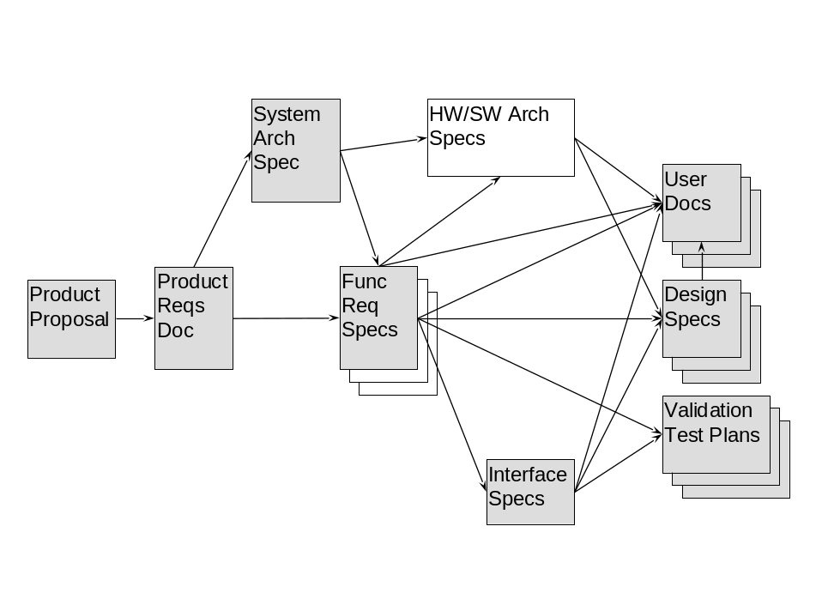

Scope
This document provides design details to functionality described in the ATCA Network Element System PRD [1] and other industry specifications, provides additional detail on system level interactions and provides the foundation for the development of detailed module-specific design specifications and test plans. Blades covered by this specification include ATCA 1200 (aka PPM2), and ATCA 2210 (aka SCM3). Other customer-specific blades may also be covered by this specification.

Assumptions
Although not specifically required, it is assumed that the reader is familiar with ATCA 3.0, its hardware and software architecture and their components.

Policy
This document defines two roughly distinct product types; deeply embedded modules and compute modules. RadiSys provides significantly more content for deeply embedded modules than for compute modules. However, it is expected that all RadiSys modules will conform to this specification wherever possible. Module specific documents are expected to add detail to how a module conforms to this specification, to list exceptions where a module does not conform to this specification, and to detail extensions that go above and beyond this specification.

Deeply Embedded Modules
Deeply embedded modules are generally described as PowerPC based, with one or more Base and Fabric interfaces. These modules run an embedded Linux operating system such as Wind River Linux, Monta Vista Linux, or RadiLyx. A flash file system provides the mass storage. The typical customer provides their own custom application using RadiSys supplied and supported APIs and device drivers, and running on a RadiSys provided operating system.

Compute Modules
Compute modules are generally x86 based, again with one or more Base and Fabric interfaces. These modules run a commercial Linux operating system such as RedHat Linux Enterprise Server. Mass storage is provided by external modules such as Fibre Channel or SAS drives. Some modules have AMC sites for SAS drive installation; others expect external PXE boot hosts to be present on the Base interface. The typical customer provides their own custom application using RadiSys supplied APIs. The device drivers used are provided by the commercial operating system in use.

Delivery
The RadiSys software support package for a specific module can be delivered in multiple formats. A typical deeply embedded module will have the software package installed on the redundant flash devices prior to delivery. Included in the installed components are licensing statements and end user license agreements where applicable. Compute modules are delivered without associated mass storage devices. The operating system is provided by the customer, with RadiSys packages subsequently installed.
For deeply embedded modules where customer application development is supported, the RadiSys board support package may be delivered as patches to the base operating system in use on the module (e.g., Wind River PNE-LE 1.4).

Functionality Overview

Overview
The primary purpose of U-Boot is to initialize the ATCA 3.0 module hardware and jump to the Linux operating system. Secondarily, U-Boot provides the user with an environment suitable for debugging, changing of the flash contents, scripting, and downloading of more complex applications via the use of a serial console and an Ethernet connection.
U-Boot is comprised of several major components:
Hardware initialization that initializes the modules memory controllers to access Flash and DRAM, and enables the console port
Debug and scripting capabilities allowing an interactive user to create and change environment variables, read and write memory and registers, and perform some basic functionality testing
Flash programming capabilities to allow saving and restoring of environment variables, reflash of U-Boot, Linux, JFFS2, and filesystem images
Tools for downloading and uploading images via TFTP, serial XMODEM, and serial binary
Advanced debugging capabilities allowing the user to download and execute specially packaged binary images. These images are in ELF format, and are specially manipulated using tools included in the U-Boot distribution
Scripting commands for verifying kernel image integrity and jumping into the kernel image
The Linux operating system provides the software platform upon which the end-user application is built. Linux provides all the usual operating system capabilities; including specifically JFFS2, RAM file system, flash programming, system management, and switching application software.
Linux is comprised of several major components:
Linux Board Support Package customized for RadiSys ATCA 3.0 hardware modules
High performance OS with high-availablity capability
Support for JFFS2, NFS, and RAM filesystems
Support for IPv4, IPv6, and other open source networking protocols
Support Time of Day (TOD) servive
Support for DHCP client and server
Support for NFS client
Support for NTP client and server
Support for SSH
Support for FTP client
Support for TFTP client and server
Support for SNMP agent
802.1Q VLAN Support
DHCP client and BOOTP client services
DHCP server
Support for AMC modules resources on modules and carriers offering AMC slots
Support for customized RadiSys diagnostic software to provide invasive and non-invasive fault diagnosis capability
Support for persistent device naming
Support for watchdog timer daemon
Support for bonding Ethernet device drivers, Ethernet link aggregation, and link failover
Support for per-VLAN network interfaces, including explicit tagging
Support for IPMI device driver
Support for module-specific functionality (e.g. control of Ethernet switch device settings, network timing subsystem, etc.)
For blades covered by this specification, U-Boot 1.1.4 is used.

Additional Documentation
For further information about image creation and flash management, see [2].
For information regarding the logical partitioning of the flash devices, see the module specific documentation of the blade or module in question.

Dual Bootstrap Mechanism
Each module in the ATCA 3.0 platform includes two identical Flash memory devices. The Local Management Processor (LMP) of the module may boot from either device. If the boot process fails using the selected device, the IPMC will force the LMP to retry the boot process, using the secondary Flash memory device. A detailed description of this process is given below. By default, the Primary Flash Device (Flash device 0) is used to boot the module.
The redundant flash devices are provided to mitigate the following potential failures.
Physical failure of flash device in U-Boot binary image. Such a failure could be caused by a hardware fault to the primary physical flash device, by a programming failure during reflash, or by an erroneous write to the binary flash image.
Failure of the Linux kernel image integrity test. Prior to jumping into the Linux kernel, U-Boot performs a checksum test of the Linux kernel binary image. If the image fails this test, the LMP requests that the IPMC reset the payload and boot from the secondary flash device.
Failure during an update process. If module power is interrupted during a reflash operation, the U-Boot or Linux image could be corrupted. This would be detected and recovery would proceed as described above.
It is important to note that the dual bootstrap devices do not mitigate failures caused by application failures or elongated boot times. Those failures are mitigated via the BMC watchdog described in 3.3 below.

Bootstrap Image Selection
Bootstrap image selection is physically controlled by the IPMC. The "Switch Active Boot Flash" IPMI command is used to set the boot device to be used in the IPMI Controller (IPMC) configuration. This command can be sent to the IPMC via the IPMI bus or by the serial connection to the IPMC implemented on ATCA 3.0 blades. The Flash device selected as active is used upon power-up at each power-cycle; the selection of the alternate flash device can be persistent (depending on parameters to “Switch Active Boot Flash IPMI” command). The choice of which device will be used to boot can also be configured by CLI for most blades. See the specific blade software specification for details.

Corrupt Flash Detection Watchdog
The RadiSys-specific Corrupt Flash Detection (CFD) watchdog timer is implemented by the firmware running on the IPMC. This watchdog timer is started any time that the Cold or Warm Reset Control is deasserted by the IPMC. Responsibility is then passed to the Local Management Processor to disable the timer. If the timer is not disabled before it expires, the IPMC firmware asserts cold reset, and if the previous was a Cold Reset, selects the alternate flash device using the Set Active Boot Flash Control, and then deasserts Cold Reset. This mechanism protects against the unlikely scenario of the boot flash being corrupted to such a degree that the boot code is unable to execute at all.
The timeout implemented for this watchdog timer is 5 seconds.

BMC Watchdog Timer and Redundant Bootstrap Image Selection
The standard BMC watchdog timer is implemented by the IPMC. Upon expiration of the BMC watchdog timer, the IPMC will perform the requested BMC Watchdog Timer Action. These actions are specified in the IPMI Interface Specification [7]. If the “System Reset” option is selected, watchdog expiration will cause a Warm Reset of the blade. System management functionality may intervene to cause the IPMC to boot from the secondary flash device if desired.

Bootstrap Flow
An example usage case is described here and diagramed below in Figure 2 Bootstr. The IPMC enables the payload power and removes reset from the LMP. U-Boot code starts executing and enables the BMC Watchdog Timer using the standard IPMI commands. Then U-Boot disables the Corrupt Flash Detection Watchdog Timer. By enabling the BMC Watchdog Timer before disabling the Corrupt Flash Detection Watchdog Timer, all of the boot code execution is “guarded” by one of the two Watchdog Timers.
- Bootstrap Flow Diagram
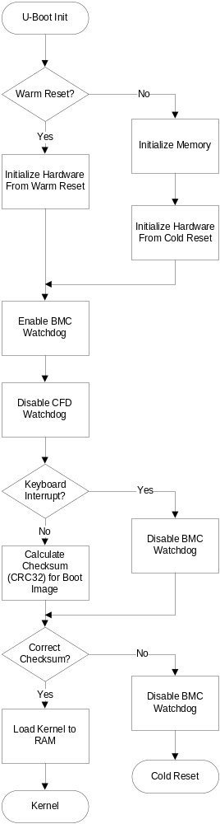

U-Boot Boot Monitor
U-Boot [5] is the bootstrap loader for the PowerQUICC III processor. It has responsibility for Linux kernel launch. U-Boot initializes as little hardware as possible, deferring full hardware initialization to the Linux kernel.
Source code for U-Boot is provided with the product in either an SRPM or a source code patch file.

U-Boot Operation
U-Boot uses the serial port as the user interface debug and console port. The physical availability of this port is described in the specific module’s HW specification. The standard serial port baud rate setting is 115200 baud, no parity, 8 data bits. Progress messages are printed to this port. A sample of early progress messages is shown below.
U-Boot 1.1.4 (Aug 16 2006 - 16:59:59)

CPU: 8541, Version: 1.1, (0x807a0011)
Core: E500, Version: 2.0, (0x80200020)
Clock Configuration:
CPU: 825 MHz, CCB: 330 MHz,
DDR: 165 MHz, LBC: 82 MHz
L1: D-cache 32 kB enabled
I-cache 32 kB enabled
Board: RadiSys SCM3 Version 1.1
CPU Board Revision 0.0 (0x0000)
PCI1: 32 bit, 66 MHz, sync
PCI2: 32 bit, 66 MHz, sync

Cold Reset and Warm Reset
U-Boot displays the reset cause on the console upon startup. A counter is implemented in the IPMC of some ATCA 3.0 blades which causes a Cold Reset when the counter reaches a configurable threshold. By default, the threshold value is 5 (i.e., 5 Warm Resets will result in a Cold Reset).

Memory Initialization
U-Boot initializes the main CPU memory. In the case of a Cold Reset, the SPD information on the memory module is read and used to automatically configure the memory controller. For the case of a warm reset, the memory controller is not initialized and only the memory required for use by U-Boot is initialized.

Error Checking and Correction (ECC)
ECC, if available on the memory module, is enabled and, on cold reset, the ECC memory is scrubbed. On warm reset, memory contents remain largely unchanged; the portion used by U-Boot and Linux during normal operation is, of course, overwritten. ECC single-bit errors are corrected; multi-bit errors cause a machine-check exception to occur.

PCI Initialization
PCI plug and play initialization is performed, and U-Boot will display to the console the PCI devices scanned and initialized.

PCI Express Initialization
PCI Express memory regions are initialized with default, 256 MB memory and 16 MB IO windows. Board specific portions of U-Boot may initialize PCI Express attached devices for use as boot sources.

Ethernet Initialization
Board specific portions of U-Boot initialize PowerQUICC Ethernet ports and other attached Ethernet boot vectors.

Serial Port Initialization
The PowerQUICC DUART peripheral is used by U-Boot as a console port and is initialized to 115200 baud, 8 data bits, no flow control, and no parity. Console port output defaults to this serial port.

Booting Linux

U-Boot Boot Device Processes

Overview
The RadiSys implementation of booting a PowerQUICC-based payload processor to an operating system is based on software entities called boot devices. Boot devices are software entities that define where an operating system will be found and how it will be retrieved. For RadiSys boards, the following boot device types are supported.

- Boot Device Types
Default Boot Order | Boot Device | Description
1 | Local Flash | This boot device attempts to load the “active” image from flash. RadiSys blades have two flash banks where the currently selected flash bank is called the “active” flash bank.
2 | Dynamic Network | This boot device dynamically retrieves and loads an image based on a DHCP request and response. The image name, server IP address, and board IP address are provided by the DHCP server. The image is retrieved using the TFTP protocol. See the DHCP Request section for information about the DHCP request format.
3 | Static Network | This boot process statically retrieves and loads an image based on statically defined U-Boot environment variables. These variables include the server IP address, local IP address, and image name. The image is retrieved using the TFTP protocol.

Boot devices are managed using an environment variable that represents a list of boot device types. The order and selection of boot devices can be changed. When U-Boot needs to boot an image, it will step through each boot device and attempt to boot from that device. The number of network retries can be configured. Ethernet devices (i.e. eTSEC0, eTSEC1, bmd0, etc) are managed using environment variables. For more information about configuration options, see the Configuration Options section.
The figure below describes the image-boot process in more detail.
- U-Boot Boot Device Flowchart
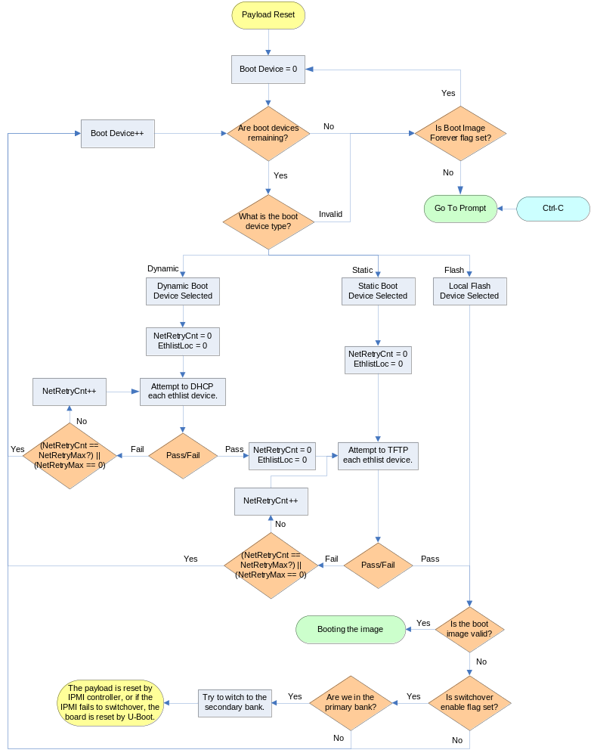
For boot devices using the network to retrieve an image, only specific network ports are used. By default, all TSEC interfaces are included. For a list of a board’s TSEC options, refer to the board’s reference manual. For node blades, the maintenance Ethernet ports and base interface channels 1 and 2 are supported. For RadiSys switch blades, only the TSEC interfaces are supported. More information about which network ports are used can be found in the UShell Application Design section.

DHCP Request
U-Boot uses a simple DHCP request format that can include the DHCP Client Identification option (DHCP Option 61). When a DHCP request is performed, U-Boot will send a “Get Device ID” IPMI command to the shelf manager to determine what kind of shelf manager is being used. The IANA value is used to determine the type of shelf manager. For Pigeon Point Shelf Managers that might have custom shelf address information depending on the vendor, the third auxiliary byte is used to determine the vendor type (i.e. NSN).
Once the shelf manager type has been learned, U-Boot will construct a shelf-specific Option 61 section that will be included as part of the DHCP request. If the shelf manager type is not a recognized kind, or if U-Boot fails to create the Option 61 section, the DHCP packet will be sent without the Option 61 fields being included.

RadiSys-specific DHCP Option 61
The format of the basic DHCP Option 61 is described in the figure and table below.
- RadiSys-specific DHCP Option 61 Format
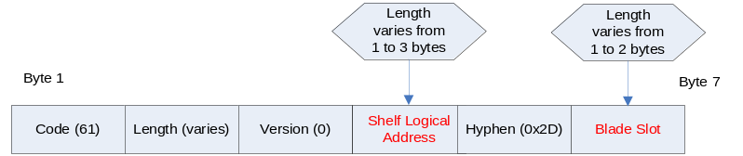
- RadiSys-specific DHCP Option 61 Fields
Field | Description | Type | Range | Default Value | Data Source
Code | Option Code | Decimal | 61 | 61 | Fixed
Length | Length of the Option Code | Decimal | 4-7 | 4-7 | Varies
Version | Version of the Option 61 Code | Decimal | 0 | 0 | Fixed
Shelf Logical Address | The decimal expansion of the Logical Shelf portion of the Shelf Address value (i.e., 1, 2, or 3 ASCII characters in the range 30H through 39H representing a 1-, 2-, or 3-digit number withno leading zeroes) | Hex | 30-39h | varies | Get Shelf Address Info command – This is the equivalent of the Logical Chassis Number.
Hyphen | A hyphen to seprate the shelf’s logical address and blade slot | Hex | 2Dh | 2Dh | Fixed
Blade Slot | The decimal expansion of the Physical Slot value (i.e., 1 or 2 ASCII characters in the range 30H through 39H representing a 1- or 2-digit number with no leading zeroes) | Hex | 30-39h | varies | Get Address Info command

An example of a DHCP Client Identifier is 3D-06-00-32-34-35-2D-37, based on a Logical Shelf value of 245 and a Physical Slot value of 7.

UShell Application Design

Overview
This section describes the features and design of the UShell application.

UShell Description
The UShell application is a standalone U-Boot application that incorporates the Broadcom Mini-Driver Kit (MDK). Its primary purpose is to configure Broadcom switches on a board, and to provide U-Boot with an API to send and receive packets over the Broadcom ports.
The UShell application is designed to support multiple RadiSys blades including; ATCA-1200, ATCA-9100, ATCA7220, and ATCA-2210. The application learns which board it is running on by reading an environment variable called “boardtype”. The “boardtype” environment variable is set in the U-Boot code by default.
UShell is called by U-Boot in two situations; during U-Boot’s initialization routine, and when U-Boot needs to retrieve an image. Users may also manually access the application by using the “go” command at the U-Boot prompt.
The UShell location can be stored in two different locations; a flash partition or the JFFS file system. Users can specify the location of UShell using an environment variable called “ushellLoc.” Users can also define where the UShell application is found in the JFFS file system using the environment variable “ushellfile.” The UShell application is stored as a file in both the JFFS file system and flash. The file is created using the Linux utility “mkimage”, which provides U-Boot with a way to verify that the file is valid before attempting to jump to it. To save flash space, the UShell is compressed using “gzip” before being encapsulated as a file.
When UShell is called during initialization it configures switches on the board, and then registers an Ethernet device with U-Boot using the “eth_register” function. One device is registered for each switch on a board. The application designates each switch with the name “bmdX”.
Each Ethernet device in U-Boot includes four function parameters: init, halt, send, and receive. The initialization function for UShell only initializes a specific set of ports for a board that are hard coded as part of the application code. All other ports are left in a disabled state to prevent creating unexpected network connections.
The “send” function for UShell Ethernet devices only tries to send a packet on one port per U-Boot send request. This is done to prevent duplicate packets from being sent from a switch. The send function learns which port to use by reading an environment variable called “bmd0port”. This variable is set by U-Boot as it steps through a list of ports defined by the environment variable “bmd0portlist”. When U-Boot reaches the end of the port list, it will start over again. Users may update the port list to include or exclude ports as needed.
Note: Only the Ethernet device” bmd0” is supported for network booting at this time.
UShell assigns a MAC address to each switch’s CMIC port. All packets that are received by the switch are forwarded to the payload processor.
The following diagram illustrates how U-Boot loads the UShell application.
- U-Boot UShell Initialization Flowchart
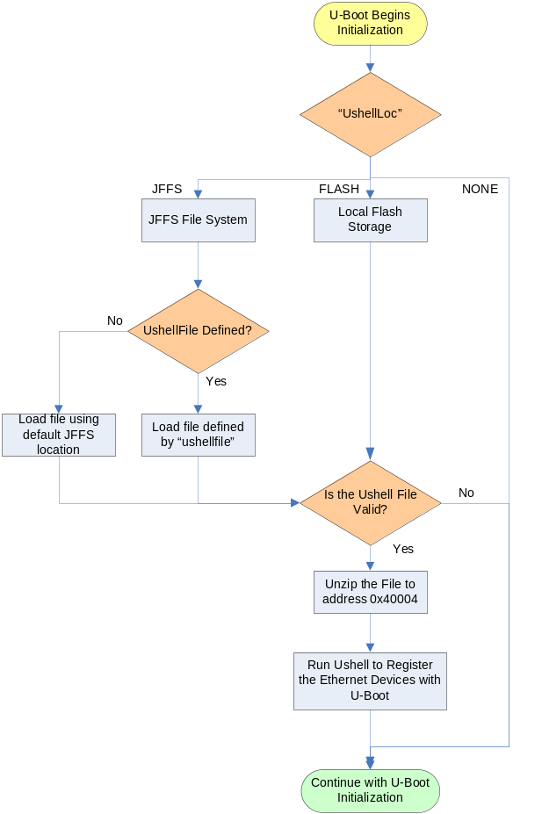

E-Key states are not checked as part of the initialization process, because the only supported ports for UShell are base channels, COM-E, or maintenance ports. According to the PICMG 3.0 specification, blades are not required to E-Key base channel ports. Maintenance and COM-E ports do not have associated E-Key descriptors so these ports do not need to be keyed.
The following table describes which switches and associated ports are used by the UShell application. The port name column in the table below applies to the “bmd0portlist” environment variable.
- UShell Switch Device Mappings
Board | Switch | Device Name | Broadcom Ports | Port Name
ATCA-1200 | BCM56502 | bmd0 | Base Channel 1 – GE21 | bi0
ATCA-1200 | BCM56502 | bmd0 | Base Channel 2 – GE22 | bi1
ATCA-9100 | BCM56500 | bmd0 | Base Channel 1 – GE0 | bi0
ATCA-9100 | BCM56500 | bmd0 | Base Channel 2 – GE1 | bi1
ATCA-9100 | BCM56502 | bmd1 | Not Used
ATCA-7220 | BCM56317 | bmd0 | Base Channel 1 – GE0 | bi0
ATCA-7220 | BCM56317 | bmd0 | Base Channel 2 – GE1 | bi1
ATCA-7220 | BCM56801 | bmd1 | Not Used

U-Boot can select which ports to use by setting the “bmd0portlist” environment variable, which is configured as a list of available ports. After each failed DHCP or TFTP attempt, U-Boot will select the next port on the list so that all interfaces are tried. Users can also change the order of the list in case they want a certain port to have priority over others.

Configuration Options
Several elements of the U-Boot Boot Device process are configurable to provide customers with more flexibility in their implementation. All configurable options are managed as U-Boot environment variables.
Currently, environment variables can be changed by accessing U-Boot through the serial console, or by using the Linux applications “fw_printenv” and “fw_setenv”. These applications are included as part of RadiSys Linux distributions.
The following table describes all of the boot process configuration options.
- Boot Process Configuration Options
Configuration Option | Variable | Factory Default
Set the Board Type  (note: This field is set by U-Boot code and should not be changed.) | boardtype | <blade-specific>  (i.e. atca1200)
Sets the number of DHCP, ARP, or TFTP retries that should be performed before moving on to the next boot device. One iteration includes all of the Ethernet devices in the “ethlist” variable. | netretrymax | 3  (Set to zero for infinite loops.)
If all boot devices fail, this flag indicates whether or not U-Boot should step through the devices again or if it should go to the prompt. This could be used to try to network boot forever. | bootdevforever | n
Sets whether or not the board should switch to the secondary flash bank if a boot image is found to be invalid. | noswitchflash | n
Indicates the board’s boot device list. The list is separated by colons. For example, the list could be “bootlist=dynamic:static”. Three options are supported: “dynamic”, “static”, and “flash”. | bootlist | flash
Indicates the board’s Ethernet list. The list is separated by colons. For example, the list could be “ethlist=bmd0:eTSEC1”. The Ethernet list will vary based on board type, but can include the TSEC devices (i.e. eTSECx) and the Broadcom devices (i.e. bmdx) if supported. | ethlist | bmd0
Indicates which ports to use on Ethernet device bmd0. This setting only applies to sending packets. The order that the ports are used depends on the order of the list. | bmd0portlist | bi0:bi1
Sets the static local IP address | staticipaddr | 10.0.0.1
Sets the static server IP address | staticserverip | 10.0.0.2
Sets the static image name to retrieve | staticbootfile | <blade-specific>  (i.e. atca1200.bin)
Sets the local MAC address for the board. The MAC address is assigned to each interface when the interface is used to send packets. | ethaddr | <varies>  (i.e. 00:E0:0C:00:00:FD)
Sets the location of the UShell application. By default, no location is defined so the standalone application will not get loaded by U-Boot. | ushellLoc | Default: “none”  Options:  “none” – UShell is not loaded  “flash” – Loads UShell from flash.  “jffs” – Loads UShell from a file in the JFFS partition.
Sets the file location of UShell application in JFFS. If this value is not set, a default location of “onboot.data/bindmount/etc/uboot-apps/ushell” is used. | ushellfile | Default: <undefined>

U-Boot Monitor Commands
When used interactively, U-Boot also provides a system monitor. The monitor is entered if user or developer intervention is detected on the serial port (by typing Ctrl-X followed by Ctrl-W). The monitor supports the standard set of U-Boot commands as described by the U-Boot web site [5].

Reflash Operations
U-Boot provides commands that can be used to update the flash contents. These commands and their usage are described on the U-Boot web site [5].

TFTP
U-Boot provides the ability to use TFTP to download files from the TFTP server into memory. The default memory location is 0x2000000 (32 MB).

Additional U-Boot Command Capabilities
U-Boot commands allow the debugger or developer to create standalone "applications" for more advanced testing needs. This feature is installed in order to simplify reuse of the U-Boot source by reducing the amount of customization required for different module support packages.

U-Boot Environment Variables
U-Boot maintains a set of environment variables. These variables are stored in the flash device and can be changed via the U-Boot system monitor. The variables can be saved to flash using the saveenv command. The U-Boot environment variables are stored as part of the 512KB area of flash allocated for U-Boot.
Writing the U-Boot environment variables to the U-Boot parameter block requires the Flash to be in “write-enable” mode. This is accomplished by executing the protect off all command, setting the environment variable, and then saving the environment via the saveenv command.
Sample U-Boot environment variables and potential values are listed in the following table.
- U-Boot Environment Variables Example
Variable | Description
bootcmd | This is the command that U-Boot executes unless there is user intervention. It can be set to run sequences of commands by separating the commands with a semicolon (prefixed with ‘\’ when typing). For example, to display the environment variables followed by invocation of the kernel, the bootcmd variable is set as follows:  bootcmd printenv\; bootm e8380000
bootargs | In the case of the Linux kernel, these boot arguments tell the kernel what root file system device to use, the IP address values to use, the name of the directory on a NFS server to be mounted as root, when booting from NFS. For a description of all the arguments, refer to the U-Boot Documentation contained in the U-Boot distribution.  The arguments used on the SCM3 are of the following format:  root=<device name> [rw] \  ip=<client-ip>:<server-ip>:<gw-ip>:<netmask>:<hostname>:<device>:<autoconf> \  nfsroot=[<server-ip>:]<root-dir>[,<nfs-options>]  The entire command is usually typed on one line. If not, use “\” before each line separator character.  root=<device name>  This option specifies the root device to be used while booting. This device has the required file system. The valid device names in this case are /dev/mtdblock<n> for JFFS2 and /dev/nfs for NFS.  nfsroot=[<server-ip>:]<root-dir>[,<nfs-options>]  If the nfsroot parameter is not given on the command line, the default /tftpboot/%s is used when booting from NFS. This parameter is omitted when booting from JFFS2.  <server-ip> Specifies the IP address of the NFS server. If this field is not specified the IP address used is the address specified by the ip variable (see below). This sub-parameter is typically unused.  <root-dir> Name of the directory on the server to mount as root. If there is a %s token in the string, the token gets replaced by the ASCII-representation of the client's IP address.  <nfs-options> Standard NFS options. Commas separate all options. If the options field is not given, the following defaults are used:  port = as given by server portmap daemon  rsize = 1024  wsize = 1024  timeo = 7  retrans = 3  acregmin = 3  acregmax = 60  acdirmin = 30  acdirmax = 60  flags = hard, nointr, noposix, cto, ac  ip=<client-ip>:<server-ip>:<gw-ip>:<netmask>:<hostname>:<device>:<autoconf>  This parameter is for configuration of the IP addresses and routes. The defaults mentioned below apply when this parameter is omitted.  <client-ip> IP address of the client. When unspecified, the address is determined either by RARP or BOOTP. The protocol is selected by the specific configuration of the OS and the <autoconf> parameter.  <server-ip> IP address of the NFS server. When RARP is used to determine the client address and this parameter is NOT empty only replies from the specified server are accepted. To use different RARP and NFS servers, the RARP server is specified here, and the NFS server is specified in the `nfsroot' parameter. When this parameter is unspecified the address of the server is used which answered the RARP or BOOTP request.  <gw-ip> IP address of a gateway when the server is on a different subnet. When this entry is empty no gateway is used and the server is assumed to be on the local network, unless a value has been received by BOOTP.  <netmask> Netmask for local network interface. When this is parameter is unspecified, the netmask is derived from the client IP address assuming classful addressing, unless overridden in a BOOTP reply.  <hostname> Name of the client. When this parameter is unspecified, the client IP address, in ASCII, is the name of the host unless a name is returned through BOOTP.  <device> Name of network device to use. If this is empty, all devices are used for RARP and BOOTP requests, and the first device whose interface receives a reply is configured. If you have only one device, you can safely leave this blank.  <autoconf> Method to use for autoconfiguration. If this is either “rarp” or “bootp”, the specified protocol is used. If the value is “both” or empty, both protocols are used so far as they have been enabled during kernel configuration. The value “off” means no autoconfiguration.  The <autoconf> parameter can appear alone as the value for the ip parameter (without all the “:” characters before) in which case auto-configuration is used.  A pair of NFS-rooted and JFFS2 configuration line examples are given below:  bootargs root=/dev/nfs rw \  ip=10.0.0.1:10.0.0.2::255.255.255.0:scm3:eth0 \  nfsroot=/opt/target panic=1\;bootm e3e80000  bootargs root=/dev/mtdblock2 rw \  ip=10.0.0.1:10.0.0.2::255.255.255.0:scm3:eth0 \  panic=1\;bootm e3e80000
ipaddr | The IP address is needed for the tftpboot command. For example, to set the IP address to 10.0.0.1, the ipaddr variable is set as follows:  setenv ipaddr 10.0.0.1
serverip | The TFTP server IP address is needed for the tftpboot command. For example, to set the TFTP server IP address to 10.0.0.30, the serverip variable is set as follows:  setenv serverip 10.0.0.30
bootdelay | The U-Boot wait time (in seconds) for intervention to stop execution of the script defined by bootcmd.
ethaddr | The special ethaddr environment variable can be set only once unless the entire parameter block is erased. The U-Boot monitor does not allow deletion or reassignment of this variable once it has been set. Note that the ethaddr parameter is used for testing only. Even if it is specified, U-Boot uses the Ethernet MAC address in the EEPROM, assuming it is programmed and not corrupted, rather than using the ethaddr variable. The FASTPATH management stack code requires the EEPROM to be programmed with a valid MAC address prior to Linux kernel invocation.  Note: The Ethernet MAC address from either the EEPROM or the ethaddr variable is used as the seed for assigning the MAC addresses for all of the interfaces on the SCM3. Due to a limitation in the FASTPATH management stack code, the lowest address must be assigned to the CPU port of the Base Interconnect. Thus, the next higher MAC address, which is always assigned to eth0, is passed to the Linux kernel upon invocation.

The following table lists the typical settings of U-Boot environment variables, again using the SCM3 as an example.
- U-Boot Environment Variables Default Settings Example
Factory Default Settings | Description
bootcmd |  | protect off all; bootm e3e80000
bootargs |  | root=/dev/mtdblock2 rw \  ip=10.0.0.1:10.0.0.2::255.255.255.0:scm3:eth0
baudrate |  | 115200
bootdelay |  | 2
stdin |  | Serial
stdout |  | Serial
stderr |  | Serial

U-Boot's default environment settings boot the module in the "normal" deployed fashion.

Operating System and Services

OS and integrated filesystems
Compute modules will include support for a commercial operating system, usually provided by the customer. Typical use is for the compute modules to use a shared root file system provided via NFS. This filesystem will be structured by the customer or operating system vendor. Filesystems used or provided by RadiSys are as delivered by the operating system vendor.
Deeply embedded modules will include support for an embedded Linux distribution. The distributions currently in use in RadiSys include WindRiver's PNE-LE, MontaVista CGL, and an internally generated kernel (RadiLyx). Individual modules may support other versions.

Source Code
Operating system source code is delivered in SRPM format or patch files to specific OS source releases. The source code is licensed for use under the GPL license; the license text is included with the delivery.

Filesystem Hierarchy Standard overview
The integrated filesystem provided by RadiSys on deeply embedded modules support the Filesystem Hierarchy Standard (FHS). FHS suggests names and locations for directories and files and specifies the read and writes characteristics of those locations.
The FHS suggests specific directory trees or files are either shareable or unshareable, and either static or variable.
A “shareable” file can reside on one host and be used by another
An “unshareable” file can reside only on the host using it
A “static” file is a library file, binary file, or other file that does not change
A “variable” file is a file that is not static.
Review the FHS documentation in [9] for complete details.

Shareable and static files
The shareable and static designation indicates files and directories whose contents do not change. These files are located in the Linux initial ram drive (initramfs). Note that for deeply embedded modules, no files are actually shared.

Unshareable and static files
Files and directories designated as unshareable and static such as /etc and /boot are located in the initramfs as well, but may be overridden at boot time; such files and directories then become variable. A RadiSys init script located in the JFFS partition overrides files. This init script uses the mount --bind mechanism to override the initramfs file(s) with corresponding file(s) on the JFFS filesystem.

Variable files
The shareable and variable and unshareable and variable designations are indistinguishable for our purpose. Variable files are created at run time and reside in the tmpfs as in 5.2.2 or are created by bind mounting a JFFS file as in 5.4.2.

File Systems
Deeply embedded ATCA 3.0 modules support JFFS2, NFS, EXT2, EXT3, ReiserFS, and RAM filesystems. An init ramdrive, formatted as an initramfs filesystem, is used as the root filesystem in a deployed module. JFFS2 storage is provided for persistent configuration storage.
Compute modules use external NFS host filesystems.

JFFS2 File System
The JFFS2 filesystem is enabled, using the standard Linux JFFS2 device drivers. The underlying Memory Technology Device drivers are used to support the physical hardware; the flash devices. Using this method, standard Linux tools for manipulating the filesystem and the MTD contents are available for use.
At boot time, the /nv1/etc directory of the JFFS2 file system will be bind mounted into the RAM disk at /etc, replacing any existing files or directories with the same name. For example, the file /nv1/etc/dhcpd.conf would be mounted so that it appeared at /etc/dhcpd.conf. bind mounting is performed by the OnBoot utility, discussed in section 5.4 below.

RAMfs
At boot time, the Linux root file system is created using an initramfs image which is expanded into a RAM disk based on tmpfs. tmpfs is a dynamic, RAM based filesystem that uses virtual memory. The amount of memory in use adjusts based on the size of the contents. The memory usage is capped at 1/2 of available RAM by default. ATCA modules limit the RAM usage to 128 MB initially. This allows:
93MB for holding contents of initrd (42.5MB flash partition expands at roughly 1:2 ratio)
32MB for various log files
This comes to 125MB and is rounded up to 128MB.
During reflash operations, additional storage in the RAM disk is required. The maximum size can be changed dynamically via the remount command. Typically, an additional 64MB is added, bringing the total to 192 MB. The size of the tmpfs RAM disk is limited by available free memory. The minimum amount of additional memory needed during reflash operation is equal to the size of the compressed image to be loaded into flash (gzip image). This is typically 27MB but may vary due to changes in the conents of the Linux image and resulting variance in compression ratio due to the contents.
Modules supporting 128 MB of flash have the ability to support a 192 MB tmpfs for the same purposes.

Runlevels
Runlevels are used to provide differing levels of service to the system user. Deeply embedded modules support customized runlevels as below.
- Halt
- Single-user “debug” mode. This mode is entered if the module determines that it’s ability to operate is compromised. See 7.2.1 for further details.
- Not used
- Full multi-user “operational” mode. This is the normal operating mode.
- Not used
- Not used
- Reboot

Runlevels are defined by the services provided to the users. The services provided to the users are defined by the startup scripts. The startups scripts physically reside in /etc/init.d. Logical links are created in /etc/rc.d/rc[0..6].d to the startup scripts in /etc/init.d.
The logical link names are pre-pended with a “K” or an “S” and a 2-digit decimal number. The “K” files are known as KILL scripts, and the “S” files are known as START scripts. The KILL scripts are run with the “stop” argument to stop the specified service upon entering a runlevel. Subsequently, the START scripts are run with the “start” argument to start the service upon entering a runlevel. The scripts within each group are run in alphabetical order; hence the 2-digit decimal number.

OnBoot utility
The ATCA 3.0 module software, as configured by RadiSys, is executed in RAM, so any changes to the filesystem (i.e., configuration files, logs, etc...) will be lost on a reboot of the module. There is a small set of scripts that run at boot time, before all other init scripts, that will modify the RAM filesystem from files stored on the /rsys JFFS partition.
OnBoot first checks to see if /rsys/onboot.d and /rsys/onboot.data exist. If they are both missing, as would be the case after a full reflash, OnBoot will copy the contents of /usr/share/onboot to /rsys. /usr/share/onboot contains files installed during flash image creation. The rest of this section will refer only to /rsys, assuming that files located there originally come from /usr/share/onboot.
The scripts that run for OnBoot are located in the /rsys/onboot.d directory. This directory is similar to the /etc/rc.d/rc[0..6].d directories. It contains scripts prefixed by two digits indicating the order in which the scripts will be executed (note there is no ‘S’ or ‘K’ prefix). Like init scripts, these scripts may generally perform any action. The scripts provided by RadiSys are described below.
Data used by OnBoot scripts is located in /rsys/onboot.data. This directory contains a sub-directory for each OnBoot script that requires it, within a directory with the same name as the script, without the prefix digits. For example, the 40bindmount script has its data in /rsys/onboot.data/bindmount. Within each script’s directory, software components are expected to add their data. Customers are also able to add data to these directories. The script sections below describe the format and content of their subdirectories.
Software components install and “own” their individual files and directories in /usr/share/onboot/onboot.data. These files and directories are most often identical to ones installed elsewhere in the filesystem (before persistent data is overlayed or bind mounted, for example). Files (not directories) should be hard-linked from their master files to avoid using additional flash space. Overlays and bind mounts will replace or mount over their original masters.
Applications should be written to access files and directories in their normal filesystem locations, unaware of /rsys (ie. only their build-time “install” script should link to /usr/share/onboot, and only for targets using OnBoot). The system manager and its CLI and API manage OnBoot on an operating module.
Unless otherwise stated, as in bind mounting below, software components should not install files (as part of their packages) to the onboot.data directory. Most directories are intended for post-installation updates, commissioning, operational configuration, persistent data, and debugging.

Overlay
The /rsys/onboot.d/30overlay script copies the contents of /rsys/onboot.data/overlay to /, the root of the RAM filesystem. Overlay is used to replace files in the RAM filesystem, for updates to executables, libraries, or data files. /rsys/onboot.data/overlay follows the same directory structure as the root filesystem (usr, bin, etc.).

Bind mounting
The /rsys/onboot.d/40bindmount script “bind mounts” files and directories from /rsys/onboot.data/bindmount to /. Bind mounting is used to allow process to write persistent data back to /etc configuration files, /var persistent state directories, etc. /rsys/onboot.data/bindmount follows the same directory structure as the root filesystem (usr, bin, etc.). Software components will install files into the bindmount directory using a “conservative” policy. Only files and directories that are required to be updated by running processes should be installed in bindmount. Most configuration files should not be installed in bindmount, to allow the customer to select the files to be bindmounted during integration and commissioning.

Bind mounting a single file
A single file can be bind mounted in order to include it in the shareable and static files. This is done by placing the file in the /rsys/onboot.data/bindmount tree.
For example, to install a persistent file in an existing directory:
- Copy the data file into the bindmount tree:
cp –lr /etc/foo.conf /rsys/onboot.data/bindmount/etc/foo.conf
- Force the settings to take effect immediately by reloading the onboot utility:
/etc/init.d/onboot reload

Bind mounting a directory
A directory can be bind mounted in similar fashion. To cause this to occur, place the directory in the /rsys/onboot.data/bindmount tree.
For example, to install a persistent file in a persistent directory:
- Create a directory in the bindmount tree:
mkdir –p /rsys/onboot.data/bindmount/etc
- Copy the data file into bindmount tree:
cp –lr /etc/foo /rsys/onboot.data/bindmount/etc/foo
- Create a “.bindmount” file in the directory to flag the OnBoot utility to bind mount the directory and not the individual files inside it:
touch /rsys/onboot.data/bindmount/etc/foo/.bindmount
- Force the settings to take effect immediately by reloading the OnBoot utility:
/etc/init.d/onboot reload

Remove
The /rsys/onboot.d/50remove script removes paths from the RAM filesystem. Removing paths is used when the presence of a file, directory, or special file affects operation of the system.
The /rsys/onboot.data/remove directory contains plain text files with one absolute path per line. Each path is file, directory, or special file to delete from the RAM filesystem. Directory contents are removed before their directory is removed. Blank lines and lines beginning with ‘#’ are ignored.
Separate remove files should be used for independent updates. Paths listed more than once in remove files do not produce an error.

Packages [future release]
The /rsys/onboot.d/10packages script updates complete software components in the RAM filesystem. Packages are delivered to customers to provide urgent software updates between releases. Note, however, that full image releases are the preferred method of releasing updates.
The /rsys/onboot.data/packages directory contains packages in a compact form suitable for deeply embedded systems (IPKG). Packages may be organized into subdirectories. Packages contain dependency information and all package headers are read to determine package installation order. If a dependency cannot be met (due to a corrupted or untested package being added to packages), the packages script will fail and the module will be placed in debug mode.
A new package can be installed using the ‘ipkg’ command. The module should be a non-operational state (such as the single user run level, with appropriate redundant modules active) when packages are updated. The module should be rebooted to ensure all updated files are reloaded.

Live patches [future release]
The /rsys/onboot.d/20livepatches script updates software components in a partial manner. Live patches are used to patch running processes using the Carrier Grade Linux recommend approach for live patches. Applications are specially written to support live patching; live patching cannot be used with arbitrary software components.
The /rsys/onboot.data/livepatches directory contains live patches in the format defined by the CGL recommended implementation. Live patches may be organized into subdirectories. Live patches contain dependency information and all patch headers are read to determine patch installation order. During boot, if a dependency cannot be met (due to a corrupt or untested patch being added to livepatches), the live patches script will fail and the module will be placed in debug mode.
Live patches can be installed in a fully operational state. The live patch(es) should be copied to the /rsys/onboot.data/livepatches directory first, then the CGL recommended utility is used to check dependencies, perform necessary preparation, install the live patch(es), and perform necessary post-installation.

IP Addressing
By default, each module as delivered from RadiSys, and as configured by upgrade or recover packages, configure its IP addressing as follows.

Local Loopback Interface (lo)
The module supports a software loopback interface, referred to as lo. IPv4 datagrams transmitted to this interface by the LMP will be received immediately by the LMP. The lo interface has a statically configured IP address of 127.0.0.1/8.

LMP Ethernet Connections
Ethernet device(s) that connect directly to the LMP (i.e. those not going through an ethernet switch) are referred to as maintenance Ethernet ports. These ports are labeled starting at eth0 and incrementing to eth1, eth2, etc. Ports physically accessible via front panel connectors are numbered first.
Maintenance connections have statically configured IP addresses. The eth0 maintenance Ethernet interface's IP address is 10.0.0.1/24. It has a sub-interface named eth0:0 with a statically configured IP address based on logical and physical location or 10.1.<LogShelf>.<PhysSlot>/16 where LogShelf represents the logical shelf and PhysSlot the physical slot in the chassis.

Update Channel Ethernet Connections
Ethernet device(s) that connect directly to the LMP and to another module via update channel connections are named following the maintenance ports.
Update channel Ethernet connections have statically configured IP addresses based on logical slot 10.0.1.<LogSlot>/24.

Base Ethernet Connections
Ethernet device(s) that connect the LMP to the Base Ethernet interface are named following the maintance ports and the Update channel ports.
Base Ethernet connections have dynamically configured IP addresses using DHCP. Base Ethernet connections have a sub-channel IP address based on logical and physical location of 10.2.<LogShelf>.<PhysSlot>/16. Modules which provide access to the Shelf Manager Server have an additional sub-channel IP address factory configured to a static IP of 192.168.16.17/24. This IP address can be configured via the Shelf Manager CLI. The Shelf Manager Server IP Address is stored in the FRU Information Repository.
Not all modules have Base Ethernet connections.

Fabric Ethernet Connections
Ethernet device(s) that connect the LMP to the Fabric Ethernet interface are named following the maintenance ports, the Update Channel ports, and the Base Ethernet ports. Fabric Ethernet connections have dynamically configured IP addresses using DHCP.
Not all modules have Fabric Ethernet connections.

Default IP Addressing
The default configuration used for all IPv4 interfaces is summarized in the following table.
Interface Type: This is either dynamic or static. The /sbin/dhclient application is used to dynamically configure a given interface only when dynamic is specified.
Dynamic Timeout (dhclient): This applies only for dynamic interfaces, and it specifies the maximum number of seconds the DHCP client will wait for a DHCP server to respond. A value of 0 represents an infinite timeout.
Static IPv4 Address: This applies only for static interfaces, and it specifies the assigned IPv4 address and mask used for each static interface.

- IPv4 Sample Configuration Values
Interface  Name | Interface Connection | Interface Type | Dynamic Timeout  (dhclient) | Static IPv4 Address
lo | Software loopback | static | N/A | 127.0.0.1/8
eth0 | LMP direct | static | N/A | 10.0.0.1/24
eth0:0 | LMP direct, sub-channel | static | N/A | 10.1.<LogShelf>.<PhysSlot>/16
eth1 | Update channel | static | N/A | 10.0.1.<LogSlot>/24
eth2 | Base Ethernet | dynamic | 300 seconds | N/A
eth2:0 | Base Ethernet, sub-channel | static | N/A | 10.2.<LogShelf>.<PhysSlot>/16
eth2:1 | Base Ethernet, sub-channel | static | N/A | Factory default 192.168.16.17/24. Can be configured via Shelf Manager CLI.
dtl1 | Fabric Ethernet | dynamic | 300 seconds | N/A

Note: This is an illustrative example only; most modules will differ. Consult specific module software specifications for details on the interfaces implemented and the assignment of their IP addresses.
Note the following:
The eth0 interface is always statically configured by default to be 10.0.0.1/24. The use of this private IPv4 address allows for easy connectivity from a Service/Maintenance terminal connected to it, provided that the terminal’s IPv4 interface is also on the 10.0.0.0/24 subnet. If IPv4 Masquerade is enabled on the module, this also allows the Service Maintenance terminal to easily communicate with other modules beyond the module’s Base interconnect, since the module translates the private addresses on the 10.0.0.0/24 network to the public or private address assigned on its eth2 interface.
For off-the-shelf RadiSys blades, nn eth0:0 sub-interface is also always statically configured by default to be 10.1.<LogShelf>.<PhysSlot>/16. The use of the eth0:0 sub-interface allows users (and especially validators) to use a shared LAN segment to maintain concurrent IPv4 connectivity to modules via their eth0:0 sub-interfaces. It also eliminates the need to statically-reconfigure the eth0 interfaces (or to enable DHCP on eth0) whenever multiple modules are expected to be networked together via their eth0 physical interfaces. Some blades may have customer specific versions which generate an eth0:0 IP address in a different way than specified above. Consult the specific blade’s software specification for details of the eth0:0 IP address.
An eth2:0 sub-interface is statically configured by default to be 10.2.<LogShelf>.<PhysSlot>/16. This interface is used to communicate with the neighbor module but can also be used by a craftsperson to configure the module or the shelf in which it resides. The subnet used for this sub-interface is taken from the Logical Shelf address field of the Shelf FRU Information. Some blades may have customer specific versions which generate an eth2:0 IP address in a different way than specified above. Consult the specific blade’s software specification for details of the eth2:0 IP address.
Note: The factory default Logical Shelf address is 255. If two shelves are connected which both have factory default settings, there will be multiple modules with the same eth2:0 IP address (10.2.255.7 for slot 7 module and 10.2.255.8 for slot 8 module). Shelves should be added to the network one at a time and commissioned before adding another shelf.
An eth2:1 sub-interface is statically configured as the Shelf Manager IP Address (see section 7.3). The factory default for this address is 192.168.16.17/24. This interface is dedicated to providing access to the Shelf Manager Server. The interface is enabled and disabled by the Shelf Manager Server. The Shelf Manager IP Address is stored in the FRU Information Repository.
The default configuration uses dynamic interfaces for configuration of eth2 and eth3.
If a timeout occurs for a dynamic interface, booting will continue and dhclient will continue attempting to acquire an IP address in the background.
Users who wish to change the default configuration of the IPv4 interfaces have three choices: (a) change the /etc/sysconfig/network-devices/template.ifconfig.<interface> template files to change the static address assignments; (b) change the external DHCP server configuration to change the dynamic address assignments; or (c) change the init scripts (i.e., /etc/rc.d/init.d/network) to modify the default behavior for configuring the static and dynamic address assignments.
Users who wish to change the actual DHCP client behavior have three choices: (a) change the /etc/dhclient.conf.template template files to change the protocol timers and options used by /sbin/dhclient; (b) change the init scripts (i.e., /etc/rc.d/init.d/network) to modify the default behavior for launching the DHCP client application; or (c) change the DHCP client application itself and the scripts that invoke it.
The dtl1 interface is a “software” interface presented by the Ethernet switching software rather than a physical interface utilizing a MAC physical layer. In all other aspects, its behavior is identical to physical Ethernet interfaces.
The IP address of an interface can also be changed to a desired static address/mask using the following standard Linux command:
ifconfig <interface> <IP address> netmask <IP mask> broadcast <broadcast IP address>
For example, the IP address for the eth0 interface can be changed to 192.168.45.20/24 using the command:
ifconfig eth0 192.168.45.20 netmask 255.255.255.0 broadcast 192.168.45.255

Control of IP Addressing
The /etc/rc.d/init.d/make-interfaces startup script invokes the /etc/sysconfig/network-devices/make-interfaces script to construct network configuration files. The init.d/make-interfaces startup script is linked from the appropriate run-level directory in /etc/rc.d, such as rc2.d or rc3.d. The user, developer, or debugger can control the IP addressing scheme using the following template files.
/etc/sysconfig/network-devices/ifc*.template: specifies configuration for /sbin/ifup, which directly configures static addresses, and which also launches a single instance of /sbin/dhclient to configure any dynamic IPv4 address(es). This pattern creates configuration files in either of these forms, using 'eth0' as an example interface: network-scripts/ifcfg-eth0 or network-devices/ifconfig.eth0
/etc/dhclient.conf.template: specifies configuration for /sbin/dhclient, which supports DHCP client behavior to obtain and renew leases for dynamic IPv4 address(es). This pattern allows for one or more configuration files, such as 'dhclient.conf' or 'dhclient1.conf'.
make-interfaces is implemented in the 'make-interfaces' package. Usage information is documented in the make-interfaces man page. Red Hat Enterprise Linux and Wind River Linux use the 'initscripts' package and interface configuration files of the form network-scripts/ifcfg-eth0. RadiLyx uses the 'lfs-bootscripts' package and interface configuration files of the form network-devices/ifconfig.eth0. MontaVista Linux uses the 'ifupdown' package with interface configuration in /etc/network/interfaces. Control of MontaVista Linux configuration is not specified at this time.
make-interfaces substitutes the strings 'LCHAS', 'SLOT', and 'CLIENT_ID' from the templates as it copies them to the configuration files.
make-interfaces uses the chassis and physical slot information cached by the fruinfo script under /var/run/fruinfo/frus (see section 7.3).

Standard Client Identifier Used for Dynamic Interfaces
For interfaces specified to be dynamic, each Ethernet interface will get an IP address related to its place in the chassis. Every DHCP client will send the location information to the DHCP server. The DHCP client uses the fields that it needs and other fields are filled with default value 0xFF.
RadiSys blades use the standard RadiSys client identifier format which is <LCHAS>-<SLOT> as an ASCII string. For example, the client identifier for a blade in slot 12 in a chassis with an LCHAS value of 10 would have a client identifier of “10-12”.

RadiSys-specific Client Identifier Used for Dynamic Interfaces

DHCP Client
The dhclient application is the DHCP client, which is compliant to both RFC 2131 and RFC 2132.
It is used in the bootup procedure to assign an IPv4 address to the dtl0 interface. See the networking bullets in section 4.2 for more details on when the various IP interfaces are configured. This client shall conform to RFC 2131 and RFC 2132.

DHCP Client Identifier
This identifier is based on FRU information for the entire shelf (i.e., the Logical Shelf portion of the Shelf Address taken from the Shelf FRU Information and for the Physical Slot in which the
blade is installed. The identifier consists of the following sequence of ASCII characters:
- a leading null character (i.e., 00H), for compatibility with the dhcpcd application
- the decimal expansion of the Logical Shelf portion of the Shelf Address value (i.e., 1, 2, or 3 ASCII characters in the range 30H through 39H representing a 1-, 2-, or 3-digit number withno leading zeroes)
- a hyphen character (i.e., 2DH)
- the decimal expansion of the Physical Slot value (i.e., 1 or 2 ASCII characters in the range 30H through 39H representing a 1- or 2-digit number with no leading zeroes)

An example of a DHCP Client Identifier is 00-32-34-35-2D-37, based on a Logical Shelf value of
245 and a Physical Slot value of 7. An example of a DHCP file that might be used with this client identifier is given below:
Example dhcpd.conf File for Supplying IP Addresses to RadiSys Blades

host ahub3-7 {
# client identifier begins with type 0 (3rd byte in table above)
option dhcp-client-identifier 00:01:41:00:00:07:00:07:01:01:14:14:01:FF:FF:FF;

# IP address
fixed-address 10.100.22.7;

# copy this file to /tftpboot directory"
filename "dhcp-load-script-1";

# IP address of TFTP server
option dhcp-server-identifier 10.100.22.252;
}

host ahub3-8 {
# client identifier begins with type 0 (3rd byte in table above)
option dhcp-client-identifier 00:01:41:00:00:08:00:08:01:01:00:2A:01:FF:FF:FF;

# IP address
fixed-address 10.100.22.8;

# copy this file to /tftpboot directory"
filename "dhcp-load-script-1";

# IP address of TFTP server
option dhcp-server-identifier 10.100.22.252;
}

DHCP custom hooks
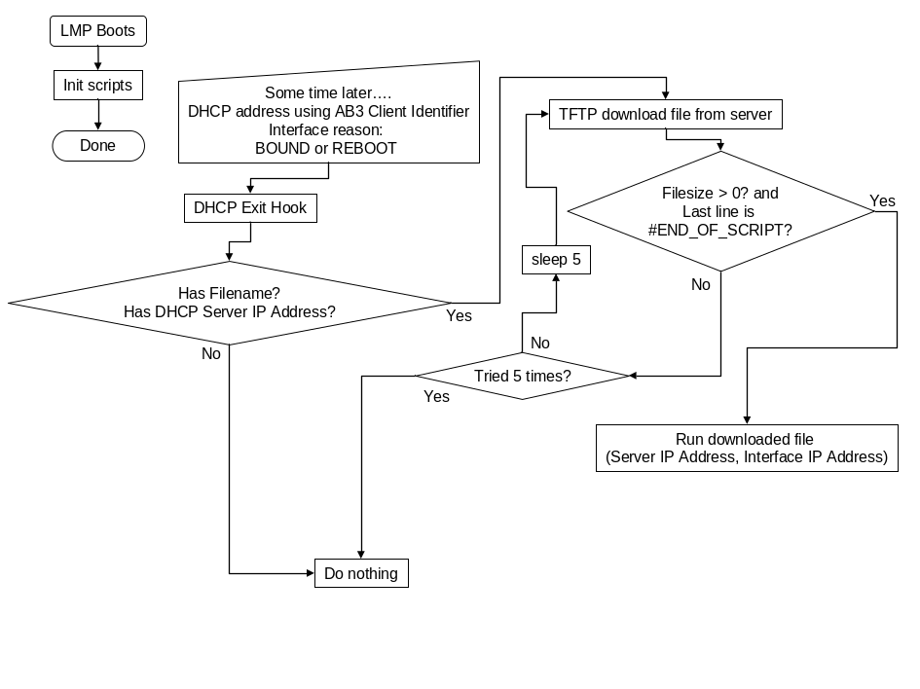

Operating System Services

Xinetd configuration
The xinetd daemon is used to provide access to operating system services. Each such enabled service must have a only_from keyword entry restricting its use to only those network interfaces intended.

Telnet Support
The module includes support for telnetd. By default, telnetd is disabled. When enabled, telnetd responds to requests on TCP port 23 by forking the login utility, which allows users to login to the Linux Shell or the Top-Level CLI.

SSH Support
The module software includes support for the Secure Shell (SSH). By default, SSH is enabled, with access restricted to only the non-fabric interfaces. SSH responds to requests on TCP port 22 according to the SSH Authentication Protocol as defined in [10].
Included on the module is the full OpenSSH distribution (version 3.0.2pl), which includes SSH client/server, scp, sftp, sftp-server, and slogin. Only SSH protocol version 2.0 is supported due to vulnerabilities in some early implementations of SSH version 1.
The SSH server is enabled in the factory default setup. CLI commands in the Blade Management group are used to enable/disable the SSH server. Keys are automatically generated the first time the module boots. The user can re-generate keys using the following commands:
/usr/bin/ssh-keygen –d –f /etc/ssh/ssh_host_rsa_key –N “” –t rsa
/usr/bin/ssh-keygen –d –f /etc/ssh/ssh_host_dsa_key –N “” –t dsa
SSH requires a password with a user account. The default password for the root account is defined in 5.9.
The SSH client can be invoked by typing ‘/usr/bin/ssh <hostname>’ at the Linux prompt. The ‘-l’ option may be added to specify the login username.

NFS
The module supports the NFS client, allowing the module to mount network disk partitions exported from an NFS host. This support is built into the kernel to allow network-mounted root filesystems. No filesystem exports are defined by default.

FTP
The Linux FTP client is installed on the default Linux filesytem. The FTP service is not present on the module.

TFTP
The module includes a Trivial File Transfer Protocol (TFTP) server and TFTP client in accordance with RFC 1350 (i.e., TFTPv2).
The TFTP server is enabled per factory default settings. The root directory for TFTP is set by default as /etc/esbconfig so that by default, only configuration files are accessible. Other files to be transferred can be placed in this directory by the user or an application.
The TFTP client in /usr/bin/tftp can be invoked from the Linux prompt.

802.1Q VLAN Support
The Linux kernel on the module supports the 802.1Q VLAN driver, for which any existing IP interface may be extended to create an additional IP interface per VLAN. It is expected that this feature would be used primarily to create per-VLAN interfaces for the existing Ethernet interfaces.
Before a VLAN can be used on the interface, the port to which the interface is connected must be configured to participate in the VLAN.
For example, on an SCM3, the switch port connected to eth2 is 2/1 on the Base Interconnect. The switch port connected to eth3 is 2/1 on the Fabric Interconnect.
To configure the use of VLAN 4 on eth2, the following commands would be issued to the Base Interconnect Ethernet CLI:
vlan database
vlan 4
exit
configure
interface 2/1
vlan participation include 4
exit
exit
The creation and removal of the per-VLAN interfaces is done using the /usr/local/bin/vconfig application. These interfaces are volatile and must be re-created during (or after) each LMP bootup sequence. The static IPv4 address/mask for each per-VLAN interface, once created, is configured using the /sbin/ifconfig application.
The /usr/local/bin/vconfig application uses the following syntax to create and remove a per-VLAN interface on a given interface for a given VLAN ID:
/usr/local/bin/vconfig add [interface-name] [vlan_id]
/usr/local/bin/vconfig rem [interface-name] [vlan_id]
The following example shows the creation of a eth2.5 interface to be used on VLAN ID 5 followed by its configuration to use IPv4 address 192.168.5.1/24:
/usr/local/bin/vconfig add eth2 5
ifconfig eth2.5 192.168.5.1 netmask 255.255.255.0
The statistics available for per-VLAN interfaces are those provided by the /sbin/ifconfig application and the /proc/net/vlan/<if>.<vid> files (of which there is one for each per-VLAN interface).

LMP Based Ethernet Bridging
The Local Management Processor (LMP) supports bridging of traffic between interfaces (e.g., between the Base inconnect and the Fabric interconnet on the SCM3). Only traffic destined for configured MAC addresses is bridged between the interconnects. The etables function of Linux is used to implement the bridge.

IPv4 Masquerade
IPv4 Masquerade is supported but is disabled by default. This capability is provided in order to allow IPv4 connectivity between hosts connected to the module's eth0 interface and hosts beyond the module’s Base and Fabric interconnect switch(es) (e.g., hosts on CPM modules or other hosts accessed via the module's Base Ethernet interface) without having to laboriously configure and re-configure static routes on the hosts beyond the switches each time they need to communicate through a different module. Note that a static route (e.g., a default gateway route) is still needed on the hosts connected to the modules eth0 interface, to ensure that they forward their datagrams to these interfaces so that the module can do its IPv4 forwarding and masquerading on the Base Ethernet interface. IPv4 masquerade can be enabled using the following standard Linux command:
/sbin/iptables –t nat –A POSTROUTING –o <interface> –s <subnet> –j MASQUERADE
For example, to enable IPv4 Masquerade on SCM3’s eth2 interface for eth0 host traffic (i.e., traffic on the 10.0.0.0/24 subnet), the following command can be used:
/sbin/iptables –t nat –A POSTROUTING –o eth2 –s 10.0.0.0/24 –j MASQUERADE

DHCP Server
The Internet Software Consortium (ISC) DHCP Server is used on the module. This server is commonly included in Linux distributions and the format of its configuration file, dhcpd.conf, is well known and documented. The service is disabled by default.

DHCP Client
The module supports DHCP client services. These services are normally used for dynamically configuring Ethernet interface IP addresses. Additionally, DHCP can be used by both U-Boot and Linux to configure client IP address when using a network mounted root file system.

NTP Server and Client
The standard Linux NTP server daemon and client are installed on the module. This allows the module to be an NTP server as well as a client. The NTP software allows the user to upload, download and display the ntp.conf file. The NTP software also allows the user to start, stop, and restart the NTP service.

SNMP Agent
Some modules optionally include a modular SNMP agent and MIB browser utility applications, along with tools to assist in their configuration.

SNMP Interface
The SNMP management interface is described in [3] and other blade specific software specifications.

Cron and at
The cron and at services allow execution of commands at specified times. The cron.allow and cron.deny files are used to control access to the cron command. By default, the cron.allow file is empty and the keyword ALL is in the cron.deny file, denying all users access to the cron service.
The at.allow and at.deny files perform the same function for the at command. By default, the at.allow is empty and the keyword ALL is in the at.deny file, denying all users access to the at service.

Kgdb
The kernel debugger KGDB will be present in the OS source and will be tested. However, it is disabled by default.

Watchdog Support
The IPMI BMC watchdog timer provides overall watchdog supervision of the Linux kernel and its applications. The Linux Watchdog Daemon along with the /dev/watchdog device are responsible for periodically clearing the IPMI BMC watchdog timer. The Watchdog Daemon reads a configuration file, /etc/watchdog.conf, which contains entries for the critical processes to be monitored as well as other configurable parameters like time interval, max CPU load, memory usage, etc. The watchdog daemon reads the pid file of the process to be monitored and pings using the kill(2) function to check the status of the process.
The critical processes might include:
Ethernet Switching and IP routing applications
The Shelf Management Server (if applicable)
The E-Key Handler
If any of these processes do not respond to the kill function call, the module will perform a warm reboot using the IPMC.
The Watchdog Daemon configures the IPMI BMC watchdog with a 2 second timeout. If the Watchdog Daemon does not kick the IPMI BMC watchdog before the timer expires, the IPMC will warm reset the LMP.

Pre-Timeout Interrupt Support
If the IPMC Pre-Timeout Interrupt is enabled in NMI mode, a Machine Check Exception is generated on the PowerQUICC III processor. The RadiSys Linux implementation allows a kernel module to register to receive this interrupt and handle it as appropriate. Linux Kernel system calls are not supported in the Machine Check Exception context.

Linux User Accounts
The module supports the use of standard Linux user account mechanisms.
The root user account is supported by default and uses root as the default password. The root user’s default application is the Linux Shell as shown in section 5.11.
Modules with CLI access to the Ethernet switch application support an additional user, admin, with a default password also of root. The admin user’s default application is the top-level CLI.

Linux Shell
Access to the Linux shell is provided via the serial port and via the telnet server or SSH daemon using a user name of root.
The default Linux shell for the root user is /bin/bash, accessed via a symbolic link from /bin/sh.

Linux Login Prompt
The default login prompt is a concatenation of the following.
the host name, (e.g. “ATCA-2210”) in upper case
the keyword “login: “
The password prompt is :
the keyword “password:”

Linux syslog
The linux syslog is used for error logging. All errors, even those reported to the System Manager, are also logged in the Linux syslog. The syslog is stored on the RAM disk. Error information logged includes user name, calendar time, and the erroring event.

Linux Shell Prompt
The default Linux shell prompt for each user is set via /etc/profile to be the concatenation of the following, which includes values from the Shelf Address which is stored in the module information files (see 7.3).
the user name (e.g., “root”)
a “@” character
the host name (e.g. “ATCA-2210”) in upper case.
a “@” character
the logical Cabinet number
a hyphen (“-“) character
the Logical Shelf number
a hyphen (“-“) character
the Physical Chassis Slot in which the module is installed (e.g., “7”)
(Optional) the Carrier Bay in which the module is installed, preceded by a hyphen character (“-“). This is primarily applicable to AMC modules.
a colon character (i.e., “:”)
the current working directory e.g. “/mnt/RAM/esb”
a “#” character if the UID is 0 (i.e., for root), or a “$” character otherwise
An example of this Linux shell prompt format is “root@ATCA-2210@245-7-5:/mnt/RAM/esb#”.
The prompt is parsed by RadiSys testing applications. The perl program below is the definitive reference for a valid prompt and is used during verification to ensure compliance.
#!/usr/bin/perl

# This is a test perl program to parse the prompt of an ATCA 3.0 module
#
# A valid prompt consists of up to 8 fields

# 1) Username (e.g. "root") followed by an "@" character
# 2) the Hostname in upper case followed by an "@" character
# 3) the Logical Cabinet followed by a "-" character
# 4) the Logical Shelf followed by a "-" character
# 5) the Physical Slot in which the module is installed (e.g., "7")
# 6) OPTIONALLY the Carrier Bay PREceded by a "-" character
# a colon character ":"
# 7) the current working directory
# 8) "#" character if the UID is 0 (i.e., for root) or a "$" otherwise

$prompt = shift || 'root@ATCA-2210@3-245-7:/mnt/RAM/esb#';

print "Testing prompt \"$prompt\" \n\n";

if ( $prompt =~ /^(.+?)@(.+?)@(\d+?)-(\d+?)-(\d+?)(?:-(\d*)|):(.+?)([\#\$])/ ) {
print "Matched Username $1\n";
print "Matched Hostname $2\n";
print "Matched Cabinet $3\n";
print "Matched LogShelf $4\n";
print "Matched PhySlot $5\n";
print "Matched CarrBay $6\n";
print "Matched cwd $7\n";
print "Matched prompt $8\n";
}

Security
System security is ensured via a layered approach. Each layer, having subsequently more capability, requires subsequently higher security.

Watchdog operation
The implementation of the CFD and the BMC watchdog provide security against erroneous execution of rogue code segments. The CFD and BMC are detailed in section 3.4.

U-Boot security
U-Boot is secured by virtue of the fact that a custom cable and physical access to the module are required for access to the U-Boot console prompt.

Linux kernel and application patches
The Linux kernel and all applications contain the latest security patches and fixes.

Linux filesystem security
The Linux filesystem ownership and access control is utilized to prevent unauthorized users for accessing and modifying kernel files. To prevent unauthorized access, all startup files, and the files called during startup, are either owned by root or the account which performs the login.

Linux kernel access security
Access to the Linux kernel and its services is provided via console login, telnet, and SSH services. These services are detailed in section 5.7.2 and 5.7.3.

Shadow passwords
Shadow passwords are enabled by default. This feature prevents regular users from using the cleartext /etc/passwd in password cracking attempts. Passwords are instead stored in the /etc/shadow file, which is readable only by root.

PAM
Pluggable Authentication Manager aware applications allow the system administrator to plug in new security modules without recompiling the applications. A list of available PAM modules can be found on the Linux PAM Modules page [6].

New Users
Creating new user accounts is most simply done using the useradd function. Accounts created with useradd are disabled by default. When shadow password is enabled, the root user is required to run passwd <username> to create a new password and enable the new account. Users are prompted to change their passwords upon their initial login. The environment created for the new user must include default and secure startup files; the default path cannot include the local directory (“.:”) and the UMASK must be at most 0027.

Default groups and users
By default, users and groups will have severely limited access. Root access will be required to create, modify, and add users and groups to the system. No default, backdoor, or non-passworded users are present. Use of NIS to allow access by remote authentication is not enabled.

Root user access
By default, the root user can login only via the serial console. All root user logins, successful or not, are logged. The logged information includes the date, time, and tty, ssh, or telnet session used to login. If the login is via the “su” command, the login name of the command issuer is logged as well. The only username with UID 0 is “root”.

Automatic Remote Access
Use of /etc/hosts.equiv and .rhosts files to allow remote access is not enabled; these files do not exist.

NFS
NFS exports are not recommended. Any NFS exports are specified with the access= and root= options set. The anon option is set to 1.

Local Management Processor Bootup Sequence
In brief, the LMP bootup sequence consists of U-Boot loading a Linux kernel, jumping to it, and then Linux initializing itself, loading its kernel modules, and starting up its applications.

Boot Sequence Details
The following lists the major steps in the boot sequence of a deeply embedded module. Compute modules, especially those booting commercial OSes like RedHat and Wind River PNE, have their own sequence. Refer to the vendor documentation for detailed information regarding those operating systems and their boot sequence.
- Hardware: The IPMC withholds power from the LMP until hardware management decides the LMP is ready to be initialized. This step may involve interaction from the active Shelf Manager Controller which could reside on another FRU.
- IPMC: Enables the CFD watchdog timer (see section 3.2). Sets the select for Flash memory so that the configured Flash memory device is used to boot the LMP (see section 3.1), and enables power to the payload.
- U-Boot: Shadows U-Boot to DRAM.
- U-Boot: Initializes LMP hardware. Memory is also initialized in the case of a cold reset.
- U-Boot: Enables the BMC watchdog timer. Disables the CFD watchdog timer.
- U-Boot: Prompts for the sequence Ctrl-X, Ctrl-W. If this sequence is not received on the serial console port within two seconds, U-Boot continues the boot process. If the Ctrl-X, Ctrl-W sequence is received, U-Boot enters the monitor program.
- U-Boot: If no input is detected, U-Boot executes the commands configured in the bootcmd environment variable. The bootcmd variable by default includes the bootm command, which performs the remaining work for U-Boot in the normal auto-boot case.
- U-Boot bootm: Computes the checksum of the Linux kernel image. If the checksum is incorrect, a “boot alternate flash” command is sent to the IPMC and the LMP is reset and started with the secondary Flash memory device selected.
- U-Boot bootm: Decompresses the kernel image into DRAM and jumps into it.
Reordering of these commands may help reduce the required boot time. See section 8.1 for additional details.
- Linux: Kernel initializes. Caches are set up and other hardware is initialized by calling the init function in each driver.
- Linux: Decompresses the initramfs image into DRAM and mounts it.
- Linux: The init process is started, and begins prcessing the /etc/inittab file.
- onboot: Mounts the JFFS2 on the primary flash device as /rsys, mounts other filesystems if needed
- onboot: Runs all the scripts in the /rsys/onboot.d directory
- onboot: Runs the packages script to install all packages in the /rsys/onboot.data/packages directory
- onboot: Runs the livePatches script to apply live updates to applications. Note: this is a future implementation
- onboot: Runs the overlay script to overlay /rsys/onboot.data/overlay files directly over the root ('/') filesystem.
- onboot: Runs the bindmount script to bind --mount files and directories in /rsys/onboot.data/bindmount
- onboot: Runs the remove script to remove files listed in /rsys/onboot.data/remove
- init: Performs standard Linux startup functions related to mounting of additional file systems and starting inetd. At this point, the requested runlevel startup scripts are executed. Typically, this is runlevel 3.
- init: Starts the shmgr application if shelf management is supported on the module. shmgr is a custom RadiSys script.
- init: Runs the fruinfo startup script to create shelf information files.
- init: Runs the make-interfaces.sh script to generate the /etc/sysconfig/network-devices/ifconfig.* files and the /etc/dhclient.conf file using template files in conjunction with the gathered shelf information. The make-interfaces.sh script is a RadiSys customized init script.
- init: Brings up the IPv4 interfaces.
- init: Starts the SNMP master agent, if applicable.
- init: Starts the Top-Level CLI application, if applicable. This applies primarily to switching modules.
- init: Starts the FASTPATH application for the Base and Fabric interconnect, if applicable. This applies primarily to switching modules.
- init: Starts the Module Management daemon by calling the rsysMMServer script.
- init: Runlevel startup script processing completes. The login prompt is presented at the console port.
The module is expected to reach the user login prompt in a predictable amount of time. While the actual value may vary from module to module, most module implementations should reach the login prompt within 40 seconds of power-on.

Example Boot Sequence
The following is an example boot sequence for the ATCA 2210 (SCM3).
U-Boot 1.1.4 (Mar 19 2007 - 20:33:18)

CPU: 8541, Version: 1.1, (0x807a0011)
Core: E500, Version: 2.0, (0x80200020)
Clock Configuration:
CPU: 825 MHz, CCB: 330 MHz,
DDR: 165 MHz, LBC: 82 MHz
L1: D-cache 32 kB enabled
I-cache 32 kB enabled
Board: RadiSys SCM3 Version 1.1
CPU Board Revision 0.0 (0x0000)
PCI1: 32 bit, 66 MHz, sync
PCI2: 32 bit, 66 MHz, sync
I2C: ready
DRAM: Initializing
Found SDRAM SPD @ i2c addr 0x54
DDR: 768 MB
FLASH: 128 MB
L2 cache 256KB: enabled
*** Warning - bad CRC, using default environment
Using EEPROM based MAC address : 00 50 00 81 62 00
PCI Autoconfig: Memory region: [90000000-9fffffff]
PCI Autoconfig: I/O region: [c3000000-c3ffffff]
PCI Autoconfig: BAR 0, Mem, size=0x10000,
Bus:00 Idsel:0c Vendor Id:14e4 Device:b800 Class:0280 Int:00
PCI Autoconfig: Memory region: [80000000-8fffffff]
PCI Autoconfig: I/O region: [c2000000-c2ffffff]
PCI Autoconfig: BAR 0, Mem, size=0x10000,
Bus:00 Idsel:0b Vendor Id:14e4 Device:b304 Class:0280 Int:00
In: serial
Out: serial
Err: serial
Net: FCC1 ETHERNET
Autobooting in 2 seconds, press Ctrl-x followed by Ctrl-w to stop...
## Booting image at fcf80000 ...
Image Name: vmlinux-2.6.14-22scm3
Image Type: PowerPC Linux Multi-File Image (gzip compressed)
Data Size: 25940574 Bytes = 24.7 MB
Load Address: 00000000
Entry Point: 00000000
Contents:
Image 0: 1109136 Bytes = 1.1 MB
Image 1: 24831426 Bytes = 23.7 MB
Uncompressing Multi-File Image ... OK
Uncompressing Ramdisk to 2c061000, end 2ff9c800 ... OK
[ 0.000000] Memory CAM mapping: CAM0=256Mb, CAM1=256Mb, CAM2=256Mb
esidual: 0Mb
[ 0.000000] Linux version 2.6.14-22scm3 (root@bld2-dsm.radisys.com)
gcc version 3.4.4 (Wind River Linux)) #1 PREEMPT Mon Mar 19 19:53:50 EST
007
[ 0.000000] SCM3 Version = 0 LED CPLD Ver = 0
[ 0.000000] PCIA 0x10 mem sz=0x10000 add=0x8fff0000
[ 0.000000] PCIA 0x10 mem sz=0x10000 add=0x9fff0000
[ 0.000000] Built 1 zonelists
[ 0.000000] Kernel command line: root=/dev/ram rw console=ttyS0,115200
[ 0.000000] OpenPIC Version 1.2 (1 CPUs and 60 IRQ sources) at
bf79000
[ 0.000000] PID hash table entries: 4096 (order: 12, 65536 bytes)
[ 0.000822] Dentry cache hash table entries: 131072 (order: 7, 524288
bytes)
[ 0.002353] Inode-cache hash table entries: 65536 (order: 6, 262144
bytes)
[ 0.029151] Memory: 712192k available (1788k kernel code, 508k data,
12k init, 0k highmem)
[ 0.230048] Mount-cache hash table entries: 512
[ 0.230587] Overmounted tmpfs
[ 0.230594] Unpacking initramfs... done
[ 0.448596] Freeing initrd memory: 64750k freed
[ 0.456952] NET: Registered protocol family 16
[ 0.457002] PCI: Probing PCI hardware
[ 0.457959] Generic PHY: Registered new driver
[ 0.457974] TSEC TBI PHY: Registered new driver
[ 0.458381] JFFS2 version 2.2. (NAND) (C) 2001-2003 Red Hat, Inc.
[ 0.458491] Initializing Cryptographic API
[ 0.463768] Generic RTC Driver v1.07
[ 0.463878] Serial: 8250/16550 driver $Revision: 1.90 $ 4 ports, IRQ sharing
disabled
[ 0.464114] ttyS0 at MMIO map 0xc0004500 mem 0xfbfba500 (irq = 90) is a 16550A
[ 0.608373] ttyS1 at MMIO map 0xc0004600 mem 0xfbfb9600 (irq = 90) is a 16550A
[ 0.615846] io scheduler noop registered
[ 0.619938] loop: loaded (max 8 devices)
[ 0.627965] Gianfar MII Bus: probed
[ 0.631612] eth2: Gianfar Ethernet Controller Version 1.2, 00:50:00:81:62:03
[ 0.638940] eth2: Running with NAPI enabled
[ 0.643229] eth2: 256/256 RX/TX BD ring size
[ 0.647669] tun: Universal TUN/TAP device driver, 1.6
[ 0.652847] tun: (C) 1999-2004 Max Krasnyansky <maxk@qualcomm.com>
[ 0.665135] RadiSys ATCA-22XX flash: Found 1 x16 devices at 0x0 in 16-bit bank
[ 0.672565] RadiSys ATCA-22XX flash: Found 1 x16 devices at 0x4000000 in 16-bit
bank
[ 0.680506] Amd/Fujitsu Extended Query Table at 0x0040
[ 0.685865] RadiSys ATCA-22XX flash: CFI does not contain boot bank location.
assuming top.
[ 0.694425] number of CFI chips: 2
[ 0.697904] cfi_cmdset_0002: Disabling erase-suspend-program due to code brokenness.
[ 0.705840] Creating 8 MTD partitions on "RadiSys ATCA-22XX flash":
[ 0.712263] 0x00000000-0x04000000 : "primary flash part"
[ 0.717755] 0x04000000-0x08000000 : "secondary flash part"
[ 0.723412] 0x00000000-0x00f80000 : "primary jffs2 file system"
[ 0.729498] 0x00f80000-0x03f80000 : "primary linux kernel and file system"
[ 0.736572] 0x03f80000-0x04000000 : "primary u-boot"
[ 0.741691] 0x04000000-0x04f80000 : "secondary jffs2 file system (unused)"
[ 0.748759] 0x04f80000-0x07f80000 : "secondary linux kernel and file system"
[ 0.756010] 0x07f80000-0x08000000 : "secondary u-boot"
[ 0.761465] CPM2 SPI: initialized
[ 0.764883] CPLD: Version 5
[ 0.767788] ks89xx: Family:KS8995 Series:M Revision:3
[ 0.772982] ks89xx: Switch started
[ 0.776467] i2c /dev entries driver
[ 0.781716] eth0: FCC ENET Version 0.3, 00:50:00:81:62:01
[ 0.787562] eth0: Phy @ 0x0, type LXT971 (0x001378e2)
[ 0.792811] eth1: FCC ENET Version 0.3, 00:50:00:81:62:02
[ 0.798504] eth1: no PHY device found, defaulting to Phy @ 0x1, type LXT971
[ 0.806684] NET: Registered protocol family 2
[ 0.900075] IP route cache hash table entries: 32768 (order: 5, 131072 bytes)
[ 0.907761] TCP established hash table entries: 131072 (order: 7, 524288 bytes)
[ 0.916381] TCP bind hash table entries: 65536 (order: 6, 262144 bytes)
[ 0.923583] TCP: Hash tables configured (established 131072 bind 65536)
[ 0.930365] TCP reno registered
[ 0.933611] TCP bic registered
[ 0.936751] NET: Registered protocol family 1
[ 0.941224] NET: Registered protocol family 17
[ 0.945839] 802.1Q VLAN Support v1.8 Ben Greear <greearb@candelatech.com>
[ 0.952800] All bugs added by David S. Miller <davem@redhat.com>
[ 0.959030] Freeing unused kernel memory: 112k init
INIT: version 2.86 booting
onboot startup files are up to date
Mount /etc on /.etc-orig
SCM port driver is up to date.
Performing 'onboot' persistent configuration actions...
Copying contents of /rsys/onboot.data/overlay to /
/bin/ttcp
Performing bind mount operations...
Mounting /etc
Mounting /var/lib/snmp
Mounting /var/lib/shmgr
Mounting /root/.snmp
INIT: Entering runlevel: 2 [ OK ]
Starting portmapper:
Remounting root file system in read-write mode... [ OK ]
Recording existing mounts in /etc/mtab... [ OK ]
Mounting remaining file systems... [ OK ]
Setting the System Clock using the Hardware Clock as reference...
System Clock set. Local time: Thu Mar 22 02:32:19 UTC 2007
Loading Module scm_port_driver.ko...
Creating device node /dev/ntsClkCtrl
Creating device node /dev/update_channel
Creating device node /dev/base_sfp
Creating device node /dev/rtm_reset
Creating device node /dev/spm3Hotswap
Starting inetd... [ OK ]
Running on SETS blade using acs8520
Loading Module for acs8520 driver
[ 2.709412] acs85xx: Family:ACS8520 Revision:0
Creating device node for acs8520 driver
major:248
Device node /dev/acs8520 c 248 0
Loading Module ds26502_spi.ko
Creating device node for ds26502 driver
major:247
Device node /dev/ds26502-4 c 247 0
major:247
Device node /dev/ds26502-3 c 247 1
major:247
Device node /dev/ds26502-2 c 247 2
major:247
Device node /dev/ds26502-1 c 247 3
Installing MCLI NTS Plugin
The plugin 'librsysntscli.so' is already present in /etc/mcli/mclid.conf
Installing NTS event management
The plugin 'librsysntsevent.so' is already present in /etc/mcli/mclid.conf
Adding Shelf Management CLI to mcli.
The plugin 'librsysShmgrCli.so' is already present in /etc/mcli/mclid.conf
Adding Platform Management CLI to mcli.
The plugin 'librsysPlatformMgmtCli.so' is already present in /etc/mcli/mclid.conf
Starting shmgr...
Creating directory for HPI configuration files ... [ OK ]
Starting the Shelf Manager...
Creating IPMI serial device interface ... [ OK ]
Loading IPMI serial driver ... [ OK ]
Issuing SEL check command ... [ OK ]
Preparing HPI configuration files ...
[ OK ]
Server will assume the standby role.
Limiting core dump size to 0 ... [ OK ]
Starting server daemon (--verbosity 5 --maxlog 8000000) ...[ OK ]
Daemon (PID 211) started.
Bringing up the lo interface... [ OK ]
Setting hostname...
Getting chassis information...
Determined we are running in a RadiSys shelf.
Return codes from iscript: C3h, D4h
Unable to communicate with Shelf Manager - retry 1 in 1 second...
Mapping slots...
Successfully mapped 6 slots.
Starting make interfaces script
Creating client identifier based on LCHAS and SLOT
LCHAS: 7
SLOT: 1
CLIENT_ID: 00:37:2d:31
Making dhclient and interface configurations from template files
Detecting RTM....OK
Adding mcli plugins to system...
Installing Ethernet CLI Plugin
The plugin 'librsysEthCli.so' is already present in /etc/mcli/mclid.conf
Adding Module Management CLI to mcli.
The plugin 'librsysMmsdCli.so' is already present in /etc/mcli/mclid.conf
Starting the Module Manager Server ...... finished
Installing RTM Plugin in CLI
The plugin 'librsysRtmPluginCli.so' is already present in /etc/mcli/mclid.conf
Installing Net-SNMP Support
grep: rtld-lazy: No such file or directory
grep: rtld-global: No such file or directory
The plugin 'libcrypto.so rtld-lazy rtld-global' is already present in
/etc/mcli/mclid.conf
Installing Net-SNMP Support
grep: rtld-lazy: No such file or directory
grep: rtld-global: No such file or directory
The plugin 'libnetsnmp.so rtld-lazy rtld-global' is already present in
/etc/mcli/mclid.conf
Installing Net-SNMP Support
grep: rtld-lazy: No such file or directory
grep: rtld-global: No such file or directory
The plugin 'libnetsnmphelpers.so rtld-lazy rtld-global' is already present in
/etc/mcli/mclid.conf
Installing Net-SNMP Support
grep: rtld-lazy: No such file or directory
grep: rtld-global: No such file or directory
The plugin 'libnetsnmpagent.so rtld-lazy rtld-global' is already present in
/etc/mcli/mclid.conf
Installing Net-SNMP Support
grep: rtld-lazy: No such file or directory
grep: rtld-global: No such file or directory
The plugin 'libnetsnmpmibs.so rtld-lazy rtld-global' is already present in
/etc/mcli/mclid.conf
Installing MCLI SNMP CLI Support
The plugin 'librsysSnmpCli.so' is already present in /etc/mcli/mclid.conf
Using Radilyx initialization utilities
Starting the Master CLI with: /usr/sbin/mclid -b -c 10001 [ OK ]
Waiting for /var/run/mcli/mclid.status
Cannot find module (SNMPv2-MIB): At line 1 in (none)
Cannot find module (IF-MIB): At line 1 in (none)
Cannot find module (IP-MIB): At line 1 in (none)
Cannot find module (TCP-MIB): At line 1 in (none)
Cannot find module (UDP-MIB): At line 1 in (none)
Cannot find module (SNMPv2-SMI): At line 1 in (none)
Cannot find module (BRIDGE-MIB): At line 1 in (none)
Cannot find module (P-BRIDGE-MIB): At line 1 in (none)
Cannot find module (Q-BRIDGE-MIB): At line 1 in (none)
Cannot find module (EtherLike-MIB): At line 1 in (none)
Cannot find module (SNMP-FRAMEWORK-MIB): At line 1 in (none)
Cannot find module (SNMP-MPD-MIB): At line 1 in (none)
Cannot find module (SNMP-TARGET-MIB): At line 1 in (none)
Cannot find module (SNMP-NOTIFICATION-MIB): At line 1 in (none)
Cannot find module (SNMP-USER-BASED-SM-MIB): At line 1 in (none)
Cannot find module (SNMP-VIEW-BASED-ACM-MIB): At line 1 in (none)
Cannot find module (RADISYS-MIB): At line 1 in (none)
Cannot find module (RADISYS-ATCA-MIB): At line 1 in (none)
Cannot find module (IEEE8023-LAG-MIB): At line 1 in (none)
Cannot find module (NET-SNMP-MIB): At line 1 in (none)
Cannot find module (NET-SNMP-TC): At line 1 in (none)
Cannot find module (NET-SNMP-AGENT-MIB): At line 1 in (none)
Warning: Failed to connect to the agentx master agent (/var/agentx/master):
Unknown host (/var/agentx/master) (No such file or directory)
Master CLI status file present. /var/run/mcli/mclid.status
Starting /usr/sbin/ekeyd...
Extracting MIB modules from /usr/share/snmp/mibs/mibs.tgz...
Sourcing more SNMPD options from /var/run/snmp/snmpd.options
BRIDGE-MIB.txt
EtherLike-MIB.txt
IANAifType-MIB.txt
IEEE8023-LAG-MIB.txt
IF-MIB.txt
IP-MIB.txt
LLDP-MIB.txt
NET-SNMP-AGENT-MIB.txt
NET-SNMP-MIB.txt
NET-SNMP-TC.txt
NOTIFICATION-LOG-MIB.txt
P-BRIDGE-MIB.txt
Q-BRIDGE-MIB.txt
RADISYS-ATCA-MIB.txt
RADISYS-MIB.txt
README.txt
RFC1155-SMI.txt
RFC1213-MIB.txt
RMON-MIB.txt
SNMP-COMMUNITY-MIB.txt
SNMP-FRAMEWORK-MIB.txt
SNMP-MPD-MIB.txt
SNMP-NOTIFICATION-MIB.txt
SNMP-TARGET-MIB.txt
SNMP-USER-BASED-SM-MIB.txt
SNMP-VIEW-BASED-ACM-MIB.txt
SNMPv2-CONF.txt
SNMPv2-MIB.txt
SNMPv2-SMI.txt
SNMPv2-TC.txt
SNMPv2-TM.txt
TCP-MIB.txt
UDP-MIB.txt
Master agent command line -C -c /var/run/snmp/disable.snmpd.conf
Starting SNMP master agent... [ OK ]
Starting switchdrvr and installing fastpath drivers...
Installing fastpath driver modules
[ 18.946274] kbde: module license 'Proprietary' taints kernel.
[ 18.952919] linux-kernel-bde (683): _pci_probe: ignoring device not in slot 11
Starting switchdrvr application (base)
Starting switchdrvr application (fabric)
switchdrvr started
Bringing up the eth0 interface...
[ 19.312522] eth0: config: auto-negotiation on, 100FDX, 100HDX, 10F[ OK ]X.
Bringing up the eth0:0 interface... [ OK ]
Bringing up the lo interface... [ OK ]
Configuring dtl0 network interfaces (in background)
(Output is redirected to /var/log/ifup-dtl0.log)
Configuring dtl1 network interfaces (in background)
(Output is redirected to /var/log/ifup-dtl1.log)
Starting ekeymon... [ OK ]
Starting sshd:
ATCA-2210 login:

Handling of Failures During the Boot Process
This section specifies the behavior of the module when specific failures occur during the boot process. For the failure cases described in sections 7.2.2and 7.2.3, if the module is booting from the configured boot device, the IPMC’s BMC watchdog timer will expire after LMP (payload) power up (see section 3.3). System management software may decide to force the module to boot from the secondary flash device. If the failure occurs while attempting to boot from the secondary boot device, the IPMC’s watchdog will be disabled. This allows the module to be debugged and also allows a new software image to be loaded onto the module.

Debug Mode
When a failure is detected, the module enters debug mode by switching to runlevel 2. The debug mode is defined as:
An error message is written to the module’s Message of the Day (MOTD) file indicating that the error which caused entry into debug mode.
Runlevel 3 init scripts abort and do not attempt to start any more services. Runlevel 1 processing is started.
The BMC watchdog state is left unchanged.
An IPMI System Firmware Progress event is generated. This event, defined in IPMI version 1.5, is generated with Sensor Type Code of 0x0f (no defined sensor) and sensor specific offset code of 0x00. The subtype code for event data 2 is used to add additional information if available.
The management interface(s) are initialized and enabled. All other physical interfaces are disabled.
The inetd service is started so that telnet and ssh can be used to connect to the module.
A login prompt is issued on the serial port. A successful login causes the BMC watchdog to be disabled, allowing interactive debugging. If no successful login occurs prior to the BMC watchdog timeout, the BMC watchdog timeout operation is performed. System management intervention can be used to take control of the failing module here as well.

Active Shelf Manager Cannot Provide Shelf Information
The fruinfo script detects this failure when it attempts to determine in which physical slot or bay the module is located. If the script does not get a successful response to its IPMI request after two minutes, the module enters debug mode as defined in section 7.2.1

FASTPATH Applications Do Not Start Correctly
This failure is detected by the init script for the FASTPATH applications. If the PID files for the FASTPATH applications are not created within two minutes of starting the applications, the module will enter debug mode as defined in section 7.2.1.

Generation of Shelf Configuration Information
During the Linux boot process, the fruinfo script is run to obtain information about the PICMG 3.0 shelf in which the module resides. This information is obtained from the active Shelf Management Controller in the shelf. The obtained information is stored in a number of files in the /var/run/fruinfo directory of the module. The files created by the fruinfo script are listed in Table 9.. The LCHAS, LCAB, C, R, H, and V files are based on the Shelf Address value from the Shelf FRU Information. If there is an error retrieving the Shelf Address, or if the Shelf Address is more than six bytes long, the specified default values will be used for the files.
If the fruinfo script is unable to obtain essential shelf information, the module will boot into a debug mode as defined in section 7.2.1.
- Files Created by fruinfo
File/Directory Name | Description | Contents
.../chassis | Directory that stores the FRU information pertaining to the chassis extracted from the Ibutton
.../chassis/GA | Directory containing Geographic Area information for the chassis
.../chassis/GA/LCHAS | Logical Chassis in cluster | ASCII decimal number between 0 and 255. Default value is 255.
.../chassis/GA/LCAB | Logical Cabinet | ASCII decimal number between 0 and 255. Default value is 255.
.../chassis/GA/C | Column location in central office | ASCII decimal number between 0 and 255. Default value of 0 indicates that FRU info was not retrieved..
.../chassis/GA/R | Row location in central office | ASCII decimal number between 0 and 255. Default value of 0 indicates that FRU info was not retrieved.
.../chassis/GA/H | Horizontal position of Chassis | ASCII decimal number between 0 and 255. Default value of 0 indicates that FRU info was not retrieved.
.../chassis/GA/V | Vertical position of Chassis | ASCII decimal number between 0 and 255. Default value of 0 indicates that FRU info was not retrieved.
.../chassis/base-subnet | IP subnet to be used for static interface on the Base Interconnect (i.e., eth2:0). | Dotted pair of format <u>.<v>.<x>.<y>/<z> where u, v, x and y are decimal numbers between 0 and 255 and z, the mask, is between 1 and 30. Default value is 10.0.0.2/24.
.../chassis/shelfip | Shelf Manager IP Address | ASCII decimal “dot quad” format IP address (e.g. 192.168.16.17). Default value is 0.0.0.0 if no shelf manager discovered.
.../chassis/slotmap | Logical to Physical Slot map | Each line contains the physical slot number which corresponds to the logical slot number. For example, the 3rd line of the file would contain the physical slot number for logical slot 3. There is no default value for the slotmap information. If the fruinfo script is unable to obtain the needed information, the module goes into debug mode.
.../slot | Directory that stores the FRU information for the switch module running fruinfo application
.../slot/fru-slot | Contains the logical slot number. If the module is an AMC or COM Express, the carrier bay the module is mounted on is indicated. | ASCII decimal number between 0 and 16. Default value of 0 indicates that FRU info was not retrieved.
…/slot/phy-slot | Contains the physical slot number. If the module is an AMC or COM Express, the carrier bay the module is mounted on is indicated. | ASCII decimal number between 0 and 16. Default value of 0 indicates that FRU info was not retrieved.
…/slot/module-slot | Contains the physical module number

Performance
More specific performance measurements are found in module specific design specification documents. The general guidelines below apply to modules running RadiSys applications.
Module boot time, defined as the amount of time elapsed from the payload power-on to the moment when the application is executing and all initialization is complete, is specified in the module specific design specification document. In general, the module configuration is complete within 60 seconds of power-on. This includes configuring for Base and Fabric interconnect switching, enabling of all login consoles, enabling all RadiSys APIs and enabling all RadiSys services.

Performance Improvements
The list below includes a number of potential areas for performance improvements.
- U-Boot currently waits some 2 seconds for a keystroke prior to auto-booting. Make that wait shorter. Also, enable the serial port earlier so that a keypress can be entered during the memory initialization and shadowing time. Currently, all keystrokes prior to the prompt are ignored.
- U-Boot currently checksums the kernel and initramfs images prior to decompressing and shadowing to DRAM. While the decompression makes the image longer, it may still be faster to checksum after decompressing to DRAM. Additionally, if the image is gzipped, which U-Boot mkimage normally would do, the compression may already introduce a checksum, potentially obviating the need to checksum a second time.
- U-Boot could use the UPM on CS2 or CS3 to access the flash, and the UPM could be programmed to allow bursting.
- U-Boot could be made to use DMA to copy the kernel and initramfs to DRAM. While not much faster, we might see more gain if U-Boot were also made to decompress the DRAM copy into other DRAM at the same time. The DRAM and the Flash are on different busses, the DMA is handled by a different machine in the CPU, the CPU does the decompression, so we have several distinct resources that could operate in parallel.
- Linux initialization scripts run in sequence. It may be possible to gain significant improvement by running init scripts in parallel. Additionally, many scripts wait for their associated services to finish starting up – e.g., Ethernet initialization waits for DHCP responses. Backgrounding such tasks allows system startup to continue with shorter boot times, and with no degradation in performance

Boot Timeline
The diagrams below provide rough detail of the boot timeline.

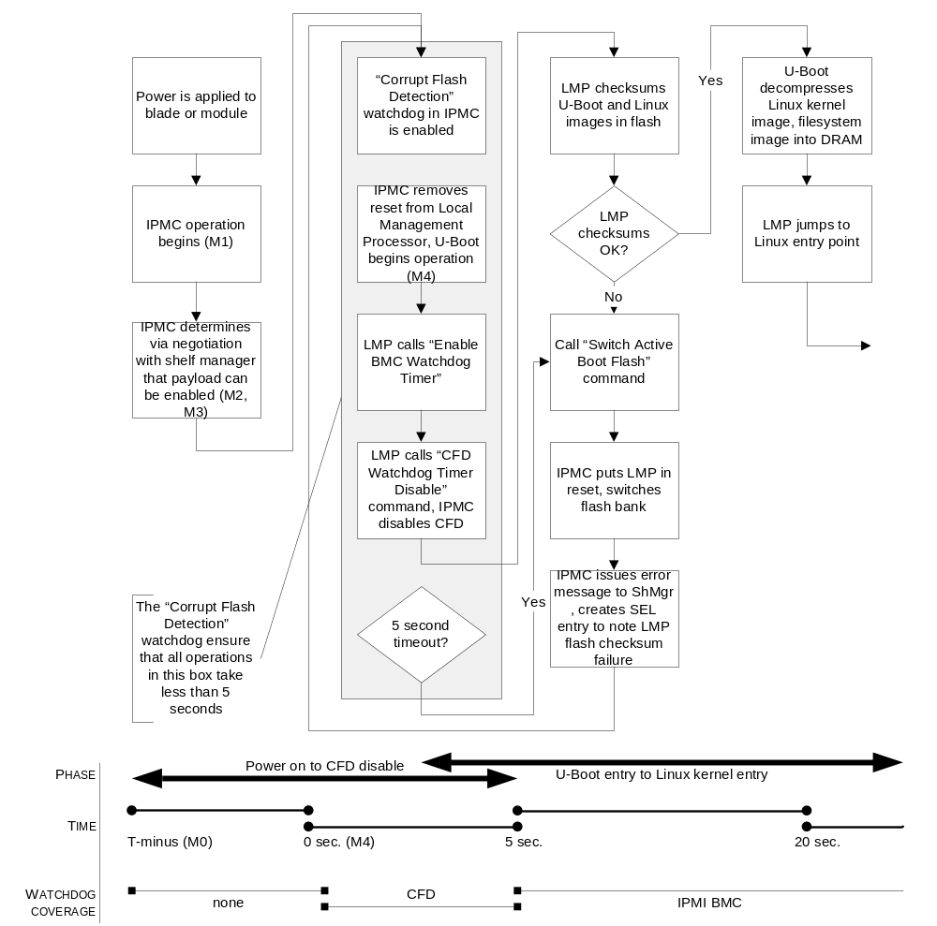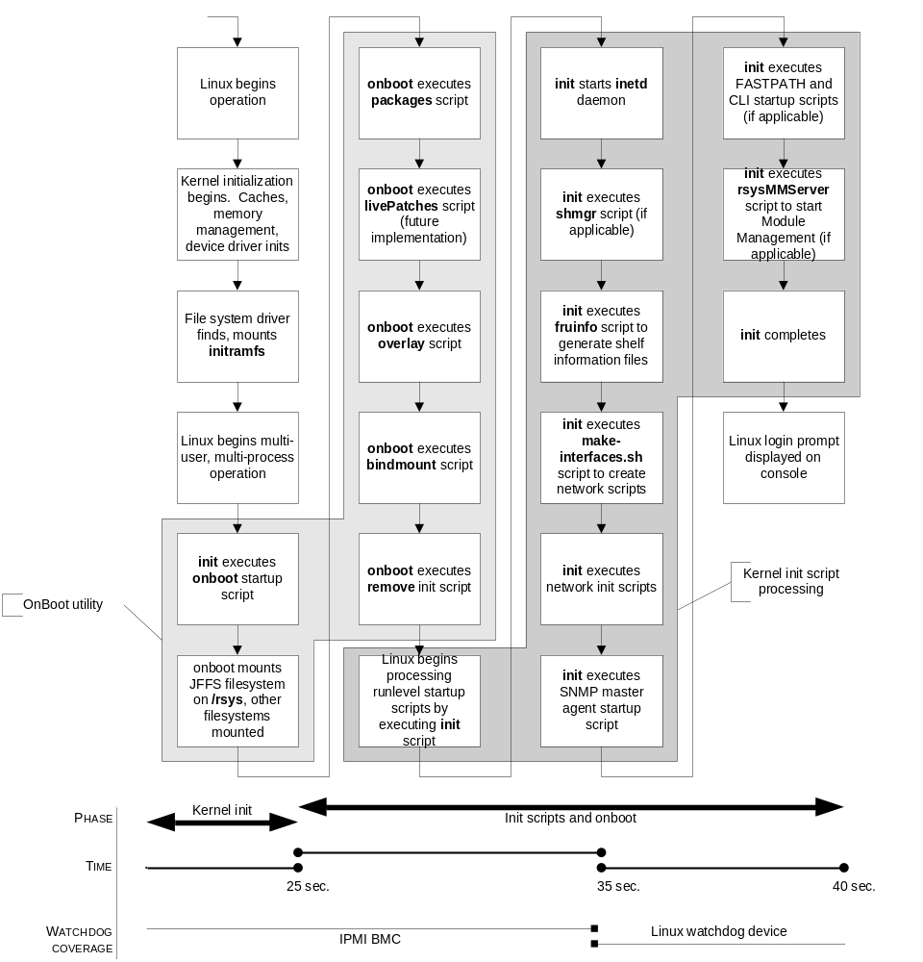
- References
  - Related Documents
    - RadiSys Documents
- RadiSys ATCA System 3 Product Requirements Document, Revision 1.0, RadiSys Document Number 002-01458-0000, July 26, 2006.
- RadiSys ATCA Common Blade Management Software Specification, Revision 0.84, RadiSys Document Number 002-04711-0000, July 28, 2006.
- RadiSys ACAR1-A Quad AMC Carrier Software Specification, Revision 1.0.92, RadiSys Document Number 002-02494-0000, April 24, 2007
    - Other Documents
- MSP20B01B Backplane External Product Specification Revision 1.0, Intel, August 31, 2001.
- Das U-Boot – Universal Bootloader web site, http://sourceforge.net/projects/u-boot/
- Linux PAM Modules web site, http://www.kernel.org/pub/linux/libs/pam/modules.html
    - Industry-Standard References
- Intelligent Platform Management Interface Specification, v1.5, Document Revision 1.1, Intel, Hewlett-Packard, NEC, Dell, February 20, 2002
- Intelligent Platform Management Bus Communications Protocol Specification v1.0 Document Revision 1.0, Intel, Hewlett-Packard, NEC, Dell, September 16, 1998.
- Filesystem Hierarchy Standard 2.3, January, 2004.
- The Secure Shell (SSH) Authentication Protocol, RFC 4252, January 2006.
  - Terminology
The following terminology is used in specific ways throughout this document. For convenience, these terms are defined here.
Term | Definition
AMC | Advanced Mezzanine Card. Mezzanine card that plugs into a slot on an ATCA blade.
Blade | A module that plugs into a slot in a shelf. This can be for computing, switching, or user I/O processing. “Card” or “Hardware Module” is an equivalent term.
Chassis | Equivalent to “Shelf”. RadiSys preferred term is “Shelf”.
Chassis Management | Equivalent to “Shelf Management”. RadiSys preferred term is “Shelf Management”.
Compute Blade | A hardware module that plugs into a slot in a shelf and contains CPUs. Its primary purpose is processing. It may or may not also have physical I/O interfaces.
Control Plane | Functionality associated with real-time control of the user data plane, i.e., the in-band or out-of-band control processes and associated communication protocols that, in conjunction with management plane interactions, determine the structure of the user information data flow. This includes, for example, dynamic signaling and routing protocols such as ISUP or BGP, but not user-managed static routing tables.
Customer Applications | In the RadiSys ATCA modular platform framework, this is any software provided by RadiSys’ customers: the system equipment manufacturers. It generally runs atop the RadiSys “middleware” provided as part of an integrated hardware/software platform, although there may be peer elements that are classified as “customer applications” simply because they are provided by the customer and not RadiSys.
Element Management | Management of one or more network elements from the same vendor. Typically, an element management system runs in a network operations center and manages all devices from a particular vendor, providing standard northbound interfaces for integration with network management systems and OSSs which manage across diverse elements.
FRU | Field Replaceable Unit. An ATCA entity that can be replaced by an operator in the field, including modules, fan assemblies, etc. FRUs may or may not be hot-swappable, and are managed via the IPMI protocol. “Intelligent FRUs” physically include an IPM controller and directly participate in the IPMI protocol. “Managed FRUs” are either Intelligent FRUs or else are represented by an Intelligent FRU (i.e., acts as a proxy). Thus, all FRUs are Managed FRUs, but not all FRUs are Intelligent FRUs. The ATCA specification specifies most of the common FRU behavior.
I/O Blade | Input/Output Blade. A hardware module that plugs into a slot in a shelf and contains physical interfaces and associated protocol processing, possibly including an interworking function. An I/O blade’s primary purpose is I/O, as opposed to a compute or switch blade that may also contain physical interfaces, but whose primary purpose is processing or switching. “I/O Blades” are generally referenced in computing platforms (e.g., blade servers) as opposed to network elements, and hence typically carry management or control plane traffic rather than user plane traffic.
Line Card | Similar to “I/O Blade”, but found in network elements as opposed to computing platforms. A hardware module that performs user plane data path functions, including service protocol processing, interworking functions, and low level data path management functions. The physical layer interface may be collocated on the module or implemented on a mating module (e.g., in a midplane architectures).
Management Plane | Functionality associated with managing the system: the human interfaces and associated logical constructs which directly support management of faults, configuration, accounting, performance, and security (FCAPS).
Middleware | Software that sits above the hardware and OS layers but below “Customer Applications”. Standard software provided by RadiSys in conjunction with an integrated hardware platform is always considered part of “Middleware” or lower layer software.
Module | Applies to either a module in a slot in a shelf (blade) or a mezzanine module (e.g., AMC). The more specific terms (blade, mezzanine module) are preferred for clarity.
Network Attached Storage | Network-attached storage (NAS) is disk storage that is set up with its own network address rather than being directly attached to a computer. The network-attached storage device is attached to a local area network (typically, an Ethernet network) and assigned an IP address. Access to a NAS device is based on file requests which are mapped by the NAS device to the disk storage.
Network Element (NE) | A single instance of a device in a network that performs an identified network function. Examples of a network element are: SGSN, Media Gateway, Router, Multi-service Switch, etc.
NE Management | Management of a single instance of a device in a network. NE management typically consists of an embedded portion, running on the device itself, such as an SNMP agent or a CLI, and an external application which communicates with the embedded software, such as an SNMP manager or GUI.
Network Management | Management of a network consisting of multiple network elements, potentially from different vendors. This is typically some sort of software system running in a NOC and communicating with element managers and/or directly with NEs.
NOC | Network Operations Center. A center that contains the management systems and/or OSSs (Operations Support Systems) used to control and monitor a service provider’s network.
Node Blade | An I/O blade or compute blade (i.e., non-controller and non-switch fabric blade) in an ATCA system.
Northbound Interface | In a protocol stack, the northbound interface refers to the interface presented to a higher layer protocol module. Using the OSI model’s network layer as an example, its northbound interface is the interface it presents to the transport layer. The northbound interface can also apply to applications. For example, the northbound interface on a system manager is the interface towards the Network Operations Center.
Platform | The baseline infrastructure functional entity for a shelf or system. It covers the common functions that are not specifically part of the user data plane, control plane, or management plane. This includes the common shelf hardware (e.g., fans, power supply, backplane), shelf management functions, high availability framework, etc. One view of an ATCA telecom/datacom system partitions all functionality into platform, user data plane, control plane, or management plane.
SAN | A Storage Area Network (SAN) is a high-speed special-purpose network (or subnetwork) that interconnects different kinds of data storage devices with associated data servers on behalf of a larger network of users. Access to a SAN device is based on block data requests.
Shelf | A single enclosure containing a backplane or midplane and multiple slots supporting various hardware modules. Typically rack mountable. Also typically contains a fan assembly and possibly power transforming circuitry.
Shelf Control | Generally equivalent to “Shelf Management”. RadiSys preferred term is “Shelf Management”.
Shelf Management | Low-level Management of the common elements of a shelf, including slot management (Module ID, hot-insertion, etc.), health monitoring, diagnostics, fan management, LED control, timing distribution, etc. Essentially covers “hardware management” functions.
Shelf Manager | The software entity responsible for shelf management functionality.
Southbound Interface | In a protocol stack, the southbound interface refers to the interface presented to a lower layer protocol module. Using the OSI model’s network layer as an example, its southbound interface is the interface it presents to the data link layer. The southbound interface can also apply to applications. For example, the southbound interface on a system manager is the interface towards the shelf manager.
Subrack | The Subrack provides the interface to PICMG 3.0 Boards and consists of the guide rails, ESD discharge, alignment/keying, handle interface, face plate mounting hardware, EMC gasketing, and backplane interface. The Subrack is a subset of the Shelf.
Switch Blade | A hardware module that plugs into a slot in a shelf containing one or more switch fabrics and whose primary purpose is switching of user, control, and/or management traffic. It may or may not also have physical I/O interfaces.
System | A somewhat general term with several meanings: 1) a single shelf with integrated HW and SW components; 2) relating to the lower level (“baseline”) functionality of a shelf with integrated HW and SW – i.e., “system software”; 3) an aggregation of one or more shelves, each with integrated HW and SW components – this may be more clearly described as a “multi-shelf system”.
System Control | Generally equivalent to “System Management”. RadiSys preferred term is “System Management”.
System Management | Management functionality beyond the scope of Shelf Management. This term implies a broader scope than shelf management in two dimensions: broader functionality and control/management of single- or multi-shelf systems. The broader functional scope typically includes all platform functionality as well as the infrastructure for network element management.
System Software | Software responsible for system and shelf management.
User Data Plane | Functionality associated with real-time user data. That is, functionality required to transport user data from an ingress interface to an egress interface, including, for example, protocol termination, encryption, data classification, metering, interworking, forwarding/switching, and traffic management.

  - Additional Terms
AC Alternating Current
A/D Analog to digital converter.
AKA Also Known As
AMM Air Mover Module
APC ATCA PMC Carrier (Expansion Module)
ARP Address Resolution Protocol
ATCA Advanced Telecom Computing Architecture
ATCA 3.0 RadiSys ATCA Platform Release 3.0 (includes ATCA 2210, ATCA 1200 and ATCA 7010).
BMC Base Management Controller (as defined in IPMI 1.5 specification)
BOOTP BOOTstrap Protocol
CISPR International Special Committee on Radio Interference
CFD Corrupt Flash Detect
CO Central Office
COM Common (relay contact)
CRC Cyclic redundancy check
DC Direct current.
DCPEM DC Power Entry Module
DFT Design for test
DFM Design for manufacturing
DHCP Dynamic Host Configuration Protocol
DSM Disk Storage Module
DUPEM Dummy Power Module
ESD Electrostatic Discharge
ETSI European Telecommunications Standards Institute
FAS Fabric Attached Storage
FC Fibre Cahnnel
FPGA Field programmable gate array device
FRU Field Replaceable Unit
FTP File Transfer Protocol
GPIO General Purpose Input/Output
H8 Renesas single-chip microcomputer. For the IPMC Controller, the H8S/2168 or the 2164
HPI Hardware Platform Interface
I²C Inter Integrated Circuit (Bus).
I/O Input/output
IC Integrated circuit
IPMB IPMI Bus. The bus structure (in this case I²C) used for transporting monitoring and management commands and data throughout the system.
IPMC Intelligent Platform Management Controller.
IPMI Intelligent Platform Management Interface. Used for hardware monitoring and management.
JTAG Joint test action group. A standard specifying how to control and monitor the pins of compliant devices on a printed circuit board.
LCD Liquid Crystal Display
LogShelf Logical Shelf number
LogSlot Logical Slot number
LED Light emitting diode
LMP Local Management Processor (e.g., PowerQUICC III)
LPC Low pin count interface
LUN Logical unit number
NAT Network address translation
NC Normally closed (relay contact).
NEBS Network Equipment Building Standard.
NO Normally open (relay contact).
NV Non-volatile.
PCB Printed circuit board.
PEM Power Entry Module
PICMG PCI Industrial Computer Manufacturers Group.
PIM PMC I/O Module
PhyShelf Physical Shelf number
PhySlot Physical Slot number
PMC PCI Mezzanine Card
P/N Part number
PrPMC Processor PMC
QSS QuickSilver Shelf
RAM Random access memory
RPL Recommended parts list
RTM Rear transition module
SAF Service Availability Forum
SCM Switch and Control Module
SDB Slot Dummy Blade
SDB-R Rear Slot Dummy Blade
SDP System Display Panel
Shelf Manager Shelf hardware management subsystem, which assures proper operation of ATCA boards and shelf components.
ShMC Shelf Management Controller
ShMS Shelf Management Server
SMC Satellite Management Controller
SMT Surface mount technology.
SP Service Provider
SPM Shelf Peripherals Module.
TBD To Be Defined
TCP Transmission Control Protocol
VLAN Virtual local area network

- NSN Specific Information

  - DHCP Client Identifier in AB3
The DHCP request includes the DHCP Client Identification option (DHCP Option 61). For NSN specific blades, a special Client Identifier format is used by both U-Boot and Linux. This section describes that Client Identifier format.

    - Creation of Client Identifier under Linux
When a DHCP request is performed, the standard make-client-id script notices the presence of a custom client ID script and allows it to override the standard behavior. The custom script used for NSN is /sbin/custom-make-client-id and it uses files generated by the fruinfo script to in turn generate the Client Identifier included in the Option 61 section of the DHCP request made by Linux.

    - Creation of Client Identifier under U-Boot
As part of creating its DHCP request, U-Boot attempts to determine the shelf manager type. Once this is determined, U-Boot will construct a shelf-specific Option 61
section that will be included as part of the DHCP request. If the shelf manager type is not
recognized, or if U-Boot fails for some other reason to create the Option 61 section, the DHCP packet will be sent without the Option 61 fields being included.

    - AB3-specific Client Identifier Used for Dynamic Interfaces
For interfaces specified to be dynamic, each Ethernet interface will get an IP address related to its place in the chassis. Every DHCP client will send the location information to the DHCP server. The DHCP client uses the fields that it needs and other fields are filled with default value 0xFF.
The location information is sent by the DHCP client using the DHCP Client UUID Option (Type 61). The UUID (Universally Unique Identifier) is broken down into the NSN specified structure shown below. The location information is given in ASCII strings with decimal numbers. The length of location information is nine bytes. The first and second bytes identify cabinet row and column in the operator’s site. The next two bytes identify vertical and horizontal deviation of the chassis. The next byte shows the blade’s slot number in the chassis or the plug-in-unit’s position address (PPA) in HMS notation. The sixth and seventh bytes define the module’s site type and number. The first byte is a copy of the FRU data site type (PICMG30). In case of an AHUB blade, this field is not used and is filled with a default value of 0xFF. The second byte is a copy of the FRU data site number (PICMG30). For example, the AMC’s internal index (1-8) in CPU blade, or in the case of an AHUB blade, the unit computer’s internal index is 1 and FI switch computer 2. The internal index is copied into the module number field. The last two bytes are for HMS cabinet and subrack numbers.
The software version information is taken from the blade’s FRU information. The FRU information is set when the blade’s software is loaded as described in section 7.3.
- Client Identifier Format
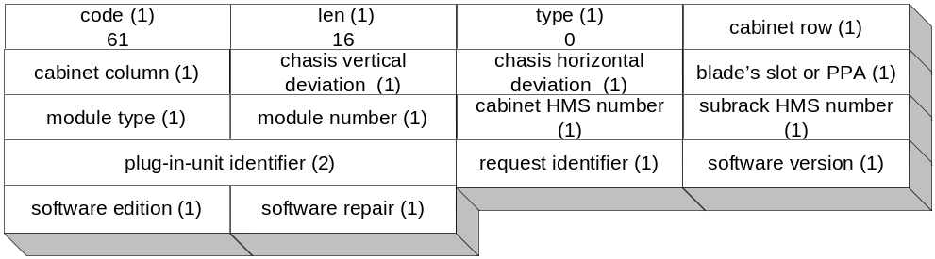

The Linux Data Source below is read from the file fruinfo generates on startup. The root path to the files is /var/run/fruinfo/frus.
- AB3-specific DHCP Option 61 Fields
Field | Description | Type | Range | Default value | Linux Data Source | U-Boot Data Source
Code | Option code | Decimal | 61 | 61 | Fixed | Fixed
Length | Length of the Option code | Decimal | 16 | 16 | Fixed | Fixed
Type | Type of the Code | Decimal | 0 | 0 | Fixed | Fixed
Cabinet Row | Cabinet row location in the central office. Number is one of the coordinates used to indicate where the cabinet is installed in the central office. | Hex | 00..FEh | FFh | file: chassis/GA/R | Get Shelf Address Info command
Cabinet Column | Cabinet column in the central office. Number is the second coordinate used to indicate where the cabinet is installed in the central office. | ASCII | A…Z | FFh | file: chassis/GA/C | Get Shelf Address Info command
Shelf Vertical Position | Vertical position of the shelf in the cabinet | Hex | 00..FEh | FFh | file: chassis/GA/V | Get Shelf Address Info command
Shelf Horizontal Position | Horizontal position of the shelf in the cabinet. | Hex | 00..FEh | FFh | file: chassis/GA/H | Get Shelf Address Info command
Blade Slot | The blade’s slot position in the chassis. | Hex | 00..FEh | FFh | file: chassis/slot/phy-slot | Get Address Info command
Module Type | Contains Site Type value as defined in PICMG 3.0 | Hex | 00..FFh | FFh | file: chassis/fru/TYPE | Get Address Info command
Module Number | Contains Site Number value as defined in PICMG 3.0 | Hex | 00..FFh | FFh | file: chassis/slot/phy-slot | Get Address Info command
Plug-in Unit Identifier | Used to identify the type of the FRU. | Hex | 0000…FFFFh | FFFFh | Retrieved from FRU information at fixed offset 0x013D.  file: slot/id1  file: slot/id2 | Retrieved from FRU information at fixed offset 0x013D.
Request Identifier | Indicates the processor or interface inside the module that requests an IP address. | Hex | 00..FEh | 1 | Fixed | Defaults to 1 in U-Boot.
Software Version | SW version of the SW that requests an IP address. | Hex | 00..FEh | FFh | file: /etc/version | Not used by U-Boot. Set to the default value.
Software Edition | SW edition of the SW that requests an IP address. | Hex | 00..FEh | FFh | file: /etc/version | Not used by U-Boot. Set to the default value.
Software Repair | SW repair of the SW that requests an IP address. | Hex | 00..FEh | FFh | file: /etc/version | Not used by U-Boot. Set to the default value.

    - Shelf Address to Option 61
