HW 1: SQL and Data Modeling

Team:
Borys Guliaiev
Sofiia Lichman
Vladyslav Saniuk

American University Kyiv
SDT 520: Web-Enabled Decision Support Systems
Instructor Viktoria Makovska
Due Date 06 Mar 2026

HW 1: SQL and Data Modeling

Team contribution statement:
- Part 1 — Conceptual and Logical Design / Vlad Saniuk
- Part 2 — Implementation and SQL Analytics / Borys Guliaiev
- Blood Donation — required queries (choose at least 4 of 6) / Sofiia Lichman
- End-to-end verification / Borys Guliaiev
- Final report / joint effort

Team discussion:
- Attributes and tables which will be present in the DB
- Normalization: which attributes should be moved the separate tables, like Donor, Clinic, ZIP etc.
- Cardinality and relationship between entities

Trade-offs:
- Remove fields like “total X” as those can be computed at a query level
- Remove multiple “last Y date” as those can be derived by JOINing other tables

Figure 1
ER diagram.
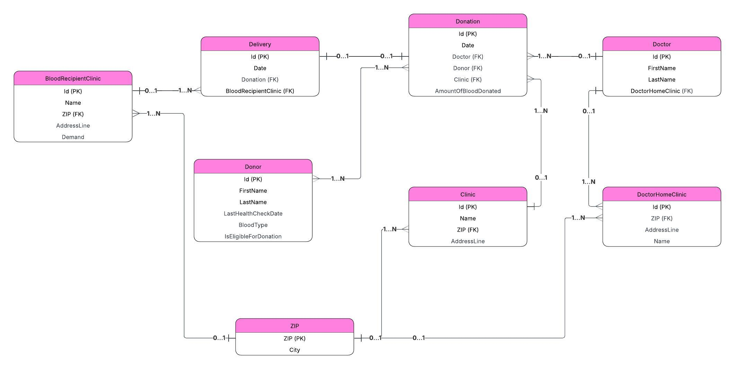

Figure 2
Relational schema.
