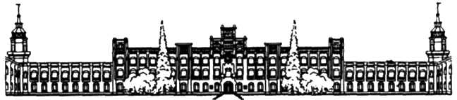

НАЦІОНАЛЬНИЙ ТЕХНІЧНИЙ УНІВЕРСИТЕТ УКРАЇНИ

«КИЇВСЬКИЙ ПОЛІТЕХНІЧНИЙ ІНСТИТУТ імені Ігоря Сікорського»

ФАКУЛЬТЕТ ПРИКЛАДНОЇ МАТЕМАТИКИ

#### Кафедра системного програмування та спеціалізованих комп’ютерних систем

**Лабораторна робота №4**

з дисципліни

**«Паралельні та розподілені обчислення»**

#### Тема «Засоби взаємодії паралельних потоків операційної системи лінукс»

Виконав: студент ІІ курсу

ФПМ групи КВ-91

Селетков В. Р.

Перевірив: Марченко О. О.

Київ – 2021

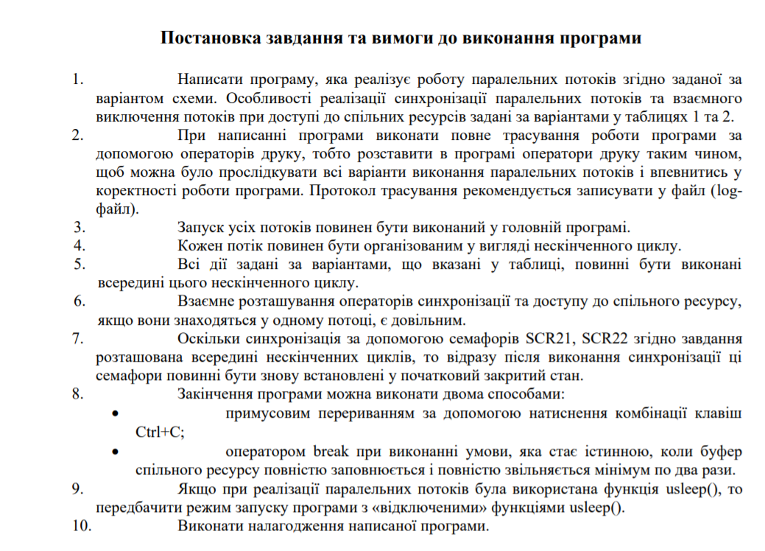**Варіант 18.**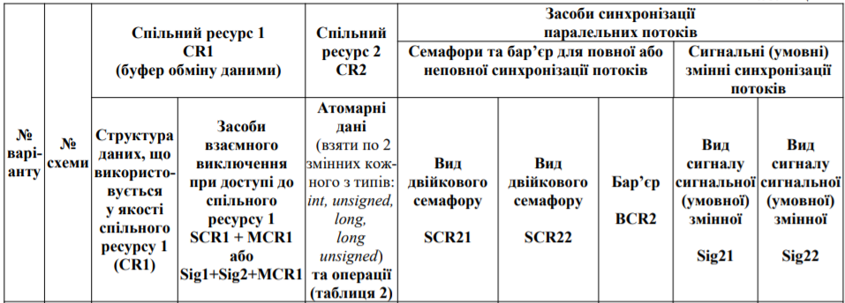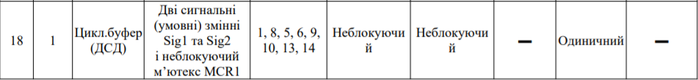

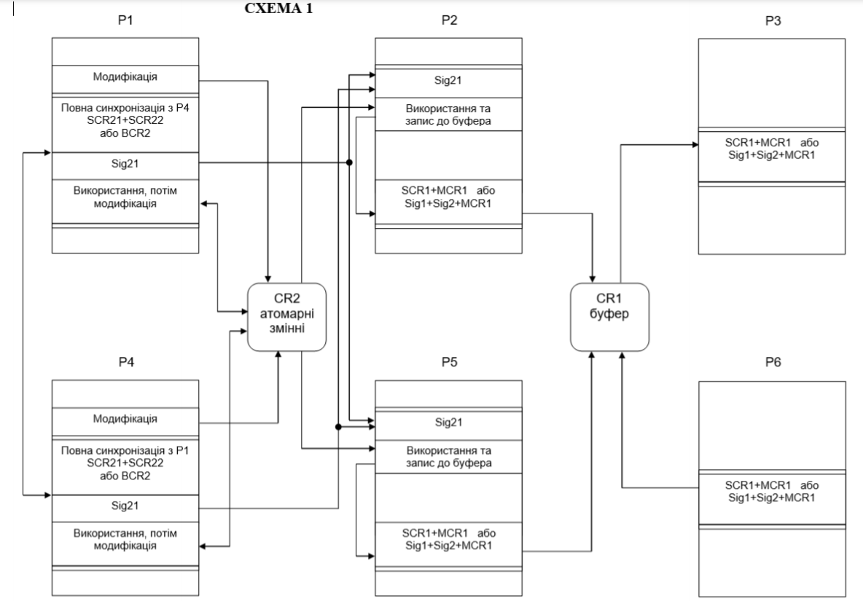

**Текст програми**

#include <stdio.h>

#include <pthread.h>

#include <semaphore.h>

#include <fcntl.h>

#include <stdlib.h>

//threads

pthread_t p1;

pthread_t p2;

pthread_t p3;

pthread_t p4;

pthread_t p5;

pthread_t p6;

//semaphores

sem_t scr21;

sem_t scr22;

//mutex init

pthread_mutex_t mcr1 = PTHREAD_MUTEX_INITIALIZER;

pthread_mutex_t mutex_for_sig21 = PTHREAD_MUTEX_INITIALIZER;

//conditional signals

pthread_cond_t sig1_not_empty = PTHREAD_COND_INITIALIZER;

pthread_cond_t sig2_not_full = PTHREAD_COND_INITIALIZER;

pthread_cond_t sig21 = PTHREAD_COND_INITIALIZER;

//file

FILE *f = NULL;

//dsd bufer values

struct cr1 {

struct cr1 *next;

int numb;

};

struct cr1 *next_in = NULL;

struct cr1 *next_out = NULL;

struct cr1 *begin_buf = NULL;

struct cr1 *end_buf = NULL;

unsigned int n = 200;

unsigned int el_numb = 0;

unsigned int new_buf = 0;

//atomic values

int int1_cr2 = 0;

int int2_cr2 = 0;

unsigned uns1_cr2 = 0;

unsigned uns2_cr2 = 0;

long long1_cr2 = 0;

long long2_cr2 = 0;

long unsigned luns1_cr2 = 0;

long unsigned luns2_cr2 = 0;

//control bufer

int empty_bufer = 0;

int full_bufer = 0;

//bufer function declarations

void DeleteBuf();

void OutputBuf();

int IsBufEmpty();

int IsBufFull();

void AddElemToBuf();

struct cr1 *GetElemFromBuf();

//atomic function declarations

void AddAtomicToBuf(int value);

void AtomicInput();

void AtomicModification();

void AtomicUsing();

void AtomicOutput();

//threads function declarations

void *P1thread(void *p_number);

void *P2thread(void *p_number);

void *P3thread(void *p_number);

void *P4thread(void *p_number);

void *P5thread(void *p_number);

void *P6thread(void *p_number);

int main() {

f = fopen("log.txt", "w");

if (f == NULL) {

printf("\nerror file\n");

exit(1);

}

srand(time(NULL));

for(unsigned int i = 0; i < n / 2; i++)

AddElemToBuf();

fprintf(f, "Cycle buffer with elements from 0-th to %d-th has been created !!!\n", (n / 2));

printf("Cycle buffer with elements from 0-th to %d-th has been created !!!\n", (n / 2));

AtomicInput();

int p1_number = 1;

int p2_number = 2;

int p3_number = 3;

int p4_number = 4;

int p5_number = 5;

int p6_number = 6;

int p1_join = -1;

int p2_join = -1;

int p3_join = -1;

int p4_join = -1;

int p5_join = -1;

int p6_join = -1;

sem_init(&scr21, 0, 0);

sem_init(&scr22, 0, 0);

pthread_create(&p1, NULL, &P1thread, (void*)&p1_number);

pthread_create(&p2, NULL, &P2thread, (void*)&p2_number);

pthread_create(&p3, NULL, &P3thread, (void*)&p3_number);

pthread_create(&p4, NULL, &P4thread, (void*)&p4_number);

pthread_create(&p5, NULL, &P5thread, (void*)&p5_number);

pthread_create(&p6, NULL, &P6thread, (void*)&p6_number);

p1_join = pthread_join(p1, NULL);

fprintf(f, "\npthread_join p%d = %d", p1_number, p1_join);

printf("\npthread_join p%d = %d", p1_number, p1_join);

p2_join = pthread_join(p2, NULL);

fprintf(f, "\npthread_join p%d = %d", p2_number, p2_join);

printf("\npthread_join p%d = %d", p2_number, p2_join);

p3_join = pthread_join(p3, NULL);

fprintf(f, "\npthread_join p%d = %d", p3_number, p3_join);

printf("\npthread_join p%d = %d", p3_number, p3_join);

p4_join = pthread_join(p4, NULL);

fprintf(f, "\npthread_join p%d = %d", p4_number, p4_join);

printf("\npthread_join p%d = %d", p4_number, p4_join);

p5_join = pthread_join(p5, NULL);

fprintf(f, "\npthread_join p%d = %d", p5_number, p5_join);

printf("\npthread_join p%d = %d", p5_number, p5_join);

p6_join = pthread_join(p6, NULL);

fprintf(f, "\npthread_join p%d = %d\n", p6_number, p6_join);

printf("\npthread_join p%d = %d\n", p6_number, p6_join);

fprintf(f, "\nAll information was written to the log file\n");

printf("\nAll information was written to the log file\n");

fclose(f);

return 0;

}

void DeleteBuf() {

struct cr1 *temp = begin_buf;

struct cr1 *temp_free = NULL;

if (temp == NULL)

return;

while(temp != end_buf) {

temp_free = temp;

temp = temp->next;

free(temp_free);

}

if (temp != NULL) {

free(temp);

}

else {

printf("\nCycle buffer error delete\n\n");

fprintf(f, "\nCycle buffer error delete\n\n");

}

fprintf(f, "\nCycle buffer was deleted\n\n");

printf("\nCycle buffer was deleted\n\n");

}

int IsBufEmpty() {

return el_numb <= 0;

}

int IsBufFull() {

return el_numb >= n;

}

void AddElemToBuf() {

if (new_buf < n) {

struct cr1 *temp = (struct cr1 *)malloc(sizeof(struct cr1));

temp->next = NULL;

if (next_in == NULL) {

//temp->numb = rand() % 50;

temp->numb = new_buf;

next_in = temp;

next_out = temp;

begin_buf = temp;

end_buf = temp;

new_buf++;

fprintf(f, "Cycle bufer was created\n");

printf("Cycle bufer was created\n");

}

else {

if (el_numb > n) {

fprintf(f, "\nerror el_numb > %d\n", n);

printf("\nerror el_numb > %d\n", n);

free(temp);

return;

}

//temp->numb = rand() % 50;

temp->numb = new_buf;

next_in->next = temp;

next_in = temp;

new_buf++;

if (new_buf == n)

temp->next = begin_buf;

end_buf = temp;

}

el_numb++;

}

else {

next_in->next->numb = rand() % 50;

if (next_in == end_buf)

next_in = begin_buf;

else

next_in = next_in->next;

el_numb++;

}

}

struct cr1 *GetElemFromBuf() {

struct cr1 *temp = NULL;

if (el_numb < 0) {

fprintf(f, "\nerror el_numb < 0\n");

printf("\nerror el_numb < 0\n");

return NULL;

}

temp = next_out;

if (temp == end_buf)

next_out = begin_buf;

else

next_out = next_out->next;

el_numb--;

return temp;

}

void OutputBuf() {

struct cr1 *temp = begin_buf;

if (temp == NULL)

return;

while (temp != end_buf) {

fprintf(f, "%d ", temp->numb);

printf("%d ", temp->numb);

temp = temp->next;

}

if (temp != NULL) {

fprintf(f, "%d ", temp->numb);

printf("%d ", temp->numb);

fprintf(f, "\n");

printf("\n");

}

else {

printf("\nCycle buffer error output\n\n");

fprintf(f, "\nCycle buffer error output\n\n");

}

}

void *P1thread(void *p_number) {

pthread_setcanceltype(PTHREAD_CANCEL_ASYNCHRONOUS, NULL);

int p_num = *((int*)p_number);

AtomicModification();

fprintf(f, "\nthread p[%d]: modificated atomic values\n", p_num);

printf("\nthread p[%d]: modificated atomic values\n", p_num);

while (1) {

fprintf(f, "thread p[%d]: opens semaphore scr22 for the thread p[4]\n", p_num);

printf("thread p[%d]: opens semaphore scr22 for the thread p[4]\n", p_num);

sem_post(&scr22);

fprintf(f, "\nthread p[%d]: semaphore scr22 is opened\n", p_num);

printf("\nthread p[%d]: semaphore scr22 is opened\n", p_num);

fprintf(f, "\nthread p[%d]: waits for the opening of the semaphore scr21\n", p_num);

printf("\nthread p[%d]: waits for the opening of the semaphore scr21\n", p_num);

trywait:

if (sem_trywait(&scr21) == 0) {

sem_close(&scr21);

sem_open("scr21", O_CREAT, 0, 0);

fprintf(f, "thread p[%d]: works after receiving semaphore scr21\n", p_num);

printf("thread p[%d]: works after receiving semaphore scr21\n", p_num);

pthread_mutex_lock(&mutex_for_sig21);

pthread_cond_signal(&sig21);

pthread_mutex_unlock(&mutex_for_sig21);

fprintf(f, "thread p[%d]: sent sig21\n", p_num);

printf("thread p[%d]: sent sig21\n", p_num);

AtomicUsing();

fprintf(f, "thread p[%d]: used atomic values\n", p_num);

printf("thread p[%d]: used atomic values\n", p_num);

AtomicModification();

fprintf(f, "\nthread p[%d]: modificated atomic values\n", p_num);

printf("\nthread p[%d]: modificated atomic values\n", p_num);

}

else {

//printf("\nthread p[%d]: does some useful work\n", p_num);

goto trywait;

}

}

fprintf(f, "thread p[%d]: stopped\n", p_num);

printf("thread p[%d]: stopped\n", p_num);

return NULL;

}

void *P2thread(void *p_number) {

pthread_setcanceltype(PTHREAD_CANCEL_ASYNCHRONOUS, NULL);

int p_num = *((int*)p_number);

int flag = 0;

int old_state = 0;

while(1) {

fprintf(f, "thread p[%d]: is waiting for sig21\n", p_num);

printf("thread p[%d]: is waiting for sig21\n", p_num);

pthread_mutex_lock(&mutex_for_sig21);

pthread_cond_wait(&sig21, &mutex_for_sig21);

pthread_mutex_unlock(&mutex_for_sig21);

fprintf(f, "thread p[%d]: received sig21\n", p_num);

printf("thread p[%d]: received sig21\n", p_num);

AtomicUsing();

fprintf(f, "thread p[%d]: used atomic values\n", p_num);

printf("thread p[%d]: used atomic values\n", p_num);

if (el_numb == 0) {

fprintf(f, "thread p[%d]: bufer is empty\n", p_num);

printf("thread p[%d]: bufer is empty\n", p_num);

empty_bufer++;

if (empty_bufer == 2)

break;

}

if (pthread_mutex_trylock(&mcr1) == 0) {

while(IsBufFull())

pthread_cond_wait(&sig2_not_full, &mcr1);

pthread_setcancelstate(PTHREAD_CANCEL_DISABLE, &old_state);

if (flag == 0)

AddAtomicToBuf((int)int1_cr2);

else if (flag == 1)

AddAtomicToBuf((int)int2_cr2);

else if (flag == 2)

AddAtomicToBuf((int)uns1_cr2);

else if (flag == 3)

AddAtomicToBuf((int)uns2_cr2);

else if (flag == 4)

AddAtomicToBuf((int)long1_cr2);

else if (flag == 5)

AddAtomicToBuf((int)long2_cr2);

else if (flag == 6)

AddAtomicToBuf((int)luns1_cr2);

else if (flag == 7)

AddAtomicToBuf((int)luns2_cr2);

pthread_setcancelstate(old_state, NULL);

flag++;

if (flag == 8)

flag = 0;

fprintf(f, "\nthread p[%d]: element %d ATOMIC CREATED; current el_numb = %d;\n", p_num, next_in->numb, el_numb);

printf("\nthread p[%d]: element %d ATOMIC CREATED; current el_numb = %d;\n", p_num, next_in->numb, el_numb);

pthread_mutex_unlock(&mcr1);

pthread_cond_signal(&sig1_not_empty);

fprintf(f, "thread p[%d]: sent sig1_not_empty\n", p_num);

printf("thread p[%d]: sent sig1_not_empty\n", p_num);

}

else {

//printf("\nthread p[%d]: does some useful work\n", p_num);

}

}

pthread_cancel(p1);

pthread_cancel(p3);

pthread_cancel(p4);

pthread_cancel(p5);

pthread_cancel(p6);

DeleteBuf();

fprintf(f, "thread p[%d]: stopped other threads and was stopped too\n", p_num);

printf("thread p[%d]: stopped other threads and was stopped too\n", p_num);

return NULL;

}

void *P3thread(void *p_number) {

pthread_setcanceltype(PTHREAD_CANCEL_ASYNCHRONOUS, NULL);

int p_num = *((int*)p_number);

struct cr1 *temp = NULL;

int old_state = 0;

while(1) {

temp = 0;

if (el_numb == n) {

fprintf(f, "thread p[%d]: bufer is full\n", p_num);

printf("thread p[%d]: bufer is full\n", p_num);

full_bufer++;

if (full_bufer == 2)

break;

}

if (pthread_mutex_trylock(&mcr1) == 0) {

while(IsBufEmpty()) {

fprintf(f, "thread p[%d]: is waiting for sig2_not_empty\n", p_num);

printf("thread p[%d]: is waiting for sig2_not_empty\n", p_num);

pthread_cond_wait(&sig1_not_empty, &mcr1);

}

pthread_setcancelstate(PTHREAD_CANCEL_DISABLE, &old_state);

temp = GetElemFromBuf();

pthread_setcancelstate(old_state, NULL);

fprintf(f, "\nthread p[%d]: element %d TAKEN; current el_numb = %d;\n", p_num, temp->numb, el_numb);

printf("\nthread p[%d]: element %d TAKEN; current el_numb = %d;\n", p_num, temp->numb, el_numb);

pthread_mutex_unlock(&mcr1);

pthread_cond_broadcast(&sig2_not_full);

fprintf(f, "thread p[%d]: sent sig2_not_full\n", p_num);

printf("thread p[%d]: sent sig2_not_full\n", p_num);

}

else {

//printf("\nthread p[%d]: does some useful work\n", p_num);

}

}

pthread_cancel(p1);

pthread_cancel(p2);

pthread_cancel(p4);

pthread_cancel(p5);

pthread_cancel(p6);

DeleteBuf();

fprintf(f, "thread p[%d]: stopped other threads and was stopped too\n", p_num);

printf("thread p[%d]: stopped other threads and was stopped too\n", p_num);

return NULL;

}

void *P4thread(void *p_number) {

pthread_setcanceltype(PTHREAD_CANCEL_ASYNCHRONOUS, NULL);

int p_num = *((int*)p_number);

AtomicModification();

fprintf(f, "\nthread p[%d]: modificated atomic values\n", p_num);

printf("\nthread p[%d]: modificated atomic values\n", p_num);

while (1) {

fprintf(f, "thread p[%d]: opens semaphore scr21 for the thread p[1]\n", p_num);

printf("thread p[%d]: opens semaphore scr21 for the thread p[1]\n", p_num);

sem_post(&scr21);

fprintf(f, "\nthread p[%d]: semaphore scr21 is opened\n", p_num);

printf("\nthread p[%d]: semaphore scr21 is opened\n", p_num);

fprintf(f, "\nthread p[%d]: waits for the opening of the semaphore scr22\n", p_num);

printf("\nthread p[%d]: waits for the opening of the semaphore scr22\n", p_num);

trywait:

if (sem_trywait(&scr22) == 0) {

sem_close(&scr22);

sem_open("scr22", O_CREAT, 0, 0);

fprintf(f, "thread p[%d]: works after receiving semaphore scr22\n", p_num);

printf("thread p[%d]: works after receiving semaphore scr22\n", p_num);

pthread_mutex_lock(&mutex_for_sig21);

pthread_cond_signal(&sig21);

pthread_mutex_unlock(&mutex_for_sig21);

fprintf(f, "thread p[%d]: sent sig21\n", p_num);

printf("thread p[%d]: sent sig21\n", p_num);

AtomicUsing();

fprintf(f, "thread p[%d]: used atomic values\n", p_num);

printf("thread p[%d]: used atomic values\n", p_num);

AtomicModification();

fprintf(f, "\nthread p[%d]: modificated atomic values\n", p_num);

printf("\nthread p[%d]: modificated atomic values\n", p_num);

}

else {

//printf("\nthread p[%d]: does some useful work\n", p_num);

goto trywait;

}

}

fprintf(f, "thread p[%d]: stopped\n", p_num);

printf("thread p[%d]: stopped\n", p_num);

return NULL;

}

void *P5thread(void *p_number) {

pthread_setcanceltype(PTHREAD_CANCEL_ASYNCHRONOUS, NULL);

int p_num = *((int*)p_number);

int flag = 0;

int old_state = 0;

while(1) {

fprintf(f, "thread p[%d]: is waiting for sig21\n", p_num);

printf("thread p[%d]: is waiting for sig21\n", p_num);

pthread_mutex_lock(&mutex_for_sig21);

pthread_cond_wait(&sig21, &mutex_for_sig21);

pthread_mutex_unlock(&mutex_for_sig21);

fprintf(f, "thread p[%d]: received sig21\n", p_num);

printf("thread p[%d]: received sig21\n", p_num);

AtomicUsing();

fprintf(f, "thread p[%d]: used atomic values\n", p_num);

printf("thread p[%d]: used atomic values\n", p_num);

if (el_numb == 0) {

fprintf(f, "thread p[%d]: bufer is empty\n", p_num);

printf("thread p[%d]: bufer is empty\n", p_num);

empty_bufer++;

if (empty_bufer == 2)

break;

}

if (pthread_mutex_trylock(&mcr1) == 0) {

while(IsBufFull())

pthread_cond_wait(&sig2_not_full, &mcr1);

pthread_setcancelstate(PTHREAD_CANCEL_DISABLE, &old_state);

if (flag == 0)

AddAtomicToBuf((int)int1_cr2);

else if (flag == 1)

AddAtomicToBuf((int)int2_cr2);

else if (flag == 2)

AddAtomicToBuf((int)uns1_cr2);

else if (flag == 3)

AddAtomicToBuf((int)uns2_cr2);

else if (flag == 4)

AddAtomicToBuf((int)long1_cr2);

else if (flag == 5)

AddAtomicToBuf((int)long2_cr2);

else if (flag == 6)

AddAtomicToBuf((int)luns1_cr2);

else if (flag == 7)

AddAtomicToBuf((int)luns2_cr2);

pthread_setcancelstate(old_state, NULL);

flag++;

if (flag == 8)

flag = 0;

fprintf(f, "\nthread p[%d]: element %d ATOMIC CREATED; current el_numb = %d;\n", p_num, next_in->numb, el_numb);

printf("\nthread p[%d]: element %d ATOMIC CREATED; current el_numb = %d;\n", p_num, next_in->numb, el_numb);

pthread_mutex_unlock(&mcr1);

pthread_cond_signal(&sig1_not_empty);

fprintf(f, "thread p[%d]: sent sig1_not_empty\n", p_num);

printf("thread p[%d]: sent sig1_not_empty\n", p_num);

}

else {

//printf("\nthread p[%d]: does some useful work\n", p_num);

}

}

pthread_cancel(p1);

pthread_cancel(p2);

pthread_cancel(p3);

pthread_cancel(p4);

pthread_cancel(p6);

DeleteBuf();

fprintf(f, "thread p[%d]: stopped other threads and was stopped too\n", p_num);

printf("thread p[%d]: stopped other threads and was stopped too\n", p_num);

return NULL;

}

void *P6thread(void *p_number) {

pthread_setcanceltype(PTHREAD_CANCEL_ASYNCHRONOUS, NULL);

int p_num = *((int*)p_number);

int old_state = 0;

while(1) {

if (el_numb == 0) {

fprintf(f, "thread p[%d]: bufer is empty\n", p_num);

printf("thread p[%d]: bufer is empty\n", p_num);

empty_bufer++;

if (empty_bufer == 2)

break;

}

if (pthread_mutex_trylock(&mcr1) == 0) {

while(IsBufFull()) {

fprintf(f, "thread p[%d]: is waiting for sig2_not_full\n", p_num);

printf("thread p[%d]: is waiting for sig2_not_full\n", p_num);

pthread_cond_wait(&sig2_not_full, &mcr1);

}

pthread_setcancelstate(PTHREAD_CANCEL_DISABLE, &old_state);

AddElemToBuf();

pthread_setcancelstate(old_state, NULL);

fprintf(f, "\nthread p[%d]: element %d CREATED; current el_numb = %d;\n", p_num, next_in->numb, el_numb);

printf("\nthread p[%d]: element %d CREATED; current el_numb = %d;\n", p_num, next_in->numb, el_numb);

pthread_mutex_unlock(&mcr1);

pthread_cond_signal(&sig1_not_empty);

fprintf(f, "thread p[%d]: sent sig1_not_empty\n", p_num);

printf("thread p[%d]: sent sig1_not_empty\n", p_num);

}

else {

//printf("\nthread p[%d]: does some useful work\n", p_num);

}

}

pthread_cancel(p1);

pthread_cancel(p2);

pthread_cancel(p3);

pthread_cancel(p4);

pthread_cancel(p5);

DeleteBuf();

fprintf(f, "thread p[%d]: stopped other threads and was stopped too\n", p_num);

printf("thread p[%d]: stopped other threads and was stopped too\n", p_num);

return NULL;

}

void AtomicInput() {

int1_cr2 = (rand() % 6) - 3;

int2_cr2 = (rand() % 6) - 3;

uns1_cr2 = (rand() % 6) - 3;

uns2_cr2 = (rand() % 6) - 3;

long1_cr2 = (rand() % 6) - 3;

long2_cr2 = (rand() % 6) - 3;

luns1_cr2 = (rand() % 6) - 3;

luns2_cr2 = (rand() % 6) - 3;

}

void AtomicOutput() {

fprintf(f, "\n");

fprintf(f, "cr2: (1) int = %d\n", int1_cr2);

fprintf(f, "cr2: (2) int = %d\n", int2_cr2);

fprintf(f, "cr2: (1) unsigned = %d\n", uns1_cr2);

fprintf(f, "cr2: (2) unsigned = %d\n", uns2_cr2);

fprintf(f, "cr2: (1) long = %ld\n", long1_cr2);

fprintf(f, "cr2: (2) long = %ld\n", long2_cr2);

fprintf(f, "cr2: (1) long unsigned = %lu\n", luns1_cr2);

fprintf(f, "cr2: (2) long unsigned = %lu\n", luns2_cr2);

fprintf(f, "\n");

printf("\n");

printf("cr2: (1) int = %d\n", int1_cr2);

printf("cr2: (2) int = %d\n", int2_cr2);

printf("cr2: (1) unsigned = %d\n", uns1_cr2);

printf("cr2: (2) unsigned = %d\n", uns2_cr2);

printf("cr2: (1) long = %ld\n", long1_cr2);

printf("cr2: (2) long = %ld\n", long2_cr2);

printf("cr2: (1) long unsigned = %lu\n", luns1_cr2);

printf("cr2: (2) long unsigned = %lu\n", luns2_cr2);

printf("\n");

}

void AtomicModification() {

__sync_fetch_and_add(&int1_cr2, (rand() % 6) - 3);

__sync_sub_and_fetch(&int2_cr2, (rand() % 6) - 3);

__sync_fetch_and_xor(&uns1_cr2, (rand() % 6) - 3);

__sync_fetch_and_nand(&uns2_cr2, (rand() % 6) - 3);

__sync_or_and_fetch(&long1_cr2, (rand() % 6) - 3);

__sync_and_and_fetch(&long2_cr2, (rand() % 6) - 3);

__sync_bool_compare_and_swap (&luns1_cr2, (rand() % 6) - 3, (rand() % 6) - 3);

__sync_val_compare_and_swap (&luns2_cr2, (rand() % 6) - 3, (rand() % 6) - 3);

}

void AtomicUsing() {

__sync_fetch_and_add(&int1_cr2, 0);

__sync_sub_and_fetch(&int2_cr2, 0);

__sync_fetch_and_xor(&uns1_cr2, 0);

__sync_fetch_and_nand(&uns2_cr2, uns2_cr2);

__sync_fetch_and_nand(&uns2_cr2, uns2_cr2);

__sync_or_and_fetch(&long1_cr2, 0);

__sync_and_and_fetch(&long2_cr2, long2_cr2);

__sync_bool_compare_and_swap (&luns1_cr2, 0, 0);

__sync_val_compare_and_swap (&luns2_cr2, 0, 0);

}

void AddAtomicToBuf(int value) {

if (new_buf < n) {

struct cr1 *temp = (struct cr1 *)malloc(sizeof(struct cr1));

temp->next = NULL;

if (next_in == NULL) {

temp->numb = value;

next_in = temp;

next_out = temp;

begin_buf = temp;

end_buf = temp;

new_buf++;

fprintf(f, "Cycle bufer was created\n");

printf("Cycle bufer was created\n");

}

else {

if (el_numb > n) {

fprintf(f, "\nerror el_numb > %d\n", n);

printf("\nerror el_numb > %d\n", n);

free(temp);

return;

}

temp->numb = value;

next_in->next = temp;

next_in = temp;

new_buf++;

if (new_buf == n)

temp->next = begin_buf;

end_buf = temp;

}

el_numb++;

}

else {

next_in->next->numb = value;

if (next_in == end_buf)

next_in = begin_buf;

else

next_in = next_in->next;

el_numb++;

}

}

**Тестування програми**

**№1**

Cycle bufer was created

Cycle buffer with elements from 0-th to 16-th has been created !!!

thread p[1]: modificated atomic values

thread p[1]: opens semaphore scr22 for the thread p[4]

thread p[1]: semaphore scr22 is opened

thread p[1]: waits for the opening of the semaphore scr21

thread p[6]: element 42 CREATED; current el_numb = 17;

thread p[6]: sent sig1_not_empty

thread p[6]: element 47 CREATED; current el_numb = 18;

thread p[6]: sent sig1_not_empty

thread p[6]: element 19 CREATED; current el_numb = 19;

thread p[6]: sent sig1_not_empty

thread p[6]: element 7 CREATED; current el_numb = 20;

thread p[6]: sent sig1_not_empty

thread p[6]: element 29 CREATED; current el_numb = 21;

thread p[6]: sent sig1_not_empty

thread p[6]: element 33 CREATED; current el_numb = 22;

thread p[6]: sent sig1_not_empty

thread p[6]: element 5 CREATED; current el_numb = 23;

thread p[6]: sent sig1_not_empty

thread p[6]: element 18 CREATED; current el_numb = 24;

thread p[6]: sent sig1_not_empty

thread p[6]: element 32 CREATED; current el_numb = 25;

thread p[6]: sent sig1_not_empty

thread p[6]: element 29 CREATED; current el_numb = 26;

thread p[6]: sent sig1_not_empty

thread p[6]: element 1 CREATED; current el_numb = 27;

thread p[6]: sent sig1_not_empty

thread p[6]: element 43 CREATED; current el_numb = 28;

thread p[6]: sent sig1_not_empty

thread p[6]: element 28 CREATED; current el_numb = 29;

thread p[6]: sent sig1_not_empty

thread p[6]: element 6 CREATED; current el_numb = 30;

thread p[6]: sent sig1_not_empty

thread p[6]: element 36 CREATED; current el_numb = 31;

thread p[6]: sent sig1_not_empty

thread p[6]: element 16 CREATED; current el_numb = 32;

thread p[6]: sent sig1_not_empty

thread p[6]: is waiting for sig2_not_full

thread p[5]: is waiting for sig21

thread p[4]: modificated atomic values

thread p[4]: opens semaphore scr21 for the thread p[1]

thread p[4]: semaphore scr21 is opened

thread p[4]: waits for the opening of the semaphore scr22

thread p[1]: works after receiving semaphore scr21

thread p[1]: sent sig21

thread p[1]: used atomic values

thread p[1]: modificated atomic values

thread p[1]: opens semaphore scr22 for the thread p[4]

thread p[5]: received sig21

thread p[1]: semaphore scr22 is opened

thread p[2]: is waiting for sig21

thread p[5]: used atomic values

thread p[4]: works after receiving semaphore scr22

thread p[4]: sent sig21

thread p[4]: used atomic values

thread p[4]: modificated atomic values

thread p[2]: received sig21

thread p[4]: opens semaphore scr21 for the thread p[1]

thread p[2]: used atomic values

thread p[3]: bufer is full

thread p[3]: element 8 TAKEN; current el_numb = 31;

thread p[3]: sent sig2_not_full

thread p[3]: element 10 TAKEN; current el_numb = 30;

thread p[3]: sent sig2_not_full

thread p[3]: element 36 TAKEN; current el_numb = 29;

thread p[3]: sent sig2_not_full

thread p[3]: element 45 TAKEN; current el_numb = 28;

thread p[3]: sent sig2_not_full

thread p[3]: element 29 TAKEN; current el_numb = 27;

thread p[3]: sent sig2_not_full

thread p[3]: element 48 TAKEN; current el_numb = 26;

thread p[3]: sent sig2_not_full

thread p[3]: element 15 TAKEN; current el_numb = 25;

thread p[3]: sent sig2_not_full

thread p[3]: element 30 TAKEN; current el_numb = 24;

thread p[3]: sent sig2_not_full

thread p[3]: element 14 TAKEN; current el_numb = 23;

thread p[3]: sent sig2_not_full

thread p[2]: element -7 ATOMIC CREATED; current el_numb = 24;

thread p[4]: semaphore scr21 is opened

thread p[2]: sent sig1_not_empty

thread p[6]: element 3 CREATED; current el_numb = 25;

thread p[2]: is waiting for sig21

thread p[3]: element 45 TAKEN; current el_numb = 24;

thread p[6]: sent sig1_not_empty

thread p[3]: sent sig2_not_full

thread p[4]: waits for the opening of the semaphore scr22

thread p[4]: works after receiving semaphore scr22

thread p[4]: sent sig21

thread p[4]: used atomic values

thread p[4]: modificated atomic values

thread p[4]: opens semaphore scr21 for the thread p[1]

thread p[4]: semaphore scr21 is opened

thread p[4]: waits for the opening of the semaphore scr22

thread p[2]: received sig21

thread p[2]: used atomic values

thread p[2]: element 7 ATOMIC CREATED; current el_numb = 25;

thread p[2]: sent sig1_not_empty

thread p[2]: is waiting for sig21

thread p[1]: waits for the opening of the semaphore scr21

thread p[1]: works after receiving semaphore scr21

thread p[1]: sent sig21

thread p[1]: used atomic values

thread p[1]: modificated atomic values

thread p[1]: opens semaphore scr22 for the thread p[4]

thread p[1]: semaphore scr22 is opened

thread p[1]: waits for the opening of the semaphore scr21

thread p[4]: works after receiving semaphore scr22

thread p[1]: works after receiving semaphore scr21

thread p[2]: received sig21

thread p[2]: used atomic values

thread p[2]: element -1 ATOMIC CREATED; current el_numb = 26;

thread p[2]: sent sig1_not_empty

thread p[2]: is waiting for sig21

thread p[3]: element 39 TAKEN; current el_numb = 25;

thread p[3]: sent sig2_not_full

thread p[6]: element 30 CREATED; current el_numb = 26;

thread p[6]: sent sig1_not_empty

thread p[3]: element 48 TAKEN; current el_numb = 25;

thread p[1]: sent sig21

thread p[1]: used atomic values

thread p[1]: modificated atomic values

thread p[1]: opens semaphore scr22 for the thread p[4]

thread p[1]: semaphore scr22 is opened

thread p[1]: waits for the opening of the semaphore scr21

thread p[4]: sent sig21

thread p[4]: used atomic values

thread p[4]: modificated atomic values

thread p[4]: opens semaphore scr21 for the thread p[1]

thread p[4]: semaphore scr21 is opened

thread p[4]: waits for the opening of the semaphore scr22

thread p[4]: works after receiving semaphore scr22

thread p[4]: sent sig21

thread p[4]: used atomic values

thread p[4]: modificated atomic values

thread p[4]: opens semaphore scr21 for the thread p[1]

thread p[4]: semaphore scr21 is opened

thread p[4]: waits for the opening of the semaphore scr22

thread p[3]: sent sig2_not_full

thread p[3]: element 24 TAKEN; current el_numb = 24;

thread p[3]: sent sig2_not_full

thread p[3]: element 30 TAKEN; current el_numb = 23;

thread p[3]: sent sig2_not_full

thread p[3]: element 9 TAKEN; current el_numb = 22;

thread p[3]: sent sig2_not_full

thread p[3]: element 47 TAKEN; current el_numb = 21;

thread p[3]: sent sig2_not_full

thread p[3]: element 42 TAKEN; current el_numb = 20;

thread p[3]: sent sig2_not_full

thread p[3]: element 47 TAKEN; current el_numb = 19;

thread p[3]: sent sig2_not_full

thread p[3]: element 19 TAKEN; current el_numb = 18;

thread p[3]: sent sig2_not_full

thread p[3]: element 7 TAKEN; current el_numb = 17;

thread p[3]: sent sig2_not_full

thread p[3]: element 29 TAKEN; current el_numb = 16;

thread p[3]: sent sig2_not_full

thread p[3]: element 33 TAKEN; current el_numb = 15;

thread p[3]: sent sig2_not_full

thread p[3]: element 5 TAKEN; current el_numb = 14;

thread p[3]: sent sig2_not_full

thread p[3]: element 18 TAKEN; current el_numb = 13;

thread p[2]: received sig21

thread p[3]: sent sig2_not_full

thread p[3]: element 32 TAKEN; current el_numb = 12;

thread p[3]: sent sig2_not_full

thread p[3]: element 29 TAKEN; current el_numb = 11;

thread p[3]: sent sig2_not_full

thread p[3]: element 1 TAKEN; current el_numb = 10;

thread p[3]: sent sig2_not_full

thread p[3]: element 43 TAKEN; current el_numb = 9;

thread p[3]: sent sig2_not_full

thread p[3]: element 28 TAKEN; current el_numb = 8;

thread p[3]: sent sig2_not_full

thread p[3]: element 6 TAKEN; current el_numb = 7;

thread p[3]: sent sig2_not_full

thread p[3]: element 36 TAKEN; current el_numb = 6;

thread p[3]: sent sig2_not_full

thread p[3]: element 16 TAKEN; current el_numb = 5;

thread p[3]: sent sig2_not_full

thread p[3]: element -7 TAKEN; current el_numb = 4;

thread p[3]: sent sig2_not_full

thread p[3]: element 3 TAKEN; current el_numb = 3;

thread p[3]: sent sig2_not_full

thread p[3]: element 7 TAKEN; current el_numb = 2;

thread p[3]: sent sig2_not_full

thread p[3]: element -1 TAKEN; current el_numb = 1;

thread p[3]: sent sig2_not_full

thread p[3]: element 30 TAKEN; current el_numb = 0;

thread p[3]: sent sig2_not_full

thread p[3]: is waiting for sig2_not_empty

thread p[2]: used atomic values

thread p[2]: is waiting for sig21

thread p[1]: works after receiving semaphore scr21

thread p[2]: received sig21

thread p[2]: used atomic values

thread p[2]: is waiting for sig21

thread p[1]: sent sig21

thread p[1]: used atomic values

thread p[1]: modificated atomic values

thread p[1]: opens semaphore scr22 for the thread p[4]

thread p[1]: semaphore scr22 is opened

thread p[1]: waits for the opening of the semaphore scr21

thread p[1]: works after receiving semaphore scr21

thread p[2]: received sig21

thread p[2]: used atomic values

thread p[2]: is waiting for sig21

thread p[1]: sent sig21

thread p[1]: used atomic values

thread p[1]: modificated atomic values

thread p[1]: opens semaphore scr22 for the thread p[4]

thread p[1]: semaphore scr22 is opened

thread p[1]: waits for the opening of the semaphore scr21

thread p[5]: element -11 ATOMIC CREATED; current el_numb = 1;

thread p[5]: sent sig1_not_empty

thread p[5]: is waiting for sig21

thread p[6]: element 9 CREATED; current el_numb = 2;

thread p[6]: sent sig1_not_empty

thread p[3]: element -11 TAKEN; current el_numb = 1;

thread p[4]: works after receiving semaphore scr22

thread p[3]: sent sig2_not_full

thread p[3]: element 9 TAKEN; current el_numb = 0;

thread p[3]: sent sig2_not_full

thread p[3]: is waiting for sig2_not_empty

thread p[4]: sent sig21

thread p[2]: received sig21

thread p[6]: bufer is empty

thread p[4]: used atomic values

thread p[4]: modificated atomic values

thread p[4]: opens semaphore scr21 for the thread p[1]

thread p[4]: semaphore scr21 is opened

thread p[1]: works after receiving semaphore scr21

thread p[4]: waits for the opening of the semaphore scr22

thread p[4]: works after receiving semaphore scr22

thread p[6]: element 12 CREATED; current el_numb = 1;

thread p[6]: sent sig1_not_empty

thread p[3]: element 12 TAKEN; current el_numb = 0;

thread p[6]: bufer is empty

thread p[5]: received sig21

thread p[4]: sent sig21

thread p[3]: sent sig2_not_full

thread p[3]: is waiting for sig2_not_empty

thread p[2]: used atomic values

thread p[2]: bufer is empty

Cycle buffer was deleted

thread p[2]: stopped other threads and was stopped too

pthread_join p1 = 0

pthread_join p2 = 0

pthread_join p3 = 0

pthread_join p4 = 0

pthread_join p5 = 0

pthread_join p6 = 0

All information was written to the log file