The recommended OS for the Raspberry Pi is Ubuntu Server 23.04 or higher because it contains the latest toolchain and apps.

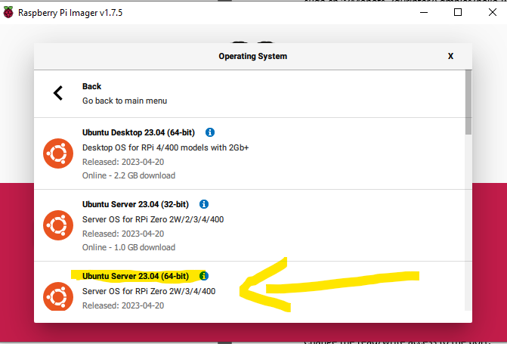

1. *sudo apt update*
2. Install cmake, min version 3.24

If you are not using the latest Ubuntu OS you may not have cmake v3.24+ in the package manager, follow these steps to install a newer cmake version(otherwise skip to step 3):

You can download the current latest release for arm chips using this command:

*curl -OL* [*https://github.com/Kitware/CMake/releases/download/v3.26.4/cmake-3.26.4-linux-aarch64.sh*](https://github.com/Kitware/CMake/releases/download/v3.26.4/cmake-3.26.4-linux-aarch64.sh)

then make the script an executable using:

*sudo chmod +x cmake-3.26.4-linux-aarch64.sh*

Then run the script to download and unzip using:

*./cmake-3.26.4-linux-aarch64.sh*

Now you should have the cmake executable in the current directory, we need to add it to the PATH so you can access it without the path prefix:

*sudo nano ~/.bashrc*

at the end of .bashrc write this line:

export PATH=”/home/$USER/cmake-3.26.4-linux-aarch64/bin:$PATH”

1. Install clang, min version 5, you may need to install clang manually if you are not using the latest Ubuntu OS

Run this command to install all tools:

*sudo apt install clang-format clang-tidy clang-tools clang clangd libc++-dev libc++1 libc++abi-dev libc++abi1 libclang-dev libclang1 liblldb-dev libllvm-ocaml-dev libomp-dev libomp5 lld lldb llvm-dev llvm-runtime llvm python3-clang*

1. *sudo apt install ninja-build*
2. Add your user to the dialout group so you can access the serial port without sudo access:

*sudo adduser $USER dialout*

1. *sudo reboot*
2. *cd ~*
3. *git clone* [*https://github.com/vladsomai/Mobots-3dPrinter.git*](https://github.com/vladsomai/Mobots-3dPrinter.git)
4. *cd Mobots-3dPrinter*
5. We must specify the path to the compiler in the build.sh file. We can find the clang path by using this command:

*clang++ –version*

you should see the installation dir of clang, now set this path in the build.sh:

*sudo nano ./build.sh*

modify the C_COMPILER and CXX_COMPILER variables to the path you got from clang++ --version

after you save the file, execute it: *./build.sh*

You should see the build files generated in the “build” folder together with the executable “RoMoController”

1. *cd build*
2. Set the serial port:

Use this command to find all the connected serial ports

*sudo dmesg | grep tty*

for example I see “/dev/ttyUSB0”

You will need to install minicom and configure the serial port to

Baudrate: 230400,

DataBits: 8

Parity: None

StopBits: 1

1. Run this command:

*minicom*

You should see minicom start, press CTRL+A then Q, to exit mincom.

Test the motors reset when sending the reset all command from the following 2 commands in the command line:

sudo echo -en '\xFF\x1B\x00' > binary.file

cat binary.file > /dev/ttyUSB0

Modify the SERIAL_PORT from config.ini to the correct serial port:

sudo nano ~/Mobots-3dPrinter/out/config.ini

1. Run the executable using:

*sudo ./RoMoController*

After running the executable you will see a log file created in the same directory as the executable, the name of the log file is the current date. The log file shall describe the steps the app makes, show errors or info, the log is not 100% complete it may not contain all the errors at the moment.