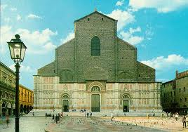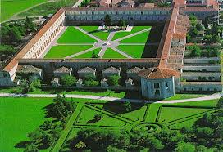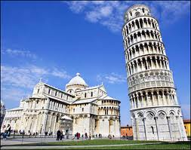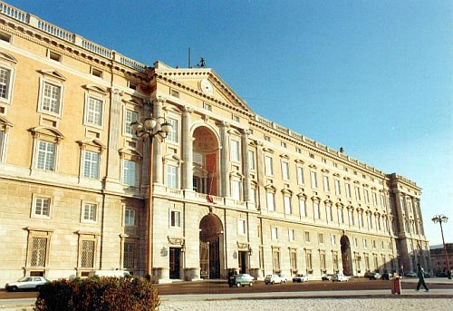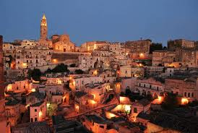MATCH THE PHOTO OF THE CITY TO THE CORRECT COUNTRY (the correct answer is in bold)

- The houses dug in the rock in Matera  
 a. Turkey  
 b. Romania  
 **c. Italy** d. Poland

The Caserta Realm  
 a. Bulgaria  
 **b. Italy** c. Romania d. Poland

Camp of miracles and the leaned tower, Pisa  
 **a. Italy**  
 b. Romania  
 c. Poland  
 d. Bulgaria

The “Certosa”, Padula  
 a. Turkey  
 b. Romania  
 **c. Italy** d. Poland

Saint Petronio cathedral, Bologna  
 a. Bulgaria  
 b. Poland c. Romania **d. Italy**