MATCH THE PHOTO OF THE FESTIVAL TO THE CORRECT COUNTRY (the correct answer is in bold)

Giffoni film festival  
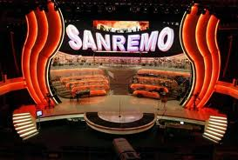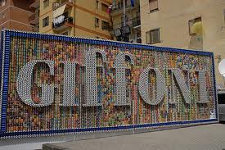 a. Turkey  
 b. Romania  
 **c. Italy** d. Poland

Song festval of Sanremo  
 a. Bulgaria  
 **b. Italy** c. Romania d. Poland

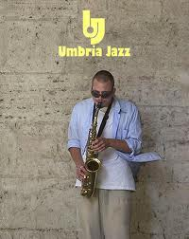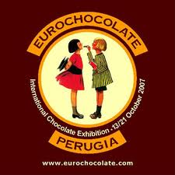Rimini welness - Festival of Fitness, Rimini  
 **a. Italy**  
 b. Romania  
 c. Poland  
 d. Bulgaria

Eurochocolate, Perugia  
 a. Turkey  
 b. Romania  
 **c. Italy** d. Poland

Umbria Jazz

a. Bulgaria  
b. Polandc. Romania **d. Italy**