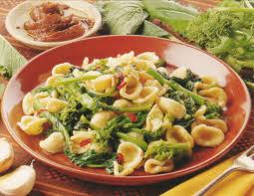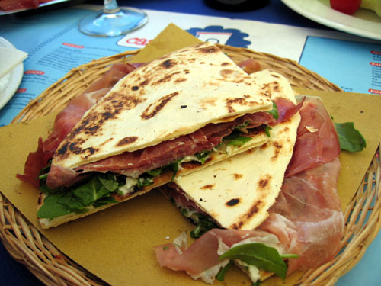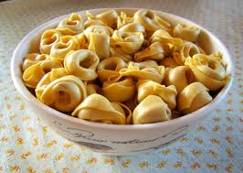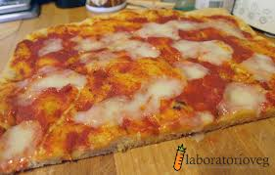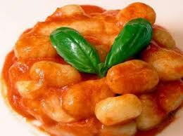Match The picture og the traditional dish to the country (the correct answer is in bold)

GNOCCHI

a. Turkey  
 b. Romania  
 **c. Italy** d. Poland

PIZZA

a. Bulgaria  
 **b. Italy** c. Romania d. Poland

MEAT-FILLED PASTA, “TORTELLINI”

**a. Italy**  
 b. Romania  
 c. Poland  
 d. Bulgaria

PIADINA

a. Turkey  
 b. Romania  
 **c. Italy** d. Poland

“ORECCHIETTE” WITH TURNIP TOPS

a. Bulgaria  
 b. Polandc. Romania **d. Italy**