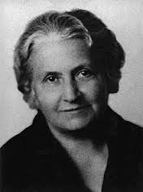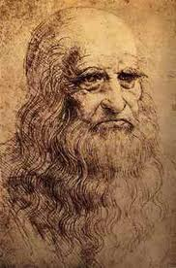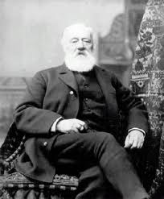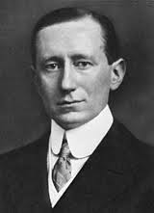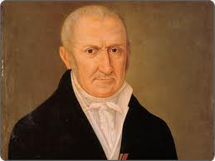MATCH THE FOTO AND THE INNOVATION/INVENTION TO THE CORRECT NAME (the correct answer is in bold)

Battery  
**a. Alessandro Volta**b. Luigi Galvani  
c. Tiberius Cavallo  
d. William Nicholson

Radio Telegraph

a. James Morse  
**b. Guglielmo Marconi**c. Davide Sarnaffo  
d. Nello Melba

Telephone

a. Domenico Guerrazzi  
b. Giuseppe Garibaldi  
**c. Antonio Meucci**  
d. Michele Cliffi

The flying Machine

a. Ludovico il Moro  
b. Cellino Vasari  
c. Alberto Duro  
**d. Leonardo Da Vinci**

Pedagogical and educational method  
**a. Maria Montessori**b. Antonia Stoppiani  
c. Domenica Giurati  
d. Angelina Benevento