All links last accessed on Friday, the 4th of January, between 18.35 and 19.

1. 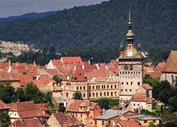 <http://www.brasovtravelguide.ro/en/brasov/surroundings/sighisoara.php>
2. 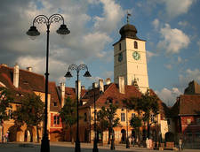 <http://www.romaniawanderer.com/category/destinations/sibiu/>
3. 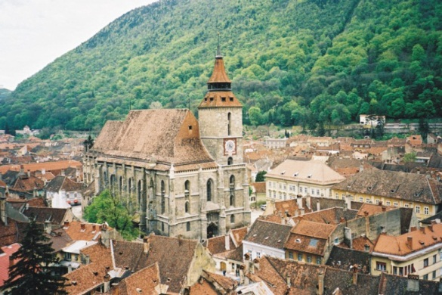http://en.wikipedia.org/wiki/File:Brasov_Biserica_Neagra.jpg
4. 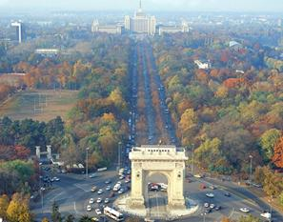http://www.bucharestairportexpress.ro/bct-arch-of-triumph.html
5. 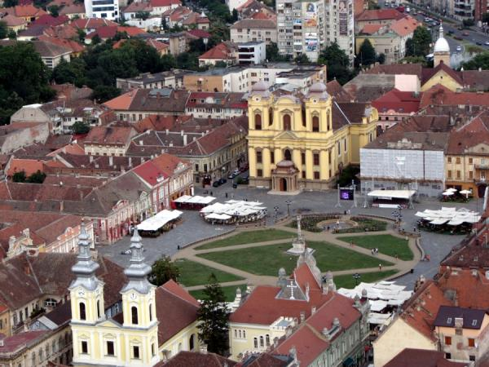http://www.panoramio.com/photo/32904546
6. 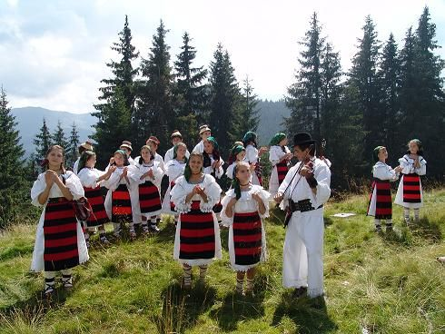 <http://www.romaniaturistica.ro/evenimente-manifestari-turistice-Bor%C8%99a-Maramure%C8%99-Hora--la-Prislop-459.html>
7. 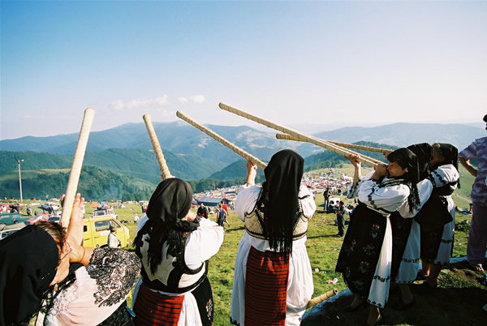 <http://elainajdavidson.blogspot.ro/2012/06/1.html>
8. 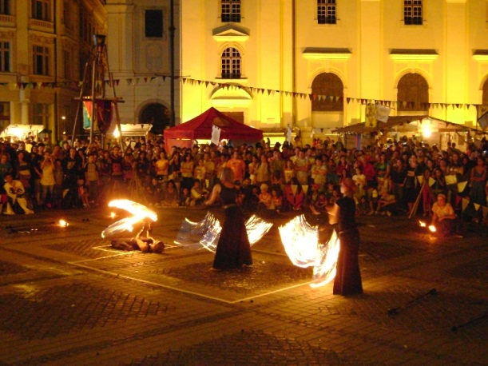http://www.evenimentelezilei.ro/ro/Festivalul-Medieval-Cetati-Transilvanene--a911.html
9. 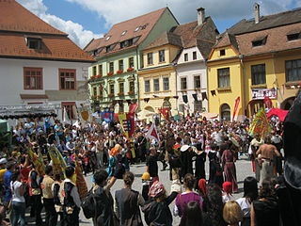http://ja.wikipedia.org/wiki/
10. 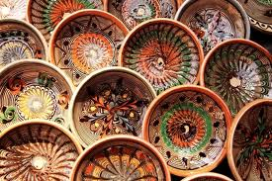 <http://www.stiridecluj.ro/national/ceramica-de-horezu-este-inclusa-de-unesco-in-patrimoniul-cultural-imaterial>
11. 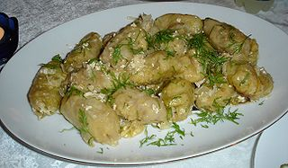 <http://en.wikipedia.org/wiki/File:Sarmale.jpg>
12. 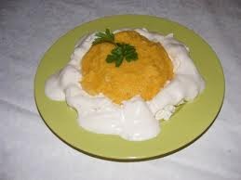 <http://blogs.fanbox.com/SinglePost.aspx?pbid=1777098&post=2465360&bts=29&apid=2465360&aid=0>
13. 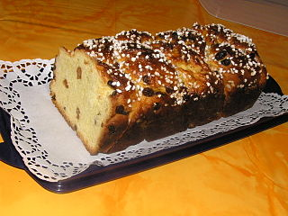 <http://ro.wikipedia.org/wiki/Fi%C8%99ier:Cozonac2.JPG>
14. 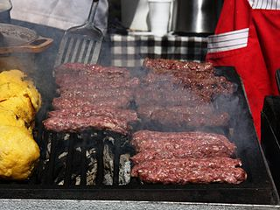 <http://roumaniedezicuzi.blogspot.ro/2010/05/passion-gratar.html>
15. 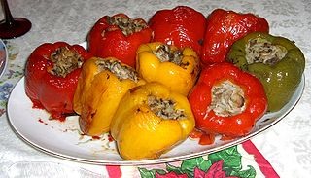 <http://en.wikipedia.org/wiki/File:Farshirovannyi_peretz.jpg>
16. 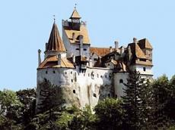 <http://beautifuleurope.wordpress.com/author/mioveni2/>
17. 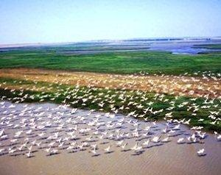http://www.evptulcea.ro/img/galerie_foto/judetul_tulcea.html
18. 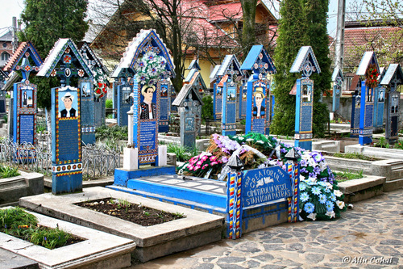http://ajilbab.com/cimitirul/cimitirul-vesel-sapanta-maramures.htm
19. 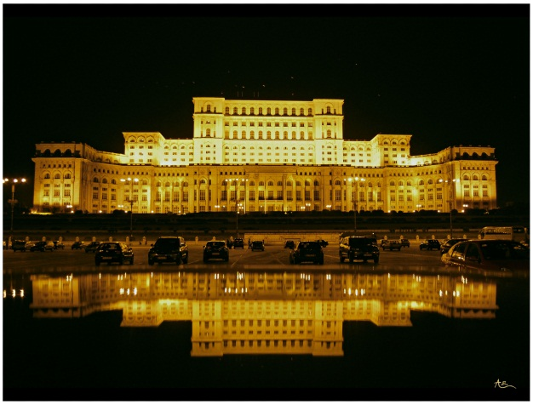http://www.bucharestdailyphoto.com/2009/12/palace-of-parliament-at-night.html
20. 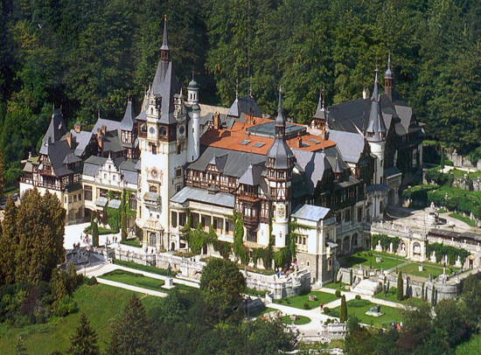 <http://www.turism-blog.ro/castelul-peles/>
21. 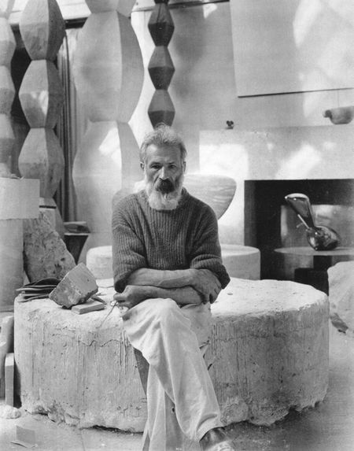 <http://pinterest.com/xavibotey/artists/>
22. 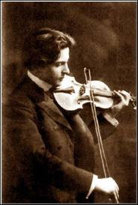http://sites.radiofrance.fr/francemusique/em/horizons/emission.php?e_id=100000058&d_id=425004605
23. http://americangymnastics.weebly.com/fun.html
24. 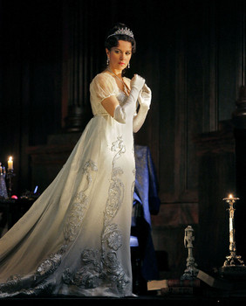 <http://www.examiner.com/article/tosca-returns-with-angela-gheorghiu-patricia-racette-mark-delavan-brian-jagde>
25. 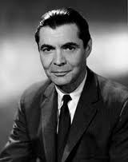 <http://www.comemorare.ro/George-Emil-Palade-210>
26. 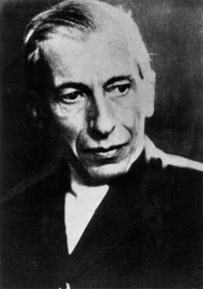 <http://en.wikipedia.org/wiki/File:Nicolae_Paulescu_-_Foto03.jpg>
27. 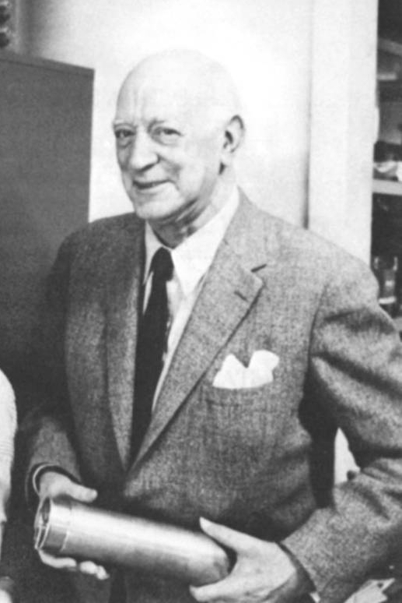 <http://cipborg.blogspot.ro/2011/10/henri-coanda-parintele-aviatiei-moderne.html>
28. 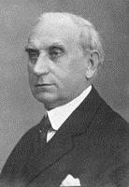 <http://ro.wikipedia.org/wiki/Fi%C8%99ier:Mina_Minovici.jpg>
29. 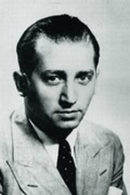 <http://revistacititordeproza.wordpress.com/2010/04/30/busola-lui-mihail-sebastian/>
30. 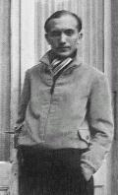 <http://la-convencion.blogspot.ro/2012_08_01_archive.html>
31. 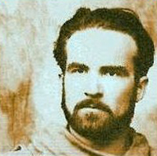 <http://www.radio3net.ro/sis/eliade/index.php?cx=bio_ro>
32. 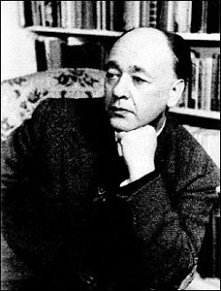 <http://www.comemorare.ro/galerie-Eugen-Ionescu/779>
33. http://www.cristea-enache.ro/25-11-2011-literatura-de-azi-tvr-cultural-27-noiembrie-20-00/
34. 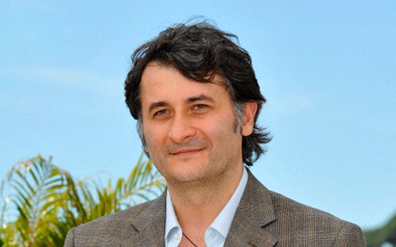 http://www.sff.ba/content.php/en/gosti_16?symfony=cfd208c7a3dc34bb8f781502e5f179fb