Match The Book With The Author

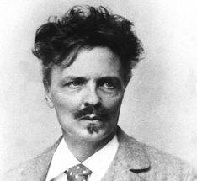 Inferno

1. Match the picture and the book with the correct author  
   a) Selma Lagerlöf  
   b) Stieg Larsson  
   c) Hennig Mankell  
   d) August Strindberg

The correct alternative is: d.

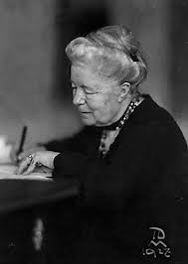 Nils Holgersson´s Wonderful Journey

1. Match the picture and the book with the correct author  
   a) Astrid Lindgren  
   b) Love Almqvist  
   c) Selma Lagerlöf  
   d) Agnes Krusenstierna

The correct alternative is: c.

 The Girl with the Dragon Tattoo

1. Match the picture and the book with the correct author  
   a) Love Almqvist  
   b) Stieg Trenter  
   c) Stieg Larsson  
   d) Wilhelm Moberg

The correct alternative is: c.

 Firewall

4. Match the picture and the book with the correct author  
a) August Strindberg  
b) Henning Mankell  
c) Stieg Larsson  
d) Werner von Heidenstam

The correct alternative is: b.

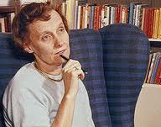 Ronia the Robber´s Daughter  
  
5. Match the picture and the book with the correct author  
a) Selma Lagerlöf  
b) Ulla Trenter  
c) Astrid Lindgren  
d) Moa Martinsson

The correct alternative is: c.