Food/drink

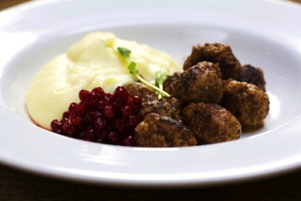 Meatballs with mashed potatoes and lingonberries

Match the food with the correct alternative

a) Turkey

b) Poland

c) Sweden

d) Italy

The correct alternative is: c.

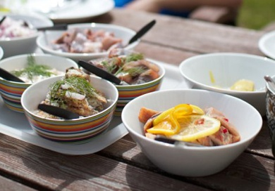 Pickled herring

Match the food with the correct alternative

a) Turkey

b) Sweden

c) Spain

d) Bulgaria

The correct alternative is: b.

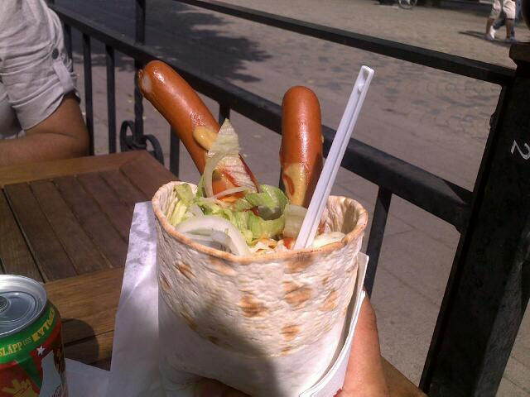 Flatbread wrap with hotdogs and mash

Match the food with the correct alternative

a) Romania

b) Poland

c) Spain

d) Sweden

The correct alternative is: d.

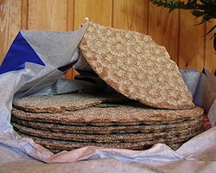 Hardbread

Match the food with the correct alternative

a) Sweden

b) Poland

c) Bulgaria

d) Italy

The correct alternative is: a.

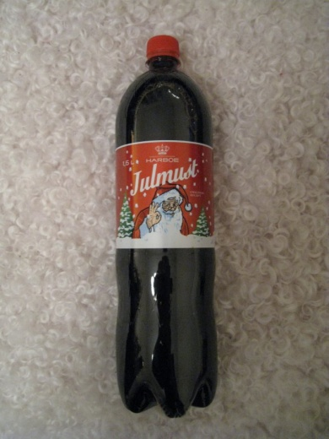 Christmas musts

Match the drink with the correct alternative

a) Turkey

b) Sweden

c) Spain

d) Bulgaria

The correct alternative is: b.