First impressions on Kickstarter: a look into what makes a crowdfunding campaign successful

Vlad Dumitrescu

Ryerson University

April, 6th, 2020

**Abstract**

This capstone project will provide insight into what makes a campaign successful on the popular crowdfunding website, Kickstarter. Over the years there have been amazing success stories that have come from Kickstarter. These humble ideas are often transformed into global phenomenon. However, while we recognize most of the accomplishments on the platform, Kickstarter is also home to tens of thousands of ideas that have gone unnoticed, unappreciated, and have ultimately failed. What determines a campaigns ultimate success, and how can aspiring entrepreneurs prepare themselves effectively for when they launch a new campaign?

I.

INTRODUCTION

This study’s objective will be to outline exactly what factors and determinants lead to a Kickstarter campaign performing well on the platform.

*RQ1: Can we use Natural Language Processing to implement machine learning techniques and predict a campaign’s success or failure (state)?*

*RQ2: Through further examination, can we build a model that accurately predicts a campaign’s success or failure (state) when separating the data by category (genre)?*

By using the descriptive ‘blurb’ of each campaign, I will tokenize every word found in the blurb descriptions and use classification algorithms to predict blurbs as either successful or failed. The relationship between campaign backers and the campaigns themselves is heterogeneous, that is to say, the backers have different expectations and goals when they decide to fund a campaign than the entrepreneurs behind the campaigns. More often than not, backers are funding campaigns that fall under “lending” or “philanthropy”[1], in which the backers expect nothing in return. This means that being able to attract as many backers is crucial for the success of your campaign, and the first impression that backers see in the campaign’s blurb is a fundamental determinant of the campaign’s success.

In the broader scope of data science, the theme of this study will primarily fall under predictive analytics. Preprocessing and cleaning will need to be precise in order to properly arrange our data. Further details of our data can be found below in part II of this report. Exploratory data analysiswill include both univariate and bivariate analysis and will be done in Python.

As we will see later in the report, Kickstarter campaigns typically fall within two extremes: *hyper-successful* and *complete failures.* This means outlier removal will need to be exact and carefully determined in order to avoid over and under-sampling biases. Machine learning techniques include: Logistic Regression and other classification algorithms such SVM, Naïve Bayes, and K- Nearest Neighbor. After the learning and implementation of these steps, we will evaluate and test our models. Evaluation techniques include: Accuracy and ROC Curve. These methods will mostly be executed using packages within Python and R.

This study will make two contributions:

First, to define the textual patterns in a Kickstarter campaign’s blurb and extract business-focused insights from this data in order to better understand and identify the opportunities that exist within the Kickstarter community.

Second, to implement text classification on the campaign’s blurb which will be used in our predictive modelling.

II.

DATA

The data for this study was compiled by using a web-scraping robot that is used to retrieve a working dataset every month of every campaign present on Kickstarter’s platform. Similar datasets are also available for crowdfunding website, IndieGogo. But Kickstarter was chosen for its notoriety and overall popularity.

The original downloaded data consisted of 57 separate .csv files which I combined before importing them into a Python notebook. The resulting dataset has nearly 216,000 rows and 38 columns of data. An appended data dictionary of these columns as well as the types of data we are working with will be provided in the appendix of this report (Fig.1). Although all columns were originally formatted as object-type data, I will define their actual type in the dictionary. Overall, this data was very rich. It consisted of nearly every possible attribute from a Kickstarter campaign and gave an unprecedented look into the minor details of a campaign that the general public might not be familiarized with.

When reviewing the data dictionary, it becomes clear as to why the original dataset of 57 .csv files reached over one gigabyte in size. In our data there exists multiple columns in JSON formatting, specifically the ‘photo’ and ‘location’ columns, both of which boosted the dataset size exponentially. In the methods sections of the report, we will go over our justification for removing numerous attributes. The original web scrape also included several columns which described the same data, specifically the columns having to do with currency. For the purpose of this study, only the campaigns located in Canada and the United States were sampled, since both were English speaking countries and relatively have similar currencies. Since our data would be trimmed to these two locations, European currencies, currency exchange rates, as well as currency symbols and trailing codes could be virtually removed without losing any story from our data.

More often than not, the data retrieved from the web scrape was performing well during analysis. More details on this can be found in later sections of this report.

III.

LITERATURE REVIEW

The current state of literature on the topic of crowdfunding is rich. In this section, I will introduce a number of different scientific articles and experiments that bridge data science with the crowdfunding industry, specifically Kickstarter.

The relationship between Kickstarter users and money pledged has been studied extensively over the last decade. Specifically, building predictors that would reveal expected money pledged and expect success range on Kickstarter by using user information such as social media profiles, twitter entries, and a comprehensive analysis between users and campaigns.[2]

The role of Kickstarter is not one of retail, but entrepreneurship. This can be increasingly difficult for the entrepreneurs behind Kickstarter campaign; promote the effectiveness of your idea and product, and you come off at a retailer.[3] This means that the campaign’s blurb is a very important attribute that can convey the entrepreneur’s beliefs in crowdfunding while promoting the campaign itself.

It is also important to note the link between a campaign’s backers and overall success. It has been found that there exists an inverted relationship between the two. The more a campaign has rewards, communication, and updates, the more crowd participation exists, and the more the campaign will ultimately reach its funding goal. However, this begins to trend downwards when looking at the degree of it’s funding goal. That is to say, a campaign will generally suffer in the long-run if it’s funding goal is unattainable, and the degree of success will be significantly less.[4]

In addition to this, a backer’s geographical proximity to the campaign will determine the individual’s level of support. What has been found is that a relationship exists between the backer’s home bias, views, and general beliefs when it comes to funding a campaign.[5]

In fact, Kickstarter’s ‘crowd capital’, or the attention and support from a tech-savvy population usually seen on crowdfunding platforms, is important when determining a campaign’s success. If a campaign fails to attract the wave of attention needed through crowdfunding, we can say that it did not resonate with the IT-audience[6] that it is being viewed by. This concept of crowd capital and crowd participation is key for this study. By looking at a campaign’s number of backers, funding goal, pledges, and deadline, we can gain insights into what strategies are most effective before launching on Kickstarter.

This study will explore exactly this, how does a campaign garner overwhelming support from the right people in the Kickstarter community. Studies have shown that the majority of users are not concerned with reward-based incentives when funding, instead more invested in supporting a great idea and message.[7] Since backers can not be swayed so easily through incentives, the most important source of information is the campaign’s blurb. This description is where the community will learn about the creator’s idea, morals, message, and long-term plan. In fact, this can be seen in the crowdfunding campaigns for the majority of Kickstarter-based documentaries. What has been found is that certain documentary genres concerning political or world news have performed better than other documentaries.[8] This suggests that when an audience is able to connect with a campaign on an emotional level, they gain some form of editorial power in what the documentary produces. If the audience’s views coincide with the creator’s views, the documentary will naturally receive more funding leading to success.[9]

Data Acquisition: Web-scrape Kickstarter.com retrieved from <https://webrobots.io/>

By looking at the campaign blurbs, a distinction will appear between campaigns that will reach their goals and be successful versus the campaigns that will overwhelmingly fail. In addition to the analysis that will be done on univariate and bivariate relationships, this study will focus a great deal of attention on the specific words and word-patterns used in these blurbs to predict a campaign’s success.

IV.

METHODS

The necessary approach for this project has several significant parts. Given the nature of the data, extensive cleaning was done on the initial web scrape. Redundant variables were removed and I chose to only focus on Kickstarter campaigns based in USA and Canada for simplicity, the fact that the majority of the campaigns would be in English, and to reduce the number of rows in the data. While most of the work for this project was done at home using my laptop, the most taxing code was run using the computer lab provided to us. I bring this up because once the COVID-19 pandemic hit Toronto, that lab was no longer open to students, so I had to drastically change and tweak the scope of my project, instead of working with hundreds of thousands of campaigns, I had to satisfy the processing power of my PC device at home. While this ultimately may have sacrificed great amounts of data, I believe the underlying story and goal of the project remains the same. The diagram below will show the path that we will take from data acquisition to our final output and deliverables.

Initial Results: find initial classifications results from entire dataset and assess their accuracy and effectiveness

Tokenization/NLP and Outliers: Determine outliers and prepare a corpus from the blurb data

Cleaning and Processing; including outlier removal and creation of new variables for later use

Filtering Top-5: Separate data by genre to give a more in-depth look at the top-5 categories on Kickstarter

Final Results: Using machine learning and classification, gather results from the top-5 genres on our dataset

Deliverables: presentation, visualizing, recapping, and concluding the results of our modelling and experiments

1) The first part of this study’s approach is concerned with data acquisition. As previously mentioned, the data was retrieved via a monthly web-scrape. This scrape was then partitioned into 57 .csv files and packaged for downloading. Once downloaded it is clear that for the purpose of this study, the files would have to be compiled together into one seamless .csv. Once that is done, importing into Python worked more efficiently.

2) After importing, cleaning and processing is integral to reduce the size of our data set by almost 10 times. Wasteful JSON formatted attributes should be removed and features relative to our research question should be kept. Overall, around 20 attributes will remain. Data types for these attributes have to be defined as the original scrape used UNIX date types. Additionally, regex formatting needs to be implemented as most of the categorical information is embedded within URL links and long text data. Finally, duplicate and missing data was filtered out and the dataset was prepared for

3) Tokenization/NLP and outlier removal constitutes the third stage of this study, in which the ‘blurb’ description of each campaign is processed and segmented into individual words. These words will then be used later in the study. By doing this, we will be able to identify key buzz words and words to avoid in descriptions. Our goal is to create a guideline as to which descriptive word patterns are most effective in leading to a successful Kickstarter campaign.

4) The initial results will be looked over in the fifth stage. Here, training will be done on several machine learning techniques such as Logistic Regression, SVM, Naïve Bayes, and KNN. The results from these algorithms will be evaluated using accuracy as well as the ROC curve.

5) Given the average results of these models from step 4, which I will go into more detail later in this report, I chose to perform filtering and more specific analysis and classification on the top-5 genres from Kickstarter.

6) Since our initial findings in step 4 focused on the Kickstarter data as a large, general sample, it made sense to separate and filter the data by genre and focus on more specifically curated samples which may be found more useful by the Kickstarter community. Since this project is focused on NLP and text, it was clear that building models using all the words from Kickstarter in step 4 can be too broad, therefore this step aims to improve on our initial results while providing Kickstarter users with a more applicable set of results.

7) Finally, visualization of our results and analysis will be used to create a final presentation to go along with this report. I hope to be able to conclude a series of guidelines for aspiring Kickstarter entrepreneurs to follow when it comes to marketing their ideas. The overall claim of this project is that a crowd’s first impression of your campaign and it’s ‘blurb’ description is of utmost significance insofar as it is one of the key determinants of a campaigns overall success.

V.

ANALYSIS

After cleaning was performed on the data in our we moved on with analysis of our data. Analysis includes Tokenization, Natural Language Processing, and Outlier Removal as well as the findings and analysis of our initial classifications.

When dealing with outliers the data was particularly inconvenient. The Kickstarter data has 3 numeric attributes of interest to our analysis: pledged amount, goal, and backers count. In order to deal with potential outliers, I decided to combine the pledged amount and goal attributes into a third column called success percentage. This wouldn’t lose any of the original columns’ inherent information and would leave us with less attributes to perform outlier removal on.

From the initial analysis of the success percentage column, it was clear that our data was drastically split between two extremes: highly successful and failed.

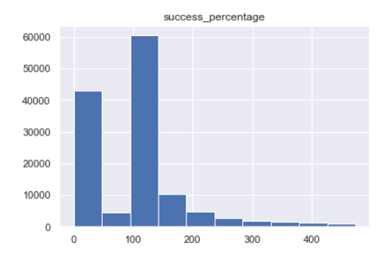

*Fig. 1 – Success Percentage Histogram*

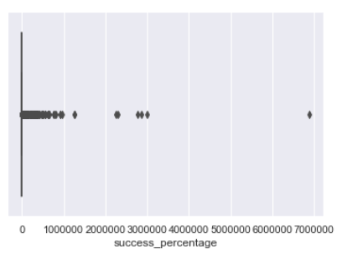

*Fig. 2 – Success Percentage Boxplot (Before)*

In order to be effective in our outlier removal, we would have to take a stringent approach. This wouldn’t have been such an issue, but since this project took place during the COVID 19 pandemic, and further steps of this project would take place on my personal laptop, careful consideration had to be applied to the data if it were to be filtered. In a perfect world, outlier removal would have been performed using the standard deviation method, in which outliers beyond 2 standard deviations are filtered out, however this still left us with quite a large dataset, and through countless iterations, NLP as well as classifications were too impractical to run on such a large dataset. Through lots of trial and error, I found the optimal range of data to be around a 100k to 130k sample size. Therefore, I chose to use the method of identifying and removing outliers by looking at the percentile range of the attribute in question. By removing outliers beyond the 95th and 5th percentiles in the success percentage column, we would retain the inherent information of the attribute, while helping our processing power by reducing the size of the data. As you can see, simply using the selected percentile range for outlier removal left us with a much more malleable dataset.

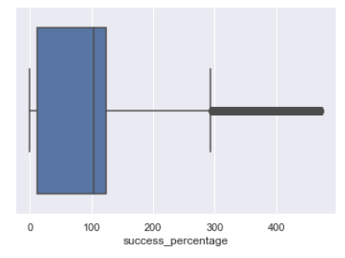

*Fig. 3 Success Percentage Boxplot (After)*

Ultimately, outlier removal left approximately 115k Kickstarter campaign with a 2:1 distribution between successful and failed campaigns.

Following the removal of outliers, NLP was implemented on the blurb column. I decided to use lemmatization in order to retain the overall meaning of the words. Stop-words were removed and a corpus of the blurb column was appended to the original dataset.

VI.

INITIAL CLASSIFICATION RESULTS

Initial classification was done on the entire dataset (all categories). I decided to include Naïve Bayes, Logistic Regression, K-Nearest Neighbors, and SVM as my classification algorithms because of their performances when dealing with text classification. The following will explore some of the initial results and what conclusions we can draw from them. When trying to predict the ‘state’ class of the Kickstarter campaign as either successful or failed, resampling was done to reorganize the asymmetrical nature of the state column which was at approximately a 2:1 ratio of success to fail.

Bigrams were chosen as our independent variables because they performed better than n-grams of 1 or 3, and since my device was able to process this without crashing I chose to work with bigrams.

Oversampling

When resampling our data, the oversampled dataset performed well.



*Fig. 4 – Naïve Bayes, Logistic Regression, KNN, SVM classification algorithm initial results for the oversampled dataset*

This data was working with a bag of bigrams of 530k and with such a large sample it is encouraging to see average accuracies around 70% with an ROC curve between 0.6 to 0.7.

Undersampling

After undersampling our data, we were left with roughly 350k bigrams in our bag and less variability when it came to the scope of these words. While the undersampled data performed well, it was significantly less effective at predicting a campaign’s ‘state’.



*Fig. 5 – Classification algorithm initial results for the undersampled dataset*

The accuracy results from the undersampled data are on average 7% lower than the oversampled data. This is largely due to the fact that the undersampled data had less data to train on and evidently misclassified, which can be seen from the relatively low recall numbers.

Considering these results, it was clear that a more exploratory look was needed to build a proper model. One thing that stood out was that the results from this step incorporated all bigrams within the Kickstarter community, regardless of their category or genre. Since most entrepreneur looking to build a Kickstarter campaign in the field of technology benefit very little from a predictive model that uses text data from genres such as food, comics, or art, it was decided that separating the Kickstarter data into genres and performing the same classifications would be an interesting look and may help with the effectiveness of this project.

VII.

EXPLORATORY ANALYSIS & FURTHER CLASSIFICATION RESULTS

The top-5 genres on the Kickstarter platform include music, film, publishing, art, and food. Given the wide array of categories which are even in the top-5, it makes sense to separate them and apply the same techniques that we did on the entire dataset in the previous section. Considering how lengthy the following section would be if I discussed all the results from all forty classifiers, I will include what I think are some of the most interesting insights that I gathered from this exploratory step in my project.

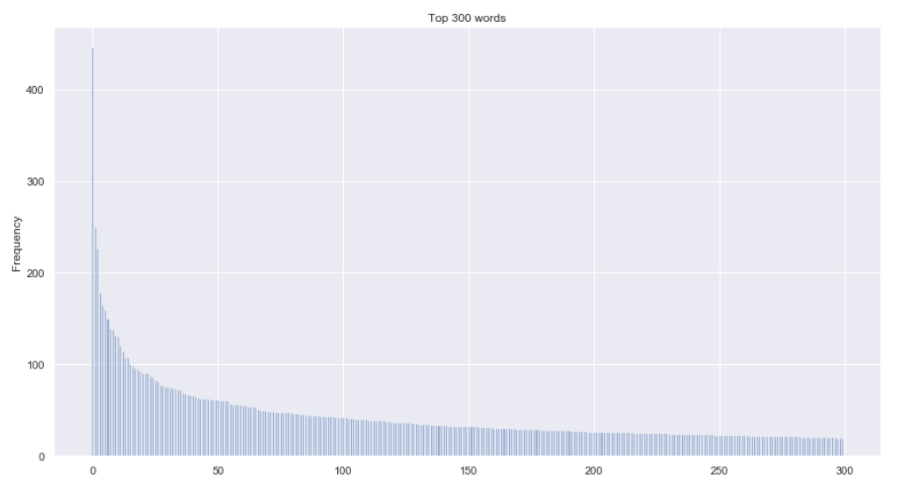

Analysis

When looking at campaigns that fall into the publishing category, there is an obvious pattern in the language used for the descriptions. Unfortunately, because of a lack of computer processing power, only the unigram frequencies were able to be collected. With that being said, they tell a very similar story just like the bigrams.

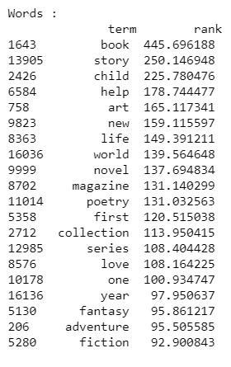



*Fig. 6 – Unigram frequencies in Kickstarter’s Publishing Category*

Words like ‘book’, ‘help’, and ‘child’ are extremely common in these blurbs. This supports the fact that Kickstarter is frequented by individuals for philanthropic means. Somebody interested in starting a campaign in children books on Kickstarter should play to this type of audience if they want to make a good first impression via their campaign’s blurb. In fact, these select words are so common that the majority of the top 300 words in the publishing category are represented by a handful of highly frequent words.

*Fig. 7 – Top 300 words and their frequencies in the publishing category on Kickstarter.*

Classification

In addition to the important insights drawn from our analysis, the classification results are equally as important. Below, I’ve selected some of the most effective classifiers when using the data from the top-5 categories.









*Fig. 8 – Best classification algorithm results using the top-5 Kickstarter categories*

Looking at these results, a few things stand out. Our initial classification results in Part VI had an average of roughly 67% and an ROC curve of 65%. These numbers are average at best, and after lots of trial and error were the best results available. On the other hand, once the data was filtered and separated by category, our highest avg. accuracy was in the publishing genre with 74%, while having the lowest avg. ROC curve with 56%, slightly better than a completely random classification. The reason behind this can be interpreted in many different ways, but from what was illustrated in figs. 6 & 7, the publishing data had some of the most skewed word occurrences which may have ultimately cause the classification to go awry.

Interestingly enough the data with less skew performed much better when classifying. Both the music and food categories have an avg. accuracy of 67% and 65% with an avg. ROC curve of 64% and 65% respectively. When looking at their analysis a pattern emerges:

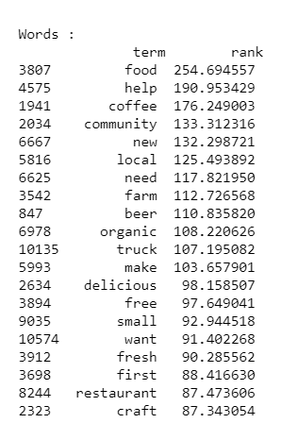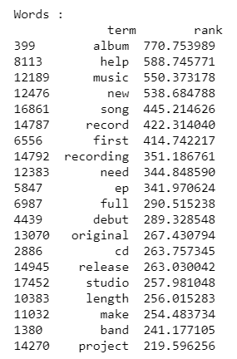

*Fig. 9 – Unigram frequencies in Music(left) and Food (right) categories*

What we see is a much more evenly distributed series of words which help bolster the classification results from these two categories. When using the food data, the SVM model operated the best out of all the other models, while the Naïve Bayes classifier operated the best across all categories.

VIII.

CONCLUSION

To wrap up this project, I’d like to revisit the research questions that we started with:

*RQ1: Can we use Natural Language Processing to implement machine learning techniques and predict a campaign’s success or failure (state)?*

*RQ2: Through further examination, can we build a model that accurately predicts a campaign’s success or failure (state) when separating the data by category (genre)?*

By using NLP and classification, we were able to answer the first question effectively. The initial results outlined in Part VI prove that it is possible to build a predictive model using a corpus of bigrams collected from the campaign blurbs. While the models performed well with acceptable accuracies, there was room for improvement.

As for the second question, I believe a denser dataset is necessary in order to train a successful model of separate Kickstarter categories. It is important to note that the initial results from Part VI came from models trained on a much larger dataset of over 100k campaigns, while the categorical results from Part VII came from significantly smaller datasets between 10-20k campaigns.

If I were to approach these questions with a blank slate, I would use data from multiple web scrapes and combine them, preferably with more computing power as to retain as large of a sample size as possible.

APPENDIX

|  |  |  |  |
| --- | --- | --- | --- |
| NAME | DESCRIPTION | TYPE | REQUIRED (Y/N) |
| 1. backers_count | # of backers to a campaign | INT | Y |
| 1. blurb | Front-page long description | STR | Y |
| 1. category | Sub-genre of campaign | STR | Y |
| 1. converted_pledged_amount | Total USD pledged | FLOAT | Y |
| 1. country | Campaign location - country | STR | Y |
| 1. country_displayable_name | Country name | STR | N |
| 1. created_at | Date created at | DATETIME | Y |
| 1. creator | Creator identification | JSON | N |
| 1. currency | Campaign location currency | STR | N |
| 1. currency_symbol | Currency symbol | STR | N |
| 1. currency_trailing_code | Currency trailing code (T/F) | BOOL | N |
| 1. current_currency | Converted currency (USD) | STR | N |
| 1. deadline | Deadline date | DATETIME | Y |
| 1. disable_communication | If comments are disabled (T/F) | BOOL | Y |
| 1. friends | *empty field - NULL* | --- | --- |
| 1. fx_rate | Currency exchange rate | FLOAT | Y |
| 1. goal | Campaign pledge goal | FLOAT | Y |
| 1. id | Campaign ID number | INT | Y |
| 1. is_backing | *empty field - NULL* | --- | --- |
| 1. is_starrable | Can star the campaign (T/F) | BOOL | Y |
| 1. is_starred | *empty field - NULL* | --- | --- |
| 1. launched_at | Launch date for the campaign | DATETIME | Y |
| 1. location | Location of campaign | JSON | N |
| 1. name | Name of campaign | STR | Y |
| 1. permissions | *empty field - NULL* | --- | --- |
| 1. photo | Raw photo text dictionary | JSON | N |
| 1. pledged | Original currency pledged | FLOAT | N |
| 1. profile | Campaign information | JSON | N |
| 1. slug | Short keyword description | STR | Y |
| 1. source_url | Campaign URL | STR | Y |
| 1. spotlight | If the campaign is on Kickstarters spotlight page (T/F) | BOOL | Y |
| 1. staff_pick | If the campaign has been staff-picked (T/F) | BOOL | Y |
| 1. state | Successful/Failed status | STR | Y |
| 1. state_changed_at | Date when state changed | DATETIME | N |
| 1. static_usd_rate | USD exchange rate | FLOAT | N |
| 1. urls | Long URL text dictionary | JSON | N |
| 1. usd_pledged | Amount in USD pledged | FLOAT | N |
| 1. usd_type | International or domestic currency | STR | N |

Table 1 – Data dictionary

REFERENCES

Allison, T. H., Davis, B. C., Webb, J. W., & Short, J. C. (2017). “Persuasion in crowdfunding: an elaboration likelihood model of crowdfunding performance.” *Journal of Business Venturing,* Vol. 32(6), pp. 707–725.

Colistra, R. & Duvall, K. (2017). “Show Me the Money: Importance of Crowdfunding Factors on Backers’ Decisions to Financially Support Kickstarter Campaigns.” *Social Media & Society,* pp. 1-12.

[Diandian X](https://link-springer-com.ezproxy.lib.ryerson.ca/article/10.1007%2Fs11747-019-00638-w#auth-1).; [Leinan Z](https://link-springer-com.ezproxy.lib.ryerson.ca/article/10.1007%2Fs11747-019-00638-w" \l "auth-2).; [Qiuyan T](https://link-springer-com.ezproxy.lib.ryerson.ca/article/10.1007%2Fs11747-019-00638-w" \l "auth-3).; [Yonggui W](https://link-springer-com.ezproxy.lib.ryerson.ca/article/10.1007%2Fs11747-019-00638-w" \l "auth-4).;  [Shuang M](https://link-springer-com.ezproxy.lib.ryerson.ca/article/10.1007%2Fs11747-019-00638-w" \l "auth-5). (2019).“Informational or emotional appeals in crowdfunding message strategy: an empirical investigation of backers’ support decisions.” [*Journal of the Academy of Marketing Science*](https://link-springer-com.ezproxy.lib.ryerson.ca/journal/11747)*,* Vol. 47, pp. 1046–1063.

[Gedda, D](https://search-proquest-com.ezproxy.lib.ryerson.ca/indexinglinkhandler/sng/au/Gedda,+David/$N?accountid=13631).; [Nilsson, B](https://search-proquest-com.ezproxy.lib.ryerson.ca/indexinglinkhandler/sng/au/Nilsson,+Billy/$N?accountid=13631).; [Såthén, Z](https://search-proquest-com.ezproxy.lib.ryerson.ca/indexinglinkhandler/sng/au/S$e5th$e9n,+Zebastian/$N?accountid=13631" \o "Click to search for more items by this author).; [Søilen, K. Solberg](https://search-proquest-com.ezproxy.lib.ryerson.ca/indexinglinkhandler/sng/au/S$f8ilen,+Klaus+Solberg/$N?accountid=13631" \o "Click to search for more items by this author). (2016). “Crowdfunding: Finding the Optimal Platform for Funders and Entrepreneurs”. [*Technology Innovation Management Review*](https://search-proquest-com.ezproxy.lib.ryerson.ca/pubidlinkhandler/sng/pubtitle/Technology+Innovation+Management+Review/$N/2034500/DocView/1961751024/fulltext/F89768C03B944048PQ/1?accountid=13631); Ottawa[Vol. 6(3), pp. 31-40.](https://search-proquest-com.ezproxy.lib.ryerson.ca/indexingvolumeissuelinkhandler/2034500/Technology+Innovation+Management+Review/02016Y03Y01$23Mar+2016$3b++Vol.+6+$283$29/6/3?accountid=13631)

Guo, L.; Guo, D.; Wang, W.; Wang, H.; Wu, Y.J. (2018). “Distance Diffusion of Home Bias for Crowdfunding Campaigns between Categories: Insights from Data Analytics.” Sustainability, Vol. 10-1251, pp. 1-22.

Mollick, E. R. (2013). “The Dynamics of Crowdfunding: An Exploratory Study.” *Journal of Business Venturing,* Vol. 29(1), pp. 1–16.

Sorensen, I. (2012). “Crowdsourcing and outsourcing: The impact of online funding and distribution on the documentary film industry in the UK.” *Media, Culture, & Society*, Vol. *34*, pp. 726–743.

Tran, T., Dontham, M. R., Chung, J. & Lee, K. (2016). “How to Succeed in Crowdfunding: A Long-Term Study in Kickstarter”. *ACM Transactions on Intelligent Systems and Technology,* pp. 1-28.

[Yin, C.](https://www-emerald-com.ezproxy.lib.ryerson.ca/insight/search?q=Chunxiao%20Yin), [Liu, L.](https://www-emerald-com.ezproxy.lib.ryerson.ca/insight/search?q=Libo%20Liu) and [Mirkovski, K.](https://www-emerald-com.ezproxy.lib.ryerson.ca/insight/search?q=Kristijian%20Mirkovski" \o "Kristijian Mirkovski) (2019). "Does more crowd participation bring more value to crowdfunding projects? The perspective of crowd capital", [*Internet Research*](https://www-emerald-com.ezproxy.lib.ryerson.ca/insight/publication/issn/1066-2243)*,* Vol. 29(5), pp. 1149-1170.

1. Mollick, E. R. (2013). “The Dynamics of Crowdfunding: An Exploratory Study.” *Journal of Business Venturing,* Vol. 29(1), pp. 3.
2. Tran, T., Dontham, M. R., Chung, J. & Lee, K. (2016). “How to Succeed in Crowdfunding: A Long-Term Study in Kickstarter”. *ACM Transactions on Intelligent Systems and Technology,* pp. 4.
3. Allison, T. H., Davis, B. C., Webb, J. W., & Short, J. C. (2017). “Persuasion in crowdfunding: an elaboration likelihood model of crowdfunding performance.” *Journal of Business Venturing, 32*(6), 707.
4. [Yin, C.](https://www-emerald-com.ezproxy.lib.ryerson.ca/insight/search?q=Chunxiao%20Yin), [Liu, L.](https://www-emerald-com.ezproxy.lib.ryerson.ca/insight/search?q=Libo%20Liu) and [Mirkovski, K.](https://www-emerald-com.ezproxy.lib.ryerson.ca/insight/search?q=Kristijian%20Mirkovski" \o "Kristijian Mirkovski) (2019). "Does more crowd participation bring more value to crowdfunding projects? The perspective of crowd capital", [*Internet Research*](https://www-emerald-com.ezproxy.lib.ryerson.ca/insight/publication/issn/1066-2243), Vol. 29 No. 5, pp. 1149.
5. Guo, L.; Guo, D.; Wang, W.; Wang, H.; Wu, Y.J. (2018). “Distance Diffusion of Home Bias for Crowdfunding Campaigns between Categories: Insights from Data Analytics.” Sustainability, Vol. 10-1251, pp.2
6. [Yin, C.](https://www-emerald-com.ezproxy.lib.ryerson.ca/insight/search?q=Chunxiao%20Yin), [Liu, L.](https://www-emerald-com.ezproxy.lib.ryerson.ca/insight/search?q=Libo%20Liu) and [Mirkovski, K.](https://www-emerald-com.ezproxy.lib.ryerson.ca/insight/search?q=Kristijian%20Mirkovski" \o "Kristijian Mirkovski) (2019). pp. 1153.
7. Colistra, R. & Duvall, K. (2017). “Show Me the Money: Importance of Crowdfunding Factors on Backers’ Decisions to Financially Support Kickstarter Campaigns.” Social Media & Society 3.
8. Sorensen, I. (2012). Crowdsourcing and outsourcing: The impact of online funding and distribution on the documentary film industry in the UK. *Media, Culture, & Society*, *34*, 726–743.
9. Colistra, R. & Duvall, K. (2017). pp. 2.