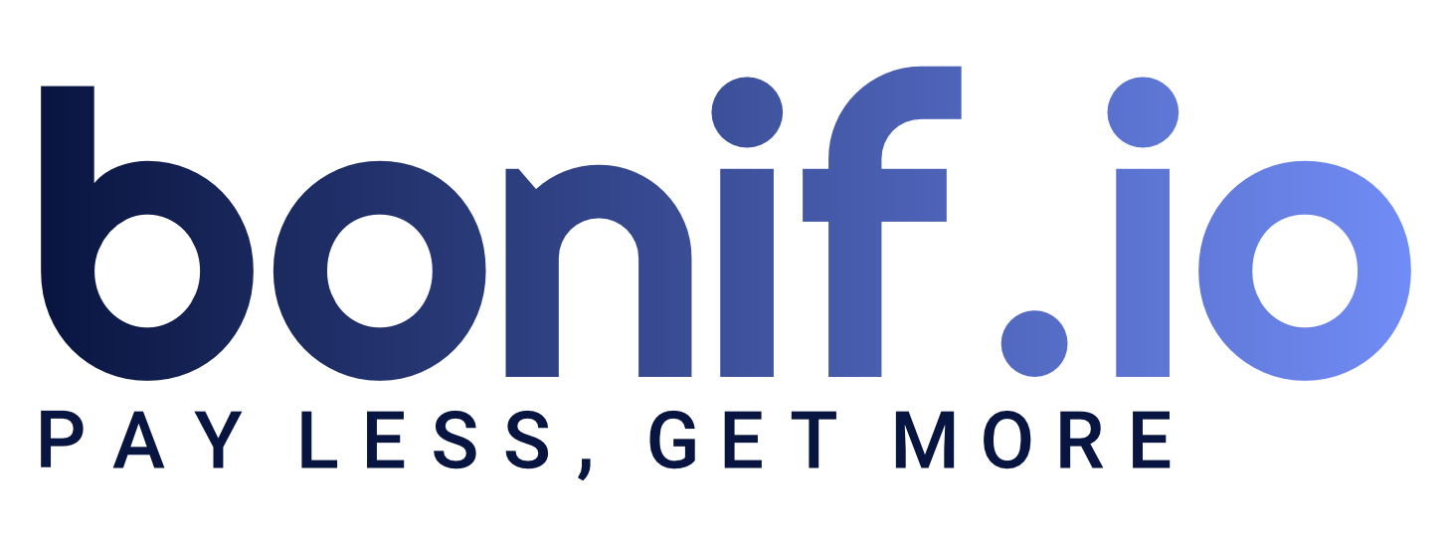

**About us**

We are a software company that want to offer various customizable gamification services that aims to integrate as much as possible the people into any type of application. Our offer involves different gamification services which can be modified by the administrator to integrate with the application theme.

The pricing plan involves three different tiers, Basic, Silver and Gold. Each one comes with its own gamification services, database, administration UI using SwaggerUI , a REST Api that can be integrated with ease into any aplication using our data models and it comes as a Docker Image containing all the configuration needed to run anywher. Also, each company will receive a token that will server as authentication to our internal servers to verify its authenticity.

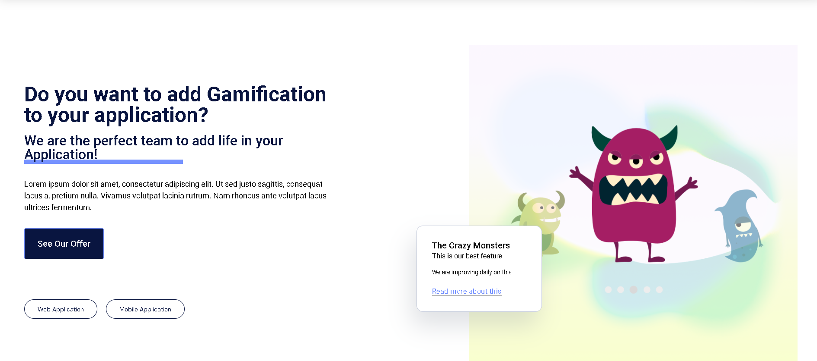

Note: We do not store into our database actual information from you business, other than IDs of the data comming from your super secret database.

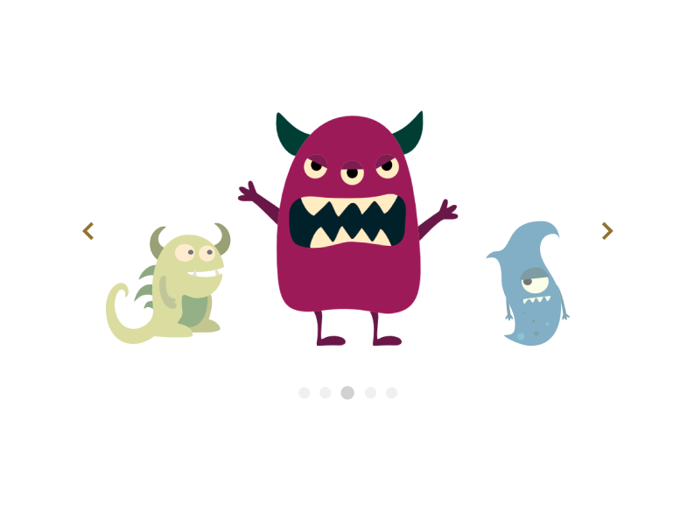

**Token**

The authenticity token will be verified at the installation of the REST Api to check what gamification services the customer can access.

**Points**

People using the application can get points as rewards that can be used to activate coupons (for now) to get discounts on products.

**Card with QR Code**

Our customers will have digital cards with QR codes that can be scanned to award their customers points.

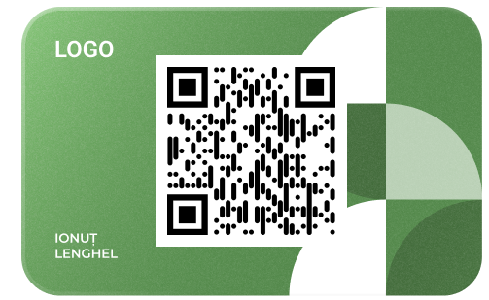

**Coupon**

We offer coupons that can be mapped to various products offering discounts.

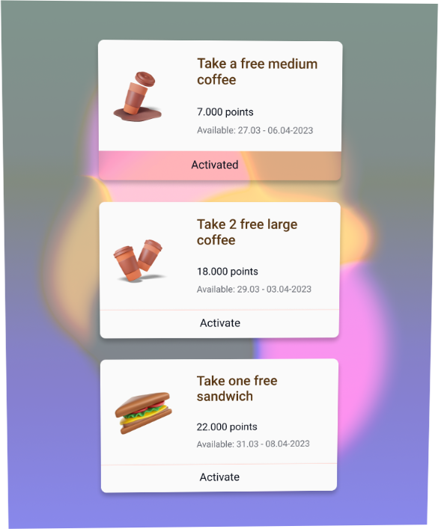

**Battlepass**

The battlepass gamification service comes as a challenge for your customers to do activities inside you application so they can gain something nice, based on their product type prefference since the configuration of this service can be either done manually or using different AI/ML techniques to generate these types of prefferences for anyone using the application.

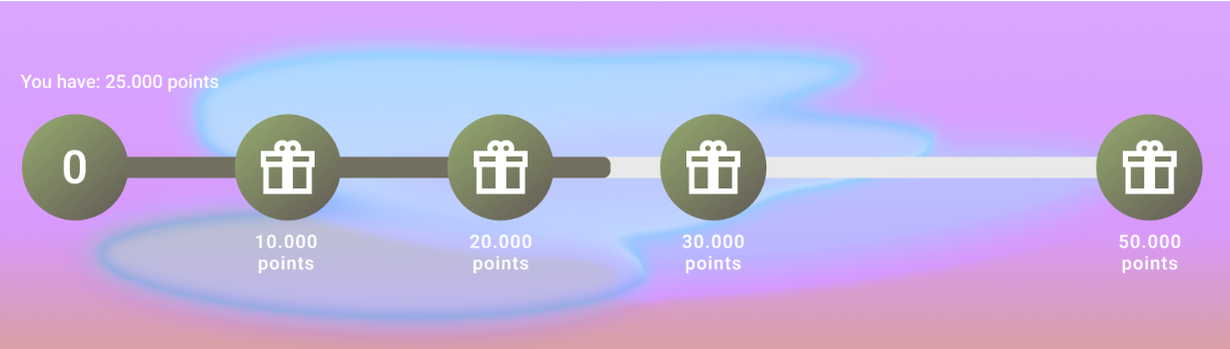

**Quest**

You can generate as many quests as you want, be as flexible as possible and create Daily, Weekly and Monthly quests for people to complete. Also, they can get points and have targets in order to complete the quest.

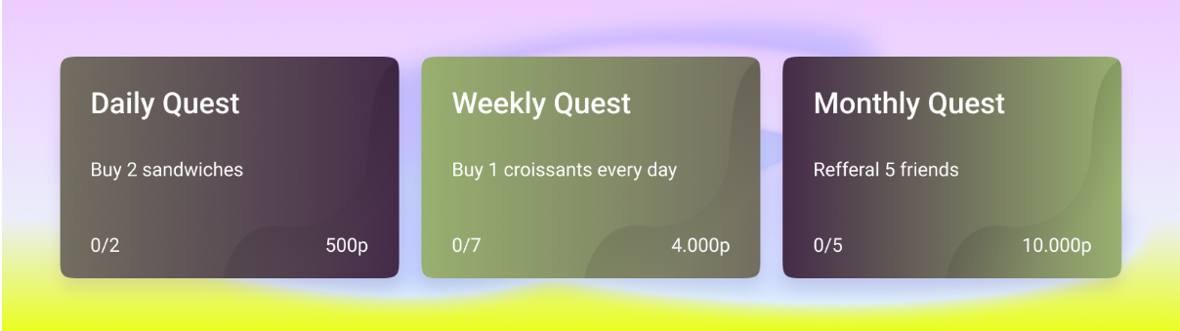

**Spinning wheel**

We offer a daily spinning wheel that can also be flexible and adaptable to the requirements of the application and the one who can configure these to generate coupons (for now) for the winner slice of the wheel.

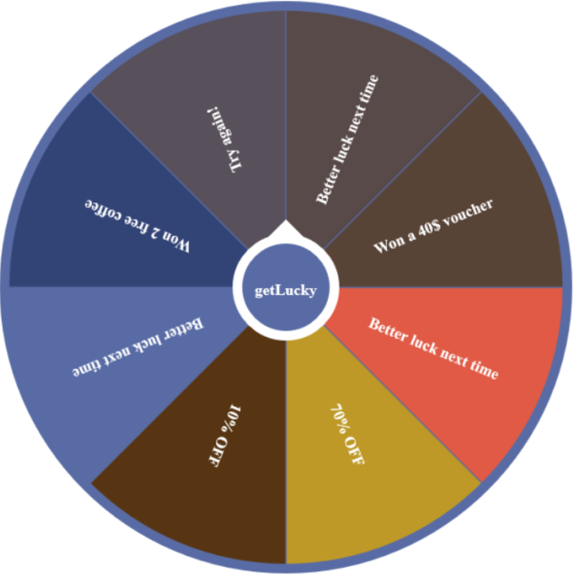

**Survey**

We also offer a mail service that can send surveys for products that have been purchased or activities done by the user when using the application and, if answered, it will generate a coupon (for now).

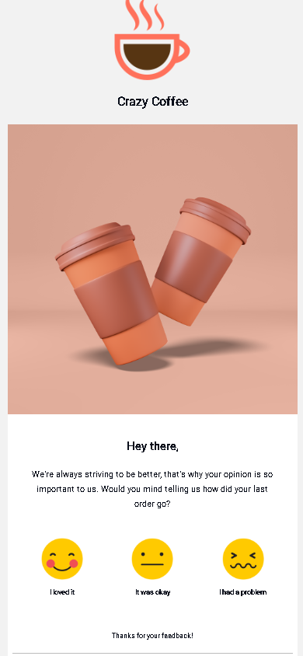

**Crazy Monster**

Our signature feature is the personal Crazy Monster. The users can pick from various small Crazy Monsters and they can change their assets when completing different tasks.

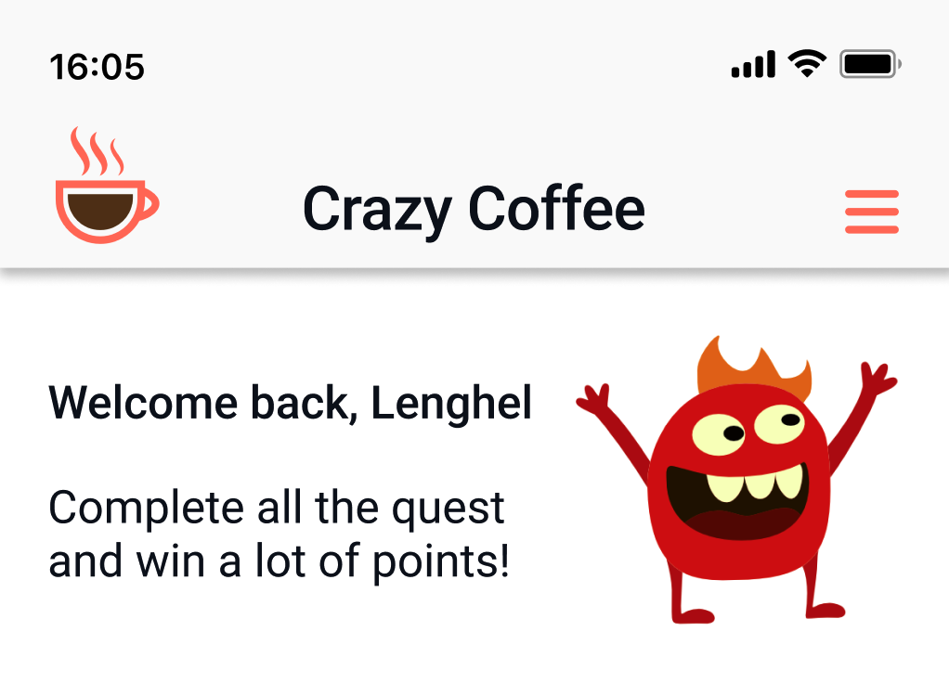

**Leaderboard**

We also have a leaderboard feature that tracks, monthly, the total acquired points of each user and will display this ranking.

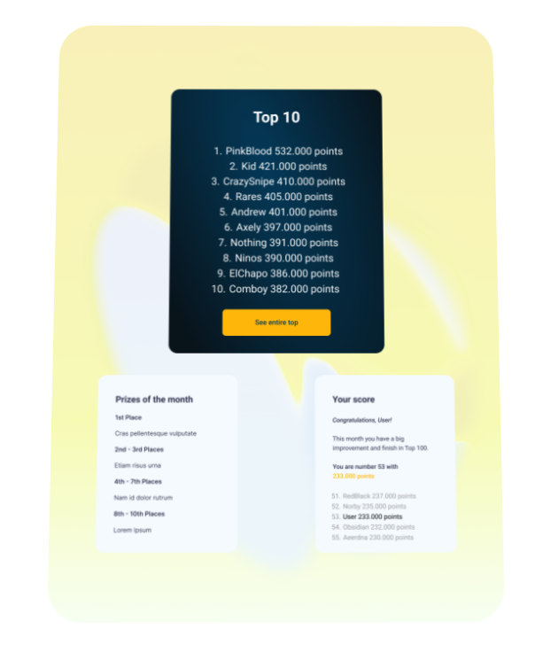

**Important notes:**

Our gamification packages are available on our website, [bonif.io](https://hackaton.mihneahututui.eu/), on the Pricing page. You can consult the prices and the packages and pick whatever fits your business or your application.

**Installation guide:**

For using our software you need to have install [Docker](https://docs.docker.com/engine/install/). You will also receive a **docker-compose.yaml** file from where you can get the container configuration and you can take it and modify it as you please. Also, there will be a **bash** script called **build_deploy.bash** that will build the Docker image and will also deploy a fully functional Docker Container with our tools.

To access the SwaggerUI, navigate to [SwaggerUI](http://localhost:8002/docs), you will find there all the endpoints for the costumization of every service available in the tier that you have picked from our software packages.