Initial Papers and Libraries Summary

<https://www.amcharts.com/>

Main library I would like to use for my thesis.

<http://www.databyou.com/>

This is a link to some fishery visualizations made with javascript d3 library. Actually this is very close to what I would like to produce as a result of my research.

1)      Visualization for fisheries management 2002

Initial paper from which I started my research. Very nice visualization but outdated (year 2002)

2)      Visualizing Fishing Data as Rasters

2018 paper which is very similar to the previous one but lacks visualization technics (from my point view doesn’t look perfect)

3)      Spatial and temporal differences in the reproductive traits of skipjack tuna

4)      Evaluation of a US west coast groundfish habitat

Good papers, use many datasources, charts, bar charts, maps, vectors. But I would say its not user friendly. For me its quite hard to read. I think it was developed more for scientists and domain expert people.

5)      Time Series Prediction

This paper is not related to fisheries, but shows many techniques for time series predictions on the example of stock prices

6)      Using GIS to visualize landsea connections

Not technical, but very neat visualization on the map connections between land and sea.

7)      The State of the Salmon

Very user friendly report, which represents many datasources to explore data. Using Tableu as a main tool.

To summarize all papers, I would say that I am going to do something similar to papers #3 & #4.

But I will use amcharts to create user friendly interface like in paper #7, but will polish it and make it understandable for end user, who is not domain expert.

My work should solve a problem of visualization complex information in an extremely simple way, but giving user ability to explore data anomalies or features.

Papers Description

Charticulator

(from InfoVis website)

<https://www.youtube.com/watch?v=5EZq4QolNy4>

This is a misrosoft research about charts and user interaction

- an interactive authoring tool that enables the creation of bespoke and reusable chart layouts.

- allows users to choose from predefined chart layouts without requiring any coding or knowledge of constraint satisfaction.

- Charticulator can export chart designs into reusable templates that can be imported into other visualization tools.

- a user study to verify its usability: a click-count comparison between Charticulator and three existing tools

Daily Routine of Famous Creative People

<https://podio.com/site/creative-routines>

* Visualization tool which categorizes unstructured data
* But shows more details on mouse over
* Looks very intuitive and user-friendly

The Year in News

<http://echeloninsights.com/wp-content/uploads/2014/12/theyearinnews20141.png>

* Echelon Insights visualizes the most talked-about news stories of 2014 on Twitter.
* Shows a great example of drill-down technique

IDMVis: Temporal Event Sequence Visualization for Type 1 Diabetes Treatment Decision Support.

<https://www.youtube.com/watch?v=Omc2cNqG7b4>

* Tool for temporal event sequences with multidimensional interrelated data
* Drill-down zooming
* Showing patterns and anomalies
* Evaluation with 6 clinicians

Draft of abstract to my paper

In my paper I am going to show trends, anomalies, year-by-year comparison (drill-down) of fishing catches and money value.

Showing correlation between these two parameters for each Canada province and fish species is a main part of the work.

This will provide a user-friendly way to show all necessary data for non-domain expert users in a web browser, using the novel js library amCharts.

Tool will help users to see/identify issues with fish amounts in certain regions as well as help fishery managers to add or remove restrictions on fish quotas etc.

Having it in a web browser is very handy for users because they don’t have to install software on their computers which may not be compatible with OS.  
This will be a highly accessible multi platform tool which will help to analyze table data much quicker and will give some answers for users who are interested in the fishery domain.

Letter Sample / Annotation

Letter to fishery researchers / fishery management people

To whom it may concern

My name is Volodymyr Kozyr, I am finishing my masters degree in Simon Fraser University, Computing Science department.

My thesis work is currently in progress and it is about fishery catches across Canadian provinces. The datasource comes from DFO (Fisheries and Oceans Canada). It is about fishing amount catches and money profit for years from 1990 until 2018.

I am creating a visualization tool to help people to understand / analyze table data in a more suitable format as chats, comparison diagrams etc.

This tool should answer this questions:  
  
     -    Is the fishery depleted? If so, what can be done to mitigate this?

* Do the current catch regulations allow for the fishery to maintain long term high-productivity levels?
* Is the biological diversity of the fishery threatened?
* Which species is being caught and how much of it?
* Year-to-year, province-to-province comparison etc.

If you are interested, would you mind helping me with evaluation of the tool, this will make it more useful and user friendly for users.

If you would like to mention some other questions, please, don’t hesitate to contact me, so we can discuss. In that case tool will be more useful for fishery researchers or fishery management.

Best,

Volodymyr Kozyr

NOTES

Notes from meeting on Aug 05 2020

- Survey of:

- Problem statements

- Data providers in the domain of Fishery management

- e.g. [SFU Library Research Data Management](https://www.lib.sfu.ca/help/publish/research-data-management/access) Look for FRDR, e.g. search for “fisheries” and find  
 Open Government Data

Could the structured discussion of problems serve as the basis for chapter 3, and can it serve as the basis for design.

Focus on the structure of the thesis, and what is needed in terms of the related literature.

Draft thesis

**Visualization tool for mariners**

**By Volodymyr Kozyr**

Abstract

In my paper I am going to show trends, anomalies, year-by-year comparison (drill-down) of fishing catches and money value.

Showing correlation between these two parameters for each Canada province and fish species is a main part of the work.

This will provide a user-friendly way to show all necessary data for non-domain expert users in a web browser, using the novel js library amCharts.

Tool will help users to see/identify issues with fish amounts in certain regions as well as help fishery managers to add or remove restrictions on fish quotas etc. The tool can help to answer questions like “Which species is being caught and how much of it?” or “Is the biological diversity of the fishery threatened?”

Having it in a web browser is very handy for users because they don’t have to install software on their computers which may not be compatible with OS.  
This will be a highly accessible multi platform tool which will help to analyze table data much quicker and will give some answers for users who are interested in the fishery domain.

Chapter 1: Introduction

* What is the motivation? What should the reader care?
  + Tools for subject matter experts
  + Beyond exploratory data analysis
* wait to write this until later

Main motivation for my research is to help users to make their work faster and more productive. I’m working on a software development company right now and sometimes we have requests not only for giving access to raw table data but for data processing, analysis and making some reports.

Of course, digging into raw data might give you results that you expect, but it usually takes a lot of time if you have a big amount of data or are not very familiar with computer software.

Visual data representation plays a very important role in data analysis. It can condense huge amounts of data into several plots and labels, giving you information about trends, it's easier to compare pictures than data rows for sure.

My research will help people who are domain experts but not very familiar with data analysis tools. The tool can help fishery management with regulation of fishery catching in certain Canadian provinces, and will help to decide which policies or fishing quotas for specific fish types should be applied.

Chapter 2: Related work

Visualization is a very important tool for decision support in fisheries

information systems.There are different groups of users in the fishery domain. Papers, discussed in this chapter are oriented mostly for fishery management, but written in a way that it is not easy to understand completely if you are not a data analyst or/and experienced computer user.

The goal of my thesis paper is to take the best part of papers I discuss and combine them into a tool which will be easily accessible for both types of users: data scientists and fishery management which are making decisions based on conclusions of the data presented in a tool.

The result of  paper [1] is a FishCAM2000 (FC), which is a computer-based integrated information system for fisheries management and marine environmental monitoring. It has a simple and user friendly interface implemented in Windows Forms. It shows output after user passes 7 screens of settings of the query wizard. It illustrates a visualization of the fishery

activity over the same spatial area of interest for a special type of fish etc. It looks like there are too many steps for a user to get a result, but it was a requirement for the tool to be as generic as possible. Good point is that it presents complex geo data on the map instead of the data table which is a huge time saving for users to understand the query output.

Next work I would like to mention is a tool which gets and analyzes data which is directly coming from vessels [2]. It is also geographical data and the amount of fish catched by a particular vessel in a certain region. Also authors show not only geographical spread of fish, but they also have year-to-year comparison charts (see pic. below) which I will use in my tool as well.

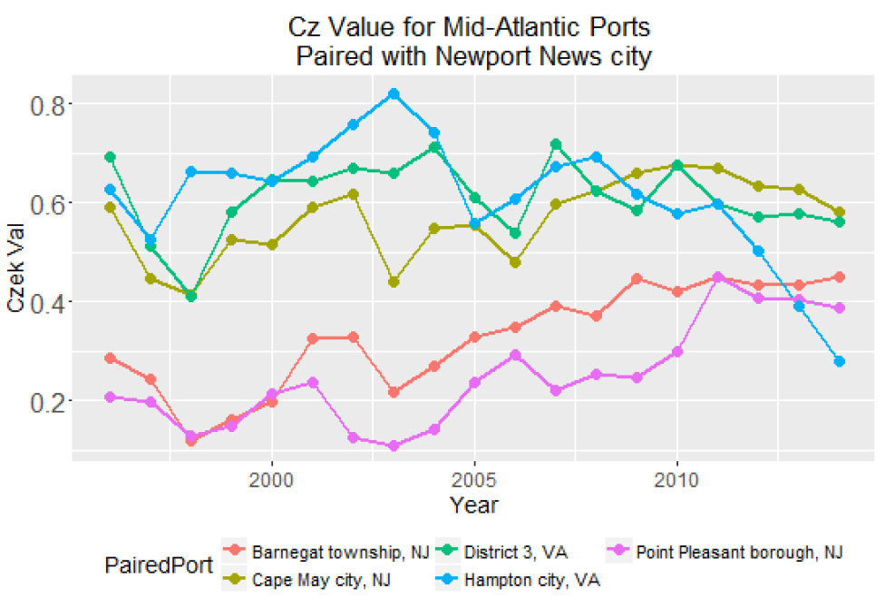

The paper about land-sea connections [6] shows to the reader human impact on the sea from land and vice versa. The maps show the connection between vessels and ports and also

depict the distribution of gear types used in different regions etc. All that is done with neat labels, lines and legends which any person can easily understand in a few seconds.

Paper about the state of the salmon [7] is a very similar work to what I am developing. It uses DFO data related to salmon in BC rivers and the author discussed and tried to produce visualizations for questions that marine experts asked him to solve.

Next papers are not related to fisheries but use some visualization techniques and methods which i would like to mention.

The paper with time series prediction on stocks [5] mostly shows the difference between prediction algorithms, but the visualization part requires special attention. Authors used distinct color coding to show results, there is no extra information on the chart which distracts or confuses readers.

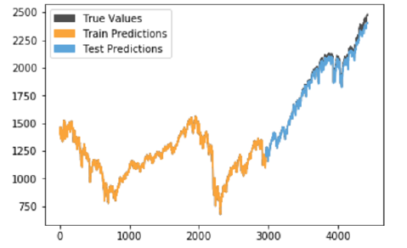

IDMVis [8]: a visualization tool for a patient with diabetes which shows multidimensional interrelated data during the day. IDMVis includes a novel technique for folding and aligning records by dual sentinel events and scaling the intermediate timeline. It was designed to help doctors to track the state of important parameters of patients and to detect anomalies. After that it can be used as a decision support tool for treatment of diabetes. Design decisions were evaluated by six clinicians.

Chapter 3: Design

* Problems as use cases
* Domain characterization
* The role of visualization in the design and in use cases

Chapter 4: Implementation (Tool overview)

The datasource comes from DFO (Fisheries and Oceans Canada). It is about fishing amount catches and money profit for years from 1990 until 2018.

I am creating a visualization tool to help people to understand / analyze table data in a more suitable format as chats, comparison diagrams etc.

The tool itself is implemented in typescript (wrapper for JavaScript) from Microsoft. Frontend framework angular 9 which is one of the most powerful and highly used web engines in the world. Back end is not needed for now as it is a test project. If the data source is changed there will be minimum code modifications to get / process data.

Chapter 5. Evaluation

Chapter 6: Conclusions and Future Work

References

[1] Visualization for fisheries management from a spatiotemporal perspective, Z. Kemp and G. Meaden, 2002

[2] Visualizing Fishing Data as Rasters, Sharon Benjamin, Min-Yang Lee, Geret DePiper, 2018

[3] Spatial and Temporal Differences in the Reproductive Traits of Skipjack Tuna, Hiroshi Ashida, 2020

[4] Evaluation of a US West Coast Groundfish Habitat Conservation Regulation via Analysis of Spatial and Temporal Patterns of Trawl Fishing Effort, Marlene A. Bellman, Scott A. Heppell, Chris Goldfinger, 2005

[5] Time Series Prediction: Predicting Stock Price, Aaron Elliot, Cheng Hua Hsu, 2017

[6] Using GIS to Visualize Land/Sea Connections: Case Study - NE Herring Fishery, Patricia Pinto da Silva, Charles Fulcher, 2007

[7] The State of the Salmon, Michael Barrus, 2017

[8] IDMVis: Temporal Event Sequence Visualization for Type 1 Diabetes Treatment Decision Support