Thesis Template Instructions:  
A guide to formatting your thesis   
using SFU Library’s Microsoft Word template

SIMON FRASER UNIVERSITY  
Fall 2020

Table of Contents

Table of Contents ii

List of Tables iii

List of Figures iv

Chapter 1. Introduction 1

1.1. About the template and instructions 1

1.2. First steps and Word settings 1

1.3. About Word styles 2

1.4. Using styles 3

1.5. Organization of thesis template styles 3

1.5.1. Paragraph and text styles 3

1.5.2. Chapter and section heading styles 4

1.6. Using the Table of Contents and lists 5

1.7. Manual formatting 5

Chapter 2. Examples 7

2.1. Font and spacing 7

2.1.1. Justification 7

2.2. Basic paragraphs and block quotations 7

2.3. Participant interviews 8

2.4. Numbered and bulleted lists 8

2.5. Poetry 9

2.6. Tables, figures, and captions 9

2.6.1. Captions 9

2.6.2. Tables 10

2.6.3. Figures 11

2.6.4. Other lists 12

2.7. Equations 12

2.8. Footnotes and endnotes 13

2.9. Reference list or bibliography 13

2.10. Landscape pages 14

Appendix A. Appendix formatting 15

Appendix B. Image file information 16

Appendix C. Customizing styles 17

List of Tables

Table 1.1. List of SFU text styles 3

Table 1.2. List of SFU heading styles 5

Table 1.3. Manual formatting applied to preliminary pages 6

Table 2.1. Elements of a table 9

Table 2.2. Elements of a figure 9

Table 2.3. A table of random data: inserted captions are created in the default Microsoft caption style, which looks like this. 10

Table 2.4. This table caption uses the style 3_CaptionAbove: always put a [tab] before the start of caption text to create a hanging indent and flush left margin 10

List of Figures

Figure 1.1. Click to show nonprinting characters 1

Figure 1.2. Click to open the Styles Pane 2

Figure 1.3. Check to open the Navigation Pane 2

Figure 2.1. As previously shown, Insert>Caption defaults to the Microsoft caption style for all caption labels (table, figure, scheme, etc.). 11

Figure 2.2. After creating the inserted caption, apply 3_CaptionBelow or 3_CaptionBelow_withNote to the paragraph. 12

# Introduction

## About the template and instructions

The SFU Library thesis template is a Word document designed to assist students in preparing theses, projects, and extended essays.

* The template contains Word styles to assist with formatting
* Headings, figure captions and table captions can be numbered automatically
* The Table of Contents, List of Tables, and List of Figures are populated and paginated automatically

The instructions given here apply to the Fall 2020 release of the SFU Library thesis template, and are intended for Word 2011 (Mac), Word 2013 (Windows), and Word 2016/Office 365 (Mac and Windows).

## First steps and Word settings

The following viewing options are recommended for best use of the template, as well as this guide:

On the Home ribbon, click the ¶ button to show nonprinting characters.

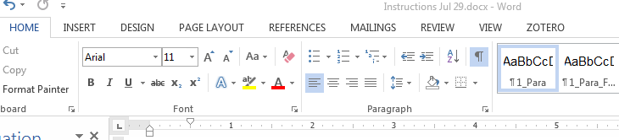

Figure 1.1. Click to show nonprinting characters

Also on the Home ribbon, click the button at the bottom right of the **Styles** menu to open the **Styles** **pane**, a full list of all the available styles in the document.

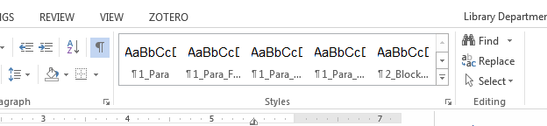

Figure 1.2. Click to open the Styles Pane

On the View ribbon, check **Navigation Pane** to display all document headings in a sidebar. For Mac users with Word 2011, the menu path is **View > Sidebar >** check **Document Map Pane**.

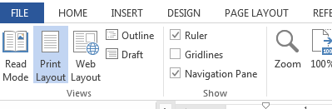

Figure 1.3. Check to open the Navigation Pane

## About Word styles

A Word style is a saved setting that determines font, type size, line spacing, and other attributes. In the thesis template, a style always applies to a whole paragraph.

Any change made from the **Font** or **Paragraph** menu can be saved as a style. This saves time and effort over formatting manually, e.g., applying italics to each figure caption in the document. Styles ensure consistency throughout the document and allow for quick, global changes to document elements.

You must use heading styles to create automatic numbering for chapters and sections, and to populate the Table of Contents.

The active style in a paragraph is highlighted on the list in the Styles pane. Mac and Word 2016 also display the active style in a window at the top of the Styles pane. You can click on examples in this guide and consult the Styles pane to see which styles are being used.

## Using styles

To apply a style, place the cursor anywhere in a paragraph and then click on a style on the style pane.

You can also select multiple paragraphs or pages and apply a style to the entire selected area.

## Organization of thesis template styles

The template contains styles created by the SFU library for thesis preparation. It also contains Microsoft default styles. To meet the library’s formatting guidelines, your thesis will primarily use SFU styles as well as some default styles.

### Paragraph and text styles

SFU text style names begin with numbered prefixes:

Table 1.1. List of SFU text styles

| Style name | Used for |
| --- | --- |
| **1_Para…**  1_Para  1_Para_FlushLeft  1_Para_Hanging Indent  1_Para_NoSpace | **Basic paragraph text**  Paragraph text, indented first line  Paragraph text, no indent  Paragraph text, first line hanging indent  Paragraphs with no space after; used for some preliminary pages |
| **2_ …**  2_BlockQuote  2_Bullet  2_Epigraph  2_List_ManualNumbering  2_ParticipantQuote  2_Poem  2_QuestionAnswer | **Quotations and lists**  Basic block quotation  Bulleted list  Introductory text or quotation  Numbered list, manual numbering  Participant interview block quotation  Poetry or verse  Q&A style interviews; drama |
| **3_ …**  3_CaptionAbove  3_CaptionBelow  3_CaptionBelow_withNote  3_Figure  3_Figure_NoCaption  3_FigureNote  3_TableData  3_TableData_Centre  3_TableData_Right  3_TableHeading_Column  3_TableNote | **Figures, tables, captions, and notes**  Caption above a table  Caption below a figure  Caption followed by a note or source line below  Figure or image  An image or illustration without a caption  Note or source line below a figure caption  Default format for table data  Table data; centered  Table data; right-aligned  Default table column heading  Notes below a table |
| **5_Ref** …  5_Ref  5_Ref_AmerAntiq_Author  5_Ref_AmerAntiq_Work | **References/works cited/bibliography**  Default reference list format  American Antiquities author entry*  American Antiquities works entry* *Noe: These 2 styles are used together for Archaeology theses |
| **9_TitlePage** …  9_TitlePage_Title  9_TitlePage_Text | **Title page**  Document title  All other text on the title page |

### Chapter and section heading styles

SFU heading style names do not have numbered prefixes. Headings should be used in descending hierarchical order.

The template includes three levels of numbered headings for chapters and sections. Use of numbering is optional: consult your supervisor or a liaison librarian to determine the best practice for your discipline or your research.

Applying a numbered heading style will create automatic numbering, e.g., “Chapter 2,” “2.1,” and so on.

Table 1.2. List of SFU heading styles

| **Heading level** | **Style name** | **Used for** |
| --- | --- | --- |
| 1 | Chapter 1. Heading 1 | Chapter headings |
| Heading 1_NoNumber | References, appendices, or any other unnumbered major section.  If you choose not to number chapters, use this style for chapter headings. |
| Heading 1_Preliminary | For preliminary page headings only: Declaration of Committee, Abstract, Table of Contents, and so on. |
| 2 | 1.1 Heading 2 | Subsections within a numbered chapter |
| Heading 2_NoNumber | For subsections in the reference list, in an appendix, or in unnumbered chapters |
| 3 | 1.1.1. Heading 3 | Subsection of a numbered level 2 section |
| Heading 3_NoNumber | Subsection of an unnumbered level 2 section |
| 4 | Heading 4 | Subsection of any level 3 section |
| 5 | Heading 5* | Subsection of any level 4 section |

* All headings up to and including Heading 4 will appear in the Table of Contents. The Table of Contents will not include headings with the Heading 5 style.

## Using the Table of Contents and lists

To update the Table of Contents, List of Tables, or List of Figures:

1. (Windows) Right-click anywhere in the table to open the field menu.

(Mac) Ctrl+click anywhere in the list to open the field menu.

2. Select Update Field; if prompted, select **Update entire table**.

3. The list will populate with the document headings and their page numbers.

## Manual formatting

Manual formatting is appropriate for unique pages or paragraphs that do not recur in the document. The thesis template uses manual formatting for some elements on preliminary pages. Details are given below in case you have to replace or recreate these pages.

Table 1.3. Manual formatting applied to preliminary pages

|  |  |  |  |
| --- | --- | --- | --- |
| **Page** | | **Default style** | **Manual formatting** |
| **Title page** | Author’s name | 9_TitlePage_Text | Add bold |
|  | Copyright statement | 9_TitlePage_Text | Reduce font size to 10pt Single-space paragraph |
| **Declaration of Committee** | Name, Degree, Thesis title | 1_Para_FlushLeft | Add bold |
|  | Committee | 1_Para_NoSpace | Add bold |
|  | Chair, Chair’s name, all committee names | 1_Para_NoSpace | Add bold |
| **Abstract** | Keywords | 1_Para_FlushLeft | Add bold to “Keywords” Add 1-inch hanging indent |
| **Dedication** | Heading | Heading 1_Preliminary | Change font colour to white to hide the heading on the page; it will still populate to the Table of Contents |

# Examples

Use the style **2_Epigraph** for an introductory quote at the beginning of a chapter or section.

(Albert Einstein)

## Font and spacing

The default font in the thesis template is Arial 11pt, using 1.5 line spacing.

### Justification

Paragraph styles are set for left justification with a ragged right margin, as seen in this document. You change the entire document to full justification in one step by editing the **Normal** style: see Appendix C for instructions.

## Basic paragraphs and block quotations

The default paragraph style is **1_Para.** This style creates an indent at the beginning of each paragraph and spacing after each paragraph.

For block quotations, use the style **2_BlockQuote**. This will single-space the quoted text and create left and right indents for the quotation, as shown below:

Should you ever be athirst in the great American desert, try this experiment, if your caravan happen to be supplied with a metaphysical professor. Yes, as everyone knows, meditation and water are wedded forever. (Melville 3)

Use **1_Para_FlushLeft** to continue a paragraph after a quote, as shown here. Do not put quotation marks around a block quote.

## Participant interviews

The template includes two styles designed for participant interviews. **2_ParticipantQuote** is shown below:

No, when I go to sea, I go as a simple sailor, right before the mast, plumb down into the forecastle, aloft there to the royal mast-head. True, they rather order me about some, and make me jump from spar to spar, like a grasshopper in a May meadow. (Ishmael, interview 3)

Remember to check the style guide you are using and consult with your supervisor to determine how interviews should be formatted.

The style **2_QuestionAnswer** is designed for Q&A formatting of interviews, as seen below:

Int: This can help make transcripts easier to read.

Sub: If there’s a long quote from a participant, the style creates a hanging indent for the participant’s name and a flush left margin for the rest of the quote.

Int: Also, remember to put a [tab] between the participant’s name and the start of the quote, as shown in this example.

## Numbered and bulleted lists

We recommend manually numbering or lettering lists in the document.

1. When using the style **2_List_ManualNumbering,** each line entry should be in a separate paragraph as shown here.

2. For each entry, type the number or letter followed by a separator (period or colon).

3. Add a [tab] before the start of the text.

4. Then apply the style.

When creating a bulleted list, each entry should be in a separate paragraph. The style **2_Bullet** will create a bullet and tab before the start of the paragraph text.

## Poetry

When using the style **2_Poem**, each line in a stanza should be separated with a line break using [shift-enter]; use [enter] to end the paragraph at the end of each stanza, as shown below:

i o be gazed dances tossing trees  
in they a of and cloud beneath  
in wandered not out saw did a  
but saw upon eye my and wealth for;

all the that way on a the  
crowd hills inward bay sparkling in lonely  
line i had dancing brought or a  
in but show and never heads

## Tables, figures, and captions

Each figure or table in the document will have up to three elements. Each element must be in a separate paragraph, with an appropriate style applied.

Table 2.1. Elements of a table

|  |  |  |
| --- | --- | --- |
| Paragraph | Element | Style |
| ¶ 1 | Table caption | 3_CaptionAbove |
| ¶ 2 | Table content | 3_TableHeading_Column… 3_TableData… |
| ¶ 3 (optional) | Note | 3_TableNote |

Table 2.2. Elements of a figure

|  |  |  |
| --- | --- | --- |
| Paragraph | Element | Style |
| ¶ 1 | Image | 3_Figure |
| ¶ 2 | Figure caption | 3_CaptionBelow 3_CaptionBelow_withNote |
| ¶ 3 (optional) | Note | 3_FigureNote |

### Captions

In order for figure and table captions to populate the lists in the preliminary pages, they must be created using the **Insert Caption** tool, found at **References>Insert Caption.**

For Mac users using Word 2011, the menu path is **Insert > Caption**.

Inserted captions will appear in the default Microsoft caption style. You must apply one of **3_CaptionAbove**, **3_CaptionBelow**, or **3_CaptionBelow_withNote** to style the inserted caption for the final document.

### Tables

Use the styles named **3_TableData…** and **3_TableHeading_Column** to format the contents of tables. Remember to apply a caption style to the table caption.

Table 2.3. A table of random data: inserted captions are created in the default Microsoft caption style, which looks like this.

|  |  |  |  |
| --- | --- | --- | --- |
| Bourbaki | 1349 | Aubergine | 3.14159 |
| 23 | 42 | 667 | 1479 |
| Orange | β | 3 | 3.3 |

Note: After creating the caption, apply the style **3_CaptionAbove** to it.

The maximum allowed width for a table is 6 inches or 15.24 cm. It is acceptable for a table to span more than one page. Use Table Properties to repeat the header row of a table at the beginning of a new page.

Table 2.4. This table caption uses the style 3_CaptionAbove: always put a [tab] before the start of caption text to create a hanging indent and flush left margin

| Dolor | Sit | Amet | Consectetur | Adipiscing |
| --- | --- | --- | --- | --- |
| 9 | 64 | 30 | 20 | 37 |
| 13 | 61 | 320 | 91 | 74 |
| 2 | 45 | 11 | 531 | 8 |
| 157 | 167* | 439 | 467 | 6109 |
| 44 | 679 | 187 | 732 | 416 |
| 5974 | 97549 | 621 | 5** | 6795 |
| 1576 | 4879 | 564 | 529 | 1 |
| 197 | 764 | 498 | 761 | 15 |

* Use the style **3_TableNote** to add notes, as shown here.  
** When adding more than one note, use a line break [shift-enter] at the end of each line for correct spacing.

### Figures

Use the **Insert > Picture** menu to place an image file on the page. The maximum dimensions allowed for images are 6” (15.24 cm) wide by 9” (22.86 cm) high. Text wrapping should be set to “In line with text” (no text wrap).

Images should be sized to an equivalent print resolution of 300 pixels per inch/dots per inch. For best results, insert images as flattened .tif, .png, or high quality .jpg files.

After inserting the image and checking dimensions, remember to apply one of the **3_Figure…** styles to the image. Remember to apply a caption style to the inserted caption.

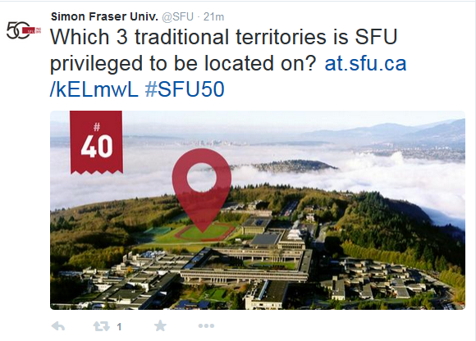

Figure 2.1. As previously shown, Insert>Caption defaults to the Microsoft caption style for all caption labels (table, figure, scheme, etc.).

Note: If adding a note, source, or image credit, do this in a separate paragraph below the caption, and apply the style **3_FigureNote** as shown here and in the example below.

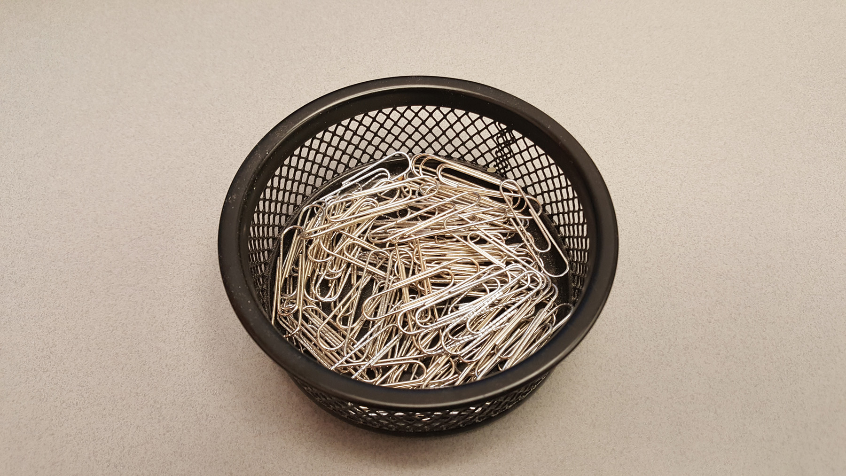

Figure 2.2. After creating the inserted caption, apply 3_CaptionBelow or 3_CaptionBelow_withNote to the paragraph.

Photo: Karen Eliot, *Despair*, 2016. Reproduced with permission.

### Other lists

In the **Insert>Caption** menu, click on **New Label** to create a new category of caption label, e.g., equation, scheme, illustration.

## Equations

Use Word’s default **Insert>Equation** tool to create equations in the document, as shown below.

(1)

Word’s default font (Cambria Math) and settings are acceptable for library submission.

## Footnotes and endnotes

Use the default Word settings for creating footnotes and endnotes: from the References tab, click **Insert Footnote[1]** and type or paste in the note.[2] The process is identical for endnotes. The library recommends using footnotes rather than endnotes for easier formatting and better readability.

## Reference list or bibliography

The style **5_Ref** creates single-spaced paragraphs with a hanging indent, acceptable for most referencing styles.

Users of SAA/American Antiquities style should apply **5_Ref_AmerAntiq_Author** and **5_Ref_AmerAntiq_Work**.

## Landscape pages

Follow these two steps to ensure correct formatting and pagination of landscape pages:

1. Create the landscape section using the **Custom Margins** dialogue.

Select the area where you want the landscape page(s) to appear.

Windows and Word for Mac 2016: **Page Layout > Custom Margins** > set Orientation to landscape, set **Apply to:** **Selected Text**.

Word for Mac 2011: Select text: **Layout > Margins > Custom Margins >** open **Page Setup** and change to landscape, set **Apply to: Selected Text**.

2. Check the page numbering in the landscape section and set to **Continue from previous section**. Repeat on the first page after the landscape section. If this setting is not changed, every new section begins with a page number of 1.

Windows and Word for Mac 2016: **Insert > Page Number > Format Page Numbers > Continue from Previous Section**

Word for Mac 2011: **Insert > Page Numbers > Format > Continue from Previous Section**

These steps can also be used to create bifold (11X17) landscape pages. Legal size pages (8.5X14) are not permitted.

#### Important note for Mac users

When converting to PDF, Word for Mac splits the document into separate PDF files at each section break. You can use Adobe Acrobat Pro or Apple Preview to rejoin the PDFs into a single document.

Appendix A.   
  
Appendix formatting

Appendices may be used for supplemental information that does not form part of the main research. If used, appendices must appear at the end of the document. Appendices should be lettered; if there is only one appendix in the thesis, the letter can be omitted.

Appendix text should be formatted using the same styles as chapter text. Tables and figures in appendices should notappear in the List of Tables or List of Figures. Do not use the Insert>Caption tool to number appendix figures and tables; instead, enter the number manually.

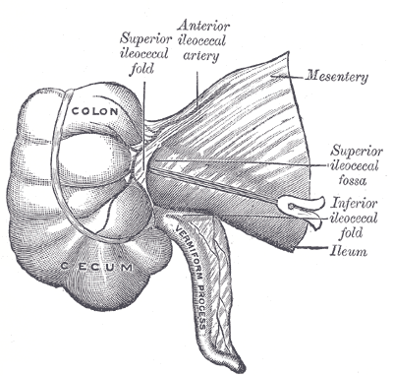

Figure A1. Superior ileocecal fossa

Source: Gray, 1918. Retrieved from http://www.bartleby.com/107/illus1043.html

Numbering should include the letter of the appendix, as shown in the examples above and below. For a single appendix without a letter, use the letter A for appendix.

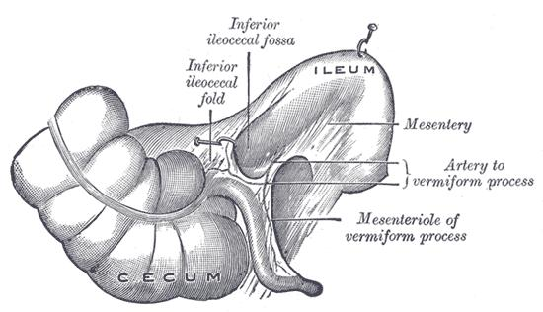

Figure A2. Inferior ileocecal fossa

Source: Gray, 1918. Retrieved from http://www.bartleby.com/107/illus1044.html

Appendix B.   
  
Image file information

Images should be sized to an equivalent print resolution of 300 pixels per inch/dots per inch.

* For example, an image 6 inches wide should be 1800 pixels wide to produce an equivalent resolution of 300 ppi.
* 6 inches X 300ppi = 1800px.

For best results, insert images as flattened .tif, .png, or high quality .jpg files. The library does not prescribe any specific file format. At this time, the library does *not* recommend using SmartArt or other Word tools to compose images. To ensure ease of use with the Word template, we recommend creating complex graphics in an external application (Illustrator, Photoshop, PowerPoint, ChemDraw, etc.) and inserting a single, flattened image file into the thesis.

Appendix C.   
  
Customizing styles

Word styles are editable. From the expanded Styles pane, mouse over the right edge of a style name to reveal a pop-down menu and select **Modify Style**.

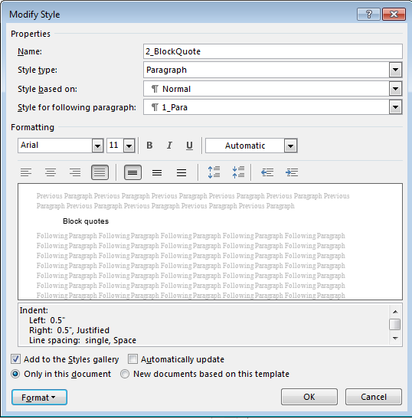

Figure C1. The Modify Style window

Basic changes such as font, justification, and line spacing can be made directly from the window shown above. To make more complex changes, click on **Format** and select a submenu.

You may edit styles at your discretion as long as the document conforms to the library’s formatting requirements, detailed on the thesis website.

The default font in the thesis template is Arial 11pt. The recommended serif font is Times New Roman 12pt. To make a global change to the document font, edit the **Normal** style to change the font.

**What is Normal?**

**Normal** is the default text style in any Word document. Almost all other styles in a document are based on the properties of **Normal**. Editing **Normal** allows you to make global changes to font, justification, line spacing, and any other font or paragraph property.

Paragraph styles are set for left justification with a ragged right margin. To change to full justification in the entire document, edit the **Normal** style and select full justification.

Block quote styles are set with 0.5 inch indents on the left and right. If your referencing style requires a left indent only:

* Edit **2_BlockQuote**
* Open the **Format** menu and select **Paragraph**
* Set **Indentation – Right** to zero.

If your document uses non-standard formatting and fonts – for example, submissions from Contemporary Arts or Arts Education – you are encouraged to contact the Theses Office early in the writing process.

1. For Mac users with Word 2011, the menu path is **Insert>Footnote*.***
2. The thesis template uses default Microsoft styles for footnotes. It’s not necessary to apply a style after creating the note.