**Points possible :** 75

**Instructions:**

* In the next few weeks, you will be completing coding assignments outlined in a document that looks like this one. For now, complete these two basic exercises to get warmed up, take screenshots of the results, and insert the screenshots in the correct place below.
* Taking good screenshots is required for this course and will help our staff assist you with your code. Here’s how to take screenshots:

On MacOS, press **Command ⌘** + **Shift** + **4** OR press **Command ⌘**  +  **Shift** + **5**

On Windows, press **Windows key**  +  **Shift +** **S**

* Once you have completed these steps, please save this file to a .pdf format, and submit it to the **Week 0: Coding Assignment Submission** Tile in the Learning Management System (LMS).

**Coding Steps:** Software development requires working knowledge of the command prompt (on **Windows**) or terminal app (on **MacOS**) on your computer, a pre-requisite for coding. For this assignment complete the following steps:

1. Open command prompt (**Windows**) or terminal app (**MacOS**) and type the commands below in order.

| **Task Name** | **On Windows, type these commands** | **On MacOS, type these commands** |
| --- | --- | --- |
| 1. **Print current directory** | cd | pwd |
| 1. **List contents of directory** | dir | ls |
| 1. **Create a new directory** | mkdir Promineo | mkdir Promineo |
| 1. **Change into that directory** | cd Promineo | cd Promineo |
| 1. **Print current directory** | cd | pwd |
| 1. **Create a new directory** | mkdir Week0 | mkdir Week0 |
| 1. **Change into that directory** | cd Week0 | cd Week0 |
| 1. **Print current directory** | cd | pwd |
| 1. **Print hostname** | hostname | hostname |

**Insert screenshot(s) of these commands and the results here**: This can be done by running the commands in a command prompt (Windows) or the terminal app (MacOS) window and taking a screenshot of that entire window.

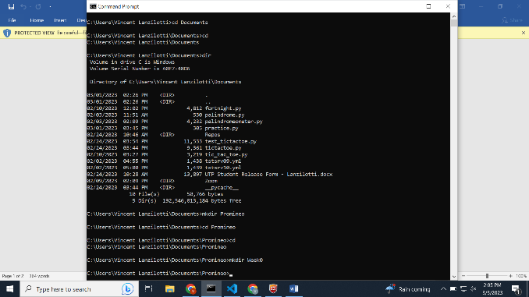 ­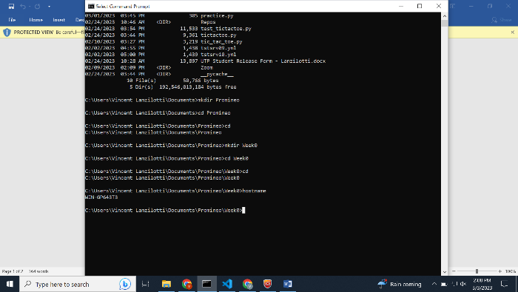

1. Go to <https://zoom.us/test> and join a test meeting. Follow all the prompts to join the meeting and test your audio and video. Once you have joined the test meeting, click on the green shield icon in the top left corner of the screen, choose Statisticson the left-hand column, and take a screenshot of that window and post it below.

**Insert a screenshot of the Statistics window here**:

