Documentation of First Assignment from DSA
It contains:
Code description,
Comparison and analysis
Presenter:
Chesnykov Vladyslav
Place:
STU BA FIIT
Software:
IntelliJ IDEA
Computer:



=================================================
Provided implementation in Java:
AVL Tree, Splay Tree, HT with Open Addressing, HT with Separated Chains.
STU BA, FIIT.
Chesnykov Vladyslav.

- Implementation of AVL Tree: (I describing main points of my code, all other will be covered in comments in code document)

Insert function:
In my code you can find algorithm where I in this part of code making an update of the node’s height:
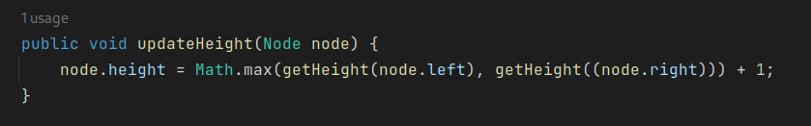
It works as increasing of the maximum value of last nodes of right and left sub-trees.

Then my algorithm by recursion searching the place for new node:

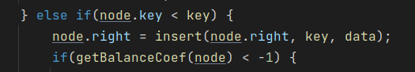
And here:
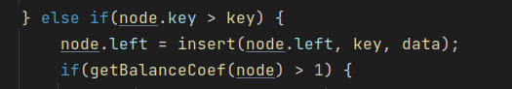
Here I made all sorts of rotation if right sub-tree is bigger then left:
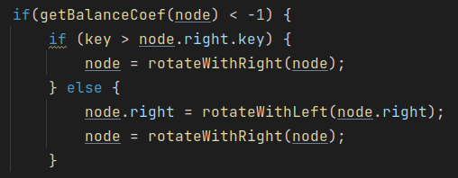

And on this picture you can see all sorts of rotations if left sub-tree is bigger then right:
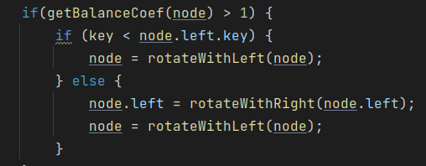

Delete function:
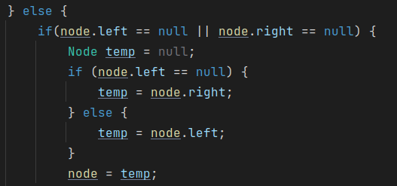
If node left child or right (or both of them) will be null, then we will rise the node which is not null (or return null).

If all the children exist, then we will find the most left child of right sub-tree, because of the conception of BST, as all right elements is bigger then parent element, and all left are less. And that is why this element must be the nearest to parent element.
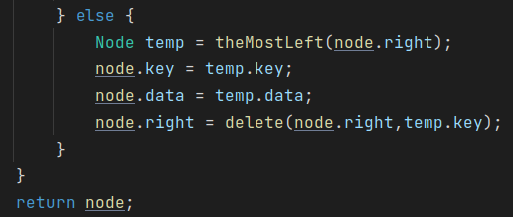

Search function:

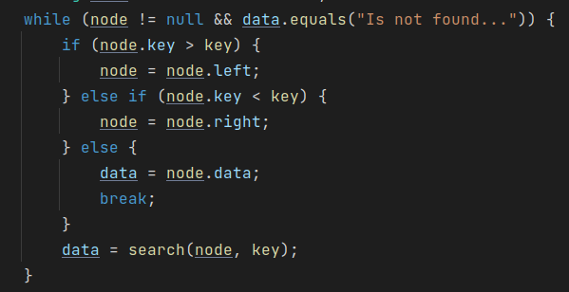
In this cycle I use recursion for finding the element which is match to the key user write.

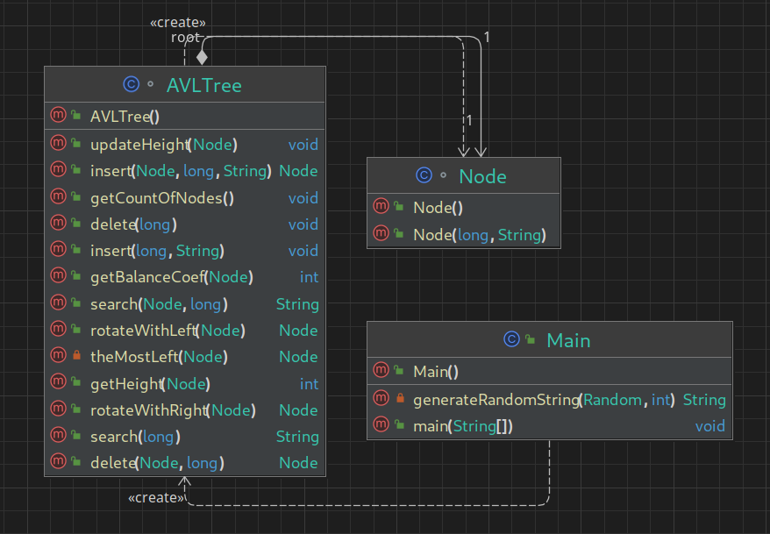

- Implementation of Splay Tree: (I describing main points of my code, all other will be covered in comments in code document)

Insert function:
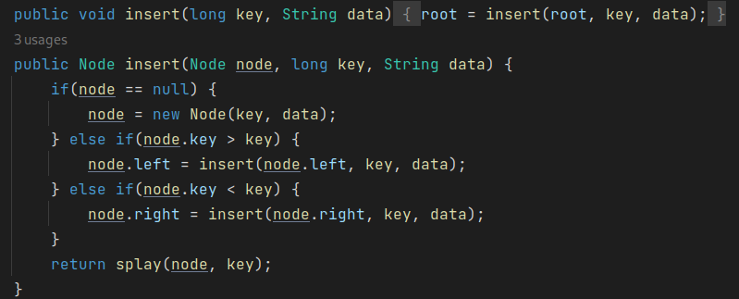
In recursion I searching the place for my element as in any BST, then I use splay function.

Delete function:
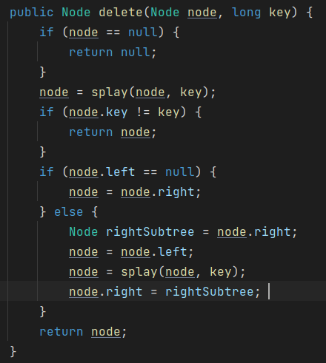

On the picture you can see that code will find the element and with the help of splay function will rise the element on the top to the root. There I chose the variant where left child will be put on the top, as a new root, and its right sub-tree will be exchanged with the previous root’s right sub-tree.

Search function:

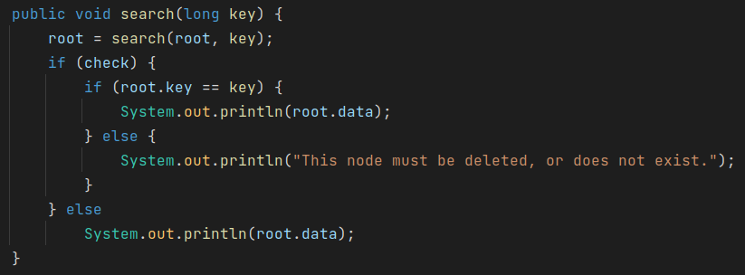

By recursion will find the element and print its data (or print that it is not exist).

And will make a splay rotation will found element.

Splay function:

This part will check if the node has the same key user entered, then its node will be returned ‘check’ factor will be changed to ‘true’.
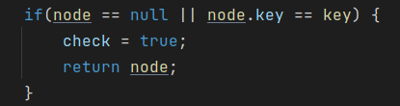

And this part of code will return in each checking if node.key has more or less value of user’s key.
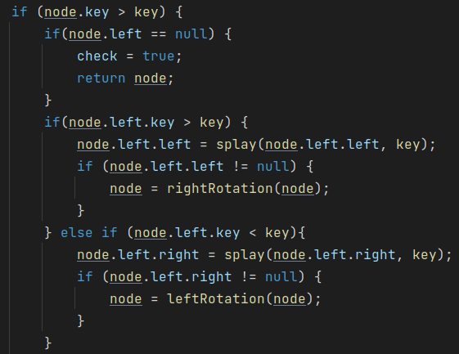

Here you can see, that we have 2 steps of comparison: first, when we figure out the key value of node.left is bigger then user’s key or less(and in every case we have 2 additional checks node.left.left and node.left.right, or node.right.left and node.right.right). For each variant we have its own sort of rotation. And by recursion we make the amount of rotation which is needed for rising the element on the top of tree.

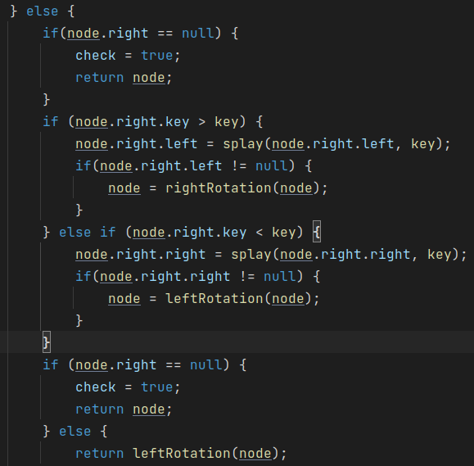

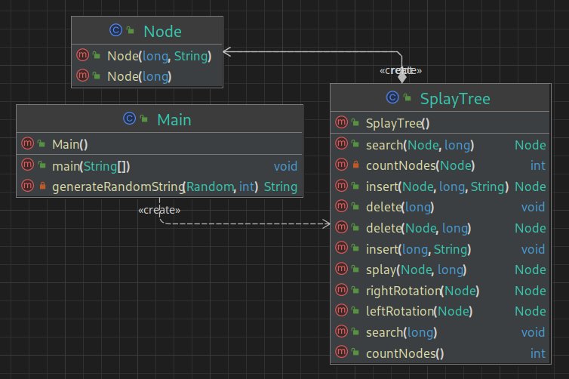
- Implementation of HT with Open Addressing: (I describing main points of my code, all other will be covered in comments in code document)

This is my Hash function:

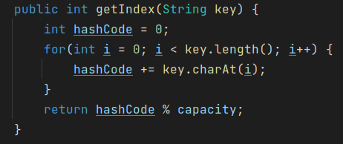
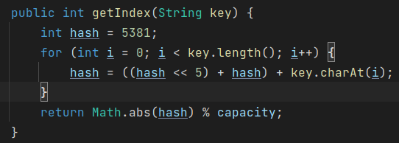
This hash function makes hash code from the string we have first any number, for instance 5381, then in binary format I move the number on 5 position, and then add binary code of 5381 and my character binary code. It provides me good hash code. And then divide it by capacity of my array.
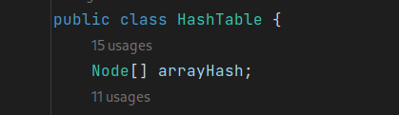
For making me code faster I made main array not as ArrayList of LinkedList:

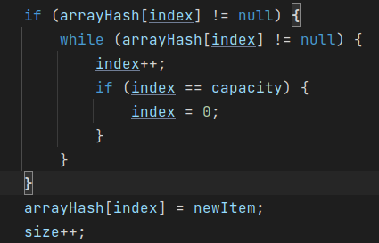

On the right picture is algorithm of searching free node in array, as in any Open Addressing hash-table.

And if the count of nodes (‘size’) is bigger then overloadIndex*capacity, then hash-table will be increased and rehashed.

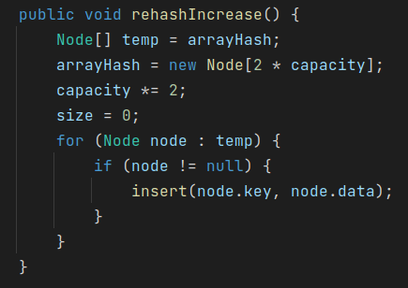

With the help of ‘temp’ I can increase capacity of my main array, and reinitialize all of the nodes. And then insert all the element from ‘temp’ into new array.

Delete function:
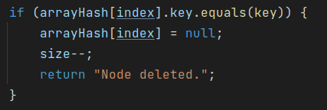
My delete function is repeating insert part in searching the element I need to delete, but if in ‘insert’ I put the value into the node, then in delete I set the node’s value to null.

Search function:

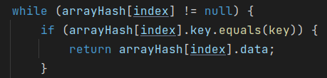
In my search function I have ‘String data’ where must be save value of searching element if it will be found. And all the code the same as in ‘delete’ or ‘insert’.

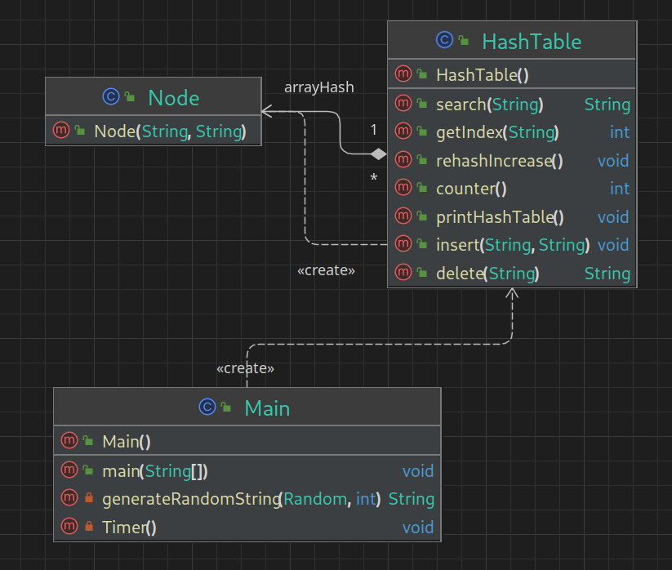

- Implementation of HT with Separated Chains: (I describing main points of my code, all other will be covered in comments in code document)

Insert function:

This part of code contains the algorithm of searching place to insert the element:
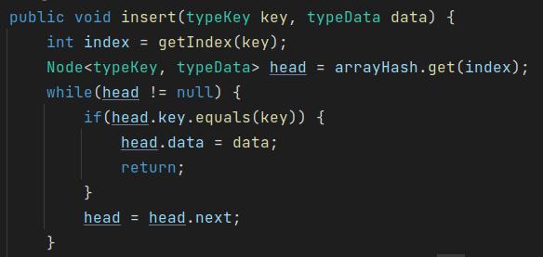
Code will find the place through hash function:
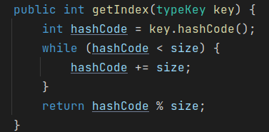

Here I used standart library for getting the hash from the object.

After this condition, as in HT with Open Addressing hash-table will be increased and rehashed:

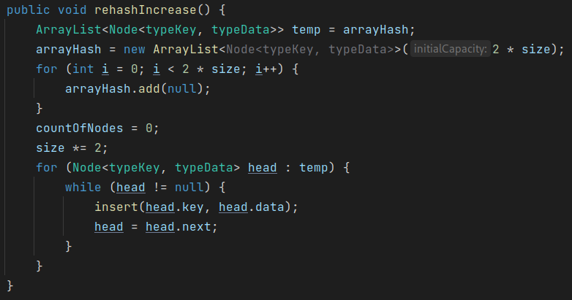
All the same as in ‘HT_OA’, but with using the ability of choosing your own type.

Delete function:

Here I searching the element and set it to null:
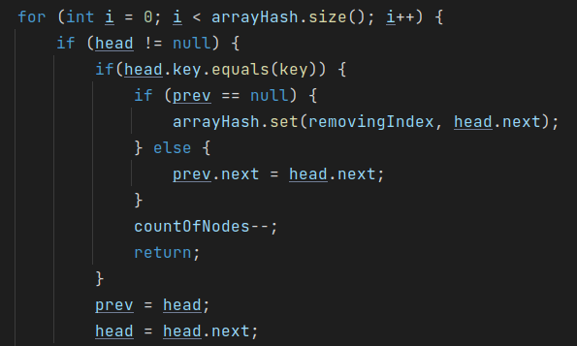
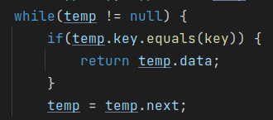

Search function:

This ‘while’ will find the element we searching by comparing its key with user’s key.
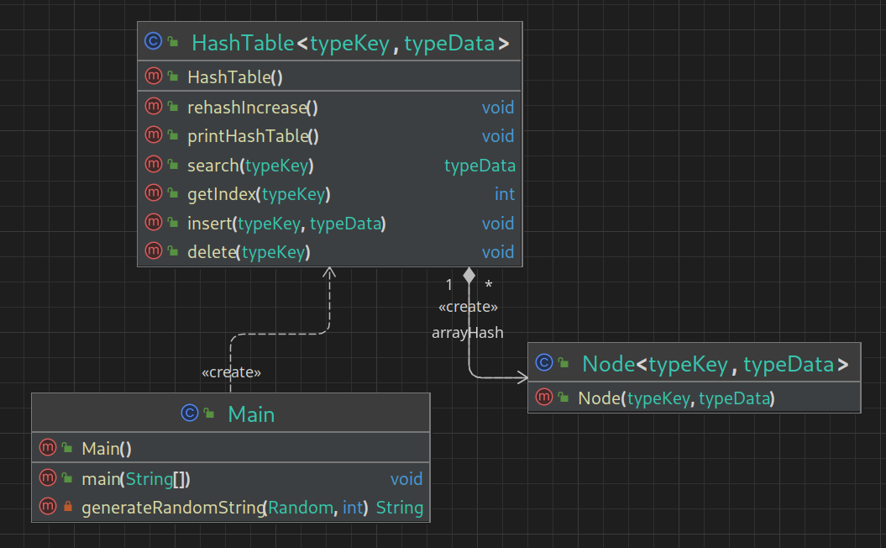

Comparisons & conclusions

Performance and Memory Cost Comparison of Node Operations in a Data Structure
This study aims to compare the performance and CPU workload of individual node operations, including insertion, search, and deletion, in a data structure. The comparison was conducted on individual random subsets of data, which were common to all stages of verification. Additionally, the CPU cost of each function was compared. The study also investigated the effects of certain circumstances, such as the non-existence of a node during search and deletion operations, on the performance of the data structure.

Investigation:
Insert
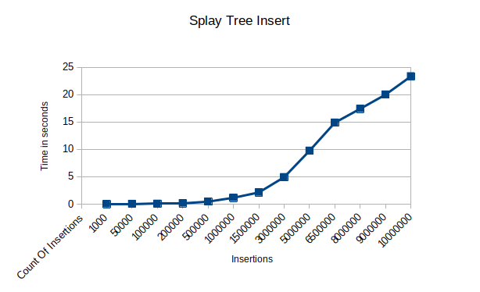
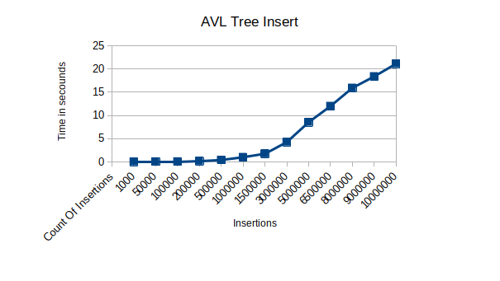

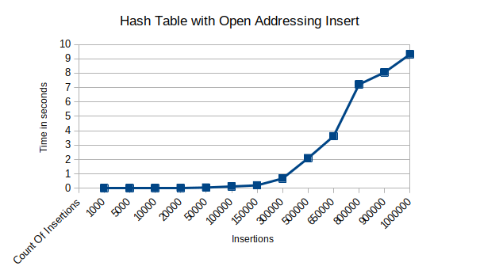
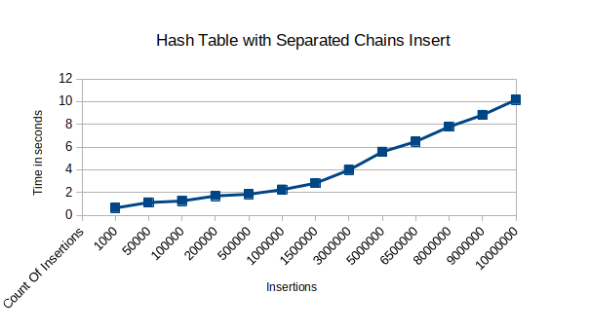

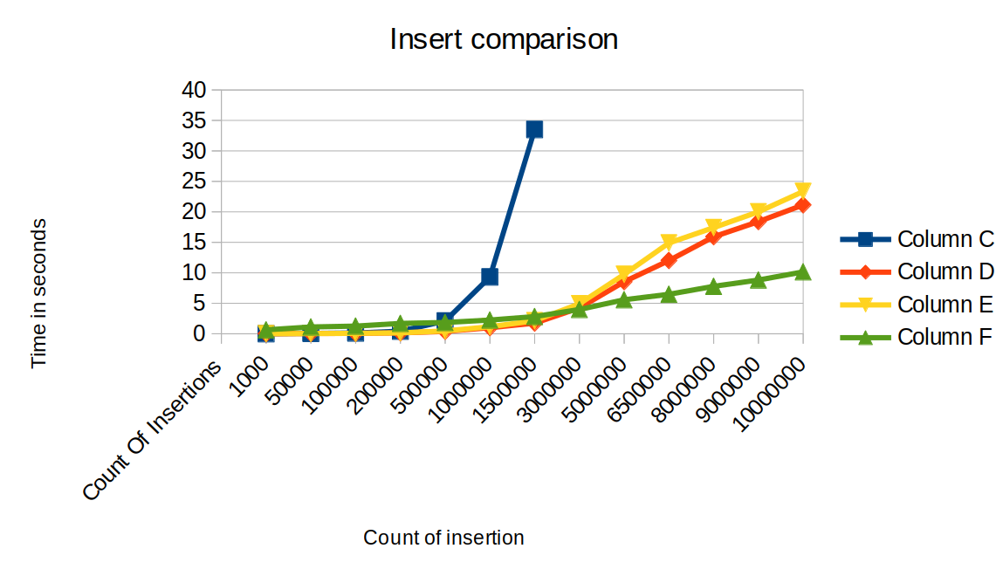
C – Open Addressing, D – AVL Tree, E – Splay Tree, F – Separated Chains

Conclusion:

The primary objective of the project was to assess the ability to construct code for functional data structures. Another key aspect was to evaluate the preservation of a confirmed logarithmic function when utilizing an alternative graph to represent the implementation of any of the suggested functions. The aforementioned images illustrate that the logarithmic function is indeed maintained, albeit not entirely. Our findings indicate that the Splay tree implementation and separated chains provided the most effective reproduction of insert function.

CPU usage:

For 10_000_000 inserted elements:

- HT with Open Addressing:
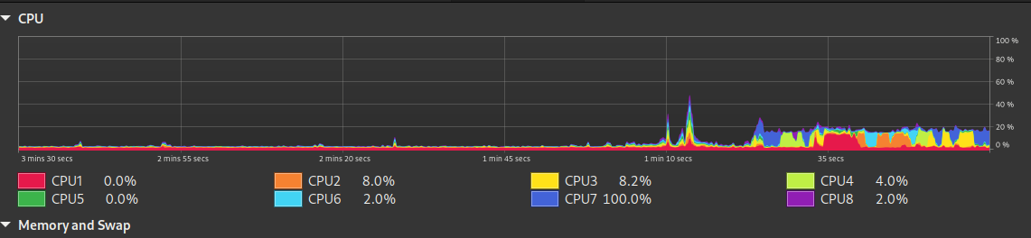
- HT with Separated Chains:
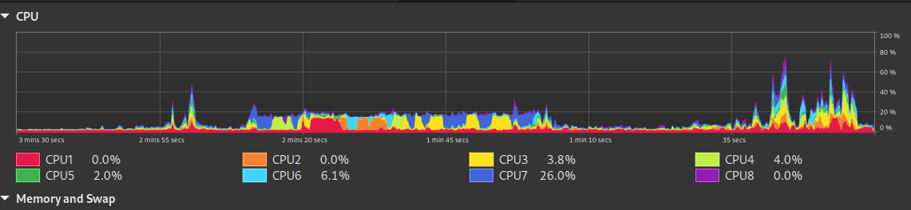
- AVL Tree:
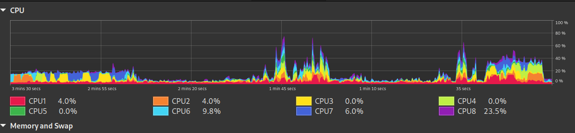
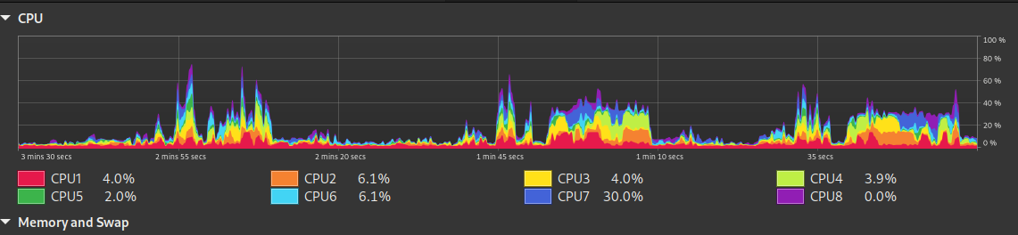
- Splay Tree:

Conclusion:

Based on the observed data represented in the graphical outputs, it is evident that the employment of AVL tree structure results in the most advantageous outcome. This is due to the remarkable performance metrics exhibited by the processor, with a significant proportion of the indicators reaching optimal levels of 75%. However, in contrast, the implementation of Hash table with open addressing appears to be inefficient in terms of the insertion process, as it fails to utilize the processor's full capacity despite its inherent potential

Search
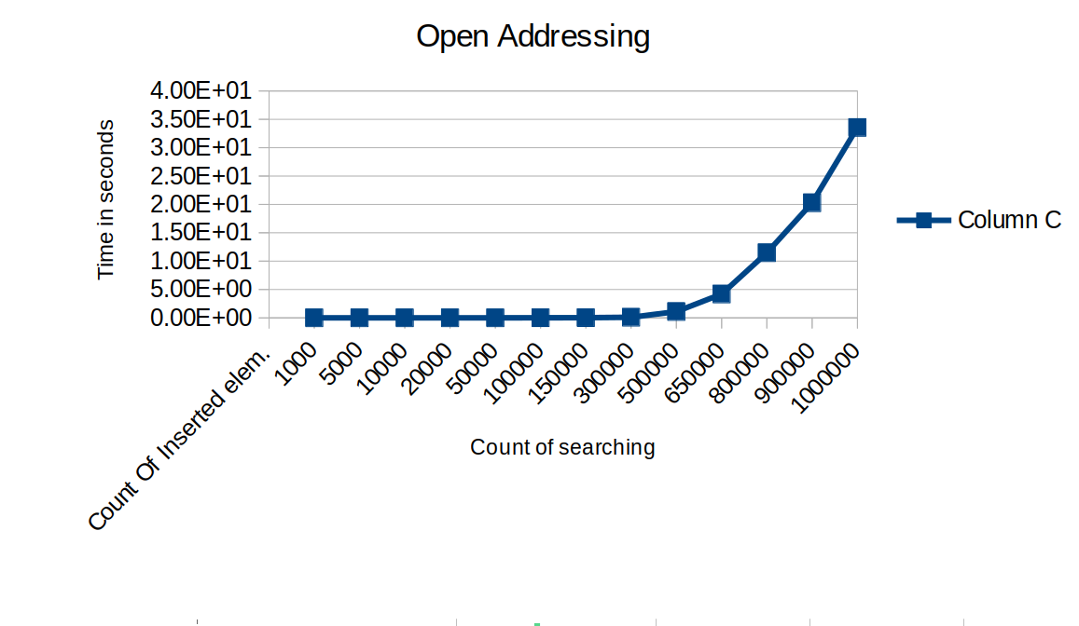
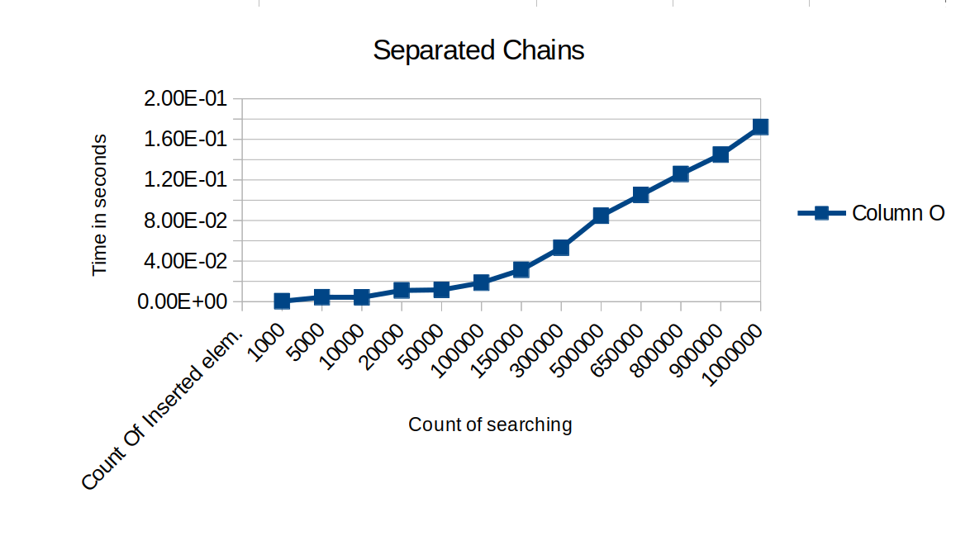

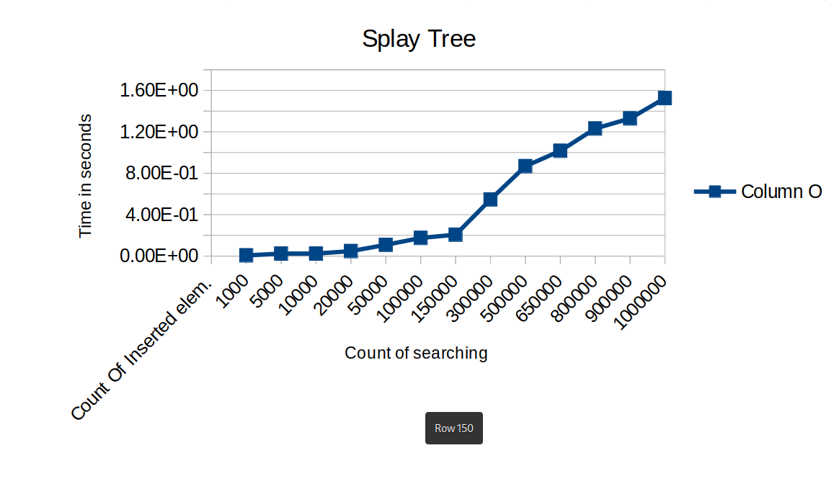
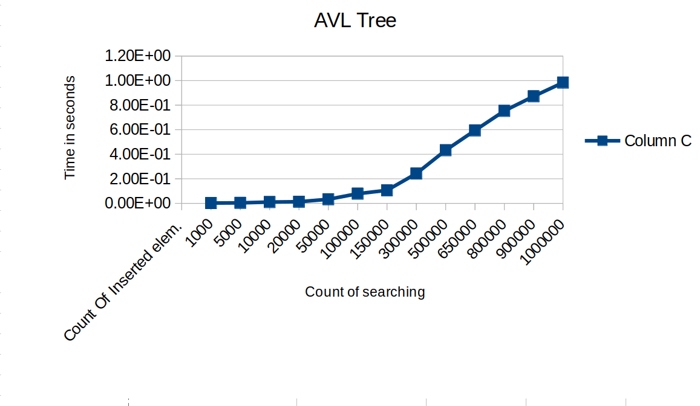
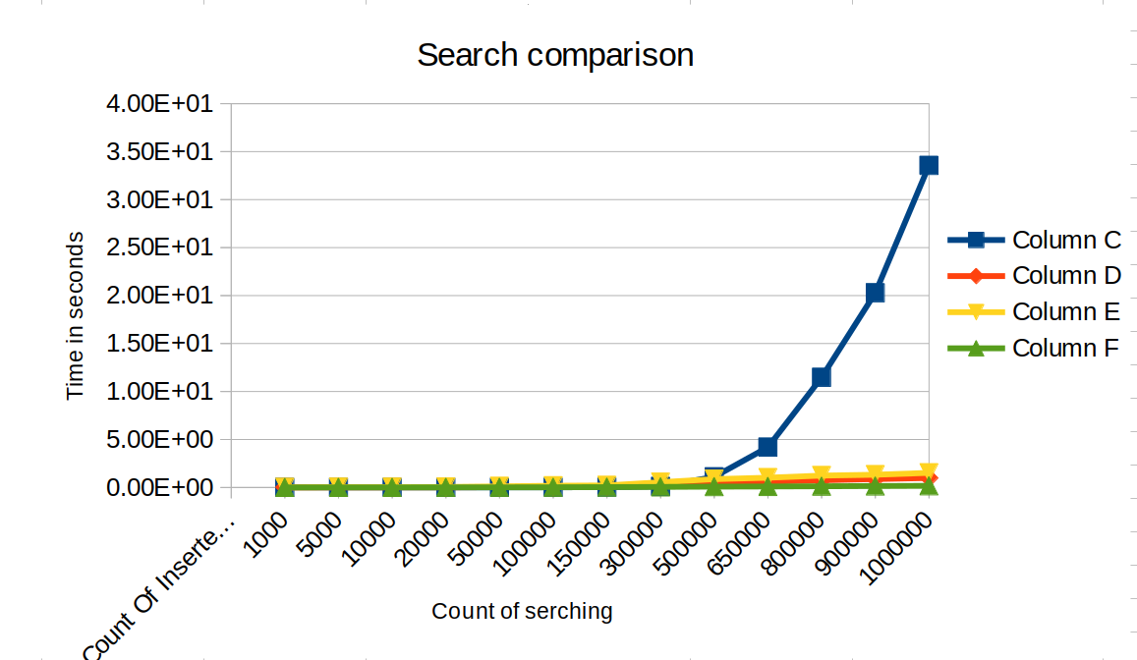

C – Open Addressing, D – AVL Tree, E – Splay Tree, F – Separated Chains

(On the picture above C – Open Addressing, D – AVL Tree, E – Splay Tree, F – Separated Chains)

Conclusion:

The objective of this study was to examine the variation in element search behavior among different algorithms. Our results indicate that search speed is affected by table completeness, with open addressing showing notably slow search speeds. The algorithmic approach of examining all filled cells to locate a suitable key placement is a typical and reasonable technique. The fastest search performance was observed with the separated chains algorithm. Additionally, an experiment was conducted to investigate the speed of single searches across varying table occupancy levels. Our findings reveal that all implementations are well-suited for custom searches and significantly outperform linear traversal of node fields.

Delete
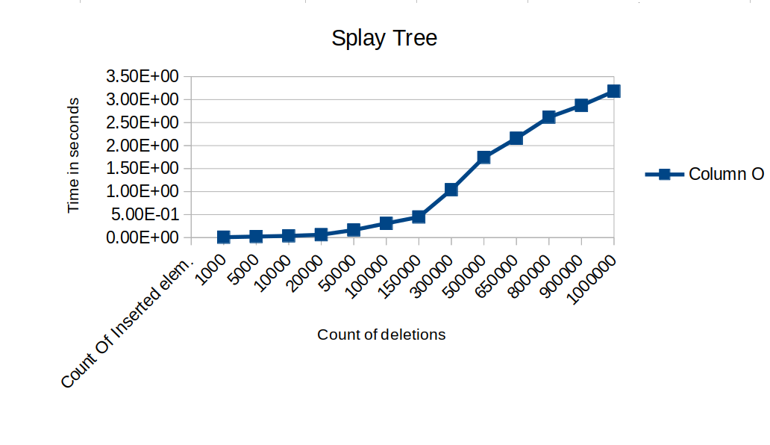

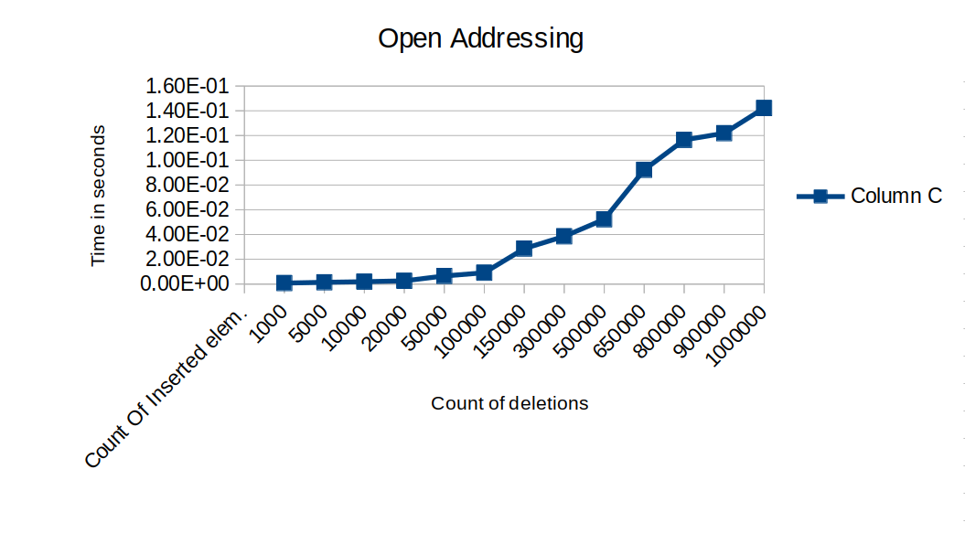

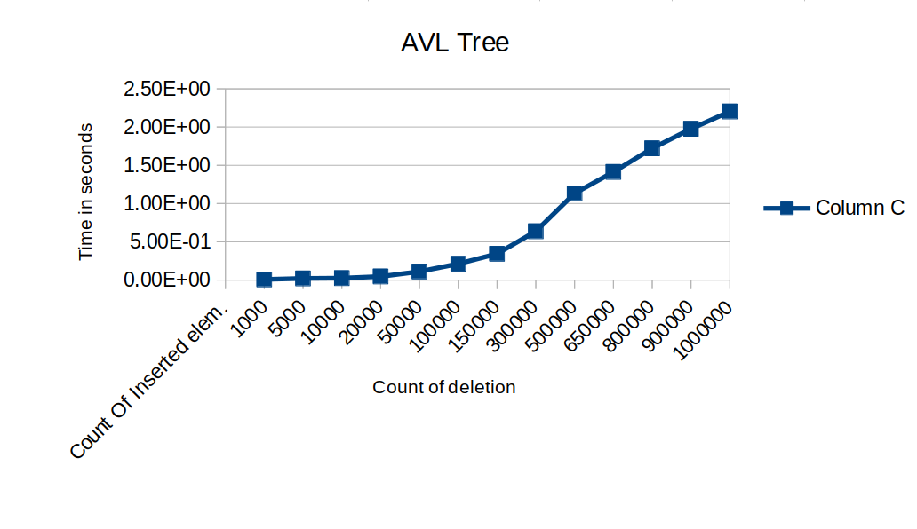

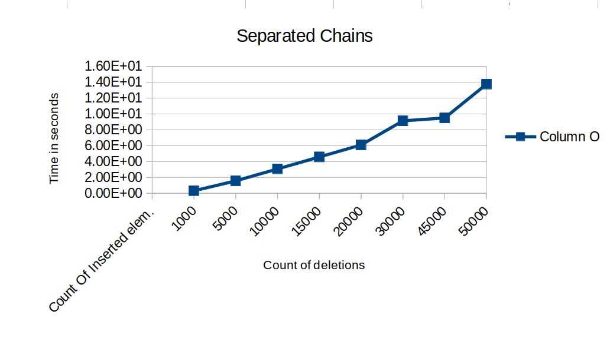

C – Open Addressing, D – AVL Tree, E – Splay Tree, F – Separated Chains

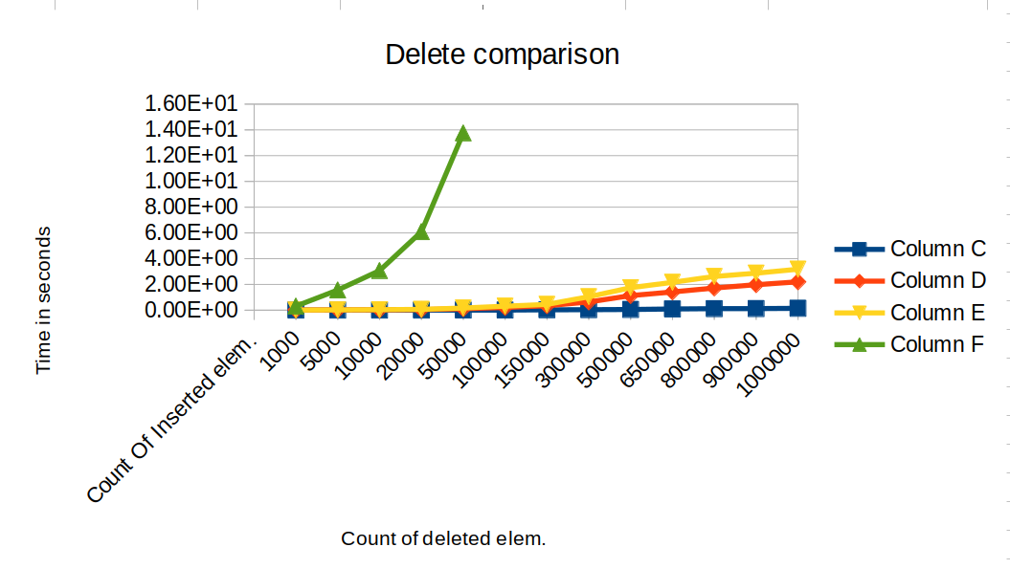
C – Open Addressing, D – AVL Tree, E – Splay Tree, F – Separated Chains

Conclusion:

Upon examining the graphs, it is evident that the separated chain implementation is the least optimal, as it displays significant sensitivity to the table's fullness. Conversely, other implementations, which involve element removal, have demonstrated higher efficacy. Notably, open addressing has been shown to be the most effective approach.

Main conclusion:
Data structures are essential tools in computer science and are used to store and organize data efficiently. The performance of data structures is an important consideration when selecting the appropriate structure for a given task. This study compares the performance and memory cost of individual node operations, namely insertion, search, and deletion, in a data structure. The study also investigates the effects of certain circumstances on the performance of the data structure.

