**1.Presentation:**

Hello everyone, our work team is made up of Andrés Felipe Almario, Laura Vanessa Rodríguez, Yuderly Sapuy and Dayana Marcela Valenzuela Erazo, apprentices who belong to the Software Analysis and Development technology, code number 2500871.

We present our project called AGROCEFA.

Img1. Developers View

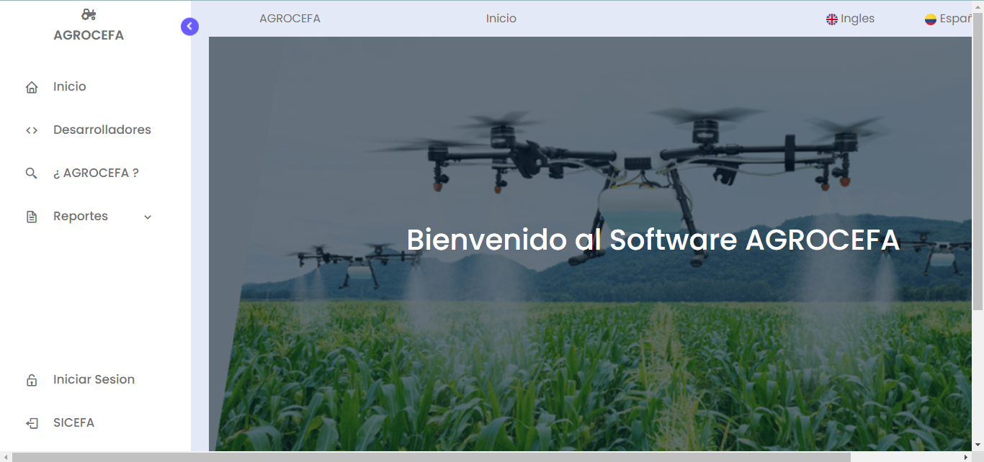

Img2.Main View

1. **Project description**

With AGROCEFA software we seek to simplify accounting processes and management of the different crops in the Agro-industrial Training Center, la Angostura. Our interest is that the Center get rid of handling physical papers and can have a quick access of data. It will also improve safety of information and help to keep control of the production and inputs used in the productive units.

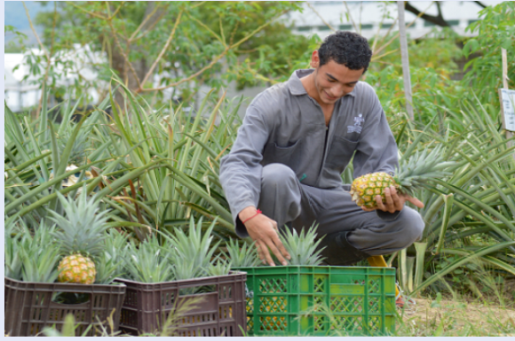

Img3. La Angostura Pineapple Production Unit

1. **Software phases**

To carry out the construction of this software we used the SCRUM development methodology and took into account the following phases:

**Phase 1: Requirements Identification**

This is focused on the identification of the requirements necessary for the optimal development of the project. It means identify the needs of the system. In this phase, the roles necessary to manage the software and permissions were also identified.

**Phase 2: Technology Analysis and Choice**

In the next phase, we analyze the information collected and make decisions about the technology to be used. In our case, our team chose the Laravel framework. In addition, we used CSS styles for the design, Laragon as a platform that provides a database and a runtime environment, JavaScript functions for the various system actions. We also used UML diagramming language and applied the IEEE 830 standard.

Img4.Framework Laravel

**Phase 3: Design Implementation**

On the third phase we focused on the implementation of the design. Our goal was to create a friendly and easy-to-use interface for customers. We began coding based on the previously prepared designs.

**Phase 4: Task Assignment and Project Management**

The objective of the phase for was to improve efficiency and track our progress as a development team. We used tools like Trello and Git. Trello allowed us to effectively assign tasks to visualize the progress of each team member. Git helped us to simplify collaboration in the team coding process.

**Phase 5: Implementation and Testing**

Finally, we come to the last phase which is the software implementation stage. During this phase, we carried out testing to identify and fix potential coding errors before delivering the project.

1. **Interaction of the roles with the AGROCEFA designed software**

To run our software, the following roles were involved:

* **Administrator:**

The Administrator is responsible for the configuration and general management of the Agricultural software. This includes creating user accounts, assigning permissions and roles, monitoring operations on the system, performing software maintenance and updating tasks to ensure optimal. User can access reports and statistics on production and inputs used in the productive units. 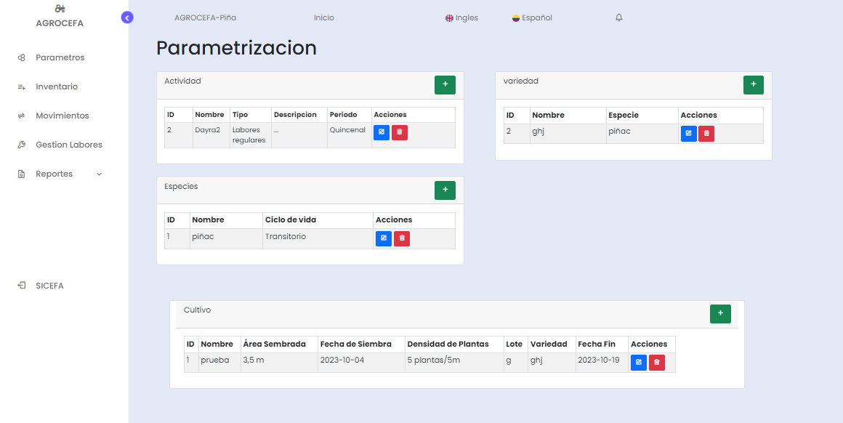

Img5.Admin View

* **Intern:**

Interns are users in training who work under the supervision of the Administrator or more experienced users. They use the Agricultural software to learn about crop management and get data related to agricultural production. They type data on production, inputs used, and other agricultural activities into the system as a part of their learning process. Interns may have limited access to certain features of the software.

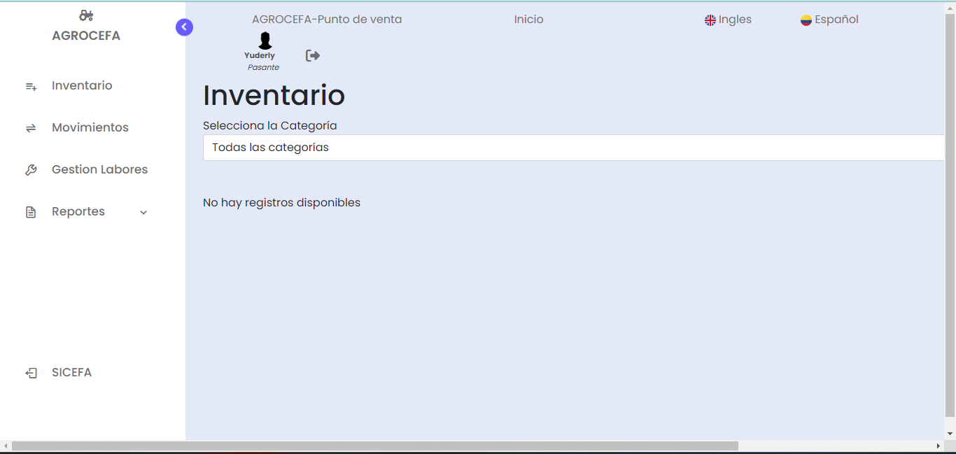

Img6. Intern View

* **User:**

This type of user has a limited set of permissions to obtain information from the software, and cannot make changes or actively interact with the system's features. It is called a "read-only user" or "user with view-only privileges."



1. Our innovation idea is to implement accounting reports through various types of formats and balance graphs of profits and expenses generated in the agricultural units.